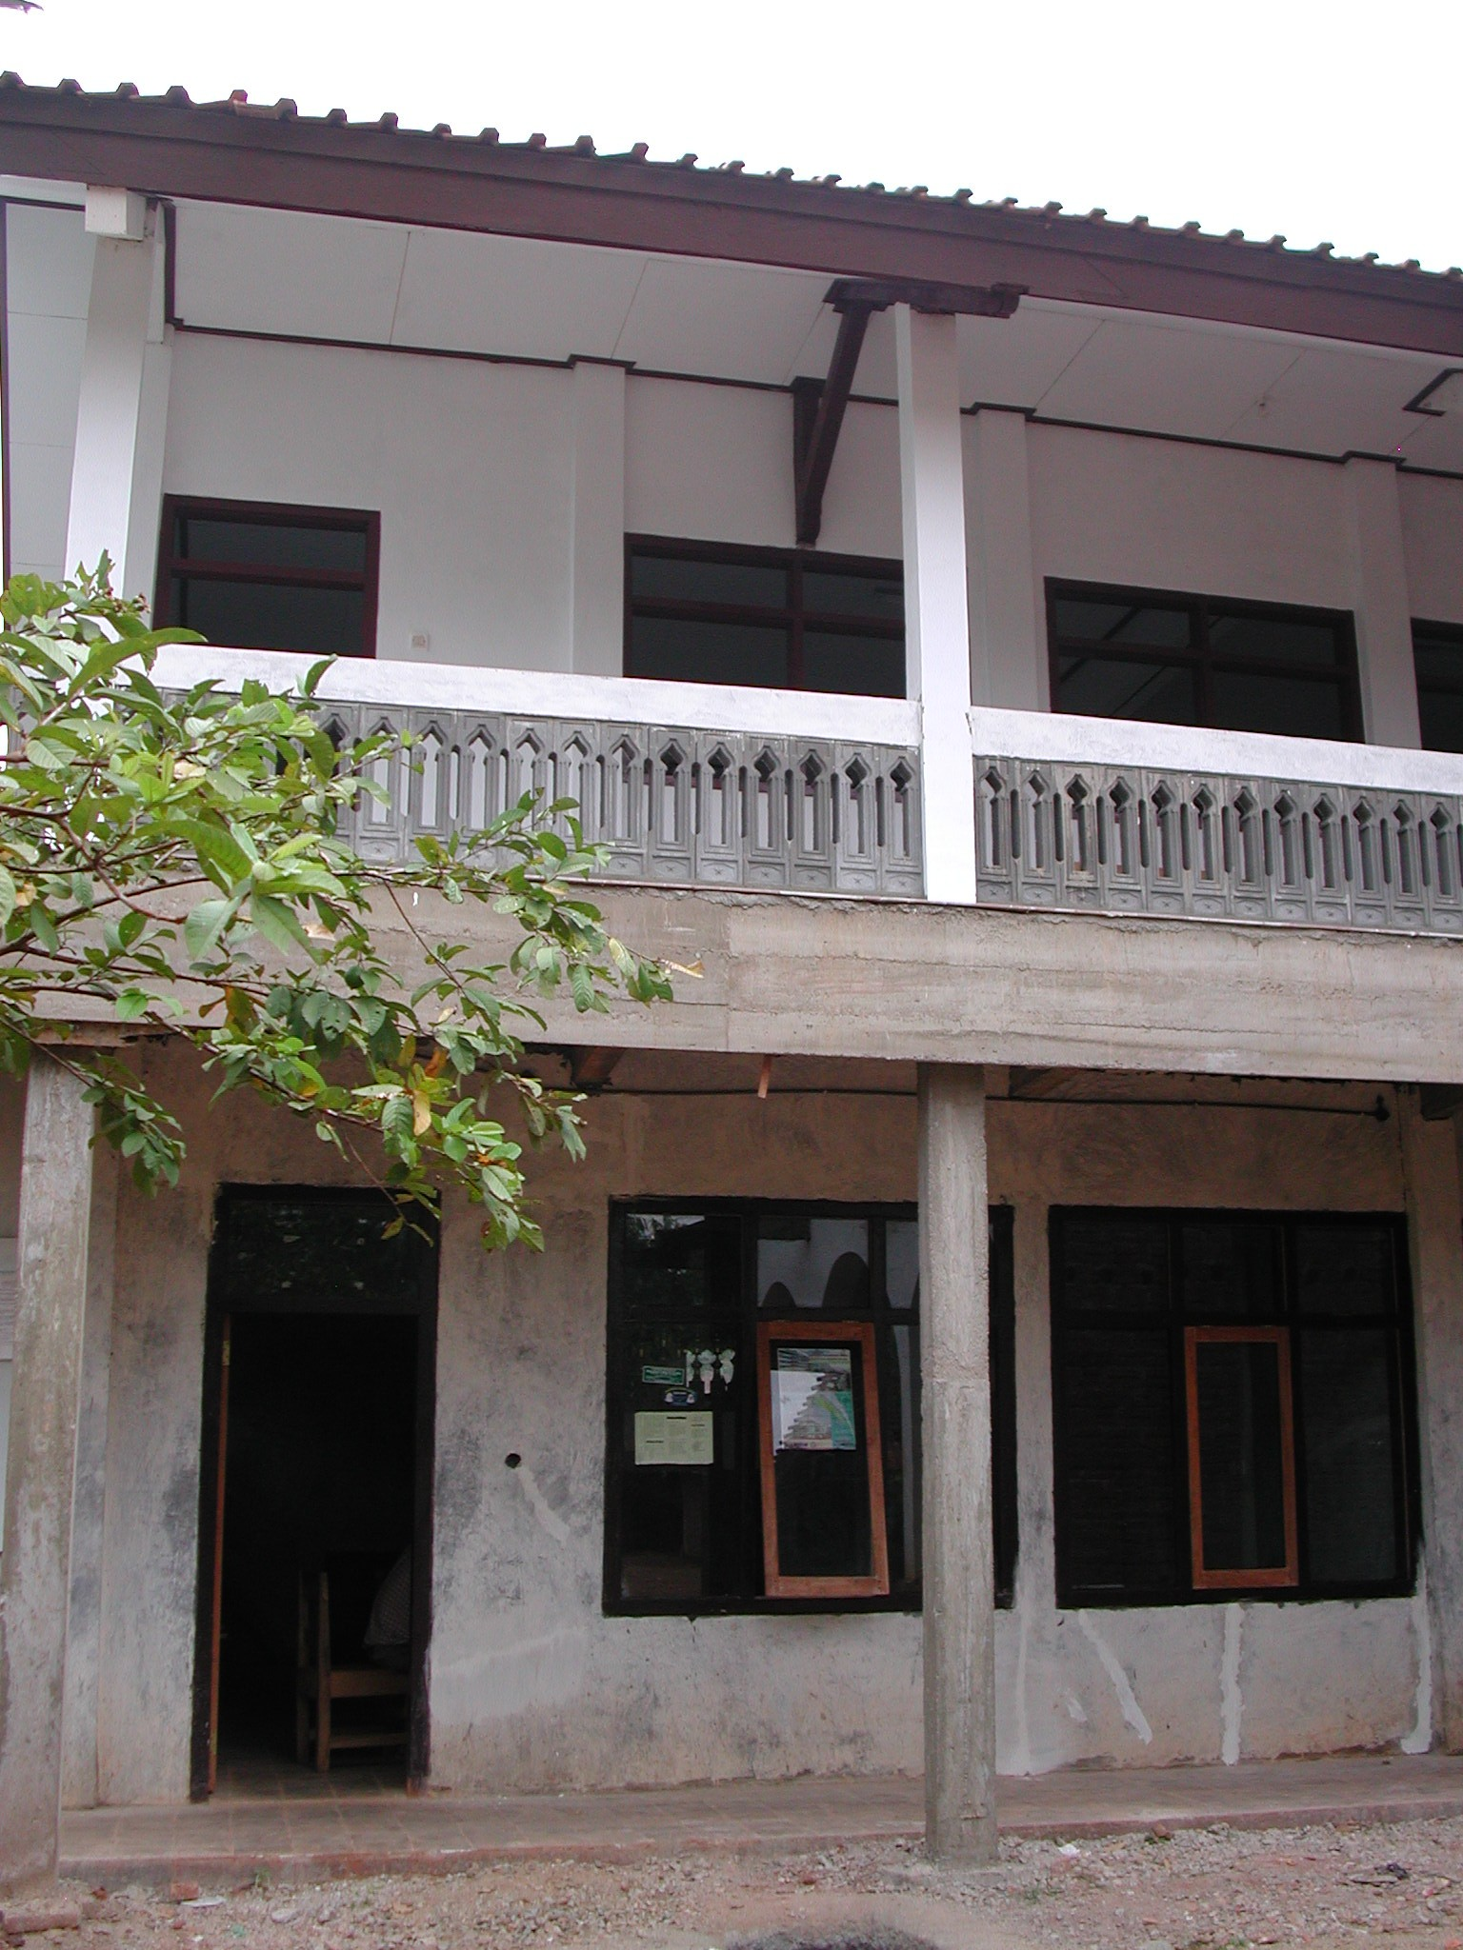
SCHOOL IMPROVEMENT GRANT PROGRAMME 2
VISITSTO PACITAN & PANDEGLANG DISTRICTS

SCHOOL REHABILITATION CONSULTANT’S REPORT
JUNE 2003

SCHOOL IMPROVEMENT GRANT PROGRAMME 2
VISITS TO PACITAN & PANDEGLANG DISTRICTS

SCHOOL REHABILITATION CONSULTANT’S REPORT
JUNE 2003

TABLE OF CONTENTS

A. General 3

B. Services to be provided by the consulting firms 4

C. Issues raised by the visit to Kabupaten Pacitan 4

- General 4
2. Issues raised concerning the services being provided 5
3. Recommendations for action 5
4. Responsibilities of the SCAs: preparation of proposals 6
5. Issues raised concerning the preparation of proposals 6
6. Recommendations for action 7
7. Responsibilities of the SCAs during the renovation process 8
8. Issues raised concerning the work of the SCAs during the
renovation process 8
9. Recommendations for action 9

D. Issues raised in Kabupaten Pandeglang 10

1. General 10
2. Issues raised concerning the preparation of proposals 10
3. Recommendations for action 10
4. Issues raised concerning the work of the SCAs during the
renovation process 11
5. Recommendations for action 11

ANNEXES

ANNEX 1: School visits in Pacitan District, East Java Province 13

ANNEX 2: School visits in Pandeglang District, Banten Province 36

A. General

1. The SIGP2 programme will provide grants for among other things renovation work to the poorest primary and junior secondary schools in 60 districts. The renovation work in each school will be managed by the school committee.

2. Kabupaten Pacitan was visited by the School Construction Advisor and the Civil Works Consultants from CIMU between June 11th and June 14th 2003 and fourteen of the five SLTP/MTs and twenty six SD/MIs that are being renovated under the SIGP2 programme this year in the kabupaten were visited.

3. Kabupaten Pandeglang was visited by the School Construction Advisor and the Civil Works Consultants from CIMU on June 20th and June 21st 2003 and seven SD/MIs that are being renovated under the SIGP2 programme this year were visited.

4. The consulting firm providing school construction advisory services to the school committees in Kabupaten Pacitan are PPA Consultants and Associates who are administering school renovations in seven kabupaten in East Java and Madura. Their base for the programme is in Kabupaten Pasuruan near Surabaya. Meetings were held with the three School Construction Advisors working in the kabupaten and the Consultant Co-ordinator during the visit.

5. The consulting firm providing school construction advisory services in Kabupaten Pandeglang is PT Jaya CM. It was not possible to meet any of the consultant’s staff during the visit.

6. The objectives of the visit were to evaluate 1) the performance of the consultants providing construction advisory services to the school committees charged with carrying out the school renovations and 2) the quality and appropriateness of the school renovations at the schools visited.

7. While the overall quality of the work at most schools visited in both kabupaten was good and the school committees generally seem to be trying very hard to make a good job of improving their schools, there are a number of structural issues that need addressing. It can also be said that the school committees do not seem to be getting the technical assistance that they require to make the most of the school improvement grants.

8. This report is part of an on-going study of the construction advisory services being provided under SIGP2 to school committees and is an interim assessment of the services being provided by two separate firms of consultants in two kabupaten. It also makes an assessment of the quality of the renovation and construction work being carried out in the two districts.

9. The report identifies a number of serious issues that were raised during the school visits concerning both the way the consulting firms and their staff are administering the project and the quality of the actual renovations. It also makes various recommendations for follow up actions to be taken by the Project Management Unit.

B. Services to be provided by the consulting firms

1. The consulting firm’s Terms of Reference state that:

- The consultants will provide a management structure that provides for supervision, training and quality assurance of the staff employed.
- All consultants employed should receive payments of salary, travel allowances and subsistence as planned so that the services are not disrupted.
- Consultants should lease motor-cycles for the use of the School Construction Advisors (SCAs) and the Consultant Co-ordinators (CCs) for the duration of their contracts.

2. The Project Team Leader’s (PTL) responsibilities as set out in the ToRs are to:

- Ensure that the firm fulfils the terms of its contract with the PMU.
- Ensure that the right people are doing the right thing at the right time
- Conduct visits to schools in every kabupaten and provide first-hand knowledge of progress in the field.

3. The PTL is also responsible for ensuring that:

- All consultants understand the programme, its detailed guidelines and their roles in its implementation
- And they were supposed to provide training for the CCs and the SCAs to ensure that this is so.

4. The Consultant Co-ordinators are supposed to:

- Manage a team of SCAs to ensure that they fulfil the terms of the contract
- Ensure that the SCAs visit their schools an adequate number of times to verify that the schools are able to conduct their rehabilitation safely, to an adequate standard and without delay.
- And accompany SCAS on some of their school visits to perform quality checks on SCA inputs, conduct on-site monitoring of recipient schools and verify progress of implementation.

5. The School Construction Advisors are supposed to:

- Provide technical assistance and advice on the renovation and construction work to SIGP recipient schools.
- And make at least 4 visits of at least 4 hours to each school

C. Issues raised by the visit to Kabupaten Pacitan

1. General

  - The consultants have stationed three SCAs (all S1 civil engineers) in Kabupaten Pacitan who each have 10 or 11 school renovations to administer. The CC (also an S1 civil engineer) for the kabupaten is however based in Kabupaten Pasaruan some 260 kilometres away which itself has 76 schools being renovated and 7 SCAs.

2. Issues raised concerning the services being provided

  - The SCAs seem to be making the requisite number of visits to the schools for which they are responsible but only for an hour or two and not for the four hours specified and the CC had only visited Kabupaten Pacitan once before the CIMU team arrived and this was for a co-ordination meeting with the District Committee and the SCAs and he had not visited any of the school sites.

  - The Project Team leader has made no visits to the kabupaten at all even though the renovation progress is well under way at all schools and almost finished at some and seems to have made no attempt to ensure that his staff are carrying out their duties as set out in the ToRs or fulfilling the terms of the contract.

  - The team was also told that the SCAs are only receiving their salaries (and these are much lower than those specified in the contract and so far they have only been paid for April), that they are not receiving any travel or other allowances and that they are having to use their own motor-cycles for transport and pay for their own petrol.

  - The CC stated that so far he has only been paid his April salary (which is also less than that specified in the contract) and that this was paid in instalments; that the firm told him to make only two visits to the district and that he has no transport. If he visits schools, he goes with the SCAs on their motor-cycles. He is only being paid Rp110, 000 per visit to Kabupaten Pacitan no matter what the length of the visit.

  - The CC has also not received a copy of the detailed ToRs which set out his duties and responsibilities but only a much shorter version.

  - There seems therefore to have been a major dereliction of duty on the part of the consulting firm in ensuring that it fulfils the terms of its contract in providing the management structure required, in ensuring that all of its staff understand their duties and responsibilities, in providing the transport required by the individual consultants and in ensuring that all consultants receive their salaries and allowances as set out in detail in the firm’s contract.

3. Recommendations for action

  - The Project Management Unit (PMU) should put pressure on the consulting firm to fulfil the terms of their contract and ensure that their individual consultants fully understand their duties and responsibilities, have transport and receive the monies due to them. Without these, it is unlikely that the consultants will carry out their duties as set out in the ToRs.

  - The PMU should also check that the consulting firms in the other regions are fulfilling all the terms of their contracts and remind them of their responsibilities under their contracts.

4. Responsibilities of the SCAs: preparation of proposals

  - The ToRs set out the responsibilities of the SCAs who will be providing technical assistance and advice to the school committees who will be carrying out the renovation work. These responsibilities include:

- Conducting a complete site survey and assessing the condition of school buildings before rehabilitation/construction.
- Completing technical drawings to be used in school rehabilitation and ensuring that the schools’ technical teams understand them.
- Revising the technical drawings if required.
- Assisting the school committees in completing and revising budgets for construction works.
- Maintaining a photographic record of each school documenting the process of rehabilitation.

5. Issues raised concerning the preparation of proposals

  - The SCAs, from the evidence gathered at the fourteen schools visited do not appear to have carried out any of the tasks outlined above or to be aware of their responsibilities as outlined in the ToRs. None of them indeed had copies of the detailed ToRs though they did have copies (but do not appear to have read them) of the project guidelines (the Jukluk). Any training that might have been provided by the PTL to the SCAs in understanding the objectives of the programme does not seem to have been effective.

  - No surveys have been carried out or assessments made of the condition of the school buildings before rehabilitation at any of the schools visited nor had any technical drawings had been prepared by the SCAs. The drawings had been prepared either by members of the school staff or their relatives or by members of the technical teams. In one case the school committee had paid an outsider Rp300,000 to prepare the drawings and proposals.

  - In all cases, the drawings being used by the schools were very sketchy and lacked any detailed information on important aspects such as foundations, roof trusses, sizes of columns and beams, sizes of reinforcement, sizes and types of windows and doors, etc. There were also no details of site works such as retaining walls which are required on several sites. All school committees would have benefited from having detailed drawings of the work to be carried out.

  - In a few cases the SCAs had commented on the drawings prepared by the schools but the comments were minor and the schools themselves were left to make any revisions.

  - The appropriateness of some of the rehabilitation proposals is also questionable. At a few schools for instance, adequate numbers of toilets (or in some cases none at all) had not been included in the proposals while less important items had been. At other schools there had been no provision for water supplies where these were badly needed. At one school which urgently requires major roof repairs, these had been ignored and instead money was being spent on painting walls and ceilings. The SCAs are specifically asked in the ToRs to discuss the schools’ proposals with the school committees and make recommendations and they should have raised these sorts of issues with the school committees.

  - In no school visited had the SCA assisted the committee in preparing the budget. In a few cases they had however advised the committee to revise the budgets but the revisions were again minor.

  - In several schools there are now issues with the budgets. At some schools the budgets have been too generous for the work being carried out and there will be fairly large amounts of money left over when the work is complete. At one school however the head teacher is worried that he will not have sufficient funds to complete the work. In all cases the school committees would have benefited from expert advice and assistance in the preparation of the budgets.

  - The SCAs do not appear to taking photographs of the progress of the renovations at any of the schools visited. At some schools they have however asked the head teachers or school committees to take photographs of the progress of the work.

  - At none of the schools visited did the school committees consider that the SCAs had provided any meaningful assistance in the preparation of the proposals, drawings or budgets.

  - It must be pointed out however that the consultants had very little time from when they were appointed to when work started at the school sites to produce drawings and budgets for all 31 schools as specified in their ToRs. This period was in some cases as short as seven days and was nowhere longer than 27 days and this was in hind site, inadequate.

  - However, although time was short, each SCA could have spent at least one day at each school commenting on the proposals and making any necessary revisions to the drawings and budgets and producing details of the work, etc. The drawings could have been sketches but could have indicated reinforcement sizes for reinforced concrete, sizes of beams and columns, sizes of doors and windows, etc all of which would have been of great use to the school committees in carrying out the work.

6. Recommendations for action

6.1 The PMU should raise the issues set out above with PPA Consultants and Associates
and ask them to ensure that the CCs and SCAs in the other kabupaten in their region are full aware of their duties and responsibilities and of the objectives of the programme, are properly trained and carry out their duties and responsibilities to the full.

6.2 The PMU should ensure that the consulting firms in the other regions are aware of the issues that have been raised in this kabupaten and that they carry out their responsibilities in providing comprehensive training for their staff and ensuring that their staff carry out their duties responsibly.

6.3 The PMU should also try and ensure in other regions that sufficient time is available from the when the consulting firms’ contracts become effective to when renovation work starts for the firms to carry out effective training of their staff and for the SCAs to carry out the work set out in the ToRs.

7. Responsibilities of the SCAs during the renovation process

  - The ToRs state that the government will contract consultants to

- ensure that quality and safety standards are maintained.

  - The ToRs also set out the responsibilities of the SCAs during the actual renovation process. These responsibilities include:

- Assisting the school committees and their technical teams during the renovation works as requested.
- Ensuring that the renovations are carried out according to safety requirements and local regulations.
- Maintaining a photographic record of each school that documents the process of rehabilitation before, during and after the rehabilitation works.
- Signing off the renovations when complete to verify that rehabilitation has met minimum safety standards and local building regulations.

8. Issues raised concerning the work of the SCAs during the renovation process

  - A number of issues were raised at the schools visited appertaining to the quality the work being carried out and the safety of the completed structures. These included the following:

  - Reinforcement to concrete columns and beams: At many if not most of the schools visited the reinforcement being used in concrete columns and beams is too small. The reinforcement for columns and beams in small buildings such as these is usually specified as being 12mm but in all of the schools visited 7, 8 and 9mm reinforcement is being used. At many of the schools this reinforcement was being used for concrete cantilever beams supporting veranda roofs where the load from the roof, particularly when the roof tiles are wet is very high. At one school 6mm reinforcement was being used in a toilet building for columns, beams and cantilever beams. The use of such small reinforcement must contravene the national code for reinforced concrete and is probably unsafe in most cases.

At no schools have the SCAs commented on this use of inadequate reinforcement sizes nor have they suggested that the correct size of reinforcement should be used.

  - Size and position of concrete columns: At one school (SDN Gendaran) the size of the freestanding columns to the veranda seems inadequate (15 x 15cm) for the height of the columns and the loads being taken. At this school and at others the position of columns is unsound in that columns do not line up, beams do not occur on column lines, roof trusses do not occur over columns, etc.

At one school (SDN Sendang 3) the columns at the rear of the building have been reduced to the thickness of the wall (approximately 11cms) and this together with the small size of reinforcement being used must make the structural strength of the columns very doubtful.

None of the SCAs have commented on any of these structural inadequacies.

  - Structural safety: At one school (Al-Fatah MTs) the safety of the school structure as built is very questionable. Under the SIGP programme an additional storey has been constructed on an existing single-storey building and it is the structure of the existing building that is questionable. The structural design and the size of the reinforcement (8mm) seems to be inadequate, the actual quality of construction leaves much to be desired and the first floor balcony has been extended in a way that is structurally unsound.

The SCA in this case should have refused to accept the school committee’s proposal and should have asked for advice from the CC. It should be noted that there is another two-storey building on this site that is in an even more dangerous condition.

At another school site (SDN Bubakan 1) the soil is very unstable (this is known to local people and all existing school buildings are badly cracked) and to avoid settlement, buildings should have specially designed foundations.

The SCA did not comment on this or provide the school with any technical advice on the matter. The head teacher however has taken it on himself to construct concrete foundations under the concrete columns. Whether this will be sufficient to prevent subsidence and cracking, only time will tell.

8.5 There seems therefore to be a general issue concerning the lack of technical assistance and advice that the SCAs are giving to the school committees. There is also a further issue in that the CC is not supervising the work of the SCAs adequately and has not therefore picked up any of these problems.

9. Recommendations for action

  - The PMU should ask the consulting firm to report on the safety of the structure of all schools being renovated in Kabupaten Pacitan and in the other kabupaten being administered by them as soon as possible. If any schools are found to be structurally unsound, then the consultants should make proposals for any measures necessary to make them structurally sound. It should be noted here that Pacitan is in an area that is prone to earthquakes.

  - The PMU should ask the consulting firm to ensure that all their individual consultants fully understand their roles during the renovation process and are carrying out their duties with due diligence both in this kabupaten and in the other kabupaten under their control.

  - The PMU should also circulate the findings of this report to the consulting firms in the other regions and ask them to ensure that the structural design and construction at the schools in their regions complies with all national codes and safety standards. All consulting firms should be reminded of their responsibilities in ensuring that rehabilitation and construction work meets minimum safety standards and also that they are required to sign off the work verifying that these standards have been met. They should pay particular attention to the design and construction of foundations and reinforced concrete columns and beams.

D. Issues raised in Kabupaten Pandeglang

1. General

1.1 It was not possible to meet with any members of staff of the consulting firm providing services to the schools being renovated in this kabupaten.

1.2 Seven schools that are being renovated this year were visited however and members of staff and communities were interviewed at these schools and similar issues were raised here as were raised in Kabupaten Pacitan particularly concerning the role and responsibilities of the SCAs.

2. Issues raised concerning the preparation of proposals

  - The SCAs again do not appear to have carried out all of the tasks outlined in their ToRs at any of the schools visited.

  - No surveys seem to have been carried out or assessments made of the condition of the school buildings at any of the schools visited nor have any site specific detailed drawings been prepared by the SCAs. At those schools where drawings had been prepared, these do not appear to have been followed.

  - At some schools standard drawings of typical primary school classrooms had been supplied to the schools by the SCAs but in most cases these drawings had also not been followed.

  - The appropriateness of some of the rehabilitation proposals is also questionable. At a number of schools for instance, one 3-classroom building is being renovated to a very high standard while a second building is being left in an also most derelict state. It would have been more appropriate to renovate both buildings to a lower standard so that all pupils had a reasonable learning environment rather than only half of them. The SCAs are specifically asked in the ToRs to discuss the schools’ proposals with the school committees and make recommendations and they should have raised these sorts of issues with the school committees.

  - At some schools the SCA had assisted the committee in preparing the budget but at least in some of these cases the budget has proved to be inaccurate.

3. Recommendations for action

3.1 The PMU should raise the issues set out above with the consultants providing services in the kabupaten and ask them to ensure that the CCs and SCAs in this and any other kabupatens in their region are fully aware of their duties and responsibilities and of the objectives of the programme, are properly trained and carry out their duties and responsibilities to the full.

4. Issues raised concerning the work of the SCAs during the renovation process

  - A number of issues were raised at the schools visited appertaining to the quality the work being carried out and the safety of the completed structures. These included the following:

  - Reinforcement to concrete columns and beams: At most of the schools visited the reinforcement being used in concrete columns and beams is too small. The reinforcement for columns and beams in small buildings such as these is usually specified as being 12mm but in all of the schools visited 6, 8 and 9mm reinforcement is being used. At one school 6mm reinforcement was being used in an office building for columns and beams. The use of such small reinforcement must contravene the national code for reinforced concrete and is probably unsafe in at least some cases.

At no schools have the SCAs commented on this use of inadequate reinforcement sizes nor have they suggested that the correct size of reinforcement should be used.

  - Size and position of concrete columns: At one school (SDN Banjar Negara1) the size of the freestanding columns to the veranda seems inadequate (11 x 18cm) for the height of the columns and the loads being taken.

At two schools (MIs Al-Ishlah Laksana and SDN Pandaj) the columns to the classroom walls have been reduced in size (approximately 15 x 15cm and 11 x 15cms) and this together with the small size of reinforcement being used must make the structural strength of the columns very doubtful.

None of the SCAs have commented on any of these structural inadequacies.

  - Position of well: At one school (SDN Pagadungan 5) a new well has been dug very close to the school toilets.

The SCA should have advised the school committee against digging the well in this position and must now ensure that the septic tank and soakaway from the toilets are built at least 15 metres away from the well.

4.5 There therefore seems to be a general issue concerning the lack of technical assistance and advice that the SCAs are giving to the school committees during the renovation process.

5. Recommendations for action

  - The PMU should ask the consulting firm to report on the safety of the structure of all schools being renovated in Kabupaten Pandeglang and in any other kabupaten being administered by them as soon as possible. If any schools are found to be structurally unsound, then the consultants should make proposals for any measures necessary to make them structurally sound.

  - The PMU should also ask the consulting firm to ensure that all their individual consultants fully understand their roles during the renovation process and are carrying out their duties with due diligence.

ANNEX 1: SCHOOL VISITS IN PACITAN DISTRICT, EAST JAVA PROVINCE

1. The following schools were visited between June 11th and June 14th 2003:

  - SDN Gendaran 01 No 113 Kecamatan Donorojo: This is an existing primary school on a small site in a rural village. The school has 144 pupils and 9 teachers. There is an existing ‘L’ shaped building one wing of which is being renovated. The existing wing was demolished down to foundation level and re-built. The foundation was extended where necessary and a new ground beam constructed. The existing building is much lower than the new building and has timber veranda columns. Six new toilets are being constructed at the rear together with a new storm drain to protect the classroom building (the site slopes up behind the school). The school is connected to the village water and electricity supplies.

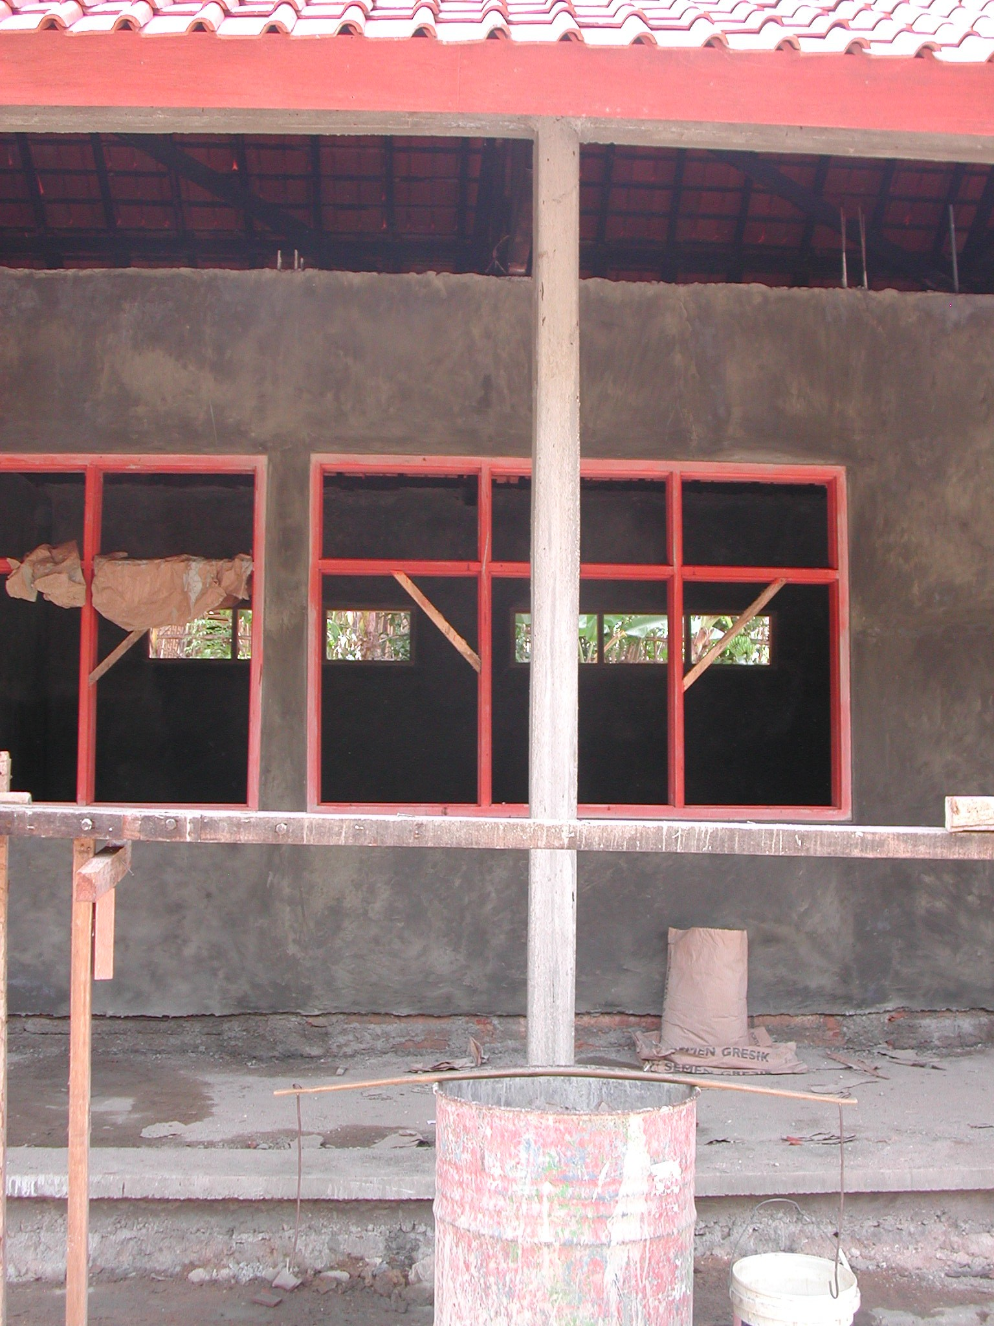

Plate 1: SDN Gendaran 01 showing inadequate column sizes, lack of intermediate columns to classroom wall and trusses over the centre of windows

The new building is constructed of rendered brick walls, RC columns and beams, timber roof trusses, clay tiled roof, timber windows and panel doors. The trusses are good, made of good quality timber and the joinery and concrete are quite good but the structure of the new building is probably inadequate. The veranda columns are only 15 x 15cm and very high. The only visible RC columns in the classroom walls are at the cross walls and these are 15 x 20cm. If there are columns in between, they are only the thickness of the walls and they are not under the roof trusses; trusses are instead positioned over windows. The reinforcement to the columns to the toilets and the ‘practical’ columns to the classrooms is only 6.5mm with 3.5mm links at 25cm centres and is thus inadequate. There is some 8mm reinforcement on site and this was probably used for the main columns to the classrooms and verandas. This size is still however inadequate; it should have been 10mm or preferably 12mm. The consultants should check the structure as soon as possible and make proposals for strengthening it if necessary.

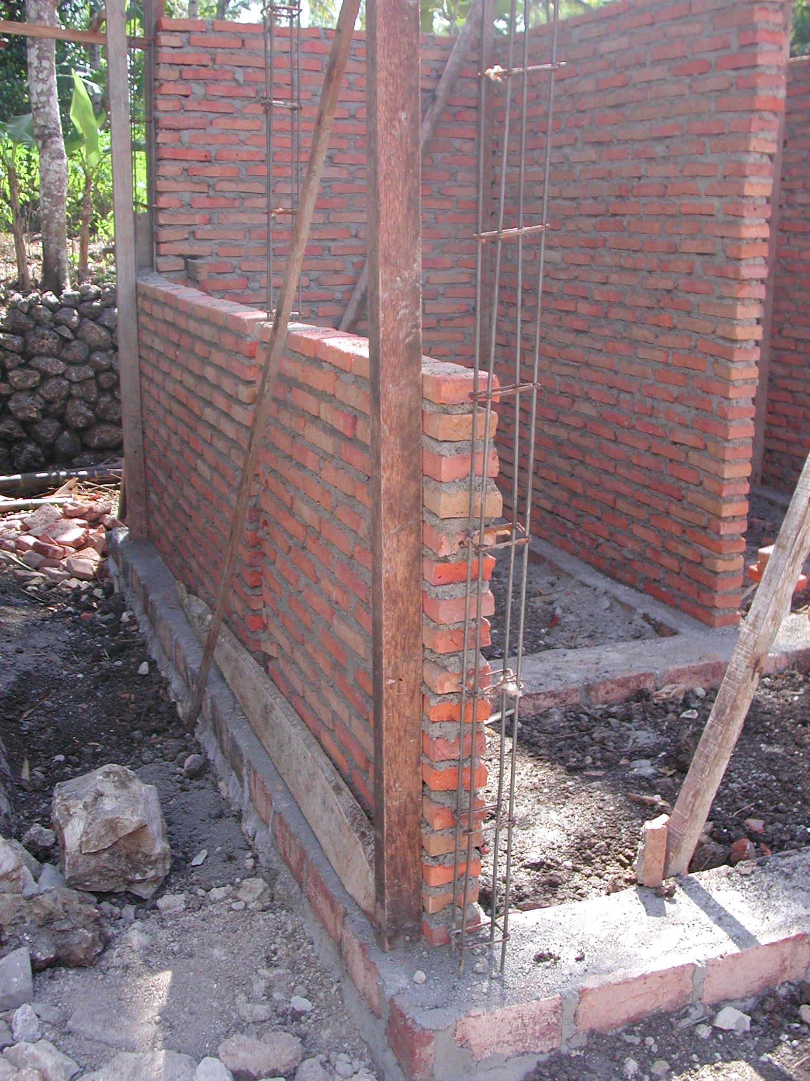

Plate 2: SDN Gendaran 01 showing inadequate column sizes to toilets

The proposals were prepared by the school committee and the drawings were prepared by a teacher who has built his own house. The drawings are very basic and the plans are different to what has been built. The columns are in different positions and are different sizes to those specified (20 x 20cm).

The Kepala Pelaksana is a local builder with no formal qualifications and all the labour is local. The technical team are ordering the materials. There are receipts for 12mm, 10mm, 8mm and 6mm reinforcement. There are eleven workers paid Rp15,000 per day and 7 craftsmen paid Rp20,000 per day working on the site. Work started on 9th April and will be finished by the end of July 2003.

According to the site book, the SCA made five visits but he seems to have had very little input. He advised that the toilet layout should be changed and that wood preservative should be used on the roof timbers but otherwise had no technical inputs. He did not help with the preparation of drawings or of the schedules of materials. No comments have been made on the changes to the designs or on the size of reinforcement being used and the school committee said that he gave no useful advice. The SCA should have amended the structural design and given the technical team some details of columns and beams before work started. He should then have ensured that the correct materials were being used and if the technical team refused to use the correct materials, reported the matter to the CC. These comments apply to all schools visited. Although the school committee received very little if any assistance from the SCA they said that they did not have the confidence to go ahead without first discussing their proposals with the SCA. The SCA is based in Pacitan town 28 kilometres from this school and has 10 other schools to administer.

The total budget was Rp120million with Rp90million for the classroom renovations, Rp13million for the new toilets and water supply, Rp14million for books and furniture and Rp3million for administration. The square metre cost for construction was therefore Rp643,750m².

  - SDN Sendang 3, Kecamatan Donorojo: This is an existing primary school on a small site in a remote rural village accessible only via rough roads. The school has 84 pupils and 9 teachers. The site slopes steeply away from the school on all sides. There is an existing 3-classroom building which is being renovated with repairs to the roof, new ceilings, new concrete tile floors where necessary, repairs to the veranda floor and painting. A new 2-classroom building (classrooms 7 x 8 metres) is also being constructed with one classroom being built on existing foundations and one on new foundations. The existing building is much lower than the new building and has timber veranda columns. It is planned to build new toilets but the village has no water supply and has to buy water from tankers. There is no accessible ground water. The school does however have an electricity supply.

The new building is constructed of rendered brick walls, RC columns and beams, concrete tile floors, timber roof trusses, clay tiled roof, cantilevered roof over the veranda, timber windows and panel doors. The building is being well constructed with good trusses and cantilevers and good quality joinery. The roof is very high; 3.5 metres to the underside of the roof trusses. The structure again must be suspect; the columns to the rear walls are only the thickness of the walls (ie 11 x 15cm) and the reinforcement to columns where it could be seen is only 8mm. There are concrete cantilevers supporting the veranda roof at the end and cross walls and the reinforcement to these is probably 8mm. The reinforcement to all columns and beams should have been a minimum of 10mm and preferably 12mm. Again the consultants should check the structure as soon as possible and make proposals for strengthening it if necessary.

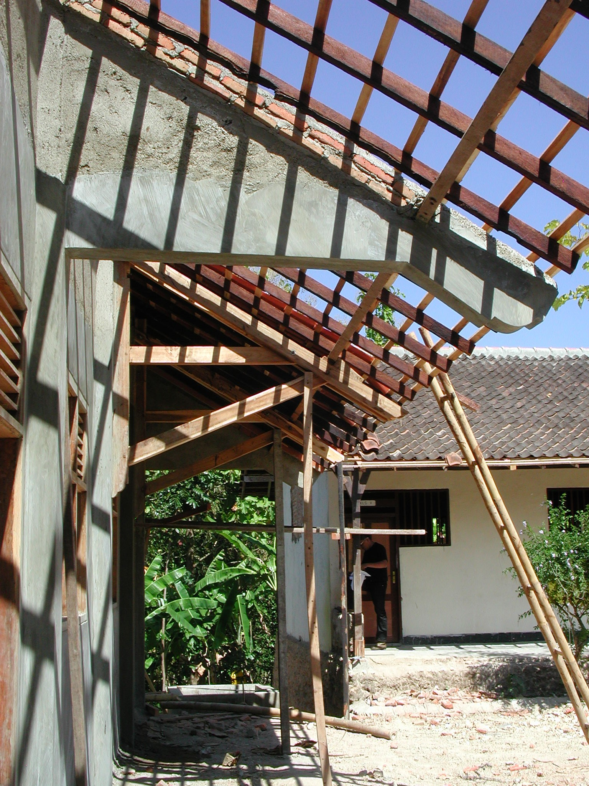

Plate 3: SDN Sendang 3 showing large concrete cantilevers, the structure of which should be checked

The proposals and drawings were prepared by the school committee and the drawings are very basic with no details.

The Kepala Pelaksana is a local builder and all the labour is local. The technical team are ordering the materials. There are five workers paid Rp15,000 per day and 11 craftsmen paid Rp20,000 per day working on the site. Work started on 25th April and will be finished by early August 2003.

According to the site book, the SCA made five visits (for approximately one hour each visit) but he seems to have had very little input. He asked the school committee to make some minor amendments to the drawings and budget and asked that wood preservative be used on the roof trusses but otherwise had no technical inputs. He did not help with the preparation of drawings or of the schedules of materials. No comments have been made on any of the construction and he does not appear to have picked up the fact that the rear columns to the classrooms have been reduced in size. The SCA should have given the technical team some details of columns and beams before work started. He should then have ensured that the correct materials were being used and if the technical team refused to use the correct materials, reported the matter to the CC. It would also have been useful to the school if the SCA had made some suggestions about improving the water supply situation at the school such as building a large water storage tank.

The total budget was Rp110million with Rp84million for the classroom renovations, Rp14million for the new toilets and water supply, Rp14million for books, teaching aides and furniture and Rp3million for administration. The community contributed 84m³ of sand worth Rp336,000.

  - SDN Gunggangan 02 No 5, Kecamatan Pringkuku: This is an existing primary school on a small, steeply sloping site in a rural village. The school has 101 pupils and 10 teachers. There are two existing 3-classroom buildings on the site and one classroom has been demolished at the end of one building and two new classrooms (7 x 8 metres) are being constructed at right angles to the existing building. The two new classrooms step down the slope.
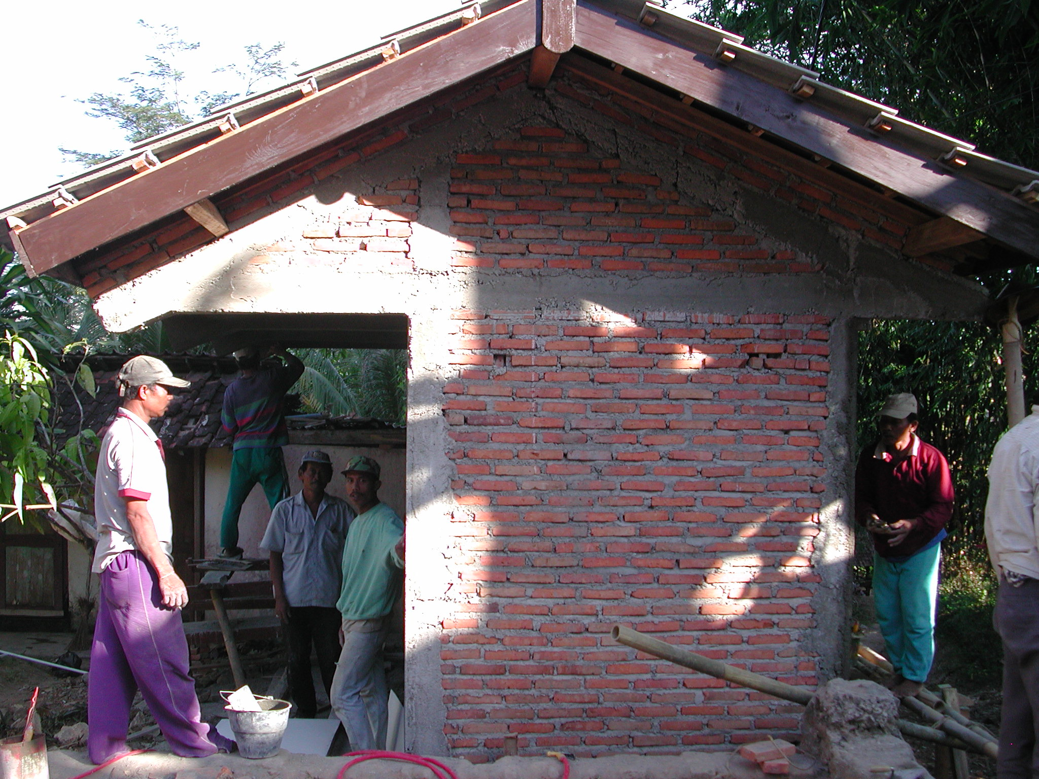

Plate 4: SDN Gunggangan 02 showing cantilevered roof to toilets with only 6mm reinforcement
New toilets are being constructed behind the classrooms. A new well has been constructed with an electric pump but it is dry during the dry season. The school is going to lay a ½ kilometre pipe to connect to a government water supply. The school does however have an electricity supply.

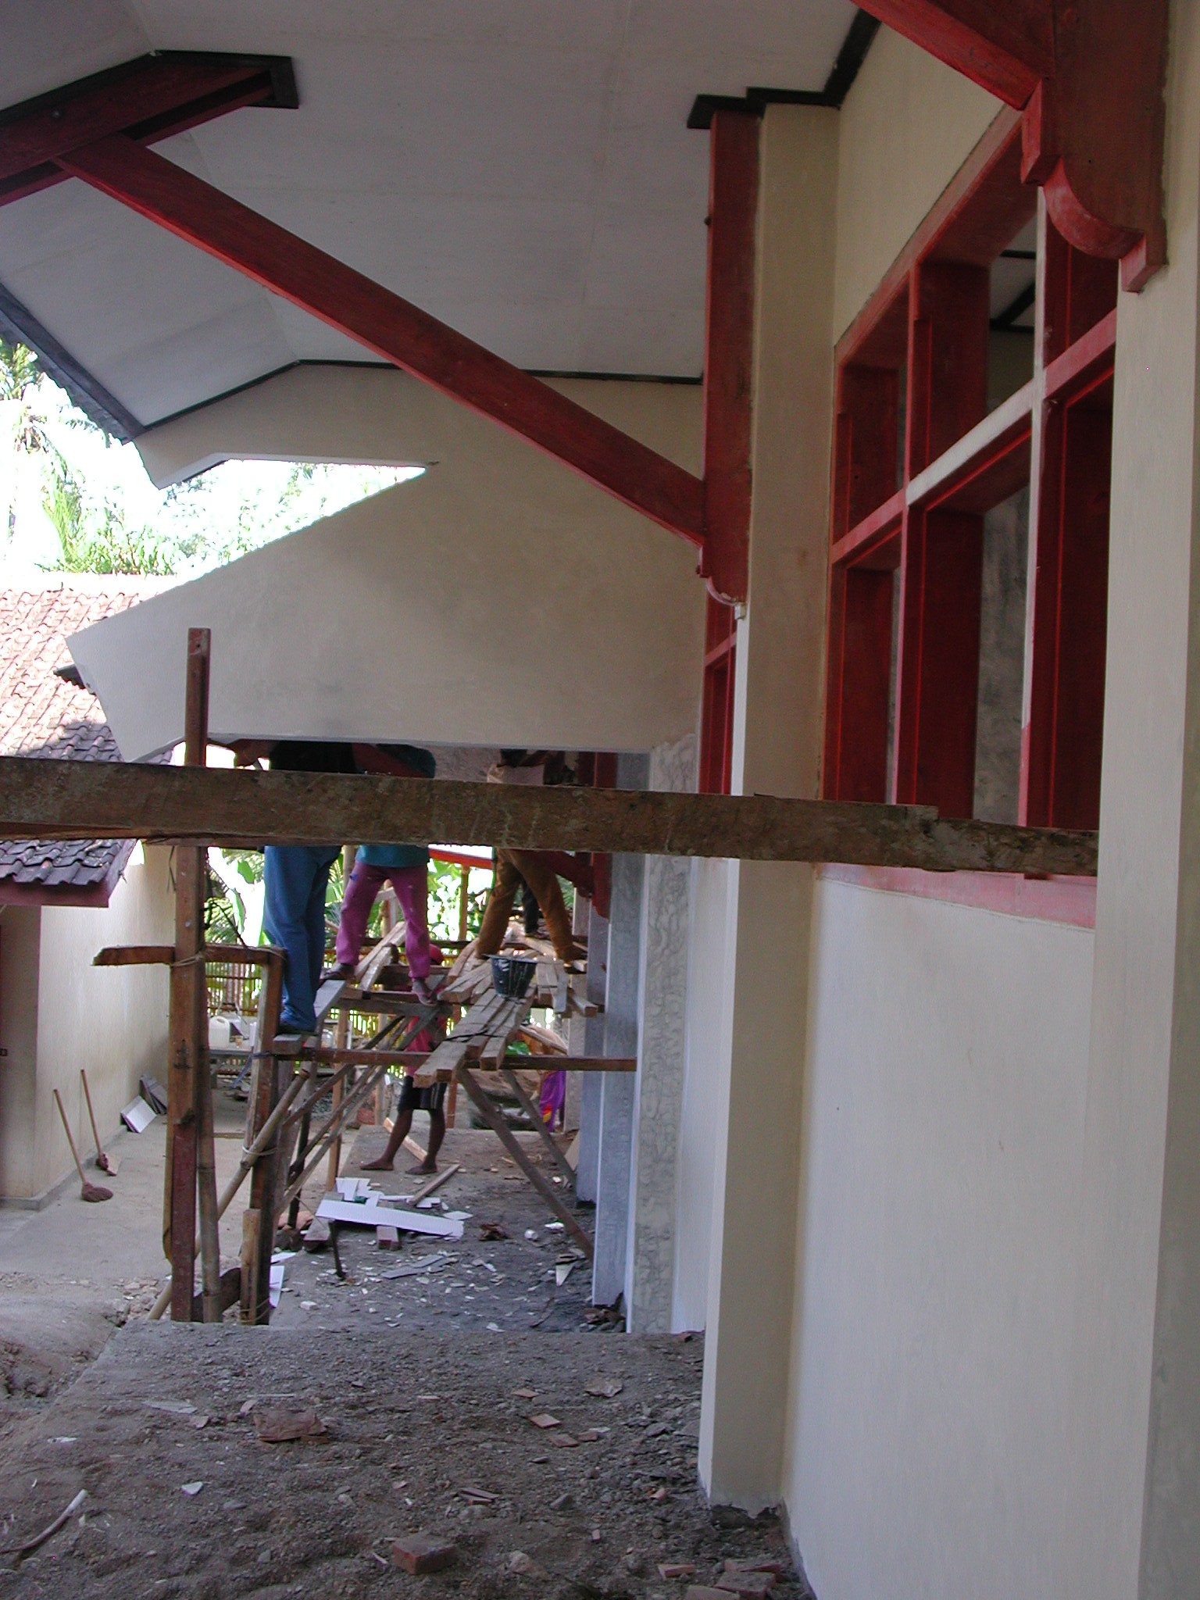

Plate 5: SDN Gunggangan 02 showing large concrete cantilevers, the structure of which should be checked

The new building is constructed of rendered brick walls, RC columns and beams, concrete tile floors, timber roof trusses, clay tiled roof, cantilevered roof over the veranda, timber windows and panel doors. The building seems to be well constructed although it was not possible to see the roof trusses or the concrete columns as ceilings had been fixed and the columns were rendered. The joinery is quite good as are the timber cantilever brackets. The reinforcement to the columns in the classrooms is 9mm but the reinforcement to the beams, cantilever beams and columns to the toilets is only 6mm and the quality of the concrete is very poor. The reinforcement to all columns and beams should have been a minimum of 10mm and preferably 12mm. Too much water was being used in the mixing of screed for the floors. . Again the consultants should check the structure as soon as possible and make proposals for strengthening it if necessary.

The proposals, budget and drawings were prepared by the son-in-law of the head teacher who works for Cipta Karya. The drawings are therefore better than at the last school but there are no construction details.

The Kepala Pelaksana is a teacher who has some experience of construction. The technical team are ordering the materials. There are thirteen workers paid Rp20,000 per day and 11 craftsmen paid Rp22,500 per day and a foreman paid Rp25,000 per day working on the site. Work started on 13th April and will be finished by the first week in July 2003.

The SCA again seems to have had very little input. He did not help with the preparation of drawings or of the bills of quantities or schedules of materials. No comments have been made on any of the construction and he does not appear to have picked up the fact that the reinforcement especially to the toilets is inadequate.

The total budget was Rp110million with Rp88,290,067 for the classroom renovations, Rp18,710,245 for the new toilets and water supply and Rp3million for administration. The square metre cost for construction was therefore Rp891,669m².

  - SLTPN Tegalombo, Kecamatan Tegalombo: This is an existing junior secondary school built in 1984 and set on a sloping site outside a rural village. The school has 325 pupils and 31 teachers and an administration building, nine classrooms, a laboratory, a library, toilets and a store. Two teachers’ toilets in the administration building are being renovated and a new septic tank is being constructed. Two student toilets and three wash rooms are also being renovated. There two other existing toilets that are working and four others which are not working and are not being renovated. This means that there are only four working toilets for 325 students. Otherwise only small repairs and renovations are being carried out using the SIGP2 funds such as repairs and replacement of doors, ceilings, fascias and eaves boards to a 2-classroom building and the re-painting of the whole school. The school has a water supply and an electricity supply.

The workmanship is reasonable although the painting is not very good. The main concern is the number of toilets being renovated. The painting of the school was not included in the original proposal and there seems to have been some funds left over from the work which is being used for this purpose. It would have been better used renovating more toilets.

The proposals were prepared by teachers at the school. There is a drawing of a 2-classroom building in the proposal but no details of the proposed renovations.

The Kepala Pelaksana is a member of the community who has some experience of construction. The technical team are ordering the materials. There are fifteen workers paid Rp20,000 per day and 5 craftsmen paid Rp25,000 per day and a foreman paid Rp30,000 per day working on the site. Work started on 9th April and will be finished by the end of June 2003.

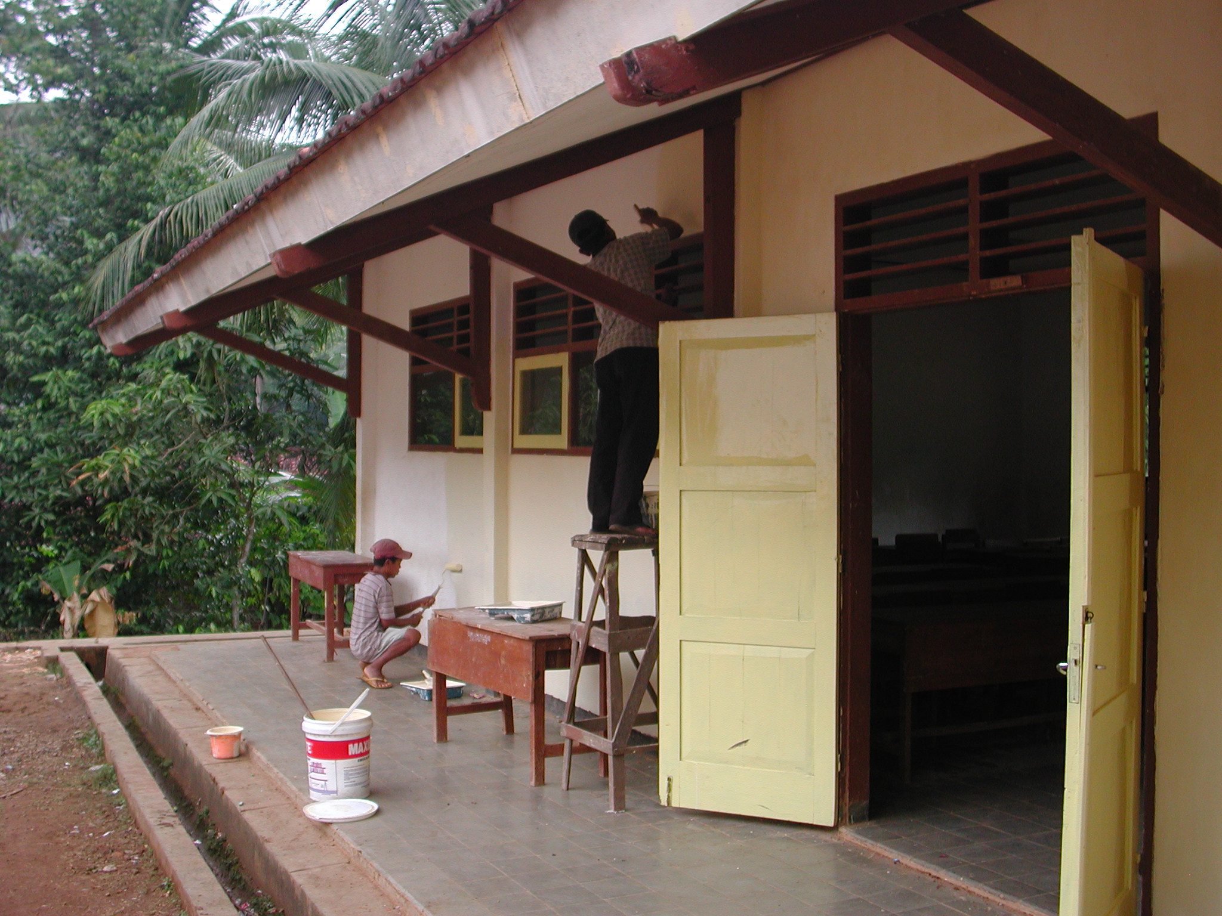

Plate 6: SLTPN Tegalombo showing renovations in progress

The SCA made five visits but seems to have made no technical comments or instructions. He did not help with the preparation of drawings or of the bills of quantities or schedules of materials. The SCA should have suggested that all toilets in the school be renovated which would have given a total of eight students toilets.

The total budget was Rp110million with Rp75million for the classroom renovations, Rp10million for the renovated toilets and water supply and RP12million for books, Rp10million for furniture and Rp3million for administration.

  - SDN Tahinan 5, Kecamatan Tegalombo: This is an existing primary school on a large, sloping site in a remote, rural village only accessible over very rough roads. The school has 96 pupils and 5 teachers. An existing office and classroom has been renovated with new rendering, roof, windows and doors. The existing concrete tile floor has been retained. An adjacent 3-classroom building was demolished and re-built. The building was widened and therefore had to have new foundations at the rear. All walls are new together with the roof, doors and windows. The existing concrete tile floor has been retained except where the rooms have been widened where there are new floors. There are no ceilings in either section. Two pupils’ toilets and a teachers’ toilet have been constructed under a lean-to roof at the end of the building. A new well has been constructed 150 metres away and below the school with an electric pump that pumps water up to the toilets. The school buildings do not have an electricity supply.
The school should really have six classrooms but the head teacher is having room dividers made to divide the classrooms in two. The school has no new furniture and only enough old furniture for two classrooms.

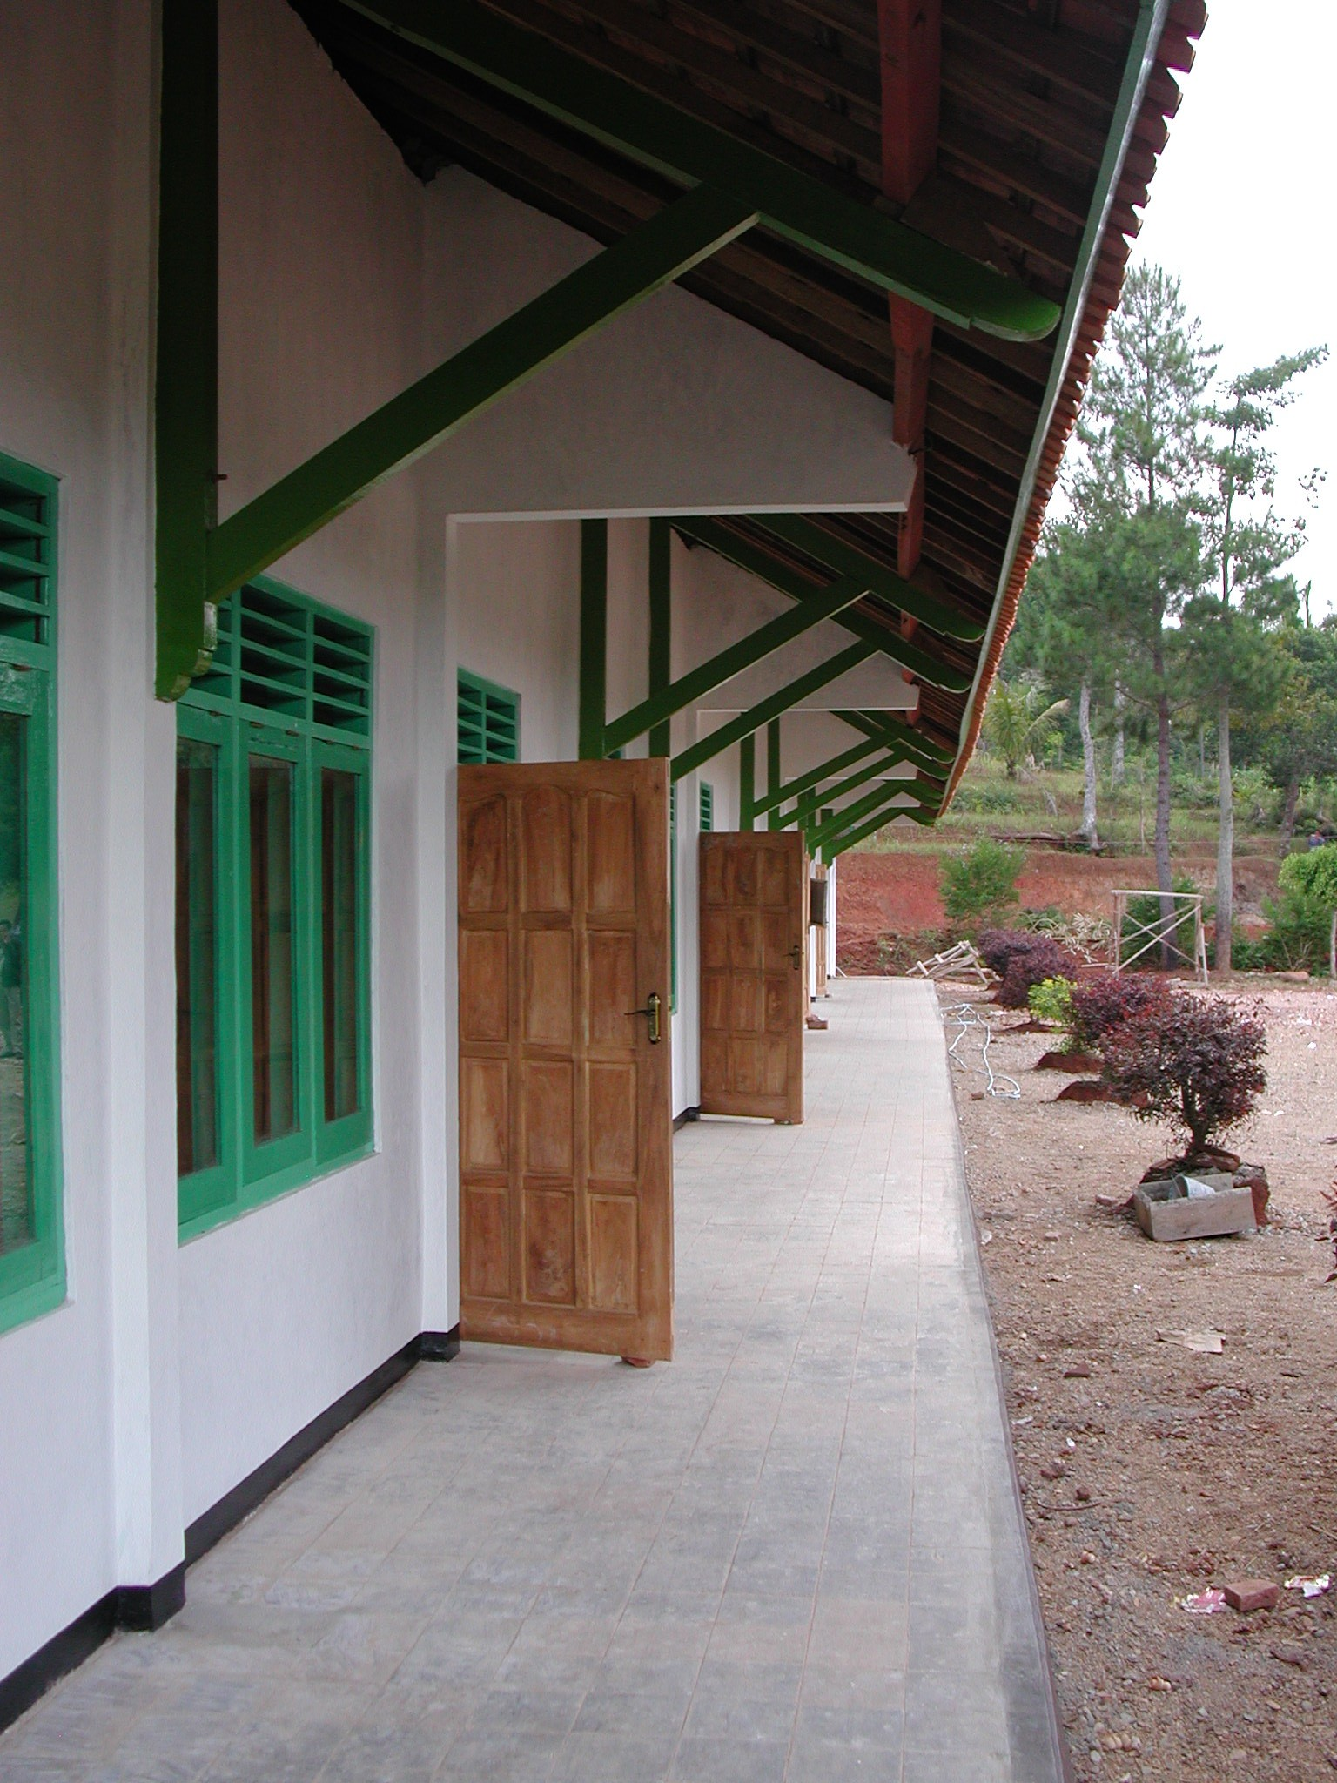

Plate 7: SDN Tahinan 5 showing concrete cantilevered beams the structure of which should be checked

The building is constructed of rendered brick walls, RC columns and beams, timber roof trusses, clay tiled roof, cantilevered roof over the veranda, concrete tiled veranda floors, timber windows and panel doors. There are not many opening windows in the office and adjoining classroom. The building is quite well constructed: the roof trusses are well made and the windows and doors are quite good. The painting however is not very good and the roof, especially at the rear is not very level (there are only three purlins per side). It was not possible to see the columns as they had been rendered but the reinforcement appeared to be 8mm. There are no ceilings but the school site is high up in the mountains and the school is quite cool. The consultants should check the structure to see if it is adequate and if not, make proposals for strengthening it.
The proposals, budget and drawings were prepared by the school committee and the drawings are very basic with no construction details.

The Kepala Pelaksana is a community member from a local village who has some experience of construction. The technical team are ordering the materials. Because this is a poor rural community, many people wanted to work on the site to earn some money. A shift system was therefore introduced and over 50 people eventually worked on the renovations. The workers were paid Rp15,000 per day, the craftsmen were paid Rp20,000 per day and the foreman was paid Rp25,000 per day. Work started on 27th April and was finished in mid-June.

The SCA visited the school four times but again seems to have had very little input. He did not help with the preparation of drawings, budgets or the schedules of materials. No comments have been made on the construction or on the fact that materials here are very expensive (see below).

The total budget was Rp100million with Rp85million for the classroom renovations, Rp12million for the new toilets and water supply and Rp3million for administration. Ceilings were to be included but the money ran out. Building materials here are very expensive: sand for instance costs more than double the usual price and cement is 23% higher than usual. The square metre cost for construction was Rp419,913m².

  - MTs Al-Fatah, Tahunan, Kecamatan Tegalombo: This is an existing junior secondary school in a small remote rural village. The school has 197 students and 18 teachers. The school now has two two-storey buildings, one for boys and one for girls on a small site with a mosque in the middle. The girls’ building was originally single-storey but was constructed with a reinforced first floor to allow for the addition of a second storey. This second storey has now been built using SIGP2 funds. There are two toilets in a separate building and the community are constructing two toilets on the ground floor of the girls’ building. The school has a water supply pumped from a well and an electricity supply.

The original construction of the ground floor of this building leaves much to be desired. The columns and beams do not line up, the reinforcement to beams and columns all seems to be 8mm and there is very little cover to some of the reinforcement. The original cantilevered balcony at first floor level has been very badly extended in width by one metre and additional columns have been built (rather badly) on the outside to support it. There appear to be no columns in the classroom walls to the veranda (or if there are, they are only the thickness of the wall in width) and some of the cantilever beams occur over windows! The structural integrity of the ground floor must therefore be in doubt.

Three additional small classrooms have been added on the first floor. The classrooms have no windows at the rear (nor do the classrooms on the ground floor) and have removable timber walls between them. They are therefore rather dark. The construction of the first floor seems better than the ground floor but the reinforcement to columns and beams is again only 8mm and some roof trusses occur in the middle of windows. The joinery, especially the panel doors is quite good. All floors are tiled with glazed tiles.
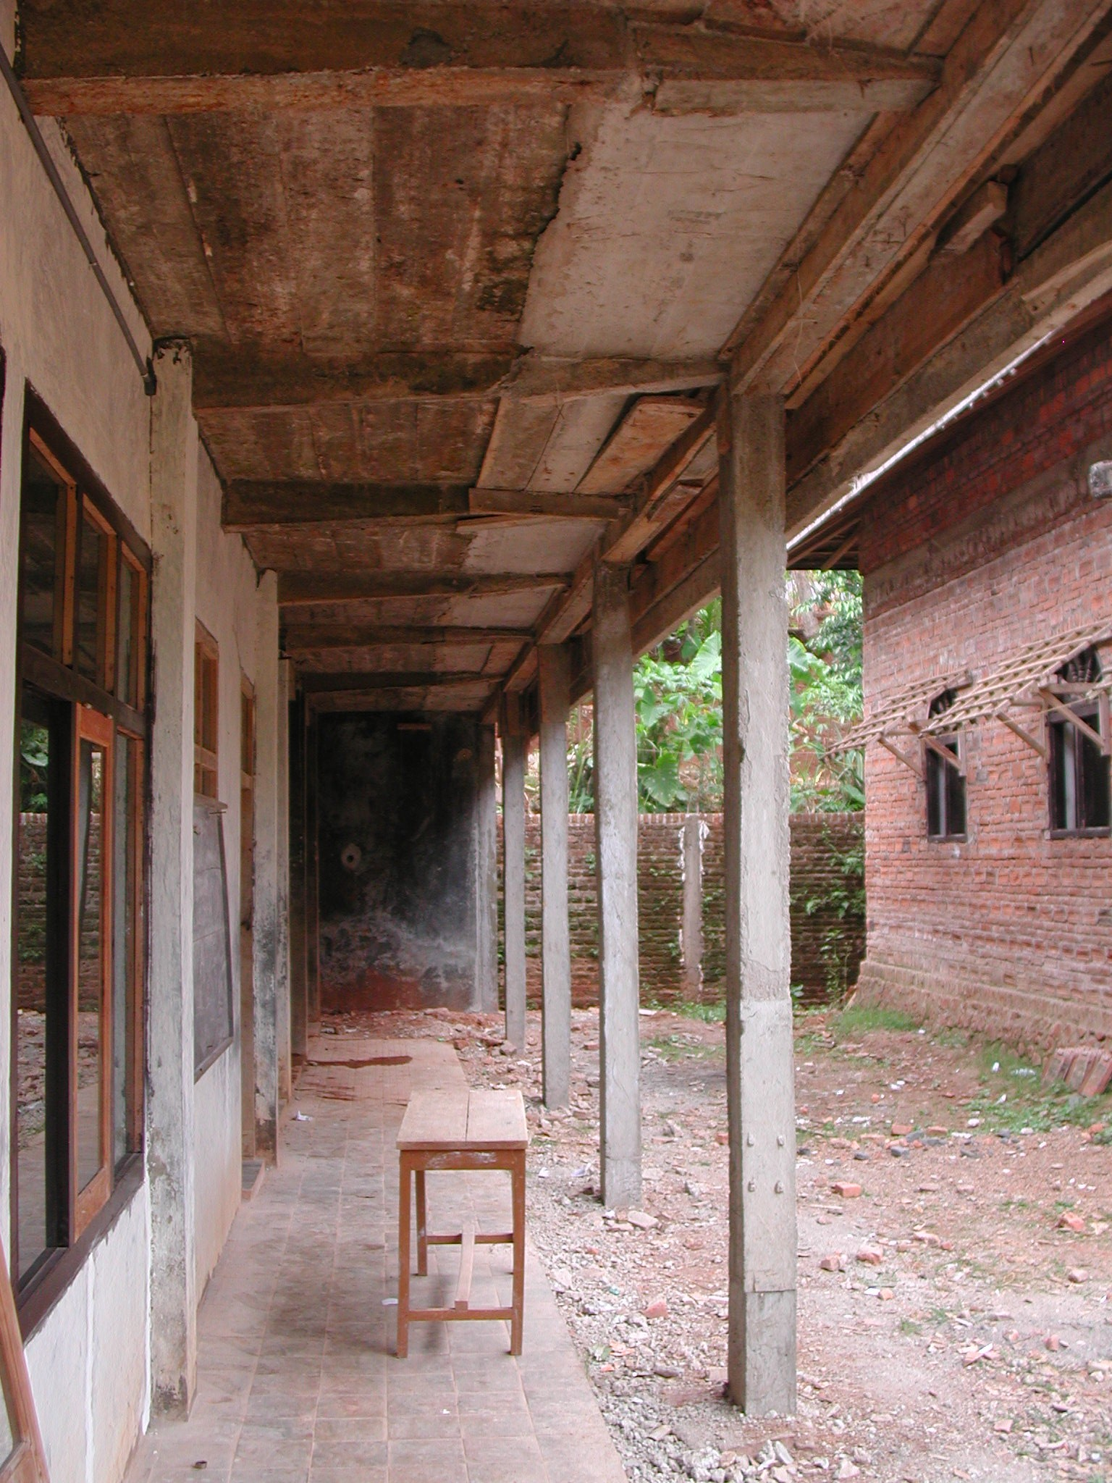

Plate 8: MTs Al-Fatah showing inadequate ground floor structure

The proposals were prepared by the school committee and the drawings are very basic and there are no details of the proposed extensions.

The Kepala Pelaksana is a local builder who also built the other school building and the mosque. The technical team are ordering the materials. There are twelve workers paid Rp20,000 per day and seven craftsmen paid Rp25,000 per day and a foreman paid Rp25,000 per day working on the site. Work started on 7th April and will be finished by the end of June 2003.

The SCA made five visits but seems to have made no technical comments or recommendations. He did not help with the preparation of drawings, budgets or schedules of materials. The SCA should in this case have told the school committee that the ground floor of the building was probably unsafe and that they should not construct a first floor on top. If they did not agree to his recommendation then he should have informed the CC. This school is in an earthquake area and the consultants should check the structure of this building as soon as possible to see if it is safe and if it is not, make proposals for strengthening it.

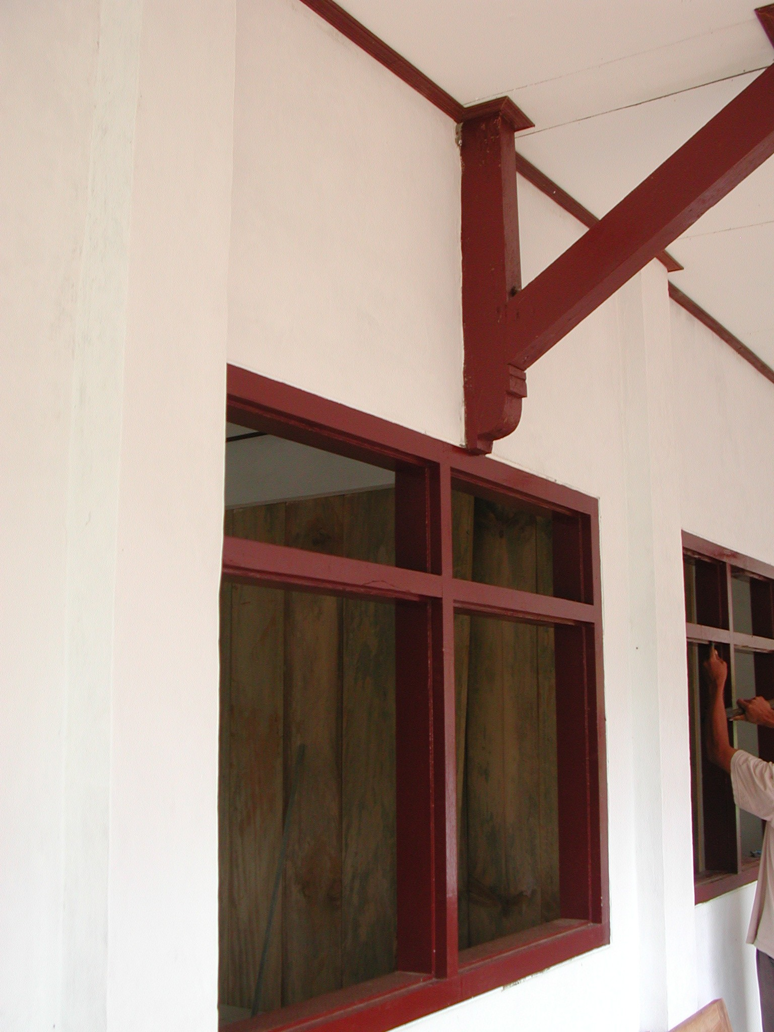

Plate 9: MTs Al-Fatah showing new roof trusses over windows

The total budget was Rp80million with Rp69.5million for the classroom renovations, Rp4.5million for furniture, Rp1.2million for teaching aides, Rp1.8million for teachers and Rp3million for administration.

It should also be noted that the other school building on the site is also in a structurally dangerous condition and the builder was asked to construct internal columns on the ground floor to support the columns on the first floor. Many of the supporting beams in this building are cracked.

  - SDN Ploso 2, Kecamatan Tegalombo: This is an existing primary school on a small site on the side of a hill in a remote, rural village only accessible over very rough winding roads. The school has 124 pupils and 9 teachers. The school also functions as an SLTP Terbuka and has 27 pupils in the afternoons. There are several buildings on the site. A 2-classroom building constructed of brick walls with steel mesh windows and a steel roof structure and aluminium sheet roof. This building is in bad condition and requires maintenance but is not being renovated. There are also two single classroom buildings that have been linked with a small office. These are not being renovated either. An existing 3-classroom has been demolished down to foundation level and is being re-built. There are also three small toilets at the end of the site. The school has an electricity supply but no water supply; pupils have to carry water up from the river which is a long way below the school.

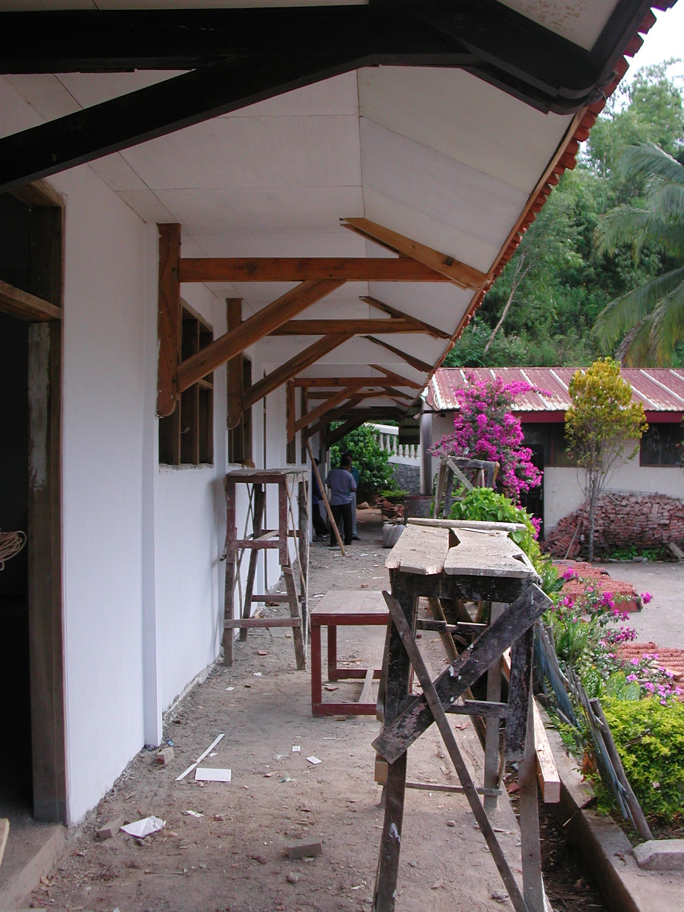

Plate 10: SDN Ploso 2 showing new building

The new building is constructed of rendered brick walls, RC columns, timber roof trusses, clay tiled roof, cantilevered timber roof over the veranda, white-glazed tiled floors to two classrooms and existing concrete tiles to the third classroom and veranda floors, timber windows and panel doors. The building is quite well constructed: the roof trusses could not be seen but the roof is straight, the roof cantilevers are well made and the windows and are quite good. It was not possible to see the columns as they had been rendered but the only reinforcement seen on site was 6mm and 4mm.
The proposals, budget and drawings were prepared by the school committee and the drawings are very basic with no construction details.

The Kepala Pelaksana is a farmer from the village. The technical team are ordering the materials. The are fifteen workers paid Rp15,000 per day and seven craftsmen paid Rp20,000 per day.

The SCA has visited the school only three times but again seems to have had very little input. He did not help with the preparation of drawings, budgets or schedules of materials. The budget seems to have been very inaccurate (see below) but no comments were made on this or on any technical matters.

The total budget was Rp100million with Rp94million for the classroom renovations, Rp3million for teachers and Rp3million for administration. The work however is nearing completion but there is Rp35million left in the bank! The school committee propose to move and re-build the 2-classroom building at the rear of the site. It would seem more sensible to try and do something about the lack of water however. The square metre cost for construction works out as Rp559,524m² but the real cost of construction taking into account that around Rp30million will be left when construction is complete will be Rp380,952m².

  - MTs Muhammadiyah 3 Ketro, Kecamatan Kebonagung: This is an existing junior secondary school on a small site next to a mosque on the main road east of Pacitan town. The school has 174 students and 20 teachers. Three existing classrooms behind the mosque have been partially demolished and three new classrooms are being constructed using the existing foundations and parts of the existing walls. Four new toilets have been completed together with a washing area. The school has a water supply pumped from a well and an electricity supply.

Construction of the classrooms has only just started; the brickwork is up to the top of window height and window and door frames have been fixed. Some of the brickwork is not very plumb not are some of the window frames. RC columns are being cast between brickwork panels. The concrete work is not very good and the reinforcement is only 7mm with 4mm links. The trusses are being manufactured on site and the timber is not very good and the trusses are not being very well made.

The proposals were prepared by the school committee and the drawings are very basic with no detailed drawings.

The Kepala Pelaksana is a local builder. The technical team are ordering the materials. There are seven workers paid Rp20,000 per day and eight craftsmen paid Rp25,000 per day and a foreman paid Rp25,000 per day working on the site. Work started on the toilets on 20th April but work on the classrooms has only just started and should be finished by the end of July 2003.

The SCA has made four visits but seems to have made no technical comments or recommendations. He did not help with the preparation of drawings, budgets or schedules of materials.

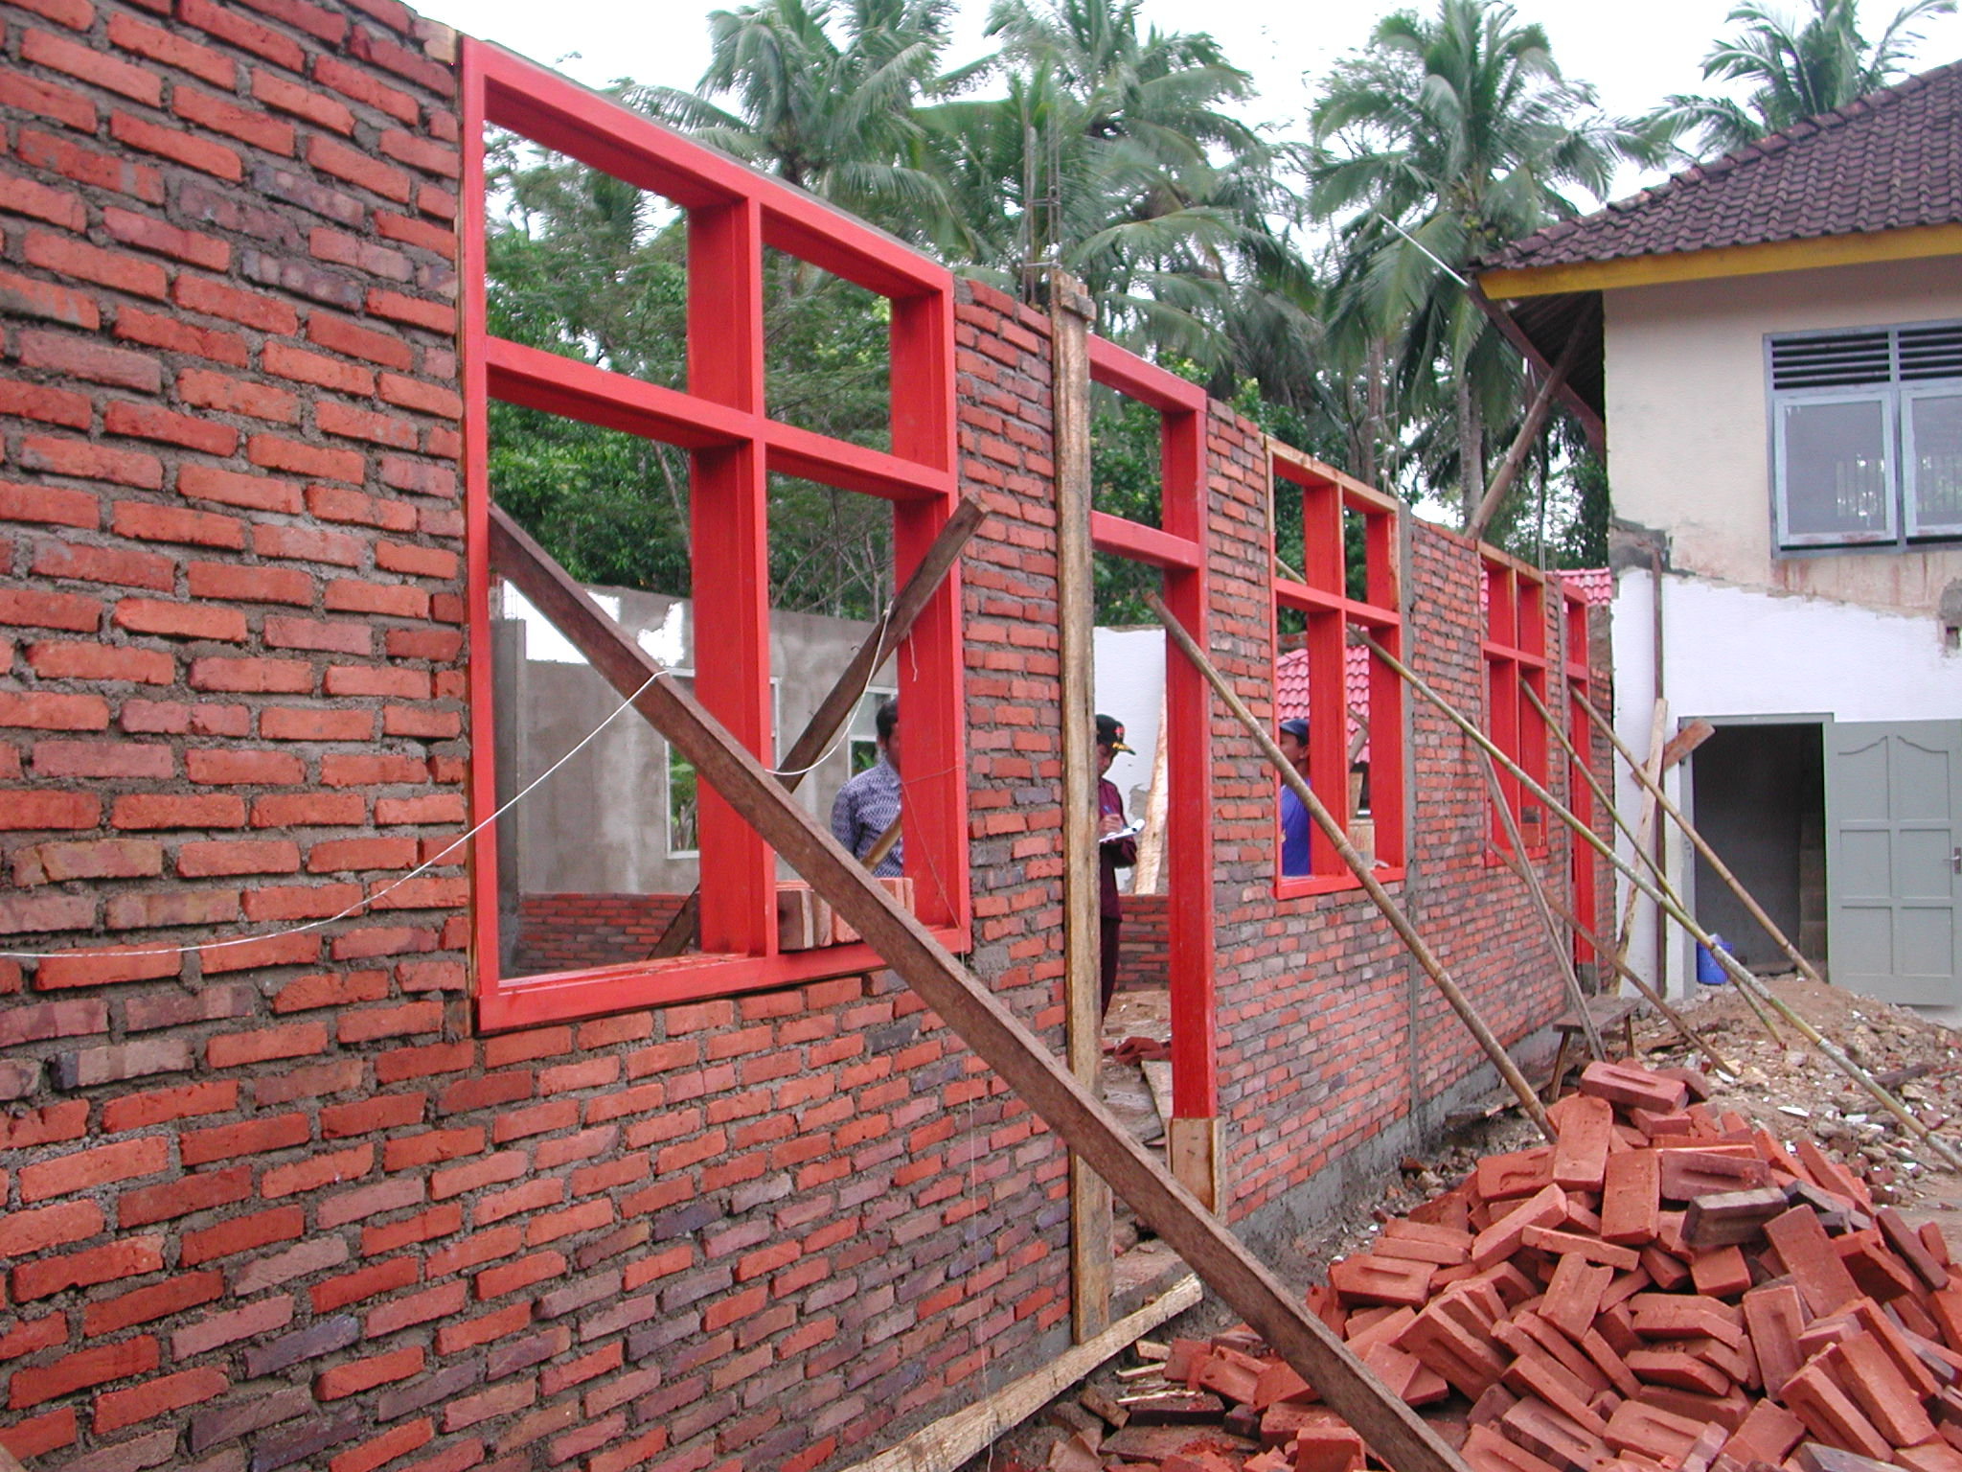

Plate 11: MTs Muhammadiyah 3 Ketro showing work in progress on classrooms

The total budget was Rp80million with Rp55.5million for the classroom renovations, Rp7.5million for toilets and water, Rp14million for furniture and Rp3million for administration.

  - SDN Ketro 2, Kecamatan Kebonagung: This is an existing primary school on a large sloping site on the main road east of Pacitan town. The school has 101 pupils and 6 teachers. There is an existing 3-classroom and office building in very poor condition and a new 3-classroom building is being constructed using the foundations of a building that was demolished; the floor level has been raised by 50cms however. Three new toilets are also being constructed. The school has an electricity supply and water is pumped from a spring to the school site where it is stored in a new tank.

The new building is constructed of rendered brick walls, timber roof trusses, clay tiled roof, RC cantilevered roof over the veranda, concrete tiles to floors and verandas, timber windows and panel doors. The workmanship is very good: the roof trusses have been very well made using good quality timber, the joinery and rendering are very good and the RC cantilevers to the veranda and the roof at the rear are very well constructed. Unfortunately the reinforcement being used for all the columns, beams and cantilevers is only 8mm and the consultants should check the structure of these cantilevers as soon as possible and make proposals for strengthening them if they are found to be under-strength. Some of the windows to the classrooms are rather small. A retaining wall is being constructed around three sides of the building and the building has pre-cast storm drains all round. The toilets are well built and finished with very neat tiling.

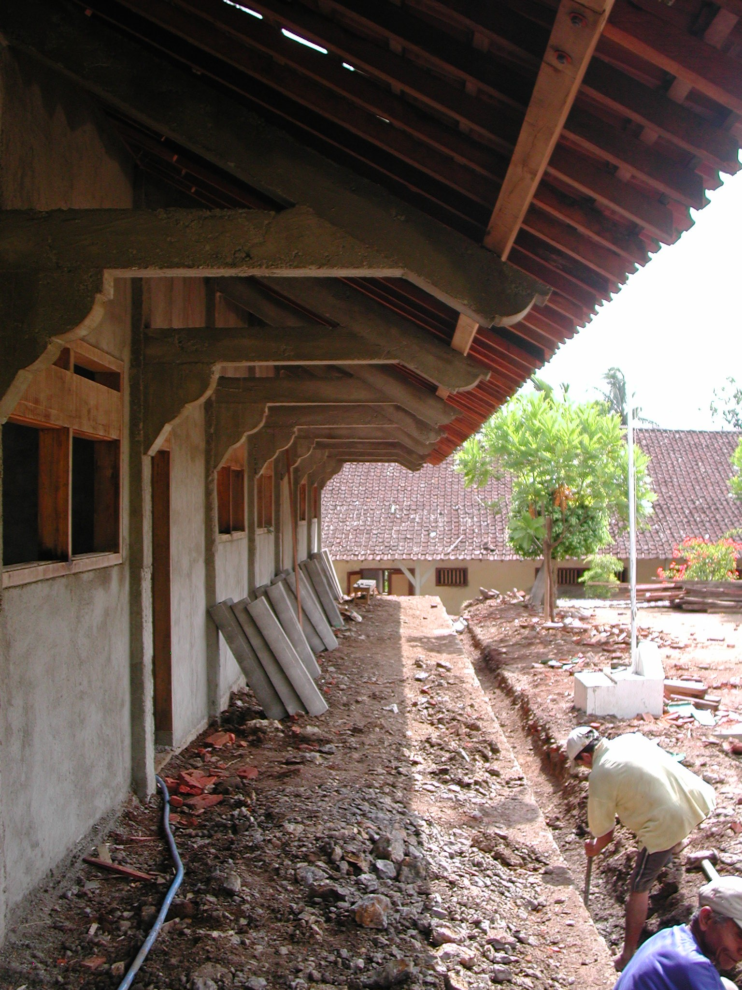

Plate 12: SDN Ketro 2 showing RC cantilevers to veranda that should be checked

The proposals, budget and drawings were prepared by the head teacher who copied drawings for another primary school even including the structural details!

The Kepala Pelaksana is a local trader but the foreman is a builder who obviously knows what he is doing. The technical team are ordering the materials. There are four workers being paid Rp15,000 per day, fifteen craftsmen being paid Rp20,000 per day and a foreman also being paid Rp20,000 per day. Work started on April 14th and should be finished by the end of July 2003.

The SCA has visited the school four times but again seems to have had very little input. He did not help with the preparation of drawings or schedules of materials but he did revise the budget. Unfortunately the budget seems to have been rather inaccurate (see below). The head teacher said that the SCA contributed very little and they could have carried out the work without him. He certainly made no comment on the small size of reinforcement being used in the RC cantilever beams.

The total budget was Rp80million with Rp67,602,000 for the classroom renovations, Rp8,398,000 for toilets and water, Rp1,000,000 for teachers and Rp3million for administration. The work is nearing completion but the head teacher is worried that there will be insufficient funds to complete the work. A lot of money has been spent on very necessary site works which were probably not budgeted for. The community contributed Rp4million in cash towards the cost of the toilets. The square metre cost for construction works out as Rp439,306m².

  - SLTPN 2 Tulakan, Kecamatan Tulakan: This is an existing junior secondary school built in 1992 on a large sloping site with lots of steps and retaining walls next to a main road outside a village. The school has 362 pupils and 31 teachers and an administration building, nine classrooms, a laboratory, a library, toilets and a store. The school would appear to have had very little maintenance and the roofs and exposed roof timbers in particular badly need repairs and maintenance. Two separate student toilets are being re-built from the foundations up and a retaining wall and paving around one classroom are also being re-built. A new large water storage tank has been built and connected to the school water supply reticulation and a retaining wall below the tank has been re-built. The whole school is also being repainted inside and outside. The school has a water supply from a well with a pump and an electricity supply.

The toilets, water tank and retaining walls are well constructed and finished although the connection from the water tank is at present through a plastic garden hose! The main concern is that no repairs are being carried out to any of the roofs although this is probably the highest priority. Many verge boards and ends of roof purlins are badly rotted and if they are not replaced soon there will be major roof problems. This work should have taken precedence over the painting of the school.

The proposals were prepared by a friend of the Kepala Pelaksana who was paid Rp300, 000 by the school for carrying out the work. There are drawings of the toilets, water tank and retaining walls but no construction details.

The Kepala Pelaksana is a member of the community who has some experience of construction. The technical team are ordering the materials. There are seventeen workers paid Rp17,500 per day and eight craftsmen paid Rp22,500 per day and a foreman paid Rp27,500 per day working on the site. Work started on 13th April and will be finished by the end of June 2003.

The SCA made four visits but gave no technical advice or assistance. He in fact asked the school committee to prepare the drawings and budget. The head teacher complained about the performance of the SCA and said that he had given the committee no advice or assistance which is why they had to pay someone else to prepare the proposal. The SCA should have advised the committee to make the roof repairs a priority rather than painting the school. The school committee does not plan to use the money budgeted for teacher training until next year and as this contravenes the guidelines, it was suggested that the money was used instead for carrying out some of the roof repairs.

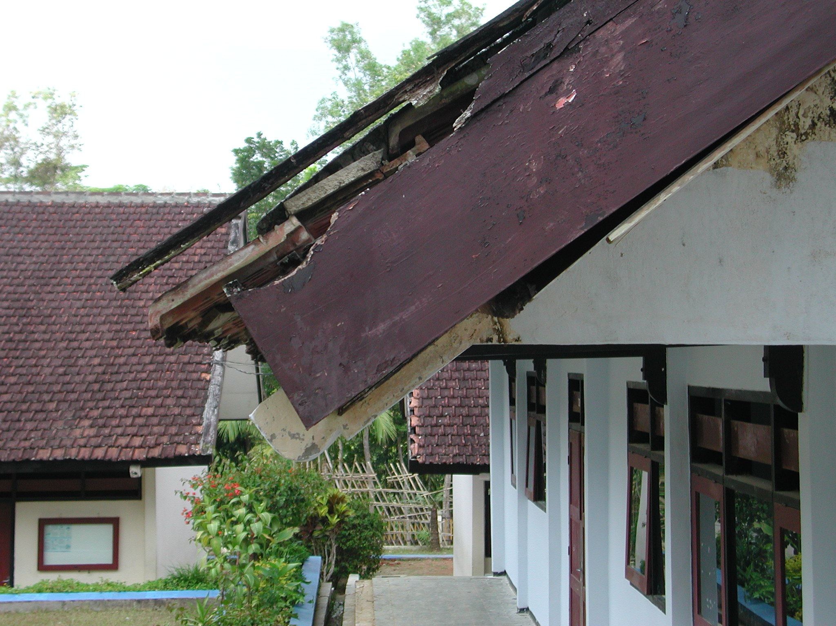

Plate 13: SLTPN 2 Tulakan showing typical roof that requires urgent repair

The total budget was Rp110million with Rp64million for the classroom renovations, d retaining walls, drains, toilets and water supply, Rp2.5million for books, Rp3.5million for furniture, Rp13million for teaching aides, Rp8.56million for teacher training and Rp3million for administration.

  - SDN Bubakan 1, Desa Bubakan, Kecamatan Tulakan: This is an existing primary school on a large sloping site in a fairly remote rural village. The school has 258 pupils and 9 teachers. There is an existing 1-classroom building and an office building that are both badly cracked. There is also an old ‘U’ shaped building the centre of which has been demolished and a new 3-classroom building is being constructed using the old foundations with new foundations for the columns. One existing end of the ‘U’ with two classrooms will be retained and the other end will be demolished. There are two existing toilets in poor condition but these will not be renovated. A new well has however been built behind the classrooms. The school has an electricity supply.

The new building is constructed of rendered brick walls, RC columns, timber roof trusses, concrete roof tiles, RC and timber cantilevered roof over the veranda, concrete tiles to floors and verandas, timber windows and panel doors. The workmanship is so far very good: the roof trusses have been very well made using good quality timber, the joinery and rendering are good and the RC and timber cantilevers to the veranda and the roof at the rear are very well constructed. It was not possible to see the size of the reinforcement but there were only receipts for 6mm and 8mm reinforcement. The soil conditions here are very bad (probably the reason why the existing buildings are so badly cracked) and the school committee have constructed the new RC columns with RC foundations below. It is suspected that the reinforcement used for all the columns, beams and cantilevers is only 8mm and the consultants should check the structure of these cantilevers as soon as possible and make proposals for strengthening them if they are found to be under-strength. The site rises quite steeply behind the classrooms and a drain will be required here to protect the building.

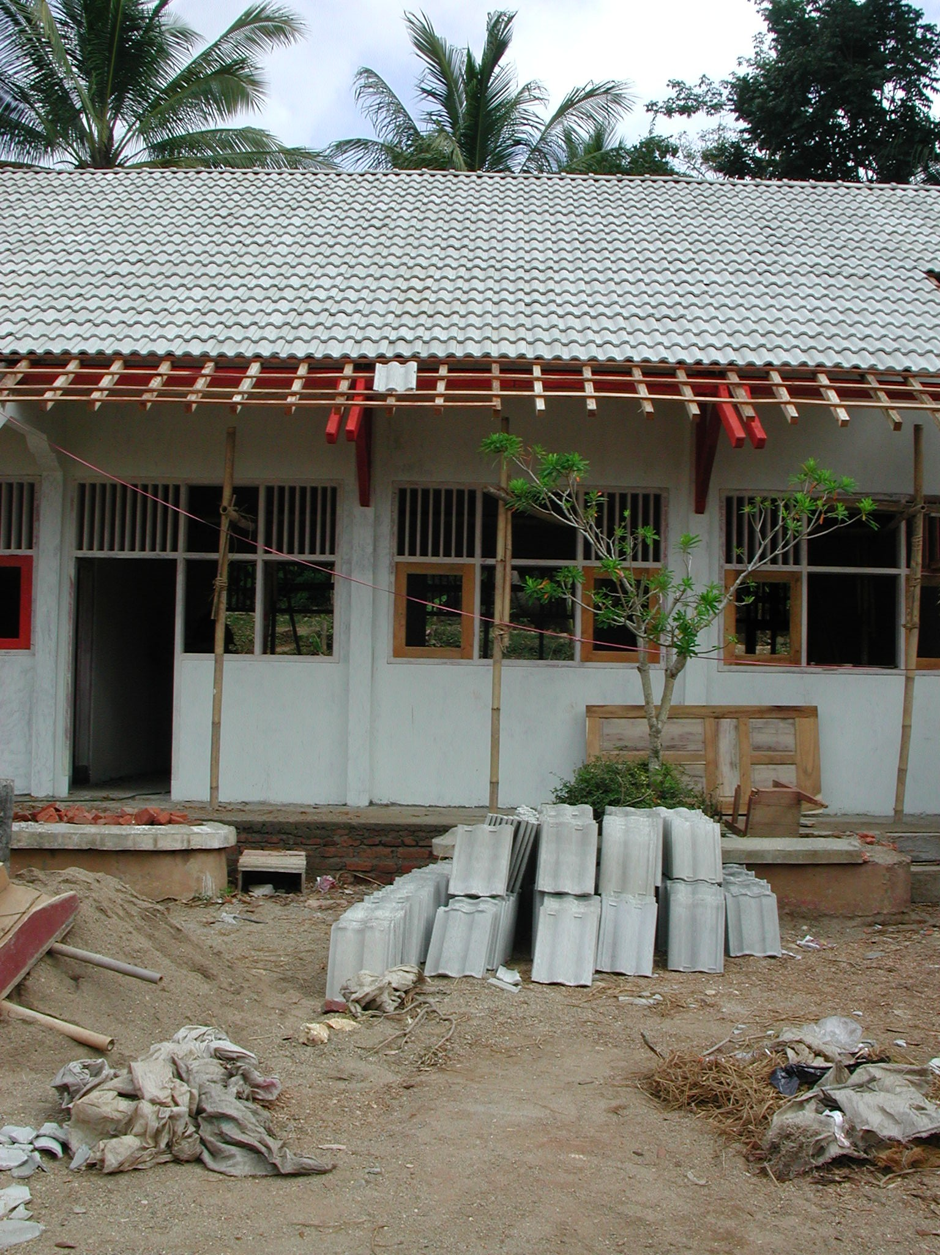

Plate 14: SDN Bubakan 1 showing new building

The proposals, budget and drawings were prepared by the head teacher and the drawings are very basic and there are no details.

The Kepala Pelaksana is a farmer/builder and he is organising the work. The technical team are ordering the materials. There are eleven workers being paid Rp15,000 per day, sixteen craftsmen being paid Rp18,000 per day and a foreman who is being paid Rp20,000 per day. Work started on April 13th and should be finished by the first week in July 2003.

The SCA has visited the school five times but again seems to have had very little input. He did not help with the preparation of drawings, budget or schedules of materials but he did revise the budget. He made no comment on the poor soil conditions but left the school committee to deal with this problem.

The total budget was Rp90million with Rp87million for the classroom renovations and Rp3million for administration. The square metre cost for construction works out as Rp517,857m².

  - MIN Bungur, Kecamatan Tulakan: This is an existing primary school on a small site in a fairly remote rural village. The school has 103 pupils and 14 teachers. There is an existing building that is old but was renovated in 1996 and has a head master’s office, a teachers’ office and two classrooms. A new extension containing three small classrooms has been built, using the foundations of the building that was demolished, at right angles to the existing building at the rear of the site. The existing toilets are derelict and they will not be renovated. The school has an electricity supply but no water supply. Water is a problem in this village. Water is obtained from a spring during the rains but this dries up during the dry season and water has to be bought.

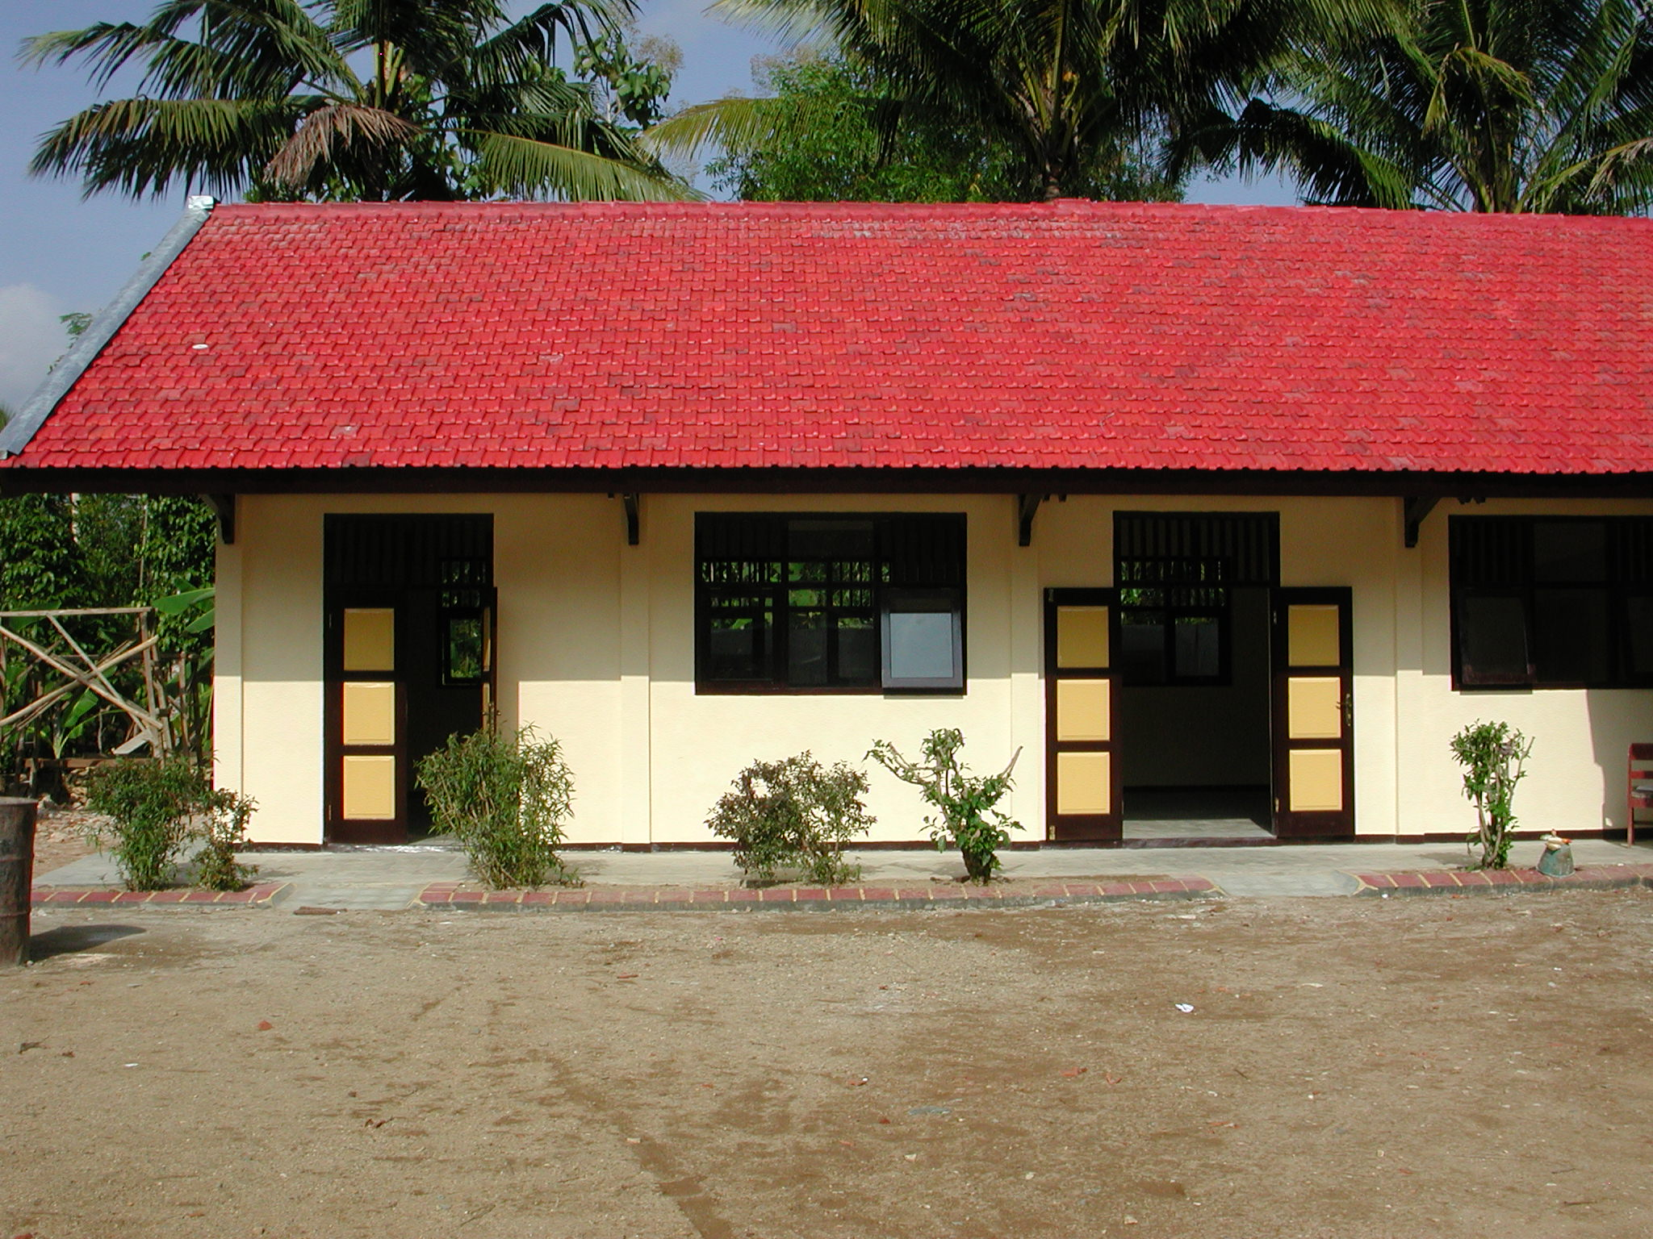

Plate 15: MIN Bungur showing new building

The new building is constructed of rendered brick walls, RC columns, timber roof trusses, concrete roof tiles, RC and timber cantilevered roof over the veranda, concrete tiles to floors and verandas, timber windows and panel doors. The building is virtually finished with only touching up to do and the workmanship is quite good with very good joinery, finishes and painting. The roof trusses and concrete work could not be seen nor could the size of the reinforcement.

The proposals and budget were prepared by the school committee and the Kepala Pelaksana did the drawings which are very basic with no details.

The Kepala Pelaksana is a farmer and he organised the work, particularly the doors and windows. The technical team are ordering the materials. There are eight workers being paid Rp20,000 per day, five craftsmen being paid Rp25,000 per day and a foreman who is being paid Rp25,000 per day. Work started on April 15th and was being completed on the day of the visit.

The SCA has visited the school five times but again seems to have had very little input. He did not help with the preparation of drawings, budget or schedules of materials and the budget was obviously not very accurate as money has been left over (see below).

The total budget was Rp70million with Rp67million for the classroom renovations and Rp3million for administration. Approximately Rp7million is left over however and this gives a square metre cost for construction of Rp697,674m². The school committee propose to build one additional classroom with the remaining funds but they will not be sufficient. They would be better advised to do something about the water supply problem. A tank could be built for instance so that they could buy water in bulk.

  - MIM Desa Sanggrahan, Kecamatan Kebonagung: This is an existing primary school on a small steeply sloping site that it shares with a small TK in a remote rural village. The school has 59 pupils and 7 teachers. There is an existing building containing two classrooms and an office behind the TK and another existing 3-classroom building (with very small classrooms) has been demolished and is being re-built complete with new foundations. The ground drops steeply away (2 metres) behind this building down to a volley ball court and a new retaining wall has been built here with a cut off drain along the top. There is a very small, one-compartment toilet but three new toilets will be built. There is a very good water supply from a spring and the school has an electricity supply.

The new building is constructed of rendered brick walls, RC columns, timber roof trusses, clay roof tiles, RC beams and columns over the veranda, concrete tiles to floors and verandas, timber windows and panel doors. The walls and roof are finished, ceilings, window and door frames are fixed and floor tiling is in progress. The workmanship so far is good but the roof trusses and concrete work could not be seen nor could the size of the reinforcement. The roof seems to be very well built however. Some repairs have also been made to the floors of the other building and new doors have also been fitted.

The proposals and budget were prepared by the school committee and the Kepala Pelaksana did the drawings which are very basic with no details.

The Kepala Pelaksana works for the Kepala Desa. The technical team are ordering the materials. There are four workers being paid Rp15,000 per day, seven craftsmen being paid Rp20,000 per day and a foreman who is being paid Rp25,000 per day. Work started on April 16th and will be completed by the end of July 2003.

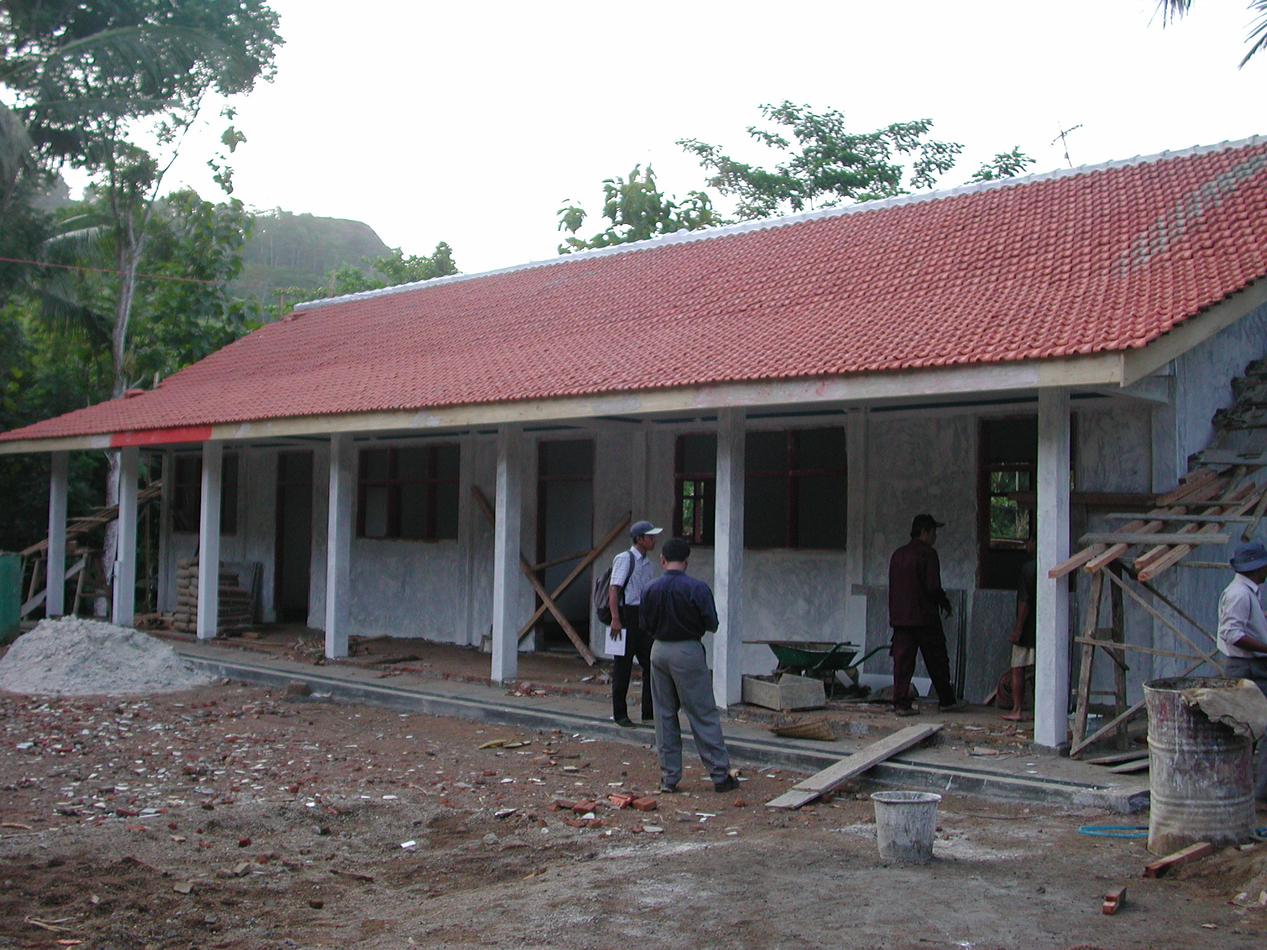

Plate 16: MIM Desa Sanggrahan showing new building

The SCA has visited the school five times but again seems to have had very little input. He did not help with the preparation of drawings, budget or schedules of materials.

The total budget was Rp80million with Rp70million for the classroom renovations, toilets and water supply, Rp7million for books, furniture and teachers and Rp3million for administration. This gives a square metre cost for construction of Rp618,676m².

  - MI Guppi, Desa Bangunsari, Kecamatan Pacitan: This is an existing primary school on a small flat site in a rural village just outside Pacitan Town. The school has only 38 pupils and 6 teachers. A new 3-classroom and office/library building has been constructed in an ‘L’ shape that follows the lines of an existing building that was partially demolished. Two new toilets have been constructed in a separate building. The school has an electricity supply and a piped water supply.

The new building is constructed of rendered brick walls (the existing walls to the office/library have been retained and raised), RC columns, timber roof trusses, clay roof tiles, large RC and timber cantilevered roofs over the verandas, concrete tiles to floors and verandas, timber windows and panel doors. The building is finished and the workmanship and finishing are generally quite good but the doors and hardware are not very good quality. The roof trusses and concrete work could not be seen nor could the size of the reinforcement but the structure of the large concrete cantilever beams is suspect and should be checked by the consultants.

The proposals and budget were prepared by the school committee and the Kepala Pelaksana, a local builder who did the drawings, which are very basic with no details, and a very detailed breakdown of materials and costs.

The Kepala Pelaksana organised the work and the technical team ordered the materials. There were fourteen workers who were paid Rp17,500 per day, nine craftsmen who were paid Rp20,000 per day and a foreman who was paid Rp22,500 per day. Work started on April 22th and was completed on June 6th 2003.

The SCA has visited the school four times but again seems to have had very little input. He did not help with the preparation of drawings, budget or schedules of materials and the budget was not very accurate as money has been left over (see below). He has also asked the school committee to prepare a maintenance plan which should really be his job.

The total budget was Rp70million with Rp57million for the classroom renovations, Rp10million for the toilets and Rp3million for administration. Approximately Rp3million was left over which has been spent on school books.

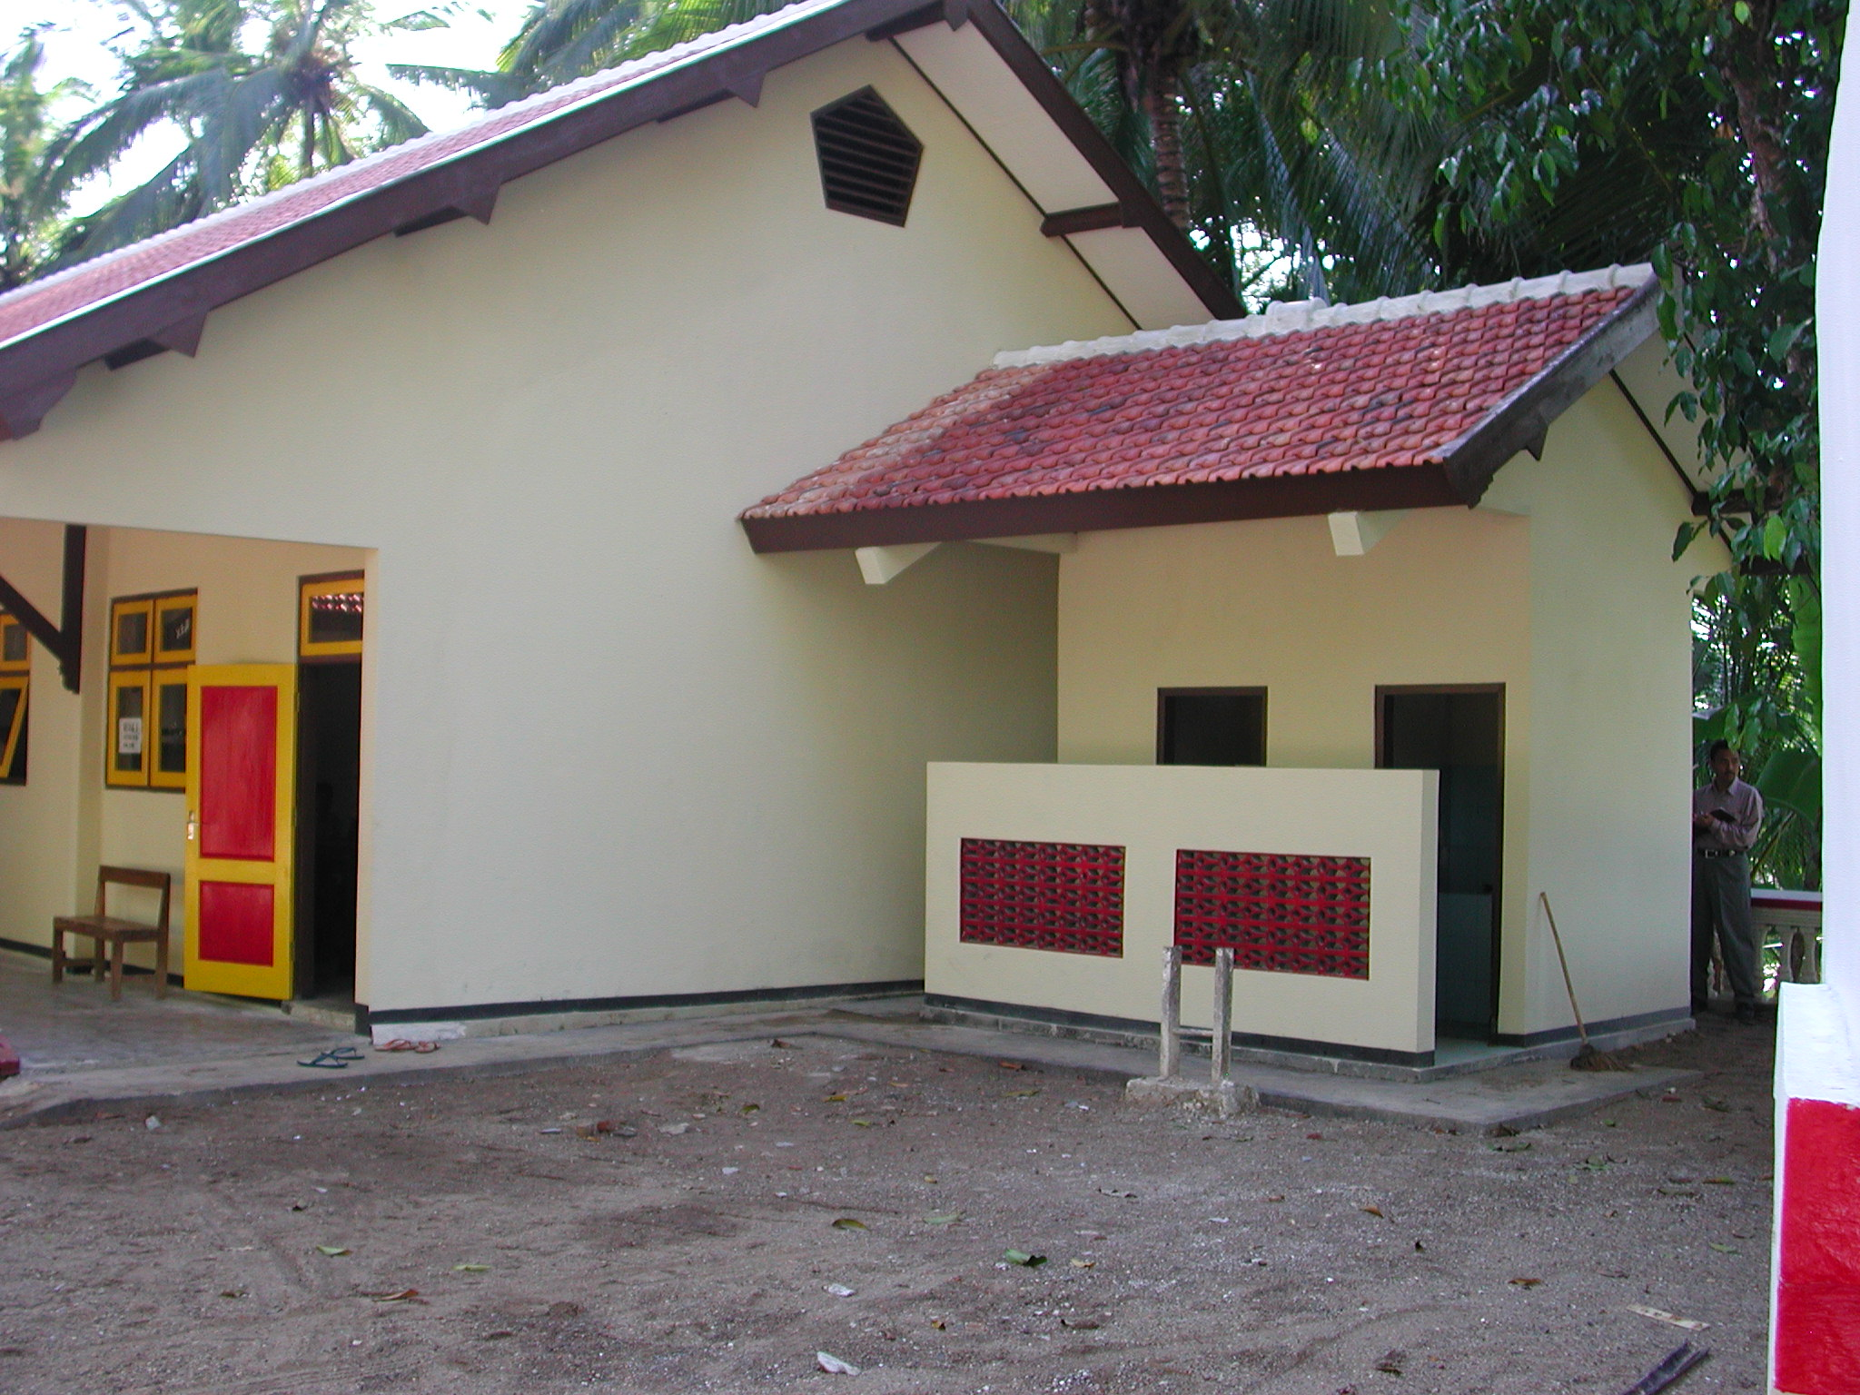

Plate 17: MI Guppi showing new toilets and large RC cantilever beams that should be checked

ANNEX 2: SCHOOL VISITS IN PANDEGLANG DISTRICT, BANTEN PROVINCE

1. The following schools were visited on June 20th and June 21st 2003:

  - SDN Kadumerak, Kecamatan Cadasari: This is an existing primary school on a small site in a rural village one kilometre off a main road. The school has 293 pupils and 8 teachers. There is an existing 3-classroom building that is in a very bad state of repair and is almost derelict: many of the asbestos roof sheets are broken, the ceilings are collapsing, the floors to classrooms and the veranda are disintegrating, many of the opening windows have disappeared and most of the doors are broken. A similar building has been demolished and a new 3-classroom and office building constructed including new foundations. The building was in a very bad state and one classroom was unusable. There is also a new separate toilet building with two toilets for girls and two toilets for boys. Water is pumped from an existing well to the toilets but there is no electricity installation even though there is electricity in the village.

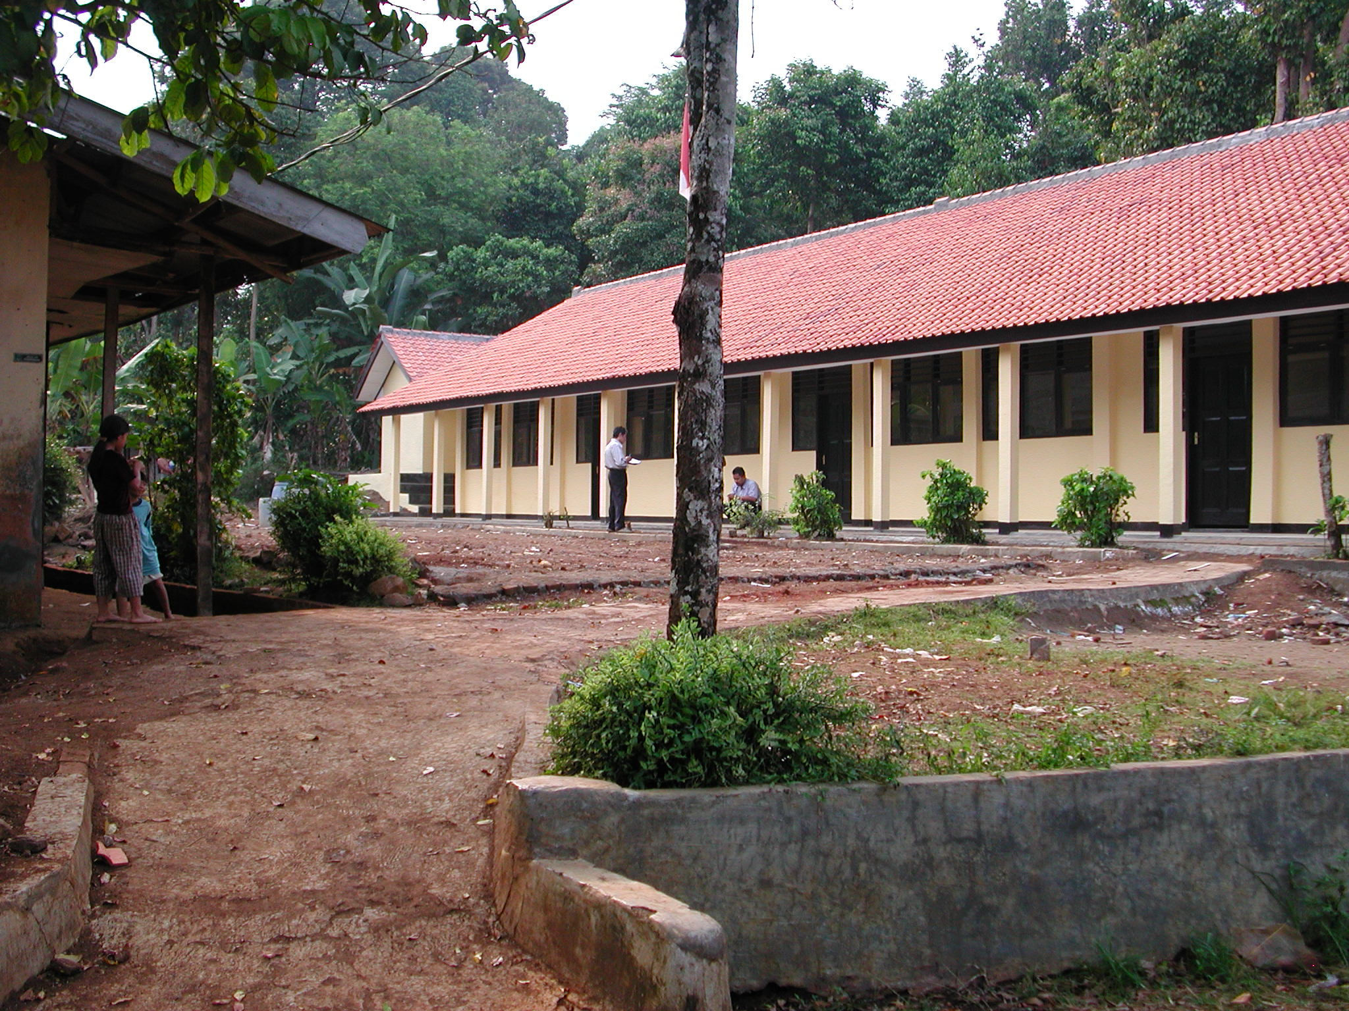

Plate 1: SDN Kadumerak showing new building with toilets at far end

The new building is finished and is constructed of rendered brick walls, RC columns, RC veranda columns and beams, timber roof trusses, clay tiled roof, white glazed floor tiles to rooms and the veranda, timber windows and panel doors. The trusses could not be seen are good neither could the concrete work which is rendered. The roof seems quite well built and is reasonably straight and the windows and panel doors are well made. The rest of the construction is not very good however: the rendering is very rough and the painting, especially to the toilets is not very good. Some of the concrete columns are not very straight or plumb, the veranda columns are small and the reinforcement to columns and beams seems to be 8mm. This is inadequate; it should have been 10mm or preferably 12mm and the consultants should check the structure as soon as possible and make proposals for strengthening it if necessary.

As stated above, the existing building that has not been renovated is in a very bad state of repair and if it not renovated will soon become unusable. It would have probably been more sensible therefore to have renovated both buildings to a lower standard than the one that has been renovated with new roofs and floors and whatever other elements that could have been afforded. This would have given all pupils in the school better classrooms rather only half the pupils as at present.

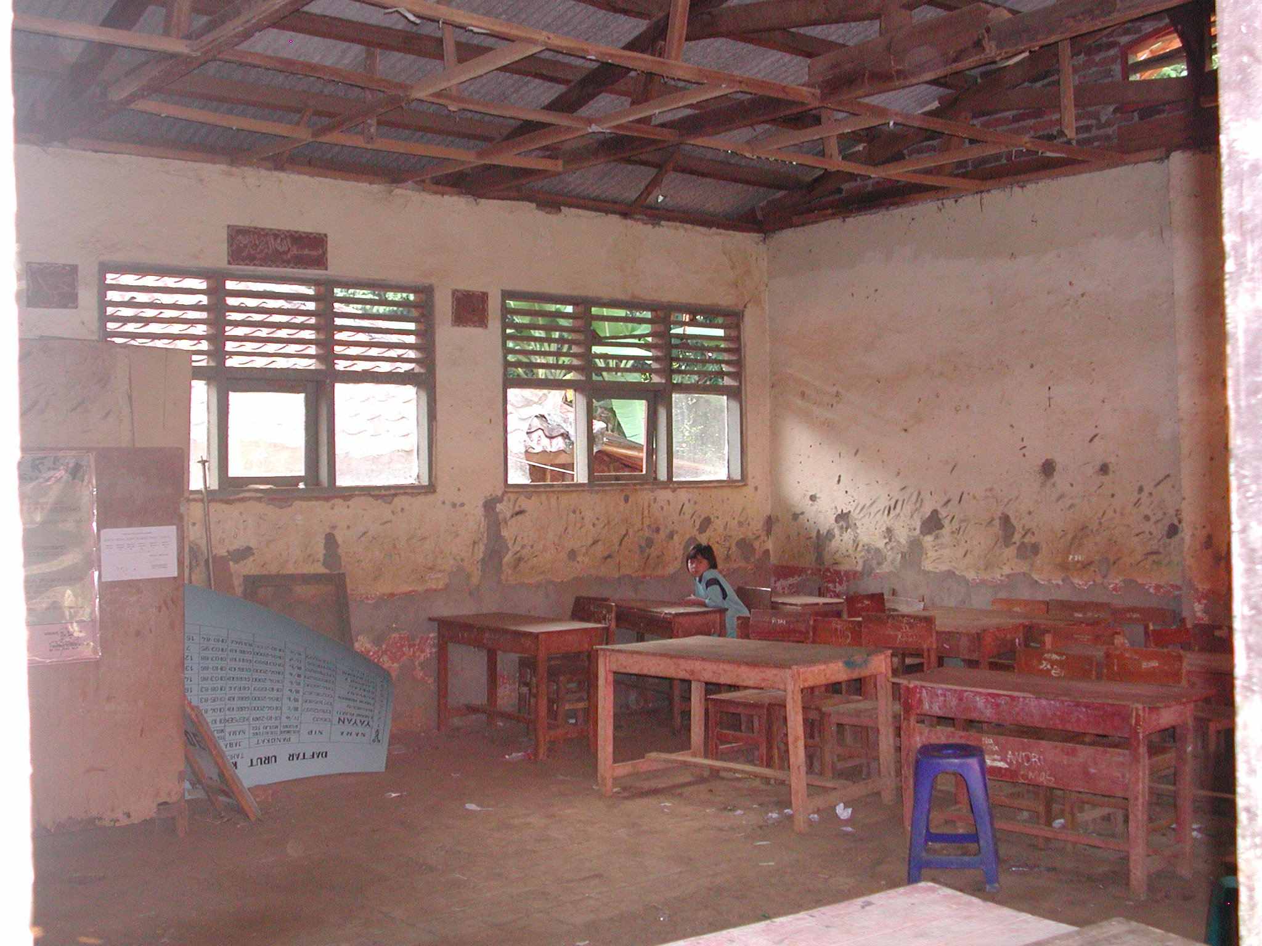

Plate 2: SDN Kadumerak showing inside of un-renovated building

The total budget was Rp110million but there were no details available of how the budget was broken down. There were no representatives of the school staff or the school committee around but the team was told that the chairman of BP3 had organised the renovations and no teachers of other representatives of the community was involved. The chairman was sent for but did not appear.

  - SDN Pagadungan 5, Kecamatan Cadasari: This is an existing primary school on a small site in a small rural village accessible only via rough roads. The school has 155 pupils and 5 teachers. There are three buildings on the site: a 3-classroom and office building with toilets at one end, an office and a staff house. The classroom building is being renovated but the other two buildings which are in very poor condition are not. There is a new, very deep well very close to the toilets but no electricity supply.

The existing walls and columns to the classroom building have been retained and raised in height by approximately 60cm but the columns at the rear have not been extended: the roof trusses sit on the new brickwork. There are new trusses and plywood ceilings throughout and new door and window frames. The reinforcement to the top ring beam seems to be 6mm and the reinforcement to the columns is 8mm. The door and window frames are reasonable but the timber used for the trusses is very poor quality. The roof is not very straight and some roof tiles are loose. There is a large opening between two classrooms and the lintel over (if there is one) is badly cracked. New columns and beams have been constructed to the veranda but there is no ground beam; the columns have individual foundations. Overall the workmanship is not very good. The original roof was constructed of asbestos roof sheets and there is now a lot of broken asbestos scattered around the site. This should be carefully removed and safely disposed of. The new septic tank to the toilets should be constructed at least 15 metres away from the well. The reinforcement to all columns and beams should have again been a minimum of 10mm and preferably 12mm and again the consultants should check the structure as soon as possible and make proposals for strengthening it if necessary.

The total budget was Rp80million but there were no details available of how the budget was broken down. There were no representatives of the school staff or the school committee around.

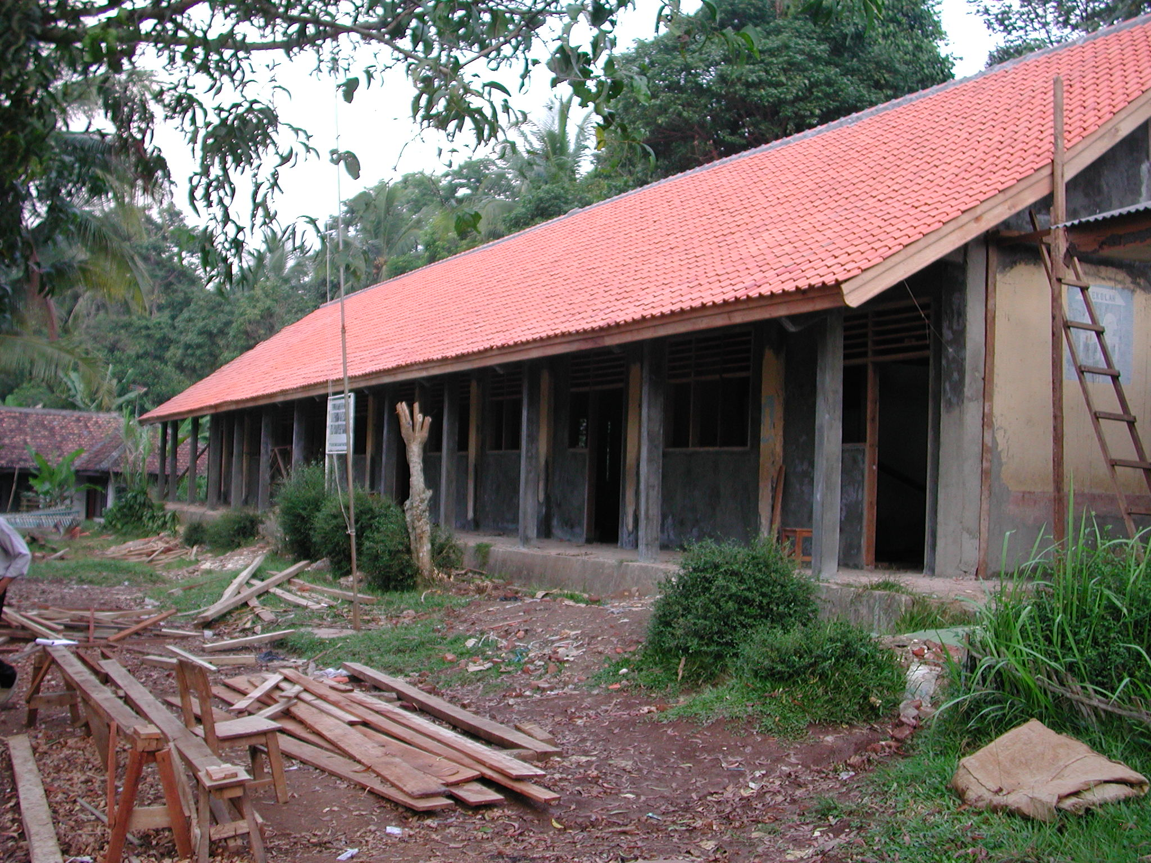

Plate 3: SDN Pagadungan 5 showing classroom building

  - MIs Al-Ishlah Laksana, Kecamatan Pandeglang: This primary school shares a small site with a small senior secondary school. The school has 97 pupils and 6 teachers. An existing classroom building has been demolished and a new 3-classroom building constructed including new foundations. A new separate toilet building is being constructed behind and very close to, the classroom building. The school has a water supply and an electricity supply.

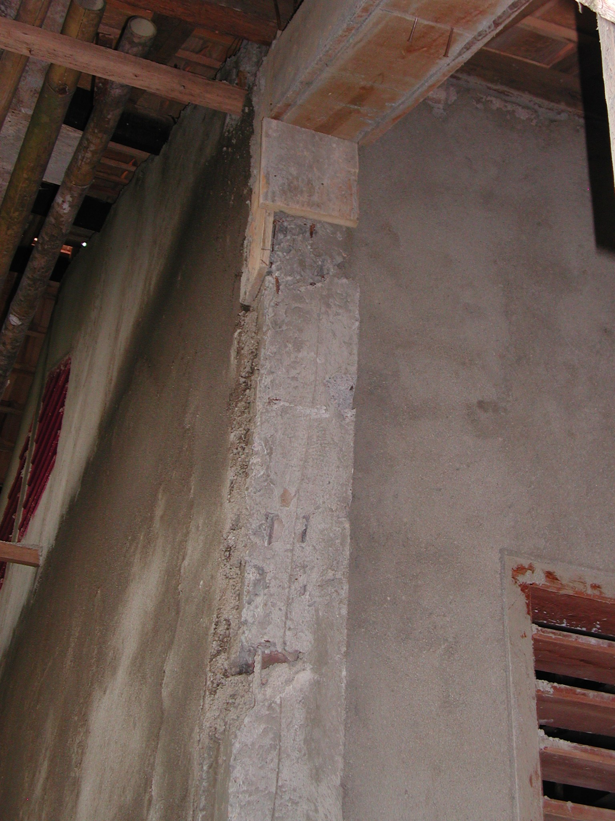

Plate 4: MIs Al-Ishlah Laksana showing poor quality concrete

The SCA provided the school committee with comprehensive drawings for a 3-classroom and toilet building. These were standard drawings however and the building as shown could not fit on the only site available which is restricted by buildings at one end and a steep slope at the other. The building as constructed is therefore quite different from the drawings. The classrooms are much smaller and have one central truss and supporting columns rather than two as shown on the drawings and the toilets are separate. The SCA quite obviously did not carry out a survey of the site and existing building and made no attempt to provide site specific drawings.

The new building is constructed of rendered brickwork with RC columns and beams to the walls and veranda. The roof is of clay tiles on timber rafters, purlins and roof trusses. The roof, roof trusses and joinery are quite good. The concrete work is however not very good. The reinforcement to the ground beam is only 6mm (there is no ground beam to the veranda columns) and the reinforcement to columns and beams is only 8mm (all with 4mm links). The columns to the classroom walls have been reduced to 15 x 15cms and are 3.5 metres high.

The total budget was Rp110million with Rp107million for the classroom renovations, toilets and water and Rp3million for administration.

  - SDN Pandaj 1, Kecamatan Mandelawangi: This is an existing primary school on a very small site in a rural village. The school has 263 pupils and 8 teachers. There is an existing office building that is in very poor condition and another classroom and office building has been demolished and is being re-built as a 3-classroom and toilet building. The water supply is from an existing well and the school does not have an electricity supply.

The SCA again provided the school committee with comprehensive standard drawings for a 3-classroom and toilet building but again the building as constructed is quite different. The classrooms are a different size and what was the office has been converted into toilets. There is also only one column and beam per classroom along the veranda and the beam therefore sits on top of a window rather than a column on the classroom side. The SCA again does not seem to have carried out a survey of the site and existing building and has made no attempt to provide site specific drawings.

The new building is constructed of rendered brick walls, RC columns and beams to rooms and veranda, timber roof trusses, clay tiled roof, white glazed floor tiles to rooms and veranda, timber windows and panel doors. The building is quite well constructed but the columns to both sides of the classrooms are only the thickness of the walls ie approximately 11 x 15cm and the reinforcement is only 8mm. The existing foundations have been re-used and there is no new ground beam. The timber used for the roof trusses is poor quality and the roof is not very straight. The rendering and joinery is quite good however. The consultants should check the structure to see if it is adequate and if not, make proposals for strengthening it.

The school committee prepared the original proposal including the budget and the original drawings. The SCA revised the proposals and the budget and gave the committee the standard drawings which they have not used.

The Kepala Pelaksana is a head teacher from another school with no construction experience. The technical team are ordering the materials. There are eight workers paid Rp25,000 per day, five craftsmen paid Rp30,000 per day and the foreman is paid Rp35,000 per day. Work started on 24th April and will be finished by 24th July 2003.

The SCA visited the school four times and did make some technical comments: he
asked for the sand to be changed as it was poor quality and made comments on the
formwork to the columns, the trusses, brickwork and window frames. He does not
seem to have commented however on the reduced size of the RC columns and
reinforcement, the lack of a ground beam, etc or on the fact that the building does not
follow the drawings. The Kepala Pelaksana said however that he was satisfied with
the assistance given by the SCA!

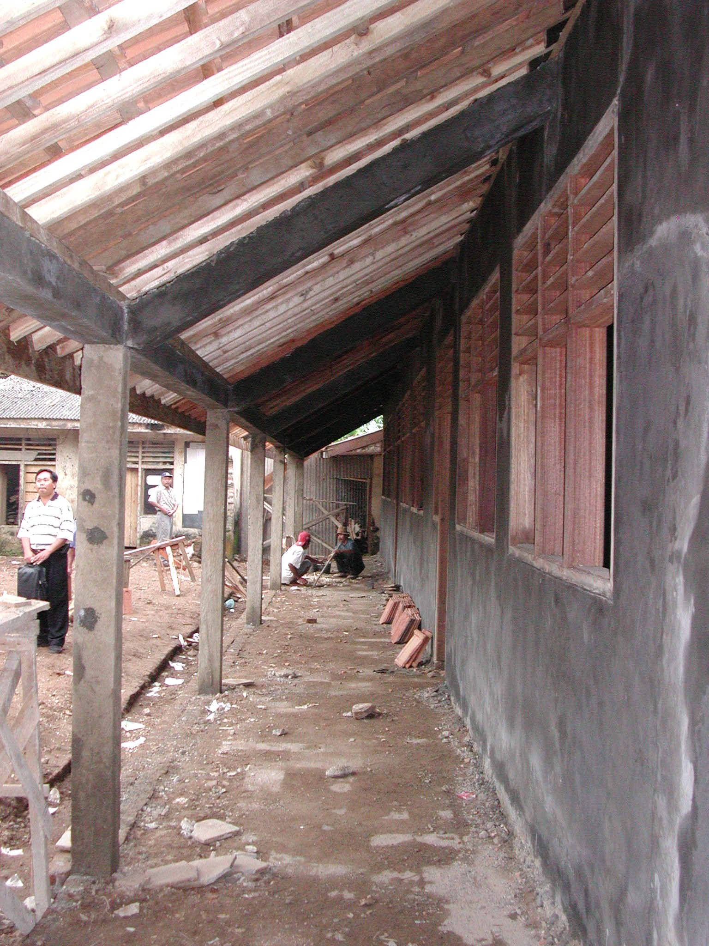

Plate 5: SDN Pandaj 1 showing veranda beams sitting over windows

The total budget was Rp100million with Rp97million for the classroom renovations, toilets and water supply and Rp3million for administration.

  - SDN Suka Raja 3, Kecamatan Jiput: This is an existing primary school on a small site in a rural village. The school has 219 students and 6 teachers. There are two buildings on the site: a 3-classroom and office building that is in very poor condition and is very dark and another 3-classroom building that is being renovated. New toilets will be constructed at the rear of the site between the two buildings. The school has an electricity supply and a good water supply from a spring but a new pipe has to be run about 500 metres to the main pipe.

The walls to the existing building have been retained and extended at the top. The RC columns to the front of the building have also been extended at the top and new RC columns and beams are being constructed along the outside of the veranda. New timber trusses have been constructed and the existing and new walls are being rendered where required. There are new fibre-cement ceilings, timber windows and panel doors and the floors have new white glazed tiles. The classroom building is almost complete and requires painting. The existing paving around the building has been retained and is being repaired where necessary. The building seems quite well built but the joinery is not very good. The reinforcement to columns and beams could not be seen.

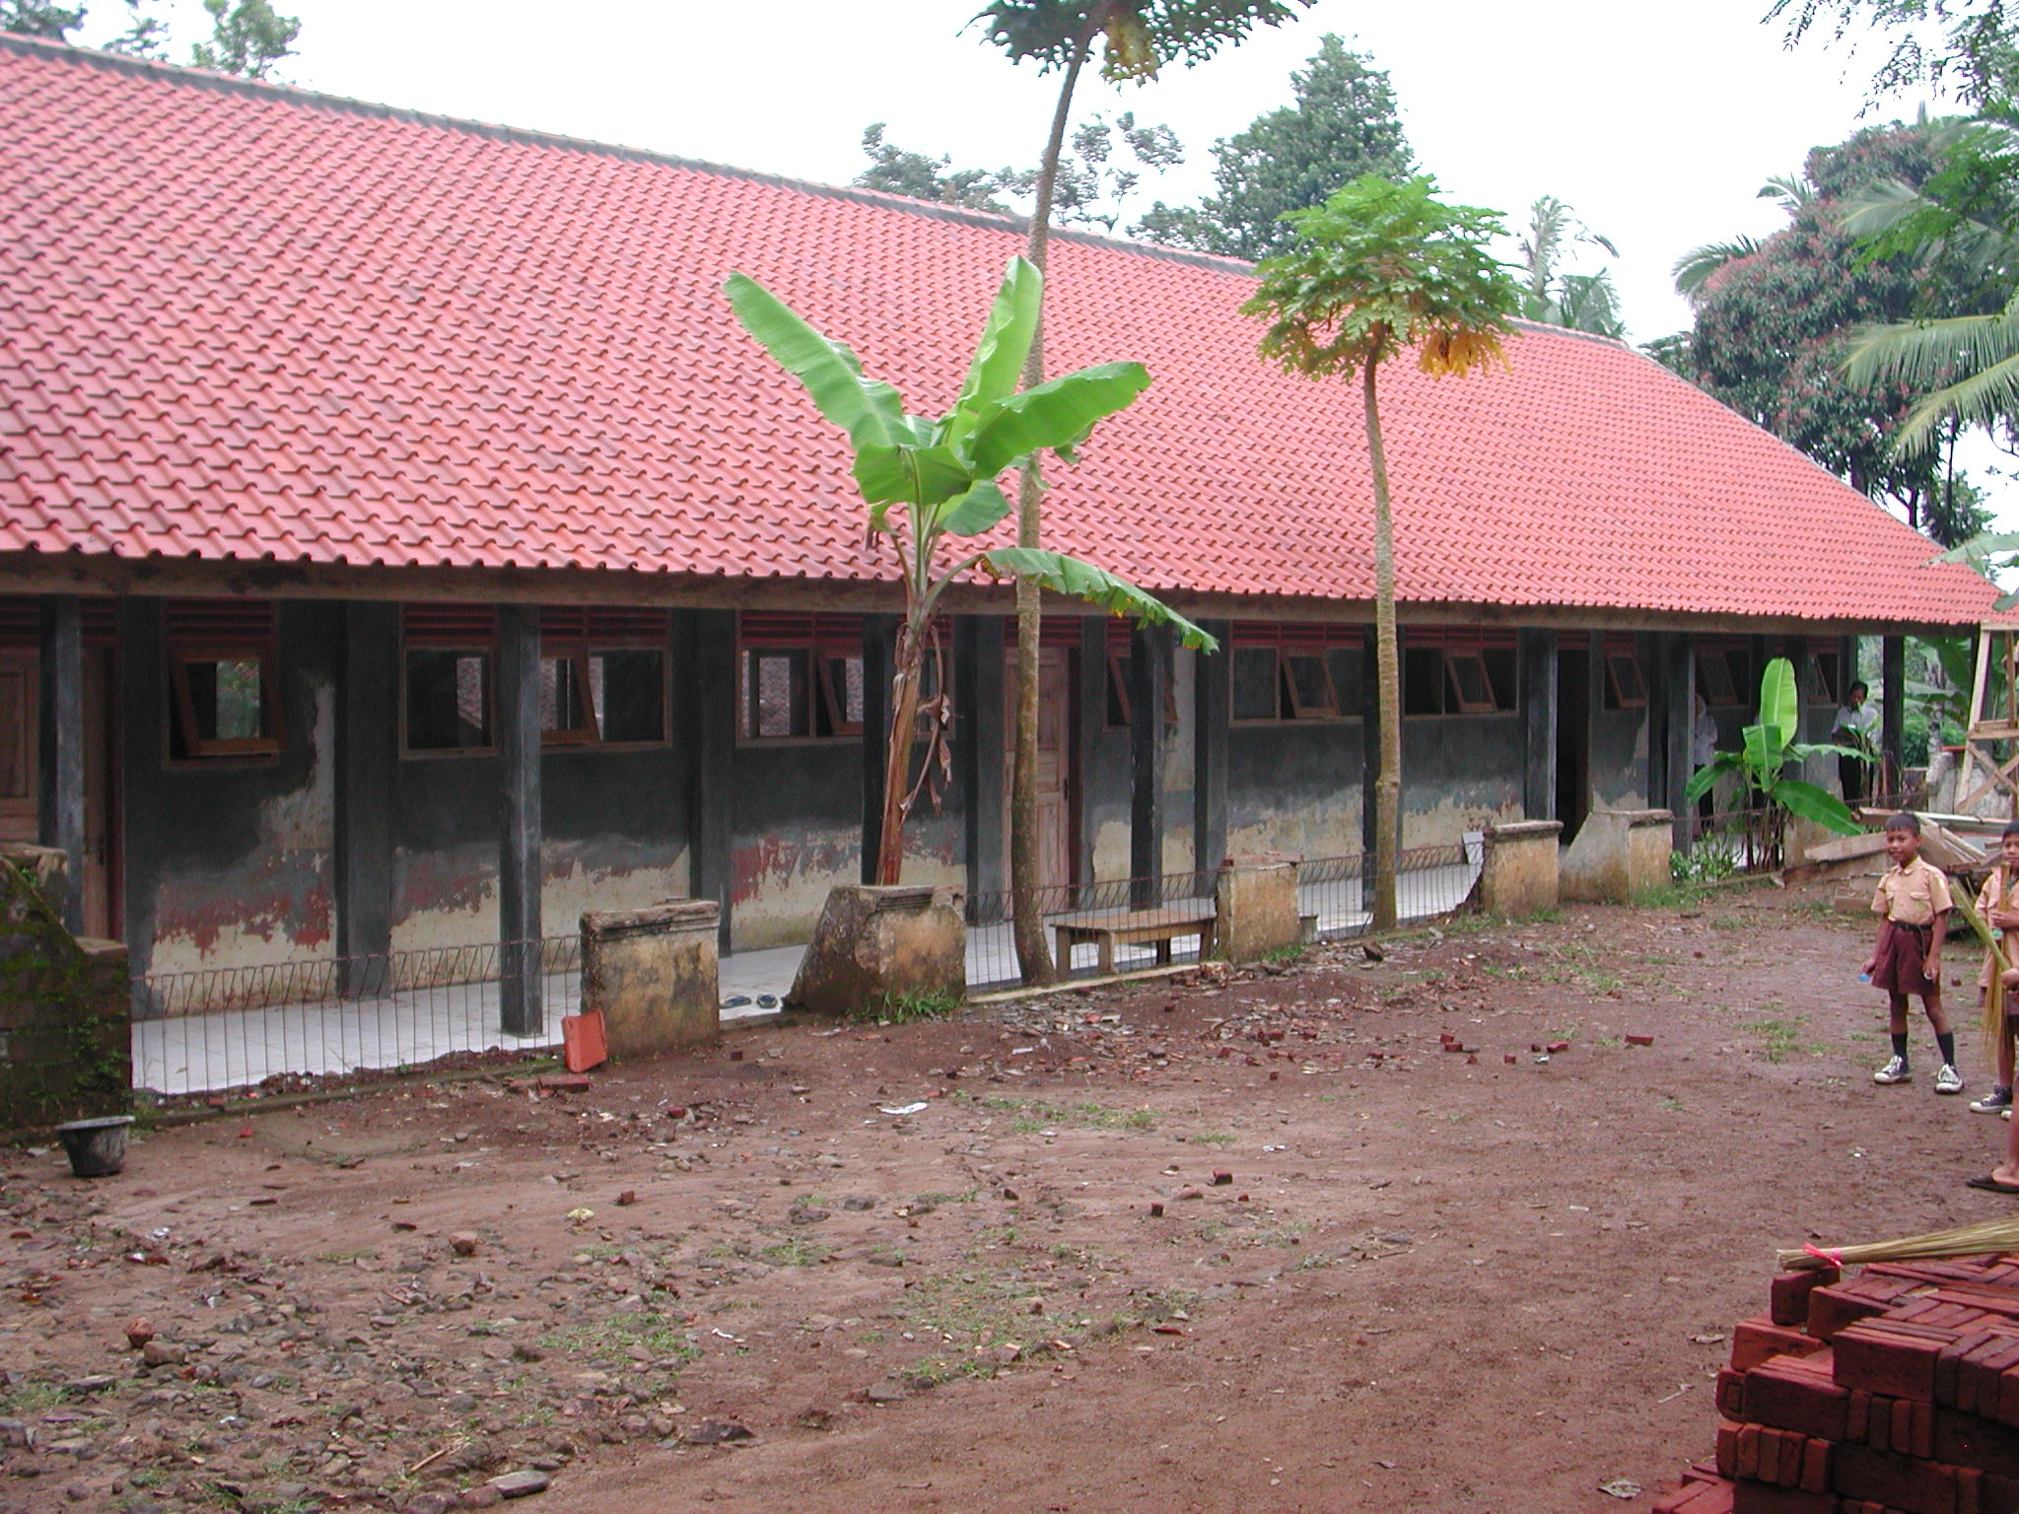

Plate 6: SDN Suka Raja showing renovated building

The SCA prepared the budget and provided basic floor plans (the dimensions are however wrong and the doors and windows are different to those on the drawings) and elevations as well as copies of the standard drawings that show some construction details. The head teacher felt that the SCA had been useful.

The work has been let as a lump sum contract to local workers and the labour will cost Rp12.5million. This includes painting but not materials. Work started on 28th April and will be finished by the end of June 2003.

The SCA made five visits and made some comments on the work particularly on the fact that the windows are not the same as those shown on his drawings. The school committee would like to re-roof the other building if any funds are left over (in one classroom the roof has nearly collapsed and is propped up on bamboo columns in the centre) and the SCA should help them prepare a budget. It would have been more sensible in fact to have spent less on the building being renovated and re-roofed both buildings and provided new concrete tiled floors, doors etc (the windows are in reasonable condition) and the school would have then had six classrooms that could be safely used. The SCA however did not suggest this.

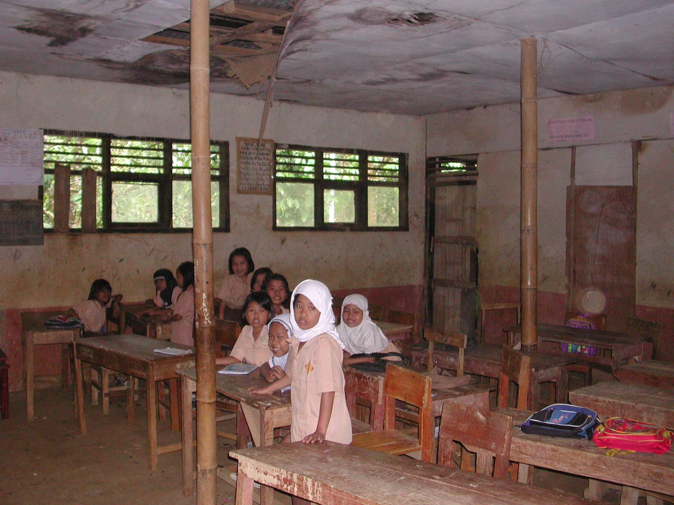

Plate 6: SDN Suka Raja showing interior of un-renovated building

The total budget was Rp100million with Rp76.5million for the classroom renovations, Rp18million for furniture, Rp1.5million for teaching aides, Rp1million for books and Rp3million for administration.

  - SDN Kerangi 1, Kecamatan Menes: This is an existing primary school on a small site in a rural village. The site is below road level at the front and falls away steeply at the back. The school has 191 pupils and 12 teachers. An existing 3-classroom building is being renovated using the existing foundations and a separate office building and new toilets will be constructed. There is also another existing 4-classroom building in very poor condition on another site across the road. The school does not have an electricity supply but will be connected to the village water supply.

The new building is being constructed of rendered brick walls, RC columns and beams to rooms and verandas, timber roof trusses, fibre-cement ceilings, clay tiled roof, white-glazed tiled floors to classroom and veranda floors and to the veranda walls up to cill level, timber windows and panel doors. The building is quite well constructed: the roof trusses seem well made and the roof is straight, the window and door frames are very good and the rendering is well finished. The veranda columns are 20 x 20 cms but it was not possible to see the reinforcement and there is no ground beam. The ground beam to the office building is in progress (the concrete did not have enough aggregate) and the reinforcement to the beam and to the columns is only 6mm! The kepala pelaksana said that the reinforcement to the classrooms was larger.
The kepala pelaksana is a local builder. There are seventeen workers and eight craftsmen working on the site. They are not being paid but are receiving food when they are working. The work started on 10th May and should be finished by the end of June 2003.

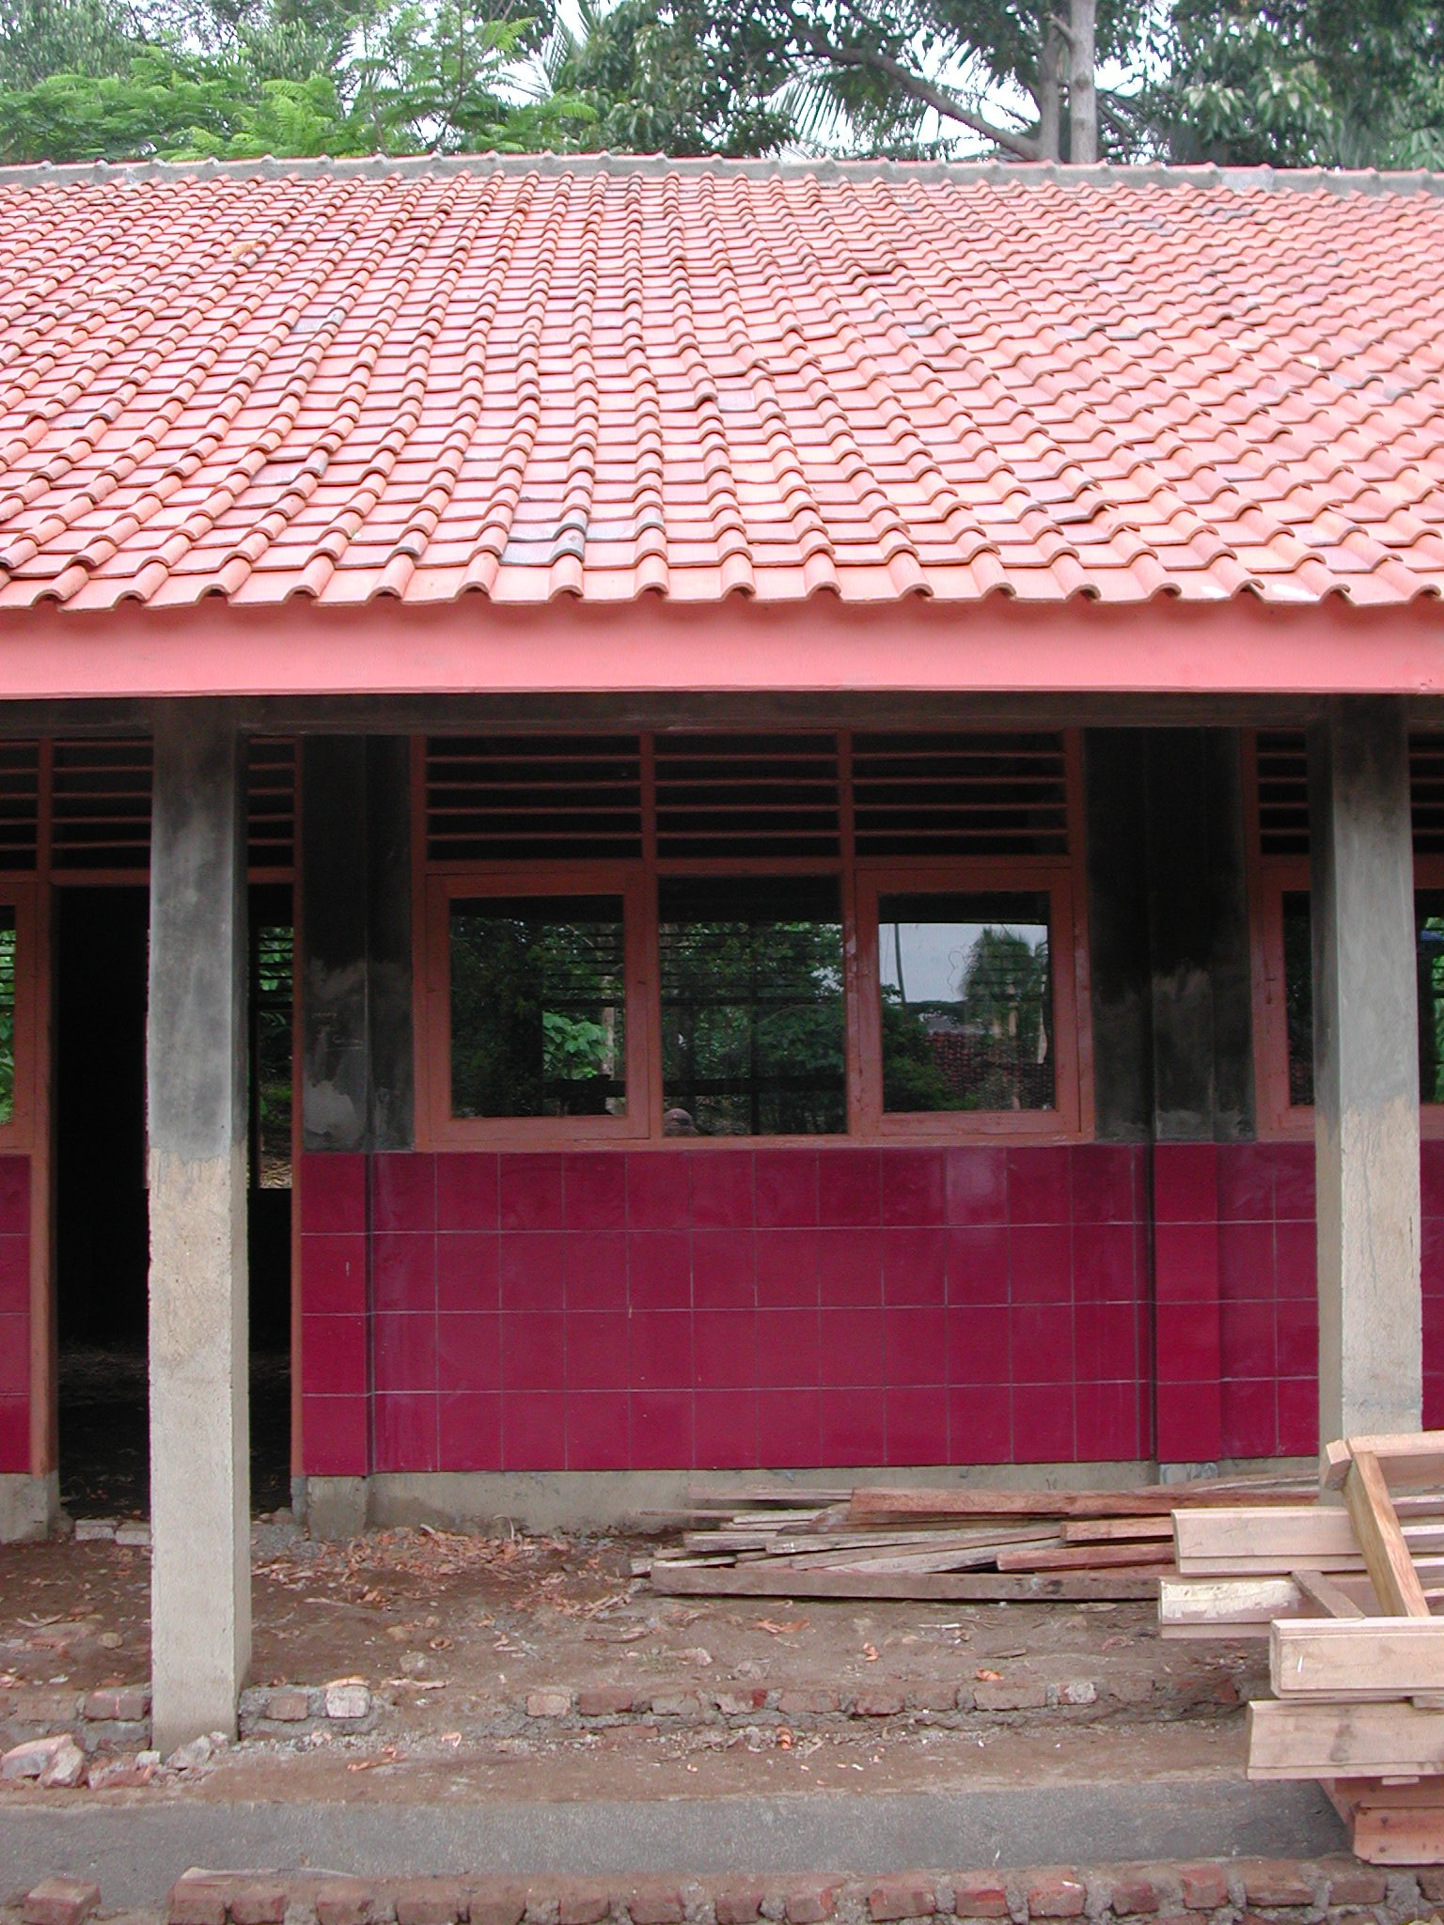

Plate 6: SDN Kerangi 1 showing renovated classrooms

The SCA has visited five times but has not visited the site for three weeks and has not made much contribution. He prepared the budget and the drawings but made no technical comments on the work. The original proposal was to renovate only one classroom and one toilet. However the community have donated materials and labour in order to increase the amount of renovation work possible.

The total budget was Rp80million with Rp63.5million for the classroom renovations, toilets and water supply, Rp3million for books, Rp10.5million for furniture and Rp3million for administration. The work school committee is not however buying the books and furniture but is spending the money on the renovations. The community has also contributed approximately Rp84.5million in materials and labour.
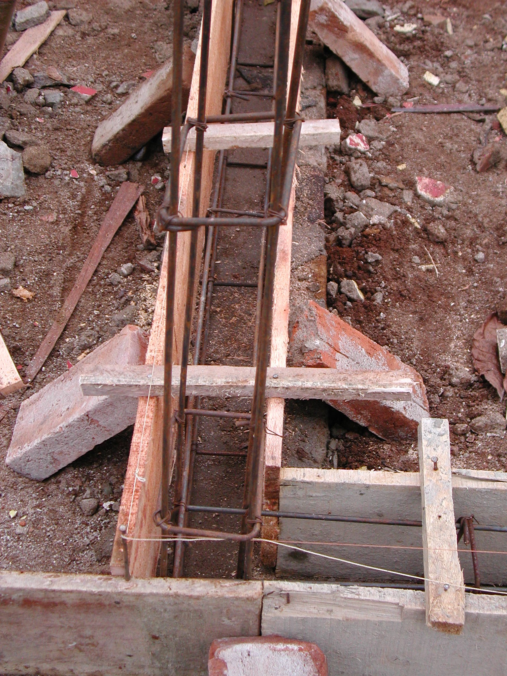

Plate 7: SDN Kerangi 1 showing 6mm reinforcement to office building

  - SDN Banjar Negara 1, Kecamatan Cisata: This is an existing primary school on a very small site in a rural village. The school has 214 pupils altogether (128 on this site) and 8 teachers. There is a 2-classroom and office building that is being renovated that is right on the road at the front with houses very close to the building behind. A small toilet building will be constructed at the end the site. There is also another 3-classroom building that is in a very bad state of disrepair approximately 200 metres away. The school does not have an electricity supply but will be connected to the village water supply from a spring.

Some walls to the renovated building are being retained and there are new columns and beams to the veranda. The building has a new clay tiled roof, new roof trusses, new fibre-cement ceilings, new ceramic tiled floors and new timber windows and panel doors. The building is quite well constructed with good roof trusses and very good windows and doors. The veranda columns however are only 18 x 11 cms and have individual foundations and the concrete is very poor generally. The reinforcement to columns and beams is 8mm.
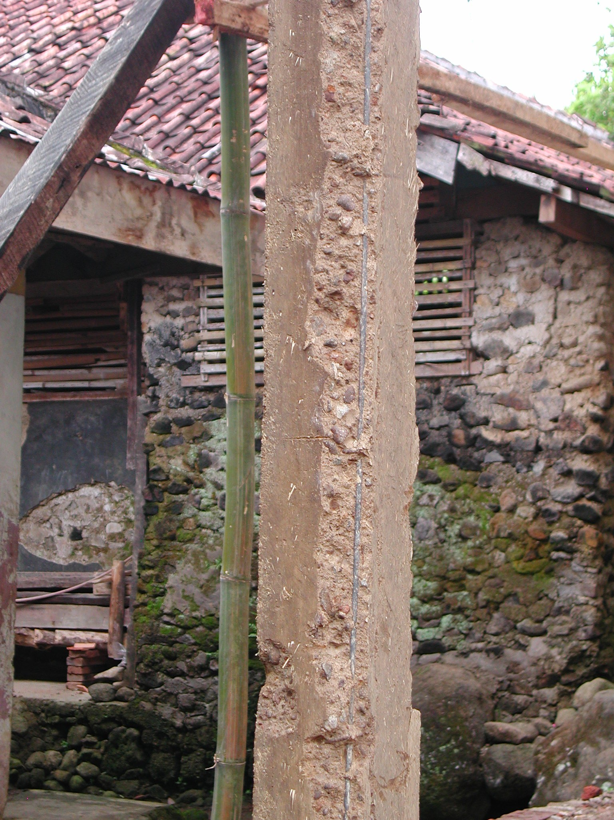

Plate 8: SDN Banjar Negara 1 showing very poor concrete

The Kepala Pelaksana is a local builder. There are five workers who are paid Rp20,000 a day, six craftsmen paid Rp25,000 a day and a foreman paid Rp30,000 a day. The work started on 10th May and should be finished by the end of July 2003.

The SCA has visited six times. He prepared the budget and the drawings and has assisted the committee with the administration of the work and the selection of materials but has made no comments on the size of reinforcement or the quality of the concrete. Again, it would have probably been more sensible to have renovated both buildings to a lower standard than the one that has been renovated with new roofs and floors and whatever other elements that could have been afforded. This would have given all pupils in the school better classrooms rather than only half the pupils as at present.

The total budget was Rp80million with Rp77million for the classroom renovations, toilets and water supply and Rp3million for administration.

