INDONESIA: JUNIOR SECONDARY EDUCATION PROJECTS
LOANS 4042-IND, 4062-IND, 4095-IND
CONSTRUCTION SPECIALIST’S REPORT
NIGEL WAKEHAM JUNE 2004

TABLE OF CONTENTS
A. Introduction 3
1. General 3
2. Construction Specialist’s Terms of Reference 3
3. Meetings 3
4. Visits 3
B. Summary of Report 3
1. Assessment of the Projects’ Construction Activities 3
2. November 1998 Mission 4
3. March 1999 Mission 4
4. October 1999 Mission 4
5. March 2003 Mission 5
6. December 2003 Mission 6
7. June 2004 Mission 6
8. Conclusions 6
9. Issues Raised by June 2004 School Visits 7
9.2.1 Design and Specification Issues 7
9.2.2 Construction Issues 9
9.2.3 Supervision Issues 10
9.2.4 Maintenance Issues 10

ANNEXES
Annex 1: Extract from Construction Specialist’s Report: November 1998 11
Annex 2: Extract from Construction Specialist’s Report: March 1999 15
Annex 3: Extract from Construction Specialist’s Report: October 1999 25
Annex 4: Extract from Construction Specialist’s Report: April 2003 30
Annex 5: Extract from Construction Specialist’s Report: December 2003 36
Annex 6: Report on Visit to Project Schools in Lampung Province 40
Annex 7: Report on Visit to Project Schools in South Sumatra Province 61

A. Introduction
1. General
1.1 The Construction Specialist visited Indonesia from June 12th to June 19th 2004 as part of the Implementation Completion Report process of the Junior Secondary Education Projects.
1.2 This report should be read in conjunction with previous reports on the construction aspects of the Junior Secondary Education Projects written by the Construction Specialist and dated November 1998, March 1999, October 1999, April 2003 and December 2003 (see abstracts of reports in Annex 1, 2, 3, 4 and 5).
2. Construction Specialist’s Terms of Reference
2.1 The Construction Specialist’s terms of reference for the mission were to:
- Draft a comprehensive, focused assessment of the projects’ construction activities (both by contractors and by communities).
- Aspects to be assessed were the comparative quality and cost-effectiveness of the two approaches, the quality of the maintenance of the facilities and the capacity of the schools, district governments and private foundations to carry out construction activities.
- In addition, the consultant was also to record the enrolment rates (both male and female) and the number and qualifications of teachers at school visited. In this regard, the consultant was to draw heavily on available reports (by consultants and CPCU/PPIUs) and to check current conditions at one or two sites in Sumatera.
2.2 In carrying out his tasks, the consultant was to co-ordinate his work with Ms Titie Hadiyatie and Ms Susiana Iskanda.
3. Meetings
3.1 Meetings were held with Ms Susiana Iskanda, the World Bank Task Team Leader, Ms Titie Hadiyatie, a Consultant to the World Bank, the Procurement Consultant and the Project Manager of the PPIU in Lampung Province, the Procurement Consultant of the PPIU in South Sumatra Province and the Manager of Construction Unit of the CPCU in Jakarta.
4. Visits
4.1 Visits were made to schools constructed under the junior secondary education projects both by contractors and school committees in Lampung and South Sumatra Province.
4.2 Details of the school visits are given in Annexes 6 and 7.
B. Summary of Report
1. Assessment of the Projects’ Construction Activities
1.1 As this report will form part of the Implementation Completion Report for the Junior Secondary Education Report, it summarises the issues raised during previous missions both during the phase when contractors were being used for construction of school facilities and during the later phase when school committees were used for construction of school facilities.
1.2 During the initial phases of the projects, contractors were used for the construction of project schools with very little if any supervision from either the World Bank or the CPCU based in Jakarta. Construction was handled by the provincial PPIUs who commissioned local firms of consultants to design and supervise new schools which were then constructed by local contractors. Supervision of both consultants and contractors was carried out by procurement consultants in the PPIUs. There were no civil works consultants in the CPCU to monitor the work of either the provincial consultants or the contractors.
1.3 In 1998, it became apparent that this approach to the construction of new schools was not working. The CPCU started to hear stories of badly constructed schools and consultants not carrying out their duties properly.
2. November 1998 Mission:
2.1 In November 1998, the Construction Consultant was asked, together with an architect hired by the CPCU, to carry out a review of project schools in East Java, Jambi and Central Java Provinces. This review raised a number of issues the most important of which were the very poor quality of a large number of the schools visited and the inadequacy of the supervision of the work by the provincial PPIUs and their consultants (see Annex 3).
2.2 Two major recommendations were made: 1) that a survey should be carried out of all schools so far constructed to establish the extent of the construction problems and 2) that both the CPCU and the PPIUs set up properly staffed technical units to monitor the work of both the consultants and the contractors.
3. March 1999 Mission:
3.1 In March 1999, the Construction Consultant made a further visit. A survey had by then been carried out of all the schools so far built by the project and this showed that 7% had structural faults, 44% had inadequate finishes, many schools were unfinished and there were problems at 14% of the schools due to the selection of unsuitable sites.
3.2 The problems seen were caused by bad workmanship, poor quality materials and ineffective or negligent supervision. These were compounded by the use of fixed-price contracts in a time of high inflation which meant that contractors were unlikely to make a profit or even break even if they kept to the terms of their contract.
3.3 The results of all this were that buildings were badly built and finished and some were in danger from landslides, subsidence, water-logging or actual collapse.
3.4 As a result of this mission, a revised schedule of accommodation to be used as the basis for the new designs for junior secondary schools was agreed with the senior consultant architect who was running the Construction Unit that had been set up in the CPCU. It was also agreed that standard designs for schools would in future be used in each province and that the CPCU would check working drawings and tender documents for all new schools before they were issued. Detailed criteria were also agreed for new school sites in order to avoid some of the problems caused previously by the use of unsuitable sites.
4. October 1999 Mission:
4.1 In October 1999, the Construction Consultant again visited and many of the issues raised during previous visits were still a reality. Remedial work was still outstanding at many schools and some schools were still in a dangerous condition. It was recommended that at least one school should be closed as it was in such a dangerous condition.
4.2 Teachers’ quarters and student dormitories had previously been built under the JSE projects by communities using block grants and under the World Bank Basic Education Projects whole schools were being built managed by school committees. Both these approaches had been reasonably successful and as the use of contractors had been so generally disastrous, a decision was taken that the junior school school construction programme should in future be undertaken by school committees.
5. March 2003 Mission:
5.1 The next visit of the Construction Consultant did not take place until March 2003 when he visited Central Java, Lampung, Jambi and West Sumatra Provinces. By this time school committees in all provinces had been managing the construction of new schools for several years. Each province had standard school designs prepared by local civil works consultants and these or other consultants were supposed to assist the school committees manage the construction of the schools by providing them with a set of site and working drawings for the buildings (having first carried out a site survey), a schedule of materials necessary to construct the buildings, an estimate of cost and a Construction Manager who would be based on site and would assist the committee in managing the works. It should have been understood by all parties that school committees were unlikely to have the experience necessary to construct a school in the way a contractor would and would therefore require a lot of technical assistance in managing the construction
5.2 The main issues raised during the mission (when schools being constructed by school committees were inspected) concerned the performance of the civil works consultants and the quality of construction which again was related to the performance of the consultants. The consultants had performed better in some provinces than in others but there were some problems in all provinces.
5.3 It seemed that the consultants were still working with the school committees as though they were contractors and were not giving them the support that was necessary. In many cases site surveys had not been carried out and the drawing and details provided were generally inadequate and did not take into account site conditions; the Construction Managers were generally young and inexperienced and did not have sufficient authority to work effectively with the committees; there were no detailed schedules of materials or cost estimates and the lack of site surveys and details had lead in many cases to inaccurate budgets and there was therefore a danger of cost-overruns; supervision and management by the Construction Managers was generally poor and the committees were in many cases not following the project guidelines.
5.4 This lack of adequate supervision and management by the consultants had led directly to a number of construction issues: concrete mixes and concrete-work (particularly columns) was very poor on many sites; reinforcement that was smaller than that specified had been used on many sites; foundations under columns were in many cases inadequate; poor quality timber was being used on some sites and trusses were being badly made; brick-work was being very badly laid on some sites; top-soil had not been properly stripped off on many sites and floors were being constructed on top of vegetable soil and on many sites, wells had been constructed much too close to septic tanks.
5.5 It was noted however that the school committees and their technical teams were, within their limitations, managing the work quite well and were very enthusiastic about this approach to the construction of schools. In particular the schools were in the main being finished to a better standard and the committees were trying to use better quality materials. The cost of schools constructed by school committees was also said to be lower than that of schools constructed by contractors. If the consultants and particularly the Construction Managers had been carrying out their duties properly and effectively most if not all of the problems noted above could have been avoided.
6. December 2003 Mission:
6.1 In December 2003, the Construction Advisor visited West Nusa Tenggara and South Sulawesi Provinces. All the problems noted during the March 2003 Mission were again observed during this mission. The problems were particularly bad in South Sulawesi Province.
7. June 2004 Mission:
7.1 In June 2004, the Construction Advisor visited Lampung and South Sumatra Provinces. Schools constructed by contractors in the early stages of the project were visited together with schools more recently constructed by school committees.
7.2 Detailed issues raised by the visits are set out in Paragraph 2 below but they all stem from four major factors: 1) problems caused by poor initial design or specification (ie by the consultants); 2) problems caused by poor construction whether by contractor or school committees; 3) problems caused by poor supervision and management by the consultants during construction and 4) problems caused by poor maintenance or the complete lack of maintenance.
8. Conclusions
8.1 Although there are still some problems, there has been a great improvement in the quality of the schools being constructed since the switch was made from construction by contractors to construction by school committees.
8.2 The problems seen in all three missions carried out since school committees took over the management of the work have nearly all been caused by the poor performance of the civil works consultants both in the preparation of the documents required by the school committees to carry out the work and in the actual management and supervision of the work by the consultants.
8.3 The school committees seem on the main to be enthusiastic and capable at a non-technical level (though there were some exceptions seen mainly in South Sulawesi Province) of carrying out the work and the cost of the work carried out by school committees seems to be lower than that carried out by contractors. The finishes in schools built by committees also seem to be better than at those built by contractors.
8.4 The real problems are those caused by poor documentation, poor management and poor supervision by the consultants. The consultants everywhere do not seem to have understood that using school committees to manage construction is different to using contractors and that different documentation and more technical assistance is required.
8.5 If this approach is to be used in future (and the government seems very keen to do this) then a different approach to the provision of technical assistance will be required. There is no doubt that school committees will require technical assistance because these are quite large and expensive projects and the committees will not be able to manage them by themselves. However, the provision of technical assistance through large contracts at the provincial level is not at present working.
8.6 A better approach might be for the PPIUs to hire individual, well qualified and experienced individual consultants, one for each school. They would then be better able to control the quality of the individual consultants than if they use a single firm. These consultants would require training in the provision of technical assistance to school committees and should also be provided with a construction hand-book similar to the one developed for the Basic Education Projects. This hand-book (which should be supplied to the school committees also) should set out the steps required in constructing the school buildings together with standard drawings, specifications and schedules of materials. It should be noted here that the Construction Unit in the CPCU has already developed a standard set of designs and drawings for new schools.
8.7 The PPIUs would also have to hire one or more civil works consultants to monitor the work of the individual consultants on the sites to ensure that they are carrying out their duties properly.
8.8 This approach should be cheaper than using large firms, should give the PPIUs more control over the consultants and should provide the school committees with a better standard of technical assistance and therefore improve the quality of the completed schools.
9. Issues raised by June 2004 school visits
9.1 This report raises a number of issues identified during the school visits to Lampung and South Sumatra Provinces and makes recommendations for dealing with these specific issues.
9.2 Similar issues were raised at the schools visited in both provinces and they all stem from four major factors: 1) problems caused by poor initial design or specification; 2) problems caused by the initial construction, whether by contractor or school committee; 3) problems caused by poor supervision during construction and 4) problems caused by poor maintenance (or the lack of maintenance).
9.2.1 Design and Specification Issues: A number of design and specification issues were raised by the school visits and these include:
- Inadequate artificial lighting to classrooms: Classrooms only have 4 tungsten light fittings which are inadequate to light the classrooms properly and are a waste of money.
Recommendation: Classrooms should either be properly lit using fluorescent fittings or (if the school buildings will not be used at night) not have any light fittings at all which would save a lot of money.
- Poor quality water pipes and fittings: Rigid plastic pipes are used for all water reticulation both inside and outside of buildings and these are very liable to breakage and very poor quality taps are also generally used both of which lead to ongoing maintenance problems.
Recommendations: Galvanised steel pipes and better quality taps should be specified that will last longer and cause fewer maintenance problems.
- Poor orientation of buildings and lack of sun protection: On all sites, some buildings are orientated east/west which, together with the small roof overhangs and high roofs, allows sun penetration into rooms in either the morning or afternoon which makes rooms very uncomfortable for students and teachers to use.
Recommendations: In the tropics ALL rooms should be orientated north/south of at all possible and large roof overhangs should protect windows from the sun. If veranda roofs are lowered this will also help to provide better protection from driving rain.
- Poor quality doors and hardware: At most schools the poor quality hardware used breaks quickly and has to be replaced. At some schools poor quality doors have been quickly broken.
Recommendations: Better quality (and simpler) hardware would last longer and cause less maintenance problems. Particular attention should also be paid to the specification of toilet doors. These should not be hollow-core flush doors as they will quickly break or rot.
- Glazed ceramic tiles to verandas: The use of glazed ceramic tiles on veranda floors is very dangerous as they get slippery when wet and can cause accidents.
Recommendations: If ceramic tiles must be used then non-slip ones should be specified.
- Wells placed close to septic tanks: At many schools wells have been constructed close to toilets because it is then easier to obtain water for the toilets. Unfortunately this can cause contamination of the well water.
Recommendations: Indonesian regulations state that wells should be at least 15 metres from septic tanks or soakaways but a better figure, especially on wet sites, would be 30 metres and it is suggested that in future school construction this dimension is used. It would also be a good idea if wells were covered to stop pollution from the top and any buckets that are used to obtain water should be round-bottomed so that they cannot be placed on the ground and get contaminated. It also is suggested that as a matter of priority, all school wells are tested for contamination and those that are contaminated should be closed and not used.
- Design of roofs to links between buildings: The design of many of the links between buildings seen at the schools visited is over-complicated with roof timbers that will be prone to water damage and rot causing maintenance problems.
Recommendations: Roof links should be kept simple and as maintenance-free as possible.
- Design of walls and lintels: At most schools wall panels are too large for the thickness of the walls and this is bound to cause cracking. Further cracking is also caused by not providing RC lintels over window and door openings.
Recommendations: RC lintels should always be provided over window and door openings (this also helps if windows or doors have to be changed at a later date) and sizes of wall panels should reduced if possible by providing RC columns at closer centres.
- Roofs to Mushollas: The roofs to most mushollas leak very badly.
Recommendations: In future the roof designs for mushollas should be simplified if possible to avoid roof leaks and any future maintenance problems.
- Fume cupboards: The fume cupboards seen in schools in South Sumatra Province will not work as presently designed and are obviously not used.
Recommendations: In future fume cupboards should be omitted from the laboratories or a new design produced that will actually work as intended.
9.2.2 Construction Issues: A number of construction issues were raised by the school visits and these include:
- Poor quality screed to floors: At some schools with screed floors, the screed is much too thin and is breaking up causing maintenance problems.
Recommendations: Screed floors are perfectly satisfactory if the base is properly made and compacted and if the screed is of an adequate thickness (at least 25mm).
- Poor quality external paving: The external paving at most schools is also too thin and badly laid causing it to break up. At some schools the paving has been laid flat with no falls to carry water away from the buildings. Both these faults will cause maintenance problems.
Recommendations: External paving should be constructed of concrete (1:3:6 mix) rather than screed and should be laid to falls away from the buildings.
- Storm drains: At several schools, the storm drains do not drain properly and could become breeding places for mosquitoes.
Recommendations: All drains should be laid to adequate falls so that they carry away the water and do not pond.
- SMPN 7 Babat Toman, South Sumatra Province: There are concerns about the size and height of the veranda columns at this school.
Recommendations: The consultants should urgently check the slenderness ratio and the reinforcement to these columns to ensure that they are adequate. If they are not then the consultants should propose remedial measures.
- SLTPN 10 Babat Toman, South Sumatra Province: There are serious problems with the floors at this school probably caused by the contractor back-filling on top of top-soil containing vegetable matter. The floors are now subsiding as the vegetable matter rots.
Recommendations: All floors will eventually have to be taken up, the vegetable soil removed, the floor area properly back-filled and compacted and new floors laid. This will be a very expensive process which could have been avoided if the floors had been properly constructed in the first place.
- SMPN 6 Gunung Megang, South Sumatra Province: There is great concern over the structural strength of the columns to the classroom walls at this school which have been reduced to the thickness of the walls with reinforcement of an unknown size.
Recommendations: The consultants should, as a matter of urgency, check the size of and reinforcement to, these columns and propose remedial measures if either are inadequate.
9.2.3 Supervision Issues: Most of the issues raised under ‘Construction Issues’ above could have been avoided if the construction had been properly supervised by the consultants.
Recommendations: In future all consulting firms should be made more aware of their responsibilities in terms of supervision, should be made to carry out their duties properly and provide properly qualified and experienced site staff.
9.2.4 Maintenance Issues: There are maintenance issues at all of the schools visited particularly with regard to roof leaks and floor finishes. Many of these issues are to do with the initial poor quality of construction but this is compounded by the inadequate funding of school maintenance. There is also a systemic problem in that many school head teachers do not seem to be prepared to take any responsibility for maintaining their schools. The project was supposed to carry out training of school staff in maintenance but if it happened, this does not seem to have been very effective.

Recommendations: It is suggested that a maintenance handbook (similar to that prepared for the Basic Education Projects) is prepared for all junior secondary schools by the Ministry of Education and that training in the need for maintenance and in maintenance techniques is given to a member of staff at each school who is designated to be responsible for organising the maintenance of the school. The government should also ensure that all schools have adequate funds every year to maintain their schools. It is much cheaper to maintain schools than to allow them to deteriorate to such an extent that they require re-building!
At SMPN 4 Indralaya, South Sumatra Province many of the roof timbers require urgent maintenance as they are rotting especially at junctions along the verandas and to the laboratory. Trees at this school that are very close to buildings should also be cut back as soon as possible.
At SLTPN 10 Babat Toman, South Sumatra Province the school should move an electric pump out of the toilets as soon as possible as it is very dangerous.

ANNEX 1: EXTRACT FROM CONSTRUCTION SPECIALIST’S REPORT: NOVEMBER 1998
3. Issues and Recommendations
3.1 Quality of School Design and Construction
3.1.1 The five schools visited in East Java Province have serious structural and design problems (see Annex 1). These have been caused by a number of factors including the way the sites have been acquired, the design and construction of the buildings, the supervision of construction and the way construction has been implemented and monitored. The six schools visited in Jambi Province (see Annex 2) are on the whole better built but still have problems caused mainly by faulty construction and inadequate supervision. The three schools visited in Central Java Province (see Annex 3) are on the whole well built but could have had better and closer supervision over some details.
3.1.2 Recommendations: The CPCU should as soon as possible employ reputable and properly qualified civil and/or structural engineers to carry out surveys and produce recommendations and costings for remedial work for all the schools that appear to have structural problems and for completing those schools that are not finished. Either revised prices should be agreed with the contractors to complete unfinished works or new contracts should be let. Ways should be found if possible to ensure that contractors put right defective work. Schools or parts of schools that have serious structural defects should not be used.
The outstanding or defective work should be completed or put right as soon as possible to avoid any further damage to buildings. It would probably be better to use funds from this year’s budgets to complete existing schools rather than starting new ones. It should be borne in mind that it is not good practice to start new buildings in the middle of the rainy season (which will not end until January) and any buildings started now will have to be completed by February 1999 which does not leave much time for good construction.
The CPCU should also look urgently at the following issues that have affected the construction of these and other schools:
3.2 Land Acquisition
3.2.1 It is obvious from the sites seen in East Java Province that proper procedures for site selection are not being followed and sites are not being checked after selection to ensure that they are suitable for school construction. Sites that are too small, badly situated, too steep, etc for school building, are being selected with the result that construction costs are increased and in some cases dangerous buildings erected. The sites in Jambi Province were donated by the communities and are more suitable for school construction as are those in Central Java Province.
3.2.2 When sites are purchased or donated, proper site and soil surveys are not being carried out with the result that school designers do not have the right information on which to base their designs. One reason for this is the way that the funding for site acquisition, design and construction at present operates. All monies for the design and construction of a school have to be expended in one fiscal year and there can be no carry-over to the next year. As funds do not usually become available until August, September or even October and construction has to be complete and funds expended by the following March this does not leave sufficient time for the process of survey, design and construction to be carried out properly.
3.2.3 No adequate site drawings were seen for any site. There were no proper surveys or details of foundations as they should be built rather than typical ones and no details of site works, retaining walls, etc.
3.2.4 Recommendation: Sites should be selected, checked, acquired and properly surveyed the year before construction is due to start. It should also be possible to carry over funds for construction from one year to the next in order that building work can be completed properly.

3.3 School Design
3.3.1 Although there is a standard schedule of accommodation for Junior Secondary Schools prepared by the Ministry of Education, there are no standard designs or working drawings and a great deal of money is being wasted on paying consultants to prepare fresh designs for each new school.
3.3.2 The designs that have been produced in East Java Province (and to some extent in Central Java Province) are much too complicated for construction in remote rural areas by small contractors. The level of accommodation provided could also be simplified and reduced. Laboratories as presently being built are rarely if ever used as intended. The author has yet to visit a rural junior secondary school that has running water and a Laboratory that is being used as it was intended. It would be better therefore to provide a Multi-purpose Room without fixed benches and sinks which could be used for a variety of purposes. Recommendations for revised designs were given in the Implementation Specialist’s reports on West Java (March 1998) and Sumatra (May 1998).
3.3.3 Similarly, the flush toilets provided rarely work because there is usually no running water. Generators and electric water pumps if provided usually break down after a while through lack of maintenance. It would be much better therefore to provide either pour-flush privies or VIP latrines away from the school buildings together with covered wells with either buckets or hand-pumps for the supply of water.
3.3.4 Money could be saved by not providing electricity to rural schools. They operate only during the day and if they do not have laboratories there is no real need for an electricity supply. There are arguments for providing electricity if the schools are used for two sessions or for SLTP Terbuka, however, if the only way to provide electricity to rural schools is through the provision of generators, these should not be provided as they are not properly maintained and soon break down.
3.3.5 It seems that funding for site works is not being included in the budgets for school construction which is causing enormous problems.
3.3.6 There is also at present no meaningful defects liability period. At completion, the contractor hands over the building to the client and it stands empty for one month after which time the contractor is paid in full and has no further responsibility (if for instance the buildings are completed during the dry season and the roofs start leaking when the rains start, the contractor has no responsibility for repairing the leaks). In many countries there is a 12 month defects liability period after construction is completed during which the building is used. 2½% of the contract sum is retained until the end of this period when the buildings are inspected and the contractor then puts right any latent defects that have appeared (he does not put right any damage caused by the client in using the buildings). This system would enable the Ministry of Education to get defective work rectified which at present cannot be done.
3.3.7 Recommendations: The CPCU should have standard designs and working drawings prepared for junior secondary schools that are based upon a simplified schedule of accommodation, use very basic construction techniques and can be used with a minimum of alteration in all Provinces. The issue of supplying rural schools with electricity supplies should be critically examined but electric water pumps should not be provided. Adequate funding for site works should be included in the budget once the site drawings have been prepared. A meaningful defects liability period should be introduced into the contract.
3.4 Construction Supervision
3.4.1 It was obvious from most of the schools inspected that little if any proper supervision of school construction is happening. Small local contractors are being given inadequate drawings and are expected to put up buildings with little or no assistance from properly qualified supervisors. Generally, supervisors seem to be technical secondary school graduates and, given the standard of construction drawings presently being prepared, do not have the expertise to supervise and assist the contractors in constructing the buildings properly. From the evidence seen and heard it seems unlikely that senior representatives of either the design or supervision consultants are visiting sites regularly if at all.
3.4.2 Recommendations: The Provincial Project Implementation Units should select consultants for the implementation phase of the project from a suitable list of competent, qualified architectural consultants with permanent offices and qualified staff. Engineers should also be employed to carry out any structural design work. Consultants for the implementation of projects should be selected the year before construction is due to start and site layouts, site works drawings, foundation designs, all necessary structural and civil works drawings and any modifications required for a particular school site should then be prepared giving adequate time the following year for construction (see Annex 4 for details).
3.5. Project Monitoring and Evaluation
3.5.1 The CPCU in Jakarta and the PPIUs in East Java and Jambi Provinces (the situation seems better in Central Java Province) have not been carrying out adequate monitoring and evaluation of the construction work and do not have the technical staff to do so. It also seems that neither the CPCU in Jakarta nor the PPIUs have taken the implications of the fall in the value of the rupiah and the subsequent escalation in the cost of building materials seriously. It seems at present that it is impossible to change a contract sum once a contract has been let. In most countries there are clauses in the contract that allow for inflation, for costs that cannot be properly estimated at the time of tender or for extra work that has not been foreseen. Contractors cannot be expected to complete building projects if they are not being properly reimbursed.
3.5.2 Recommendations: The CPCU in Jakarta should set up a technical unit headed by a properly qualified and experienced architect to prepare the brief and oversee the preparation of revised designs and working drawings for junior secondary schools. The architect should also prepare and/or check building contracts, bills of quantities, schedules of materials, etc, monitor Project costs and the implementation of the Project by the PPIUs and visit Provinces and sites regularly. The Ministry should set up similar technical units headed by a suitably qualified and experienced architect in each Province to oversee the employment of consultants, the preparation of site drawings, the letting of contracts and the supervision of the work. When construction work is in progress, this architect should spend most of his/her time visiting sites and ensuring that construction work is proceeding properly, within budget, etc and agreeing any necessary changes with the supervising consultants and contractors. Ways should be found to allow changes to contract sums especially in times of rapid price escalation.

ANNEX 2: EXTRACT FROM CONSTRUCTION SPECIALIST’S REPORT:
MARCH 1999
3. Issues and Recommendations
A. 1997/1998 School Construction Programme
1. School Construction Quality
1.1 Issues
1.1.1 The main issue, highlighted by visits and reports from the Implementation Specialist and the independent consultants retained by both the World Bank and MOEC, is the poor quality of construction of many of the schools built in 1997/98. Although most of the schools built are structurally sound, 12 schools (7%) are deemed to have structural faults and 76 schools (44%) are deemed to have inadequate finishes. Many school buildings are also unfinished (see November 1998 report and Annexes 1 & 2).
1.1.2 These faults are the result of bad workmanship on the part of contractors, poor quality materials and inadequate, incompetent or negligent supervision on the part of both the contractors and the Supervising Consultants.
1.1.3 The rapid rise in the price of building materials during the construction period and the fact that the contracts were ‘fixed-price, lump sum’ contracts also contributed to the poor quality of construction. Contractors were unable to gain recompense for the rapidly rising cost of materials and therefore reduced the quality of materials and construction in general.
1.1.4 The faults have been compounded at 25 schools (14%) by unsuitable sites or locations. Sites and buildings are in danger from landslides, subsidence, water-logging or actual collapse.
1.1.5 The schools have been signed off as complete and satisfactory by the Supervising Consultants, the Provincial Project Implementation Units (PPIUs) and presumably by PU Cipta Karya and the contractors have been paid in full. It is very doubtful therefore if it will be possible to make any of the contractors complete outstanding work or rectify any defects at their own expense.
1.1.6 As stated above there has been little meaningful supervision of construction by the Supervising Consultants and there has also been little supervision of the Consultants by the PPIUs or monitoring of construction by the CPCU in Jakarta because of a lack of technical expertise.
1.2 Recommendations
1.2.1 The PPIUs will have to enter into new contracts with competent contractors, selected according to World Bank guidelines, to make good defective and complete outstanding, work. There is now no time to do this in the present (1998/99) financial year but schedules of work and contracts should be organised as soon as possible in order that work can start as soon as the DIP becomes available in the 1999/2000 financial year.
1.2.2 The PPIUs will also have to enter into new contracts with competent Supervising Consultants to supervise the completion works.
1.2.3 On no account should the same contractors or consultants who carried out or supervised the original work be retained for the completion works at those schools that have major structural or other defects.
1.2.4 World Bank funds should not be used for rectifying defects or completing outstanding work contained in the original contracts. GOI will have to fund this work out of its own resources.
1.2.5 A Construction Unit should be set up in the CPCU, headed by an architect, to supervise and monitor in future the production of design, working drawings and tender documents, the progress of construction work and the work of the PPIUs and Consultants (for details of the Construction Unit see Annex 3).

2. Site Works at Project Schools
2.1 Issues
2.1.1 Nearly all of the schools constructed in 1997/98 are incomplete due to the omission in the drawings, tender documents and contracts of the majority of the site works. The only site works included were septic tanks and soakaways, wells and in some instances water tanks and towers, flag poles and bicycle sheds. Even the cost of the verandas to the buildings was not included in the majority of cases.
2.1.2 In no case were adequate site works drawings prepared by the Planning Consultants. Even though, due to a misunderstanding of the BAPPENAS guidelines, no funding was included in the original contracts for site works, the Design Consultants should have prepared drawings for these works as it is obvious that the schools could not be completed or in many cases safely used, without them.
2.1.3 The omission of the site works particularly retaining walls, adequate drainage and paths and steps, has rendered many of the sites and buildings unsafe. Additionally, because no funds for site works were included in the contracts, contractors have generally reduced the specification of the work to cover the cost of those site works that they have carried out.
2.2 Recommendations
2.2.1 The PPIUs will have to enter into new contracts with competent Planning Consultants to prepare working drawings, bills of quantities and tender documents for the outstanding site works. This work should be completed in the present (1998/99) financial year in order that the work can start as soon as possible in the next financial year.
2.2.2 All drawings, bills of quantities and tender documents should be submitted to the Construction Unit, CPCU for approval and possible revision before being submitted to the World Bank for `No Objection Letters’.
2.2.3 The PPIUs will have to enter into new contracts with competent contractors, selected according to World Bank guidelines, to carry out the outstanding site works as soon as the 1999/2000 DIP becomes available. This work should be packaged with the completion works mentioned in paragraph 1.2.1 above.
2.2.4 On no account should the same contractors or consultants who carried out the original work be retained for the completion of the site works at those sites that have major structural or other defects.
2.2.5 World Bank funds can be used for the completion of site works as they were not included in the original contracts.
3. School Services and Utilities
3.1 Issues
3.1.1 Very few schools constructed in 1997/98 have adequate clean water supplies although some have wells, tanks and electric pumps. Where there are wells, they are usually not deep enough to contain water during the dry season. In many cases where there are water pumps there is no electricity supply and in at least one case the well is too deep for the existing pump to raise the water to ground level let alone pump it up to the high level water tank. At many sites where there are wells, they have been constructed too close to septic tanks and soakaways and there is a real danger of cross-infection if the wells are used for drinking water. Water reticulation systems have been installed on all sites but in most cases will never be used.
3.1.2 Most schools have electrical installations in the buildings but few have main connections. At those that do, it is doubtful whether the schools have sufficient funds to pay for electricity to be used in all rooms. It should be noted that at one school visited the only functioning electric points were two external lights and at another the Head Teacher stated that she could only afford to light two offices and this was funded by BP3. Some installations seen were at best inadequate and at least one was positively unsafe.
3.1.3 Many toilet blocks in the new schools are too large and too complicated and very few of them have toilets that actually work.
3.1.4 All schools have squat toilets connected to septic tanks and soakaways. All Planning Consultants seem to have used their own design for both the septic tanks and the soakaways and at least one septic tank inspected was very badly built.
3.2 Recommendations
3.2.1 All schools constructed in 1997/98 should have an adequate clean water supply provided. This will usually mean completing an existing well, providing an additional well or providing rainwater storage tanks. Where wells have been built closer than 15 metres to a septic tank or soakaway, these should only be used for flushing toilets and at least one new well should be constructed for the supply of drinking water. Appropriate designs for wells should be obtained by the Construction Unit, CPCU and these should be included in the Site Works Contracts mentioned in paragraph 2.2.2 above. No electric pumps or additional water tanks or towers should be provided.
3.2.2 All existing electrical installations should be checked and made safe if necessary. The PPIUs should arrange this work as soon as possible. No electrical connections to main supplies should be made over a distance greater than 100 metres and no electricity generators should be supplied.
3.2.3 All septic tanks should be checked to ensure that they are properly built.
B. 1999/2000 (1998/1999) School Construction Programme
1. General
1.1 Sites have been selected and working drawings and tender documents have been prepared for the schools that were originally going to be built in the 1998/99 financial year. Because of the financial crisis in 1998 and the problems uncovered in the 1997/98 school construction programme, these schools were not built and it is now too late to build them as only just over one month of the financial year remains.
1.2 A much smaller programme of school construction will now take place in 1999/2000 if government funds are made available, using only some of the sites selected and documents prepared for 1998/99.
2. Site Selection
2.1 Issues
2.1.1 Sites for schools for what was originally going to be the 1998/99 school construction programme but which will now be developed in 1999/2000 have been selected by the provincial authorities. Many of these sites are very large, some up to 20,000m², which will make site development extremely expensive.
2.1.2 From the selection of drawings for new schools that have been seen, it would appear that accurate topographical surveys have not been prepared for most sites and soil tests have not been carried out for some difficult sites.
2.2 Recommendations
2.2.1 The sites selected for next year’s construction must be carefully checked by the PPIUs for the suitability of their location and their suitability for construction. Steeply sloping or excessively wet sites should be rejected if at all possible. If there is any doubt, the sites should be checked by the Construction Unit, CPCU.
2.2.2 A maximum of 6,000m² should be developed for 6-Classroom, Type D schools and 4,200m² for 3-Classroom, Type E schools. The school layouts if complete should be re-designed if necessary to fit onto these size sites but should also allow for future expansion of the schools.
2.2.3 Detailed topographical surveys must be carried out for all sites and soil tests should also be carried out if there is any doubt about the suitability of the soil for school construction or if it is suspected that special foundations might be required.
3. Working Drawings and Tender Documentation
3.1 Issues
3.1.1 Working drawings and bills of quantities have been prepared for the schools that will now be built in 1999/2000 if funds are available. From the selection of documents inspected from South Sumatra, Lampung, Jambi, Central Java, East Java and Central Kalimantan Provinces it would appear that the drawings for all schools require a great deal more work especially with regard to site works.
3.1.2 Some of the buildings, particularly the Administration buildings and Toilets are too large and greatly exceed the limits set in the `Green Book’ `Pembakuan Bangunan’.
3.1.3 Some Classrooms are under-lit with very high window cills on the veranda side.
3.1.4 The one Student Dormitory seen was very badly managed and looked after.
3.1.5 The finishes of many buildings are either too expensive (such as glazed ceramic floor tiles) or very inferior (such as .25mm thick galvanised corrugated steel roof sheets).
3.1.6 In the existing tender documents, the contractor’s defects liability period is set at one month during which time the school is not allowed to use the buildings. This is not sufficient time to establish whether there is any hidden or defective work that is the responsibility of the contractor to rectify.
3.2 Recommendations
3.2.1 The working drawings and bills of quantities should be revised to include all site works including the following (which is not an exhaustive list): entrance roads and paths, internal site paths and covered ways and covered links (including levels); storm-drains (with invert levels) including outlets outside the site; retaining walls, embankments, etc; fences and gates; wells, septic tanks and soakaways and any other external items.
3.2.2 Detailed site layouts should be prepared showing existing and proposed levels and the floor levels of all buildings, all related to a known datum.
3.2.3 Sections and elevations of all buildings should show the actual existing and proposed ground levels and foundation details should be prepared that relate to actual ground levels and not just typical ones. The foundations should be designed by qualified structural engineers if soil conditions so require.
3.2.4 The Administration buildings, Toilets, etc should be reduced in size. The Laboratories (which will become Multi-purpose Units) should have all benches taken out except for along one wall together with all sinks except one and glazed ceramic floor tiles if specified.
3.2.5 No Student Dormitories should be built until an effective way of managing them has been devised.
3.2.6 Windows sizes should be increased if necessary and cill levels on both sides of classrooms should be equalised at 120cms. All Classroom windows should be opening windows to allow for maximum ventilation. Glass louvre windows should not be used: all opening windows should be top-hung timber windows.
3.2.7 All materials and finishes including the thickness of galvanised corrugated roof sheets where used should be agreed with the Construction Unit.
3.2.8 All drawings, bills of quantities and tender documents should be submitted to the Construction Unit, CPCU for approval and possible revision before being submitted to the World Bank for `No Objection Letters’.
3.2.9 The defects liability period should be set at 6 months (to include one rainy season) in the tender documents and a method should be found to carry over the recommended 5% retention sum from one financial year to the next. In addition, the Supervising Consultants’ contracts should not be complete or final payment made to them until the final inspection at the end of the defects liability period is made and any defective work is put right.
4. School Services and Utilities
4.1 Issues
4.1.1 All schools should have adequate supplies of clean drinking water and appropriate functioning toilets.
4.1.2 Schools to have connections to main electricity supplies only if these are available within 100 metres of the site.
4.2 Recommendations
4.2.1 The Construction Unit, CPCU should obtain appropriate designs for wells and toilets and details of these should be included on the drawings and in the Bills of Quantities. Wells should be dug during or at the end of the dry season and should penetrate at least 3 metres into the water table. Allowance should be made in the Bills of Quantities for contractors to use pumps to enable them to do this. At least three wells should be built at most school sites: two to serve toilets and one to supply drinking water. Wells for the supply of drinking water should not be located any closer than 15 metres to any septic tank, soakaway or latrine. No electric pumps, high-level water storage-tanks, towers or water installations in and around the buildings should be provided unless there is a dependable main or spring water supply. The Construction Unit, CPCU should explore the use of hand-pumps for wells where these can be maintained and spare parts are available.
4.2.2 Where wells are impractical due to the depth of the water table, the provision of large rainwater storage tanks fed by gutters on the buildings should be explored by the Construction Unit, CPCU.
4.2.3 Provision should be made on drawings and in Bills of Quantities for the provision of electrical services to all buildings except Toilets. Where there is no electricity supply to a particular site, the electrical installation should be omitted from the tender documents for that site.
4.2.4 Where main electricity supplies exist within 100 metres from the edge of the site, schools should be connected to this supply. Where there is no such electricity supply, the electrical installation should be omitted from that site. No generators should be supplied to any schools.
4.2.5 The Construction Unit should establish standards for septic tank and soakaway designs to be used in each Province.
C. Future School Construction Programmes
1. Junior Secondary School Design
1.1 Issues
1.1.1 The main issues raised by the review are:
a. Most rural schools do not have a dependable source of running water. Electric pumps when supplied are generally not maintained and therefore have a short useful life.
b. School toilets are usually too large and dependent on running water to operate.
c. Most rural schools do not have a dependable source of main electric power and the provision of electrical installations in school facilities should therefore be re-examined.
d. School layouts are usually designed at present in the form of an `L’ or a `U’. This means that some rooms face east/west and these rooms will become very uncomfortable due to sun penetration and solar heating.
e. The provision of specialist Laboratories with fixed tiled benches, sinks and floor ducts in 6-Classroom Schools seems to be a major waste of resources because few if any rural schools have dependable electrical or water supplies.
f. The provision of a large Library but no facilities for teaching basic science, art, handicrafts, etc in 3-Classroom Schools seems to be illogical.
g. The Teachers’ Quarters, where provided are extremely small and not suitable for teachers with families.
h. Student Dormitories where provided are overly complicated in design.
i. At present each new school is treated as a separate design and there is no standardisation of designs within each Province.
1.2 Recommendations
1.2.1 Revised Schedules of Accommodation for 3-Classroom (Type E) and 6-Classroom (Type D) Junior Secondary Schools have been agreed with the Construction Unit, CPCU. These should be used as the basis for the design of any new Junior Secondary Schools (see Annex 4).
1.2.2 In future, Civil Works Planning Consultants should be selected to produce standard designs for each Province based upon the revised Schedules of Accommodation for both types of junior secondary school. These standard buildings will then be used, arranged as site conditions necessitate, at each of the various school sites.
2. Site Selection
2.1 Issues
2.1.1 In the past, sites for new schools have been selected that are too small, badly sited, too wet or on hillsides that are difficult and expensive to develop.
2.2 Recommendations
2.2.1 PPIUs will select, with the agreement of the Provincial authorities, sites for future phases of school construction.
2.2.2 Sites for schools to be constructed by the Project should be situated in remote, rural or poor areas. The number and size of the schools to be constructed will depend upon 1) the present and projected numbers of children of junior secondary school age and 2) the location and size of existing Junior Secondary Schools.
2.2.3 Only Type D and Type E schools will be built by the Project and Type E schools should be proposed where the number of SD feeder schools will ensure a minimum of 30 graduates a year within a maximum radius of 5 kilometres or a one-hour trip. Type E schools should be given priority in remote rural areas or island situations.
2.2.4 New sites for Junior Secondary Schools should be a minimum of 6,000m² in area for Type D schools and 4,200m² for Type E schools and should not present any major problems for construction. They should if possible be flat and well drained and the soil should have adequate bearing capacity for single-storey buildings.
2.2.5 The ownership documentation for the sites should be completed before construction is started.
2.2.6 The Construction Unit, CPCU should advise on the location and adequacy of all sites and the ownership documentation prior to school construction and should visit and check any sites that have particular problems.
3. Working Drawings and Tender Documentation
3.1 Issues
3.1.1 The working drawings and bills of quantities that have been prepared so far have been greatly deficient especially in site works details but also in terms of foundation drawings and other building details (see sections 1 and 2 above). No accurate site surveys were carried out and very little information on levels was put on the drawings.
3.2 Recommendations
3.2.1 When the school designs for each Province have been approved, the Provincial Civil Works Planning Consultants should prepare working drawings and bills of quantities for the various building types which will be standard for all sites (see Annex 3: Revised Accommodation Schedules for 3-Classroom and 6-Classroom Junior Secondary Schools).
3.2.2 When the sites for the new schools have been procured, the Provincial Civil Works Planning Consultants should carry out topographical surveys of each site and also soil tests if considered necessary for any particularly difficult sites.
3.2.3 The Consultants should then prepare site layouts showing all school buildings, staff houses, etc and working drawings to cover the foundation works and site works for each site. The site layouts should show the levels of all buildings and drains and the adjacent ground levels. The site works should include entrance roads, internal paths and covered ways, storm-drains, soil drains, any water and electrical services and connections, retaining walls, fences and gates, landscaping and any other external items.
3.2.4 The Consultants should note that all buildings should if at all possible be oriented to face north/south to minimise the amount of solar penetration into the buildings.
3.2.5 Electrical layouts should be prepared for all building types but, when preparing the tender documents for particular sites, the Consultants should allow for electrical installations and connections only at those schools that have access to main electricity supplies. Schools that do not have access to main electricity supplies will not require electrical installations and these should not be included in the tender documents. Generators will not be supplied to any schools.
3.2.6 Only those schools that have access to a dependable water supply should have a water installation, flush toilets, etc included in the tender documents. Schools without a water supply should have either rainwater storage tanks or wells included in the tender documents. Similarly, only at those schools with dependable water supplies should flush toilets be built. All other schools will have either Pour-Flush or VIP Latrines depending on their location and local custom. All toilets of whatever sort will be constructed away from the main school buildings. Where wells for drinking water and latrines are constructed on a site, there should be a minimum separation between them of 15 metres.
3.2.7 The Construction Unit will check all working drawings and tender documents for each site before they are approved.
4. Tendering and Construction
4.1 Issues
4.1.1 The major issue in construction is the requirement at present to complete designs, working drawings and construction in one financial year. When, as is usual, the DIP does not come through until September and construction has to be completed by the end of February, this leaves at most five months to complete the whole process. It also means that all construction work has to take place during the rainy season.
4.1.2 A second issue is that at present it seems that small firms of Supervising Consultants are being engaged to supervise individual sites. From experience gained in 1997/98, it seems that these firms do not generally have the capacity to carry out proper supervision of the work.
4.2 Recommendations
4.2.1 A two-year cycle should be instigated in future school construction programmes. Sites should be purchased, surveys carried out and designs, working drawings, bills of quantities and tender documents prepared in Year 1 and construction should take place in Year 2. If necessary, depending on when construction starts, retention sums should be held over into Year 3.
4.2.2 All Tenders shall be properly advertised nationally and contractors selected according to World Bank guidelines. Contracts shall not be split and there should be one contract for all construction work on any site.
4.2.3 The use of a fluctuating or `unit price’ contract should be considered in future instead of the present `fixed price’ or `lump sum’ contract to get over the problems caused by rapid inflation in the price of building materials and increases in labour rates.
4.2.4 Construction of schools should only start if funds become available from the DIP on or before the end of September in any financial year.
4.2.5 Provincial Civil Works Supervising Consultants will be engaged to supervise the construction works and the PPIU should ensure that they have sufficient experienced senior staff to supervise the work. If possible, one firm of Supervising Consultants should supervise all construction work in any one Province.
4.2.6 Progress meetings will take place on site at least fortnightly with representatives of the PPIU, the supervising consultants and the contractor present. The consultants will report fortnightly to the PPIU on the progress of the works at all sites and the Construction Consultant in the PPIU will monitor both the progress of the works and the performance of the consultants.
4.2.7 The PPIU in each Province will report monthly to the Construction Unit in CPCU on the progress of the works in the Province and the Construction Unit will carry out random inspections of sites in all Provinces.
4.2.8 All tender documents shall include a defects liability period of at least 6 months (to include one rainy season). A retention sum equal to 5% of the contract sum will be held by the PPIU from the contractor’s account during this period. At the end of the defects liability period the Supervising Consultants should carry out an inspection and prepare a list of defective and outstanding work to be handed to the contractor. When the contractor has put right or completed the work the retention sum will be released. In addition, the Supervising Consultants’ contracts should not be complete or final payment made to them until the final inspection at the end of the defects liability period has taken place and any defective work has been put right.

ANNEX 3: EXTRACT FROM CONSTRUCTION SPECIALIST’S REPORT: OCTOBER 1999
3. Issues and Recommendations
A. 1997/98 School Construction Programme
1. School Construction Quality
1.1 Issues
1.1.1 The main issue highlighted in the Aide-Memoir of the last supervision mission was the poor quality of construction of many of the schools built in 1997/98 in all Provinces. 12 schools (7% of the total) were deemed to have structural faults and 76 schools (44%) were deemed to have inadequate finishes. Many school buildings were also to some degree unfinished.
1.1.2 The faults were largely the result of bad workmanship and the use of poor quality materials by the contractors and inadequate, incompetent or negligent supervision on the part of both the contractors and the supervising contractors.
1.1.3 The faults were compounded at 25 schools (14%) by the selection of unsuitable sites or locations. Sites and buildings were in danger from landslides, subsidence, and waterlogging and/or actual collapse.
1.1.4 These issues still seem to be a reality especially in schools seen in East Java Province and to a lesser degree in Lampung Province. SLTPN 3 Sumbermanjing in East Java Province is in more or less in the same condition as reported in November 1998 (see Annex 1). Some further work has been carried out but this only seems to have made matters worse. The condition of the school is such that it is a danger to the pupils and this danger will get worse as the rainy season gets under way. Some work has also been carried out at SLTPN2 Pringkuku in East Java but a great deal more is required to make the school safe. As noted in previous reports, many schools in East Java have serious cracks to concrete beams and no remedial work has been carried out to these. At schools seen in Lampung Province such as SLTPN 3 Kutoreto, there are also remedial works outstanding though not to the same degree as in East Java. In both Provinces completion works to the buildings such as tiling to floors still remains to be carried out. In contrast, the schools seen in Central Kalimantan Province seem to have been built to a better standard than in the other Provinces but there are also some completion works outstanding. It was unfortunately not possible to visit NTT Province to inspect the schools there but it is known that the quality of construction of the 1997/98 schools was very poor.
1.2 Recommendations
1.2.1 Each PPIU should provide as soon as possible a report to the Construction Unit at the CPCU on what action is being taken to rectify the structural faults and inadequate finishes found at project schools in their Province by the independent consultants together with a time-scale for the completion of the work and the CPCU should forward these reports to the Bank. In East Java, a structural engineer should be retained to report on the cracks to concrete beams in all schools and what remedial work is required.
1.2.2 Both the CPCU and the Bank should consider carefully the case for omitting all future construction work in East Java Province because of the very poor quality of construction in 1997/98 and also because there seems to be very little enthusiasm on the part of the provincial authorities to rectify the faults. NTT Province should be visited by the Implementation Specialist during the next supervision mission to determine whether construction should continue there.
1.2.3 SLTPN 3 Sumbermanjing should be closed down and alternative accommodation found for its pupils until all repair works (and external works, see below) are certified complete by a competent, independent engineer.
1.2.4 World Bank funds should not be used for rectifying defects or for completing outstanding work contained in the original contracts.

2. Site Works at Project Schools
2.1 Issues
2.1.1 Nearly all of the schools constructed in 1997/98 were found to be incomplete due to the omission in the drawings, tender documents and contracts of the majority of the site works.
2.1.2 The site works have now been put out to tender in all Provinces but no work has yet been started. It is not clear whether contracts for supervision of the work have been advertised or let in all of the provinces.
2.2 Recommendations
2.2.1 The site works should be completed as soon as possible (but the contractors who carried out the original work should not be used), supervised by consultants who were not involved in the original contracts.
3. School Water Supplies and Sanitation
3.1 Issues
3.1.1 Very few if any of the schools constructed in 1997/98 had adequate clean water supplies. Where there were wells they were usually not deep enough to contain an adequate water supply during the dry season. Very few wells had sealed tops or hand pumps and many were very dirty.
3.1.2 At many sites wells have been constructed too close to septic tanks and soakaways and there is a real danger of cross-infection if the wells are used for drinking water or even for washing. This is particularly true in the schools seen in Central Kalimantan Province where the water table on most sites is very high. At one school, SLTPN 2 Katingan Hilir, staff said that pupils are often falling sick with diarrhoea. The septic tanks here (and at the other schools seen in the Province) are very close to wells (some no more than 4 metres away), are very small and constructed of timber and must be leaking into the ground water. If there are any soakaways (and this is not clear) they will not be able to function because of the high ground water level.
3.2 Recommendations
3.2.1 All existing wells should be further excavated to a level at least 3 metres below the ground water level at the end of the dry season. Wells should be lined, have a concrete surround and be sealed with a concrete slab at the top. Wells should also be equipped with a heavy-duty hand pump complete with a full set of spares (the Construction Unit should carry out some research into what is the best model of pump to supply). This work should be included in the external works contracts for these schools.
3.2.2 Where the wells are too close to septic tanks or soakaways (15 metres minimum separation in areas with low water tables and 30 metres in areas such as in Central Kalimantan with high water tables) new wells should be constructed as soon as possible as described above.
3.2.3 In Central Kalimantan new septic tanks built of rendered brickwork or concrete of an adequate size should be constructed and soakaway mounds or evapo-transpiration beds should be used instead of soakaways. Urgent action needs to be taken in this Province to stop pupils and staff from using polluted water supplies. Septic tanks and soakaways in other Provinces where there are high ground water tables should also be checked and remedial action taken if necessary.
B. 1999/2000 & 2000/2001 School Construction Programmes
1. Issues
1.1 The 89 schools to be built in the current 1999/2000 financial year will all be built on sites originally obtained for the 1998/1999 programme using drawings and tender documents prepared for that programme. These drawings and documents have been extensively revised and the Construction Unit at the CPCU has checked them. It is not clear however whether all the sites have been checked for suitability. School construction will be in one or two packages in each Province and the packages are at present out to tender. It is unlikely that construction will now start before the end of November and the time available for construction and a 6-month defect’s liability period is again an issue.
1.2 A further issue is the size of the school construction programme for 2000/2001. The programme will be much reduced because of budget cuts but site selection, preparation of site surveys, final designs and working drawings should be completed before the end of this financial year in order to allow construction to proceed as early as possible next year (the two year construction cycle) to avoid further problems. Although most Provinces have sites selected and documents prepared that were not used for the 1998/1999 programme, the sites still have to be checked for suitability and the documents revised, completed and checked by the Construction Unit before they can be used.
1.3 Many of the schools visited in Lampung and Central Kalimantan Provinces have inadequate facilities for the number of pupils and staff that they now have to accommodate. Both 3- and 6-Classroom schools were visited that require further classrooms and most of the teachers quarters seen in Central Kalimantan were grossly overcrowded because of the cost or unavailability of suitable accommodation in the villages in which the schools are located.
1.4 Problems were caused in the 1997/98 construction programme because the tender process for both consultants and contractors was not seen to be fair or transparent and steps must be taken to ensure that this is not the case for the upcoming programme.
1.5 There have also been problems with the preparation of this year’s construction programme caused by the slowness of the World Bank office in Jakarta in issuing NOLs both for the approval of drawings and contracts.
2. Recommendations
2.1 The Construction Unit should report on the suitability of sites selected for the 1999/2000 schools construction programme as soon as possible.
2.2 Funds will have to be carried over to 2000/2001 to allow sufficient time both for construction and for a 6-month defect’s liability period for the 1999/2000 programme.
2.3 The Construction Unit should report as soon as possible on the progress made to date on the preparations for the construction programme for 2000/2001 and emphasise to the PPIUs the necessity for carrying out all of the preparation work this year.
2.4 The provision of additional classrooms for schools already constructed by the projects together with the construction of additional teacher’s quarters and pupils’ dormitories should be considered for both the 1999/2000 and the 2001/2002 programmes. Teacher’s quarters have been built by local communities, provided with building materials by the project, in Central Kalimantan and this model should be used if possible for the provision of further teacher’s quarters and pupils’ dormitories.
2.5 The tender and appointment process for both consultants and contractors should be both fair and transparent and the Construction Unit should ensure that this is so. An independent person of good standing (to be approved by the CPCU) should be appointed to each provincial tender committee.
2.6 The Bank should try to ensure that all NOLs are issued as quickly as possible in order that progress on the construction programme is not delayed.
C. Construction Unit, CPCU and Provincial Construction Consultants
1. Issues
1.1 The Construction Unit in the CPCU was set up in early 1998 following the realisation by the CPCU and the World Bank that there were serious problems with the schools that had been constructed in all provinces in 1997/98.
1.2 The Unit is now headed by a senior consultant architect who was taken on by the Ministry of Education on an individual contract. He is assisted by a consultant architect/engineer who is also on an individual contract and there are also two junior architects who are permanent staff of the Ministry of Education.
1.3 The contracts of the senior consultant architect and the architect/engineer end in December 1999 and the Ministry then intends that the running of the Construction Unit should be taken over by a firm of consultant architects or engineers. The consulting firm will provide and architect/project co-ordinator, 3 architects/ civil engineers/quantity surveyors and a senior procurement specialist to provide support services to the Construction Unit for the remaining 1½ years that the projects will run. The Ministry also intends to appoint a national consultant architect to be based in the new Quality Assurance Unit to oversee the work of the Construction Unit.
1.4 The main issue for the CPCU therefore is the continuity of staff in the Construction Unit. The two consultant architects now running the Unit have built up a great deal of experience in dealing with the problems of construction in the projects and they have done a very good job in revising designs and working drawings for new schools to be built in all provinces and in supporting and assisting the PPIUs.
1.5 All of the PPIUs have taken on (or are taking on) extra construction consultants to assist with supervision and monitoring of future construction work. East Timor Province has taken on 6 consultants who will be based in the Districts during construction. The other Provinces will have an additional 2 consultants who will travel around the province overseeing construction and supervision.
2. Recommendations
2.1 It is recommended that the senior consultant architect now running the Construction Unit is appointed to the position of consultant architect in the new Quality Assurance Unit in order that he can use his experience of the past construction problems in the projects in overseeing the work of the Construction Unit for the rest of the life of the projects.
2.2 It is also hoped that the other consultant architect/engineer at present working in the Construction Unit, will be taken on by the consulting firm when appointed in order that they can use his experience.
2.3 Even though the PPIUs have taken on additional construction consultants to assist with construction supervision and monitoring, they will still require close supervision by the Construction Unit to ensure that future construction implementation is successful.

ANNEX 4: EXTRACT FROM CONSTRUCTION SPECIALIST’S REPORT:
APRIL 2003
B. Issues and Recommendations
1. General
1.1 The main issues raised by the school visits concern the performance of the civil works consultants and the quality of the construction.
2. Civil Works Consultants
2.1 Community-based projects: The civil works consultants working on the projects in all four provinces visited need to change the way that they approach these projects. At present, most of the consultants seem to be treating the school committees and technical teams that they are working with in the same way that they would treat contractors. They give them the drawings and expect them to carry out the work with only the supervision of the site-based construction managers (CMs) who are in many cases young and/or inexperienced and without sufficient authority to be able to advise and guide the school committees.
Recommendations: The civil works consultants must realise that community-based projects require a different approach (and different drawings and documentation; see below) to projects that use contractors. They should employ as CMs, engineers that have sufficient qualifications, experience and authority to give them the respect of the communities and school committees that they will be working with and to enable them to lead and influence the school committees. The CMs need to realise that they are there to advise and assist the school committees in managing the work on site, on procuring materials to the correct specifications and on keeping financial records and to lead them in making decisions on these matters as well as in supervising the construction work. They also have to recognise that they have an important role to play in improving the skills of workers on the site and ensuring that the quality of the completed work is as specified. The CMs to a large extent should take on the role of the contractor and be pro-active in dealing with problems on site.
2.2 Drawings: At many of the sites visited, the drawings and details were inadequate. Working drawings for buildings for community-based projects should be simple and easy to understand and should contain all necessary information and details. On many drawings, dimensions were missing as were important details such as the detail of column bases. The site works drawings in particular were inadequate: there were no levels on the buildings, very few setting out dimensions and no details of links between buildings, retaining walls, steps, etc. Without these details it is difficult to see how the consultants can have prepared accurate estimates for the work at the schools (see budgets below) and there is a danger on some sites of the funds running out before construction is completed. The lack of detailed drawings also means that the CMs are having to prepare the site works details and might not have the time, experience or expertise to do this properly.
At one site in Central Java Province, the site layout did not take into account the steep falls on the site and this had necessitated a lot of cut and fill, additional foundations and extra expense. At a site in Lampung Province, the site layout had had to be changed on site because the layout did not take into account the levels on the site.
It was noted in several provinces that in the design for the standard buildings, there were no RC lintels or beams over window and door openings and that the brickwork was being built off the timber frames. This is very bad practice and will lead to cracks in the brickwork over the frames and difficulties in future in changing frames.
Recommendations: All the consultants should as soon as possible, prepare any missing details that might be required for the buildings and also detailed site drawings showing the levels of all buildings and giving details of links between buildings, any retaining walls, steps, etc that are required and site drainage, etc to enable the CMs and school committees to make a good job of constructing the schools.
For all phase 2 sites, the consultants must carry out proper site surveys and ensure that they achieve efficient and economic site layouts particularly on sites with large differences in levels.
Where necessary, the detail design for the standard buildings should be revised so that all window and door openings have an RC lintel or beam over them.
2.3 Other Documentation: At all sites visited, apart from those in Lampung Province, the other documentation that the consultants should have prepared according to the project guidelines was missing. The consultants should have prepared detailed schedules of materials for all buildings, estimates of labour requirements, cost estimates based on surveys of local material prices and wage rates, projections for when the materials and labour will be required and cash flow projections. Where these were missing, the CMs were having to prepare some or all of this material on site and some staff did not have the experience or expertise to carry out this work.
Recommendations: At those sites where the CMs have not prepared schedules of materials, estimates of labour requirements, cash flow projections, etc, the consultants should assist the CMs in preparing them as soon as possible. The CMs, with the assistance of their team leaders, should then keep them updated.
2.4 Budgets: As stated above, where detailed site drawings have not been prepared, especially on sites with steep falls or other problems, it is difficult to see how the consultants can have prepared accurate estimates of the cost of the work.
Estimates of the cost of the work at individual schools should have been based on the prevailing material prices and labour rates and schedules of materials required for the buildings but at least one of civil works consultants has used contractors’ or PU rates for preparing their estimates. The cost of construction for community-based projects should be substantially lower than these rates because the contractors’ overheads and profits will be omitted and community-based projects do not pay tax.
At some sites, large numbers of workers were being employed without any regard to the cost implications and again there were dangers of the budget being insufficient to complete the work if this continued.
At some sites, large sums of money were being spent on materials and labour without reference to any cash flow projections with the danger that there would not be sufficient funding to complete the next stage of the work necessary to trigger the next tranche of the funding.
Recommendations: At several sites in Central Java Province, the consultants were asked to stop the work while they completed the site works drawings and checked their estimates in order to ensure that there were sufficient funds to complete all the work including the site works. The consultants in all provinces should check their estimates for all sites to ensure that there will be sufficient funding to complete all of the works including any necessary site works.
The consultants should also check the numbers of workers at all sites to ensure that the cost of labour will be within the original estimate if there was one, or can be afforded within the budget available.
The consultants should check the money being spent on materials and labour against the cash flow projections and the overall progress of the work at regular intervals in order to ensure that the work is being carried out within the framework of the budget available.
Note: all these actions are examples of work that would normally be carried out by a contractor and that must, in community-based projects, be carried out by the civil works consultants or by the technical team with the assistance of the consultants.
2.5 Supervision and management: The CMs should take more care in supervising the work and working with the technical teams. They have to ensure that the work is carried out according to the drawings and specifications and they should be providing quality control and training if necessary to ensure that this is the case. The consultants’ team leaders should be supervising their field staff much more closely to ensure that they are carrying out their duties properly and in accordance with the guidelines. If any CMs are found to be incapable of working with the school committees or technical teams or of carrying out their duties properly then they should be replaced as soon as possible.
Recommendations: The PPIU procurement consultants in all provinces should closely supervise the work of the civil works consultants to ensure that they are carrying out their duties properly and diligently and in accordance with the project guidelines.
2.6 Project Guidelines: One of the civil works consultants’ most important duties is to ensure that the school committees are following the project guidelines with regard to finances, in particular with regard to cash withdrawals, payments to suppliers, financial records, etc. At many sites this is not happening and school committees are not following the guidelines.
Recommendations: The consultants, particularly the CMs, should ensure that the project guidelines especially with regard to finances are followed. Withdrawals should be kept to Rp10million, suppliers should be paid by cheque or by bank transfer and proper and accurate records should be kept of all withdrawals and payments. The team leaders and the procurement consultants in the PPIUs should keep a close check on all sites to ensure that this is happening.
3. Construction Issues
3.1 A number of construction issues were noted during the visits and most of them occurred on more than one site. They included:
3.2 Setting out: On at least one site, the setting out of the buildings was inaccurate.
Recommendation: the setting out of buildings on all sites should be checked before the foundations are excavated.
3.3 Concrete: There are problems with the mixing of concrete on most if not all sites. The problems include: inaccurate measurement of the materials, insufficient mixing of the materials when dry, using too much water in the mix and only mixing part of the materials measured out. On at least one site the amount of aggregate (split) being used in the mix was insufficient and on several sites the sand being used for concrete was poor quality. All of these will result in poor quality and weak concrete.
Recommendations: Much more care must be taken with the mixing of concrete to ensure that it reaches the required strength and finish.
3.4 Reinforcement: The reinforcement specified on all sites for the main columns and beams is 12mmØ but on many sites 10mmØ or even 8mmØ reinforcement is being used. While 10mmØ may be acceptable (the consultants should check), 8mmØ is not and should not be used. On some sites the laps to the reinforcement in columns were inadequate and the reinforcement to beams had not been taken into columns.
Recommendations: The consultants, especially the CMs, must ensure that the correct size of reinforcement is used and the laps where the reinforcement is joined are adequate. Team leaders must check those sites where smaller sized of reinforcement than specified have been used and ensure that the reinforcement is adequate.
3.5 RC Columns: On nearly all sites (only two sites were visited where this was not the case) columns in walls are being cast between panels of brickwork rather than being cast in proper formwork before the brick walls are built. This usually results in poor quality concrete because the cover to the reinforcement cannot be controlled; the formwork is not straight, etc.
Recommendations: At all sites, columns should be cast in formwork before the brick work is started and ties for the brickwork should be cast into the columns.
3.6 Foundations: On many sites, the stone foundations below columns had not been increased in size as shown on the layout drawings.
Recommendations: All consultants should prepare a detail of the column foundation for the use of the CMs and should ensure that the foundations below all columns are adequate.
3.7 Timber: Poor quality timber is being used on some sites for trusses and window and door frames.
Recommendations: The consultants at all sites should ensure that good quality timber is used and that all timber, especially that being used for joinery, is properly finished.
3.8 Roof trusses: On several sites, roof trusses were being nailed rather than being bolted and on many sites roof trusses were not being properly secured to the tops of columns.
Recommendations: The CMs should ensure that all roof trusses are constructed and fixed in accordance with the drawings and specifications.
3.9 Brickwork: Poor quality brickwork was noted on some sites.
Recommendations: The CMs should ensure that the brickwork is laid in accordance with the specifications and good practice.
3.10 Top-soil: On many sites top soil, roots and vegetable matter had not been stripped off the area of the buildings and was even being used for back-filling. On one site, a foundation had been built over the trunk and roots of a small tree!
Recommendations: The consultants, especially the CMs, must ensure that all top soil and vegetable matter is stripped off the area of the buildings before excavation is started. At those sites where this has not been done, the CMs must ensure that the top-soil and vegetable matter is removed from within the foundations before any back-filling takes place. The CMs must then ensure that the correct materials are used for back-filling under the floor and veranda areas.
3.11 Wells and septic tanks: On many sites, wells are being located in positions very close to septic tanks and soakaways and there are serious dangers of contamination of the wells.
Recommendations: The CMs must ensure that septic tanks and soakaways are located at least 15 metres and preferably 30 metres (especially on wet sites) away from wells.
3.12 Site organisation: On many sites, door and window frames and roof trusses are being made and left out in the open, exposed to sun and rain and on some sites cement is being stored on the ground. All materials, particularly finished ones, should be properly protected.
Recommendations: The CMs must ensure that their sites are properly organised with covered areas for making door and window frames and roof trusses and covered storage areas where these items can be stored away from the sun and rain. All other building materials should be properly and securely stored.
Note: Again many if not all of these issues are ones that would normally be dealt with by the contractor but, in community-based projects, have to be carried out or dealt with by the consultants or by the school committee with the assistance of the consultants.
4. Other Issues
4.1 Project Guidelines: It was obvious in all provinces that neither the civil works consultants not the school committees had a full understanding of either the objectives of the projects or of the project guidelines.
Recommendations: The PPIUs in all provinces should give both the civil works consultants and the school committees more training in both the objectives of the projects and in following the project guidelines.
4.2 Transparency: It was noted that on many sites that there were no notice-boards giving details of the project.
Recommendations: The consultants must ensure that on all sites, sign-boards are placed in prominent positions giving details of the total cost of the project, the expenditure so far, etc and that the details are up-dated regularly.
4.3 Matching Grants: At one school visited there were serious problems with site drainage that could not be properly addressed because drainage is not included in the guidelines but a new site wall was being constructed.
Recommendations: The guidelines should be revised to include site drainage where necessary and probably to exclude new site walls or fences.
5. Phase 2 of the School Building Projects
5.1 The Implementation Specialist was asked to evaluate the readiness of the projects for starting the second phase of the school construction programme in accordance with the bench marks previously established. These bench marks are:
- All locations shall be selected in accordance with the criteria set out in the guidelines.
- 90% of the selected locations in Phase 1 will have agreements signed by the school committees and the PPIUs in accordance with the guidelines.
- 80% of schools being constructed in Phase 1 will have reached 35% of completion.
- 65% of the sites for the new schools will have been selected and verified according to the guidelines.
5.2 From the schools seen during the site visits, it seems highly unlikely that the third condition can be reached in the near future. It is also understood that the selection and verification of the sites for the second phase has nowhere reached 65% yet. It is unlikely therefore that the bench marks can be reached in time for the second phase of school construction to be completed by the target date which is end of December 2003.
5.3 However, even if these targets were met, given the facts that: 1) the sites once selected have to be surveyed and detailed site plans and site works drawings drawn up and schedules of materials, surveys of material and labour prices and cost estimates prepared and agreed (2 or possibly 3 months); 2) agreements with the school committees and PPIUs and with the Bupatis have to be prepared and signed (1 or possibly 2 months); 3) construction of the new schools will take at least 5 months and because of problems such as delays in obtaining the funds from the district finance office, problems on site, problems obtaining materials, etc could take much longer; 4) construction should actually be finished by the end of November 2003 in order that the books can be closed by the end of December and 5) it is now the beginning of April, it is highly unlikely that the target date can be met.
5.4 It should also be borne in mind that even if the schools were completed at the end of December 2003, it is unlikely that they will be used until the new school year starts in July 2004.
5.5 Recommendation: It is recommended therefore that the completion date for the second phase of schools is extended to the end of June 2004. This will have a number of advantages: 1) the site surveys and preparation of site works drawings, schedules of materials, cost estimates, etc can be properly carried out by the civil works consultants which was not the case in the first phase; 2) construction need not be hurried and school committees can be given enough time to do the work properly and 3) it will also give more time for ordering books and equipment and for identifying and employing head teachers and classroom teachers.

ANNEX 5: EXTRACT FROM CONSTRUCTION SPECIALIST’S REPORT: DECEMBER 2003
B. Issues and Recommendations
1. General
1.1 The main issues raised by the school visits concern the performance of the civil works consultants and the quality of the construction.
1.2 Most of the construction issues noted occurred on more than one site and many of them, such as the quality of the concrete, occurred on many sites.
2. Civil Works Consultants
2.1 Many of the problems noted at the school sites were the result of poor management and supervision by the civil works consultants, particularly the construction managers (CMs) on site. These problems included:
2.1.1 Drawings: All schools in both provinces have been supplied with sets of standard drawings with only the site layout varying at each school. While the drawings are in most cases quite good as far as they go there is everywhere a lack of working details. There are no large-scale sections or details of roof trusses and there are also no details of how the columns and ground beams should be set out and this has led to problems on some sites.
There seem to have been no levels surveys carried out at any of the sites in either province and none of the site layouts have detailed levels of the buildings, drains, etc and there are no site works details. Some sites are very wet and require extensive site drainage or cut-off drains and some sites slope and will require extensive retaining walls, steps, etc. Without details of these site works it is difficult to see how the consultants can have prepared accurate budgets for the works.
The drawings prepared by PT Karya Utama Citramandiri in South Sulawesi Province are some of the worst ever seen on such a project. They are totally inadequate for the work to be carried out and are probably a contributory factor to the very poor quality work being carried out at SLTPN Pallangga.
Recommendations: The consultants in both provinces should prepare all necessary details for the buildings and detailed site works drawings for the use of the CMs and the school committees.
PT Karya Utama Citramandiri must ensure that all their sites have sufficient accurate and detailed drawings of both the buildings and the sites to enable the school committees to construct the buildings to an acceptable standard with the assistance of the CMs.
2.1.2 Budgets: There is a danger on some sites in both provinces that there will be insufficient funds for completing all the necessary site works.
Recommendations: The consultants in both provinces must check the budgets at all sites and ensure that there are sufficient funds to cover all necessary site works including drains, retaining walls, steps, etc. They should report to the CMU as soon as possible if they consider that there may be a shortfall at any of the sites.
2.1.3 Site Organisation: On many sites in both provinces, door and window frames and roof trusses are being made and/or left out in the open, exposed to sun and rain.
Recommendations: The consultants in both provinces are asked to ensure that all materials, particularly finished ones, are properly protected.
2.1.4 Management: The problems seen on the sites in both provinces do not appear to have been picked up by the consultants’ team leaders who should have resolved the problems before they became serious.
Recommendations: The consultants in both provinces should work more closely with the School Committees to improve the quality of the work. The consultants should also supervise the sites and the work of their CMs more closely and ensure that any problems are picked up and rectified at an early stage.
3. Construction Issues
3.1 A number of construction issues were noted during the visits and most of them occurred in both provinces. They included:
3.1.1 Concrete: There are problems with the mixing of concrete on many sites. The problems include: inaccurate measurement of the materials; insufficient mixing of the materials when dry; using too much water in the mix; only mixing part of the materials measured out; using too little cement and aggregate and too much sand in the mix. On several sites the sand being used for concrete was very poor quality and the aggregate was either too small or too large.
Recommendations: The consultants in both provinces must ensure that all of these bad practices which will result in poor quality and weak concrete are stopped.
The consultants in both provinces should also check the quality of the concrete work already completed at all sites and report back to the CMU.
Concrete work at SLTPN Plampang and SLTPN 02 Jerowaru Lotim in West Nusa Tenggara Province has been stopped and the consultants must check the quality of concrete beams and columns at both schools as soon as possible and assess what remedial work needs to be carried out and report back to the CMU.
All work at SLTPN Pallangga in South Sulawesi Province has been stopped due to the extremely poor quality of the work, particularly the structural concrete work and the consultants must check the quality of concrete beams and columns as soon as possible and assess what remedial work needs to be carried out and report back to the CMU.
3.1.2 Reinforcement: The reinforcement specified in both provinces for the main columns and beams is 12mmØ but on many sites smaller reinforcement is being used. On some sites the laps to the reinforcement in columns are inadequate and the reinforcement to beams has not been taken into columns. On many sites the links to the reinforcement are spaced at greater intervals than those specified.
Recommendations: The consultants in both provinces must check the reinforcement being used at all sites and ensure that both the correct sizes of reinforcement and sufficient reinforcement are being used in all structural concrete.
3.1.3 RC Columns: On all sites in West Nusa Tenggara Province, columns in walls are being cast between panels of brickwork rather than being cast in proper formwork before the brickwork is built. This usually results in poor quality concrete because the cover to the reinforcement cannot be controlled; the formwork is not straight, etc.
Recommendations: In future the consultants should ensure that columns are cast in formwork (as they are being at most of the sites in South Sulawesi Province) before the brickwork is started and that ties for the brickwork are cast into the columns.
3.1.4 Foundations: On some sites in both provinces, the stone foundations below columns have not been increased in size or the position of the ground beams and the columns is such that the columns are partly unsupported and are overhanging the foundations.
Recommendations: The consultants in both provinces should prepare details of the column foundations for the use of the CMs and ensure that on those sites where there are overhanging columns, the column foundations are increased in size and properly tied into the existing foundations.
3.1.5 Top-Soil: On all sites in both provinces top-soil, roots and vegetable matter has not been stripped off the area of the buildings and top-soil is also being used for back-filling. On several sites, foundations have been built over the roots of trees.
Recommendations: It is a fundamental of good building practice that all top-soil and vegetable matter is stripped off the area of construction to avoid failures of foundations and floors and in future the consultants in both provinces should ensure that all top soil and vegetation is stripped off the area of the buildings before excavation is started.
At all sites, the consultants must ensure that all top-soil (and any back-filling already placed) is removed from the internal areas of the buildings including the verandas and that back-filling is carried out using suitable material laid in 15cm layers and properly compacted.
3.1.6 Wells and Septic Tanks: At SLTPN 02 Batulayar in West Nusa Tenggara Province where the site is very wet, the consultants should ensure that all septic tanks and soakaways are at least 30 metres away from the well.
At all other sites, any wells should be constructed at least 15 metres away from septic tanks and soakaways on dry sites and at least 30 metres away on wet sites.
4. Other Issues
4.1 Sites
4.1.1 In West Nusa Tenggara Province there were no particular issues noted about the sites. All sites seemed large enough, there seemed to be no ownership issues and access to the sites visited did not seem to be a problem. There also seemed to be sufficient numbers of potential students for the schools.
One site in Tana Toraja District however is not accessible by road during the rainy season and could not be visited.
Recommendations: The Provincial Technical Team should check whether this affects access by students during the rainy season.
4.1.2 In South Sulawesi Province all sites visited seemed large enough and access to them did not seem to be a problem. There also seemed to be sufficient numbers of potential students for the schools. There did not appear to be any ownership issues apart from at SLTPN Cakkeawo.
Recommendations: At SLTPN Cakkeawo, there is an existing house on the site adjacent to the entrance and the District Technical Team must ensure that the house is removed as soon as possible and any ownership problems resolved.
At SLTPN 04 Pallangga, the Administration Building is very close to some village houses on the entrance side and the consultants should check that there is sufficient room for access.
4.2 Community Participation
4.2.1 At all of the sites visited, there were School Committees and Technical Teams set up to manage the construction and they seemed in the main to be managing the work quite well.
4.2.2 At only one site, SLTPN 04 Pallangga in South Sulawesi Province, was there any real doubt about the ability of the School Committee and Technical Team to manage the construction.
Recommendations: The CMU should investigate the composition and abilities of both the School Committee and the Technical Team and in particular the role of the kepala pelaksana, to see whether they are capable of improving the standard of construction. If they are not, all members of both should be changed.

ANNEX 6: REPORT ON VISIT TO PROJECT SCHOOLS IN LAMPUNG PROVINCE
1. General
  - Lampung Province was visited on June 13th and 14th 2004.
  - Five junior secondary schools (three constructed by contractors and two constructed by school committees) were visited in the company of the PPIU Procurement Consultant and the Project Manager.
  - Construction is similar in all schools: foundations are of stone set in mortar; walls are of rendered brickwork with RC columns, floor beams, ring beams and veranda beams and columns; roofs are of clay tiles on battens, on timber rafters, purlins and trusses; ceilings are of plywood or fibre-cement sheets; windows and doors are of hardwood with timber panel doors and top-hung windows with vents over; floors are of screed, concrete or glazed ceramic tiles on a screed bed.
  - It should be noted that it was impossible to check either the quality of the concrete work (which is all covered) or the size of the reinforcement.
  - The schools built by contractors have the following original accommodation: two 3-classroom buildings, an administration building, a library, a laboratory, a musholla, a student toilet building (with a store and an OSIS room), a head-teacher’s house, teachers’ accommodation, a penjaga’s house and a bicycle shed. Some of these schools have since had further accommodation built either by the school committee or by the district.
  - The schools built by school committees have the following accommodation: two 3-classroom buildings, an administration building, a library, a laboratory, a multi-purpose room, a musholla, a student toilet building, a head-teacher’s house and a bicycle shed.
  - Two schools visited, SMPN 2 Way Pengubuan and SMPN 3 Natar have class sizes slightly smaller than the average of 44 but are still quite well utilised. One old school, SLTPN 11 Terbanggi Besar requires 5 more classrooms to bring class sizes down to acceptable levels and both of the new schools visited require an additional three classrooms to accommodate Class 3 students in two years time. It would have been more sensible (and cheaper) to have constructed these classrooms during the initial construction phase.
  - The civil works consultants for the new schools visited were Mott MacDonald Indonesia from Jakarta.
  - Most junior secondary schools in the province seem to have some computers for teaching students IT. They all seem to have entered into an agreement with a private company to lease computers (and teachers) and the students have to pay a set amount each month to cover this cost.
  - All schools were easily accessed by road.
2. Issues
2.1 The issues raised at the schools visited all stem from four major factors: 1) problems caused by poor initial design or specification; 2) problems caused by the initial construction, whether by contractor or school committee; 3) problems caused by poor supervision during construction and 4) problems caused by poor maintenance (or the lack of maintenance).
  - Design and Specification Issues: A number of design and specification issues were raised by the school visits and these include:
- Inadequate artificial lighting to classrooms: Classrooms only have 4 tungsten light fittings which are inadequate to light the classrooms properly and are a waste of money. Classrooms should either be properly lit or not have any light fittings at all which would save a lot of money.
- Poor quality water pipes and fittings: Rigid plastic pipes are used for all water reticulation both inside and outside of buildings and these are very liable to breakage especially where taps are fitted which leads to ongoing maintenance problems. Galvanised steel pipes would last longer and cause fewer problems. Very poor quality taps are also generally used which again leads to maintenance problems.
- Poor orientation of buildings and lack of sun protection: On all sites, some buildings are generally orientated east/west which, together with the small roof overhangs and high roofs, allows sun penetration into rooms in either the morning or afternoon which makes rooms very uncomfortable to use. In the tropics ALL rooms should be orientated north/south of at all possible and roof overhangs should protect windows from the sun. If veranda roofs are lowered this will also provide better protection from driving rain.
- Poor quality doors and hardware: At most schools poor quality hardware breaks quickly and has to be replaced. Better quality hardware would last longer and cause less maintenance problems. Particular attention should also be paid to the specification of toilet doors. These should not be hollow-core flush doors as they will quickly break or rot.
- Glazed ceramic tiles to verandas: The use of glazed ceramic tiles on veranda floors is very dangerous as they can get slippery when wet and cause accidents. If ceramic tiles must be used then non-slip ones should be specified.
- Wells placed close to septic tanks: At many schools wells are constructed close to toilets because it is then easier to obtain water for the toilets. Unfortunately this can cause contamination of the well water. Indonesian regulations state that wells should be at least 15 metres from septic tanks or soakaways but a better figure, especially on wet sites, would be 30 metres. It is suggested that as a matter of priority, all school wells are tested for contamination and those that are contaminated should be closed and not used. It would also be a good idea if wells were covered to stop pollution from the top and any buckets that are used to obtain water should be round-bottomed so that they cannot be placed on the ground.
- Design of roofs to links between buildings: The design of many of the links between buildings seen at the schools visited is over-complicated with roof timbers that will be prone to water damage and rot. Links should be kept simple and as maintenance-free as possible.
- Design of walls and lintels: At most schools wall panels are too large for the thickness of the walls and this is bound to cause cracking. Further cracking is also caused by not providing RC lintels over window and door openings. RC lintels should always be provided (this also helps if windows or doors have to be changed at a later date) and wall panels should reduced by providing RC columns at closer centres.
- Roofs to Mushollas: In future the roof designs for mushollas should be simplified if possible as these buildings at the schools visited had many roof leaks and will be the cause of many maintenance problems.
2.3 Construction Issues: A number of construction issues were raised by the school visits and these include:
- Poor quality screed to floors: At some schools with screed floors, the screed is much too thin and is breaking up causing maintenance problems. Screed floors are perfectly satisfactory if the base is properly made and compacted and if the screed is of an adequate thickness (at least 25mm).
- Poor quality external paving: The external paving at most schools is also too thin and badly laid causing it to break up. At some schools the paving has been laid flat with no falls to carry water away from the buildings. Both these faults will cause maintenance problems.
- Storm drains: At several schools, the storm drains do not drain properly and could become breeding places for mosquitoes. All drains should have adequate falls so that they carry away the water.

2.4 Supervision Issues: Most of the issues raised under ‘Construction Issues’ above could have been avoided if the construction had been properly supervised by the consultants. In future, all consulting firms should be made aware of their responsibilities in terms of supervision and be made to carry out their duties properly and provide properly qualified and experienced staff.
2.5 Maintenance Issues: There are maintenance issues at all of the schools visited particularly with regard to roof leaks. A lot of these issues are to do with inadequate funding of school maintenance but there also seems to be a cultural problem in that most school head teachers and staff do not seem to take any responsibility for maintaining their schools.
The project was supposed to carry out training of school staff in maintenance but this does not seem to have been very effective. It is suggested that a maintenance handbook (similar to that prepared for the Basic Education Projects) is prepared for all junior secondary schools by the Ministry of Education and that training in the need for maintenance and in maintenance techniques is given to a member of each school staff who is designated to be responsible for maintaining the school. The government should also ensure that all schools have adequate funds every year to maintain their schools. It is much cheaper to maintain schools than to allow them to deteriorate to such an extent that they require re-building!
3. School Visits
  - SLTPN 11 Terbanggi Besar, Lampung Tengah: The school was constructed by a contractor in the first phase of the project in 1997. It originally had two 3-classroom buildings but because of the numbers of students wanting to attend the school an additional 2-classroom building was constructed in 2000 using a block grant from the Province. Another 2-classroom building was constructed in 2001 by the Kabupaten using a contractor and a further 3-classroom building was constructed in 2002 using a matching grant from the project. An additional toilet building was also constructed in 2002. The school committee is at present constructing a large multi-purpose hall using funds that they are raising themselves.
The site is mainly flat but slopes down at the rear towards some fish ponds that belong to the school. The school has a mains electricity supply and a deep well with a pump and a tank and four shallow wells that supply water. The school is building a fish pond on the site as a science teaching resource.

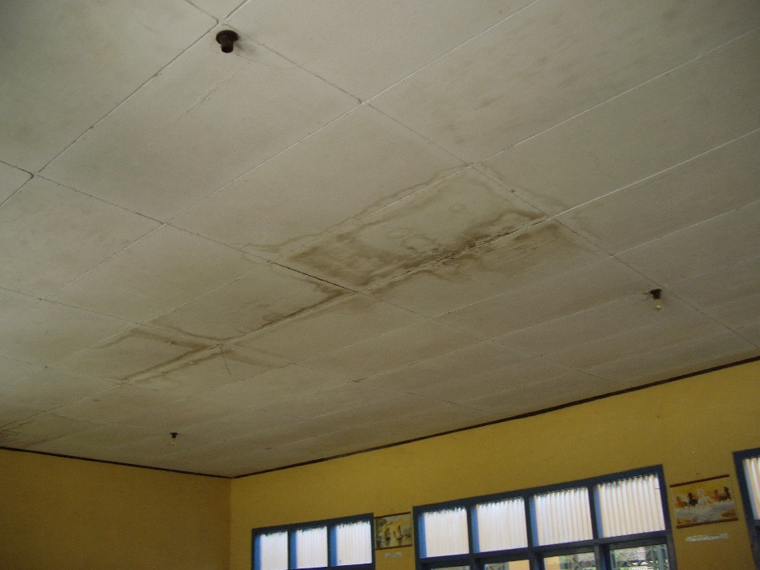
Plate 1: Typical roof leak and stained ceiling
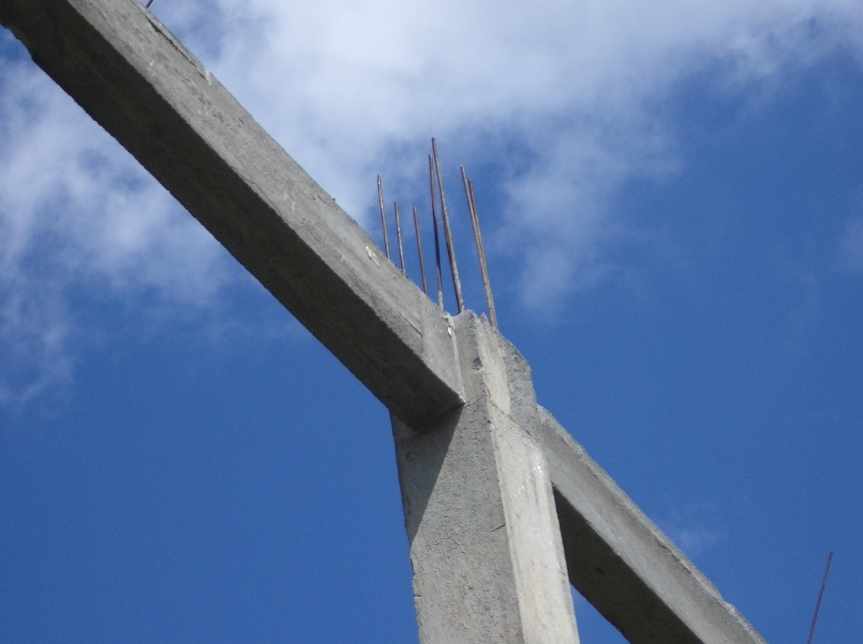
Plate 2: Inadequate reinforcement to multi-purpose building
Administration: The building is in reasonable condition. It has concrete-tiled floors. There are a few cracks to walls and a lot of stains on the ceilings indicating a number of on–going roof leaks. The external paint is flaking badly.
2-Classroom Building (Block grant 2000): The building was constructed by the school committee and is in reasonable condition. It has glazed ceramic tiled floors which have been added after construction. The joinery is not very good and is not very well painted. There are some ceiling stains indicating roof leaks. The furniture is in quite good condition but some repairs are required.
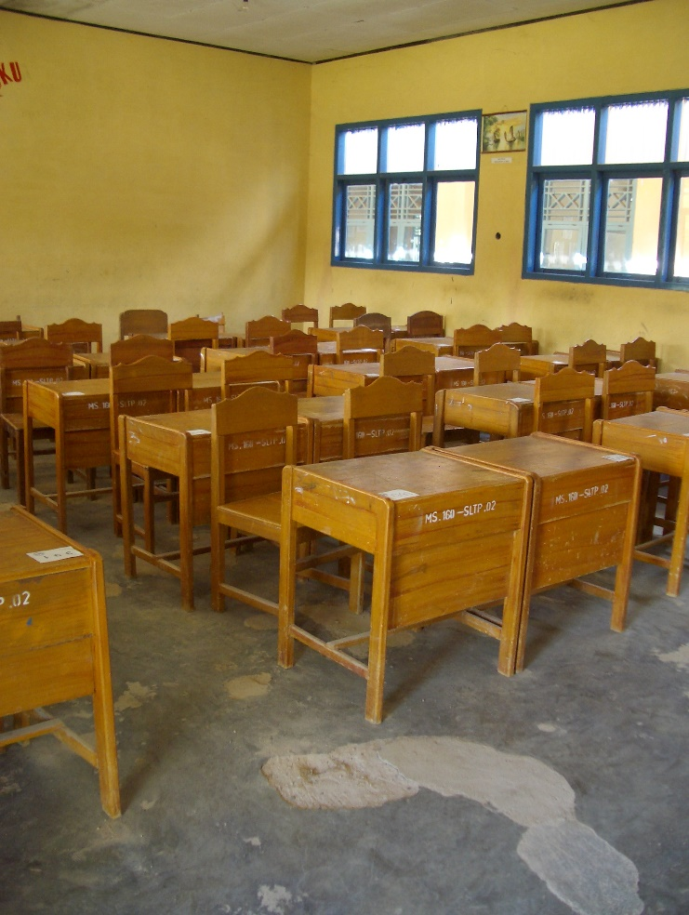
Plate 3: Screed floor breaking up
Library: The building is in reasonable condition but has some very bad roof leaks. It has concrete-tiled floors and the veranda tiles have been repaired. It has very low tables and no chairs. There are not many books and these are mainly text books.
3-Classroom Building 1 (original): This building has screed floors that are breaking up (the screed is only about 1cm thick) and urgently require repairs or replacement. The screed finish to the veranda is in reasonable condition. There are some very bad roof leaks. There are a few wall cracks and painting work is poor as is the joinery. The classrooms have only 4 tungsten fittings (which are missing) for lighting. The furniture is in quite good condition but some repairs are required.
Student Toilets: The toilets were said to be working but were locked even though it was a school day. The external paving around the building is breaking up; it consists only of a very thin screed.
Laboratory: The building is in reasonable condition although there are a few roof leaks. There are tiled benches to three sides of the lab with tiled sinks (the sinks do not appear to be used). The original water pipes in the wall leaked and these have been replaced with plastic pipes on the surface of the wall. The lighting is inadequate with only six tungsten fittings.
3-Classroom Building 2 (original): This building has screed floors that are breaking up (the screed is only about 1cm thick) and urgently require repairs or replacement. The screed finish to the veranda has been repaired. There are some very bad roof leaks mainly under the ridge. The painting work is poor as is the joinery. The classrooms have only 4 tungsten fittings (which are missing) for lighting. The furniture is in good condition and was supplied in 2001.
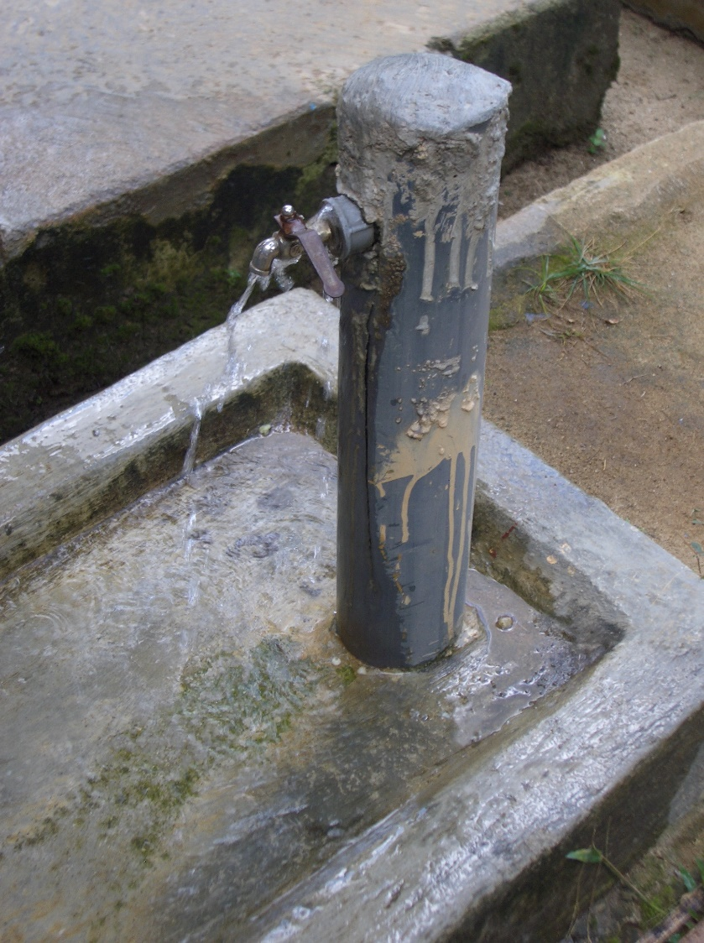
Plate 4: New plastic stand pipe leaking
3-Classroom Building 3 (Matching Grant 2002): The building was constructed by the school committee and is in reasonable condition. It has white glazed floor tiles to classroom and veranda floors and stone facing to the veranda walls. There appear to be no cracks and only one roof leak and the joinery is better than in the other classrooms. The paint work is flaking externally.
2-Classroom Building 1 (Block Grant 2003): The building was financed by the Province using APBN funds (Rp86 million) and was constructed by the school committee. The building seems well constructed and there appear to be no cracks or roof leaks. The paint work is also better than in the other buildings.
2-Classroom Building 2 (2001): The building was financed by the Kabupaten using APBD funds (Rp100 million) and was constructed by a contractor. The building has screed floors and verandas and is in reasonable condition although the veranda screed surface is starting to deteriorate, the internal and external paint work is flaking and the external paving is breaking up. The joinery is reasonable and there appear to be no roof leaks or cracks to walls. Some repairs are required to furniture.
Student Toilets (2002): There are three student toilets and one staff toilet in this building constructed by the school committee. The building is in good condition. Water for the toilet comes from a well that is only approximately 10 metres from the septic tank.
Musholla: The building is in reasonable condition but has lots of roof leaks.
Multi-purpose Hall: This building is being constructed of RC columns and beams and brickwork. The RC frames are up to roof height and the brickwork is about 80% complete. The building is approximately 13 x 21 metres and is quite high. The reinforcement to columns however seems to be only 10mm diameter and would appear to be inadequate and it is suspected that similar reinforcement has been used for beams.
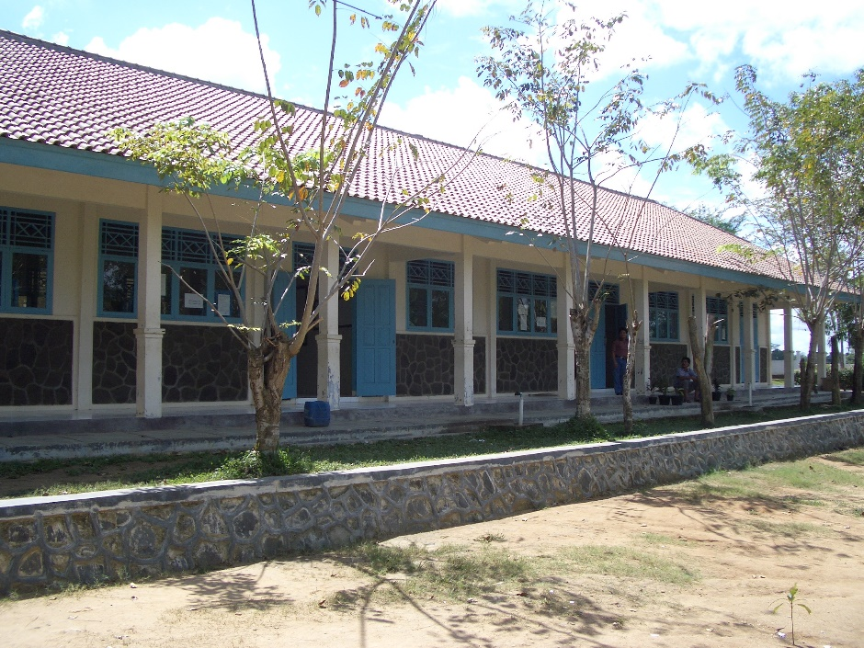
Plate 5: Well built and finished classroom building constructed by school committee
Conclusions: The school is clean and well kept and well planted. The only maintenance activity that seems to be carried out is painting which was said to be done once a year using money raised by the school committee; the paint used however is not very good quality. All buildings require some maintenance and the repairs to the floors and roof should be carried out as soon as possible in order to stop further damage. The buildings constructed by the school committee seem to be generally better built and finished than those constructed by the original contractor. New water reticulation around the site had to be installed by the school committee in 2001 because the original reticulation was leaking badly. Both were carried out in rigid plastic pipe which is not really suitable as it gets brittle and breaks.
School Data:
The school operates one shift and has three streams in each class and the numbers are:
Class | Boys | Girls | Total
Class 1 | 119 | 125 | 244
Class 2 | 135 | 132 | 267
Class 3 | 142 | 116 | 258
 |  |  | 769
The classes are therefore very large (average class size 59) and the school requires an additional five classrooms to bring class sizes down to below 44 students per class.
The school has 44 teachers and 9 administrative staff. 36 teachers have S1 degrees, 6 have diplomas and 2 are SMU graduates. 28 teachers are paid by central government, 4 are contract teachers paid by central government, 1 is paid by the district and 11 are paid by the school committee out of school fees.
The school’s operational budget is as follows: the school receives Rp47 million a year from the district to run the school including maintenance. The school also receives Rp70.3 million a year from students in school fees, Rp40 million of which goes towards teachers’ salaries and the rest is spent on stationery, running the school and maintenance.
  - SMPN 2 Way Pengubuan (SLTPN 9 Terbanggi Besar), Kabupaten Lampung Tengah: The school was built in the first phase of the project in 1997 by a contractor. It originally had two 3-classroom buildings but because of the numbers of students wanting to attend the school an additional 3-classroom building was constructed in 2001 using a block grant. An old building on the site (that was a primary school) was renovated in 2002 as a large multi-purpose/meeting room also using a matching grant. There is also a small building used as a computer lab and a new toilet building, both of which were constructed by the school committee using its own resources.
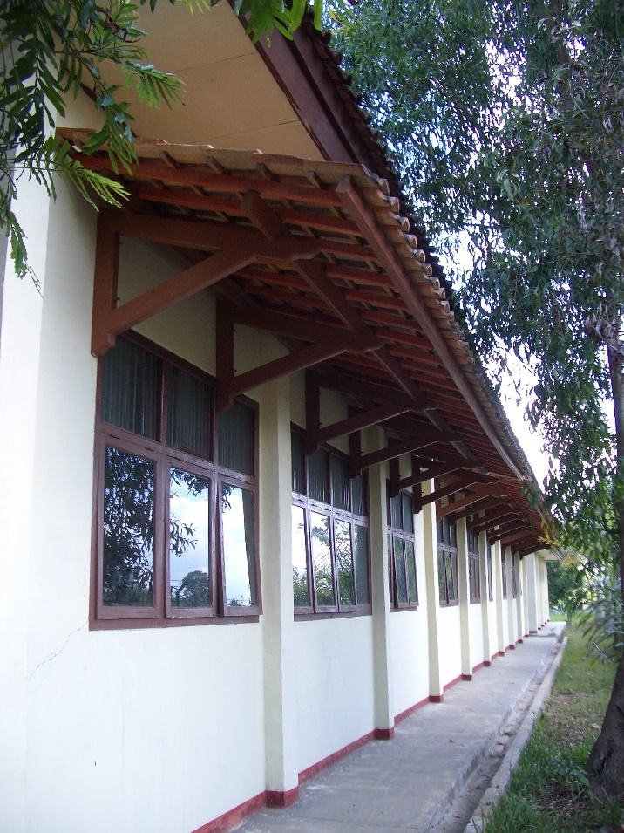
Plate 6: Sunscreen added to classroom to keep sun out of rooms
The site is flat and very wet. The school has a mains electricity supply and water is supplied from two wells, one of which has an electric pump connected to an overhead tank. There is also an old well that has no water and is full of rubbish.
3-Classroom Building 1 (original): The building is in reasonable condition but there are some small cracks to walls and a few roof leaks. The screed floors have been repaired in places. The windows are quite good but the doors are not very well made. A sunshade has been added over the windows to the rear of the building to stop sun penetration into the classrooms. The furniture is in reasonable condition. All classrooms have only 4 tungsten fittings for lighting.
Laboratory: The building is in reasonable condition but the screed floor is starting to break up and there are a few roof leaks. The pipe work for the water supply to sinks is original but the taps have been replaced.
Administration: The building is in reasonable condition. It has concrete tiled floors which are not damaged but the veranda screed finish is cracked in places. There are lots of roof leaks.
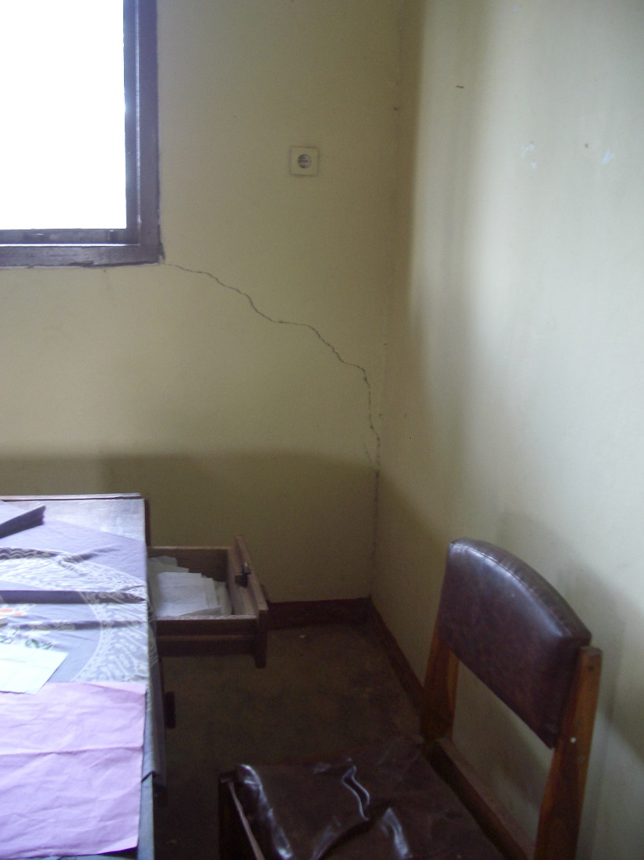
Plate 7: Crack to wall
Library: The building is in quite good condition but the veranda floor has been extensively repaired. The concrete tiled floor is not damaged but there are a few roof leaks. The library has good furniture, a large number of books (mainly text books) and is very well kept.
Musholla: The building has lots of roof leaks and the surrounding paving is starting to break up.
New Toilets: The new toilets have two compartments and are quite well constructed and finished. There is also a new well serving the toilets that is only 12 metres from the septic tank.
3-Classroom Building 2 (original): The building was renovated in 2003 using Rp30 million from APBN funds (the school was also re-painted using these funds) and is therefore in good condition. There are however some bad roof leaks and some cracks over windows and the paving around the building is starting to break up. The furniture is in good condition.
3-Classroom Building 3 (Block Grant 2001): The building was constructed by the school committee and is in reasonable condition but there are some roof leaks and the paving around the building is starting to break up. The joinery is better than in the original buildings and the furniture is in good condition.
Multi-Purpose Building (Matching Grant 2002): This building was completely renovated by the school committee. The original building was demolished down to the foundations and the length of the building was extended and the veranda widened. It seems well constructed with good joinery and ceramic tiled floors. There are a few roof leaks and a few small cracks over windows. The lighting is not very good as there are only has 12 tungsten fittings.
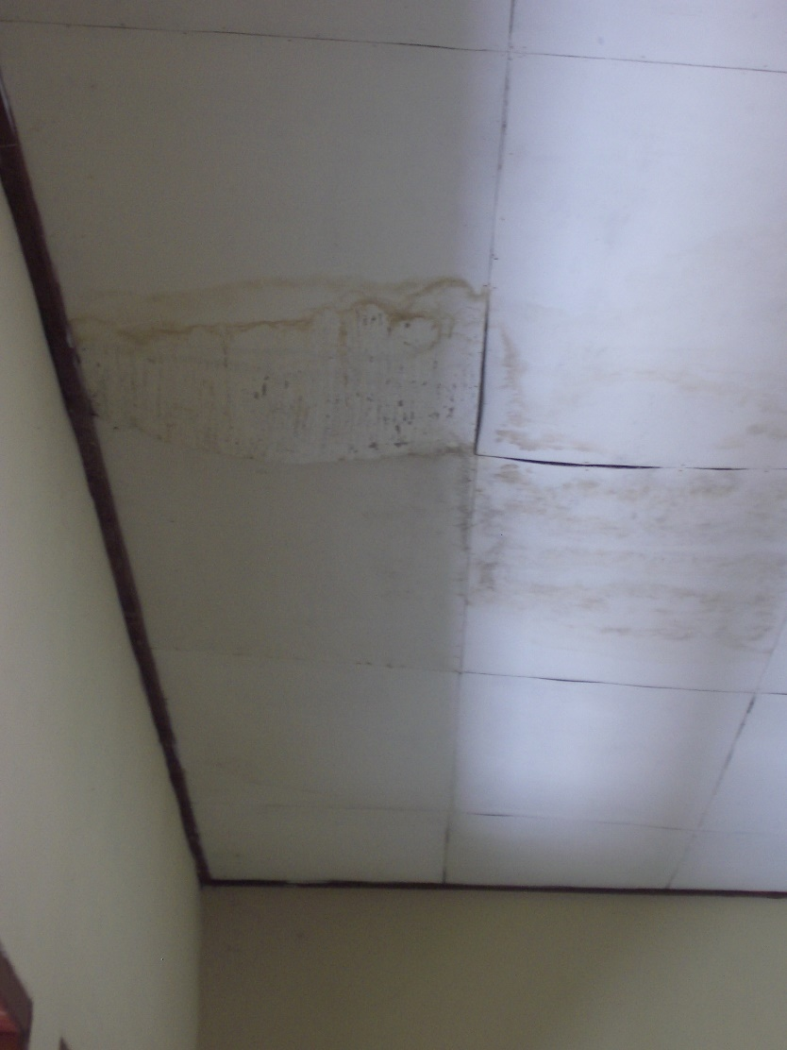
Plate 8: Typical roof leak
Computer Laboratory: This building was constructed by the school committee in 2003 using Rp30 million supplied by the district (they also bought books and sports equipment out of this money). It is not very well built; the school committee were obviously trying to make the funds stretch as far as possible. There are 14 quite old computers on very low tables; the students must sit on the floor to use them!
Conclusions: The school is very neat, well kept and planted though the classrooms are rather dirty. The only maintenance activity that seems to be carried out is painting which does not seem to be carried out regularly. All buildings require some maintenance and the repairs to the floors and roof should be carried out as soon as possible in order to stop further damage. Again the buildings constructed by the school committee (apart from the Computer Lab) seem better built and finished than the original buildings.
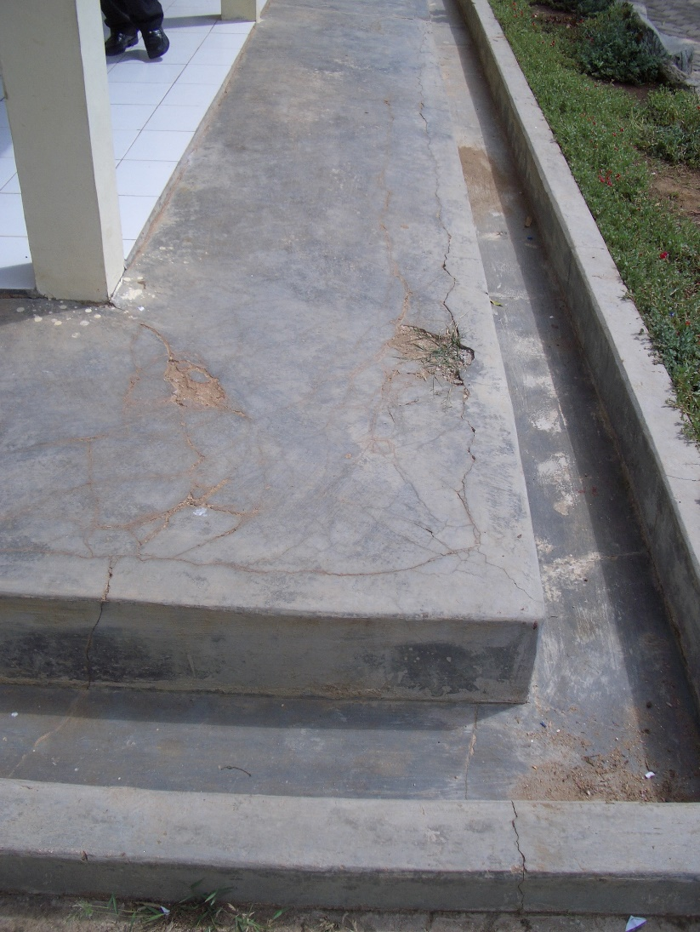
Plate 9: Paving breaking up around buildings
School Data:
The school operates one shift and has three streams in each class and the numbers are as follows:
Class | Boys | Girls | Total
Class 1 | 57 | 70 | 127
Class 2 | 49 | 60 | 109
Class 3 | 62 | 67 | 129
 |  |  | 365
The classes are therefore smaller than the norm of 44 (average class size 40.5) and the school does not require any additional classrooms.
The school has 25 teachers and 3 administrative staff. 13 teachers have S1 degrees, 3 have D3 diplomas and 9 are SMU graduates with a D1 diploma. 17 teachers are male and 8 are female.
The school’s operational budget is as follows: the school receives Rp27 million a year from the district to run the school including maintenance. The school also receives Rp56.25 million a year from students in school fees some of which goes towards teachers’ salaries and the rest is spent on stationery, running the school and maintenance.
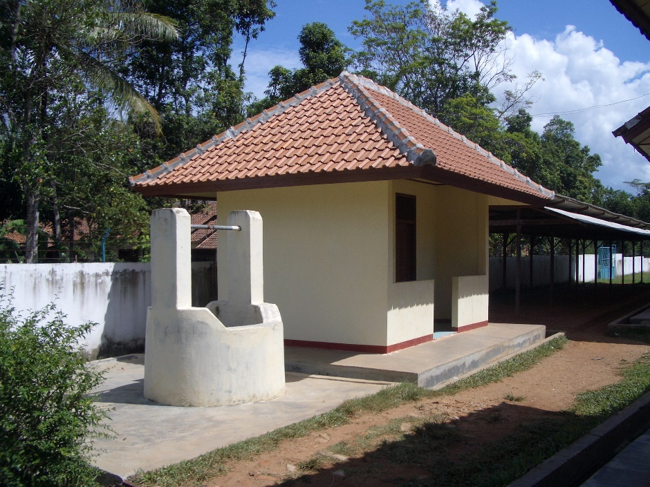
Plate 10: Well adjacent to toilets and too close to septic tank
  - SMPN 3 (SLTPN 5) Natar, Kabupaten Lampung Selatan: The school was constructed in the second phase of the project in 1999 by a contractor. The school was partially renovated by the school committee in 2003 using a block grant of Rp30 million from APBN funds. The original concrete tiles to the administration, library and laboratory buildings were replaced with glazed ceramic tiles, the school was painted and the library roof was repaired where tiles were leaking. All the hardware to classroom doors which were broken was also replaced with simple locks and strong pull handles. An additional 3-classroom building was constructed in 2000 using a block grant from the project and another 3-classroom building and a toilet building were constructed in 2002 using a matching grant from the project. The original buildings have concrete floor tiles and quite good joinery and the new buildings have glazed ceramic floor tiles.
There is a satellite school (Kelas Jau) run by this school some 6/7 kilometres away that has 6 classrooms and 301 students. The same teachers teach at both schools.
There is a gradual fall across the site which has necessitated a lot of site works including paths, walls, paving and drains. The school has mains electricity and water is supplied from a deep well with a pump and a high level tank and some shallow wells. No wells are covered.
Administration: The building is in reasonable condition but there are a few roof leaks and the paving around the building is starting to break up in places.
Library: The building is in reasonable condition but there are a few roof leaks and the paving around the building is starting to break up in places. The library is well looked after and furnished but there are few books and these are mainly text books.
Laboratory: The building is in reasonable condition but there are a few roof leaks and the paving around the building is cracking in places.
3-Classroom Building 1: The building is in reasonable condition and there are only a few roof leaks. The furniture is in good condition.
Musholla: The building is in reasonable condition but there are a lot of roof leaks.
3-Classroom Building 2: The building is in reasonable condition and there are only a few roof leaks. One classroom is used for IT and has 20 computers.
3-Classroom Building 3 (Block Grant 2000): The building was constructed by the school committee and is quite well built with good joinery but there are some roof leaks. It has glazed ceramic floor tiles.
3-Classroom Building 4 (Matching Grant 2002): The building was constructed by the school committee and is quite well built with good joinery but again there are some roof leaks and a few cracks to walls. It has glazed ceramic floor tiles.
Students Toilets: The toilets are very dirty and not well maintained. The taps are leaking.
New Students Toilets: These toilets are also very dirty and not well maintained. The taps are all broken and one of the entrance doors (which are hollow flush doors) is also broken.
Conclusions: The school is (apart from the toilets) very neat, well kept and planted. The buildings seem quite well constructed and looked after (again apart from the toilets). All buildings however require some maintenance and the repairs to the roofs should be carried out as soon as possible in order to stop further damage. The new hardware fitted to the classroom doors is much stronger than the original.
School Data:
The school operates one shift and has three or four streams in each class and the numbers are as follows:
Class | Boys | Girls | Total
Class 1 | 139 | 137 | 276
Class 2 | 128 | 110 | 238
Class 3 | 121 | 87 | 208
 |  |  | 722 (including Kelas Jau)
When the students at the Kelas Jau are deducted from the total, the total number of students at the school is 421. The classes are therefore smaller than the norm of 44 (average class size 38) and the school does not require any additional classrooms. The number of students per class at the Kelas Jau however is very high at an average of 50.
The school has 46 teachers and 7 administrative staff. 35 teachers have S1 degrees, 2 have D3 diplomas and 7 are SMU graduates. 11 teachers are male and 35 are female.
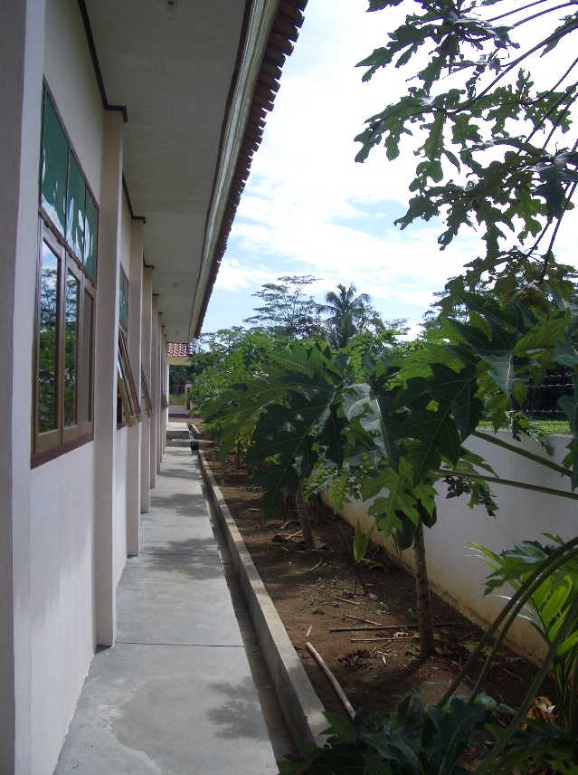
Plate 11: Inadequate roof over-hang and sun protection
The school’s operational budget is as follows: the school receives Rp59.7 million a year from the district to run the school including maintenance. The school also receives Rp65.94 million a year from students in school fees some of which goes towards teachers’ salaries and the rest is spent on stationery, running the school and maintenance.
  - SMPN 3 Batanghari Nuban, Kabupaten Lampung Timor: This school was constructed by the school committee and completed in November 2003. The total budget was Rp988 million. It was constructed by workers from the adjacent village and the pelaksana was a local S1 engineer. The consultants had an S1 engineer based on site. The members of the school committee are from the adjacent village.
The site has a slight fall across it and is fenced all round with a brick fence with steel railings at the top. There are paving and drains around all buildings, a paved area for assembly, site paths and drains. The school has mains electricity and the water supply is from a well with a pump next to the toilets and only 12 metres from the septic tank.
Administration: The building seems well constructed but there are some roof leaks.
Library: The building seems well constructed but there are some roof leaks and some cracks to walls below windows. The furniture is well made but there are only a few text books.
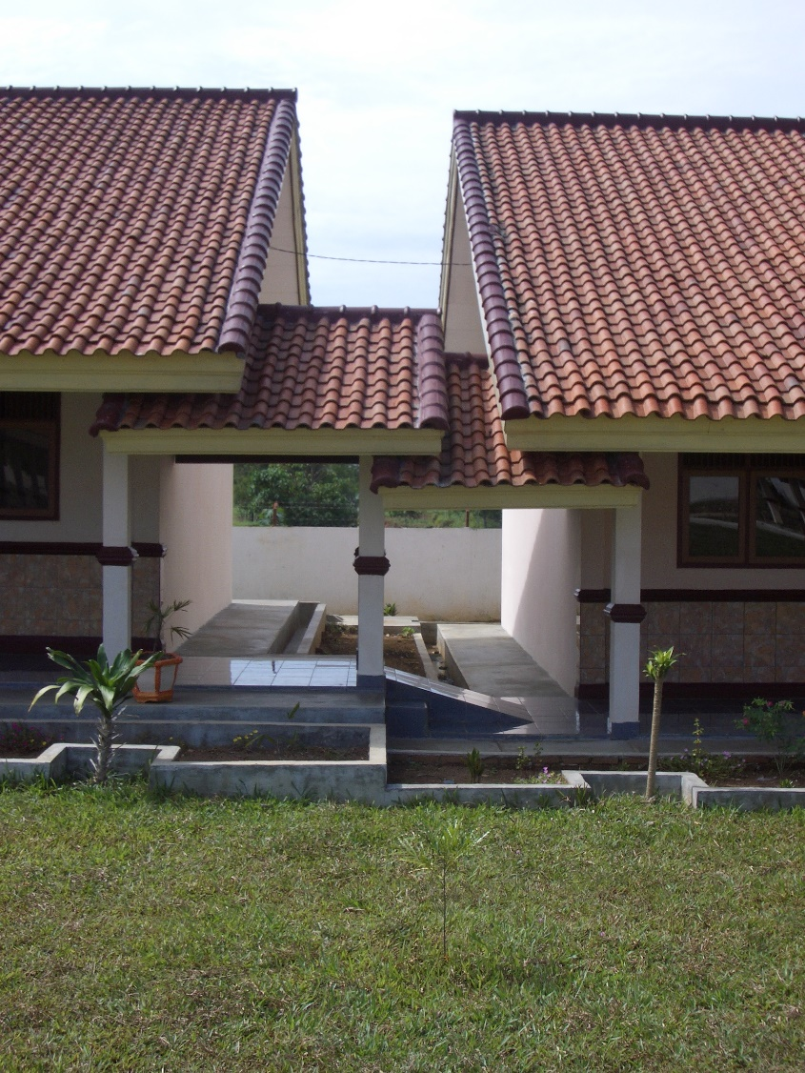
Plate 12: Over complicated links between buildings that will lead to maintenance problems
Students’ Toilets: The building seems well constructed and has two male toilets and two female toilets. The pipe work is plastic and will probably not last long.
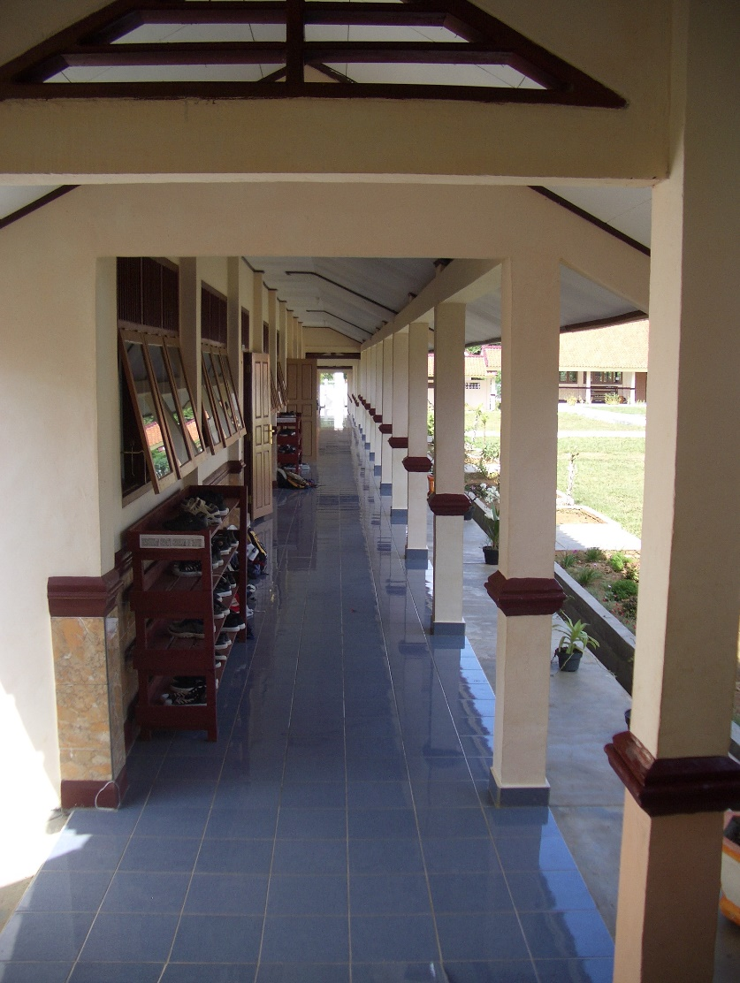
Plate 13: Typical classroom veranda showing good quality finishes
Laboratory: The building seems well constructed and has tiled benches to two walls with two sinks in one bench. Pipe work is plastic set in the walls and there are some roof leaks.
3-Classroom Buildings 1 and 2: The buildings seem well constructed but again there are some roof leaks. The furniture is quite well made. All classrooms have 4 tungsten light fittings.
Musholla: The building seems quite well constructed but again there are some roof leaks.
Multi-Purpose Room: The building seems quite well constructed but again there are some roof leaks.
Conclusions: As stated above, the buildings seem well constructed and are well finished. All veranda walls are finished with glazed ceramic tiles to the underside of window cill level. The only real problem seems to be the roof leaks which should be fixed as soon as possible before they cause more damage to ceilings, etc. The hardware to doors and windows is also not very good quality and will not last long.
The roofs to the covered links between buildings are quite complicated and could cause problems in future and it was also noticed that the site water reticulation and stand pipes are in rigid plastic which is easily damaged and there are already some leaks.

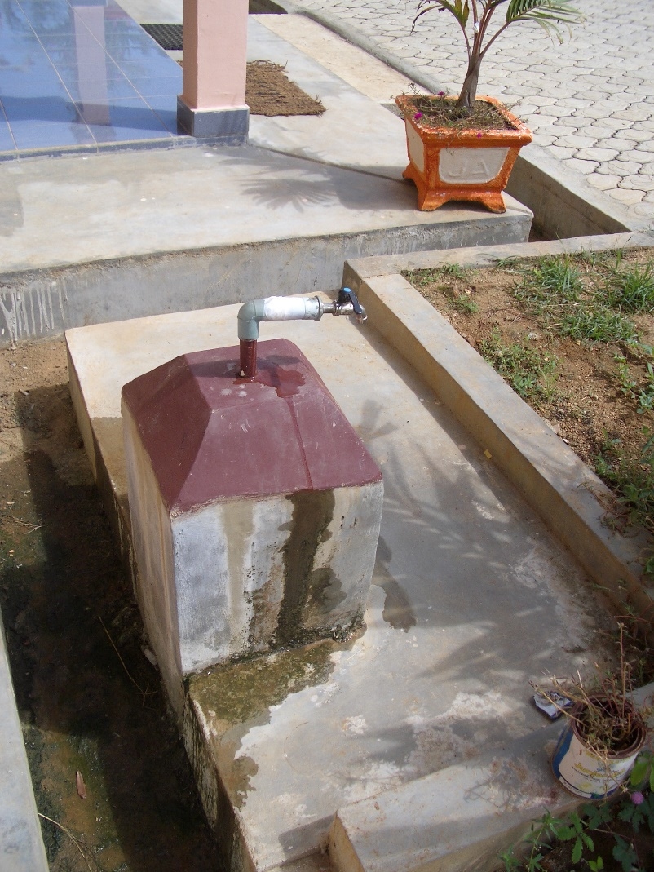
Plate 14: New plastic stand pipe leaking
School Data:
The school operates one shift and as it is in its first year only has students in Class 1. There are three streams and the numbers are as follows:
Class 1 | Boys | Girls | Total
Stream 1 | 17 | 23 | 40
Stream 2 | 20 | 20 | 40
Stream 3 | 20 | 20 | 40
 |  |  | 120
The school has six classrooms so there will not be a problem in accommodating another 120 students in Class 1 next year. However, there will be a problem the following year as there will not be classrooms available for that year’s intake. The school has made a proposal to the district for building another 3-classroom building next to the musholla which has been agreed. It will be funded out of APBD funds and the school committee will build it. The cost is estimated at Rp150 million. The students all come from nearby villages: 92 from within 3 kilometres and 28 from within 4/6 kilometres.
The school has 17 teachers and 3 administrative staff. 10 teachers have S1 degrees and 10 have D3 diplomas.
The school’s operational budget is as follows: the school receives Rp28.8 million a year from the district to run the school including maintenance. The school also receives Rp15,000 a month (Rp21.6 million a year) from students in school fees some of which goes towards teachers’ salaries and the rest is spent on stationery, running the school and maintenance.
The school’s only computer is used for administrative purposes.
  - SLTPN 1 Bumi Agung, Kabupaten Lampung Timor: This school was constructed by the school committee and completed in June 2003. The total budget was Rp1,003 million. It was constructed by workers from the adjacent village. The consultants had an S1 engineer based on site. The members of the school committee are from the adjacent village.
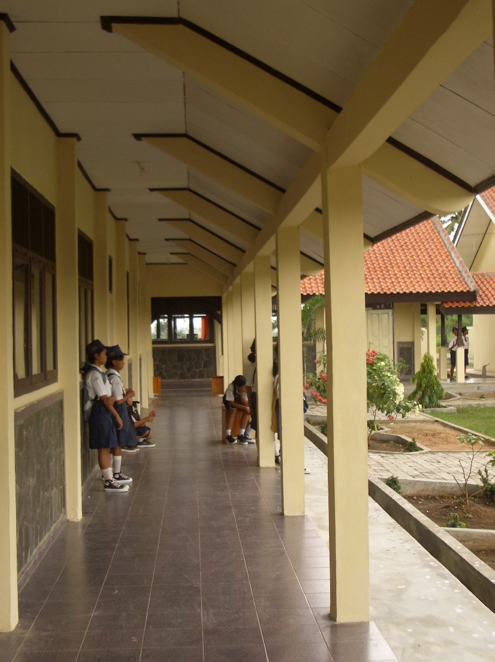
Plate 15: Typical classroom veranda showing good quality finishes
The site is flat and quite wet and is fenced all round with a brick fence with steel railings at the top in front and barbed wire on the other three sides. There are paving and drains around all buildings, a paved area for assembly, site paths and drains. The school has mains electricity and the water supply is from a well with a pump next to the toilets and not far from the septic tank. The site is very neat and tidy and has been grassed. There is also a pit for burning rubbish.
Administration: The building seems well constructed. There is one crack and there has been a roof leak which has been fixed.
Library: The building seems well constructed and there are no cracks or roof leaks. The furniture is well made but there are only a few text books.
Students’ Toilets: The building seems well constructed and has two male toilets and two female toilets. The pipe work is plastic and will probably not last long.
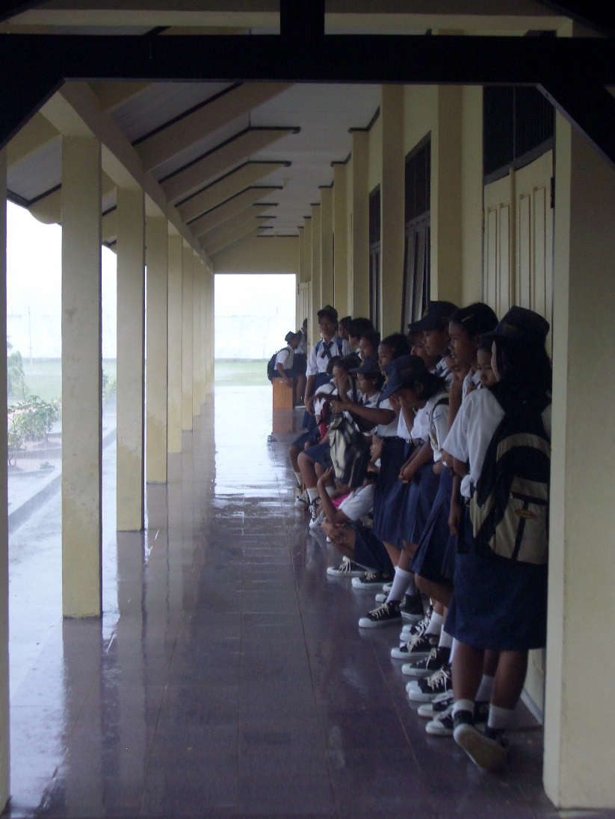
Plate 16: Rain driving into verandas
Laboratory: The building seems well constructed and has tiled benches to two walls with two sinks in one bench. Pipe work is plastic set in the walls.
3-Classroom Buildings 1 and 2: The buildings seem well constructed and there appear to be no roof leaks. The furniture is quite well made. All classrooms have 4 tungsten light fittings.
Musholla: The building seems quite well constructed.
Multi-Purpose Room: The building seems quite well constructed.
Conclusions: As stated above, the buildings seem well constructed and are well finished. The joinery is very good and all veranda walls are finished with stone facing and the verandas are finished with non-slip tiles (the Construction Consultant suggested this on his visit last year). There have been a few roof leaks which the Head Teacher said he has had fixed. The hardware to doors and windows is not very good quality and will not last long and there will probably be more problems with the water pipes and eventually with the roofs to the links between buildings.
Another problem is that the paving around the buildings does not slope adequately and will collect water which will have a detrimental affect on the buildings in time. It was also noticeable during the visit when it was raining heavily that the veranda roofs being so high give very little protection against the rain which drives under the roofs onto the verandas.
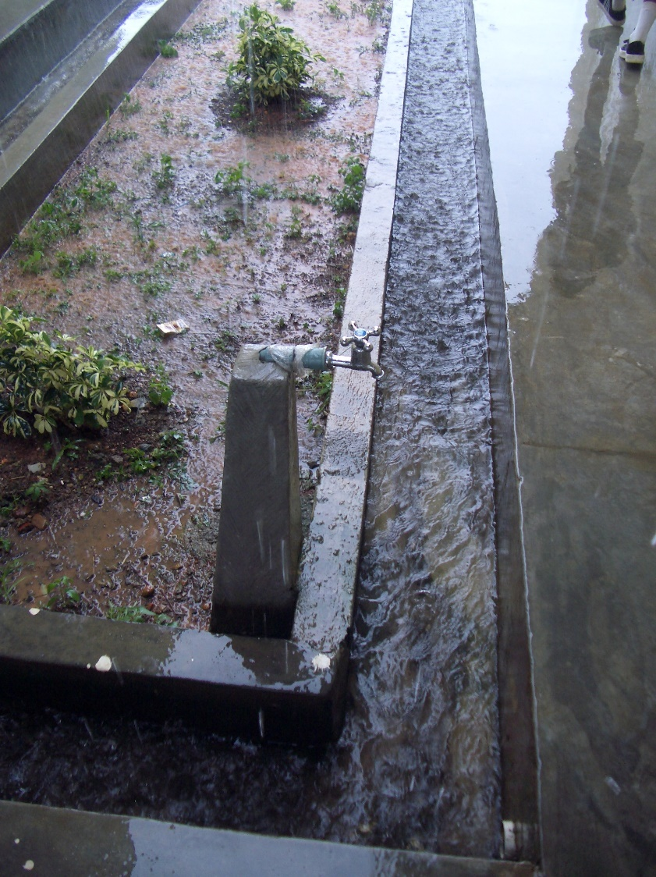
Plate 17: Leaking plastic stand pipe
School Data:
The school operates one shift and as it is in its first year only has students in Class 1. There are three streams and there are 69 girls and 50 boys.
The school has six classrooms so there will not be a problem in accommodating another 120 students in Class 1 next year. However, there will be a problem the following year as there will not be classrooms available for that year’s intake. The school has made a proposal for building another 3-classroom building to the district which has agreed to fund it out of APBD funds using the school committee to build it.

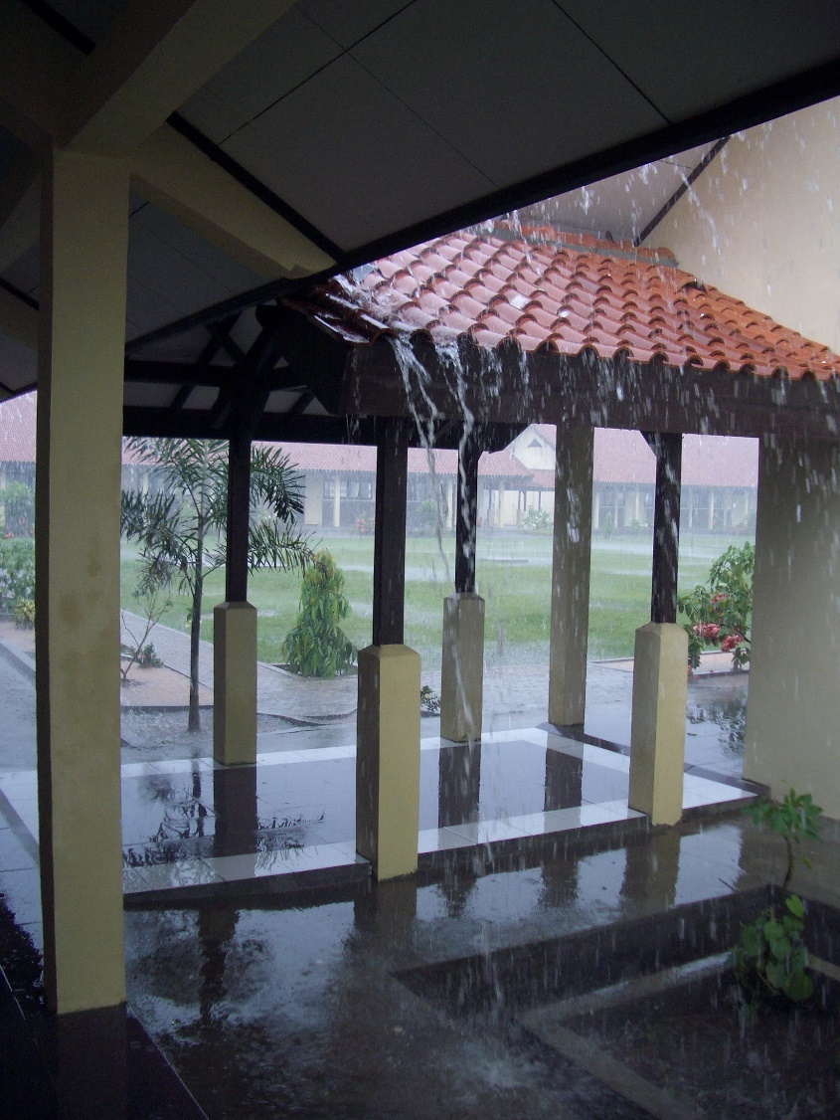
Plate 18: Inadequate falls to paving around buildings
The school has 15 teachers and 5 administrative staff. 9 teachers have S1 degrees, 4 have D3 diplomas and 2 are SMA graduates. 3 teachers are ‘honor’ teachers and are paid out of school fees together with 3 administrative staff and the penjaga.
The school’s operational budget is as follows: the school receives Rp28.8 million a year from the district to run the school including maintenance. The school also receives Rp15,000 a month (Rp21.6 million a year) from students in school fees some of which goes towards teachers’ salaries and the rest is spent on stationery, running the school and maintenance.
The school has 10 computers in a store off the multi-purpose room which are used by students twice a week. All students have to pay an extra Rp5,000 a month to cover the cost of the computers and 2 teachers.

ANNEX 7: REPORT ON VISIT TO PROJECT SCHOOLS IN SOUTH SUMATRA PROVINCE
1. General
  - South Sumatra Province was visited on June 15th and 16th 2004.
  - Four junior secondary schools (two constructed by contractors and two constructed by school committees) were visited in the company of the PPIU Procurement Consultant.
  - Construction is similar in all schools: foundations are of stone set in mortar; walls are of rendered brickwork with RC columns, floor beams, ring beams and veranda beams and columns; roofs are of clay tiles on battens, on timber rafters, purlins and trusses; ceilings are of plywood or fibre-cement sheets; windows and doors are of hardwood with timber panel doors and top-hung windows with vents over; floors are of screed, concrete or glazed ceramic tiles on a screed bed. All buildings have paving and storm-drains around them.
  - It should be noted that it was impossible to check either the quality of the concrete work (which is all covered) or the size of the reinforcement.
  - The schools built by contractors have the following accommodation: two 3-classroom buildings, an administration building, a library, a laboratory, a musholla, a student toilet building, a head-teacher’s house, teachers’ accommodation, a penjaga’s house and a bicycle shed. Some of these schools have since had further accommodation built either by the school committee or by the district.
  - The schools built by school committees have the following accommodation: two 3-classroom buildings, an administration building, a library, a laboratory, a musholla, a student toilet building, a head-teacher’s house and a bicycle shed. There are no multi-purpose buildings at the new schools in this province.
  - It should be noted that the window cill height to classrooms in the new schools in this province has been reduced to 90cm (as suggested by the Construction Adviser in previous reports and as against the 120cm height used in the past) and the rooms are lighter and much better ventilated. The head teacher at this school said that there was no problem with students being distracted because they could now see out of the windows.
  - Only one school visited, SLTPN 10 Babat Toman is under-utilised due to inadequate numbers of pupils in its catchment area. The other three schools all have adequate numbers of students for the existing accommodation or require further accommodation. SMPN 4 Inderalaya requires two additional classrooms in order to bring class sizes down to reasonable levels and both of the new schools visited require additional classrooms to accommodate Class 3 students in two years time. It would have been more sensible (and cheaper) to have constructed these classrooms during the initial construction phase.
  - All schools are accessible by road.
2. Issues
2.1 The issues raised at the schools visited are similar to those raised in Lampung Province and all stem from four major factors: 1) problems caused by poor initial design or specification; 2) problems caused by the initial construction, whether by contractor or school committee; 3) problems caused by poor supervision during construction and 4) problems caused by poor maintenance (or the lack of maintenance).
  - Design and Specification Issues: A number of design and specification issues were raised by the school visits and these include:
- Inadequate artificial lighting to classrooms: Classrooms only have 4 tungsten light fittings which are inadequate to light the classrooms properly and are a waste of money. Classrooms should either be properly lit or not have any light fittings at all which would save a lot of money.
- Poor quality water pipes and fittings: Rigid plastic pipes are used for all water reticulation both inside and outside of buildings and these are very liable to breakage especially where taps are fitted which leads to ongoing maintenance problems. Galvanised steel pipes would last longer and cause fewer problems. Very poor quality taps are also generally used which again leads to maintenance problems.
- Poor orientation of buildings and lack of sun protection: On all sites, some buildings are generally orientated east/west which, together with the small roof overhangs and high roofs, allows sun penetration into rooms in either the morning or afternoon which makes rooms very uncomfortable to use. In the tropics ALL rooms should be orientated north/south of at all possible and roof overhangs should protect windows from the sun. If veranda roofs are lowered this will also provide better protection from driving rain.
- Poor quality doors and hardware: At most schools poor quality hardware breaks quickly and has to be replaced. Better quality hardware would last longer and cause less maintenance problems. Particular attention should also be paid to the specification of toilet doors. These should not be hollow-core flush doors as they will quickly break or rot.
- Glazed ceramic tiles to verandas: The use of glazed ceramic tiles on veranda floors is very dangerous as they can get slippery when wet and cause accidents. If ceramic tiles must be used then non-slip ones should be specified.
- Wells placed close to septic tanks: At many schools wells are constructed close to toilets because it is then easier to obtain water for the toilets. Unfortunately this can cause contamination of the well water. Indonesian regulations state that wells should be at least 15 metres from septic tanks or soakaways but a better figure, especially on wet sites, would be 30 metres. It is suggested that as a matter of priority, all school wells are tested for contamination and those that are contaminated should be closed and not used. It would also be a good idea if wells were covered to stop pollution from the top and any buckets that are used to obtain water should be round-bottomed so that they cannot be placed on the ground.
- Design of roofs to links between buildings: The design of many of the links between buildings seen at the schools visited is over-complicated with roof timbers that will be prone to water damage and rot. Links should be kept simple and as maintenance-free as possible.
- Design of walls and lintels: At most schools wall panels are too large for the thickness of the walls and this is bound to cause cracking. Further cracking is also caused by not providing RC lintels over window and door openings. RC lintels should always be provided (this also helps if windows or doors have to be changed at a later date) and wall panels should reduced by providing RC columns at closer centres.
- Roofs to Mushollas: In future the roof designs for mushollas should be simplified if possible as these buildings at the schools visited had many roof leaks and will be the cause of many maintenance problems.
- Fume cupboards: The fume cupboards seen in several schools will not work as presently designed and are obviously not used. In future they should be omitted from the laboratories or a new design produced that will actually work as intended.
2.3 Construction Issues: A number of construction issues were raised by the school visits and these include:
- Poor quality screed to floors: At some schools with screed floors, the screed is much too thin and is breaking up causing maintenance problems. Screed floors are perfectly satisfactory if the base is properly made and compacted and if the screed is of an adequate thickness (at least 25mm).
- Poor quality external paving: The external paving at most schools is also too thin and badly laid causing it to break up. At some schools the paving has been laid flat with no falls to carry water away from the buildings. Both these faults will cause maintenance problems.
- Storm drains: At several schools, the storm drains do not drain properly and could become breeding places for mosquitoes. All drains should have adequate falls so that they carry away the water.
- SMPN 7 Babat Toman: There are concerns about the veranda columns at this school and the consultants should urgently check the slenderness ratio and the reinforcement to these columns to ensure that they are adequate. If they are not then the consultants should propose remedial measures.
- SLTPN 10 Babat Toman: There are serious problems with the floors at this school caused probably by the contractor back-filling on top of top-soil containing vegetable matter. The floors are now subsiding as the vegetable matter rots. All floors will eventually have to be taken up, the vegetable soil removed, the floor area properly back-filled and compacted and new floors laid. This will be a very expensive process which could have been avoided if the floors had been properly constructed in the first place.
- SMPN 6 Gunung Megang: There is great concern over the structural strength of the columns to the classroom walls at this school which have been reduced to the thickness of the walls. The consultants should, as a matter of urgency, check the strength of these columns and propose remedial measures if they are inadequate.
2.4 Supervision Issues: Most of the issues raised under ‘Construction Issues’ above could have been avoided if the construction had been properly supervised by the consultants. In future, all consulting firms should be made aware of their responsibilities in terms of supervision and be made to carry out their duties properly and provide properly qualified and experienced staff.
2.5 Maintenance Issues: There are maintenance issues at all of the schools visited particularly with regard to roof leaks. A lot of these issues are to do with inadequate funding of school maintenance but there also seems to be a cultural problem in that most school head teachers and staff do not seem to take any responsibility for maintaining their schools.
At SMPN 4 Indralaya, many of the roof timbers require urgent maintenance as they are rotting especially at junctions along the verandas and to the laboratory. Trees at this school that are very close to buildings should also be cut back as soon as possible.
At SLTPN 10 Babat Toman, the school should move an electric pump out of the toilets as soon as possible as it is very dangerous.
The project was supposed to carry out training of school staff in maintenance but this does not seem to have been very effective. It is suggested that a maintenance handbook (similar to that prepared for the Basic Education Projects) is prepared for all junior secondary schools by the Ministry of Education and that training in the need for maintenance and in maintenance techniques is given to a member of each school staff who is designated to be responsible for maintaining the school. The government should also ensure that all schools have adequate funds every year to maintain their schools. It is much cheaper to maintain schools than to allow them to deteriorate to such an extent that they require re-building!
3. School Visits
  - SMPN 7 Babat Toman, Kabupaten Musi Banyuasin: The school was constructed by the school committee using a block grant and was finished in October 2003. The budget was Rp1,099,326,000. All buildings have glazed ceramic tile floors and verandas. The civil works consultants were Bina Karya from Jakarta.

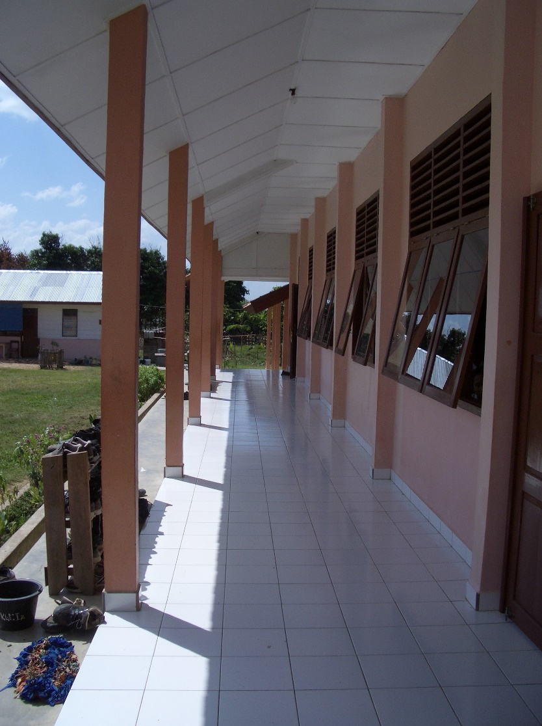
Plate 1: Inadequate veranda column size
The site has a slight fall across it. There is a large paved assembly area and connecting paths and drains. The site has a wall at the front and a barbed wire fence to the other three sides. The school has a mains electricity supply and at present a shallow well (without a cover) that supplies water (the well is on the opposite side of the site from the septic tank to the students’ toilet). There is a main water pipe that runs past the school but the pipe is owned by Pertamina and the school has not yet been able to get connected to it.
Administration: The building seems well built although the rendering is not very good in places. There are no cracks or roof leaks.

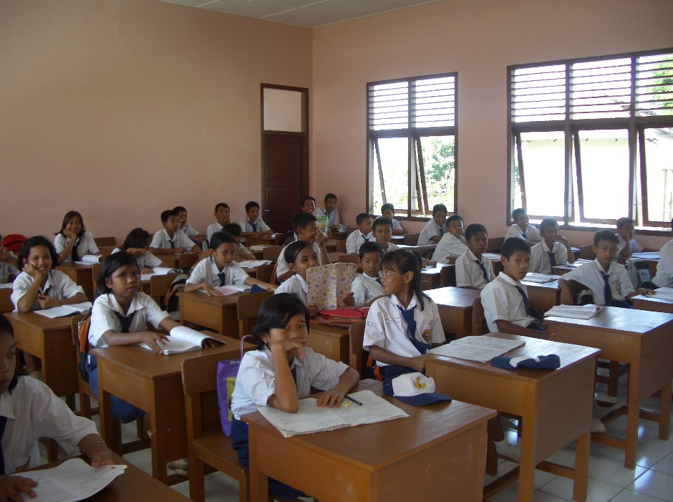
Plate 2: Low window cill height giving better light and ventilation to classrooms and good quality furniture and finishes
3-Classroom Building 1: The building seems well built and there are no cracks or roof leaks. The classroom doors have simple locks and pull handles which will last longer than the usual hardware fitted to these doors at other schools.
Library: The building seems well built and there are no cracks or roof leaks. The floor tiling is not however very level and the painting is not very good. The furniture is well made but the desks are much too high and the legs should be cut down. There are not many books and these are mainly text books.
3-Classroom Building 2: The building seems well built but the painting to the ceiling is not very good. There are no cracks or roof leaks. It should be noted that all classrooms have 6No 100cm fluorescent light fittings which will give a reasonable standard of lighting at night. All classroom furniture is well made.
Student Toilets: The toilets seem well built, are very clean and well maintained. The floors and walls are tiled. The water pipes are however plastic and it is likely that the connection between the taps and pipes will fail soon.
Laboratory: The building seems well built and there are no cracks or roof leaks. There is a tiled bench to one side of the lab with a single stainless steel sink and drainer at one end (although there is no running water yet). At the other end of the bench there is a ‘fume cupboard’. This has a solid brick, tiled side, a top-hung glazed timber door to the front and a 75mm pipe at the top (without a fan) for ventilation. It is difficult to see how this could work properly as a fume cupboard as it is more or less impossible to work inside of it because of the way the door opens, it would be impossible for students to see any demonstration experiments because the side is not glazed and any fumes would not be removed from the cupboard because there is no fan! There is also no water or electricity supply or drip sink in the cupboard. The laboratory furniture is well made although it is again too high for the students and the height should be reduced.
Musholla: The building seems well built and there are no cracks or roof leaks.
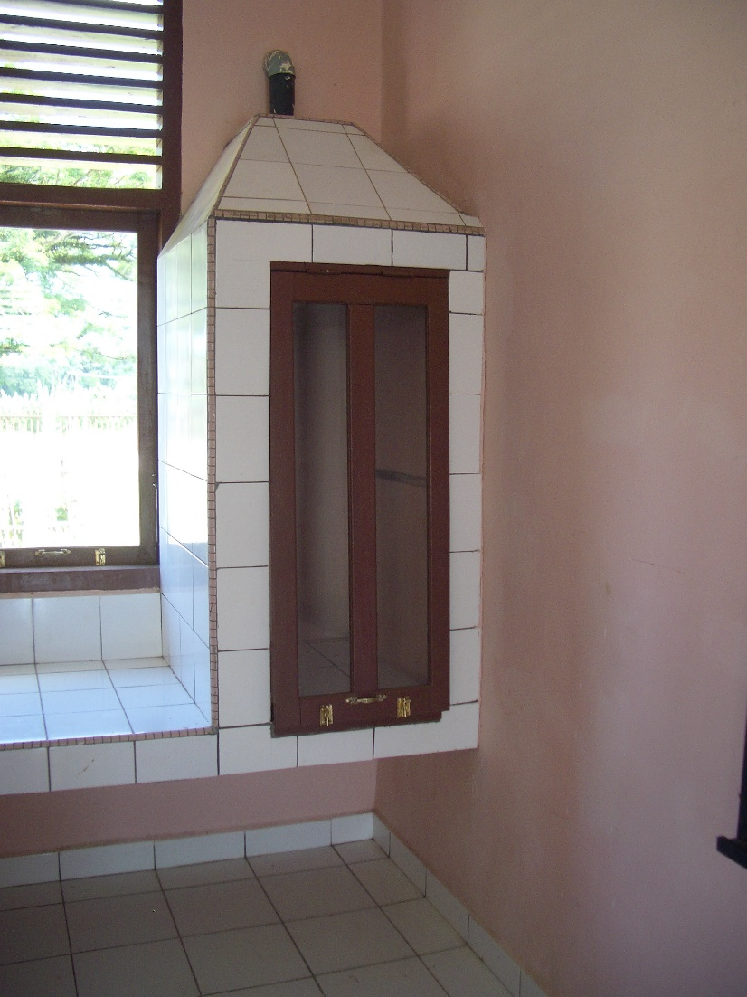
Plate 3: Fume cupboard to laboratory showing inadequate design
Conclusions: The school is very clean and well kept. There are however a few problems. The main one is that the free-standing veranda columns are only 17cm x 14cm and this probably includes rendering so the actual size is likely to be 15cm x 10cm. As the columns are well over 3.5 metres high, there are no stiffening beams in any direction and there is also the usual doubt as to the size of the reinforcement that has been used, it is felt that these columns are much too small. The consultants should therefore check the slenderness ratio of the columns and also the reinforcement size and make proposals to rectify the situation if there are any structural problems. This is a serious supervision failure by the consultants and it is suggested that any remedial work should be carried out at their own cost. Another problem is that there is insufficient fall to the storm drains and water is therefore collecting in the drains providing breeding places for mosquitoes. This is another supervision failure and the consultants should again make proposals for rectifying the problem. The general construction however seems very good, the joinery is of a good standard and the buildings are well painted and looked after.
School Data:
The school operates one shift and has at present three streams of Class 1 only. There are 125 students in total, 68 boys and 57 girls.
The average class size is therefore just over 40. Demand for places is high and 150 students have already enrolled for the coming year. They could all be accommodated but the average class size will be very high at 50 per class. There will be a problem in the following year because the school only has six classrooms. The school is going to propose to the Bupati that three more classrooms are built using APBD funds. This usually means however that a contractor is used although the head teacher would prefer to use the school committee.
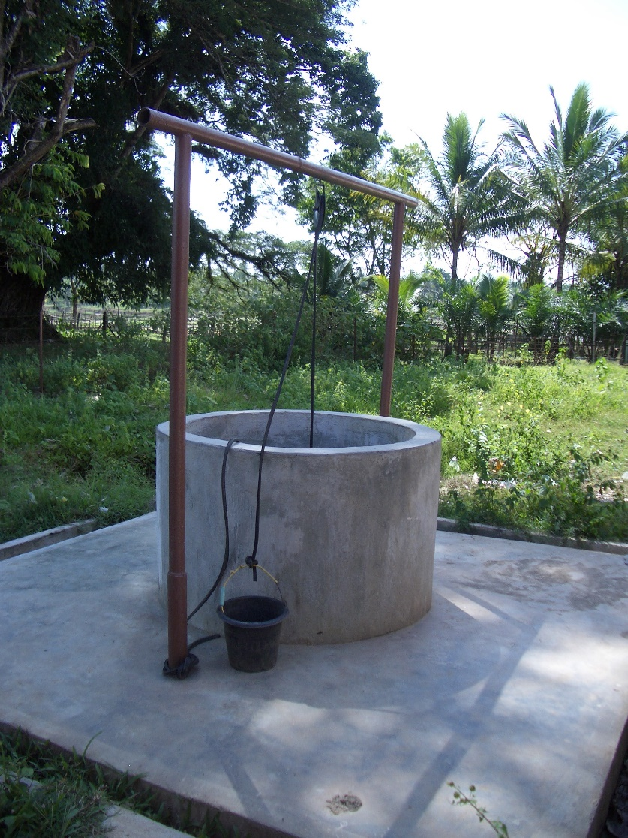
Plate 4: Well with no cover and bucket sitting on ground
The school has 13 teachers and 3 administrative staff. 12 teachers have S1 degrees and 1 has a D1 diploma. 3 teachers are paid by central government, 2 are contract teachers paid by central government and 8 are ‘honor’ teachers paid by the school committee out of school fees. 7 teachers are women and 6 are men. The head teacher was the head of the school committee during construction.
For the first year of operation the school has not received any funds from government but has received Rp99 million from the project to run the school. The schools in this district are not allowed to charge school fees and so the only funds that will be available in future for operational purposes including maintenance will be Rp15,000 a student per quarter (Rp75, million a year) from the district government. The school committee will have to raise funds therefore to pay the ‘honor’ teachers and to meet any maintenance or repair costs.

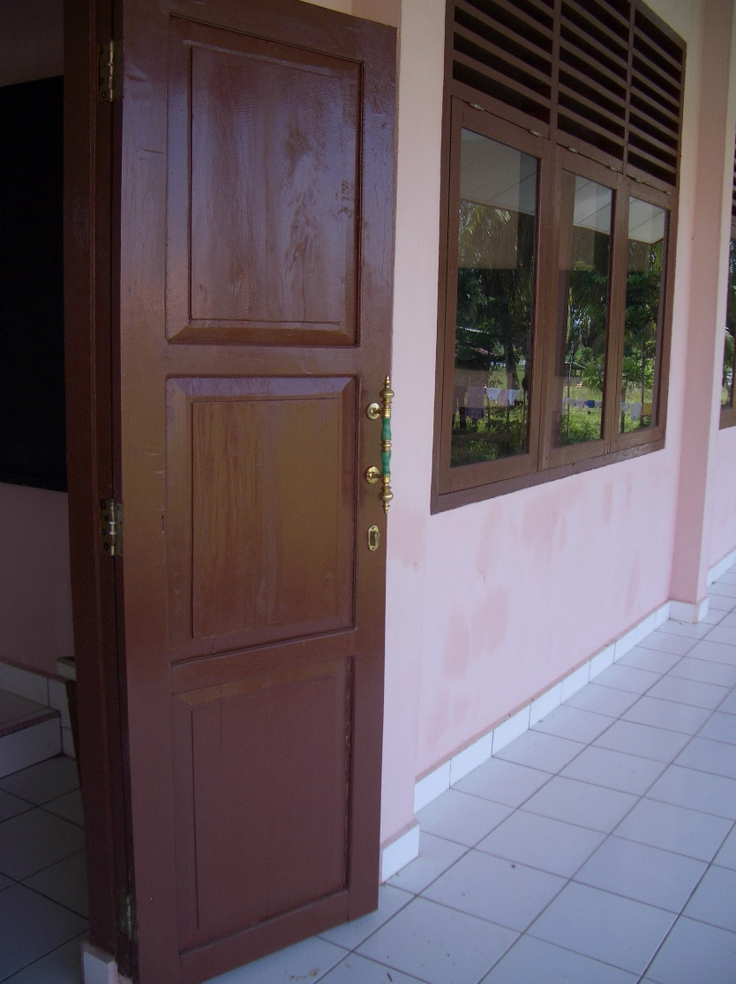
Plate 5: Simple hardware to classroom doors that should last longer than the normal door
handles
3.2 SLTPN 10 Babat Toman, Kabupaten Musi Banyuasin: This school was built by a contractor in 2000. The budget was approximately Rp800 million. All buildings have concrete tiles to the floors and verandas and veranda columns are at least 20cm x 20cm. Window cills are 120cm high.
The site is in a village and is flat and rather wet. There is a rendered brick wall all round the site. The school has a mains electricity supply and water is pumped from a well using a pump that is installed in a toilet compartment. The electricity connection is rather dangerous as it is exposed to water! The well is about 15 metres from the septic tank. There is no high level tank.
3-Classroom Building 1: The building is in reasonable condition but the floors are dropping and there are a few roof leaks. All door handles to classrooms are broken. All classrooms have only 4 tungsten fittings for lighting.
3-Classroom Building 2: The building is in reasonable condition but again the floors are dropping and there are a few roof leaks. All door handles to classrooms are broken. All classrooms have only 4 tungsten fittings for lighting.
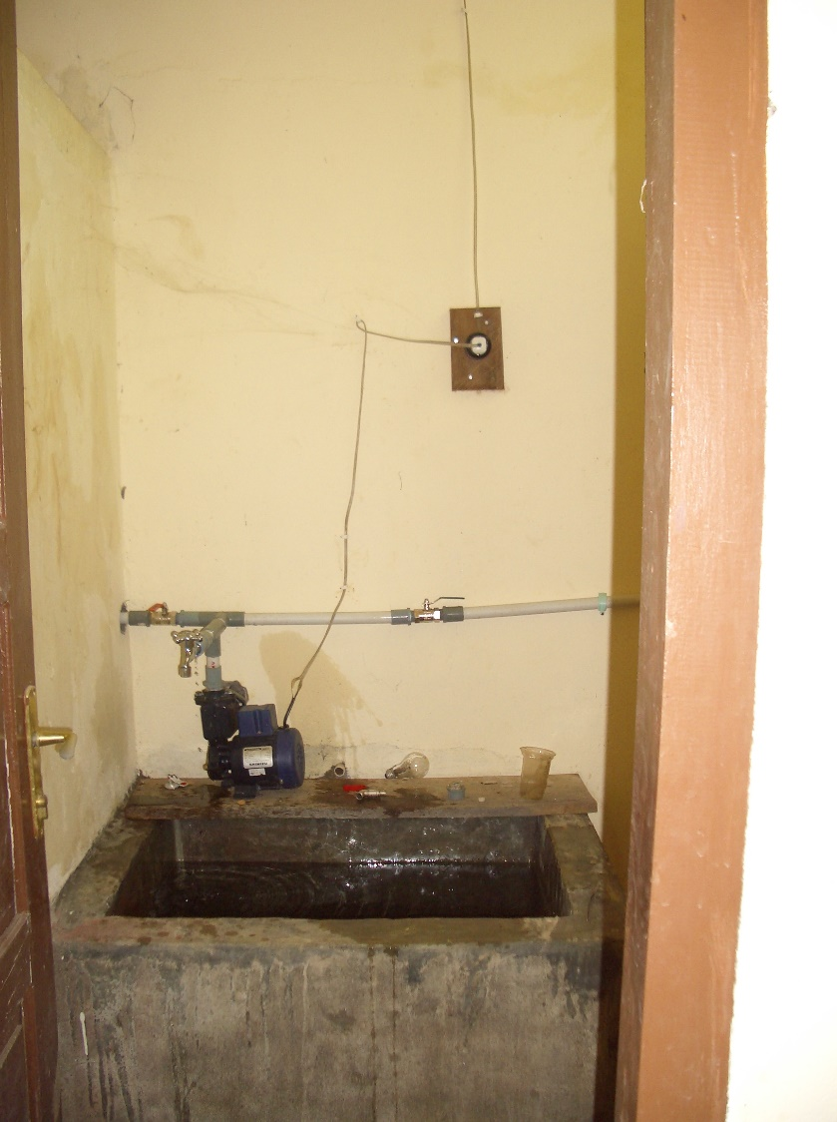
Plate 6: Dangerous water pump and electrical installation
Laboratory: The building is in reasonable condition but again the floor is dropping and there are a few roof leaks. There is no fume cupboard.
Administration: The building is in reasonable condition but again the floors are dropping and there are a few roof leaks.
Library: The building is in reasonable condition but the floors are dropping and there are a few roof leaks.
Musholla: The building has lots of roof leaks.
Toilets: The toilets are not tiled and are dirty and not well looked after. The floors are sinking and the ‘mandis’ are leaking through the walls. New surface pipe work has been installed and as stated above the pump installation in one toilet is rather dangerous. The paving around the building is collapsing.
Staff Quarters: Each of the staff quarters has its own well. Unfortunately these wells are only about 10 metres from the septic tanks serving the houses and are probably contaminated.

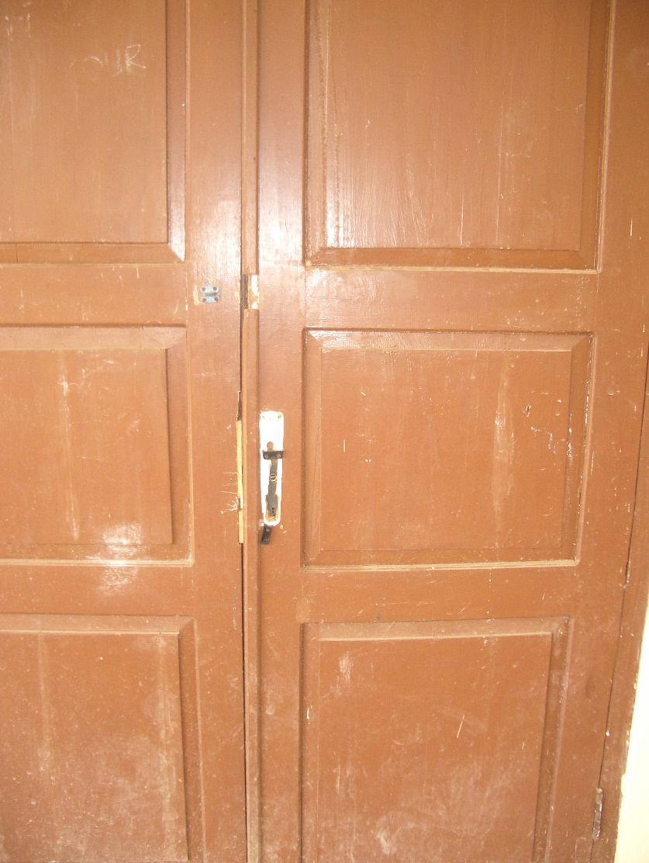
Plate 7: Broken hardware to door
Conclusions: The school is quite clean (apart from the toilets) but there are serious problems with the floors caused probably by the contractor back-filling on top of top-soil containing vegetable matter. The floors are now subsiding as the vegetable matter rots. All floors will eventually have to be taken up, the vegetable soil removed, the floor area properly back-filled and compacted and new floors laid. This will be a very expensive process which could have been avoided if the floors had been properly constructed in the first place. This is a failure on the part of both the contractor and the supervisor. There are also a number of roof leaks that should be fixed as soon as possible before more damage is caused and some of the paving around the buildings is collapsing and requires repair. The toilets also require urgent repairs and the electrical/pump installation should be made safe as soon as possible. All wells should be checked to see if they are contaminated. Altogether, very little basic maintenance seems to have been carried out.

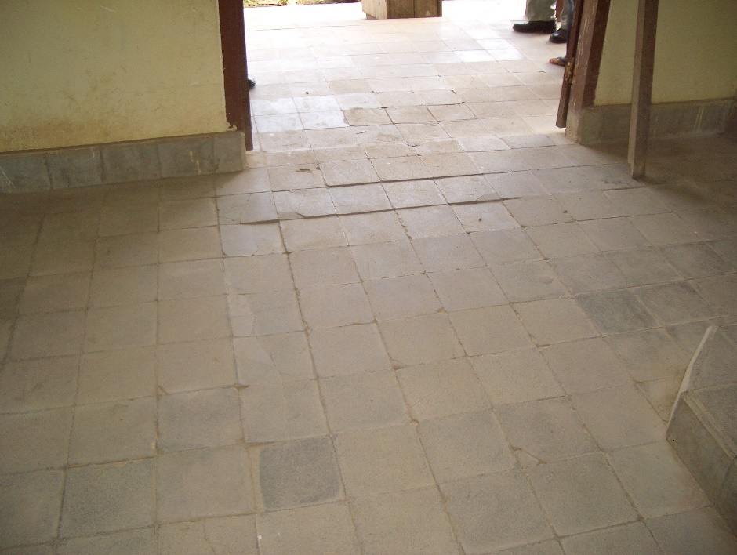
Plate 8: Floor and tiles subsiding
School Data:
The school operates one shift and has two streams in each class and the numbers are as follows:
Class | Boys | Girls | Total
Class 1 | 34 | 35 | 69
Class 2 | 42 | 33 | 75
Class 3 | 36 | 35 | 71
 |  |  | 221
The classes are therefore smaller than the norm of 44 (average class size 37) and the school does not require any additional classrooms. The school is operating under capacity because there are not enough graduates from the surrounding primary schools.
The school has 19 teachers and 5 administrative staff. All teachers have S1 degrees. 10 teachers are male and 9 are female.
The school’s operational budget is as follows: the school receives Rp15,000 a student a month (Rp39.78 million a year) from central government to run the school (this has not been received so far this year). 75% of this goes towards teachers’ welfare and incentives and 10% towards the cost of students’ extra-curricular activities. The school also receives Rp32 million a year from the district for operation and maintenance some of which is spent on stationery, running the school and maintenance. The school has also received some extra money from APBN for maintenance; the school has been painted once and some repairs have been carried to ceilings and furniture.
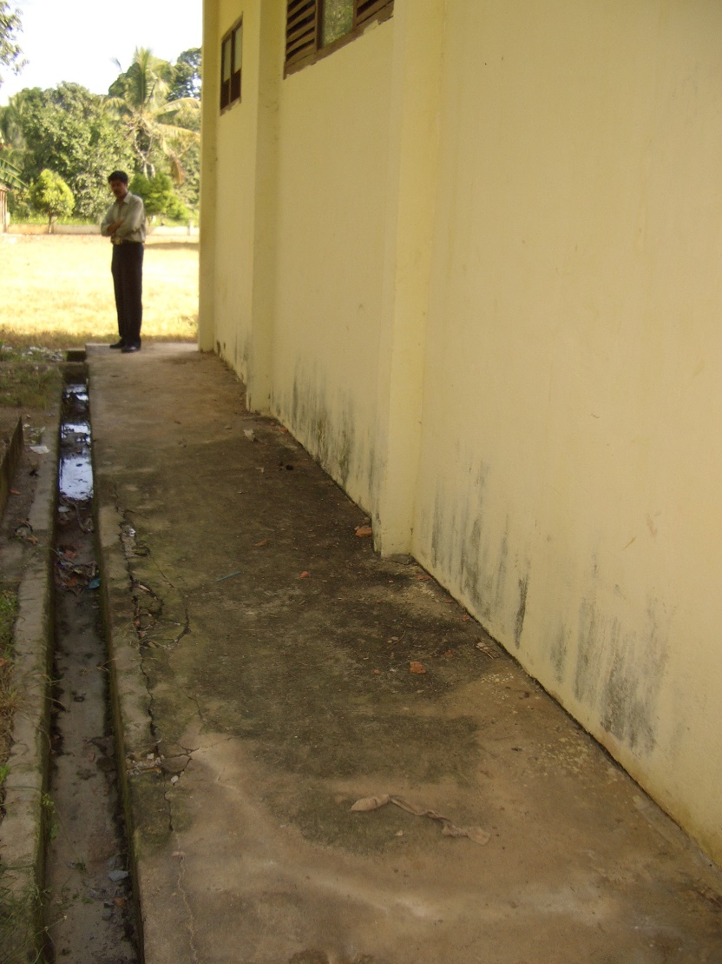
Plate 9: Paving around building breaking up
  - SMPN 4 Inderalaya, Kabupaten Organilia: The school was constructed in 1998 by a contractor. Two additional 2-classroom buildings have been constructed under the project, one in 2002 using matching grant funds and one in 2001 using block grant funds. The original buildings have concrete floor tiles and quite good joinery.
The site is flat and well planted. The school has mains electricity and water is supplied from a shallow well which has a pump that is broken. There are also two ground level water storage tanks that used to be fed by gutters but these are broken and the tanks are no longer in use.
Administration: The building is in reasonable condition but there are some bad roof leaks. The building was renovated in 2000 using district funds and glazed floor tiles were laid.
Library: The building is in reasonable condition but there are some roof leaks and the paving around the building is starting to break up in places.
Laboratory: The building is in reasonable condition but there are some bad roof leaks and the bargeboard and fascia board are rotting at one external corner. There are two tiled wall benches and tiled sinks but no water supply. There is a fume cupboard similar to that at the previous school but with side hung doors. It is obviously never used as there is a bird’s nest in the ventilation pipe!
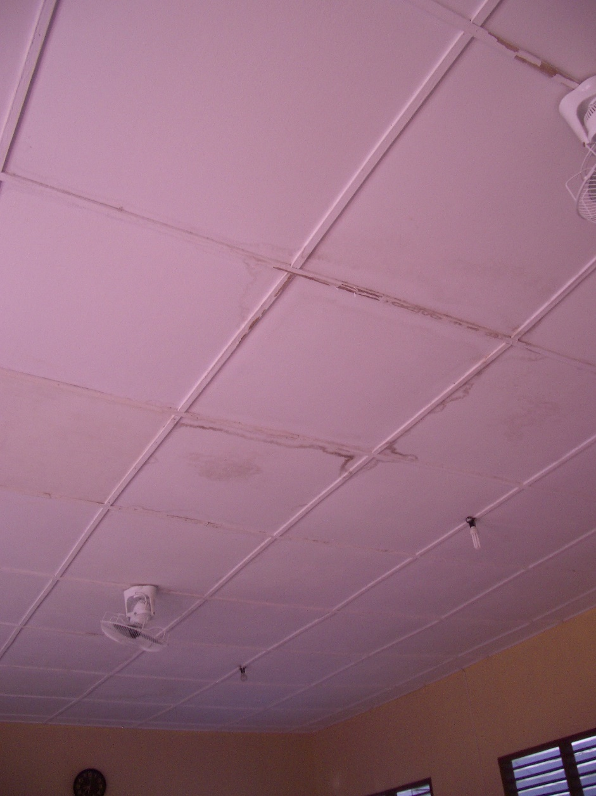
Plate 10: Typical roof leaks
3-Classroom Building 1: The building is in reasonable condition but some ceiling panels are broken, the concrete tiles to the veranda are starting to break up and all door handles are broken. There are also some roof leaks.
Musholla: The building is in reasonable condition but there is one roof leak.
3-Classroom Building 2: The building is in reasonable condition but there are some roof leaks, the concrete floor tiles are starting to break up and the paving around the building is also breaking up.
2-Classroom Building 1 (Block Grant 2001): The building was constructed by the school committee and is well built with quite good joinery but there are some roof leaks and some broken ceiling panels to the veranda. It has glazed cement floor tiles.
2-Classroom Building 2 (Matching Grant 2002): The building was constructed by the school committee and cost Rp93 million. It is well built with quite good joinery and finishes. It has glazed ceramic floor tiles.

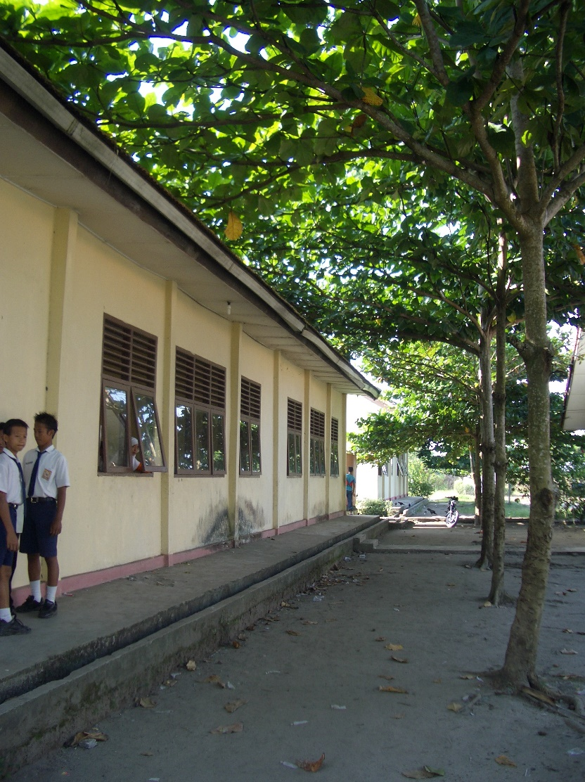
Plate 11: Trees too close to building and broken gutter for collecting roof water
Students Toilets: The old toilets are very dirty and not well maintained. The taps are broken, the floor tiles are very dirty and are starting to break up. The well next to it is very deep but dry and full of rubbish.
New Students Toilets (Matching Grant 2002): The toilets cost Rp16 million but were locked (because there is no water) and no inspection was possible.
Conclusions: The construction of the original school buildings was quite good (although some roofs are not very level) and the construction carried out by the school committee was also quite good. The school however is very dirty and run down and very little maintenance or even cleaning is being carried out (there is litter all over the school). The school has apparently been painted twice since it was built using funds raised by the school committee. All buildings now require some maintenance and the repairs to the roofs that are leaking (and to the ceilings) should be carried out as soon as possible in order to stop further damage. There are some serious problems of rot to some of the roof timbers particularly along the verandas and at roof junctions and these should be cut out and repaired as soon as possible. The covered roof link between the administration building and the laboratory seems to be collapsing and should be repaired or taken down as soon as possible. The surface to some concrete tiles is deteriorating and some paving around buildings is breaking up. Some trees behind one of the 3-classroom buildings have their branches resting on the roof and these should be cut back before they damage the roof or roof timbers.
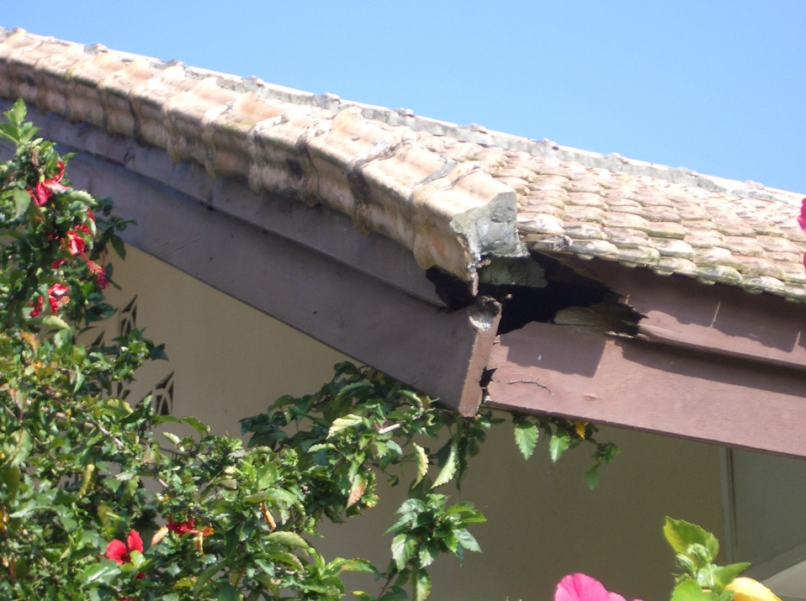
Plate 12: Rotting fascia and verge board to laboratory
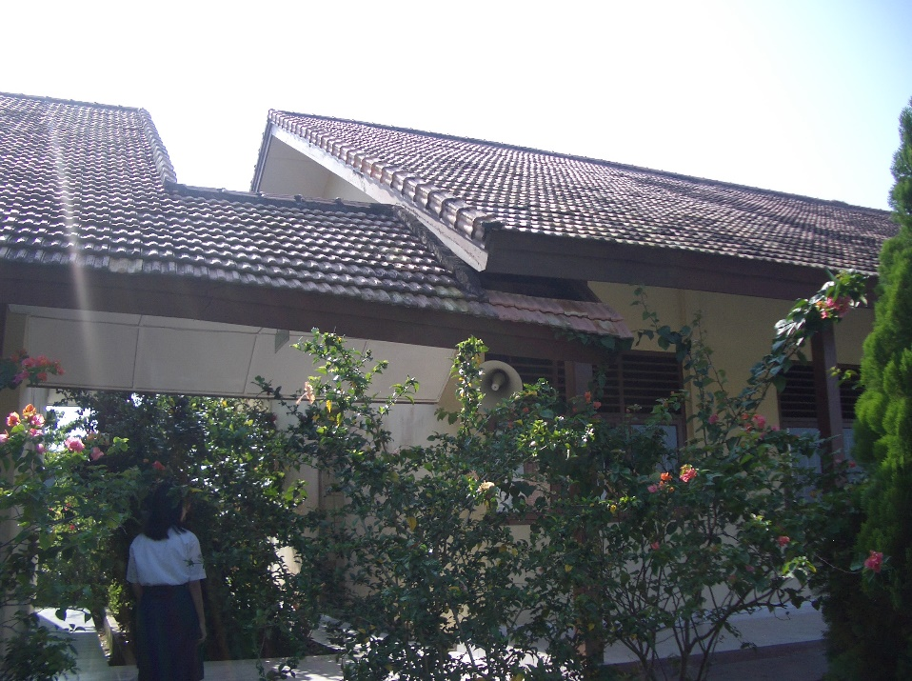
Plate 13: Roof to link between laboratory and administration collapsing
School Data:
The school operates one shift and has two or three streams in each class and the numbers are:
Class | Boys | Girls | Total
Class 1 | 115 | 81 | 196
Class 2 | 106 | 64 | 170
Class 3 | 78 | 64 | 142
 |  |  | 508
The classes are larger than the norm of 44 (average class size 51) and the school really requires two additional classrooms so that it could have three streams in each class.
The school has 30 teachers and 6 administrative staff. All teachers have S1 degrees. 24 are paid by central government, 1 is a contract teacher and 5 are ‘honor’ teachers.
The school’s operational budget is as follows: the school receives Rp12 million from the district to run the school including maintenance. The school also receives Rp60.96 million from students in school fees some of which goes towards teachers’ salaries and the rest is spent on stationery, running the school and maintenance.
  - SMPN 6 Gunung Megang, Kabupaten Muara Enim: This school was constructed by the school committee, was completed in March 2003 and has been in use since July 2003. The head teacher was the head of the school committee. The total budget was Rp1,087,927,700. The school does not have a musholla because there is one close by in the village. The civil works consultants for this school were Indra Karya from Jakarta.
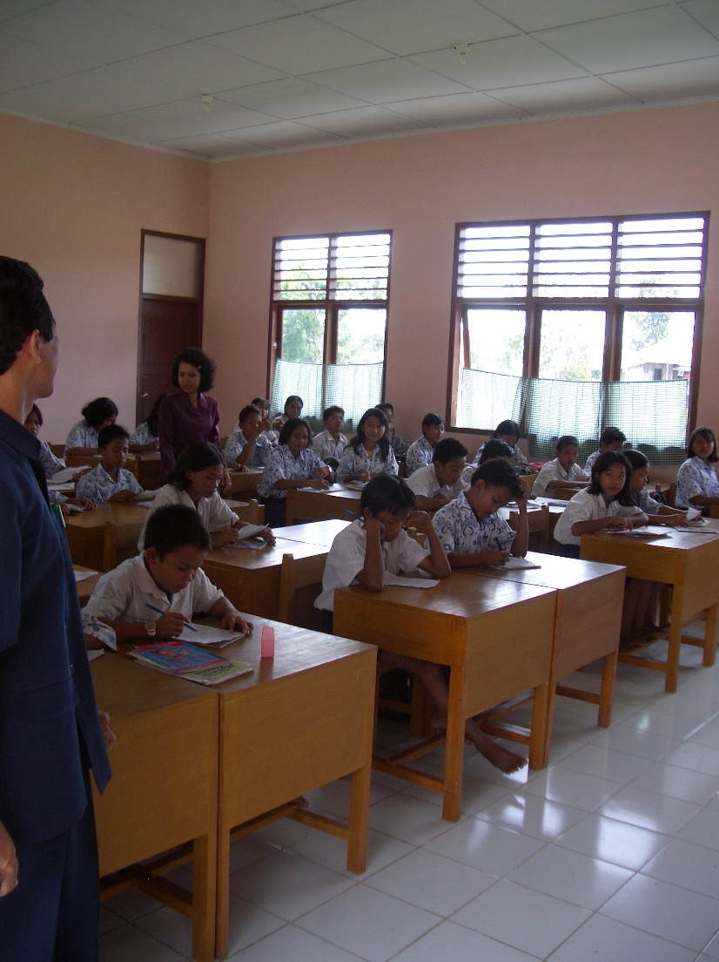
Plate 14: Well lit and ventilated classroom with good quality furniture and finishes
The site is on the edge of a village and has houses very close to the front of the site. A new concrete access road (approximately 200 metres long) with drains to both sides has been constructed from the main road to give access to the site. The site is flat and quite wet. There is a brick fence with steel railings at the top at the front of the site and a barbed wire fence to the other three sides. There are paving and drains around all buildings, a paved area for assembly, site paths and drains. The school has mains electricity and the water supply is from a well with a pump next to the toilets and about 15 metres from the septic tank.
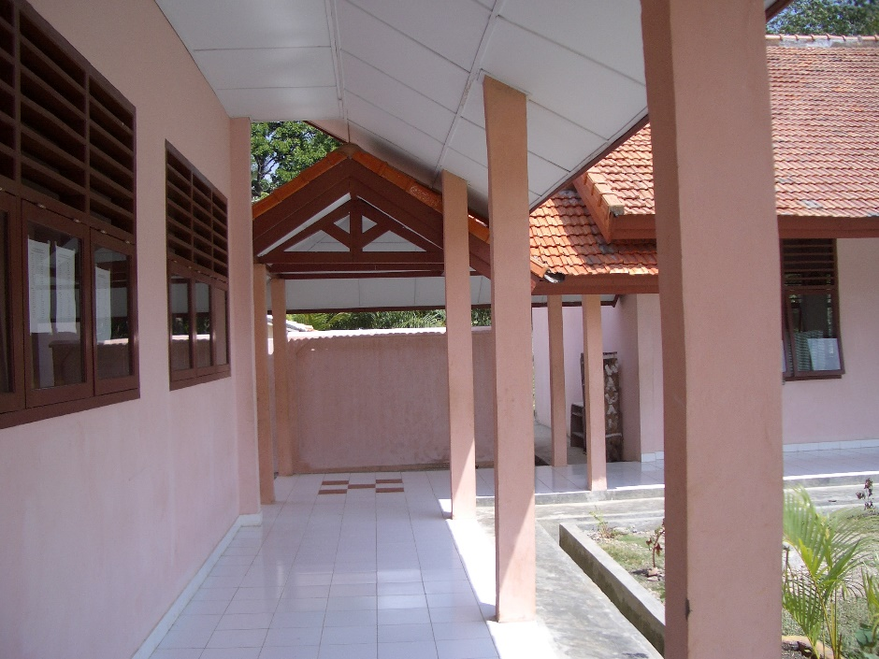
Plate 15: Veranda to classrooms: note no visible column to classroom wall but good quality finishes
Administration: The building seems well constructed and there are no roof leaks or cracks to walls.
Library: The building seems well constructed and there are no roof leaks or cracks to walls. The furniture is well made but there are only a few text books.
Students’ Toilets: The building seems well constructed and has two male toilets and two female toilets. The pipe work is plastic and will probably not last long. The ‘mandis’ are already leaking through the outside walls which are stained.
Laboratory: The building seems well constructed and has tiled benches to two walls with two sinks in one bench. There is again a fume cupboard similar to that at the previous schools.
3-Classroom Buildings 1 and 2: The buildings seem well constructed and there are no roof leaks or cracks. The columns to the window walls between cross walls have however been reduced to the width of the wall. The furniture is quite well made. All classrooms have 4 tungsten light fittings.
Conclusions: As stated above, the buildings seem generally well constructed and finished and there are no signs yet of roof leaks or cracks to walls. However there is great concern about the structural strength of the columns to the classroom walls. These have been reduced to around 10cm x 15/20cm and the reinforcement is probably only 10mm diameter. The consultants should, as a matter of urgency, check the strength of these columns and if they are inadequate propose remedial measures. This again is a supervision failure on the part of the consultants and if remedial measures are required it is felt that the consultants should pay for them.

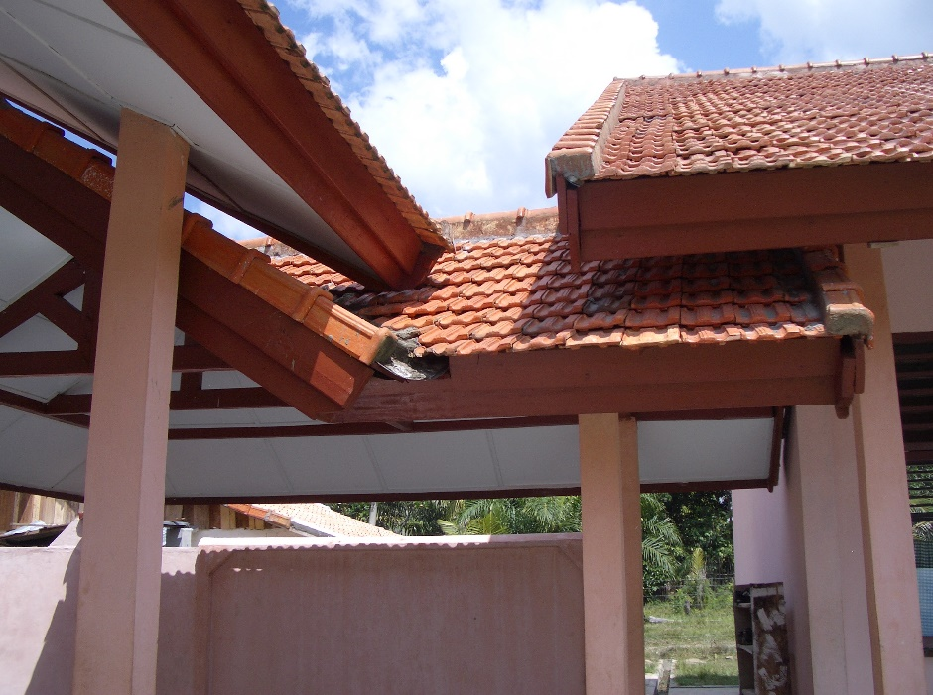
Plate 16: Very complicated roofs to links between buildings that will cause maintenance problems in the future
The hardwood doors seem to have been made from unseasoned wood and are already splitting badly and the hardware is very poor quality and will not last long. The tiling to the verandas has not been laid very well.
Another problem is that the verandas and paving around the buildings have been constructed flat with no falls to drain away the water which is therefore collecting around the buildings and the drains do not have sufficient falls to drain away storm water which is collecting and could provide breeding areas for mosquitoes.
The roof links between buildings are very complicated and will probably cause problems in the long run due to rotting timbers, etc.
School Data:
The school operates one shift and as it is in its first year only has students in Class 1. There are four streams and the numbers are as follows:
Class 1 | Boys | Girls | Total
Stream 1 | 27 | 16 | 43
Stream 2 | 27 | 18 | 45
Stream 3 | 26 | 19 | 45
Stream 4 | 22 | 23 | 45
 |  |  | 178
The school has six classrooms four of which are in use for Class 1. Next year therefore the school will require an additional two classrooms and the year after that an additional four classrooms. The head teacher has asked for an additional six classrooms but only two have been approved for next year and these will not be built until September. The school will therefore have to do some double-shifting until these classrooms are finished. Six primary schools feed the school and the nearest SMP is 9 kilometres away.

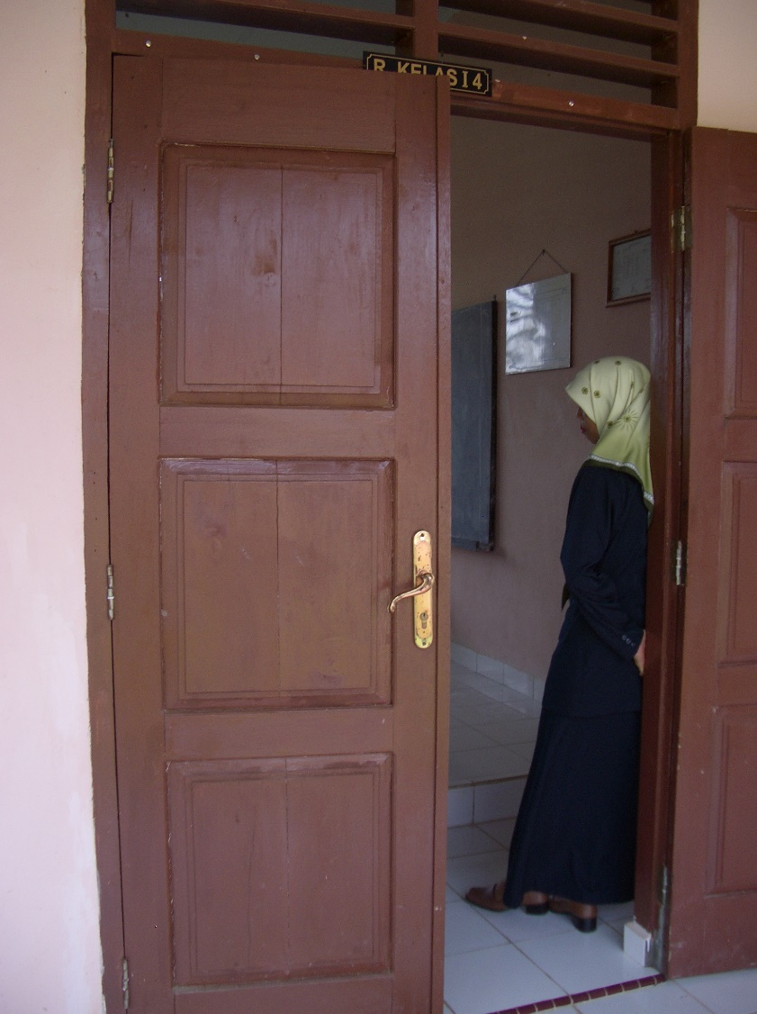
Plate 17: Poor quality timber to door already splitting; note also poor quality hardware
The school has 17 teachers, 15 of whom have S1 degrees, 1 has a D3 diploma and 1has D1 diploma. 4 teachers are paid by the government, 9 are contract teachers and 4 are ‘honor’ teachers. Some of the teachers have to travel 20 kilometres to the school and wanted teachers’ quarters to be built.
The school’s operational budget is as follows: the school receives Rp16 million a year from the district to run the school including maintenance. The school also receives Rp13,000 a month/per student (Rp27.77 million a year) in school fees some of which goes towards teachers’ salaries and the rest is spent on stationery, running the school and maintenance.
The school’s only computer is used for administrative purposes.

