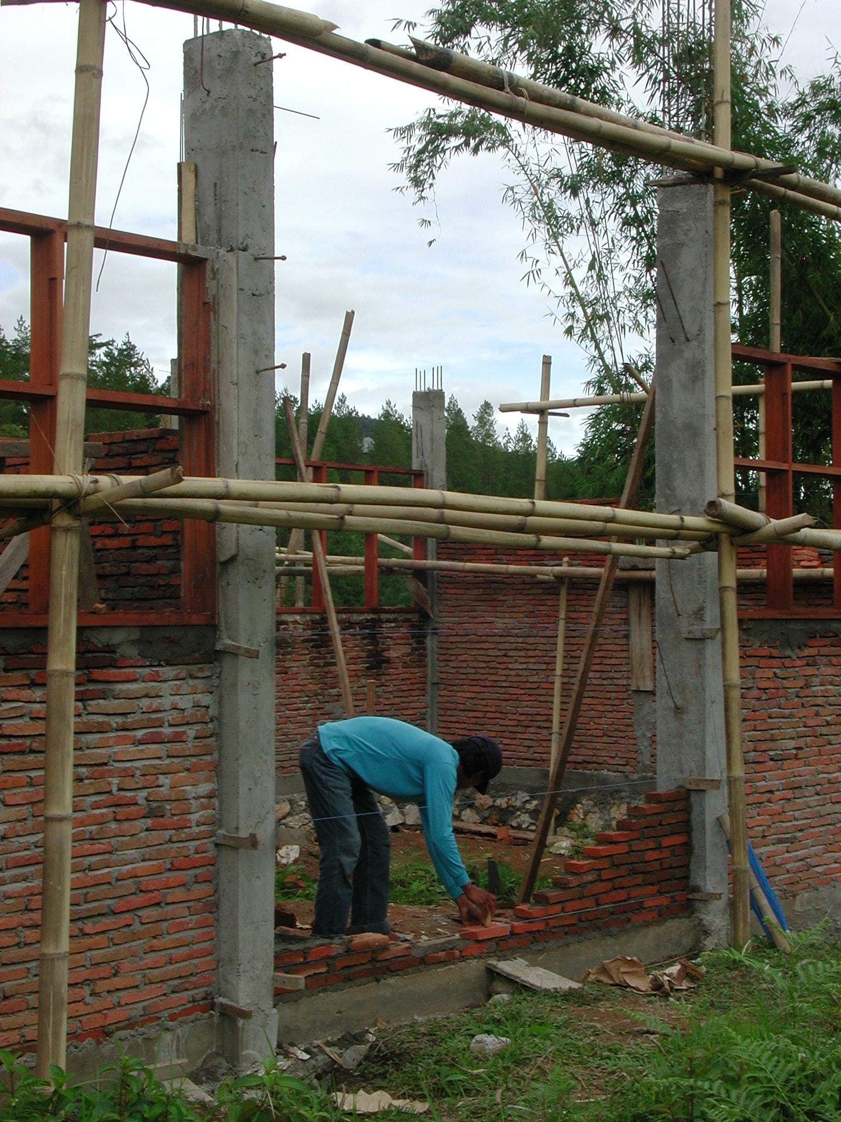
JUNIOR SECONDARY EDUCATION PROJECTS

CONSTRUCTION SPECIALIST’S REPORT
DECEMBER 2003

JUNIOR SECONDARY EDUCATION PROJECTS
LOANS 4042-IND, 4062-IND, 4095-IND

CONSTRUCTION SPECIALIST’S REPORT: DECEMBER 2003

TABLE OF CONTENTS

A. Introduction 3

1. General 3
2. Construction Specialist’s Terms of Reference 3
3. Meetings 3
4. Visits 3

B. Issues and Recommendations 4

1. General 4

2. Civil Works Consultants 4

2.1.1 Drawings 4
2.1.2 Budgets 4
2.1.3 Site Organisation 5
2.1.4 Management 5

3. Construction Issues 5

3.1.1 Concrete 5
3.1.2 Reinforcement 5
3.1.3 RC Columns 6
3.1.4 Foundations 6
3.1.5 Top-Soil 6
3.1.6 Wells and Septic Tanks 7

4. Other Issues 7

4.1 Sites 7
4.2 Community Participation 7

ANNEXES

Annex 1: Report on Visit to West Nusa Tenggara Province 8
Annex 2: Report on Visit to South Sulawesi Province 26

Cover Illustration: SLTPN Peta Kurra, Kabupaten Tana Toraja, South Sulawesi Province
A. Introduction

1. General

  - The Construction Specialist visited Indonesia from December 7th to December 20th 2003 to assess the progress of the implementation of the Block Grants being provided by World Bank loans for new Junior Secondary School construction in West Nusa Tenggara and South Sulawesi Provinces.

2. Construction Specialist’s Terms of Reference

2.1 The Construction Specialist’s terms of reference for the mission were to:

- Assess the readiness to implement the Block Grant programme in terms of its compliance with the agreed manual, particularly with respect to:

  - Compliance with the criteria for site selection (especially in terms of community demand and technical appropriateness of the land).

  - Status of the land.

  - Readiness of the community for the programme as reflected by the formation and composition of the Construction Committee (KP-USB).

- Assess the readiness and performance of the Construction Management Consultants and provide them with inputs for improvement.

- Discuss the findings and recommendations with the CPCU and concerned provincial and district officials.

- Discuss the findings with other World Bank consultants.

- Provide the Task Team Leader with a summary report and a complete report.

3. Meetings

3.1 Meetings were held with the manager of the Construction Management Unit of the CPCU and his staff, with members of the Provincial and District Technical Teams, with the civil works consultants and their site staff and with members of school committees and their technical teams on the school sites in the provinces visited.

4. Visits

4.1 Visits were made to new school construction sites in two provinces: West Nusa Tenggara Province and South Sulawesi Province. Details of the visits are given in Annexes 1 to 2.

B. Issues and Recommendations

1. General

  - The main issues raised by the school visits concern the performance of the civil works consultants and the quality of the construction.

1.2 Most of the construction issues noted occurred on more than one site and many of them, such as the quality of the concrete, occurred on many sites.

2. Civil Works Consultants

2.1 Many of the problems noted at the school sites were the result of poor management and supervision by the civil works consultants, particularly the construction managers (CMs) on site. These problems included:

    - Drawings: All schools in both provinces have been supplied with sets of standard drawings with only the site layout varying at each school. While the drawings are in most cases quite good as far as they go there is everywhere a lack of working details. There are no large-scale sections or details of roof trusses and there are also no details of how the columns and ground beams should be set out and this has led to problems on some sites.

There seem to have been no levels surveys carried out at any of the sites in either province and none of the site layouts have detailed levels of the buildings, drains, etc and there are no site works details. Some sites are very wet and require extensive site drainage or cut-off drains and some sites slope and will require extensive retaining walls, steps, etc. Without details of these site works it is difficult to see how the consultants can have prepared accurate budgets for the works.

The drawings prepared by PT Karya Utama Citramandiri in South Sulawesi Province are some of the worst ever seen on such a project. They are totally inadequate for the work to be carried out and are probably a contributory factor to the very poor quality work being carried out at SLTPN Pallangga.

Recommendations: The consultants in both provinces should prepare all necessary details for the buildings and detailed site works drawings for the use of the CMs and the school committees.

PT Karya Utama Citramandiri must ensure that all their sites have sufficient accurate and detailed drawings of both the buildings and the sites to enable the school committees to construct the buildings to an acceptable standard with the assistance of the CMs.

    - Budgets: There is a danger on some sites in both provinces that there will be insufficient funds for completing all the necessary site works.

Recommendations: The consultants in both provinces must check the budgets at all sites and ensure that there are sufficient funds to cover all necessary site works including drains, retaining walls, steps, etc. They should report to the CMU as soon as possible if they consider that there may be a shortfall at any of the sites.

    - Site Organisation: On many sites in both provinces, door and window frames and roof trusses are being made and/or left out in the open, exposed to sun and rain.

Recommendations: The consultants in both provinces are asked to ensure that all materials, particularly finished ones, are properly protected.

    - Management: The problems seen on the sites in both provinces do not appear to have been picked up by the consultants’ team leaders who should have resolved the problems before they became serious.

Recommendations: The consultants in both provinces should work more closely with the School Committees to improve the quality of the work. The consultants should also supervise the sites and the work of their CMs more closely and ensure that any problems are picked up and rectified at an early stage.

3. Construction Issues

3.1 A number of construction issues were noted during the visits and most of them occurred in both provinces. They included:

    - Concrete: There are problems with the mixing of concrete on many sites. The problems include: inaccurate measurement of the materials; insufficient mixing of the materials when dry; using too much water in the mix; only mixing part of the materials measured out; using too little cement and aggregate and too much sand in the mix. On several sites the sand being used for concrete was very poor quality and the aggregate was either too small or too large.

Recommendations: The consultants in both provinces must ensure that all of these bad practices which will result in poor quality and weak concrete are stopped.

The consultants in both provinces should also check the quality of the concrete work already completed at all sites and report back to the CMU.

Concrete work at SLTPN Plampang and SLTPN 02 Jerowaru Lotim in West Nusa Tenggara Province has been stopped and the consultants must check the quality of concrete beams and columns at both schools as soon as possible and assess what remedial work needs to be carried out and report back to the CMU.

All work at SLTPN Pallangga in South Sulawesi Province has been stopped due to the extremely poor quality of the work, particularly the structural concrete work and the consultants must check the quality of concrete beams and columns as soon as possible and assess what remedial work needs to be carried out and report back to the CMU.

    - Reinforcement: The reinforcement specified in both provinces for the main columns and beams is 12mmØ but on many sites smaller reinforcement is being used. On some sites the laps to the reinforcement in columns are inadequate and the reinforcement to beams has not been taken into columns. On many sites the links to the reinforcement are spaced at greater intervals than those specified.

Recommendations: The consultants in both provinces must check the reinforcement being used at all sites and ensure that both the correct sizes of reinforcement and sufficient reinforcement are being used in all structural concrete.

    - RC Columns: On all sites in West Nusa Tenggara Province, columns in walls are being cast between panels of brickwork rather than being cast in proper formwork before the brickwork is built. This usually results in poor quality concrete because the cover to the reinforcement cannot be controlled; the formwork is not straight, etc.

Recommendations: In future the consultants should ensure that columns are cast in formwork (as they are being at most of the sites in South Sulawesi Province) before the brickwork is started and that ties for the brickwork are cast into the columns.

    - Foundations: On some sites in both provinces, the stone foundations below columns have not been increased in size or the position of the ground beams and the columns is such that the columns are partly unsupported and are overhanging the foundations.

Recommendations: The consultants in both provinces should prepare details of the column foundations for the use of the CMs and ensure that on those sites where there are overhanging columns, the column foundations are increased in size and properly tied into the existing foundations.

    - Top-Soil: On all sites in both provinces top-soil, roots and vegetable matter has not been stripped off the area of the buildings and top-soil is also being used for back-filling. On several sites, foundations have been built over the roots of trees.

Recommendations: It is a fundamental of good building practice that all top-soil and vegetable matter is stripped off the area of construction to avoid failures of foundations and floors and in future the consultants in both provinces should ensure that all top soil and vegetation is stripped off the area of the buildings before excavation is started.

At all sites, the consultants must ensure that all top-soil (and any back-filling already placed) is removed from the internal areas of the buildings including the verandas and that back-filling is carried out using suitable material laid in 15cm layers and properly compacted.

    - Wells and Septic Tanks: At SLTPN 02 Batulayar in West Nusa Tenggara Province where the site is very wet, the consultants should ensure that all septic tanks and soakaways are at least 30 metres away from the well.

At all other sites, any wells should be constructed at least 15 metres away from septic tanks and soakaways on dry sites and at least 30 metres away on wet sites.

4. Other Issues

4.1 Sites

4.1.1 In West Nusa Tenggara Province there were no particular issues noted about the sites. All sites seemed large enough, there seemed to be no ownership issues and access to the sites visited did not seem to be a problem. There also seemed to be sufficient numbers of potential students for the schools.

One site in Tana Toraja District however is not accessible by road during the rainy season and could not be visited.

Recommendations: The Provincial Technical Team should check whether this affects access by students during the rainy season.

4.1.2 In South Sulawesi Province all sites visited seemed large enough and access to them did not seem to be a problem. There also seemed to be sufficient numbers of potential students for the schools. There did not appear to be any ownership issues apart from at SLTPN Cakkeawo.

Recommendations: At SLTPN Cakkeawo, there is an existing house on the site adjacent to the entrance and the District Technical Team must ensure that the house is removed as soon as possible and any ownership problems resolved.

At SLTPN 04 Pallangga, the Administration Building is very close to some village houses on the entrance side and the consultants should check that there is sufficient room for access.

4.2 Community Participation

4.2.1 At all of the sites visited, there were School Committees and Technical Teams set up to manage the construction and they seemed in the main to be managing the work quite well.

    - At only one site, SLTPN 04 Pallangga in South Sulawesi Province, was there any real doubt about the ability of the School Committee and Technical Team to manage the construction.

Recommendations: The CMU should investigate the composition and abilities of both the School Committee and the Technical Team and in particular the role of the kepala pelaksana, to see whether they are capable of improving the standard of construction. If they are not, all members of both should be changed.
ANNEX 1: REPORT ON VISIT TO WEST NUSA TENGGARA PROVINCE

1. General

  - West Nusa Tenggara Province was visited between December 8th and December 12th 2003 together with the manager of the Construction Management Unit of the CPCU.

  - Meetings were held with the head of the Provincial Technical Team, the World Bank implementation consultant, the CMU representative in the province, the civil works consultants and their site staff and members of school committees and their technical teams on the new school sites.

  - The civil works consultants in the Province are PT Adhicipta Engineering Consultants.

  - New schools were visited in three districts: Kabupaten Sumbawa on Sumbawa Island and Kabupaten Lombok Barat and Kabupaten Lombok Timor on Lombok Island.

  - A standard design for the junior secondary schools is being used in the province and the schools consist of six classrooms in two 3-classroom buildings; a multi-purpose room (replacing the traditional laboratory and designed to serve a variety of functions); a library; an administration building; a musholla; toilets; a penjaga’s house/canteen; a head teacher’s house, a bicycle shed and separate toilets. The total area of the buildings is 888.5m² with 306.48m² of verandas giving a total building area of 1,195m².

  - Construction is similar at all schools: foundations are of stone set in mortar; walls are of rendered brickwork with RC columns, ground beams, ring beams and veranda beams; roofs are of clay tiles on battens, on timber rafters, purlins and trusses, ceilings are of plywood; windows and doors are of timber with timber panel doors and glazed windows; floors and verandas are of ceramic tiles on screed.

2. Issues

2.1 Civil Works Consultants: Many of the problems noted at the school sites were the result of poor management and supervision by the civil works consultants, particularly the construction managers (CMs) on site. These problems included:

    - Drawings: All schools have been supplied with same set of standard drawings with only the site layout varying at each school. While the drawings are quite good as far as they go there is a lack of working details. There are no large-scale sections or details of roof trusses and there are also no details of how the columns and ground beams should be set out and this has led to problems on some sites.

There seem to have been no levels surveys carried out at any of the sites and none of the site layouts have detailed levels of the buildings, drains, etc and there are no site works details. Some sites are very wet and require extensive site drainage or cut-off drains and one site slopes steeply and will require extensive retaining walls, steps, etc. Without details of these site works it is difficult to see how the consultants can have prepared accurate budgets for the work.

Recommendations: The consultants should prepare all necessary details for the buildings and detailed site works drawings for the use of the CMs and the school committees.

    - Budgets: There is a danger on some sites that there will be insufficient funds for completing all the necessary site works.

Recommendations: The consultants must check the budgets at all sites and ensure that there are sufficient funds to cover all necessary site works including drains, retaining walls, steps, etc.

    - Site Organisation: On many sites, door and window frames and roof trusses are being made and/or left out in the open, exposed to sun and rain.

Recommendations: The consultants were asked to ensure that all materials, particularly finished ones, are properly protected.

    - Management: The problems seen on the sites do not appear to have been picked up by the consultant’s team leader who should have resolved them before they became serious.

Recommendations: The consultants were asked to work more closely with the School Committees to improve the quality of the work. The consultants were also asked to supervise the sites and the work of their CMs more closely and ensure that any problems are picked up and rectified at an early stage.

2.2 Construction: A number of construction issues were noted during the visits and most of them occurred on more than one site. They included:

2.2.1 Concrete: There are problems with the mixing of concrete on many sites. The problems include: inaccurate measurement of the materials; insufficient mixing of the materials when dry; using too much water in the mix; only mixing part of the materials measured out; using too little cement and aggregate and too much sand in the mix. On several sites the sand being used for concrete was very poor quality and the aggregate was either too small or too large.

Recommendations: The consultants must ensure that all of these bad practices which will result in poor quality and weak concrete are stopped. The consultants in both provinces should also check the quality of the concrete work already completed at all sites and report back to the CMU.

Concrete work at two schools (SLTPN Plampang and SLTPN 02 Jerowaru Lotim) has been stopped and the consultants must check the quality of concrete beams and columns and assess as soon as possible what remedial work needs to be carried out and report back to the CMU.

2.2.2 Reinforcement: The reinforcement specified on all sites for the main columns and beams is 12mmØ but on many sites smaller reinforcement is being used. On some sites the laps to the reinforcement in columns are inadequate and the reinforcement to beams has not been taken into columns. On many sites the links to the reinforcement are spaced at greater intervals than those specified (15cms).

Recommendations: The consultants must check the reinforcement being used at all sites and ensure that the correct sizes of reinforcement and sufficient reinforcement is being used in all structural concrete.

2.2.3 RC Columns: On all sites, columns in walls are being cast between panels of brickwork rather than being cast in proper formwork before the brick work is built. This usually results in poor quality concrete because the cover to the reinforcement cannot be controlled; the formwork is not straight, etc.

Recommendations: In future the consultants should ensure that columns are cast in formwork before the brick work is started and that ties for the brickwork are cast into the columns.

2.2.4 Foundations: On some sites, the stone foundations below columns have not been increased in size or the position of the ground beams and the columns is such that the columns are partly unsupported and are overhanging the foundations.

Recommendations: The consultants should prepare a detail of the column foundations for the use of the CMs and ensure that on those sites where there are overhanging columns, the column foundations are increased in size and properly tied into the existing foundations.

2.2.5 Top-Soil: On all sites top-soil, roots and vegetable matter have not been stripped off the area of the buildings and top-soil is also being used for back-filling. On one site, a foundation has been built over the roots of a tree.

Recommendations: In future the consultants should ensure that all top soil and vegetation is stripped off the areas of the buildings before excavation is started.

At all existing sites, the consultants must ensure that all top-soil (and any back-filling already placed) is removed from the internal areas of the buildings including the verandas and that back-filling is carried out using suitable material laid in 15cm layers and properly compacted.

2.2.6 Wells and Septic Tanks: At SLTPN 02 Batulayar where the site is very wet, the consultants should ensure that all septic tanks and soakaways are at least 30 metres away from the well.

2.3 Sites

2.3.1 There were no particular issues noted about the sites. All sites seemed large enough, there seemed to be no ownership issues and access to the sites visited did not seem to be a problem.
One site in Tana Toraja District however is not accessible by road during the rainy season and could not be visited.

Recommendations: Access by students to this site in the rainy season should be checked by the Provincial Technical Team.

3. Site Visits

3.1 Kabupaten Sumbawa: The following school sites were visited:

SLTPN 4 Lape Lopok, Kecamatan Lape Lopok: The school is being constructed on a large rural site that slopes approximately 1.5 metres down from the entrance road towards a swamp and is very wet in the rainy season. The site is adjacent to the village road which is surfaced and access is not a problem. Water is a problem as the site is close to the sea and the ground water is brackish. Water has to be paid for and is brought by tanker from a source 10 kilometres away. There is an electricity supply that runs over the site and the school will be connected next year.

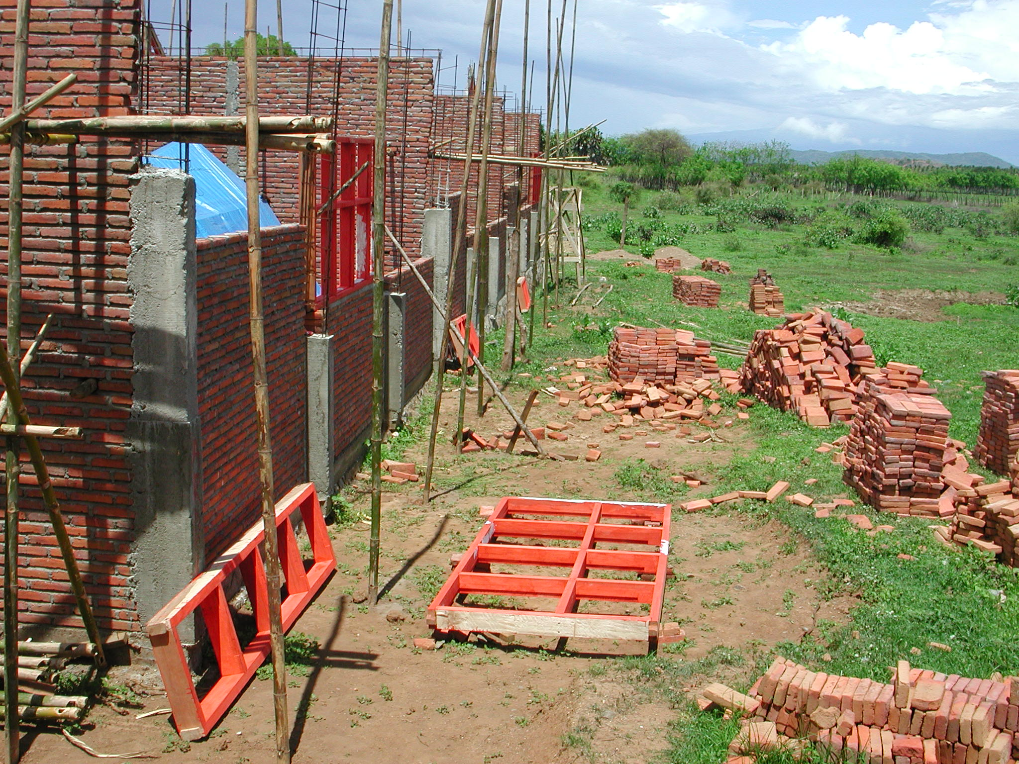

Plate 1: SLTPN 4 Lape Lopok showing columns cast between brickwork

The consultants have a construction manager (civil engineer S1) to manage the work and the head of the technical team (kepala pelaksana) is also a civil engineer S1. The school serves three villages and the labour was recruited from all three and the CM and the kepala pelaksana did the final selection. There is a problem with the accounts being kept for labour payments: individual workers are not signing for their wages, the building co-ordinator is signing for all the wages and then distributing them. Skilled workers are being paid Rp27,000 a day; unskilled workers Rp17,000 and the foreman Rp30,000. There are between 30 and 40 workers on the site.

The budget for the work is Rp989,657,000 giving a square metre cost of Rp828,165m² including the area of the verandas. The school committee have so far received the first two instalments of the funding.

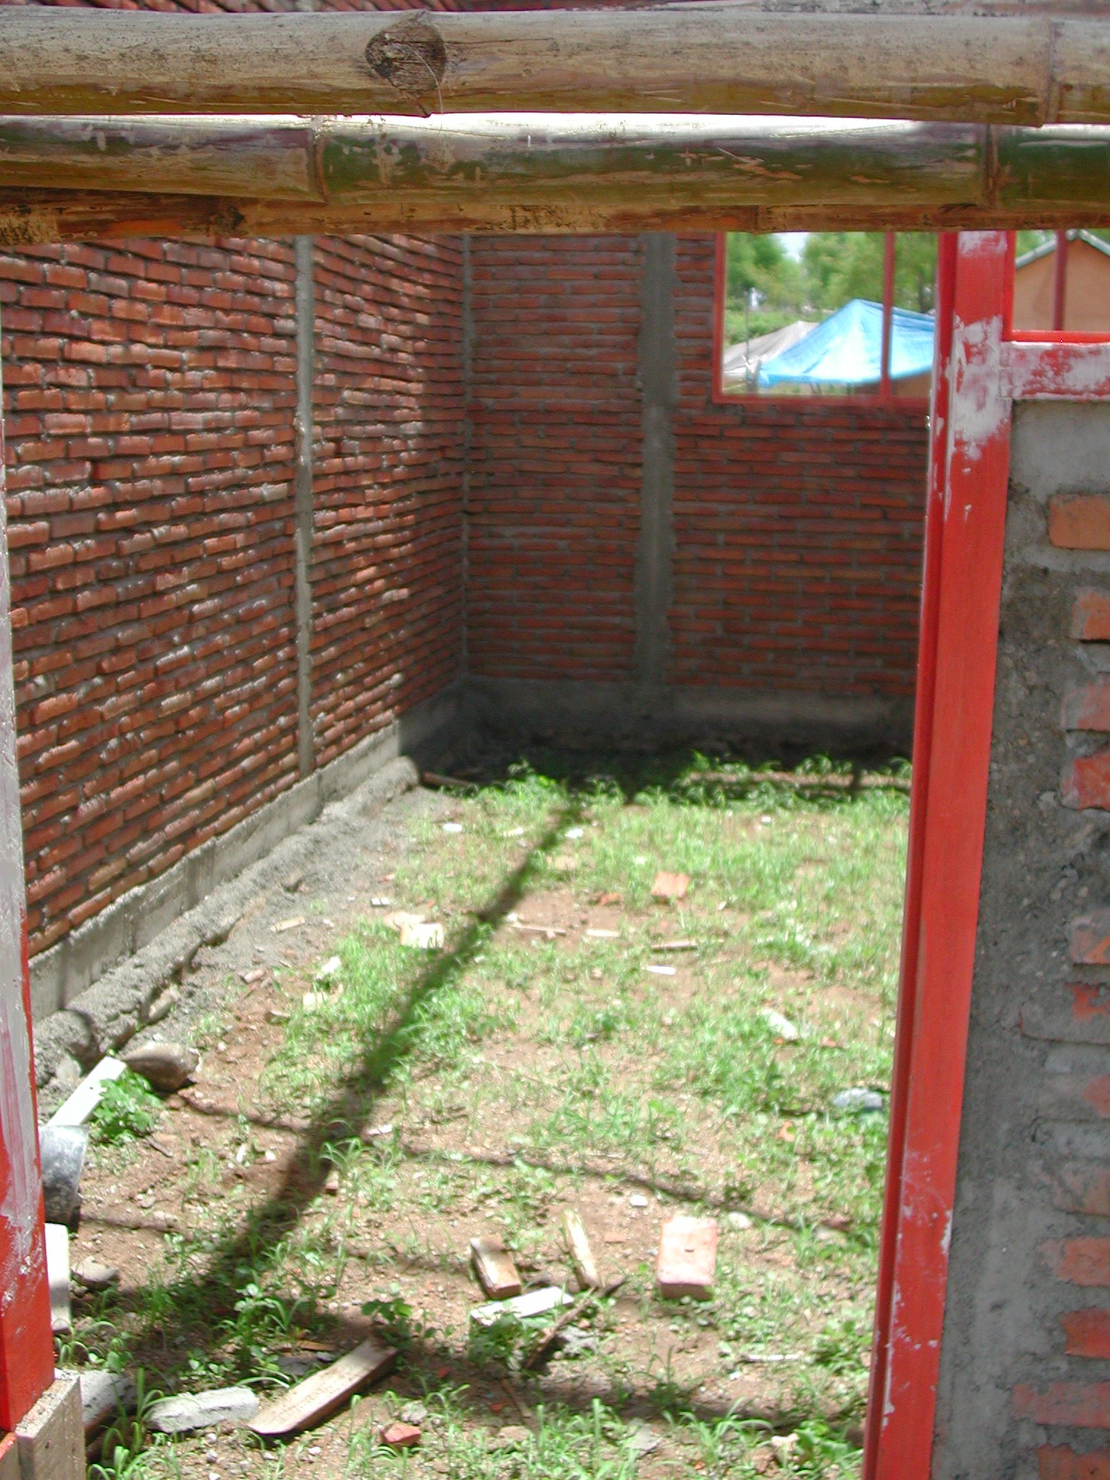

Plate 2: SLTPN 4 Lape Lopok showing top-soil inside buildings

Work started on September 16th 2003 and should be completed by March 15th 2004. At the time of the visit the progress should have been 19% but was actually 27%. Admin: RC frame and brickwork complete; door and window frames fixed; roof trusses fixed. Library and Multipurpose: RC frame and brickwork complete; door and window frames fixed; rendering complete; roof trusses, purlins and rafters fixed. 3-Classroom 1: RC frame and brickwork complete; door and window frames fixed. 3-Classroom 2: reinforcement to columns and beams complete; RC frame and blockwork 70%. Toilets: reinforcement to columns and beams complete; RC frame and brickwork 90%. Head Teacher’s House: foundations complete; reinforcement for columns in place; door and window frames fixed; brickwork 30%. Musholla: foundations complete; reinforcement for columns in place; brickwork started.

The site has an office and a store for materials and shaded areas for making roof trusses and joinery. The technical team got quotations from 3 suppliers. All payments for materials are being made in cash. The school has a notice board outside the office with details of the budget, progress, etc displayed.

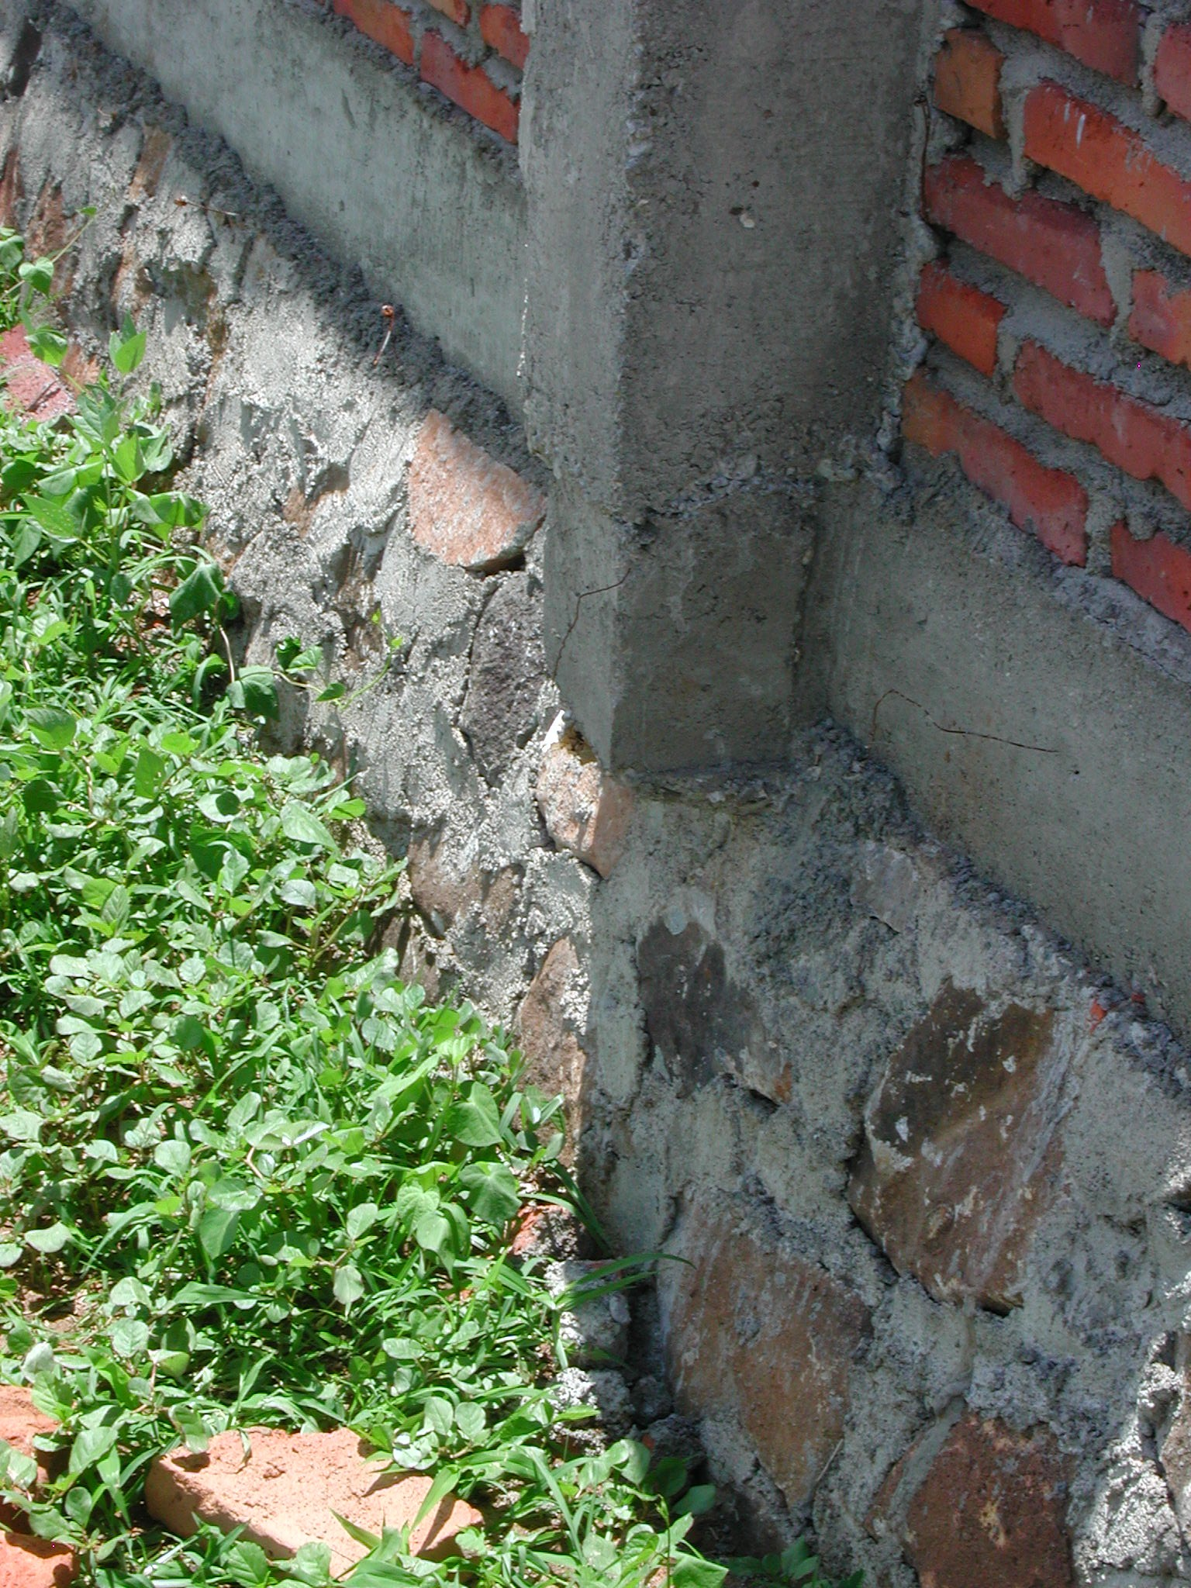

Plate 3: SLTPN 4 Lape Lopok showing overhanging columns

The workmanship is not very good: the site has not been stripped of topsoil apart from those areas where levels have been reduced and topsoil is being used for backfill; the main RC columns are being cast between brickwork panels in short lengths and many columns are not plumb or straight; RC columns around the perimeter of the buildings overhang the foundations because the ring beams and walls are not built in the middle of the columns; all the reinforcement being used is undersized: 12mm bars are actually 10.5mm, 10mm bars are actually 8mm and 6mm bars are actually 4mm; some reinforcement to columns does not extend the full height and many junctions of reinforcement between columns and beams are not properly lapped; all links to reinforcement are at 20/25cm centres rather than 15cm centres; some of the timber used for the roof trusses is poor quality. The bricks are locally made and a little irregular but well burnt. The door and window frames are also quite good. There are RC lintels over door and window openings but these have been placed two brick courses above the windows thereby making them ineffective!

Some remedial work is required and the consultants must ensure that it is carried out. Laps and joints to all reinforcement must be checked and rectified where necessary. All foundations under hanging columns must be extended either in concrete or stone and the extended foundations tied into the existing foundations. All topsoil and vegetable matter must be removed from inside the buildings and verandas. Appropriate material must be used for back-filling and back-filling must be carried out in 15cm layers, properly compacted.

SLTPN 05 Plampang, Kecamatan Plampang: The school is being constructed on a slightly sloping rural site. Access is not a problem. The site is very close to the sea and the ground water is very brackish but the school will be connected eventually to a piped water supply nearby. There is an electricity supply along the access road.

The consultants have a construction manager (civil engineer S1) to manage the work and the kepala pelaksana is also a civil engineer S1. The school serves four villages and the labour was recruited from all four and the school committee did the final selection.

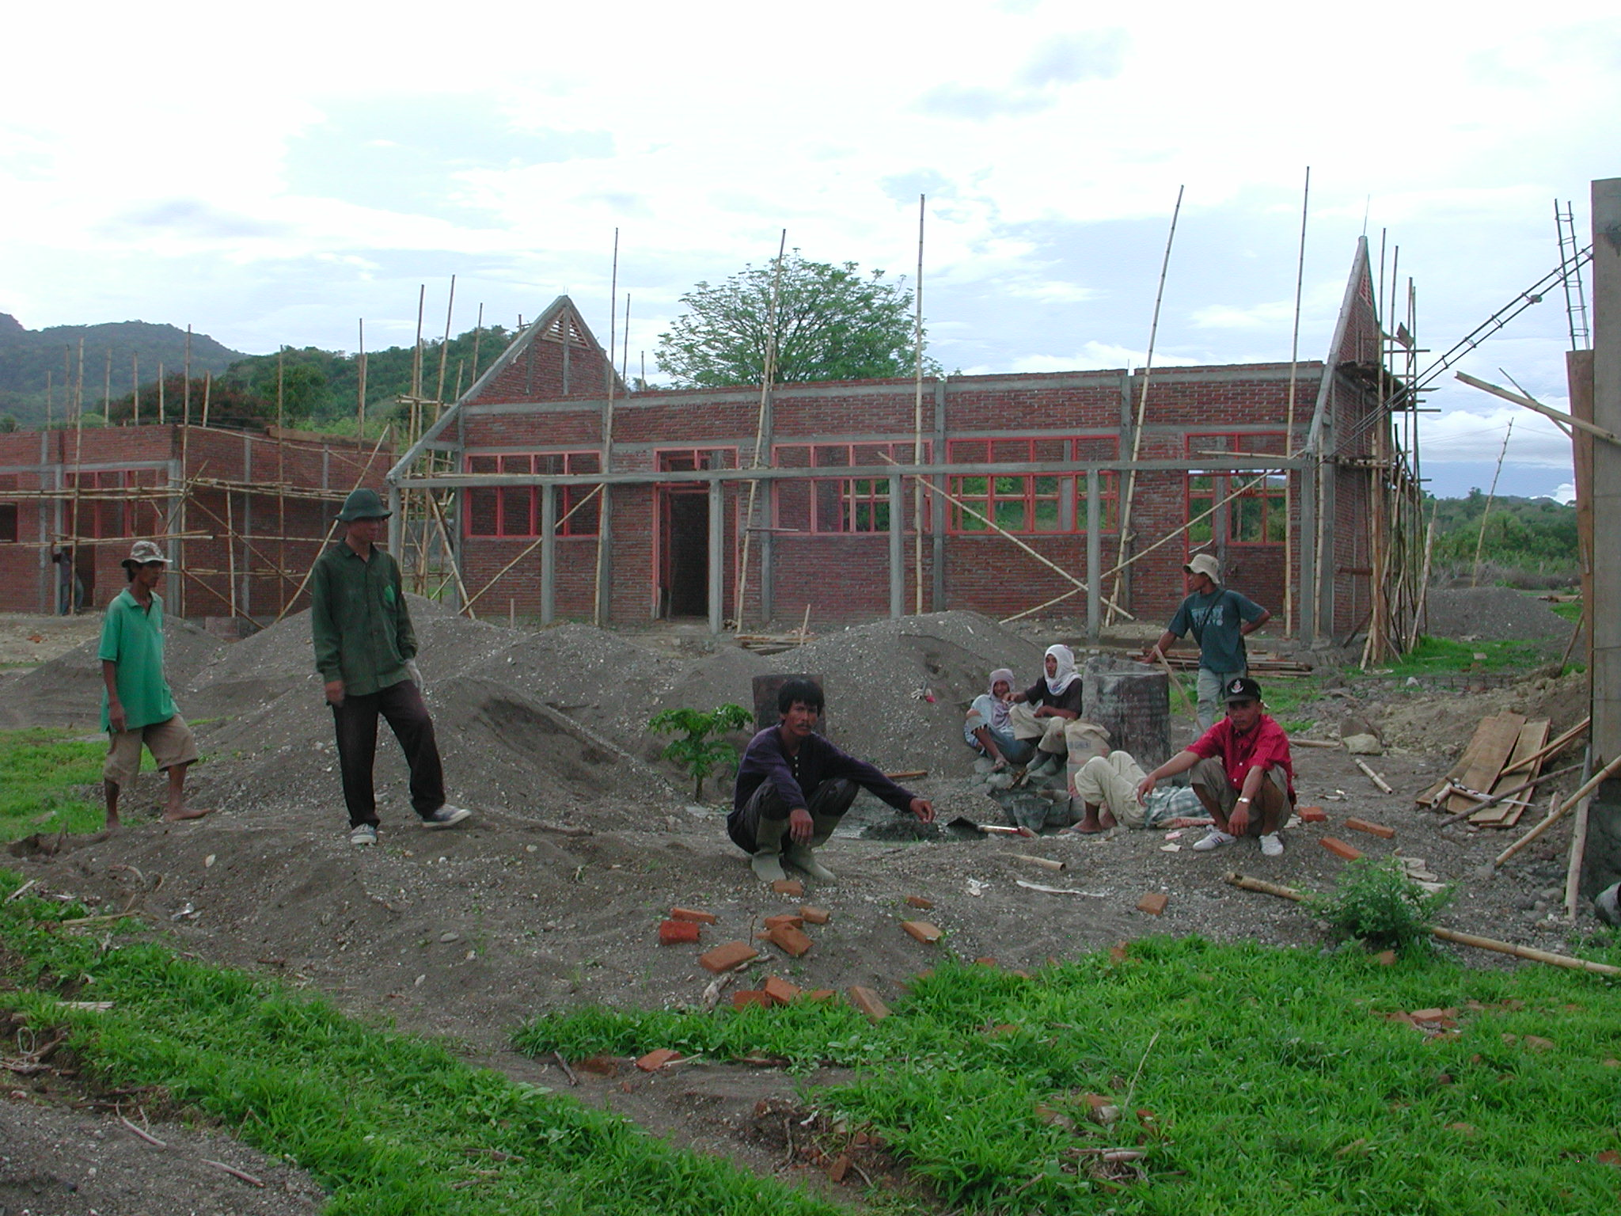

Plate 4: SLTPN 05 Plampang
The budget for the work is Rp987,991,000 giving a square metre cost of Rp826,770m² including the area of the verandas.

Work started on September 15th 2003 and should be completed by March 15th 2004. At the time of the visit the progress should have been 14% but was actually 26%. Library: RC beams and columns including veranda complete; brickwork complete; door and window frames fixed. Multipurpose: RC beams and columns complete (but not veranda); brickwork complete; door and window frames fixed. Administration and 2No 3-Classroom Buildings: RC beams and columns complete to ring beam; ring beam in progress, brickwork complete; doors and window frames fixed. Toilets: foundations and ground beam complete; reinforcement for columns fixed; door frames fixed; brickwork in progress. Head Teacher’s House: RC columns and beams complete; brickwork complete; door and window frames fixed. Musholla: RC frame and brickwork complete to ring beam; door and window frames fixed. Penjaga’s House: RC frame and brickwork complete; door and window frames fixed; roof timbers in progress.

The site has an office, a store for cement and other materials and shaded areas for making the joinery. There is a notice-board outside the site office giving details of the work including bank statements.

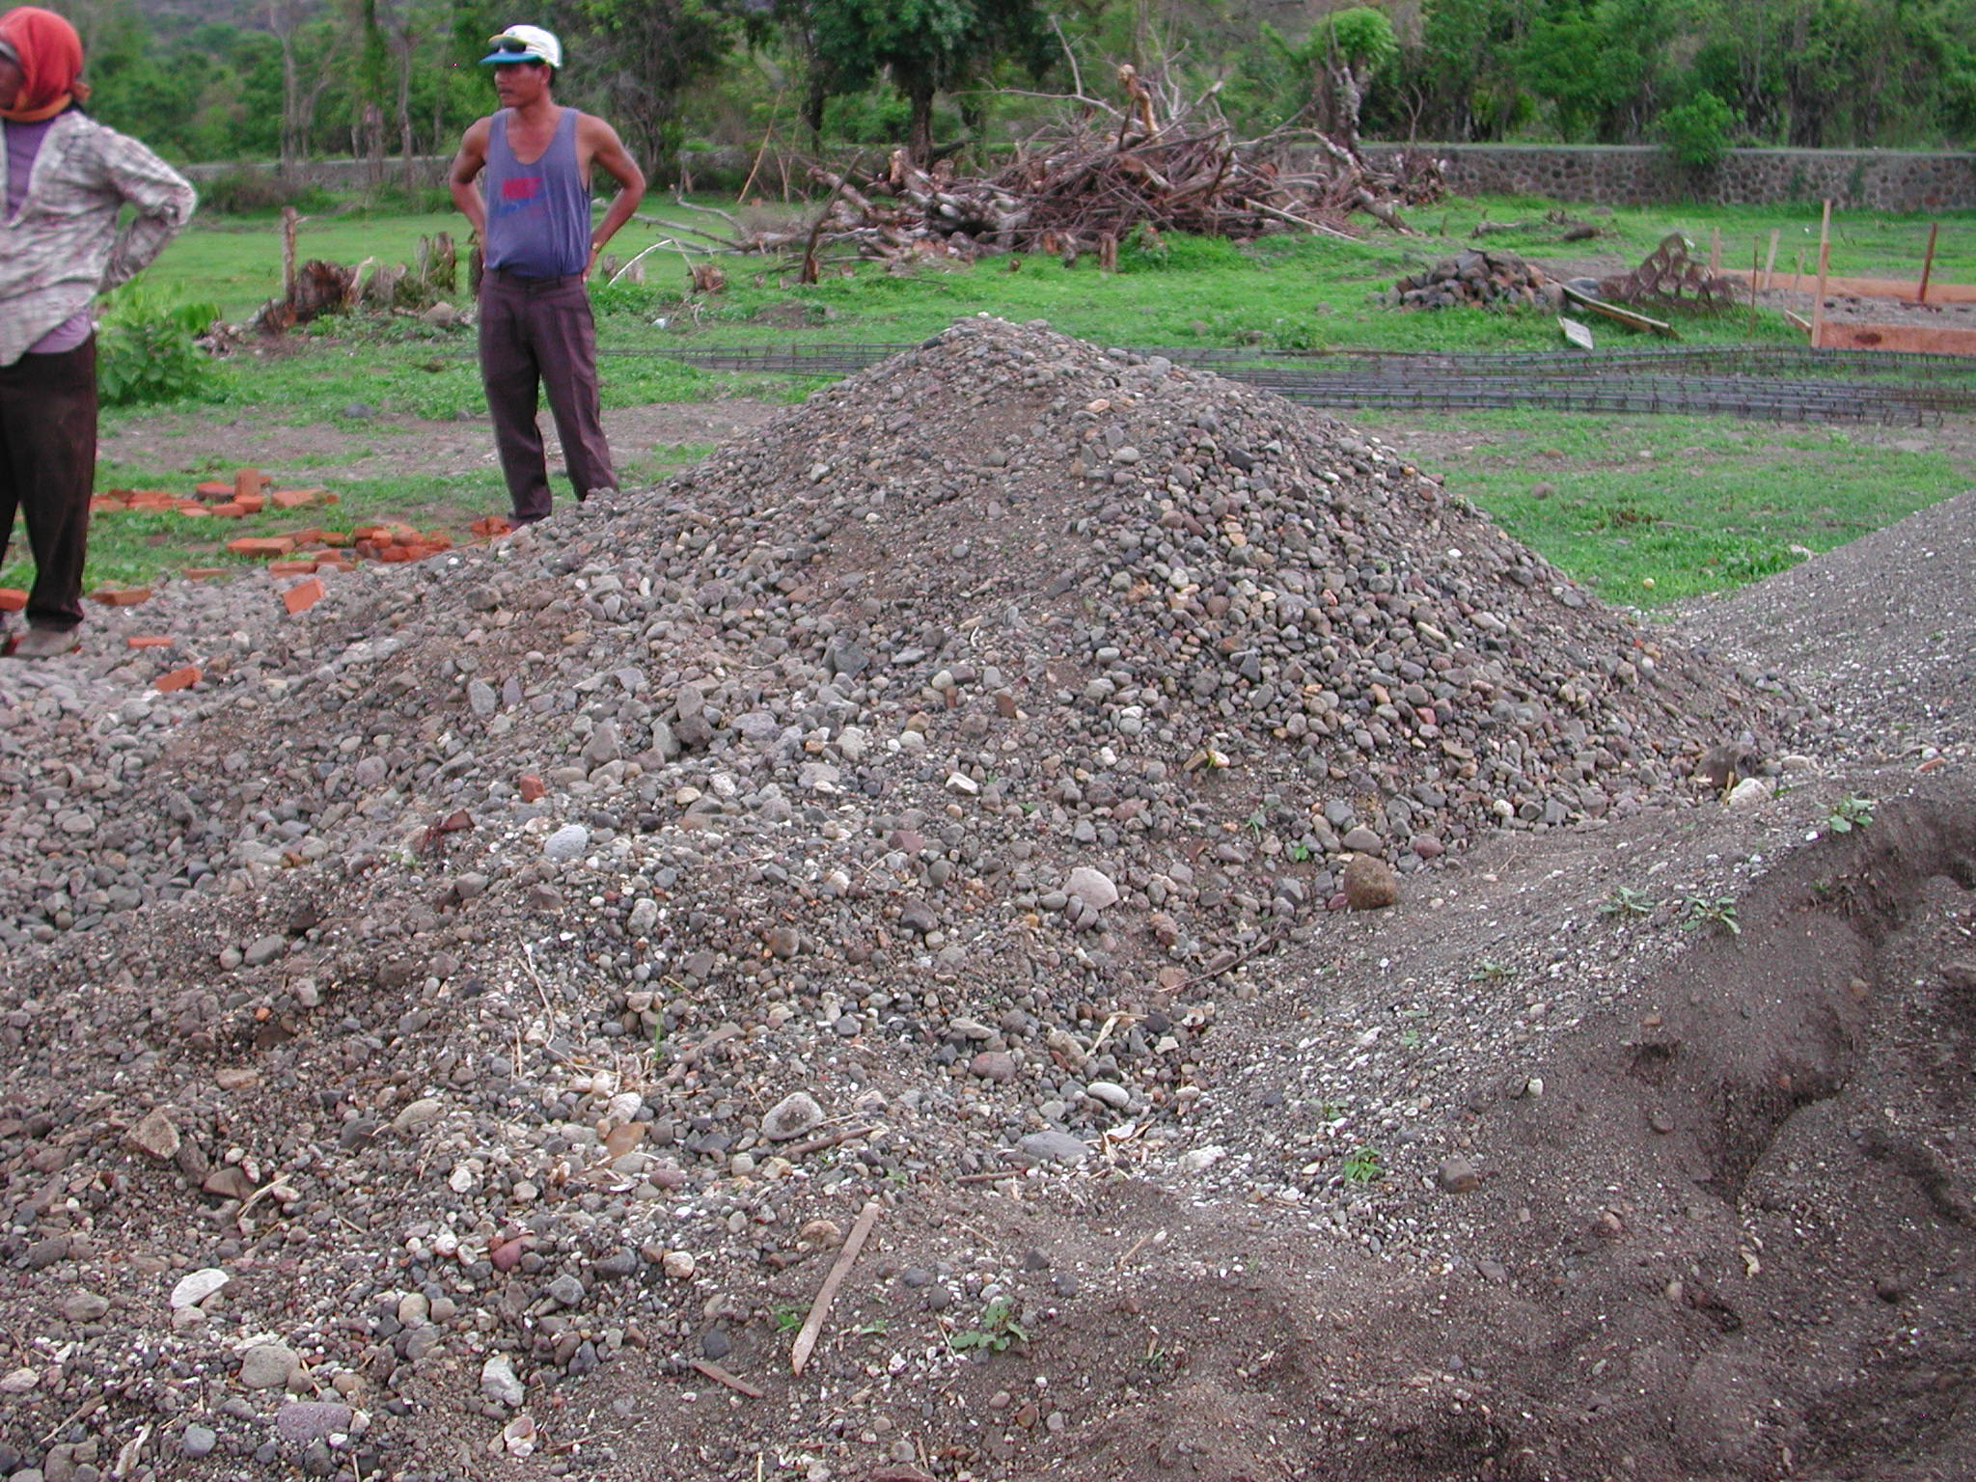

Plate 5: SLTPN 05 Plampang showing poor quality aggregate

The workmanship is not very good and there are several serious problems. Concrete was being mixed by hand on site at the time of the visit and three things were immediately apparent: 1) too much water was being used, 2) there was very little large aggregate in the mix and 3) all the sand and what little large aggregate there was on site was very dirty. There was in fact very little large aggregate on the site and after some tests on concrete columns it appeared that none of the concrete has sufficient aggregate in it. The other problem is that none of the existing top-soil and vegetable matter has been stripped off the site and it was apparent from the numerous tree stumps on the site that it had been covered with trees. These have been cut down but it appeared that none of the roots have been removed. One tree stump was very close to the foundation of a new building and the roots must spread under the foundation and there was at least one tree stump inside a building. The back-fill that was being used was very good but it was being placed on top of existing top soil. The RC columns are being cast between brickwork panels and are not very straight or plumb. The reinforcement being used in the main columns is all 11mm. The bricks being used are not very well fired and are poor quality. The timber being used for roof trusses and joinery is very good however and the door and window frames are well finished. RC lintels are being constructed over the window and door openings.

A lot of remedial work is required and the consultants must ensure that it is carried out. The School Committee was told that all concrete work must stop and all existing columns and beams must be tested to ensure that their structural strength is adequate and meets the specification. Where it does not meet the specification, the consultants must make proposals for demolition and replacement as soon as possible. Adequate supplies of clean sand and large aggregate must also be obtained as soon as possible. All back-fill must be removed and the inside areas of all buildings and verandas must be stripped of top-soil and vegetable matter before any more back-filling is carried out. All tree stumps and roots must be removed before any back-filling takes place.
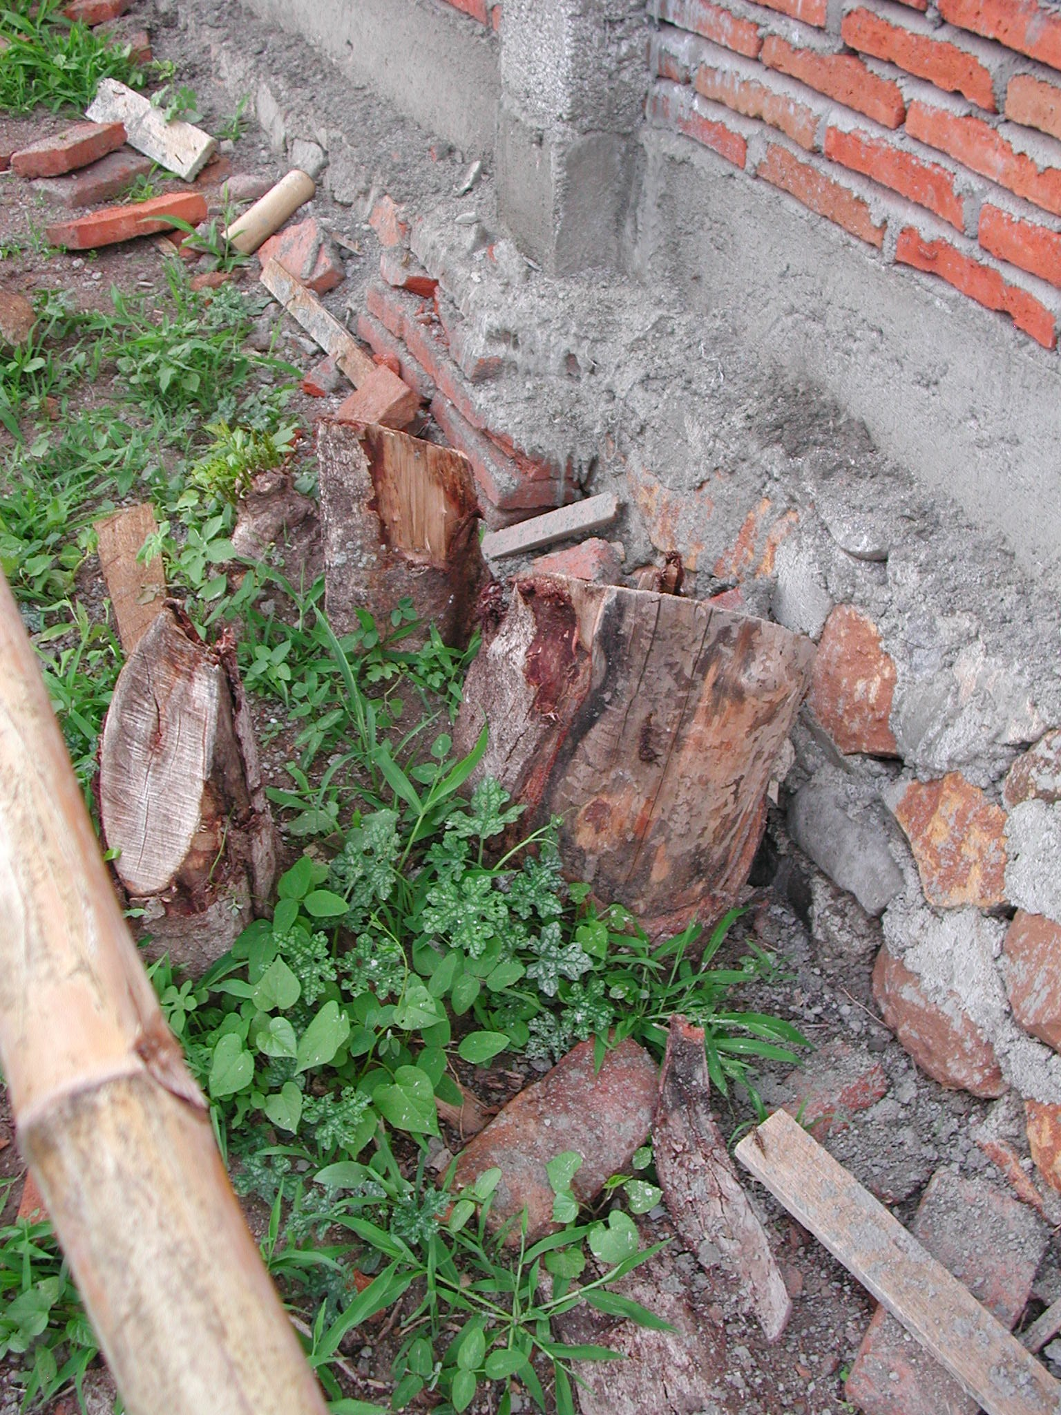

Plate 6: SLTPN 05 Plampang showing root under foundation

  - Kabupaten Lombok Timor: The following school sites were visited:

SLTPN 02 Pringgasela, Kecamatan Pringgasela: The school is being constructed on a sloping site on the edge of a rural village. Water is a problem in the area and a ground tank has been built to store water for construction. The school will eventually be connected to a water supply being constructed nearby under a World Bank project. There is an electricity supply along the access road.

The consultants have a construction manager (civil engineer S1) on site to manage the work. The kepala pelaksana is also an S1 civil engineer with 13 years experience who lives in a local village. There is quite a steep slope on the site but the original site plan had no levels and the site layout has been changed on site to suit the levels.

The budget for the work is Rp965,492,000 giving a square metre cost of Rp807,943m² including the area of the verandas. The school committee is now waiting for the third instalment of the funding. The consultants should check that
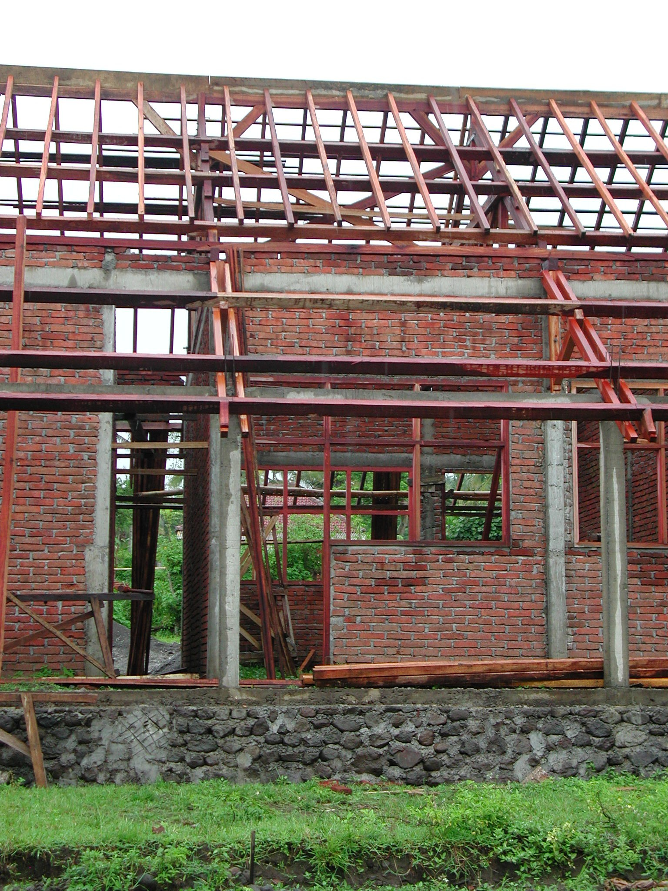

Plate 7: SLTPN 02 Pringgasela

there will be sufficient funds available to pay for the extensive site works that are necessary and report to the CMU if there are insufficient funds.

Work started on September 15th 2003 and should be completed by March 15th 2004. At the time of the visit the progress should have been 16% but was actually 39%. Multi-purpose: walls complete; render 50%; door and window frames fixed; roof timbers and roof tiling complete; finishing coat of lime plaster complete. Admin: walls complete and rendered; door and window frames fixed; roof trusses, purlins and rafters complete; battens for roof tiles in progress. Musholla: walls complete; door and window frames fixed; roof trusses complete; rafters in progress. Library: walls complete; door and window frames fixed; roof trusses and purlins complete. 3-Classroom 1: walls complete and rendered; door and window frames fixed; roof timbers and roof tiling complete; finishing coat of lime plaster complete; 3-Classroom 2: walls complete; door and window frames fixed; roof trusses and purlins complete. Toilets: walls complete; door frames fixed; roof timbers complete. Head Teacher’s House: walls complete; door and window frames fixed; roof timbers and tile battens complete.

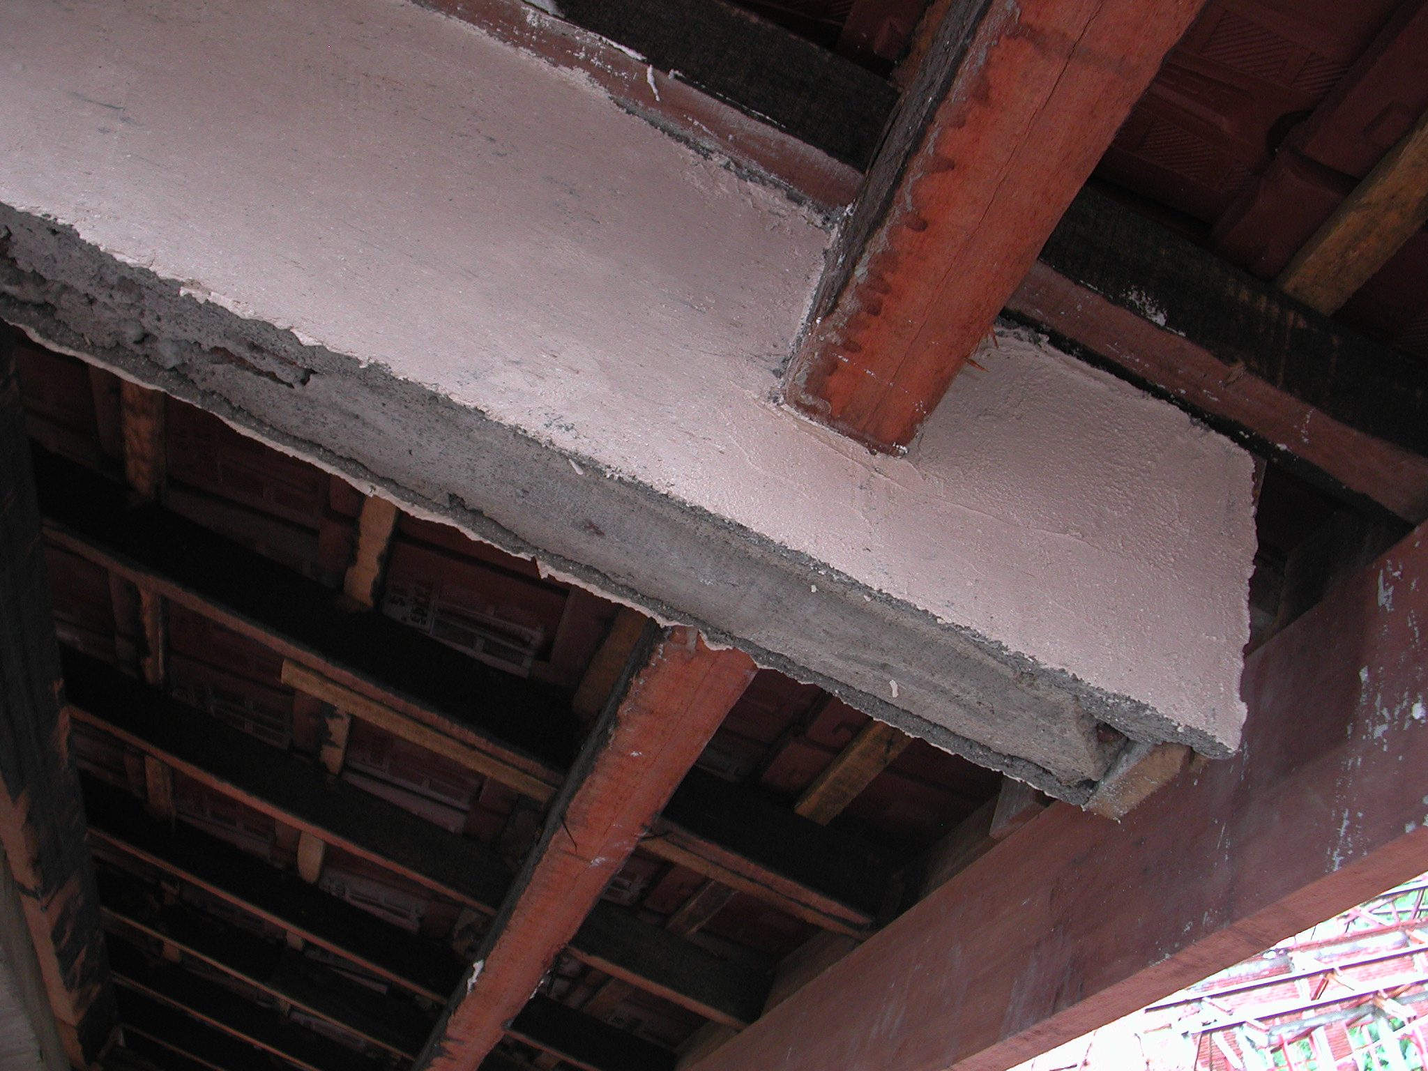

Plate 8: SLTPN 02 Pringgasela showing structurally inadequate veranda roof beam

The site is well organised with a very well built site office with all the information about the project displayed on a veranda and samples of all the materials to be used displayed inside the office. There is also a material store next to the office and shaded areas for making the trusses.

The workmanship at this school is generally very good. The correct size of reinforcement is being used and the concrete columns, although cast between brickwork panels are generally straight and plumb. The brickwork is good and the joinery and trusses which are being made on site are well made of good quality timber. The sand and aggregate are clean and of good quality. RC lintels are being constructed over the window and door openings here. Some of the roof timber details particularly where they sit on RC beams at the ends of the buildings are however not very good. Large, good quality concrete storm drains are being cast on site using timber moulds made on site. The site has not however been stripped of top-soil and top-soil is being used for back-fill.

Some remedial work is therefore necessary. All top-soil must be stripped off the inside areas of the buildings and verandas and all top-filling must be carried out using suitable material and in layers of 15cm, properly compacted. Some of the junctions between roof purlins and concrete beams particularly at the ends of buildings should be re-built.
SLTPN 02 Jerowaru Lotim, Kecamatan Jerowaru Lotim: The school is being constructed on a flat site on the edge of a remote, rural village. The site was originally rice paddies and is still very wet. The site area is 16,065m². The water supply is from a well on site and there is an electricity supply along the access road. The site layout has no levels or any indications of the drains that will be required. The layout of the buildings is also eccentric to say the least. The buildings are pushed to one side of the site and are very close together when they could have been more widely spaced about the site.

The consultants have a young S1 civil engineer as construction manager on site to manage the work and the kepala pelaksana is a young craftsman with not much experience. Neither seems to inspire confidence in the workers on the site.

The budget for the work is Rp1,050,549,000 giving a square metre cost of Rp879,120m² including the areas of the verandas. The site will require a lot of large drains and the consultants should check the budget in detail to ensure that all site works can be built.

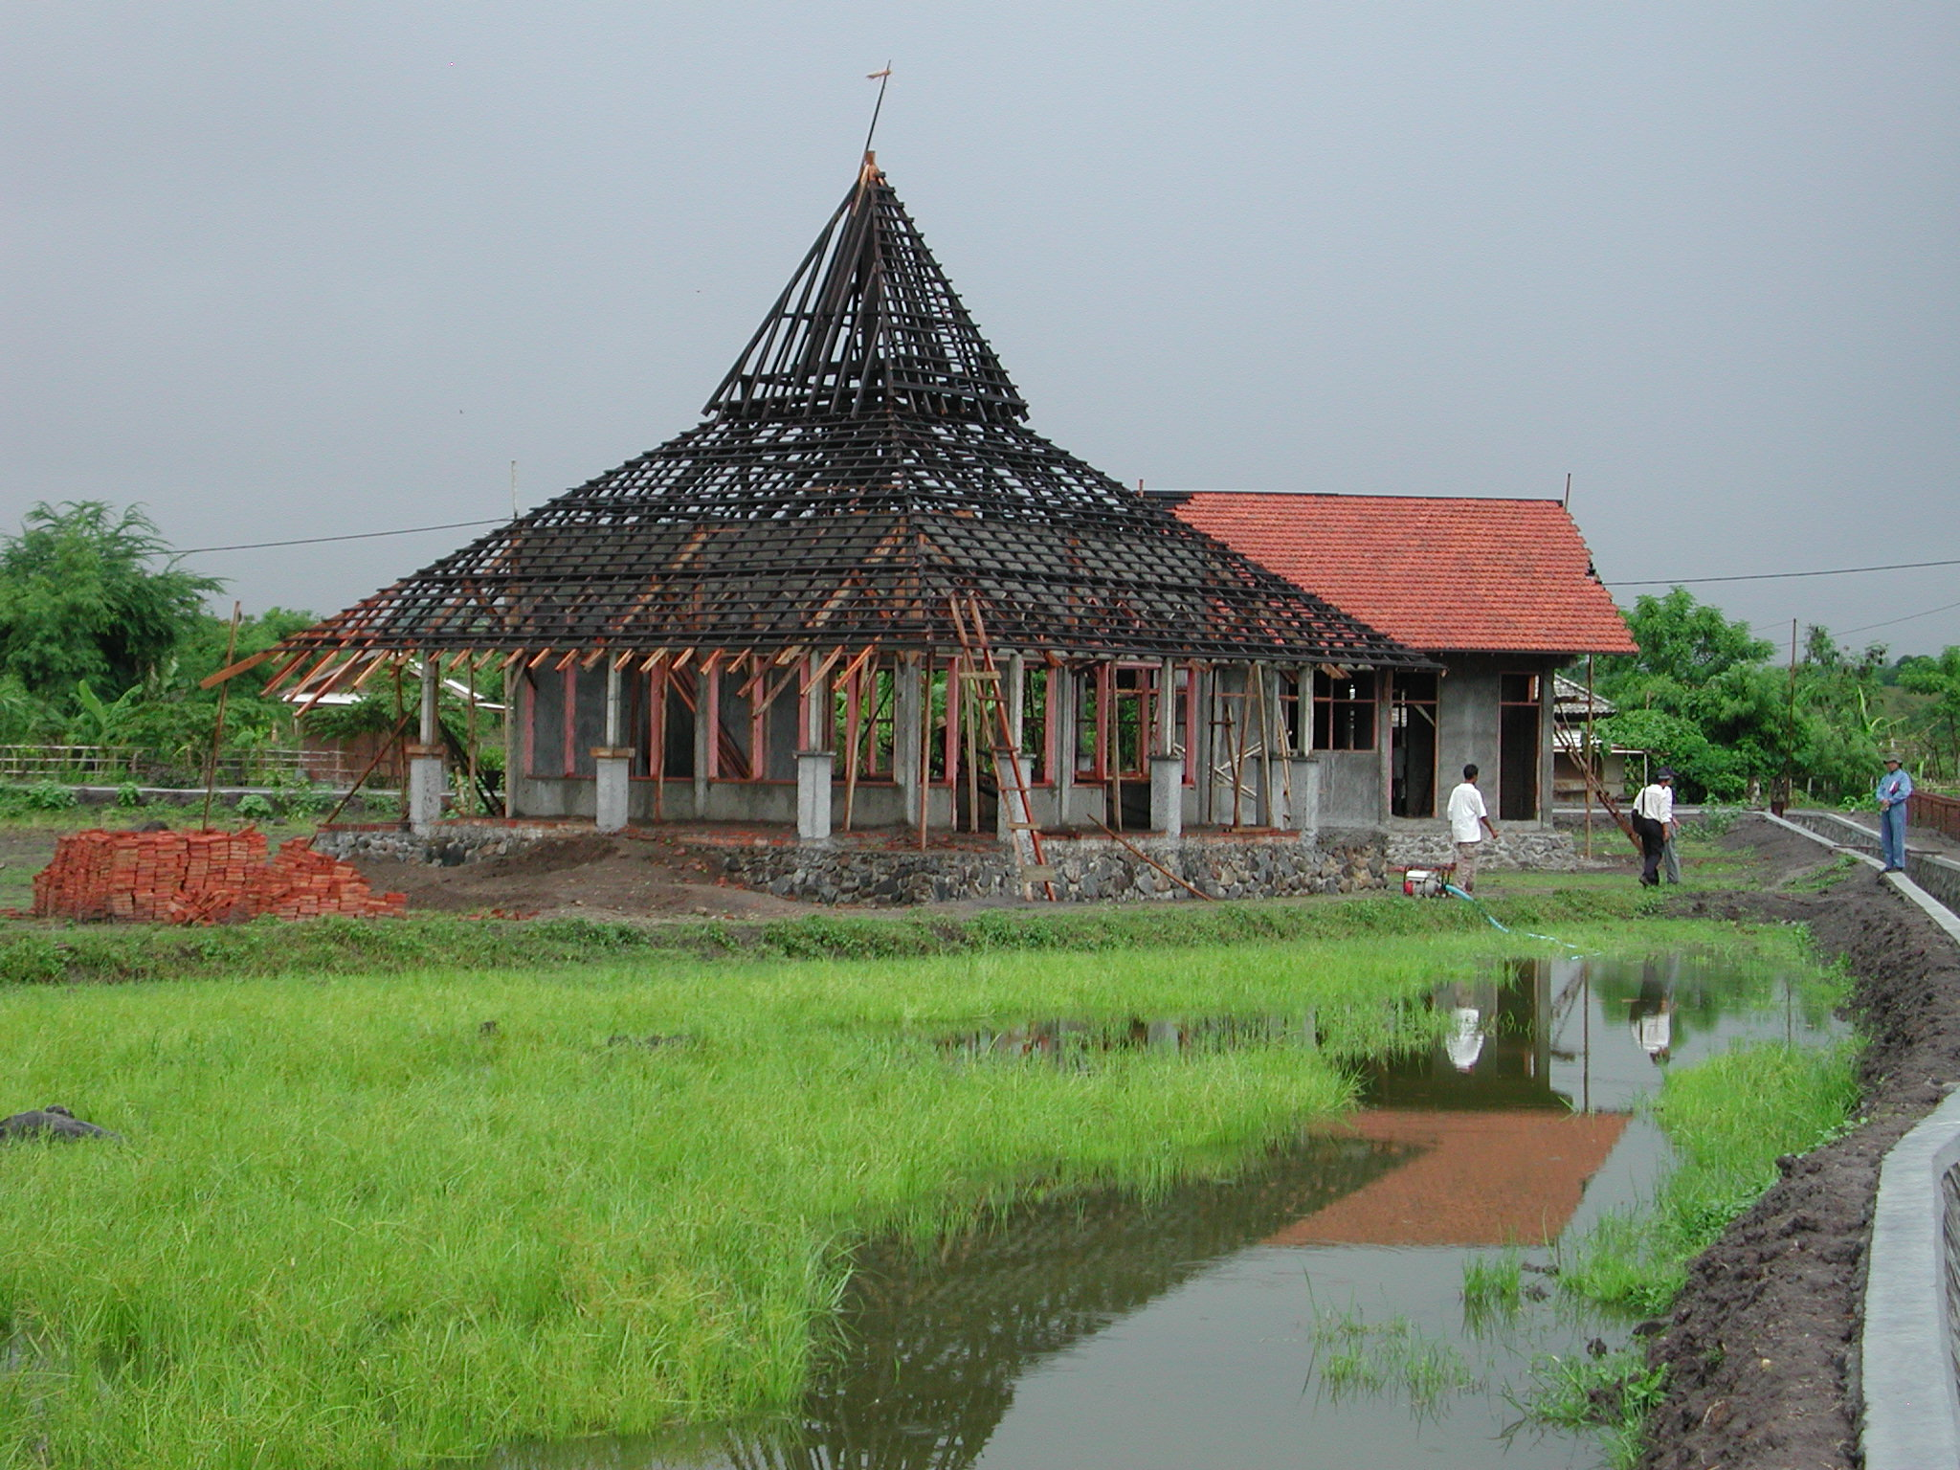

Plate 9: SLTPN 02 Jerowaru Lotim showing drain and pool of water at edge of site

Work started on September 15th 2003 and should be completed by March 15th 2004. At the time of the visit progress was 38% but should have been 45%. Progress had been quite good at the start but was now falling behind. Multipurpose: walls complete; door and window frames fixed; roof timbers complete, tiling battens in progress. Admin: as Multipurpose but roof tiling 40% complete. 3-Classroom 1 and Library: walls complete and rendered 90%; door and window frames fixed; roof complete and tiled. 3-classroom 2: walls complete and rendered 60%; door and window frames fixed; roof complete and tiled. Toilets: walls complete and rendered; door frames fixed; roof complete and tiled. Musholla: walls complete; door and window frames fixed; roof timbers complete and tiling battens fixed. Head Teacher’s House: walls complete, rendering in progress; door and window frames fixed; roof complete and tiled. Penjaga’s House: walls complete and doors and window frames fixed; roof timbers complete and tiling battens in progress.

The workmanship is generally very poor. The concrete-work is very bad: stone is being hand broken on site and not enough is being used in the concrete mix; too much water is being used in the mix; there is not enough cover to a lot of the reinforcement; beams are not the same width as columns and therefore the reinforcement from the columns does not connect with the beams; concrete beams are not a consistent size and many are out of level; the main columns overhang the foundations on the outside of the buildings. The timber being used for the roof is not very good, rafters are not fixed straight and purlins are out of level. None of the top-soil has been stripped off the site and as the site was once a rice paddy there is a lot of vegetable matter. Top-soil is also being used for backfill. The door and window frames are however quite good. It was noted from the visitors’ book that the consultant’s team leader had visited the site approximately three weeks before the team’s visit but had apparently not picked up any of these problems.

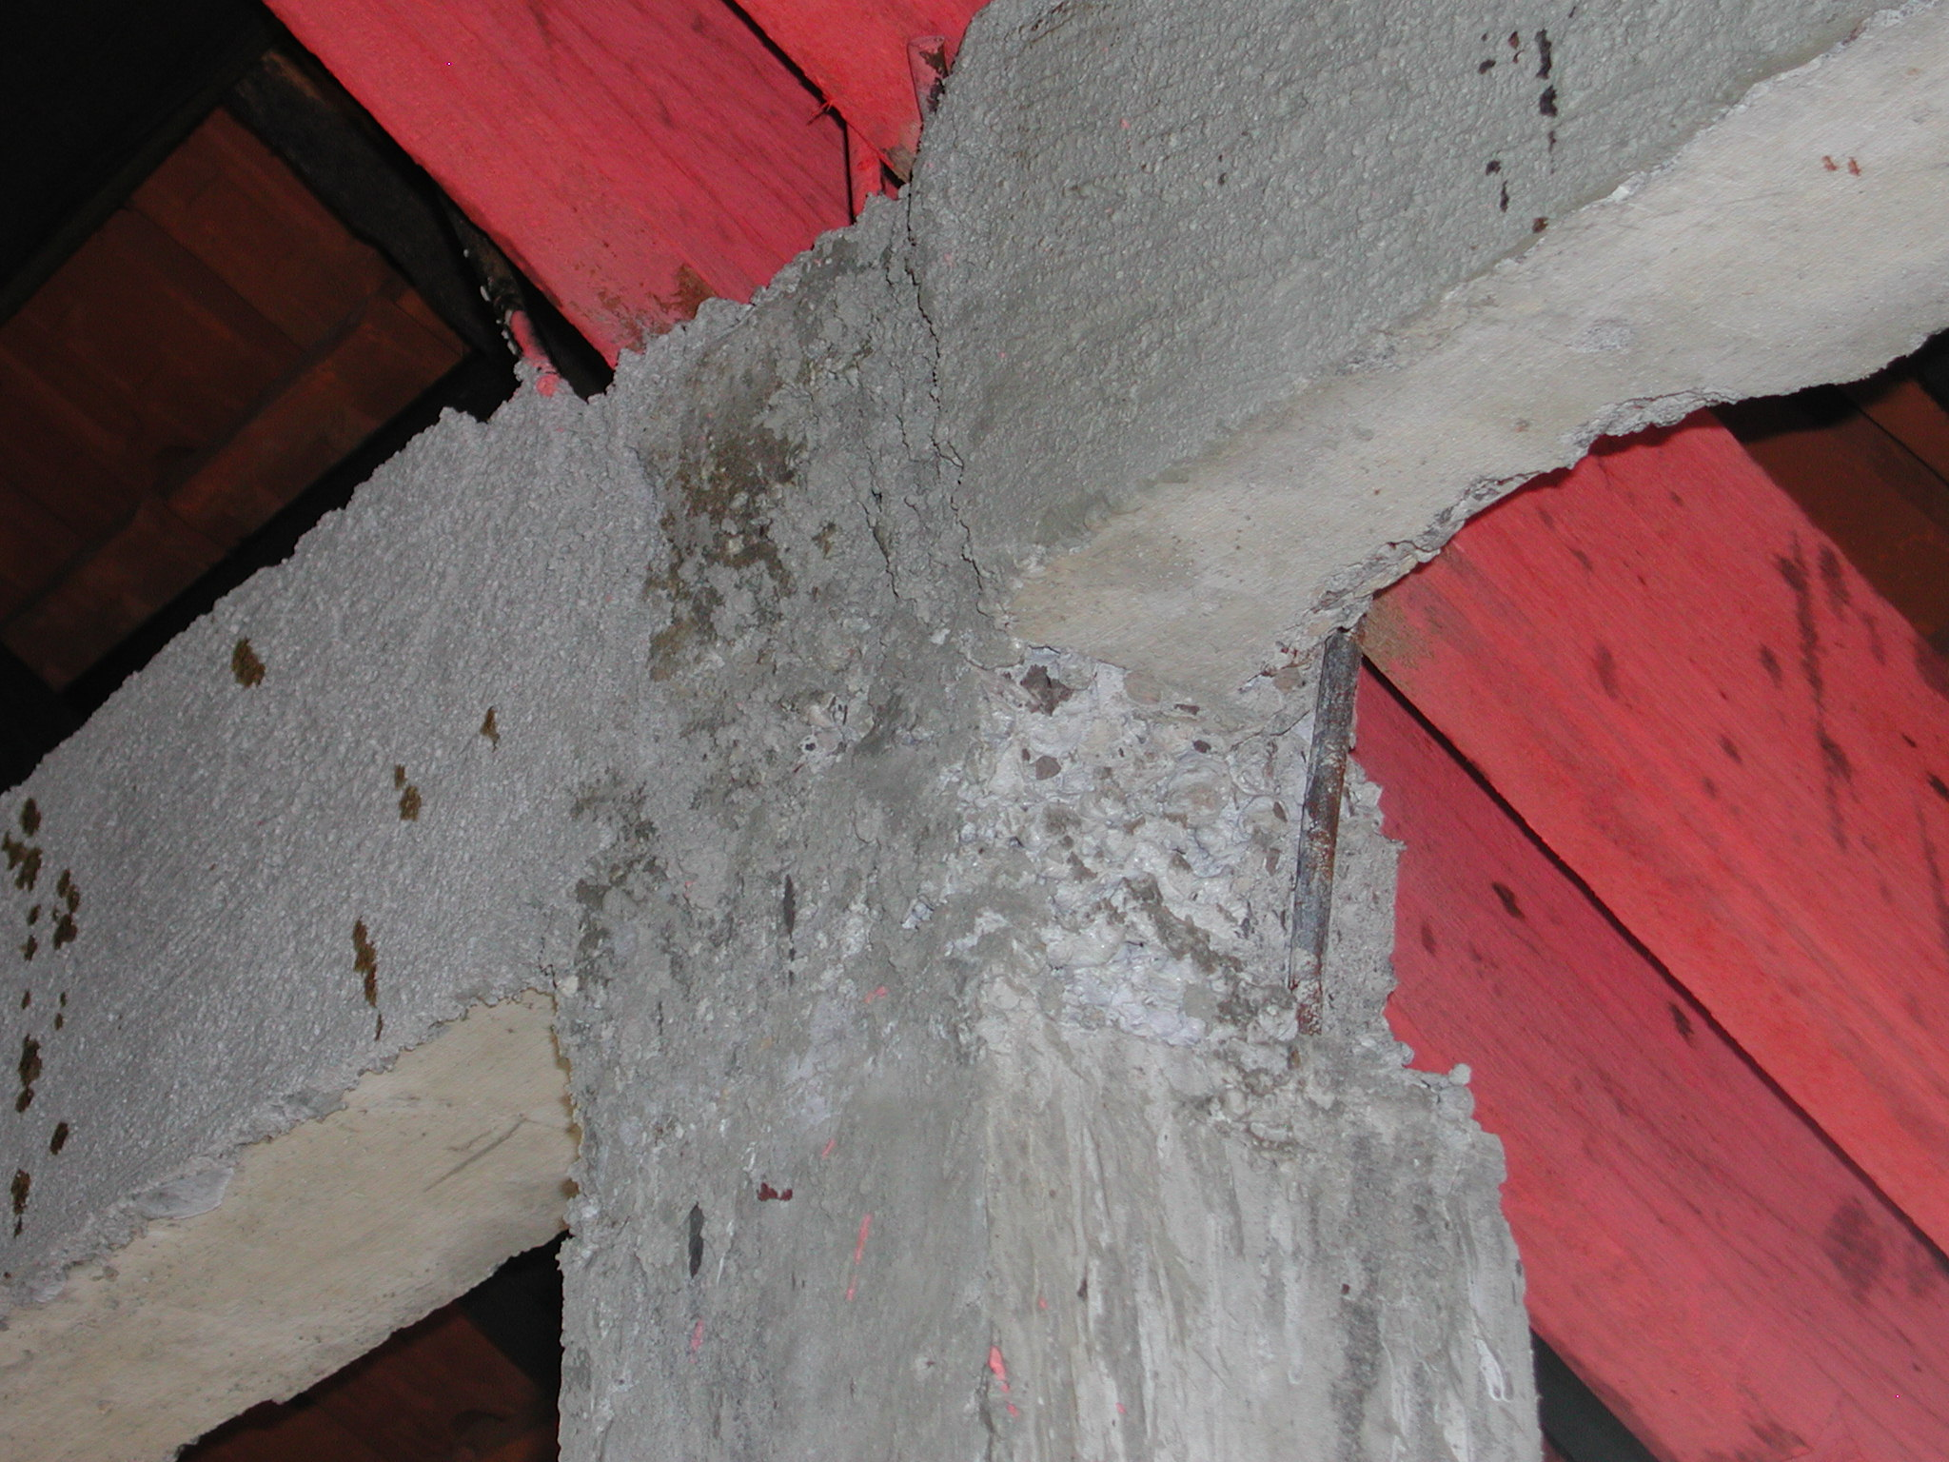

Plate 10: SLTPN 02 Jerowaru Lotim showing poor quality concrete

There are other problems caused by the physical properties of the site. The site is below the level of the road and because it was formerly rice paddies is very wet. A large drain has been constructed down one side of the site but the level of the bottom of this drain is above the level of the site and it is thus impossible to drain the site into it and a large pool has formed inside the drain. There is no drain on the other side of the site even though the rice paddies on this side are as high or are higher than the school site.

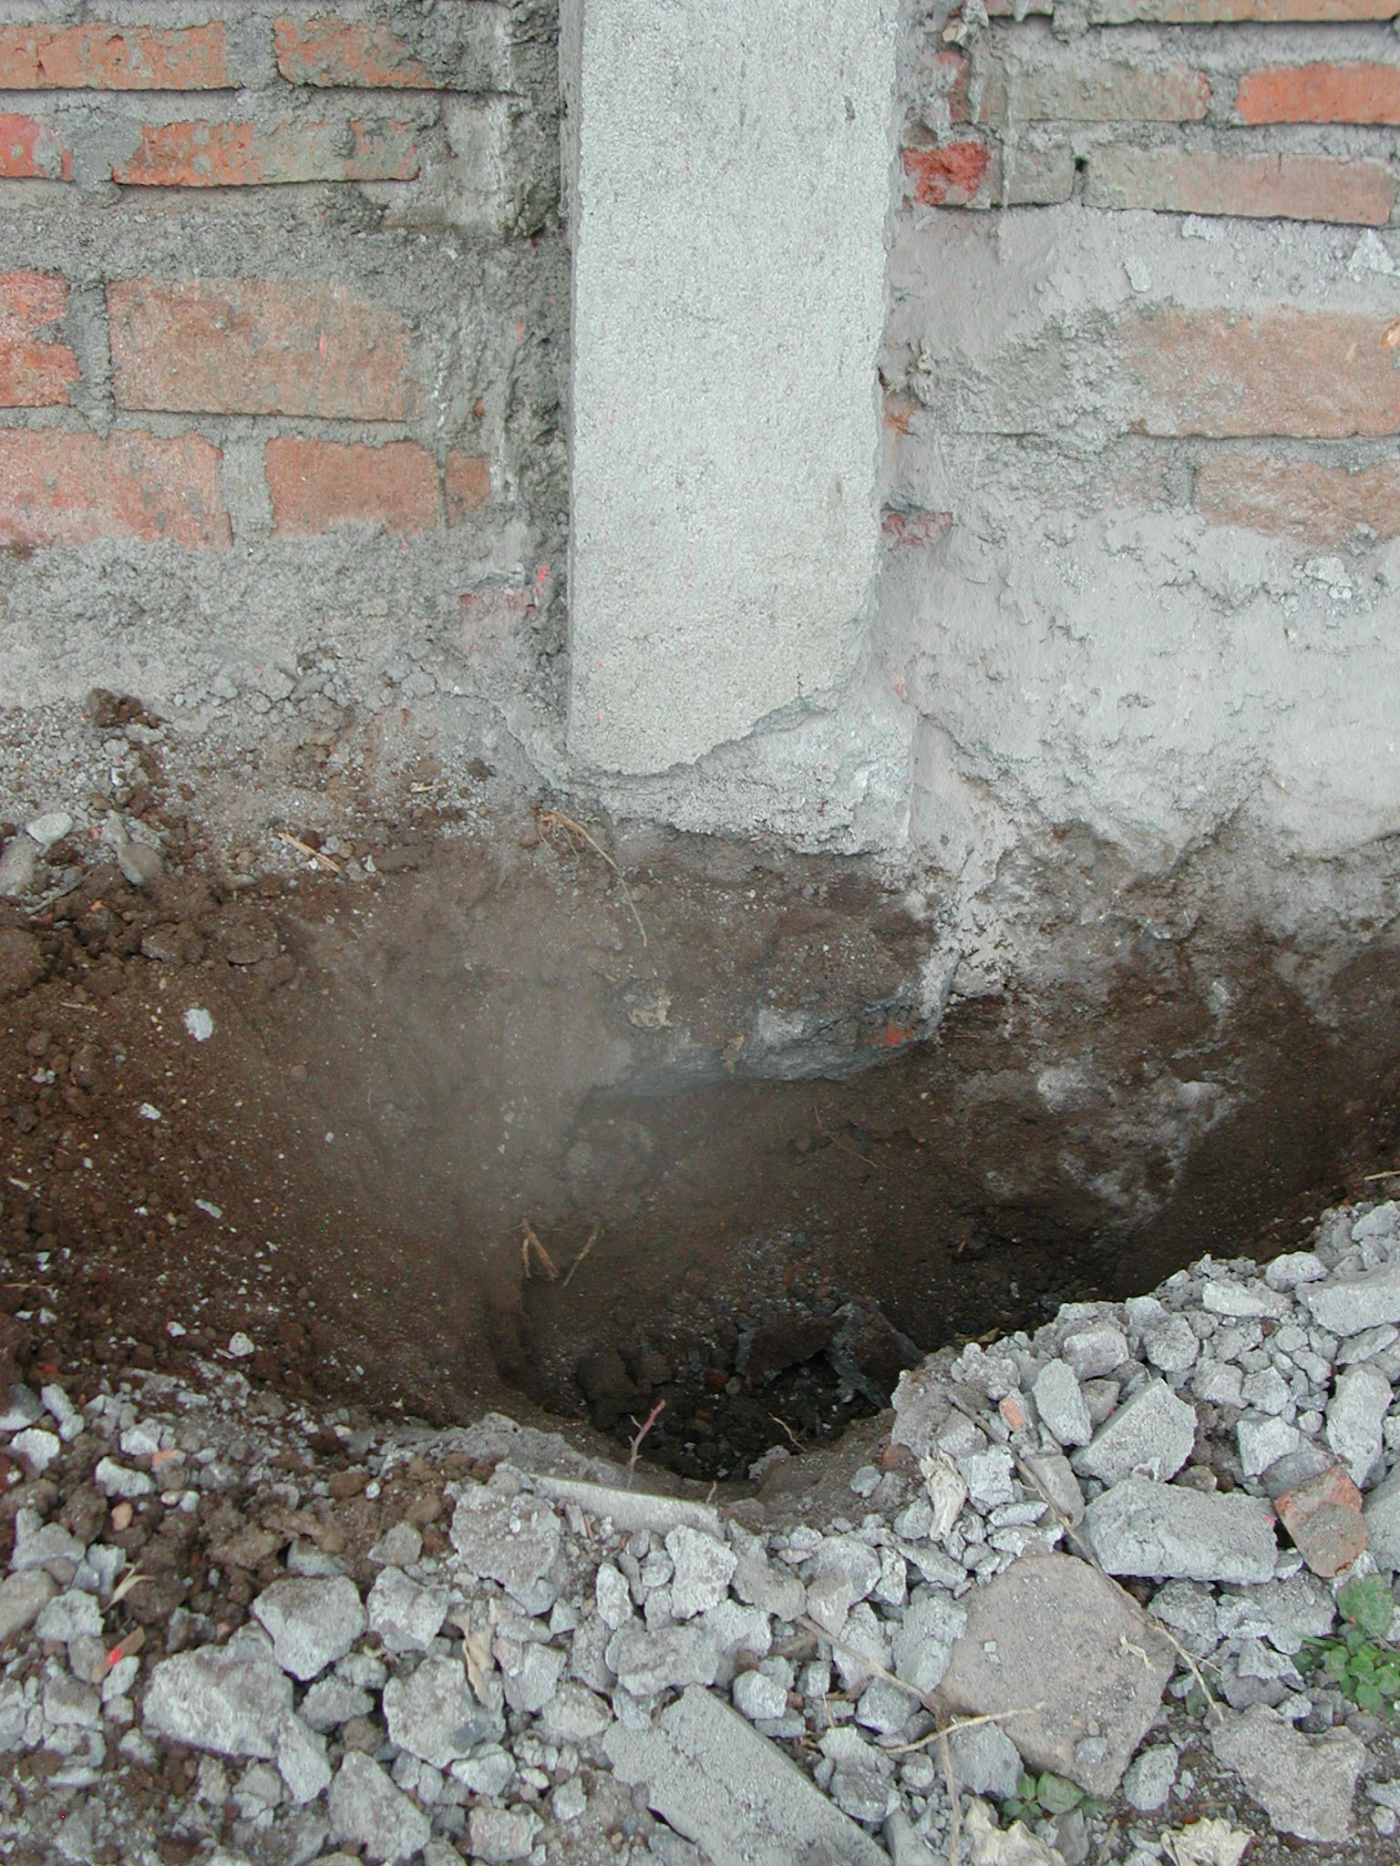

Plate 11: SLTPN 02 Jerowaru Lotim showing overhanging column foundation

A lot of remedial work is required and the consultants must ensure that it is carried out. The school committee was told that concrete work should be stopped and that all existing columns and beams must be tested to ensure that their structural strength is adequate and meets the specification. Where it does not meet the specification, the consultants must make proposals for demolition and replacement as soon as possible. Adequate supplies of large aggregate must also be obtained as soon as possible. All back-fill must be removed and the inside areas of all buildings and verandas must be stripped of top-soil and vegetable matter before any more back-filling is carried out. Back-filling should then be carried out using suitable material in 15cm layers, properly compacted. A solution is also required for the large pool of water that has gathered on the other side of the site; maybe it should be used for fish-farming! Because of the wet condition of the site, the consultants should check that the foundations are deep enough and that there is adequate drainage of the site. A cut-of drain is probably required at the front to stop water draining down into the site and there should also probably be a large drain down the side of the site where there is not one at present to stop water encroaching from the adjacent rice paddies.

  - Kabupaten Lombok Barat: The following school sites were visited:

SLTPN 02 Batulayar, Kecamatan Batulayar: The school is being constructed on a small flat site in a village not far from Mataram. The site was formerly paddy fields and is very wet. There are paddy field on three sides of the site, the water level in the fields is approximately 30cm higher that the site and the buildings have been raised approximately 50cm above the level of the site. The site is close to the village road and access is not a problem. The water supply is from a well and there is an electricity supply along the road.

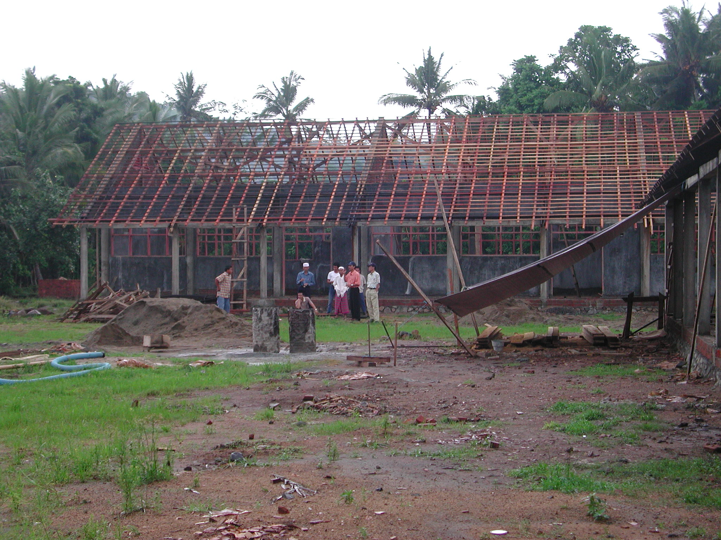

Plate 12: SLTPN 02 Batulayar

The consultants have a young construction manager (S1 civil engineer) on site to manage the work and the kepala pelaksana has a lot of construction experience.

The budget for the work is Rp960,732,000 giving a square metre cost of Rp803,960m² including the area of the verandas. The site will require a lot of large drains and the consultants should check the budget in detail to ensure that all necessary site works can be built.

Work started on September 15th 2003 and should be completed by March 15th 2004. At the time of the visit the progress was 34% and should have been 32%. Library: walls complete, roof trusses, rafters and battens complete. Multi-purpose: as Library plus roof tiling 60%. Admin: as Multi-purpose plus ceiling battens complete; 3-Classroom Buildings 1 and 2: as Library. Head Teacher’s and Penjaga’s Houses, Toilets and Musholla not yet started.

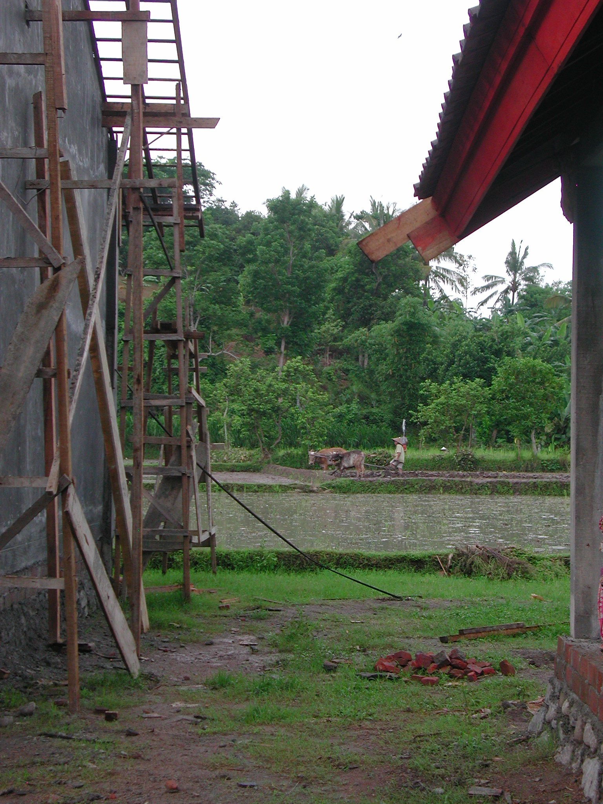

Plate 13: SLTPN 02 Batulayar showing surrounding rice paddies

The site is well organised with an office and store and a large notice-board outside the office with details of cost and drawings. The construction manager seems to have done lots of detailed sketches (particularly of site works) to assist the workers and has also, together with the kepala pelaksana, re-designed the Musholla. The school committee also seem to be keen and committed.

The workmanship is generally very good. 10mm bars have been used for column reinforcement but 6No bars have been used rather than 4No bars. The concrete-work, brickwork, rendering, roof trusses, roof tiling and door and window frames are all very good and the quality of timber being used is also very good. The major problem is that that the site has not been stripped of top-soil, back-filling is taking place on top of top-soil and the site having been a rice paddy has lots of vegetable matter. The actual back-fill material is very good being mainly aggregate.

The only remedial work required is to strip off the top-soil (and the back-fill that has already been placed) inside the buildings and verandas and then back-fill with suitable material in 15cm layers. It was also suggested that the Penjaga’s House is moved to the other side of the site in order that the septic tank to the house is well away from the well. All septic tanks and soakaways should be at least 30 metres from the well as the site is so wet. The school committee said that they planned to construct a drain all round the site and this will help to keep the site dry.

ANNEX 2: REPORT ON VISIT TO SOUTH SULAWESI PROVINCE

1. General

  - South Sulawesi Province was visited between December 14th and December 19th 2003 together with the manager of the Construction Management Unit of the CPCU.

  - Meetings were held with the head of the Provincial Technical Team, the heads of the Technical Teams in Tana Toraja and Gowa Districts, the CMU representative in the Province, the two firms of civil works consultants and their site staff and members of school committees and their technical teams on new school sites.

  - New schools were visited in three districts: Kabupaten Tora Toraja, Kabupaten Luwo and Kabupaten Gowa.

  - A standard design for the junior secondary schools is being used in the province that is derived from the school design used in East Java Province and the schools consist of six classrooms in two 3-classroom buildings; a multi-purpose room (replacing the traditional laboratory and designed to serve a variety of functions); a library; an administration building; a musholla; toilets; a penjaga’s house; a head teacher’s house, a bicycle shed and separate school toilets. The design has very complicated and expensive RC roof beams in the classroom buildings. The total area of the buildings is 888.5m² with 338m² of verandas giving a total of 1,226.5m².

  - There are two firms of civil works consultants: PT Delta Romindo Internasional working in the north of the Province and PT Karya Utama Citramandiri working in the south.

  - Construction is similar at all schools: foundations are of stone set in mortar; walls are of rendered brickwork with RC columns, ground beams, ring beams and veranda beams; roofs are of clay tiles on battens, on timber rafters, purlins and trusses, ceilings are of plywood; windows and doors are of timber with timber panel doors and glazed windows; floors and verandas are of ceramic tiles on screed.

2. Issues

2.1 Civil Works Consultants: Many of the problems noted at the school sites were the result of poor management and supervision by the civil works consultants, particularly the construction managers (CMs) on site. These problems included:

    - Drawings: The drawings supplied by PT Delta Romindo Internasional are standard drawings with only the site layout varying at each school. While the drawings are quite good as far as they go there is a lack of working details. There are no large-scale sections or details of roof trusses and there are also no details of how the columns ring beams and ground beams should be set out and this has led to problems on some sites.
There seem to have been no levels surveys carried out at any of the sites and none of the site layouts have detailed levels of the buildings, drains, etc and there are no site works details. Some sites are very wet and require extensive site drainage or cut-off drains and one site slopes steeply and will require extensive retaining walls, steps, etc. Without details of these site works it is difficult to see how the consultants can have prepared accurate budgets for the work.

The only drawings seen that have been prepared by PT Karya Utama Citramandiri were at SLTPN Pallangga and they are extremely poor. There are only very basic 1:100 scale drawings with very few dimensions. There are no details of foundations, columns, beams or roof trusses and no structural details. There are no setting-out dimensions on the site plan and no site works details. The drawings are some of the worst ever seen on such a project, they are totally inadequate for the work to be carried out and are probably a contributory factor to the very poor quality work being carried out at SLTPN Pallangga.

Recommendations: PT Delta Romindo Internasional should prepare all necessary details for the buildings and detailed site works drawings at their sites for the use of the CMs and the school committees.

PT Karya Utama Citramandiri must ensure that all their sites have sufficient accurate and detailed drawings of the buildings and the sites to enable the school committees to construct the buildings to an acceptable standard.

    - Budgets: There is a danger on some sites that there will be insufficient funds for completing all the necessary site works.

Recommendations: The consultants must check the budgets at all sites and ensure that there are sufficient funds to cover all necessary site works including drains, retaining walls, steps, etc.

    - Site Organisation: On many sites, door and window frames and roof trusses are being made and/or left out in the open, exposed to sun and rain.

Recommendations: The consultants were asked to ensure that all materials, particularly finished ones, are properly protected.

    - Management: The problems seen on the sites do not appear to have been picked up by either of the consultants’ team leaders who should have resolved them before they became serious.

Recommendations: Both firms of consultants were asked to work more closely with the School Committees to improve the quality of the work. The consultants were also asked to supervise the sites and the work of their CMs more closely and ensure that any problems are picked up and rectified at an early stage.

PT Karya Utama Citramandiri were asked to visit all the sites that they were supervising and check that similar problems to those at SLTPN Pallagga (see below) were not in evidence. The manager of the CMU was also asked to visit these sites and check the progress and the quality of the work.

2.2 Construction: A number of construction issues were noted during the visits and most of them occurred on more than one site. They included:

    - Concrete: There are serious problems with the concrete at SLTPN Pallangga. There is not enough cement or aggregate in the mix and too much sand and water. The columns are also too small for their height, the reinforcement is not the correct size and it was felt that the columns are structurally dangerous.

Recommendations: Work at this school must stop and the consultants must check the quality of concrete beams and columns and assess as soon as possible what remedial or replacement work needs to be carried out and report back to the CMU.

    - Reinforcement: The reinforcement specified on all sites for the main columns and beams is 12mmØ but on many sites smaller sizes are being used. On some sites the laps to the reinforcement in columns are inadequate and the links to the reinforcement are spaced at greater intervals than those designed (15cms).

Recommendations: The consultants must check the reinforcement being used at all sites and ensure that the correct sizes and sufficient reinforcement is being used in all structural concrete.

    - Foundations: On at least one site, SLTP Cakkeawao, the position of the ground beams and the columns is such that the columns are overhanging the foundations.

Recommendations: The consultants should prepare details of the column foundations for the use of the CMs and ensure that where there are overhanging columns, the foundations are increased in size and properly tied in to the existing foundations.

    - RC Lintels: On one site (SLTPN Peta Kurra) RC lintels over door and window openings have been omitted from some buildings and on two sites (SLTPN Cakkeawao and SLTPN Binturu), lintels have been constructed but there is no connection between the reinforcement in the lintels and in the columns!

Recommendations: In future the consultants should ensure that there are RC lintels over all door and window openings and that these are properly connected to the columns.

    - RC Ring Beams: At two sites (SLTPN Cakkeawo and SLTPN Binturu) the RC ring beams do not connect adequately with the tops of the RC columns.

Recommendations: The consultants must check the structures at these schools and ensure that structurally adequate connections are made between all ring beams and columns.

    - Top-Soil: On all sites top soil, roots and vegetable matter has not been stripped off the area of the buildings and is also being used for back-filling.

Recommendations: In future the consultants should ensure that all top soil and vegetation is stripped off the area of the buildings before excavation is started.

At all existing sites, the consultants must ensure that all top-soil (and any back-filling already placed) is removed from the inside areas of the buildings including the verandas and that back-filling is carried out using suitable material laid in 15cm layers and properly compacted.

2.3 Sites

2.3.1 All sites visited seemed large enough and access to them did not seem to be a problem. There did not appear to be any ownership issues apart from at SLTPN Cakkeawo.

Recommendations: At SLTPN Cakkeawo, there is an existing house on the site adjacent to the entrance and the District Technical Team must ensure that the house is removed as soon as possible and any ownership problems resolved.

At SLTPN 04 Pallangga, the Administration Building is very close to some village houses on the entrance side and the consultants should check that there is sufficient room for access.

3. Site Visits

3.1 Kabupaten Tana Toraja: The following school site was visited:

SLTPN Peta Kurra, Kecamatan Peta Kurra: The school is being constructed on a large (10,200m²) slightly sloping rural site in a valley not far from a surfaced road and access is not a problem. There is an existing primary school on an adjacent site and two other primary schools within a 5km radius with at least 60 pupils available for class 1. The nearest SLTP is 5 km away. The water supply is from an 8m deep well and the school will have electricity from a nearby supply. As this is a Christian school, the musholla has been replaced by a handicrafts building.

The consultants have a construction manager (civil engineer S1 with 25 years experience) to manage the work and the kepala pelaksana is also a civil engineer S1 with 5 years experience. Skilled workers are being paid Rp30,000 a day and unskilled workers Rp20,000 a day; there were 38 workers on site at the time of the visit although there were supposed to be 30 more.

The budget for the work is Rp1,242,590,000 giving a square metre cost of Rp1,013,119m² including the area of the verandas. Materials are very expensive here. Timber has to be transported about three hundred kilometres and costs three times as much as in Sumbawa. The bricks have to be transported 200 kilometres and are also expensive. The sand, cement and aggregate are however locally available. Only 0.33mm thick roof sheets are available not the 0.35mm sheets that were specified.
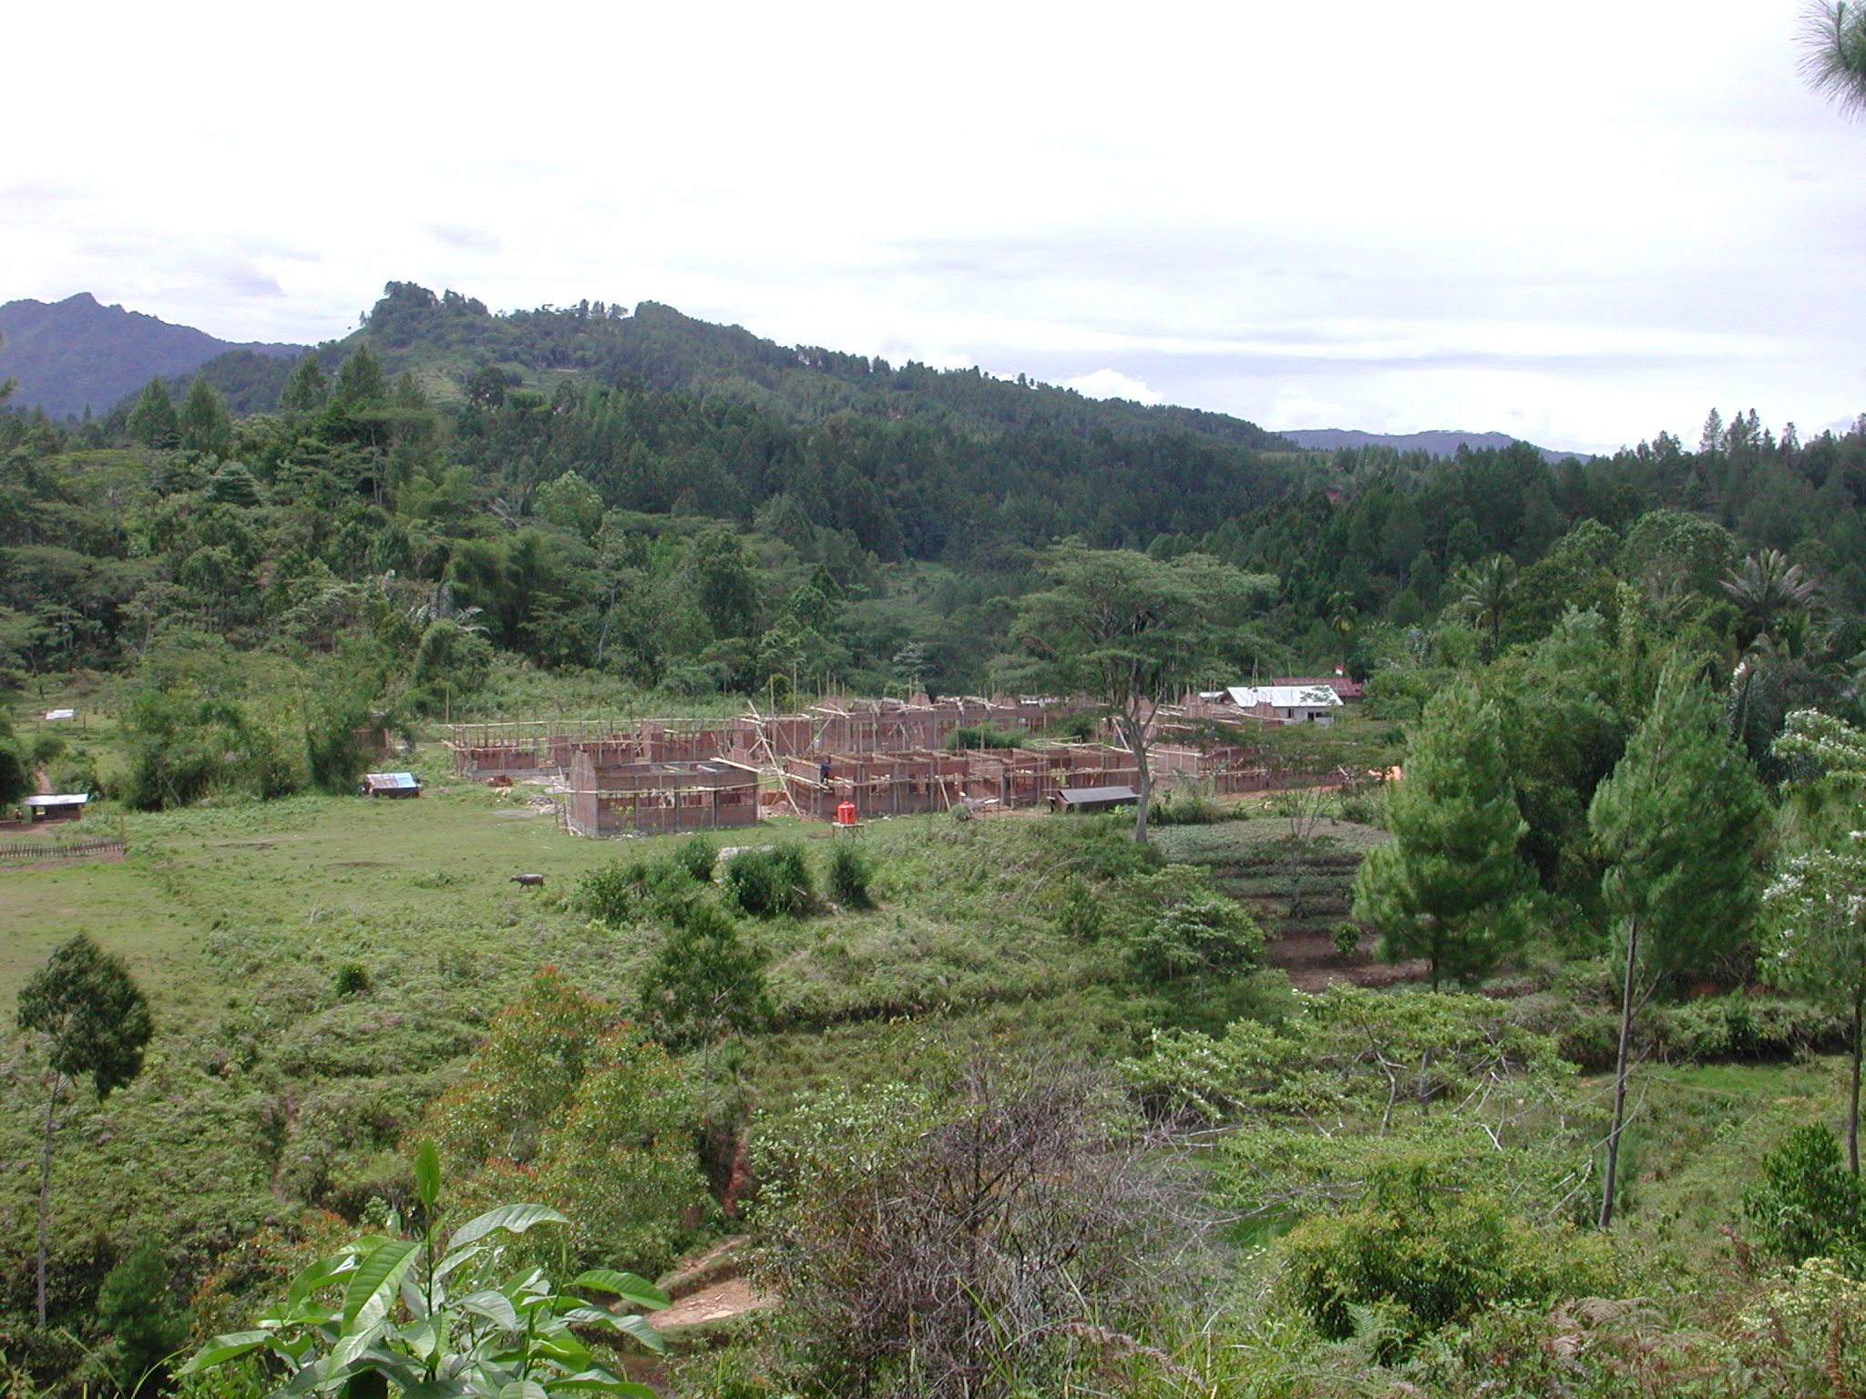

Plate 1: SLTPN Peta Kurra

The school committee stated that a survey of material prices had been carried out. There was also a breakdown of materials for each building but a weekly take-off of materials to be ordered was being carried out on site.

Work started on September 23rd 2003 and should be completed by March 23rd 2004. At the time of the visit the progress should have been 30.7% but was actually 30.2%. Admin: RC frame and brickwork complete to underside of ring beam, ring beam in progress, door and window frames fixed. Library: RC frame and brickwork 90%, door and window frames fixed. Multipurpose: RC frame and brickwork 90% to underside of ring beam; door and window frames fixed. 3-Classroom 1: RC frame (including roof beams) and brickwork complete; door and window frames fixed. 3-Classroom 2: RC columns to ring beam level; brickwork to underside of ring beam level 75%; door and window frames fixed. Toilets: RC frame and brickwork 80%. Handicrafts and Penjaga’s House: RC frame and brickwork complete; door and window frames fixed. Head Teacher’s House: RC frame and brickwork complete including ring beams.

The site has an office and a store for materials. The roof trusses are being made in the open and are not protected and door and window frames have been left lying unprotected around the site. The school has a notice board outside the office with details of the budget, progress, etc displayed.

The workmanship is generally good: the concrete columns are being cast in formwork with ties for the brickwork and the concrete work is very good. Columns are either 30 x 20cm or 25 x 20cm and both sizes should have 6No 12mm bars but in fact they all have 4 x 12mm and 2 x 10mm bars. There are no problems with the foundations. RC beams are being cast over most windows and doors but not for some reason in the Admin and Handicrafts buildings or in the two houses. The brickwork is not very good, the bricks are irregular and not very well burnt but the brickwork will of course be rendered. The door and window frames are well made and very good timber is being used for the roof and door and window frames. The main problem is that the site has not been stripped of top-soil and top-soil is being used for backfill.

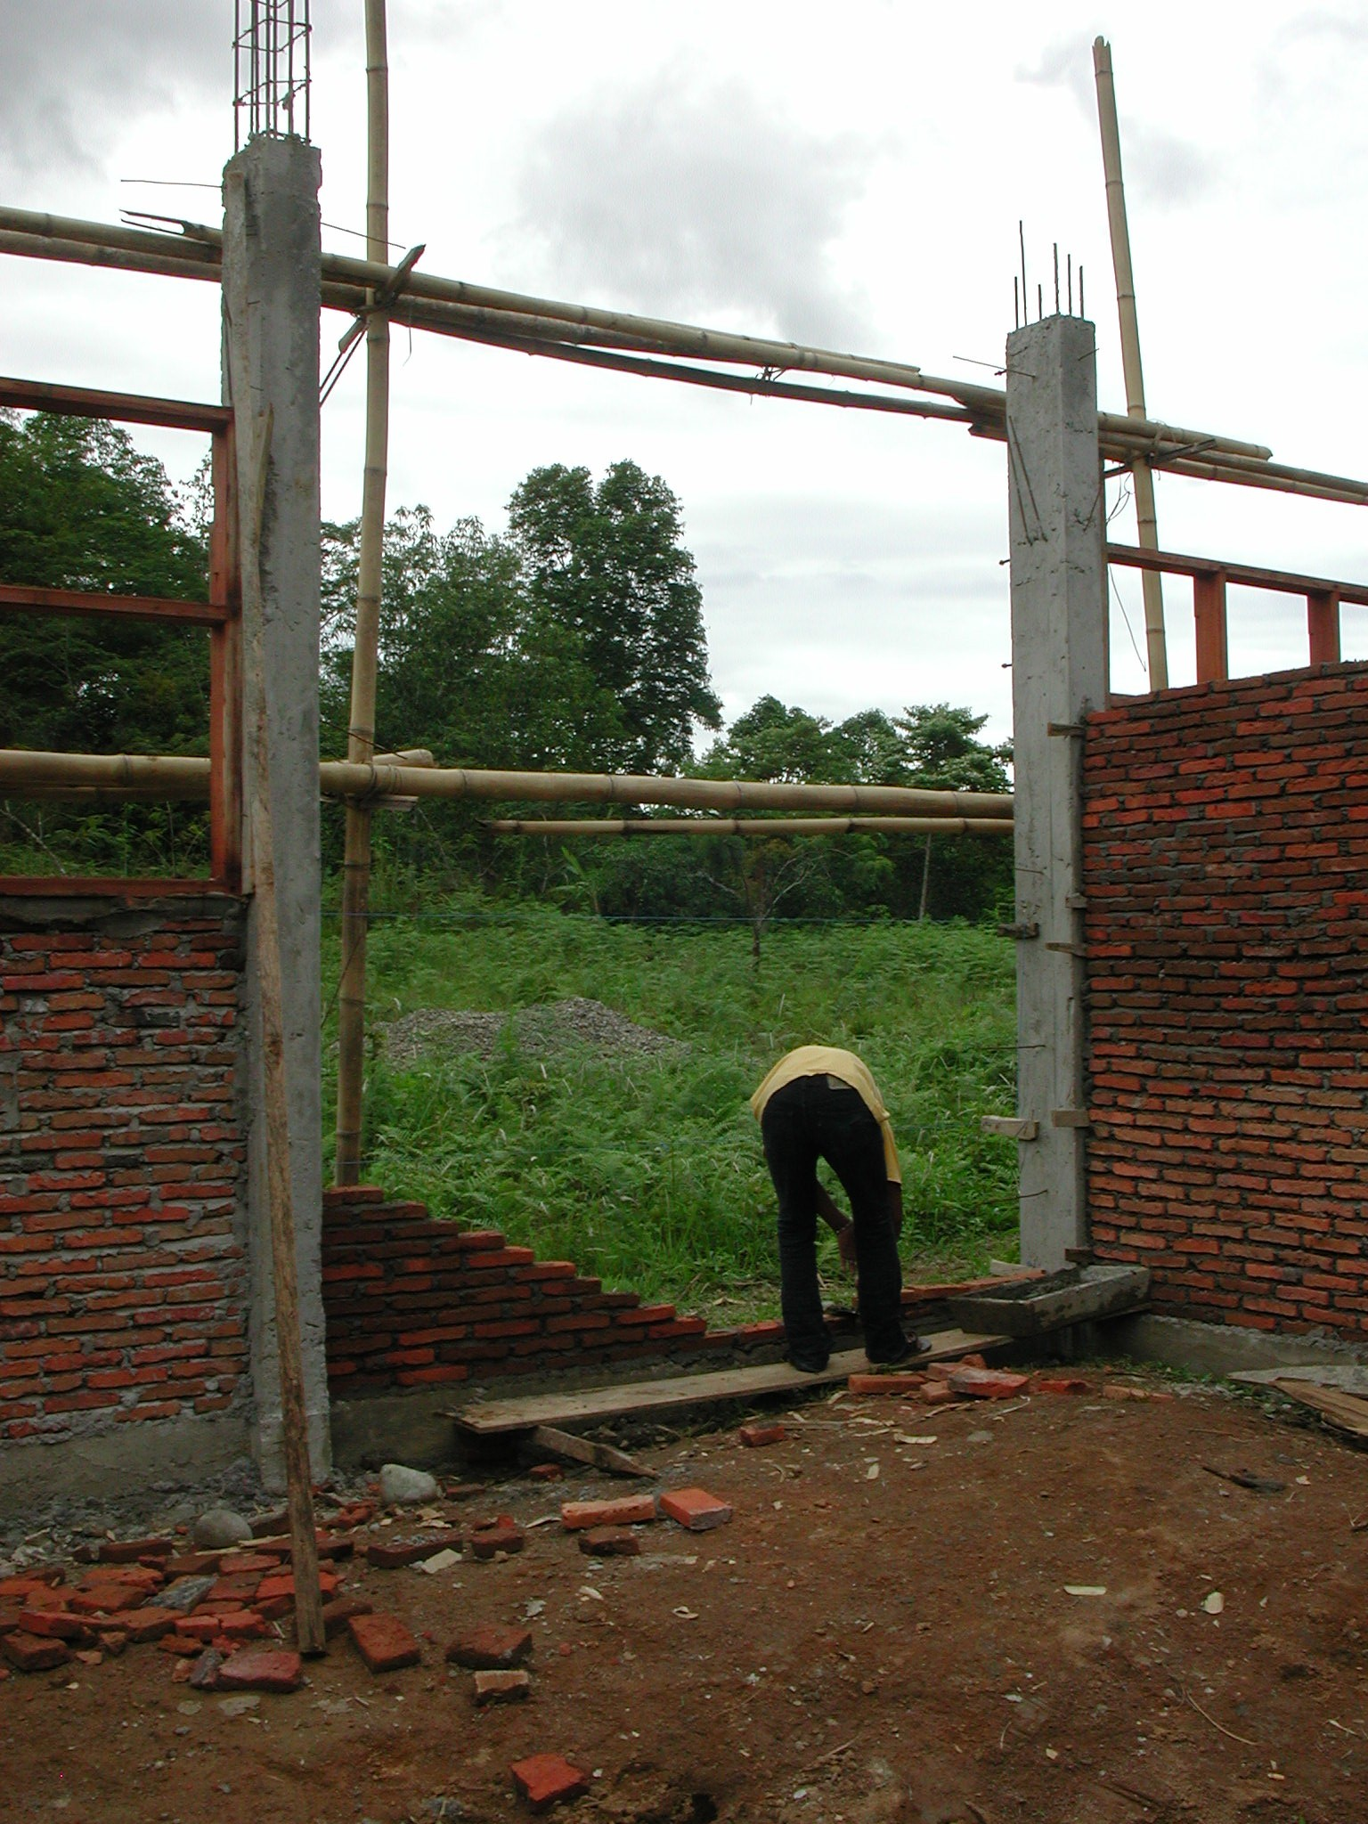

Plate 2: SLTPN Peta Kurra SLTPN Peta Kurra showing RC columns cast in formwork and brickwork in progress: note the ties in the columns

Some remedial work is required and the consultants must ensure that it is carried out. All topsoil and vegetable matter must be removed from inside the buildings and suitable material used for back-filling in 15cm layers, properly compacted. All timber work should be carried out under cover and all finished components should be stacked under cover. The consultants should also check the reinforcement to the columns, especially the classroom columns to ensure that it is adequate.

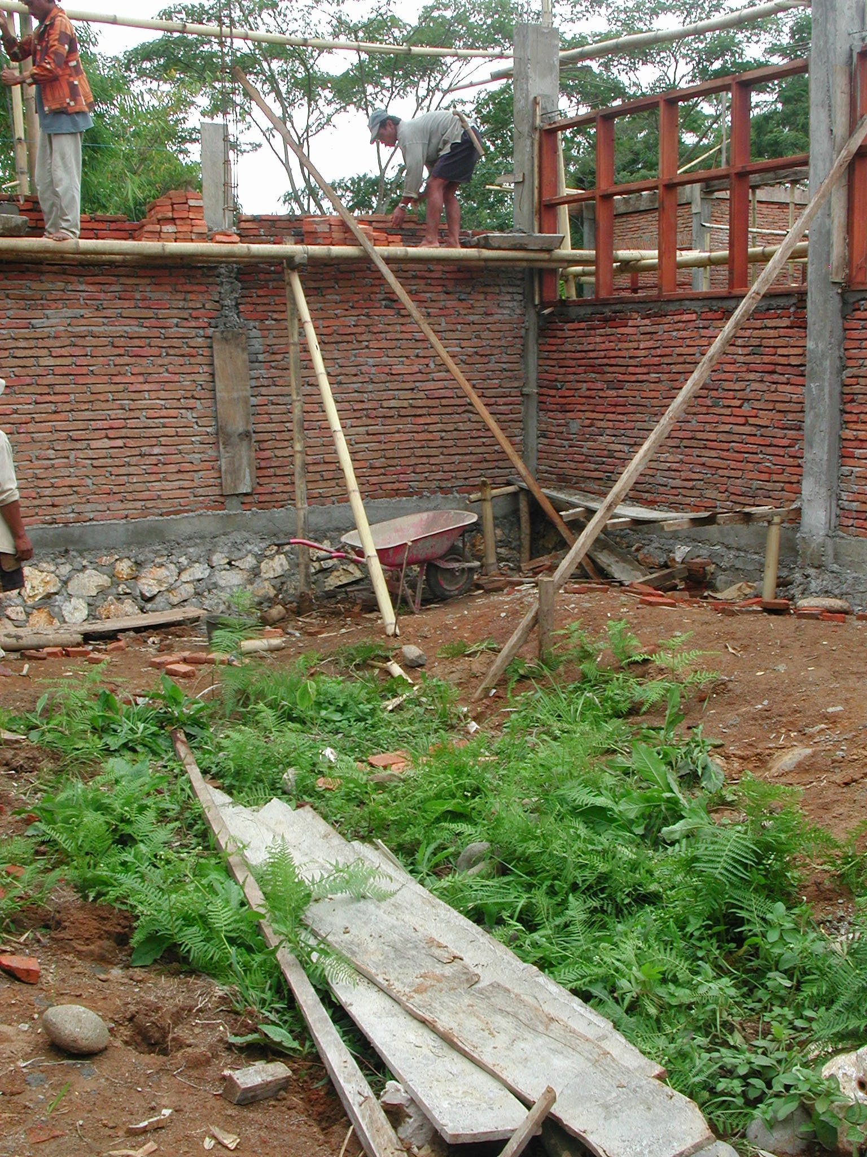

Plate 3: SLTPN Peta Kurra SLTPN Peta Kurra showing top-soil and vegaetable matter that has not been stripped off the site

3.2 Kabupaten Lowu: The following school sites were visited:

SLTPN Cakkeawo, Kecamatan Suli: The school is being constructed on a large (10,000m²) sloping site that was originally covered in trees in a rural village. The site is next to a road and access is not a problem. There are 5 primary schools within a 3km radius and the nearest SLTP is over 5km away. The school’s water supply will come from a new well on the site and there is an electricity supply along the road adjacent to the site.

The consultants have a construction manager (civil engineer S1 with 10 years experience) to manage the work and the kepala pelaksana is an architect with 3 years experience (but of constructing roads not buildings). Skilled workers are being paid Rp30,000 a day and unskilled workers Rp20,000 a day.

The budget for the work is Rp1,259,240,000 giving a square metre cost of Rp1,026,694m² including the area of the verandas. However, the site plan prepared by the consultants has no levels indicated even though there is a 2 metre fall across the site and this must have budgetary implications. There are no details of any site works indicated on the drawings even though there will have to be a lot of retaining walls, steps, etc and it is doubtful if these works have been included in the budget. There must be some doubt therefore as to whether the budget will be sufficient to complete the works.

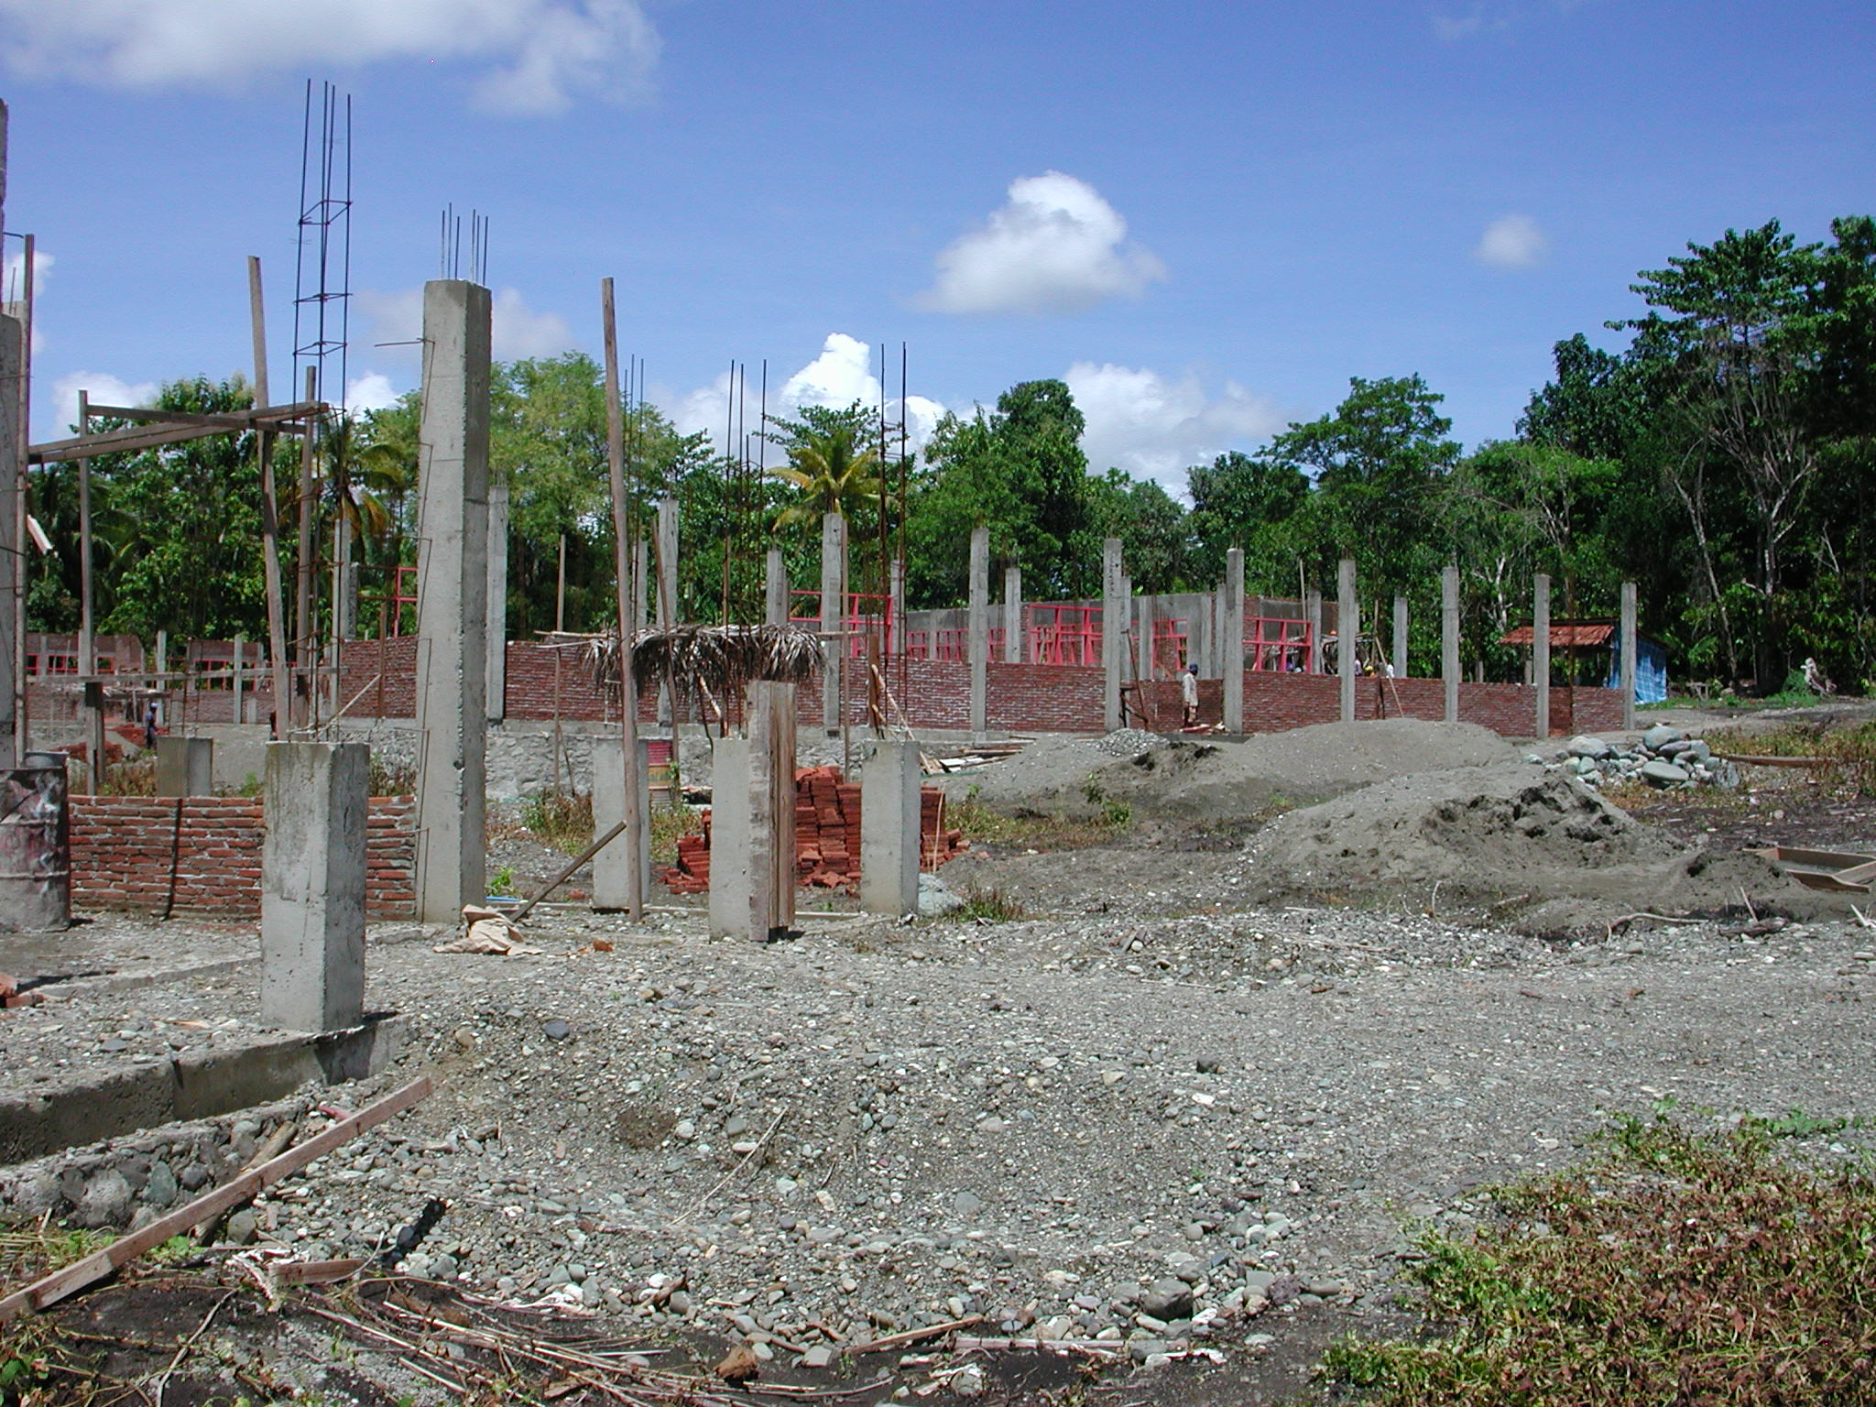

Plate 4: SLTPN Cakkeawo

Work started on September 25th 2003 and should be completed by March 25th 2004. At the time of the visit the progress should have been 47.7% but was actually 28.07%, approximately 3.5 weeks behind programme. The reason for the lack of progress had been a month-long delay in receiving the second instalment of the funds. 3-Classroom 1: RC frame and brickwork complete to top of ring beam; door and window frames fixed; external rendering complete; internal rendering in progress. 3-Classroom 2: RC columns to complete to underside of ring beam; brickwork to underside of ring beam 70% complete; door and window frames 40%. Library: RC frame and brickwork complete to top of ring beam and rendered; door and window frames fixed. Multipurpose: RC columns complete to underside of ring beam; brickwork 70% complete; door and window frames 70% fixed. Admin: RC columns complete to underside ring beam; brickwork 30% complete; doors and window frames being fixed. Toilets: RC columns complete to underside of ring beam. Head Teacher’s House: RC frame and brickwork complete to underside of ring beam; door and window frames fixed. Musholla: RC columns complete to underside of ring beam, brickwork in progress. Penjaga’s House: RC frame and brickwork complete to top of ring beam; door and window frames fixed; rendering 80%.

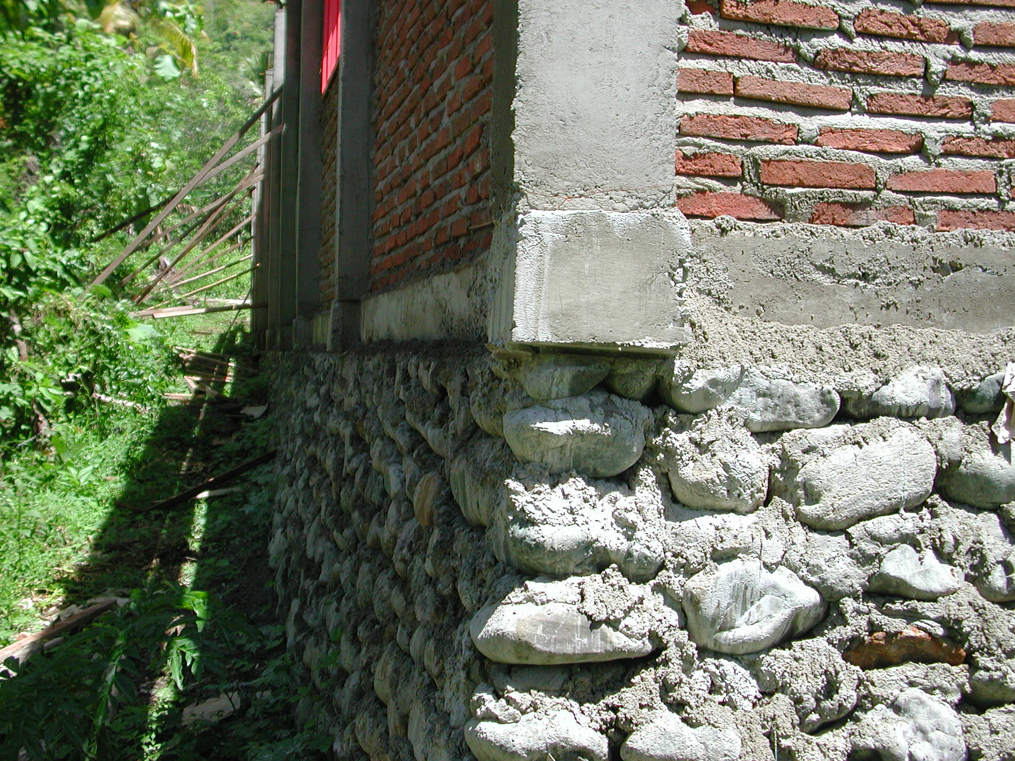

Plate 5: SLTPN Cakkeawo showing columns overhanging foundations

The site is well organised with an office and a store for cement and other materials. There is a notice-board outside the site office giving details of the work including bank statements and samples of materials to be used in the office. The timber being used for joinery is good and the quality of the joinery is very good. The roof timbers have not been ordered yet as the second instalment of the funding has only just been received.

The workmanship overall is quite good but there are several serious problems. The columns have been cast in formwork and the quality is good but the columns overhang the ground beams and foundations in many places, in some cases by up to a third of the depth of the columns. RC lintels have been constructed over door and window openings but there is no connection between the lintels and the reinforcement in the columns! The ring beams have been constructed on the rear face of the columns and therefore the beams only connect with the two rear reinforcing rods in the columns and at the corners of the buildings the beams only connect with one reinforcement rod! The reinforcement is a mixture of 10mm and 11mm diameter not 12mm as specified. The other major problem is that none of the existing top-soil and vegetable matter has been stripped off the site. It was apparent from the numerous tree stumps on the site that it had been covered with trees and that these have been cut down but none of the roots had been removed. In the Admin Building for instance, there are two large roots that are still growing. Top-soil is also being used as back-fill.
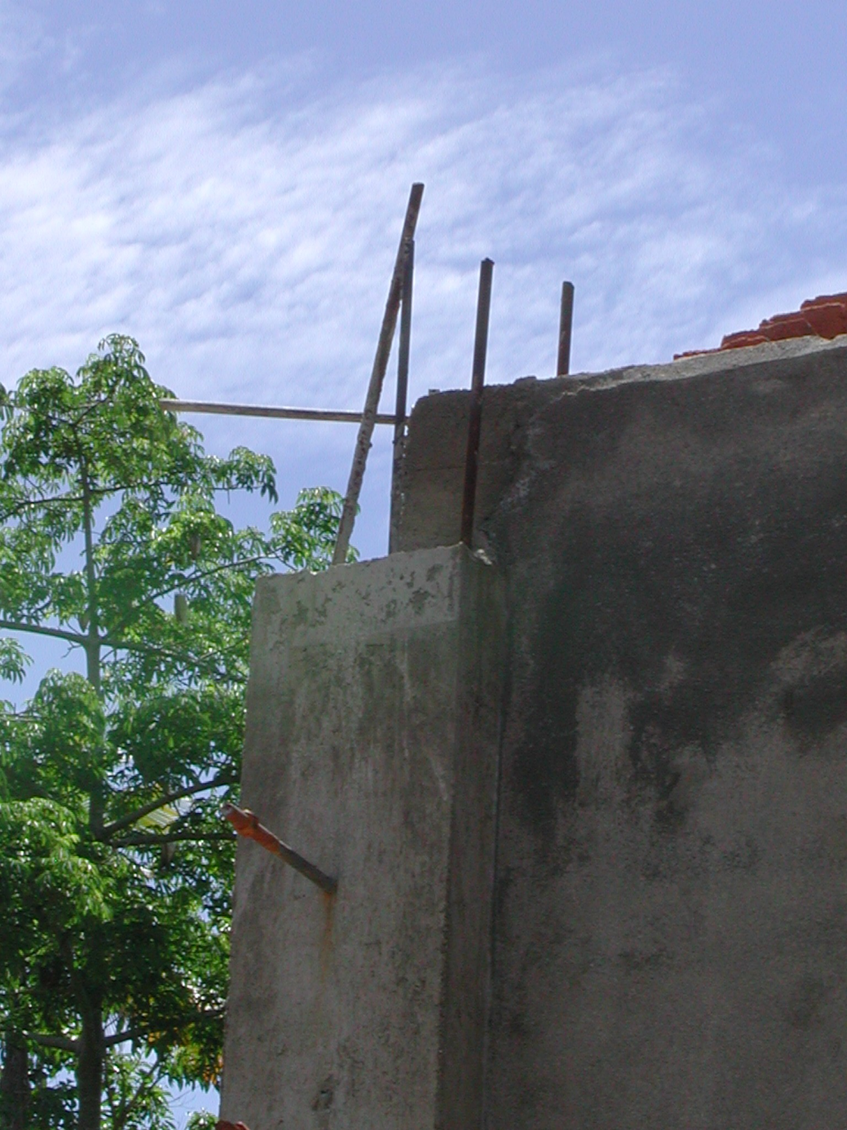

Plate 6: SLTPN Cakkeawo showing lack of connection between column and ring beam

A lot of remedial work is required and the consultants must ensure that it is carried out. The consultants must modify the junctions between the top of columns and the ring beams to ensure that the connections are adequate. They must ensure that the foundations beneath columns are enlarged either in stone or concrete and tied into the existing foundations to give adequate support to the columns. They must also ensure that all top-soil, roots, etc including fill is removed from the inside areas of the buildings including the verandas and that back-filling with suitable material, properly compacted is carried out in layers not exceeding 15cm thick.

The consultants must also prepare, as soon as possible, a site layout showing the levels of all the buildings and details of all necessary site works including retaining walls, steps, paths, drains, etc and produce a revised budget for the completion of the works. If the budget estimate exceeds the money available they must inform the CMU as soon as possible.

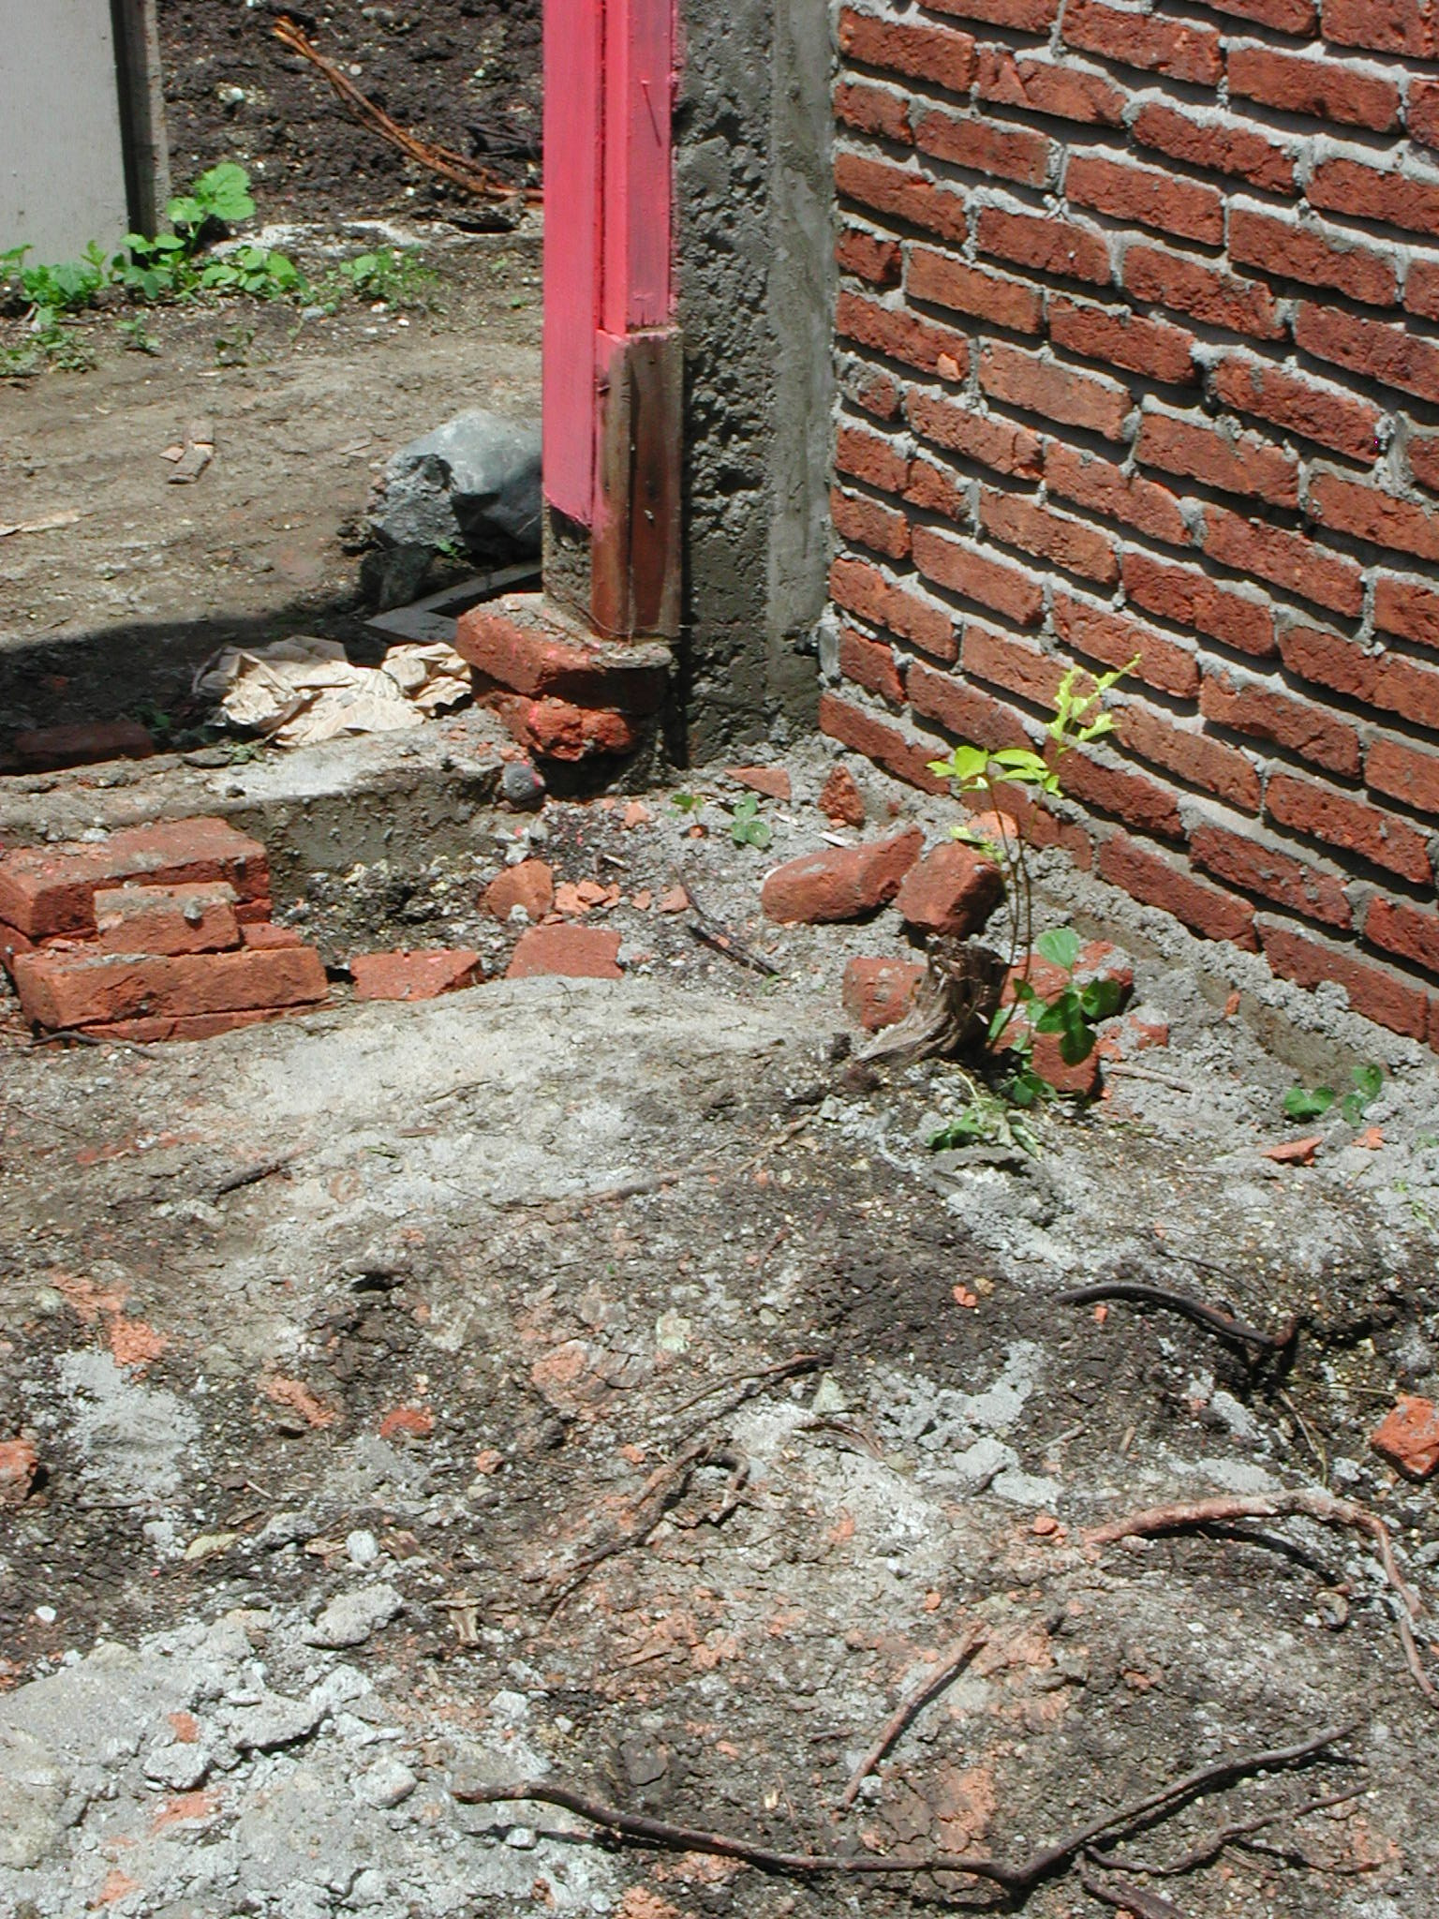

Plate 7: SLTPN Cakkeawo showing tree roots in Admin Building

In order to speed up the work and reduce costs, it was suggested that the concrete roof beams in the classroom buildings are omitted and replaced with simple roof trusses and the consultants should also prepare drawings for these.

It was also noted that there is an existing house situated on the school site at the entrance. The project manager should ensure that this house is removed as soon as possible.

SLTPN 04 Binturu, Kecamatan Larompong: The school is being constructed on a sloping site in the middle of a remote rural village. The site is very wet and slopes down from the village road. Access is not a problem. There are six primary schools in the catchment area of the new school and the nearest SLTP is about 5 kilometres away. There is a good water supply to the village from a spring but the village does not have an electricity supply.

The consultants have a construction manager (civil engineer S1 with eight years experience) on site to manage the work. The kepala pelaksana is also an S1 civil engineer with 7 years experience. Skilled workers are being paid Rp30,000 a day and unskilled workers Rp20,000 a day. There are a total of 21 workers on the site.

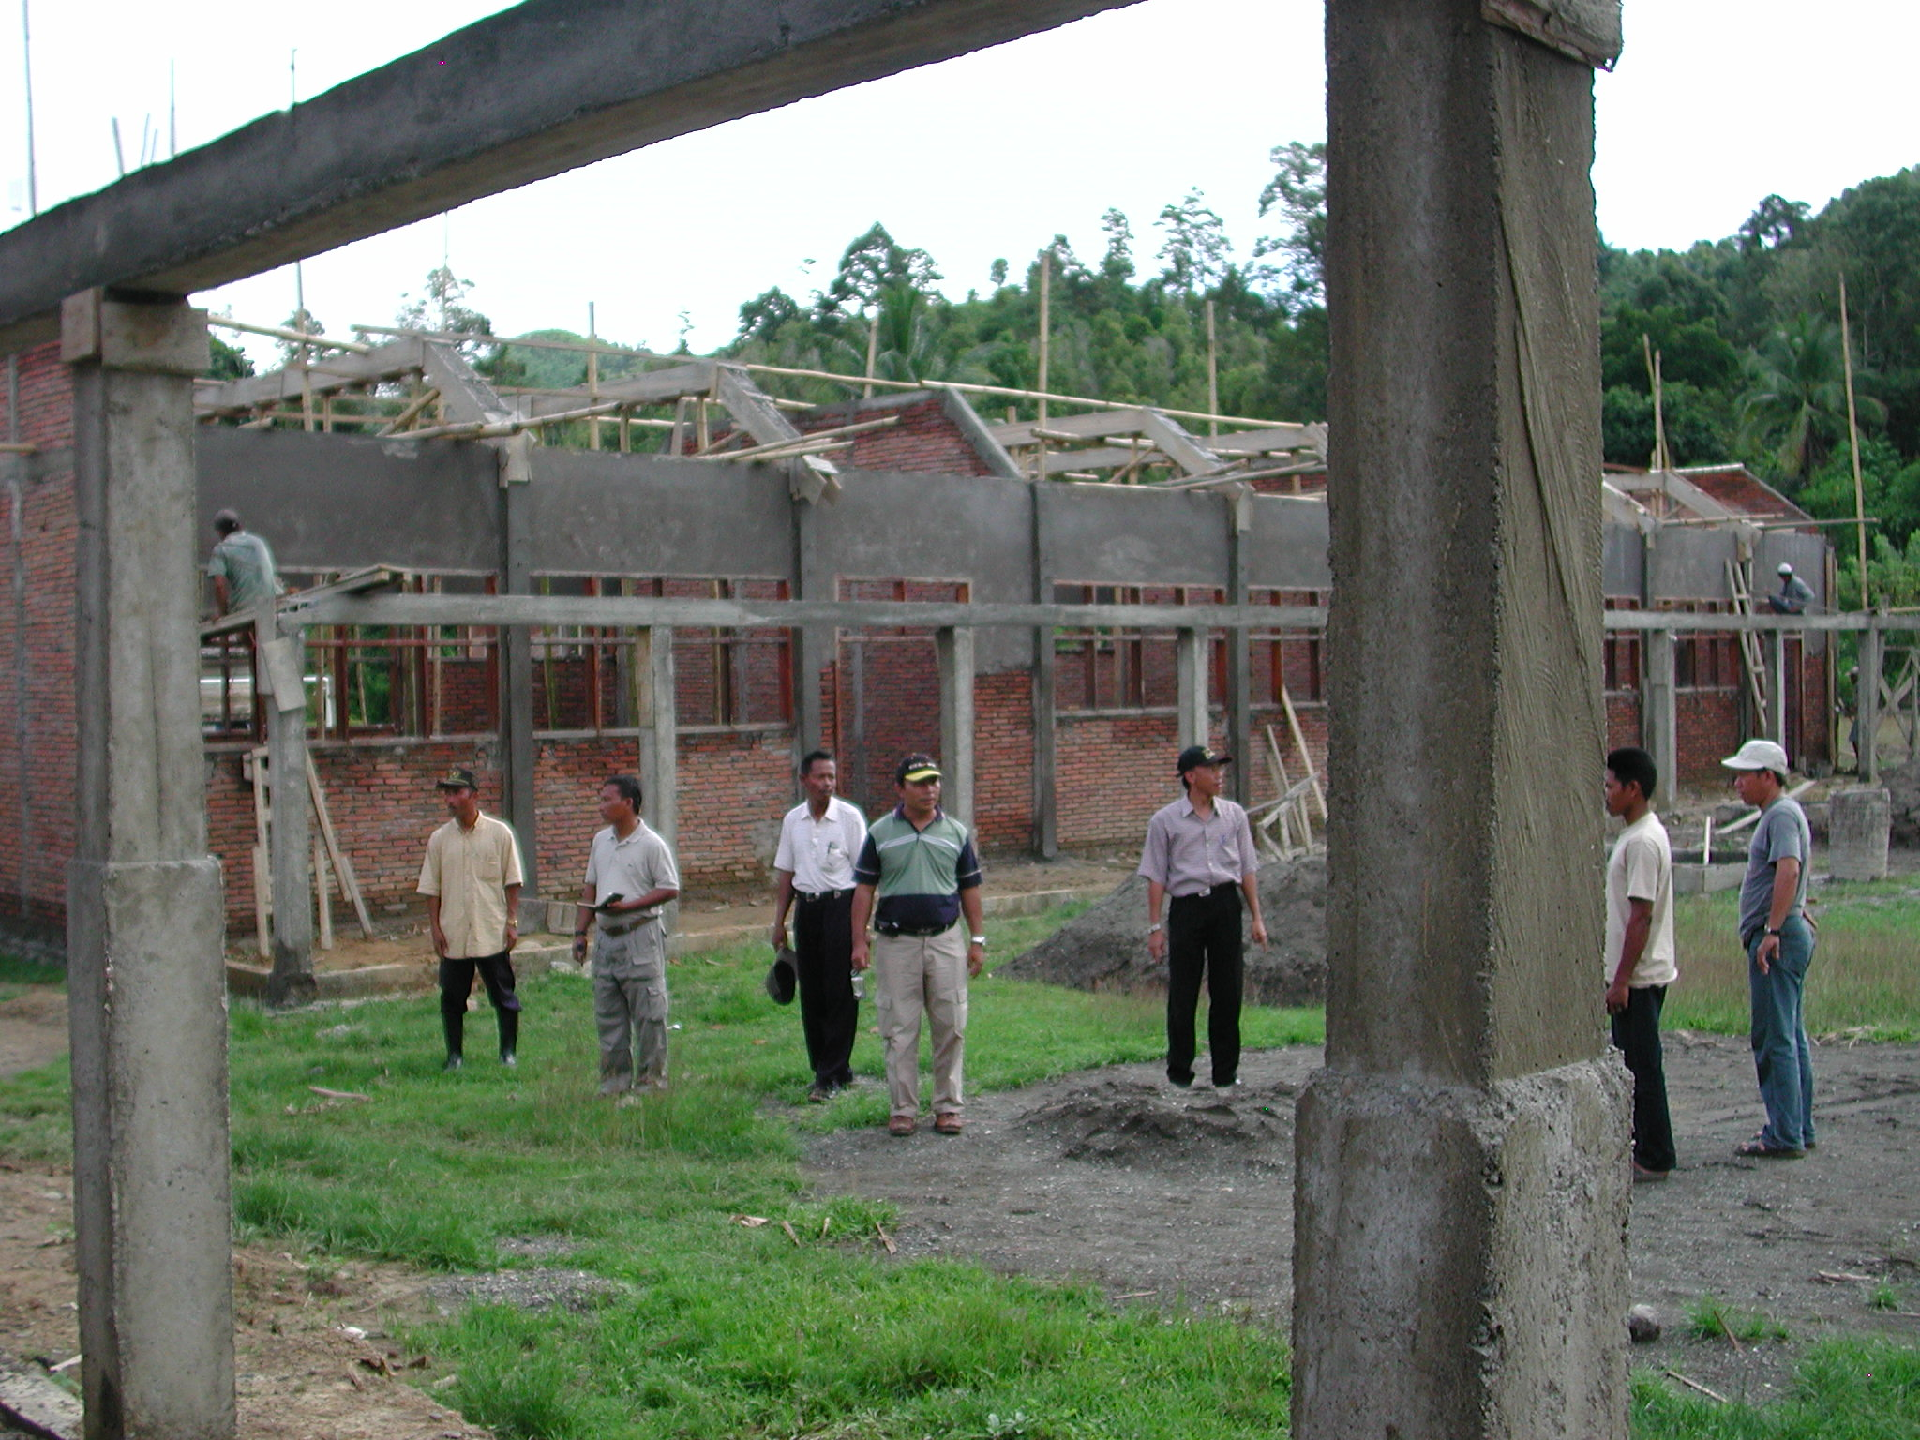

Plate 8: SLTPN 04 Binturu: note complicated RC roof beams

The budget for the work is Rp1,295,640,000 giving a square metre cost of Rp1,056,372m² including the area of the verandas. The site layout prepared by the consultants shows some levels but these are wrong and there is no indication of any drains to deal with the water running across the site or of any other site works. A large drain will probably be required on at least three sides of the site to cut off the water running across it and the consultants should check that the available budget will cover the cost of the site works.

Work started on October 5th 2003 and should be completed by March 5th 2004. At the time of the visit the progress should have been 48% but was actually 38%, 3 weeks behind schedule. Multi-Purpose and Library: columns, including veranda columns, complete to underside of ring beam; brickwork 75%; door and window frames fixed. Admin: RC frame complete; brickwork 90%; door and window frames fixed; roof trusses complete, purlins in progress. Musholla: foundations and ground beam complete; reinforcement for columns in place. 3-Classroom 1: RC frame to top of ring beam including veranda columns and beams, complete; brickwork complete; door and window frames fixed; rendering 80%. 3-Classroom 2: RC frame including beams over classrooms complete; brickwork 90%; door and window frames fixed; rendering in progress. Head Teacher’s House: Columns complete to underside of ring beam; door and window frames fixed; brickwork 75%. Toilets: Columns and brickwork complete to underside of ring beam. Penjaga’s House: Foundations and ground beam complete; columns 50%.

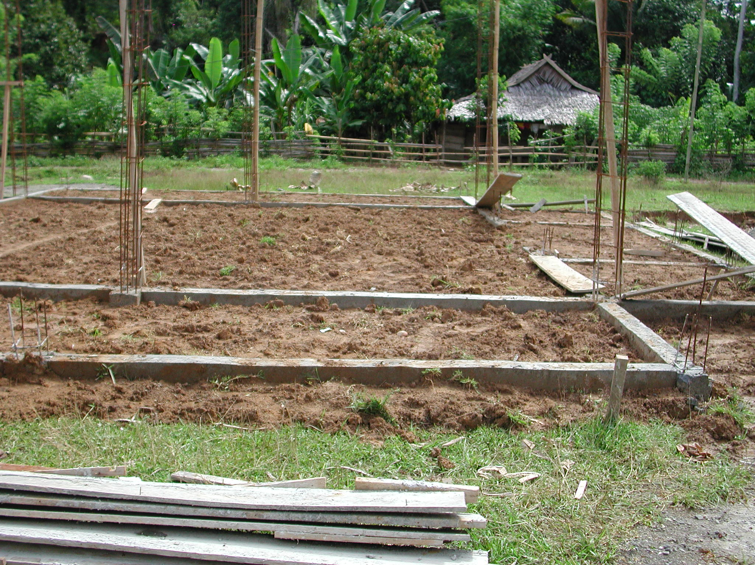

Plate 9: SLTPN 04 Binturu showing top-soil being used for back-filling

The site has a very well built site office with all the information about the project displayed on a veranda and samples of all the materials to be used displayed inside the office. There is also a material store next to the office. The roof trusses are being made and stacked under cover but none of the other timber is protected.

The workmanship overall is not as good as at the last site and there are again some serious problems similar to those at the last site. The columns have been cast in formwork but the quality of the concrete is not very good and some of the aggregate is too big. RC lintels have been constructed over door and window openings but again there is no connection between the lintels and the reinforcement in the columns! The ring beams have been constructed in the centre of the columns and therefore the beams have no connection with the reinforcing rods of the columns (except at the corners) at all! All reinforcement is 11mm diameter not 12mm as specified. The other major problems are that none of the existing top-soil and vegetable matter has been stripped off the site and top-soil is being used for back-fill. The door and window frames are quite well made of good timber but the timber being used for the roof trusses is not very good, the workmanship is not very good and the metal straps to the trusses are only 2mm thick not 4mm as specified.

Some remedial work is required and the consultants must ensure that it is carried out. The consultants must modify the junctions between the top of columns and the ring beams to ensure that the connections are structurally adequate. They must also ensure that the correct steel straps are used on the trusses. They must ensure that all top-soil including fill is removed from the inside area of the buildings including the verandas and that back-filling with suitable material, properly compacted is carried out in layers not exceeding 15cm thick.

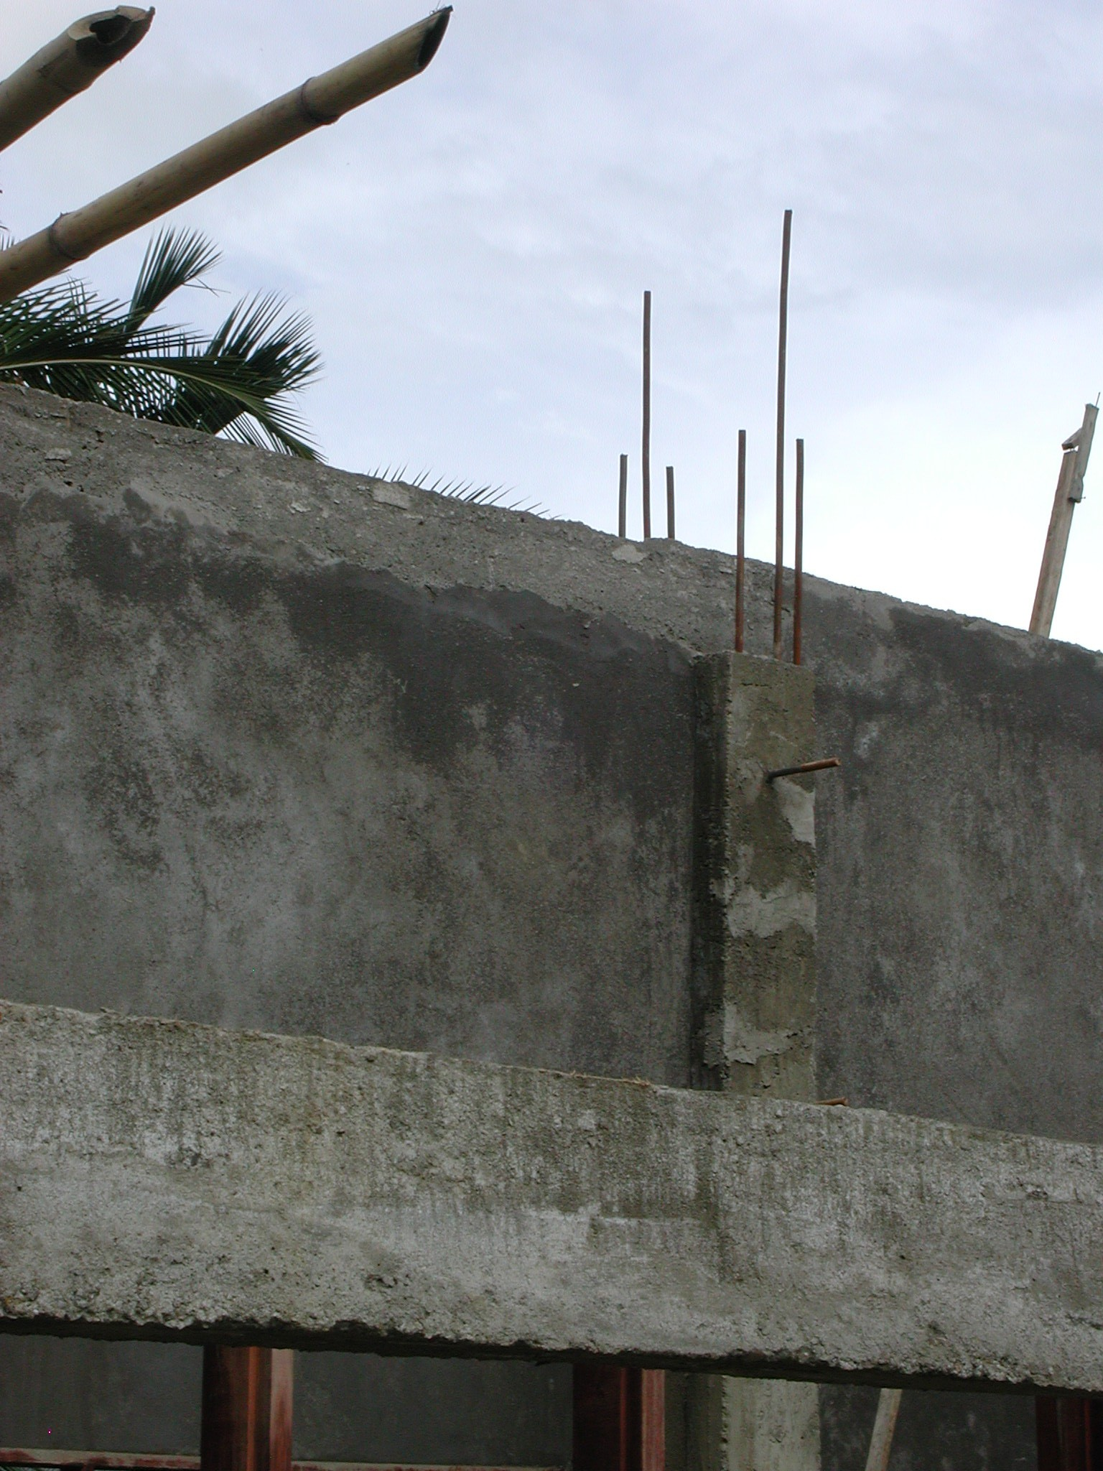

Plate 10: SLTPN 04 Binturu showing lack of structural connection between column and ring beam

The consultants must also prepare, as soon as possible, a site layout showing the levels of all the buildings and details of all necessary site works including steps, paths, cut-off drains, etc and produce a revised budget for the completion of the works.

To speed up the works, the concrete roof beams in the first 3-Classroom Building should be omitted and replaced with timber roof trusses as at the previous school.

  - Kabupaten Gowa: The following school site was visited:

SLTPN 04 Pallangga, Kecamatan Pallangga Cini Talassar: The school is being constructed on a very restricted site (6,005m²) in a village 20 kilometres from Makassar. The site is flat and very wet. There are 5 primary schools in the catchment area of the school but the nearest SLTP is only 2.5 kilometres away. The village has a piped water supply and an electricity supply.

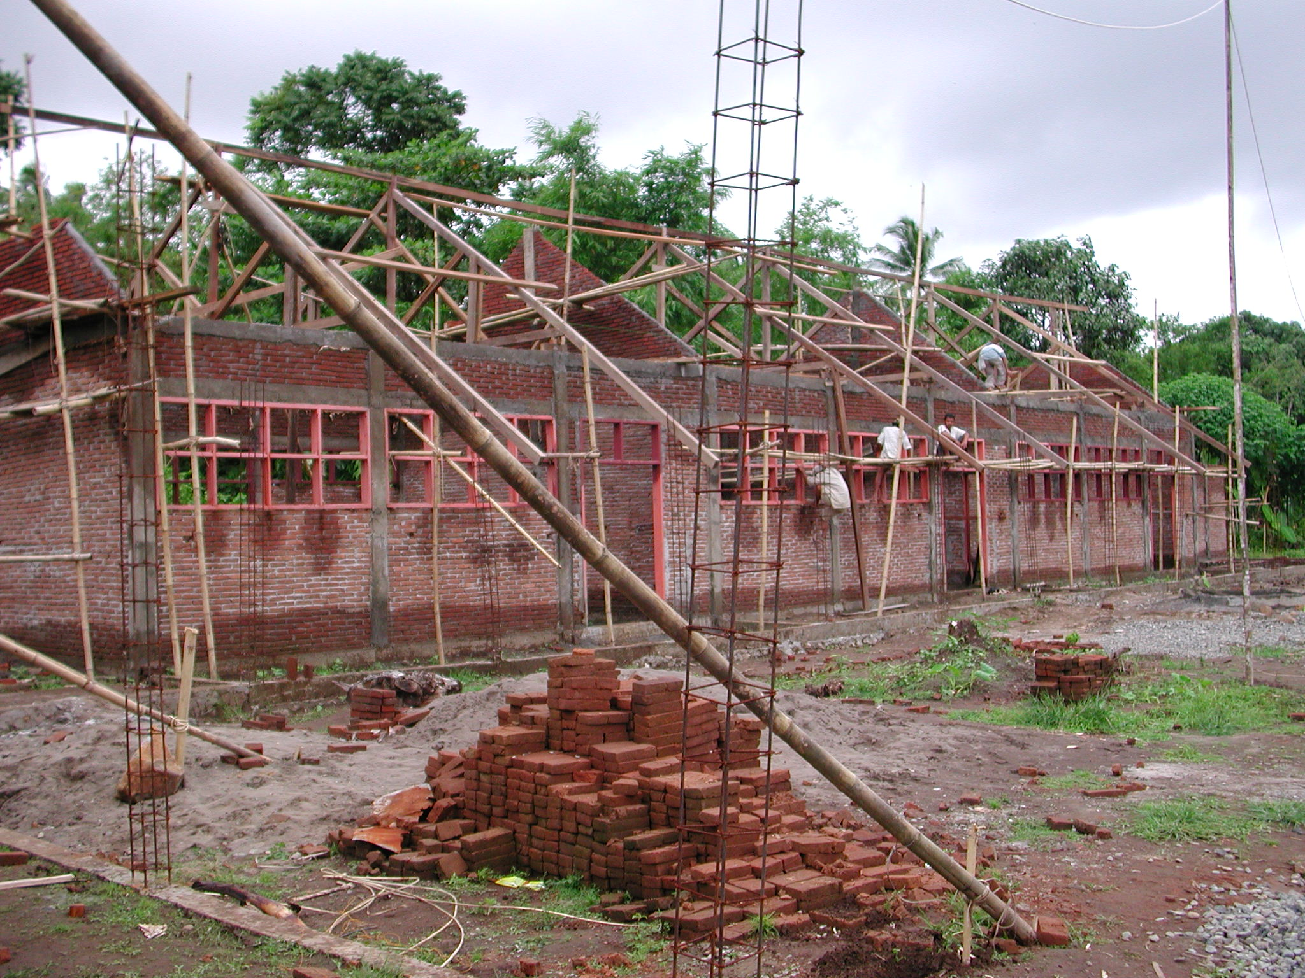

Plate 11: SLTPN 04 Pallangga: note the under-sized reinforcement

The consultants have a civil engineer (S1 with ten years experience) as construction manager on site to manage the work and the kepala pelaksana is also a civil engineer S1 with 27 years experience. Skilled workers are being paid Rp25,000 a day, unskilled workers Rp17,500 a day and foremen Rp35,000 a day.

The budget for the work is Rp1,186,381,000 giving a square metre cost of Rp967,290m² including the area of the verandas.

Work started on September 17th 2003 and should be completed by March 12th 2004. At the time of the visit progress was 29.5% but should have been 56%. There had been a delay of one month before the second instalment of the funding had been received and heavy rain had also delayed the work. Multipurpose: cross walls complete to underside of ring beam, other walls to underside of window cills; door and window frames fixed. Admin: brickwork to underside of ring beam 75%; door and window frames fixed. 3-Classroom 1: brickwork complete; door and window frames fixed; ring beam cast; roof trusses fixed, purlins in progress. 3-Classroom 2: brickwork to underside of ring beam 80%; door and window frames fixed; ring beam being shuttered. Library: brickwork to underside of ring beam 60%; door and window frames fixed. Toilets: brickwork to underside of ring beam complete. Musholla: brickwork to lintel level; door and window frames fixed. Head Teacher’s House: brickwork to cill level. Penjaga’s House: brickwork to underside of ring beam 75%; doors and window frames fixed.

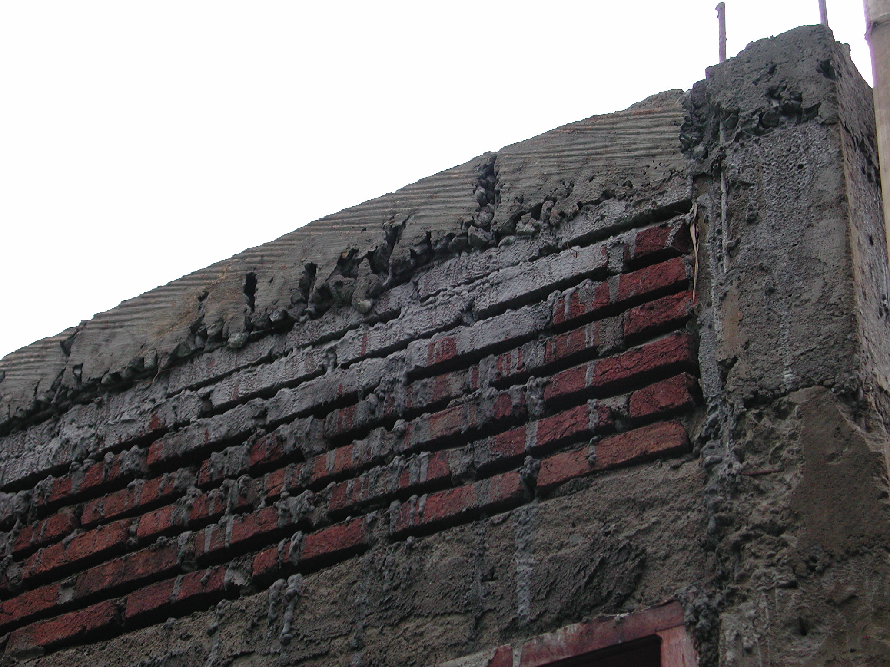

Plate 12: SLTPN 04 Pallangga showing very poor quality ‘concrete’

The workmanship is generally very poor. The site has not been stripped of top-soil or vegetation and there are a lot of tree roots in and around the buildings. At least one root is actually under the foundations of the library. The concrete work is terrible: columns have been cast in between the brickwork panels in short lengths and are in many cases not straight or plumb; the concrete mix that is being used has too much sand, too much water, too little cement and too little large aggregate (there is a pile of ‘split’ on the site but it does not appear to have been used); concrete columns, which should be 25 x 20cm with 4No 12mm bars, are 20cm wide but only about 15cm deep and have 4No 10mm bars; columns have been cast the same width as the ground beam which is 15cm wide (or less in some places). The brickwork is also very poor: string-lines are not being used and the courses are very uneven. The joinery and roof trusses are quite good (although some timber is not very good quality) but the roof trusses to 3-Classroom Building 1 have been fixed before the ring beams have been cast. All timber, finished and unfinished is stacked up out in the open with no protection and fungus is starting to grow on the timber.

There is now a new site office which has an information board inside and a store for storing materials. The small quantity of cement in the store was stacked directly on the concrete floor. The original site office was located in an existing house on the site
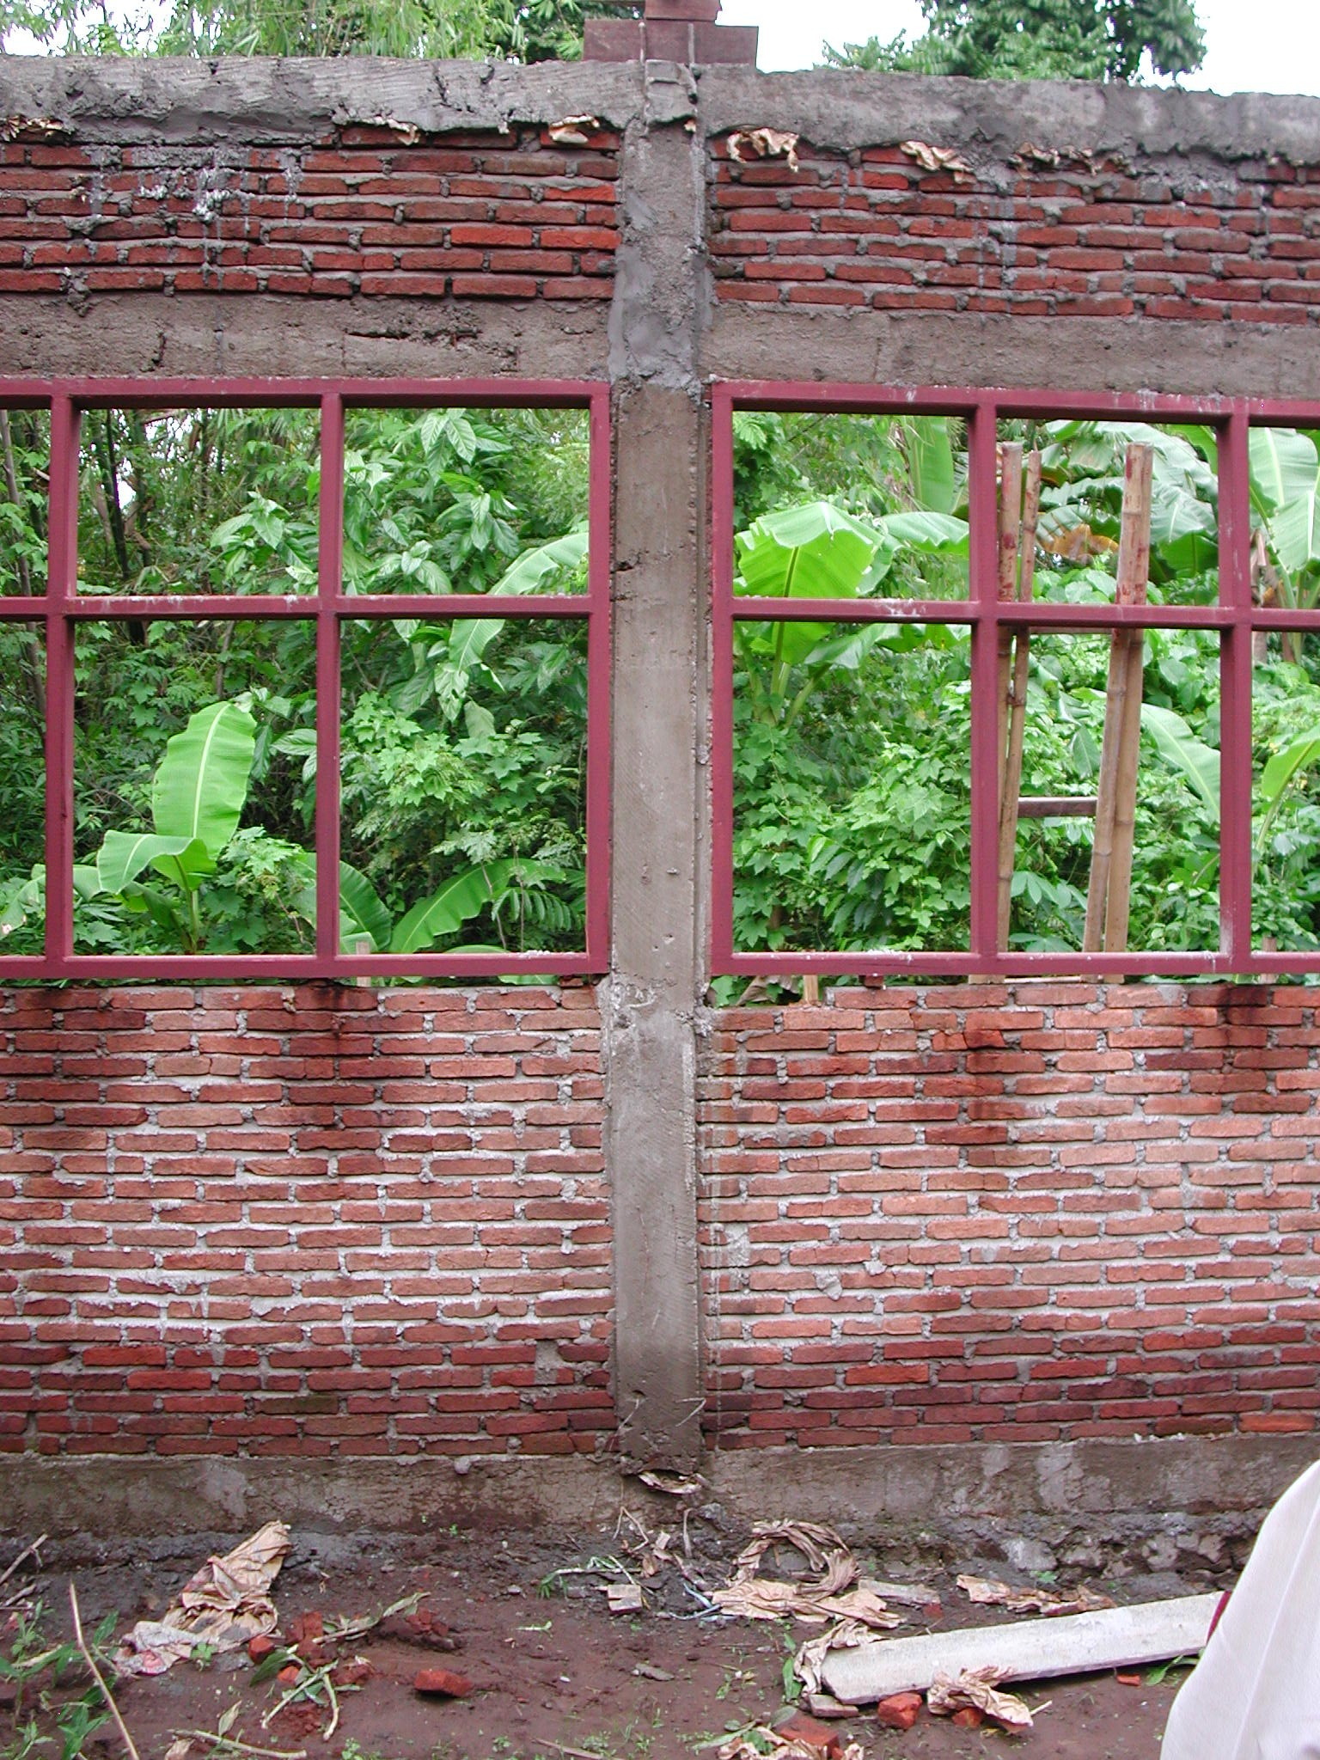

Plate 13: SLTPN 04 Pallangga showing poor quality concrete and problems caused by not using formwork: columns not plumb or straight

which is now being demolished. The house is located in the middle of the Admin Building and construction has started around the existing building. There are no setting-out dimensions on the site drawing but the Admin Building is much closer to the front boundary (and an existing house) than is shown on the drawing. The site is very wet but there are no drainage details or any other site works details.

The school committee was asked to stop construction work immediately as it was felt that the small size of the columns together with the undersized reinforcement and the very poor quality concrete mix made the concrete columns (and beams) unsafe. The consultants were asked to carry out concrete tests as soon as possible, to report in one week on all remedial work that was required and demolish any concrete-work that did not reach the required specification. They were also asked to check the height of the roofs over the verandas to see if there is sufficient headroom and to produce drainage details for the site. The District Technical Team will have to make proposals for paying for any work that has to be demolished and re-built.
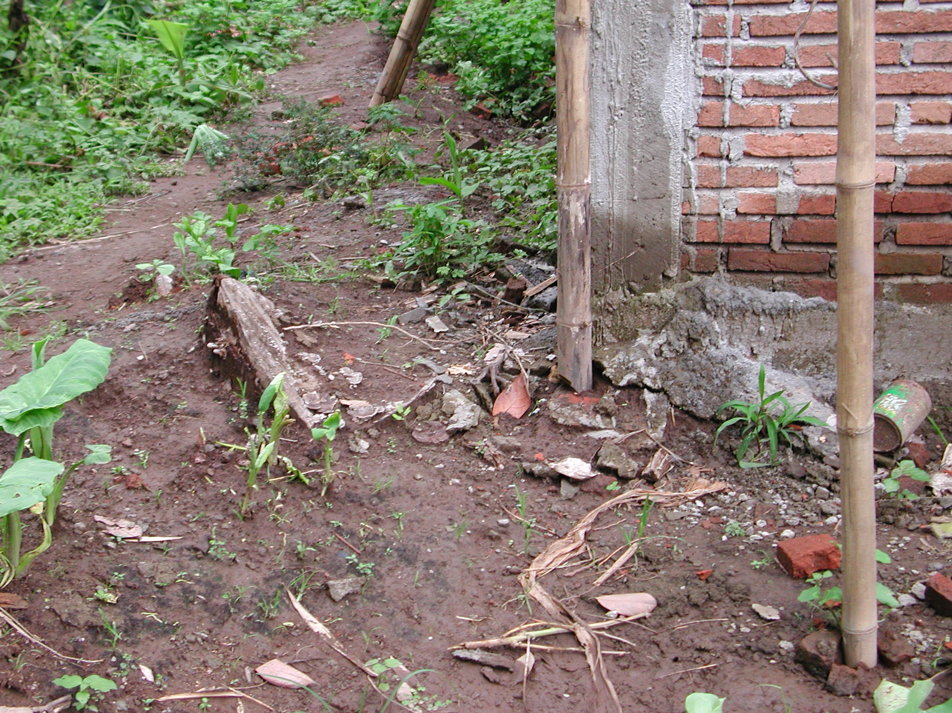

Plate 14: SLTPN 04 Pallangga showing large tree root next to foundation

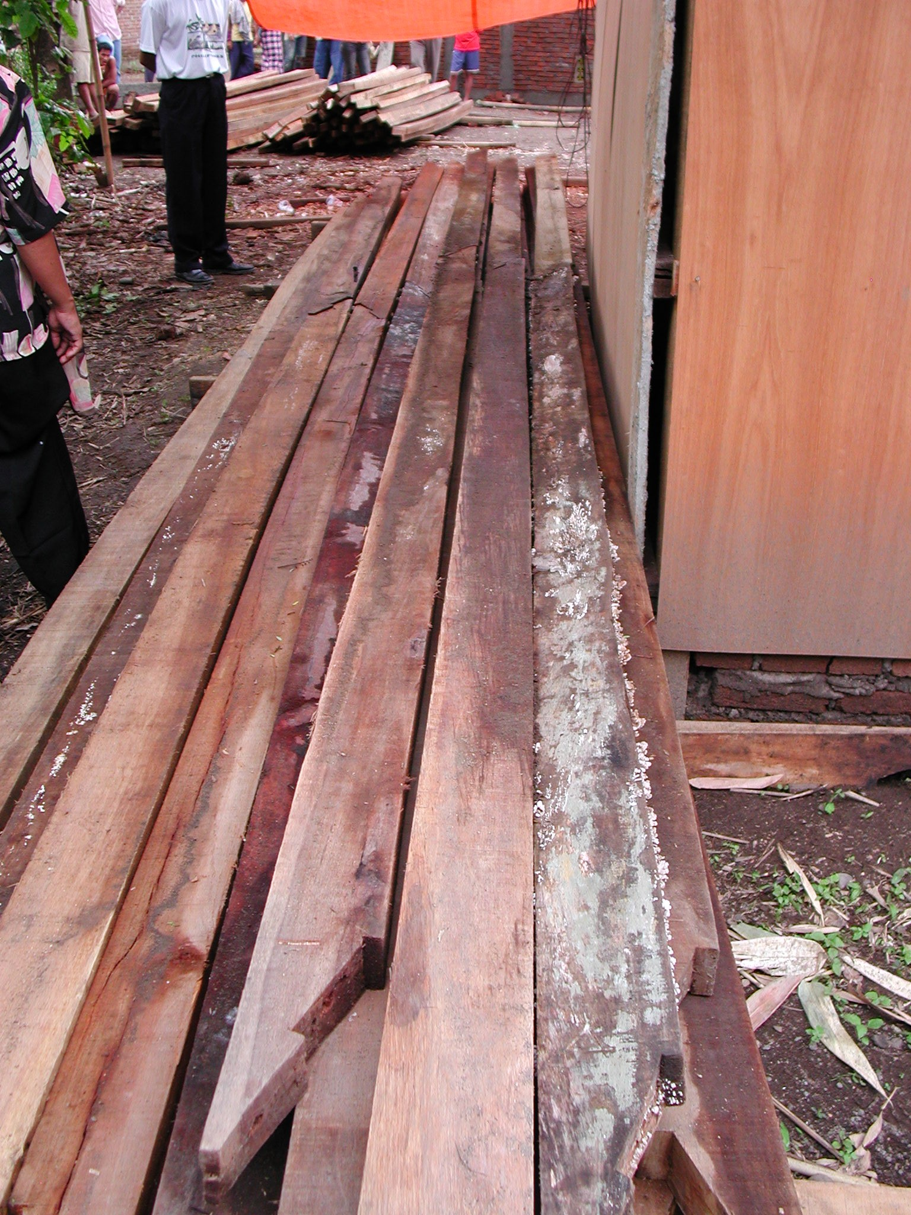

Plate 15: SLTPN 04 Pallangga showing unprotected timber starting to rot

