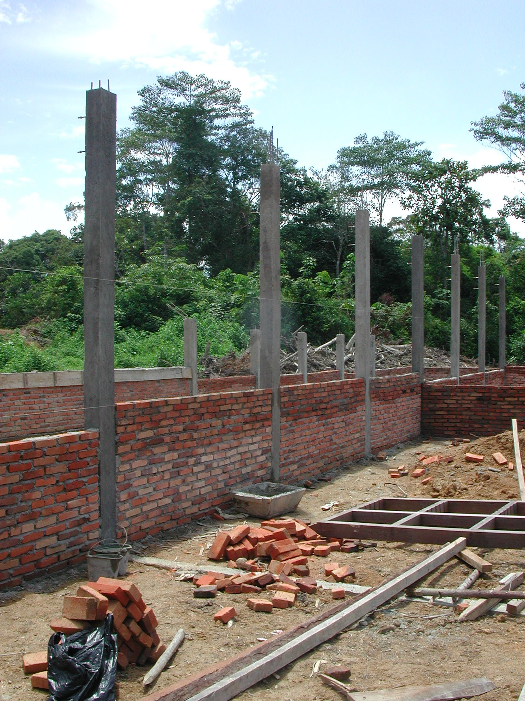
JUNIOR SECONDARY EDUCATION PROJECTS

IMPLEMENTATION SPECIALIST’S REPORT
APRIL 2003
JUNIOR SECONDARY EDUCATION PROJECTS
LOANS 4042-IND, 4062-IND, 4095-IND

IMPLEMENTATION SPECIALIST’S REPORT: MARCH 2003

TABLE OF CONTENTS

A. Introduction

- General
- Construction Specialist’s Terms of Reference
3. Meetings
4. Visits

B. Issues and Recommendations

1. General
2. Civil Works Consultants
2.1 Community-Based Projects
2.2 Drawings
2.3 Other Documentation
2.4 Budgets
2.5 Supervision and Management
2.6 Project Guidelines
3. Construction Issues
3.1 Setting Out
3.2 Concrete
3.3 Reinforcement
3.4 RC Columns
3.5 Foundations
3.6 Timber
3.7 Roof Trusses
3.8 Brickwork
3.9 Top-Soil
3.10 Wells and Septic Tanks
3.11 Site Organisation
4. Other Issues
4.1 Project Guidelines
4.2 Transparency
4.3 Matching Grants
5. Phase 2 of the School Building Projects

ANNEXES
Annex 1: Report on Visit to Central Java Province
Annex 2: Report on Visit to Lampung Province
Annex 3: Report on Visit to Jambi Province
Annex 4: Report on Visit to West Sumatra Province
Annex 5: Report on visits to schools receiving matching grants in West Kalimantan and Jambi Provinces by Eng. Hernawan Mahfudz
A. Introduction

1. General

  - The Construction Specialist visited Indonesia from March 10th to March 29th 2003 to assess the progress of Phase I and the readiness to start Phase II of the junior secondary school construction programme through community participation under the World Bank Junior Secondary Education Projects.

2. Construction Specialist’s Terms of Reference

2.1 The Construction Specialist’s terms of reference for the mission were, together with the CPCU staff and other Consultants, to:

- Assess the status of the construction of Phase I USB and readiness to start Phase II based on the agreed Manual for Block Grant-USB and Conditions for Phase II USB. Visit selected sites in each loan and specifically:

- With Ms. Titi Hadiyati, Consultant (i) provide directions to the other consultants (Takim Andriono, Hernawan Mahfudz) and ensure that the Manual for Block Grant-USB and Conditions for Phase II USB are well understood and (ii) decide on which locations to visit.

- Assess whether the USB process complies with the Manual, especially with regard to:

  - site selection (both in terms of technicalities and community demands for a new school)
  - land certification
  - grant award process (proposal, including the appropriateness of cost estimates, etc.)
  - establishment of the construction committee (KP-USB) – transparency and democracy in the process.
  - efficiency and transparency (as indicated by workers’ capacity, efficient purchase of materials, book-keeping and reporting, etc.)

- Check the availability of Memorandum of Agreements (MoAs) between the district authorities and the DGPSE and their compliance with the reality in the field, especially with regard to:

Availability of the school principal
  - Plan to recruit qualified teachers
  - Readiness to allocate some budget for the schools’ operation and maintenance (starting January FY. 2004)
  - Readiness to operate the schools in AY 2003/04 (Open students registration for AY 2003/04, along with the existing schools)

- Assess the quality of construction

- Assess the effectiveness of the PPIUs (and Tim Teknis Provinsi) in supervising and monitoring the USB establishment process.

- Based on items no 1-7 and the Conditions for Phase II USB, assess the project readiness to start with the Phase II.

2.2 Soon after the field visits, the Implementation Specialist was (together with the other consultants) to discuss his findings and recommendations with the TTL (and when necessary with the CPCU and PPIUs).

2.3 The Implementation Specialists was to consolidate his and the other consultants’ reports and submit them to the Bank one week after his last provincial visit (report to be in English and include photos and any other necessary documents).

3. Meetings

3.1 Meetings were held with the manager of the CPCU and his staff, the managers of the PPIUs and their staff in the provinces visited, with civil works consultants and their site staff and with members of school committees and their technical teams on the school sites in the provinces visited.

4. Visits

4.1 Visits were made to new school construction sites in four provinces: Central Java Province, Lampung Province, Jambi Province and West Sumatra Province. Two schools being renovated under the matching grants programme in Jambi and West Sumatra Provinces were also visited. Details of the visits are given in Annexes 1 to 4.

B. Issues and Recommendations

1. General

  - The main issues raised by the school visits concern the performance of the civil works consultants and the quality of the construction.

1.2 Most of the construction issues noted occurred on more than one site and many of them, such as the quality of the concrete, occurred on many if not all sites.

2. Civil Works Consultants

  - Community-Based Projects: The civil works consultants working on the projects in all four provinces visited need to change the way that they approach these projects. At present, most of the consultants seem to be treating the school committees and technical teams that they are working with in the same way that they would treat contractors. They give them the drawings and expect them to carry out the work with only the supervision of the site-based construction managers (CMs) who are in many cases young and/or inexperienced and without sufficient authority to be able to provide effective advice and guidance to the school committees.

Recommendations: The civil works consultants must realise that community-based projects require a different approach (and different drawings and documentation; see below) to projects that use contractors. They should employ as CMs, engineers that have sufficient qualifications, experience and authority to give them the respect of the communities and school committees that they will be working with and to enable them to lead and influence the school committees. The CMs need to realise that they are there to advise and assist the school committees in managing the work on site, on procuring materials to the correct specifications and on keeping financial records and to lead them in making decisions on these matters and not just to supervise the construction work. They also have to recognise that they have an important role to play in improving the skills of workers on the site and ensuring that the quality of the completed work is as specified. The CMs to a large extent should take on the role of the contractor and be pro-active in dealing with problems on site.

  - Drawings: At many of the sites visited, the drawings and details were inadequate. Working drawings for buildings for community-based projects should be simple and easy to understand and should contain all necessary information and details. On many drawings seen, dimensions were missing as were important details such as the detail of column bases. The site works drawings in particular were inadequate: there were no levels on the buildings, very few setting out dimensions and no details of links between buildings, retaining walls, steps, etc. Without these details it is difficult to see how the consultants can have prepared accurate estimates for the work at the schools (see budgets below) and there is a danger on some sites of the funds running out before construction is completed. The lack of detailed drawings also means that the CMs are having to prepare the site works details and might not have the time, experience or expertise to do this properly.

At one site in Central Java Province, the site layout did not take into account the steep falls on the site and this had necessitated a lot of cut and fill, additional foundations and extra expense. At a site in Lampung Province, the site layout had had to be changed on site because the layout did not take into account the levels on the site.

It was noted in several provinces that in the design for the standard buildings, there were no RC lintels or beams over window and door openings and that the brickwork was being built off the timber frames. This is very bad practice and will lead to cracks in the brickwork over the frames and difficulties in future in changing frames.

Recommendations: All the consultants should as soon as possible, prepare any missing details that might be required for the buildings and also detailed site drawings showing the levels of all buildings and giving details of links between buildings, any retaining walls, steps, etc that are required and site drainage, etc to enable the CMs and school committees to make a good job of constructing the schools.

For all phase 2 sites, the consultants must carry out proper site surveys and ensure that they achieve efficient and economic site layouts particularly on sites with large differences in levels.

Where necessary, the detail design for the standard buildings should be revised so that all window and door openings have an RC lintel or beam over them.
  - Other Documentation: At all sites visited, apart from those in Lampung Province, much of the other documentation that the consultants should have prepared according to the project guidelines was missing. The consultants should have prepared detailed schedules of materials for all buildings, estimates of labour requirements, cost estimates based on surveys of local material prices and wage rates, projections for when the materials and labour will be required and cash flow projections. Where these were missing, the CMs were having to prepare some or all of this material on site and again some staff did not have the experience or expertise to carry this out.

Recommendations: At those sites where the CMs have not prepared schedules of materials, estimates of labour requirements, cash flow projections, etc, the consultants should assist the CMs in preparing them as soon as possible. The CMs, with the assistance of their team leaders, should then keep them updated.

  - Budgets: As stated above, where detailed site drawings have not been prepared, especially on sites with steep falls or other problems, it is difficult to see how the consultants can have prepared accurate estimates of the cost of the work and there are dangers of the budget being insufficient to complete the work. Estimates of the cost of the work at individual schools should have been based on the prevailing material prices and labour rates and schedules of materials required for the buildings but at least one of civil works consultants has used contractors’ or PU rates for preparing their estimates. The cost of construction for community-based projects should be substantially lower than these rates because the contractors’ overheads and profits will be omitted and community-based projects do not pay tax.

At some sites, large numbers of workers were being employed without any regard to the cost implications and again there were dangers of the budget being insufficient to complete the work if this continued.

At some sites, large sums of money were being spent on materials and labour without reference to cash flow projections with the danger that there would not be sufficient funding to complete the next stage of the work and then trigger the next tranche of the funding.

Recommendations: At several sites in Central Java Province, the consultants were asked to stop the work while they completed the site works drawings and checked their estimates in order to ensure that there were sufficient funds to complete all the work including the site works. The consultants in all provinces should check their estimates for all sites to ensure that there will be sufficient funding to complete all of the works including any necessary site works.

The consultants should also check the numbers of workers at all sites to ensure that the cost of labour will be within the original estimate if there was one, or can be afforded within the budget available.

The consultants should check the money being spent on materials and labour against the cash flow projections and the overall progress of the work at regular intervals in order to ensure that the work is being carried out within the framework of the budget available.
Note: all these actions are examples of work that would normally be carried out by a contractor and that must, in community-based projects, be carried out by the civil works consultants or by the technical team with the assistance of the consultants.

2.5 Supervision and management: The CMs should take more care in supervising the work and working with the technical teams. They have to ensure that the work is carried out according to the drawings and specifications and they should be providing quality control and training if necessary to ensure that this is the case. The consultants’ team leaders should be supervising their field staff much more closely to ensure that they are carrying out their duties properly and in accordance with the guidelines. If any CMs are found to be incapable of working with the school committees or technical teams or of carrying out their duties properly then they should be replaced as soon as possible. There are four sites where it has been recommended that the CMs should be replaced, two in Central Java Province, one in Lampung Province and one in Jambi Province and one site in West Sumatra where the CM requires close supervision and possible replacement (see Annexes 1, 2, 3 and 4).

The PPIU procurement consultants in all provinces should closely supervise the work of the civil works consultants to ensure that they are carrying out their duties properly and diligently and in accordance with the project guidelines.

  - Project Guidelines: One of the civil works consultants’ most important duties is to ensure that the school committees are following the project guidelines with regard to finances, in particular with regard to cash withdrawals, payments to suppliers, financial records, etc. At many sites this is not happening and school committees are not following the guidelines.

Recommendations: The consultants, particularly the CMs, should ensure that the project guidelines especially with regard to finances are followed. Withdrawals should be kept to Rp10million, suppliers should be paid by cheque or by bank transfer and proper and accurate records should be kept of all withdrawals and payments. The consultants’ team leaders and the procurement consultants in the PPIUs should keep a close check on all sites to ensure that this is happening.

3. Construction Issues

3.1 Setting out: On at least one site, the setting out of the buildings was inaccurate.

Recommendations: the setting out of buildings on all sites should be checked before the foundations are excavated.

3.2 Concrete: There are problems with the mixing of concrete on most if not all sites. The problems include: inaccurate measurement of the materials, insufficient mixing of the materials when dry, using too much water in the mix and only mixing part of the materials measured out. On at least one site the amount of aggregate (split) being used in the mix was insufficient and on several sites the sand being used for concrete was poor quality. All of these will result in poor quality and weak concrete.

Recommendations: Much more care must be taken with the mixing of concrete to ensure that it reaches the required strength and finish.

3.3 Reinforcement: The reinforcement specified on all sites for the main columns and beams is 12mmØ but on many sites 10mmØ or even 8mmØ reinforcement is being used. While 10mmØ may be acceptable (the consultants should check this), 8mmØ is not and should not be used. On some sites the laps to the reinforcement in columns were inadequate and the reinforcement to beams had not been taken into columns. On many sites the links were at greater centres (up to 40cms) than they should have been (15cms).

Recommendations: The consultants, especially the CMs, must ensure that the correct size of reinforcement is used and the laps where the reinforcement is joined are adequate. Team leaders must check those sites where smaller sized of reinforcement than specified have been used and ensure that the reinforcement is adequate.

  - RC Columns: On nearly all sites (only two sites were visited where this was not the case) columns in walls are being cast between panels of brickwork rather than being cast in proper formwork before the brick walls are built. This usually results in poor quality concrete because the cover to the reinforcement cannot be controlled; the formwork is not straight, etc.

Recommendations: At all sites, columns should be cast in formwork before the brick work is started and ties for the brickwork should be cast into the columns.

  - Foundations: On many sites, the stone foundations below columns had not been increased in size as shown on the layout drawings.

Recommendations: All consultants should prepare a detail of the column foundation for the use of the CMs and should ensure that the foundations below all columns are adequate.

  - Timber: Poor quality timber is being used on some sites for trusses and window and door frames.

Recommendations: The consultants at all sites should ensure that good quality timber is used and that all timber, especially that being used for joinery, is properly finished.

  - Roof trusses: On several sites, roof trusses were being nailed rather than being bolted and on many sites roof trusses were not being properly secured to the tops of columns.

Recommendations: The CMs should ensure that all roof trusses are constructed and fixed in accordance with the drawings and specifications.

  - Brickwork: Poor quality brickwork was noted on some sites.

Recommendations: The CMs should ensure that the brickwork is laid in accordance with the specifications and good practice.

  - Top-soil: On many sites top soil, roots and vegetable matter had not been stripped off the area of the buildings and was even being used for back-filling. On one site, a foundation had been built over the trunk and roots of a small tree!

Recommendations: The consultants, especially the CMs, must ensure that all top soil and vegetable matter is stripped off the area of the buildings before excavation is started. At those sites where this has not been done, the CMs must ensure that the top-soil and vegetable matter is removed from within the foundations before any back-filling takes place. The CMs must then ensure that the correct materials are used for back-filling under the floor and veranda areas.

  - Wells and septic tanks: On many sites, wells are being located in positions very close to septic tanks and soakaways and there are serious dangers of contamination of the wells.

Recommendations: The CMs must ensure that septic tanks and soakaways are located at least 15 metres and preferably 30 metres (especially on wet sites) away from wells.

  - Site organisation: On many sites, door and window frames and roof trusses are being made and left out in the open, exposed to sun and rain and on some sites cement is being stored on the ground.

Recommendations: The CMs must ensure that their sites are properly organised with covered areas for making door and window frames and roof trusses and covered storage areas where these items can be stored away from the sun and rain. All other building materials should be properly and securely stored and protected.

Note: Again many if not all of these issues are ones that would normally be dealt with by the contractor but, in community-based projects, have to be carried out or dealt with by the consultants or by the school committee with the assistance of the consultants.

4. Other Issues

  - Project Guidelines: It was obvious in all provinces that neither the civil works consultants not the school committees had a full understanding of either the objectives of the projects or of the project guidelines.

Recommedations: The PPIUs in all provinces should give both the civil works consultants and the school committees more training in both the objectives of the projects and in following the project guidelines.

  - Transparency: It was noted that on many sites that there were no notice-boards giving details of the project.

Recommendations: The consultants must ensure that on all sites, sign-boards are erected in prominent positions giving details of the total cost of the project, the expenditure so far, the labour employed, etc and that the details are up-dated regularly.

4.3 Matching Grants: At one school visited there were serious problems with site drainage that could not be properly addressed because drainage is not included in the guidelines. A new site wall was however being constructed which was not a priority.

Recommendations: The guidelines should be revised to include site drainage where necessary and probably to exclude new site walls or fences.

5. Phase 2 of the School Building Projects

  - The Implementation Specialist was asked to evaluate the readiness of the projects for starting the second phase of the school construction programme in accordance with the bench marks previously established. These bench marks are:

- All locations should have been selected in accordance with the criteria set out in the guidelines.
- 90% of the selected locations in Phase 1 should have agreements signed by the school committees and the PPIUs in accordance with the guidelines.
- 80% of schools being constructed in Phase 1 should have reached 35% of completion.
- 65% of the sites for the new schools should have been selected and verified according to the guidelines.

  - From the schools seen during the site visits, it seems highly unlikely that the third condition can be reached in the near future. It is also understood that the selection and verification of the sites for the second phase has no t yet reached 65%. It is unlikely therefore that the bench marks can be reached in time for the second phase of school construction to be completed by the target date which is end of December 2003.

  - However, even if these targets were met, given the facts that: 1) the sites once selected have to be surveyed and detailed site plans and site works drawings drawn up and schedules of materials, surveys of material and labour prices and cost estimates prepared and agreed (2 or possibly 3 months); 2) agreements with the school committees and PPIUs and with the Bupatis have to be prepared and signed (1 or possibly 2 months); 3) construction of the new schools will take at least 5 months and because of problems such as delays in obtaining the funds from the district finance office, problems on site, problems obtaining materials, etc could take much longer; 4) construction should actually be finished by the end of November 2003 in order that the books can be closed by the end of December and 5) it is now the beginning of April, it is highly unlikely that the target date can be met.

  - It should also be borne in mind that even if the schools were completed at the end of December 2003, it is unlikely that they will be used until the new school year starts in July 2004.

  - Recommendation: It is recommended therefore that the completion date for the second phase of schools is extended to the end of June 2004. This will have a number of advantages: 1) the site surveys and preparation of site works drawings, schedules of materials, cost estimates, etc can be properly carried out by the civil works consultants which was not the case in the first phase; 2) construction need not be hurried and school committees can be given enough time to do the work properly and 3) it will also give more time for ordering books and equipment and for identifying and employing head teachers and classroom teachers.

ANNEX 1: REPORT ON VISIT TO CENTRAL JAVA PROVINCE

1. General

  - Central Java Province was visited between March 12th and March 15th 2003.

  - Meetings were held with the Project Manager and the Procurement Consultant in the PPIU, the four firms of civil works consultants and their site staff and members of school committees and their technical teams on new school sites.

  - New schools were visited in three of the four zones in the Province where construction is taking place. Each of the four zones has a different firm of civil works consultants managing the school construction and advising the school committees. There was insufficient time available to visit the fourth zone but drawings and documentation prepared by the consultants for one school was inspected at the PPIU offices.

  - A standard design for a junior secondary school has been agreed in the province and this is being used by all four firms of consultants. The new schools will consist of six classrooms, usually in two, 3-classroom buildings (but this varies on some sites); a multi-purpose room (replacing the traditional laboratory and designed to serve a variety of functions); a library; an administration building; a musholla; a canteen/penjaga’s house; a head teacher’s house, a bicycle shed and school toilets, either attached to the classroom buildings or a separate building. The total area of the buildings is 989m².

  - Construction is similar at all schools: foundations are of stone set in mortar; walls are of rendered brickwork with RC columns, floor beams, ring beams and veranda beams; roofs are of clay tiles on battens, on timber rafters, purlins and trusses, ceilings are of plywood; windows and doors are of timber with panel doors and timber glazed windows; floors and verandas are of ceramic tiles on screed.

  - All schools have land certificates, agreements with the Bupatis to providing funding, etc and all have lists of proposed teachers. All schools have school committees and technical teams.

  - Access to all schools was not a problem even though many of them are very remote. Most schools seemed to have sufficient Class 6 pupils in primary schools within their catchment area to provide two streams of Class 1 at the new junior secondary schools. Only at one school (SLTPN4 Pracimantoro) were the numbers low (84 pupils) given the fact that not all of these pupils will go on to junior secondary schools.

2. Issues

2.1 Civil Works Consultants: Many of the problems noted at the school sites were the result of poor management and supervision by the civil works consultants, particularly the construction managers (CMs) on site.

    - Approach: All civil works consultants need to change the way that they approach these projects. They must realise that community-based projects require a different approach and different documentation to projects that use contractors. CMs based on sites in particular need to realise that they are there to advise the school committees on managing the physical work, on procuring materials to the correct specifications and on keeping financial records as well as in supervising the construction work. They also have an important role to play in improving the skills of workers on the site and ensuring that the quality of the completed work is as specified.

    - Site Works Drawings: At many of the sites visited, there were inadequate site works drawings. All consultants should prepare surveys of the sites and detailed site drawings showing the levels of all buildings and giving details of links between buildings, any retaining walls, steps, etc that are required and site drainage, etc. Without these details it is difficult to see how the consultants can have prepared accurate estimates for the work at the schools and there is a danger on some sites of the funds running out before the construction is completed. The lack of detailed drawings also means that the CMs are having to prepare the site works details and might not have the experience or expertise to do this properly. They also have a lot of other duties to carry out on site and should not have to do this extra work.

    - Site Layouts: At one site in Central Java, the site layout that the consultants had prepared did not take into account the steep falls on the site and this had necessitated a lot of extra cut and fill, additional foundations and extra expense. In phase 2, consultants must carry out proper site surveys and ensure that they achieve an efficient and economic site layout particularly on sites with large differences in levels.

    - Budgets: At two sites, the consultants were asked to stop the work while they completed the site drawings and checked their estimates in order to ensure that there were sufficient funds to complete the work.

At some sites, large numbers of workers were being employed without any regard to the cost implications and again there were dangers of the budget being insufficient to complete the work if this continued.

Budgets for the work at individual schools should be based on the prevailing material prices and labour rates and schedules of materials required for the buildings. At least one of civil works consultants has been using contractors’ or PU rates for preparing their estimates. The cost of construction for community-based projects should be substantially lower than these rates because the contractors’ overheads and profits will be omitted and community-based projects do not pay tax.

    - Documentation: At many of the sites visited, the other documentation that the consultants should have prepared according to the project guidelines was missing. The consultants should have prepared detailed schedules of materials for all buildings, estimates of labour requirements, cost estimates based on surveys of local material prices and wage rates, projections for when the materials and labour will be required and cash flow projections. All of these were missing on many sites and the CMs were having to prepare some or all of this material. Again, some staff did not have the experience or expertise to carry out this work.

    - Project Guidelines: One of the consultants’ duties is to ensure that the school committees are following the project guidelines with regard to finances, in particular with regard to cash withdrawals, payments to suppliers, financial records, etc. Again, at many sites this is not happening and school committees are not following the guidelines.

2.2 Construction: A number of construction issues were noted during the visits and most of them occurred on more than one site. They included:

2.2.1 Concrete: There are problems with the mixing of concrete on many sites. The problems include: inaccurate measurement of the materials, insufficient mixing of the materials when dry, using too much water in the mix and only mixing part of the materials measured out. On several sites the sand being used for concrete was poor quality. All of these will result in poor quality and weak concrete.

    - Reinforcement: The reinforcement specified on all sites for the main columns and beams is 12mmØ but on many sites 10mmØ or even 8mmØ reinforcement is being used. While 10mmØ may be acceptable (the consultants should check this), 8mmØ is not and should not be used. On some sites the laps to the reinforcement in columns were inadequate and the reinforcement to beams had not been taken into columns. On many sites the links to the reinforcement were spaced at greater intervals (up to 40cms) than those designed (15cms).

    - RC Columns: On all sites, columns in walls are being cast between panels of brickwork rather than being cast in proper formwork before the brick work is built. This usually results in poor quality concrete because the cover to the reinforcement cannot be controlled; the formwork is not straight, etc. In all cases, columns should be cast in formwork before the brick work is started and ties for the brickwork should be cast into the columns.

    - Foundations: On many sites, the stone foundations below columns had not been increased in size as shown on the layout drawings. The consultants should prepare a detail of the column foundation for the use of the CMs.

    - Lintels: It was noted that in the design for some schools, there were no lintels over window and door openings and the brickwork was being built off the frames. This is very bad practice and will lead to cracks in the brickwork over the frames and difficulties in future in changing frames.

    - Top-Soil: On many sites top soil, roots and vegetable matter had not been stripped off the area of the buildings and was even being used for back-filling. On one site, a foundation had been built over the trunk and roots of a small tree! All top soil and vegetation should be stripped off the area of the buildings before excavation is started and proper materials should be used for back-filling.
    - Wells and Septic Tanks: On some sites, wells are being excavated in positions very close to septic tanks and soakaways and there are serious dangers of contamination of the wells. Septic tanks should be located at least 15 metres and preferably 30 metres (especially on wet sites) away from wells.

    - Site Organisation: On many sites, door and window frames and roof trusses are being made and/or left out in the open, exposed to sun and rain. All materials, particularly finished ones, should be properly protected.

2.3 Other Problems: Several other problems were noted:

2.3.1 SLTPN 9 Batang: The PPIU should investigate the problems identified at this school.

    - Training: More training of the civil works consultants and of school committees in the objectives of the project and in following the project guidelines is required.

2.3.3 Supervision: The CMs should take more care in supervising the work and working with the technical teams. They have to ensure that the work is carried out according to the drawings and specifications and they should be providing quality control and training if necessary to ensure that this is the case. The team leaders should be supervising their field staff to ensure that they are carrying out their duties properly and in accordance with the guidelines. If CMs are found to be incapable of carrying out their duties then they should be replaced. It is recommended that the CMs at SLTPN 09 Karangasem and SLTPN 04 Pracimantoro are replaced as soon as possible.

The PPIU procurement consultant should also supervise the work of the civil works consultants to ensure that they are carrying out their duties properly and diligently.

2.3.4 Transparency: It was noted that on some sites there were no notice boards. All sites should have notice boards displayed in a prominent position giving full details of the total cost, the expenditure so far, labour employed, etc.

3. Site Visits

3.1 Kabupaten Pekalongan: The following school site was visited:

MTs Al Fatah, Desa Batursari, Kecamatan Talun: The school is being constructed on a rather narrow, sloping site (approximately 7 metre fall across the site) in a remote, rural village. The area of the site is 6,970m² and there is room for some expansion of the school but not for a sports field. The nearest existing SLTP is 8 kilometres away (outside the Kecamatan) and there are 21 primary schools in the new school’s catchment area with a total of 518 children in the present Class 6. The site is adjacent to the village road which is surfaced and access is not a problem. There is a village water supply and an electricity supply along the village road.

The consultants have a construction manager (civil engineer S1) and an assistant (D3) on site to manage the work and the head of the technical team went to a vocational school. The workers are all local and were recruited by the head of the technical team with the final selection being made by the construction manager (CM). Skilled workers are being paid Rp25,000 a day; unskilled workers Rp17,500 and the foreman Rp30,000. There are between 90/100 workers on the site working in 4 teams. The rates of pay were decided by the community.

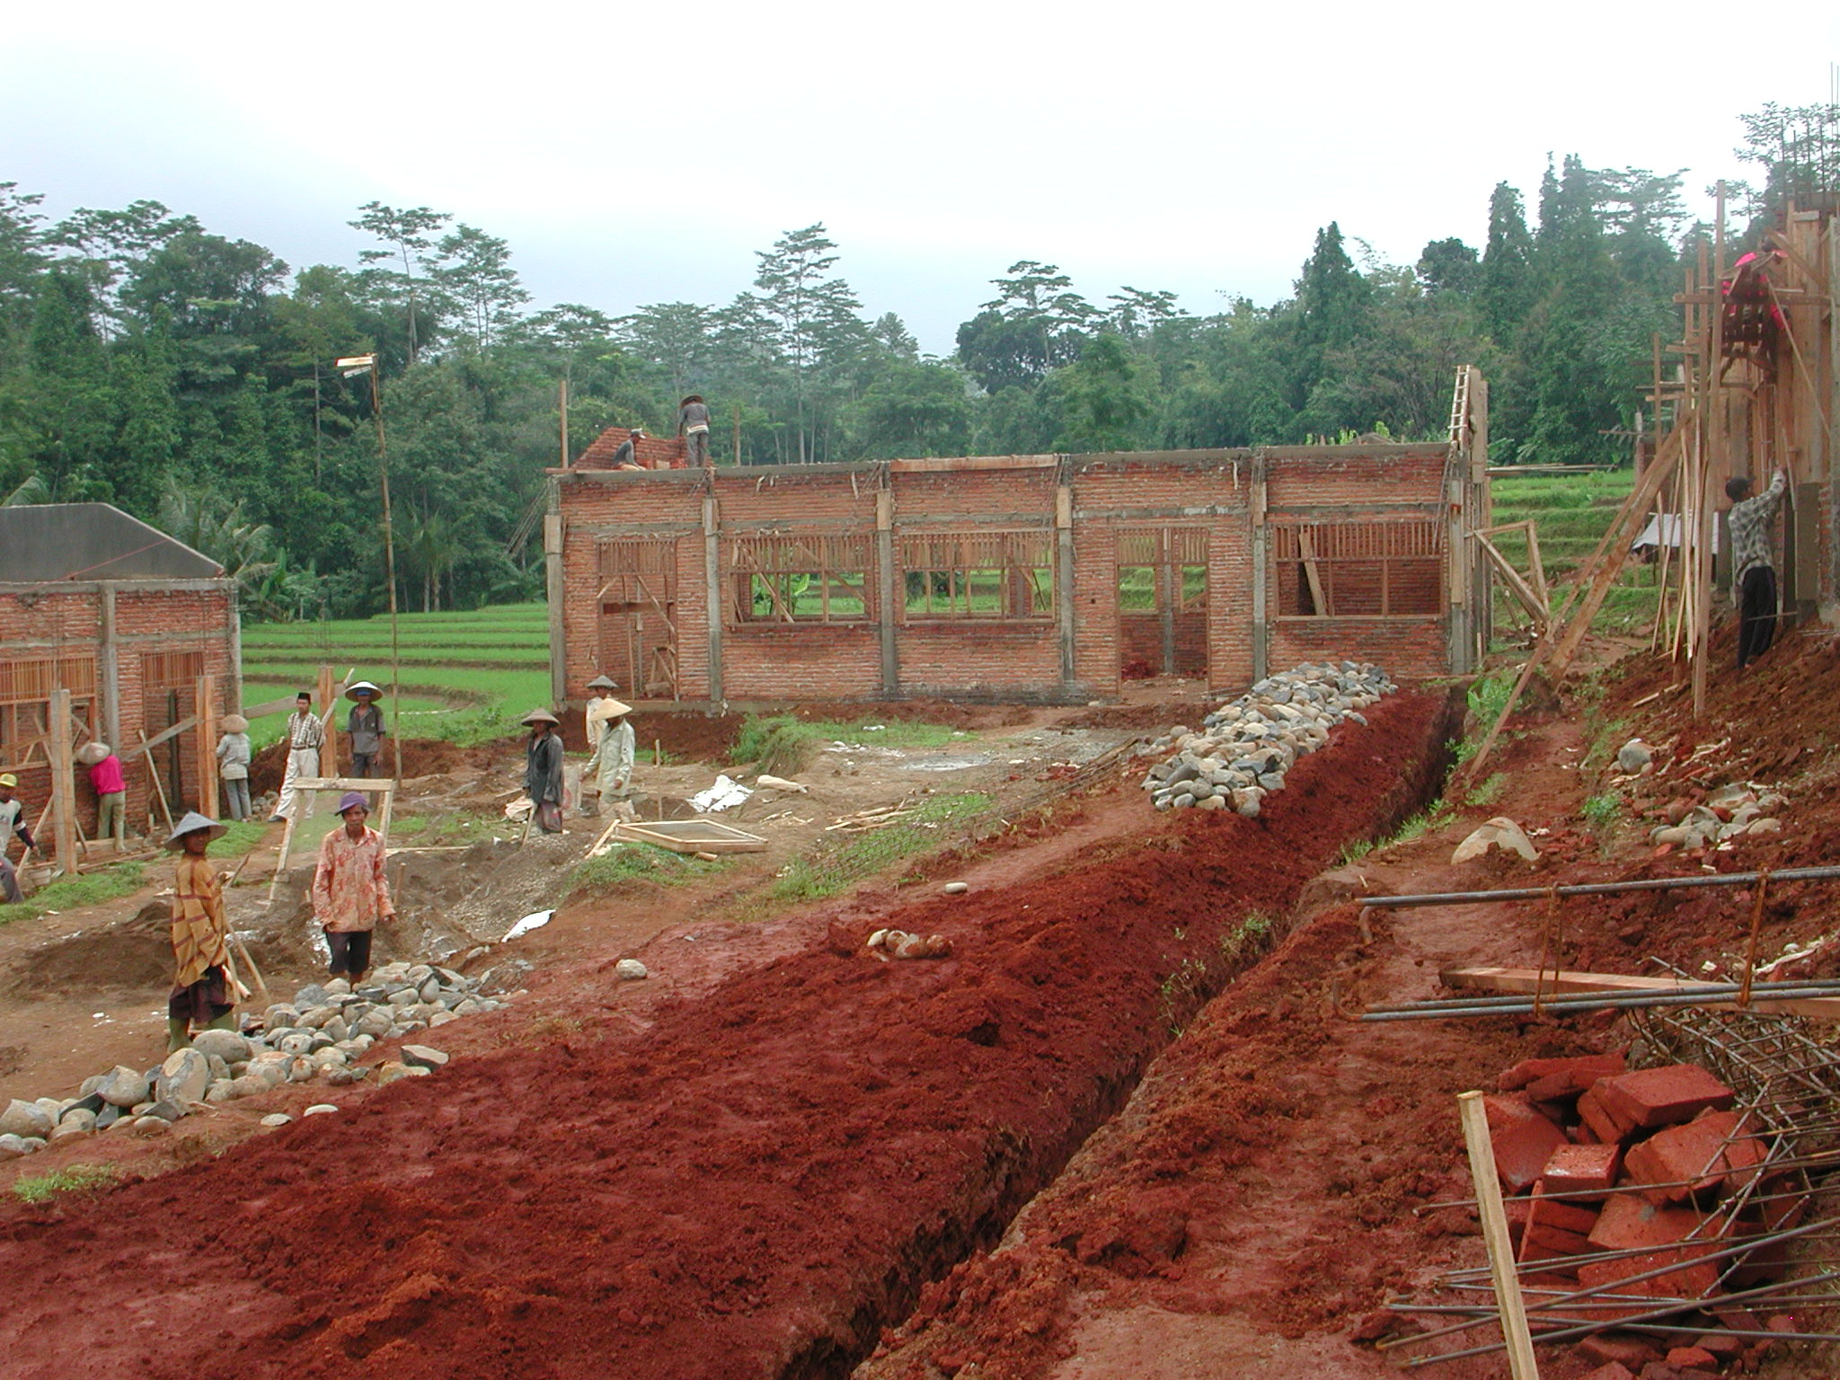

Plate 1: MTs Al Fatah showing slope of site.

The CM stated that it was difficult to get very skilled workers because of the rural location and some of the workmanship is not very good, particularly the concrete work. The concrete columns are being cast between brickwork panels with all the problems this entails and the formwork being used is not very long and the columns are therefore not very straight. The brick work is reasonable and the joinery, which is being made on site, is good; the quality of the timber is also good. There is a problem with the design of the buildings in that there is no RC lintel over the window and door openings but several courses of brickwork sit directly on top of the frames. There will eventually be cracking of this brickwork because of differential movement between the frames and the brickwork.

The budget for the work is Rp1,029,500,500 giving a square metre cost of Rp1,040,951m² and the consultants stated that they had taken the site conditions into account in preparing the budget. However, the consultants have had to revise the site plan to take into account the steep slope and it was not clear 1) why they had not designed the layout to take into account the site levels in the first place and 2) if their budget would cover all the site works now envisaged. The site will require a lot of site works including retaining walls, steps, drainage, etc.

Work started on February 9th and should be completed by July 9th 2003. At the time of the visit the progress as planned should have been 22.57% but was actually 25.9%, approximately 1 week ahead of schedule and the work could be completed by mid-June 2003. All buildings had brickwork up to ring beam level except the library which was 75% to ring beam. The gable walls and walls between classrooms to both 3-classroom buildings were complete and the ring beam had been started in one 3-classroom building. Excavation for retaining walls and other site works was in progress.

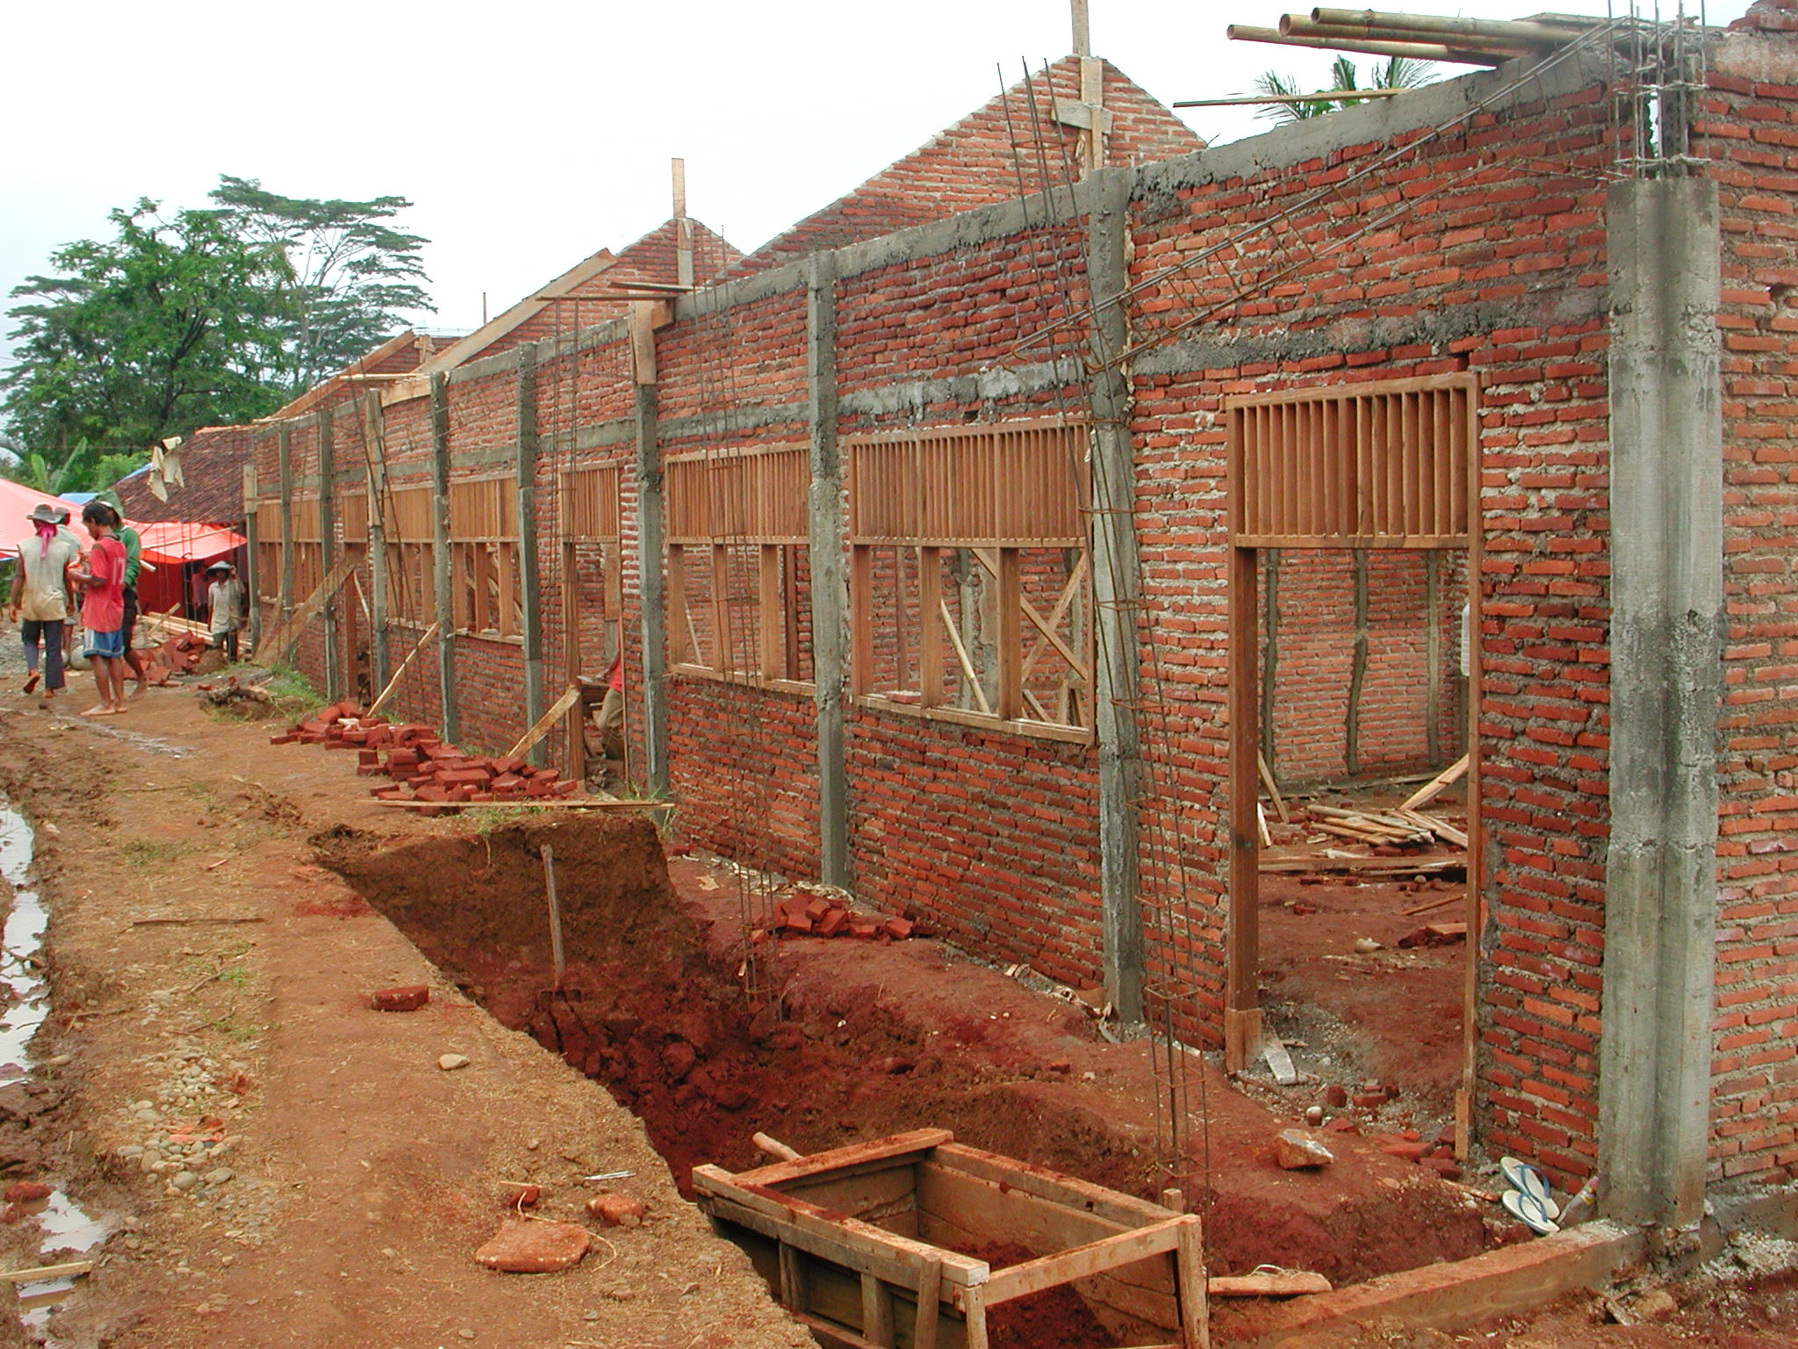

Plate 2: MTs Al Fatah showing brickwork over window and door frames and poor quality concrete columns.

The site is well organised with an office, a store for cement and other materials, shaded areas for making roof trusses and joinery and the timber is stacked and protected. The technical team make proposals for purchasing materials which are approved by the CM and they get quotations from 3 suppliers. The consultants have not prepared schedules of materials for use by the school committee in ordering the materials and the CM is having to do this on site. Neither have they prepared projections for when the materials will be required, for what labour will be required or cash flow projections. The financial records are not being well kept nor are they in accordance with the project guidelines.

3.2 Kabupaten Batang: The following school sites were visited:

SLTPN 04 Bandar, Desa Binangun, Kecamatan Bandar: The school is being constructed on a site that slopes in two directions next to an un-paved road in a remote, rural village. Access is not a problem. The area of the site is 6,100m² and there is room for some expansion of the school but not for a sports field. This will be the only SLTP in the Kecamatan and there are 12 primary schools in the school’s catchment area with a total of 252 children in the present Class 6. The site is adjacent to the village road which is surfaced and access is not a problem. There is a village water supply and an electricity supply along the road.

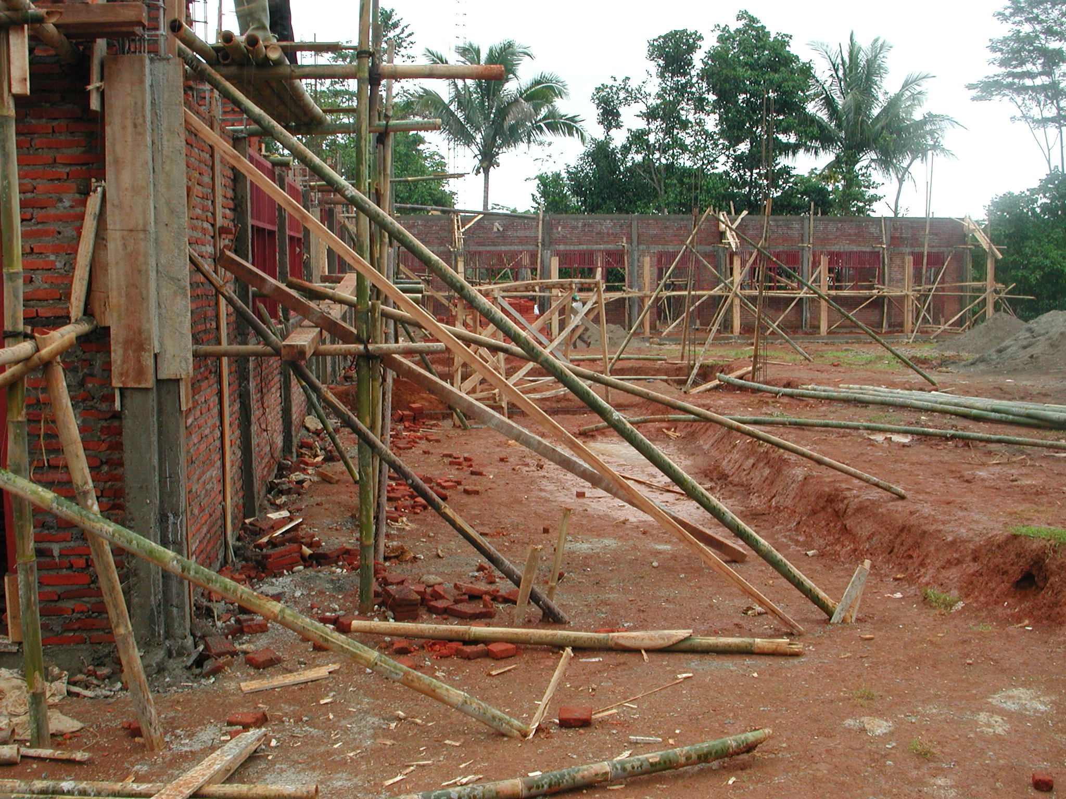

Plate 3: SLTPN 04 Bandar, Desa Binangun

The consultants have a construction manager (civil engineer S1) and an assistant (also S1) on site to manage the work; the leader of the technical team has a lot of experience on drainage and irrigation schemes. The school is supported by three villages which agreed the labour rates and which are all supplying some of the labour with the final selection being made by the CM. Skilled workers are being paid Rp20,000 a day; unskilled workers Rp15,000 and the foreman Rp25,000.

Again there are problems in getting skilled workers because of the rural location. The concrete work is better than at the last site even though the concrete columns are again being cast between brickwork panels. The brick work is reasonable and the joinery and trusses which are being made on site are good; the quality of the timber is also good. RC lintels are being constructed over the window and door openings here.

The budget for the work is Rp984,340,000 giving a square metre cost of Rp995,288m². The consultants stated that the PU budget for SLTPs in this district is Rp1.2million/m² and that this does not include site works which would probably add another 25% and that the PU specification is lower. The consultants stated that they had taken the site conditions into account in preparing the budget. However, the site will require a lot of site works including retaining walls, steps, drainage, etc and because of the way the budget has been prepared, it might not cover all the site works that will be required. As at the last site, the consultants should check the budget to ensure that all site works can be built.

Work started on February 3rd and should be completed by July 3rd 2003. At the time of the visit the progress as planned should have been 24.28% but was actually 19.17%, approximately 5 days behind schedule. Work has been delayed by heavy rainfall. The two 3-classroom buildings had brickwork up to ring beam level and rendering had started. The administration building had brickwork to top of window/door frame level and the stone foundations to the musholla, head teacher’s house, library and multi-purpose buildings were complete. The stone retaining wall in front of the library was in progress.

The site is well organised with an office, a store for cement and other materials, shaded areas for making the joinery and reinforcement but not for the trusses. The timber being used for joinery and trusses is very good quality. The technical team make proposals for purchasing materials which are approved by the CM and they get quotations from 3 suppliers. The consultants have not prepared schedules of materials for use by the school committee in ordering the materials and the CM is again having to do this on site. Neither have they prepared projections for when the materials will be required, for what labour will be required or cash flow projections. The consultants stated that they had estimated the local cost of materials and then had taken the PU estimate for an SLTP in this location, reduced it by 30% and then added 25% for site works. The financial records are being better kept here but they are still not in accordance with the project guidelines. Work will probably have to stop for one week at the end of March because the second disbursement of funds has not yet been applied for and it seems that the financial guidelines for disbursement are not being followed. Withdrawals of Rp40million in cash at one time are being made. The average wage bill per week is Rp8million. There is a notice-board outside the site office giving details of the work including bank statements.

SLTPN 09 Karangasem, Kecamatan Karangasem: The school is being constructed on a large flat site in a fishing village near the sea. The site is reclaimed paddy fields and is adjacent to a paved road and access is not a problem. The area of the site is 10,500m² and there is room for some expansion of the school and for a sports field. This will be the only SLTP in the Kecamatan and there are 15 primary schools in the school’s catchment area with a total of 484 children in the present Class 6. There is a village water supply and an electricity supply along the road.

The consultants have a construction manager (civil engineer S1) and an assistant (civil engineer D3) on site to manage the work. There are approximately 98 workers on the site and skilled workers are being paid Rp25,000 a day; unskilled workers Rp17,500 and the foreman Rp30,000. There are three or four villages in the vicinity of the school and the workers come from these villages.

The concrete work is better than at the first site even though the concrete columns are again being cast between brickwork panels. The brickwork is good and the joinery and trusses which are being made on site are good; the quality of the timber is not as good as at the two previous sites. RC lintels are being constructed over the window and door openings here. The site has an office and store and a shaded area for making the trusses which are however being stored outside.

The budget for the work is Rp1,026,930,000 giving a square metre cost of Rp1,038,352m². Back-filling the site has added approximately 12% to the total cost and all main columns have concrete bases and 2 metre concrete piles below them which has also added to the total cost. However, this site is much more accessible than the last site and will require less site works and even with the extra cost of back-filling and concrete piles, it is not clear why the square metre cost should be that much higher.

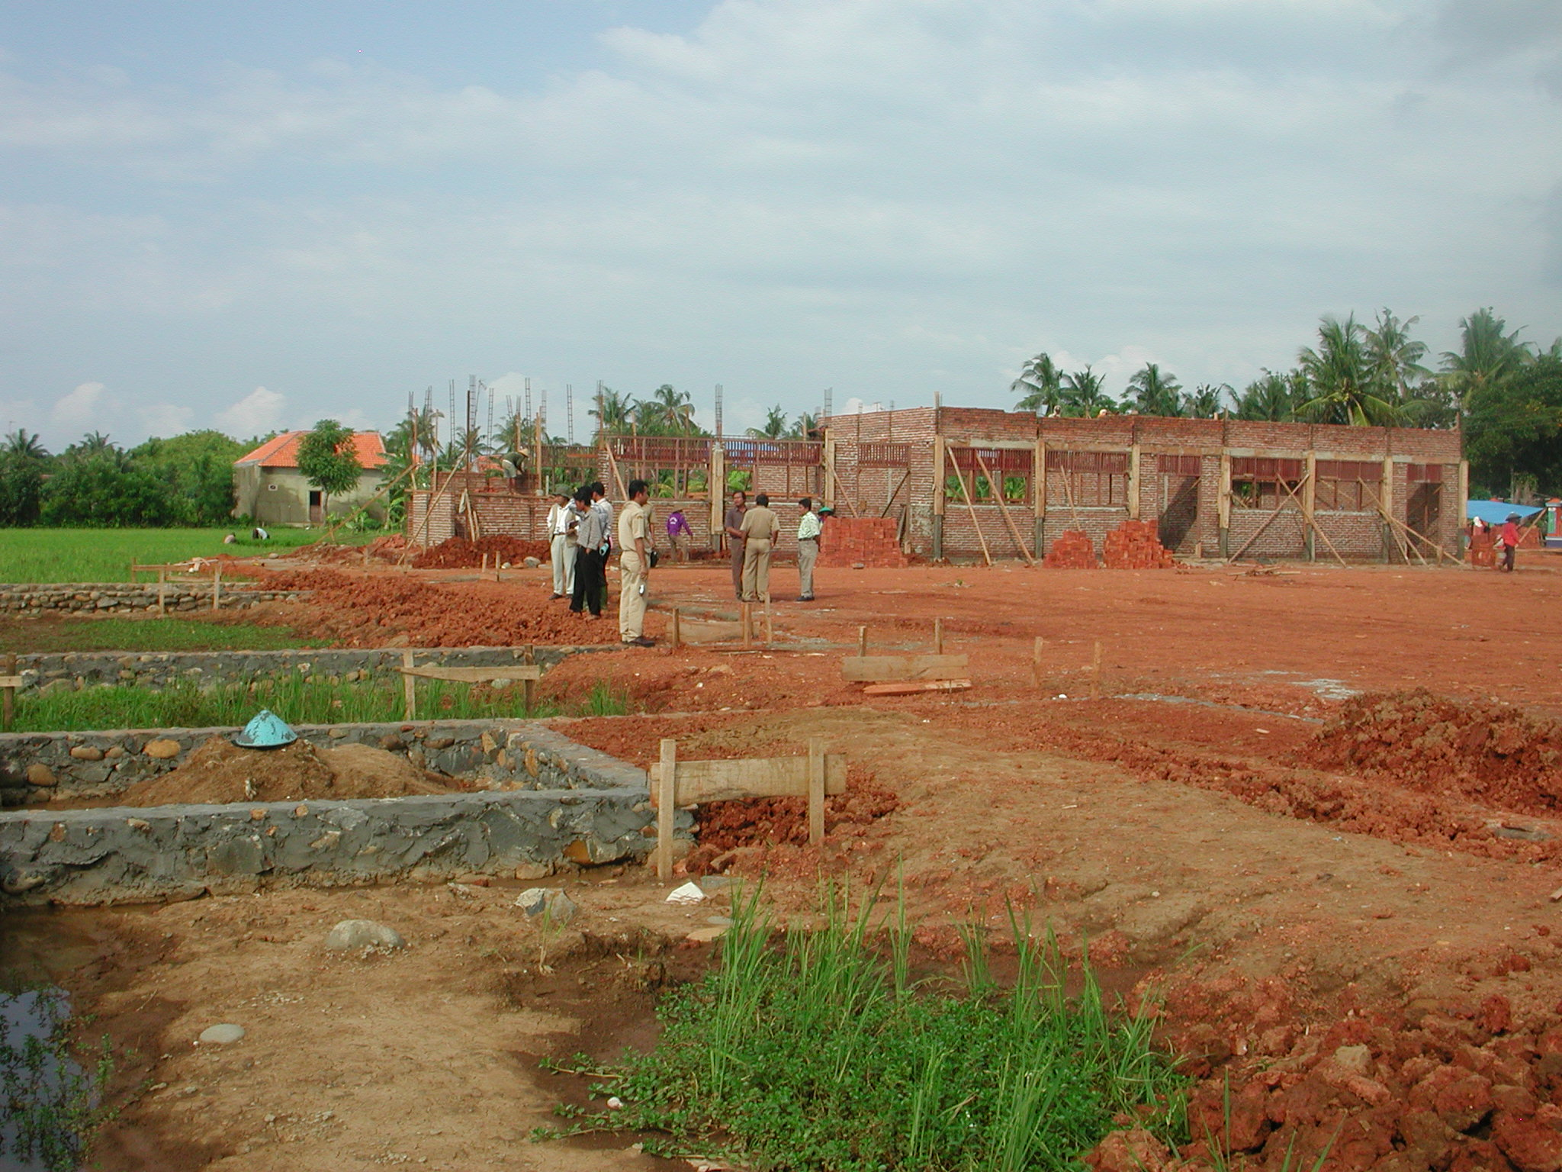

Plate 4: SLTPN 09 Karangasem showing rice paddies and fill to site.

Work started on February 8th and should be completed by the end of July 2003. At the time of the visit the progress as planned should have been 20% but was actually 24%, approximately 10 days ahead of schedule. The whole site had been back-filled and consolidated and one of the 3-classroom buildings had brickwork up to ring beam level and the other had 40% of the brickwork up to ring beam. The administration building had 50% of the brickwork to top of window/door frame level and the stone foundations to the head teacher’s house, library and multi-purpose buildings were complete. The remaining buildings had not yet been started.

The consultants have again not prepared schedules of materials for use by the school committee in ordering the materials and the CM is again having to do this on site. Neither have they prepared projections for when the materials will be required, for what labour will be required or cash flow projections. The school committee is operating two bank accounts which is not allowed under the project guidelines. The financial records are also not very well kept and are not in accordance with the project guidelines. There are also a lot of other administrative problems and possibly some local political interference which the PPIU should investigate. The funds available from the first payment were virtually finished at the time of the visit and work will have to be stopped until the second payment is received. There seems to be little financial planning by either the school committee or the CM. Because of the these problems it is recommended that the CM is replaced as soon as possible.

3.3 Kabupaten Wonosobo: The following school sites were visited:

SLTPN 03 Garung, Desa Kayugiyang, Kecamatan Garung: The school is being constructed on a steeply sloping site on the edge of a remote, rural village. The site is adjacent to the stone-paved village road and access is not a problem. The area of the site is 6,160m² and there is room for some expansion of the school and for a sports field at the bottom of the site. There are two other SLTPs in the Kecamatan, one 1.7 kilometres away and one 3.5 kilometres away. There are 31 primary schools in the Kecamatan with a total of 931 pupils in Class 6 this year. There are eight primary schools in the catchment area of the new SLTP and 17 students are already enrolled and studying in a nearby primary school. A lot of children are not attending the other SLTPs because of the distance they would have to travel. There is a village water supply and an electricity supply along the road.

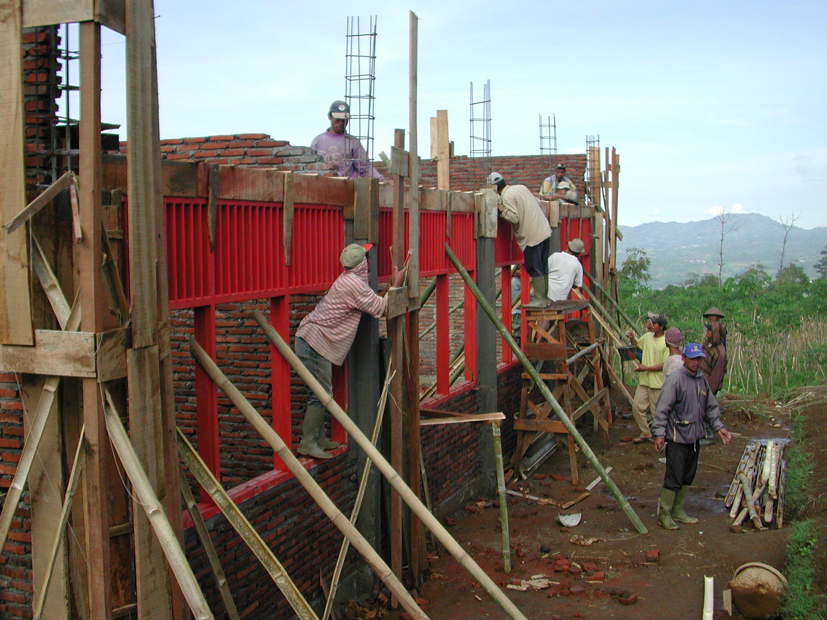

Plate 5: SLTPN 03 Garung

The consultants have a construction manager (SMK with 25 years building experience) and an assistant (S1 civil engineer) on site to manage the work. There are approximately 87 workers on the site all from three surrounding villages; the unskilled workers are all from the nearest village. The head skilled workers are being paid Rp18,500 a day; skilled workers Rp16,000 a day; unskilled workers Rp12,500 and the foreman Rp13,500.

The concrete work seems quite good but the concrete being mixed on site at the time of the visit was much too wet. The concrete columns are again being cast between brickwork panels. The brick work was very neat and the joinery was very good.

The budget for the work is Rp1,050,549,000 giving a square metre cost of Rp1,062,234m². The site will require a lot of site works including cut and fill, retaining walls, steps, drainage, etc and because of the way the budget has been prepared it might not cover all the site works that will be required. The consultants should check the budget in detail to ensure that all site works can be built.

Work started on January 27th and should be completed by June 27th 2003. At the time of the visit the progress was actually 18.83% but there was no progress chart or any detailed planning of the construction work and therefore it was not possible to check whether the work was on schedule or not. The two 3-classroom buildings had brickwork up to ring beam level and veranda columns and beams in progress. The administration building and the penjaga’s house had 60% of brickwork to ring beam level. The musholla had brickwork up to ring beam level. The library and multi-purpose buildings had brickwork in progress and door and window frames were being fixed. The other buildings had not been started yet.

The site is well organised and is using a disused health centre as an office and store and has a workshop for making door and window frames. Trusses are not being made yet. The consultants have again not prepared schedules of materials for use by the school committee in ordering the materials and the CM is again having to do this on site. Neither have they prepared projections for when the materials will be required, for what labour will be required nor any cash flow projections. The financial records are being quite well kept here with details of all transactions, receipts, etc but they are still not in accordance with the project guidelines. The school committee is also not following the guidelines in terms of cash withdrawals but is paying suppliers large sums of money in cash. The committee members stated that the suppliers they were using did not have bank accounts and therefore they had to pay them in cash. There is a notice-board outside the site office giving details of the work.

SLTPN 05 Kaliwiro, Kecamatan Kaliwiro: The school is being constructed on a small sloping site on the edge of a rural village next to a primary school. The site is adjacent to the village road and access is not a problem. The area of the site is 6,025m² and there is room for some expansion of the school but no room for a sports field. There are 9 primary schools in the Kecamatan with a total of 207 pupils in Class 6 this year. There are 67 students already enrolled in Class 1who are studying in the adjacent primary school. There is a village water supply and an electricity supply along the road.

The consultants have a construction manager (D3 civil engineer) and an assistant (D3 civil engineer) on site to manage the work and the team leader visits the site twice a month.

The workmanship generally was not as good as at the last school. The concrete work was mixed with some being good and some bad. It is likely that too much water was again being used in the concrete mix. It was noted that the laps and joints on some of the reinforcement particularly between columns and beams were insufficient or non-existent and should be cut out and replaced. The concrete columns were again being cast between brickwork panels. The brick work was not very good and the quality of concrete sand was very poor. There was no timber on site yet for roof trusses.

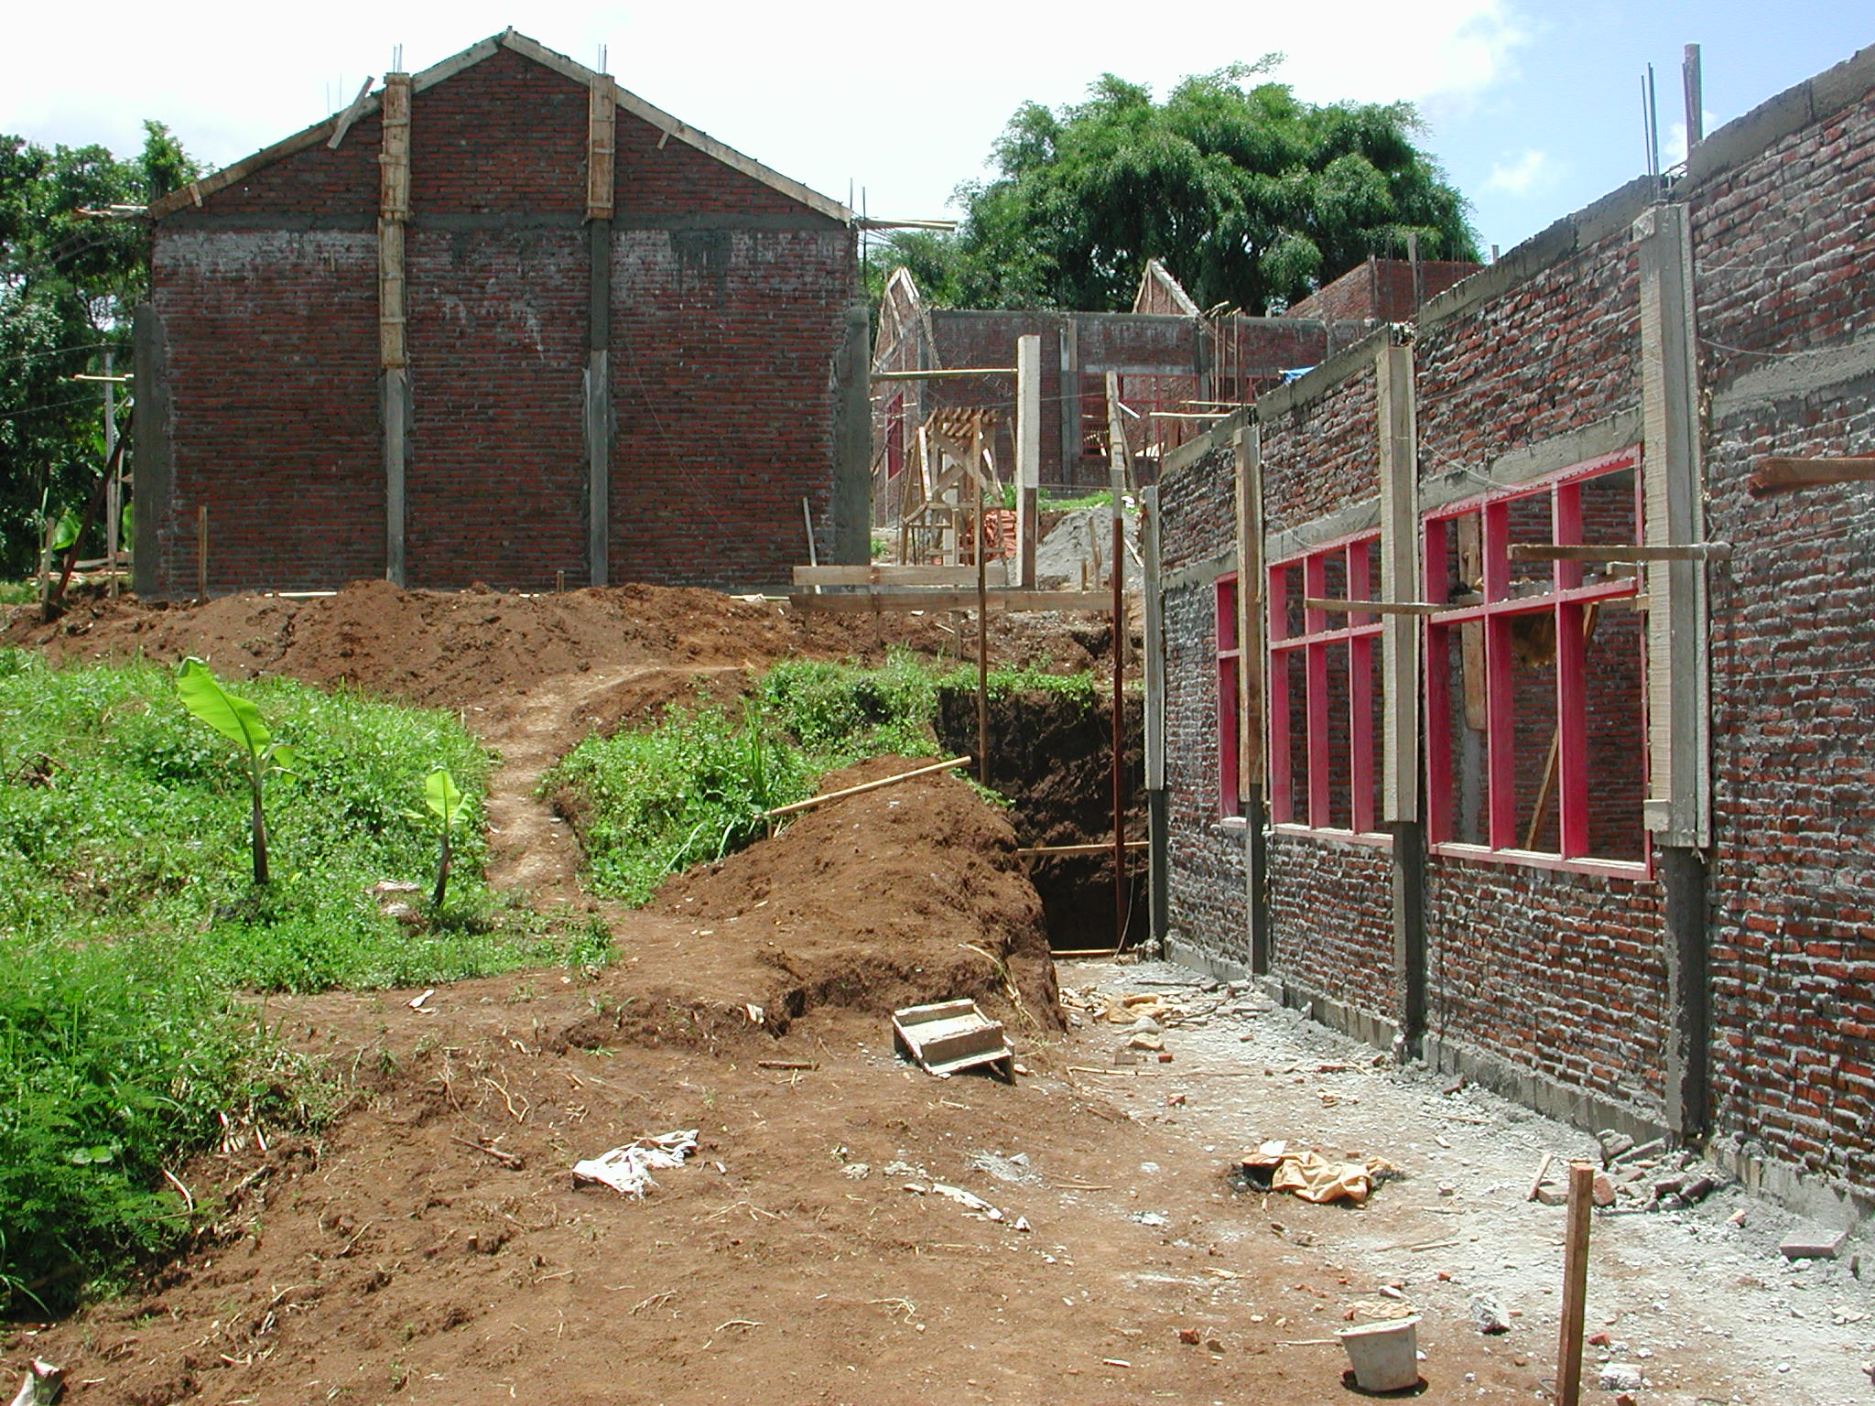

Plate 6: SLTPN 05 Kaliwiro showing poor quality concrete.

The budget for the work is Rp1,052,369,000 giving a square metre cost of Rp1,064,074m². The site will require a lot of site works including cut and fill, retaining walls, steps, drainage, etc. The consultants should check the budget in detail to ensure that all site works can be built.

Work started on January 15th and should be completed by June 15th 2003. At the time of the visit the progress was actually 20.214% and the CM stated that the work was two weeks ahead of programme but there was no progress chart or any detailed planning of the construction work and therefore it was not possible to check whether the work was on schedule or not. The 4-classroom building had 75% of brick work up to ring beam level and the 2-classroom building, administration building, multi-purpose building, library and penjaga had the ring beams complete and the gable walls in progress. The other buildings had not been started yet.

The site has an office and store and it was noted that the cement was stacked directly on to the concrete floor and some bags had started to go off. The consultants have again not prepared schedules of materials for use by the school committee in ordering the materials and the CM is again having to do this on site. Neither have they prepared projections for when the materials will be required, for what labour will be required nor any cash flow projections. The financial records are being quite well kept here with details of all transactions, receipts, etc but they are still not in accordance with the project guidelines. The school committee is also not following the guidelines in terms of cash withdrawals but is paying suppliers large sums of money in cash. The committee members again stated that the suppliers they were using did not have bank accounts and therefore they had to pay them in cash.

SLTPN 06 Kepil, Desa Ropoh, Kecamatan Kepil: The school is being constructed on a long steeply sloping site (12 metres fall from top to bottom) on the edge of a remote, rural village. There is a large amount of surface water running across the site. There is a primary school and a playing field next to the site. The site is adjacent to the village road and access is not a problem. The area of the site is 6,762.9m² and there is room for expansion of the school. There are ten primary schools in the catchment area of the new SLTP and approximately 200 pupils in the present Class 6. There is a village water supply and an electricity supply along the road.

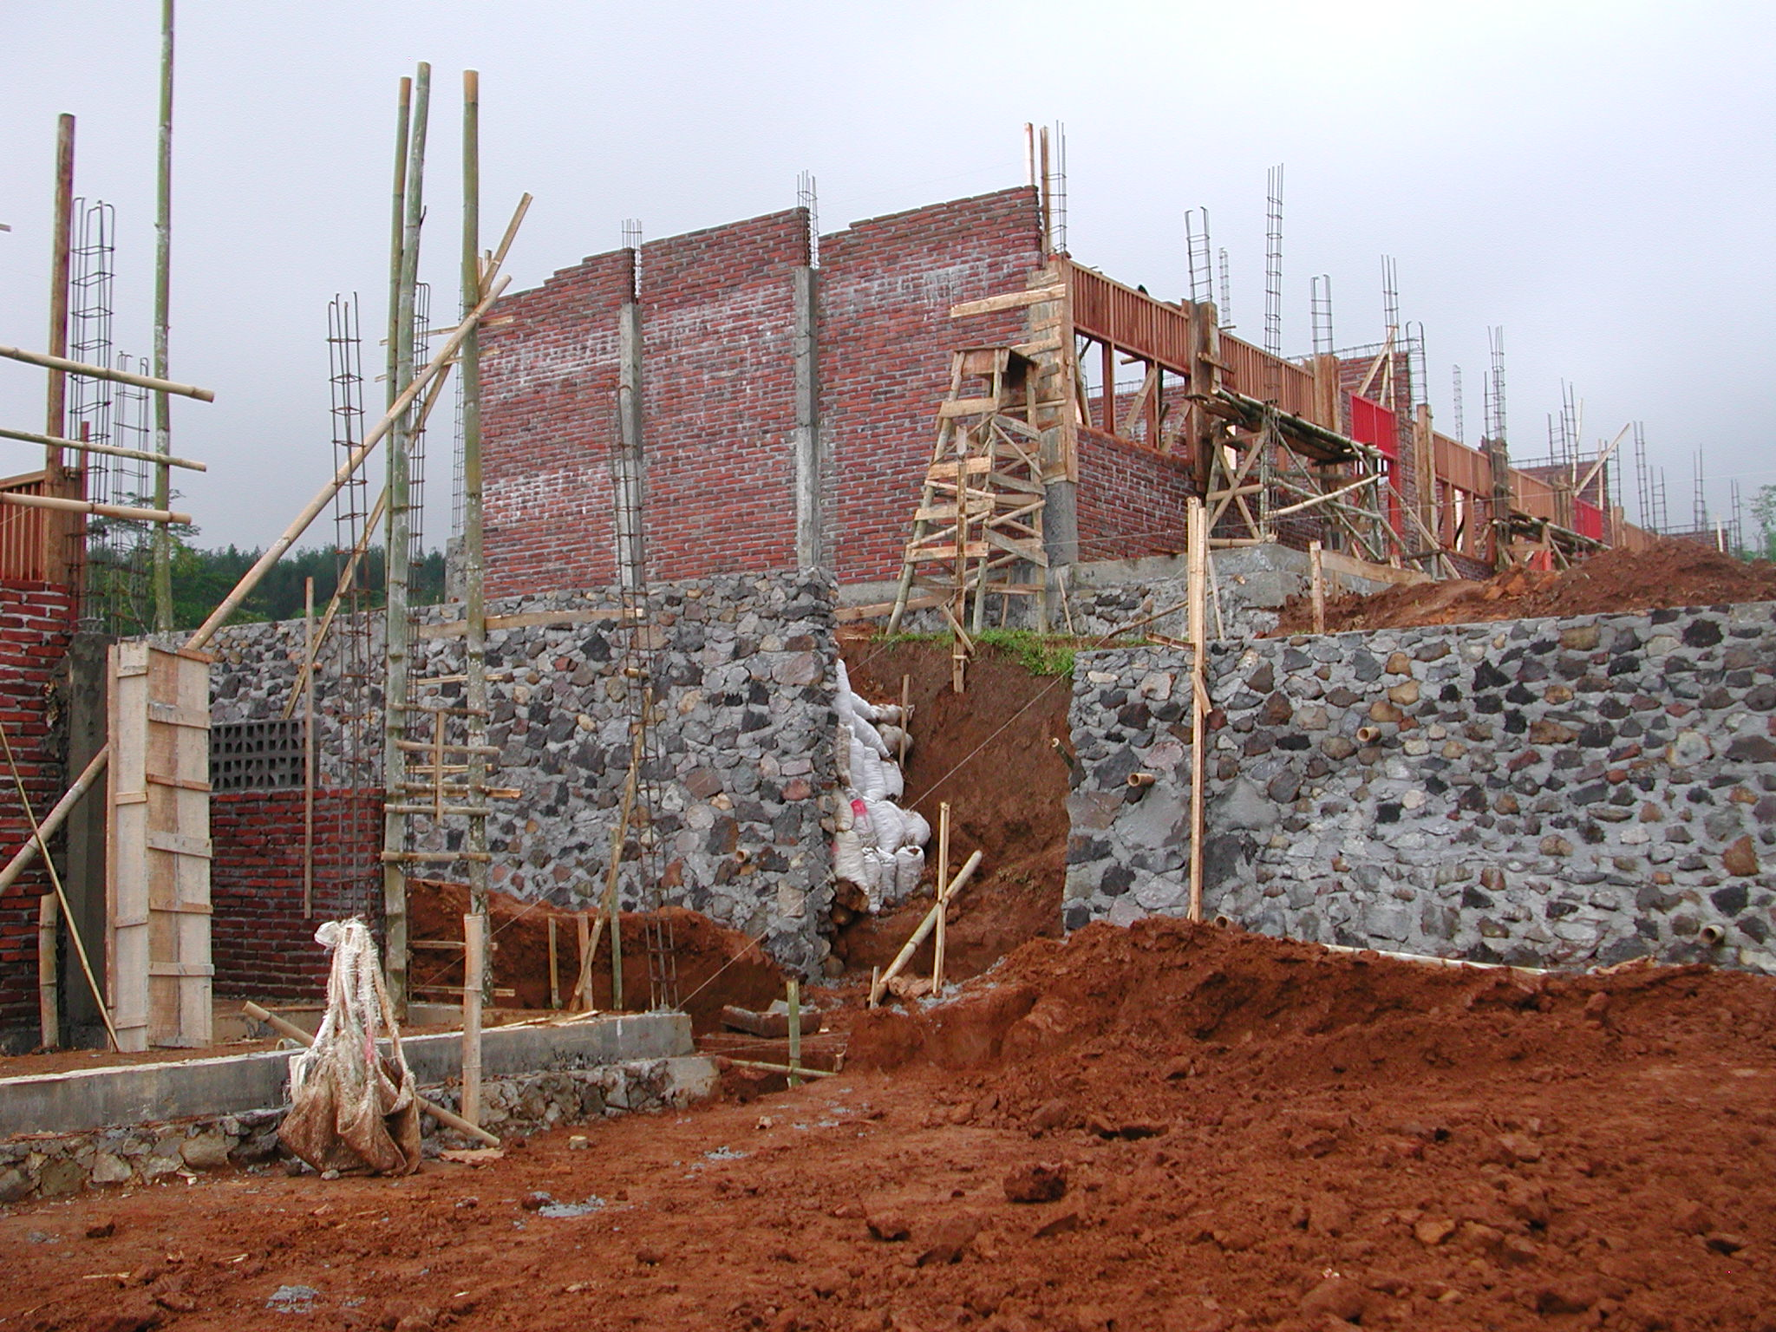

Plate 7: SLTPN 06 Kepil showing retaining wall.

The consultants have a construction manager (S1 civil engineer with 5 years experience) and an assistant (SMK with 5 years experience) on site to manage the work. There are potentially 150 workers registered who would like to work on the school (they are listed on the information board outside the office). The heads of the teams are being paid Rp16,000 a day; skilled workers Rp14,000 a day; unskilled workers Rp10,000.

The workmanship here is generally much better than at all the previous schools. The sand is good and the brick work and concrete work is good. The concrete columns are again however being cast between brickwork panels. The joinery is being made to a good standard using good quality timber.

The budget for the work is Rp1,051,817,000 giving a square metre cost of Rp1,063,516m². The site will require a lot of site works including cut and fill, retaining walls, steps, drainage, etc and because of the way the budget has been prepared it might not cover all the site works that will be required. The consultants should check the budget in detail to ensure that all site works can be built.

Work started on February 1st and should be completed by mid-June 2003. At the time of the visit progress was 17% and the planned progress was 12% and the work was about one week ahead of schedule. The 4-classroom building had 50% of window frames fixed and lintels over cast and brickwork in progress. The 2-classroom building had brick work in progress and no frames fixed. The library had cross and gable end walls to ring beam level and no frames fixed. The administration building had 80% of brickwork to ring beam level and window and door frames fixed. The musholla had brickwork in progress. The head teacher’s house and the penjaga’s house/canteen had brick work to ring beam level. The multi-purpose building had not been started because the school committee wanted to increase the size to accommodate a badminton court. They were told that this would not be possible. The wall to the front of the site had been built and two retaining walls were in progress.

The site is well organised and has an office and a store. Trusses are not being made yet. The consultants have again not prepared schedules of materials for use by the school committee in ordering the materials and neither have they prepared projections for when the materials will be required, for what labour will be required nor any cash flow projections. The site team has however prepared an analysis of local material prices and are keeping detailed records of materials bought and used. Good records are being kept of all payments that are made. The CM, the school committee and the technical team are obviously working well together as a team. Large withdrawals have been made to pay for materials but they are now switching over to paying by cheque and stated that there was no problem with their suppliers over this even though the nearest bank is 35 kilometres away. Most materials are available locally apart from concrete sand which has to be transported 75 kilometres. The CM has a computer in his house that he is using for project documentation. The financial records are being quite well kept with details of all transactions, receipts, etc but they are still not in accordance with the project guidelines. There is a notice-board outside the site office giving details of the work.

3.4 Kabupaten Karanganyar: The following school site was visited:

MTs Muhammadiyah, Kecamatan Gondangrejo: The school is being constructed on a slightly sloping site (2½ metre fall across the site) that was formerly a rice paddy behind the village office in a rural village not far from Solo. The site is adjacent to the surfaced village road and access is not a problem. The area of the site is 6,189m² and there is some room for expansion of the school but not for a sports field. There are twelve primary schools in the Kecamatan and approximately 304 pupils in the present Class 6. Teachers have already been employed and are teaching at another school at present. No pupils have been enrolled yet. There is no village water supply and a deep well has been excavated. There is a village electricity supply along the road.

The consultants have a construction manager (S1 civil engineer with 9 years experience) and an assistant (SMK with 30 years experience) on site to manage the work. The technical team leader is a teacher who also has a civil engineering qualification (S1) and some experience of construction. He was at college with the CM and there is a good relationship. The team leader visits all sites once or twice a week. There are approximately 62 workers from the village who were selected by the technical team and the CM. The foreman is being paid Rp22,000 a day; the heads of teams Rp22,000 a day; skilled workers Rp22,000 a day; unskilled workers (male) Rp15,000 and female Rp14,000.

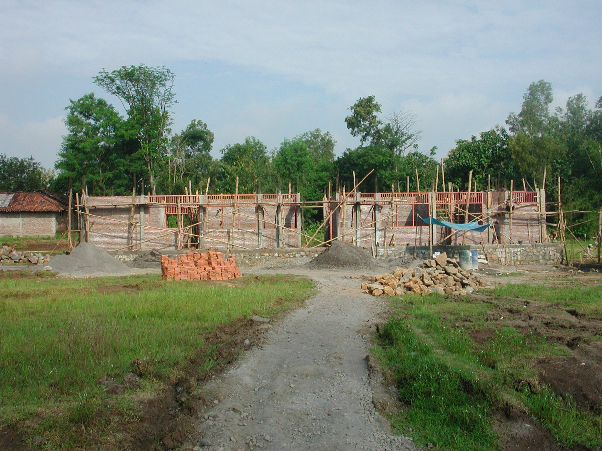

Plate 8: MTs Muhammadiyah

The site is well organised. The site office is in the village office and the team have a computer that they have rented. There is also an information board in the office with details of the project. A large room next to the office is being used for making trusses and storing materials. The timber for the trusses and window and door frames is very good quality and the workmanship is also very good. The workmanship here is generally good with neat brickwork and good quality concrete. The concrete columns are again however being cast between brickwork panels. Top soil was also being used for back-filling and the CM was asked to stop this immediately.

The budget for the work is Rp947,000,000 giving a square metre cost of Rp957,533m². The well is located very close to the toilet building and the CM was asked to make sure that the septic tank and soakaway are located at least 20 metres away from the well down the site. Extensive site works will not be required on this site but drainage will need careful consideration.

Work started on January 29th and should be completed by July 14th 2003. At the time of the visit progress was 14.5% and the planned progress was 15% and the work was about three days behind schedule. Progress has been impeded by heavy rain but there are no technical problems. The administration building had all window and door frames fixed and brickwork to the top of frames. One 3-classroom building had 50% of window frames fixed and brickwork in progress. The toilets, multipurpose building and library had brickwork in progress. The foundations to the penjaga’s house/canteen were in progress.

The consultants have again not prepared schedules of materials for use by the school committee in ordering the materials and neither have they prepared projections for when the materials will be required, for what labour will be required nor any cash flow projections. There are also some problems with the accounts and record keeping; they do not for instance seem to differentiate between deposits and payments. Withdrawals in cash over Rp10million have been made to pay for materials and the committee was asked to switch over to paying by cheque or transfers. The CM, the school committee and the technical team are obviously working well together as a team.

5.6 Kabupaten Wonogiri: The following school sites were visited:

SLTPN 02 Batuwarno, Desa Ronggojati, Kecamatan Batuwarno: The school is being constructed on a steeply sloping site (9 metres fall from one end to the other and a cross fall of 2/3 metres) on the edge of a rural village 35 kilometres from Wonogiri. The site is adjacent to the surfaced village road and access is not a problem. The area of the site is 6,019m² and because of the layout of the buildings and the slope there is no room for expansion of the school or a sports field. There are six primary schools in the Kecamatan and approximately 102 pupils in the present Class 6. There is no village water supply and a deep well has been excavated and an electric pump installed. There is a village electricity supply along the road.

The consultants have a construction manager (S1 civil engineer) and an assistant (S1 civil engineer) on site to manage the work. The technical team leader is also an S1 civil engineer.

A large building behind the village head’s house is being used for making the door and window frames. Very good timber is being used and the joinery work itself is very good. The workmanship here is generally quite good. The concrete columns are again however being cast between brickwork panels and the stone foundations below the columns have not been enlarged as shown on some of the drawings.

Extensive site works including retaining walls, storm drains and steps will be required on this site because of the steep slopes. However the consultants have only provided the CM with an outline site plan with no levels indicated for the buildings and no details of the site works. The consultants had also designed the layout of the buildings so that the classroom buildings ran across the contours rather than along them which will greatly increase the construction time and the foundation costs. The consultants stated that they had not carried out a survey of material prices and labour costs and had based their budget on PU estimates for contractors. Because of the lack of any site works details it is probable that the consultants have under-estimated the cost of these works and there is a serious danger that the project could run out of funds before the works are complete.

The consultants were asked to stop work on site apart from on the two classroom buildings, until they had prepared detailed site works drawings and checked their estimate to see if it is sufficient to cover the cost of the work including all the site works.

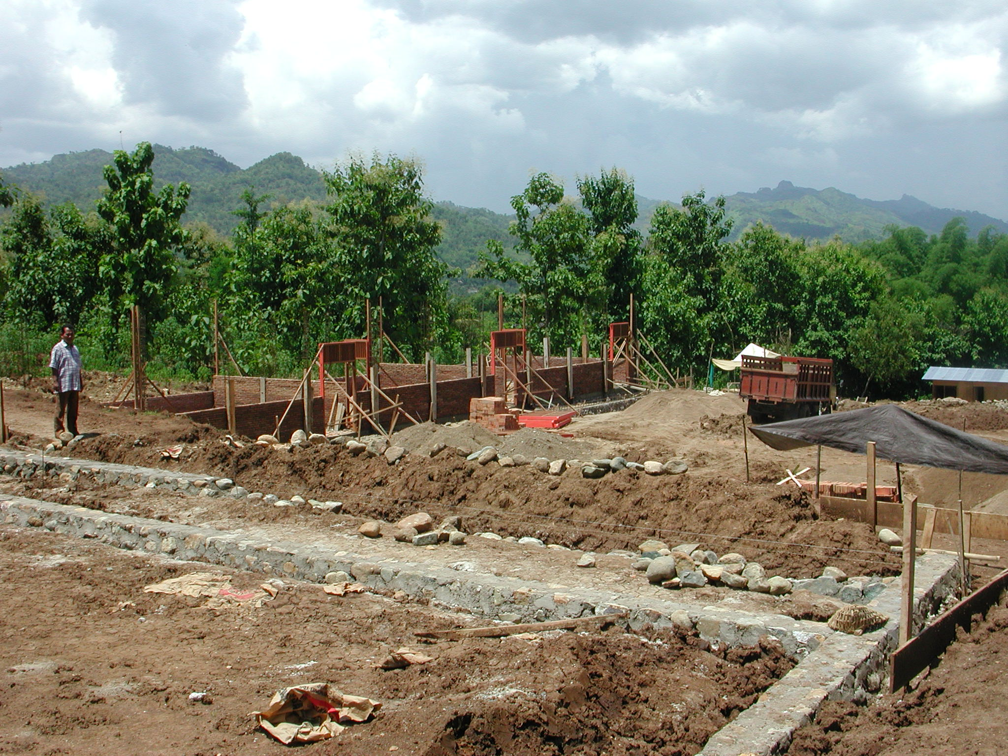

Plate 9: SLTPN 02 Batuwarno showing steep falls on site.

Work started on January 27th and should be completed by July 27th 2003. At the time of the visit overall progress was 9% but there was no way of knowing if this was ahead of or behind schedule. The soil on the site is very wet clay and this has delayed the work. The administration building had all window and door frames fixed and brickwork to the top of frames. One 3-classroom building had door frames fixed and brickwork to cill level. The other 3-classroom building had brickwork complete to ring beam level and reinforcement in place for the columns. The stone foundations to the multipurpose building were complete. The library was being set out. The foundations to the penjaga’s house/canteen and the head master’s house were being excavated.

The consultants have again not prepared schedules of materials for use by the school committee in ordering the materials and neither have they prepared projections for when the materials will be required, for what labour will be required nor any cash flow projections. There are also problems with the accounts and record keeping. There had been one withdrawal of Rp50million at the very start of construction and the district auditors had instructed the school committee to pay this money back into their account. However the whole amount had been spent by January 29/30th probably on timber and other materials. The committee was asked to switch over to paying by cheque or transfers.

SLTPN 04 Pracimantoro, Kecamatan Pracimantoro: The school is being constructed on a steeply sloping site (8 metres fall from one end to the other) with a stream running down one side on the edge of a remote rural village. The site is adjacent to the surfaced village road and access is not a problem. The area of the site is 6,025m² and because of the layout of the buildings and the slope there is no room for expansion of the school or a sports field. There are five primary schools in the Kecamatan and they have approximately 84 pupils in the present Class 6. There is no village water supply and a deep well has been excavated and an electric pump installed. There is a village electricity supply along the road.

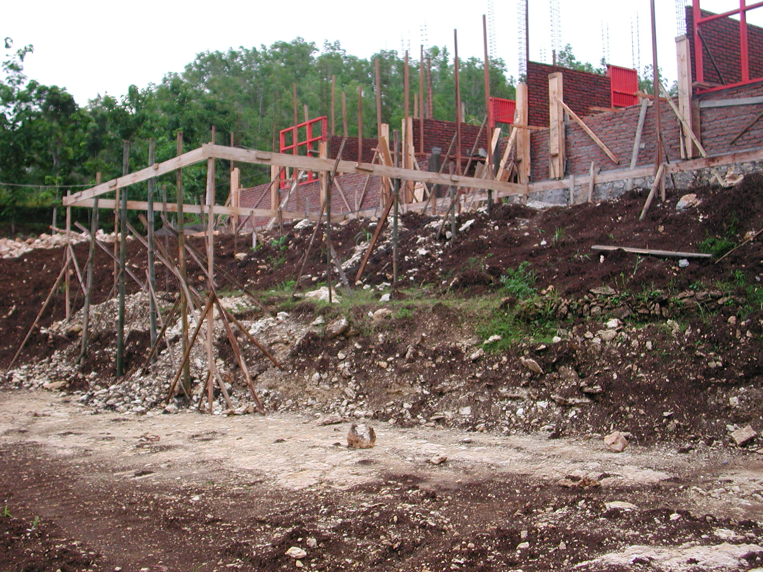

Plate 10: SLTPN 04 Pracimantoro showing change in level in front of administration

The consultants have a construction manager (S1 civil engineer with 13 years experience) and an assistant (30 years experience as foreman/contractor) on site to manage the work. There are approximately 80 workers from the village who were selected by the technical team and the CM. The foreman is being paid Rp13,500 a day; the heads of teams Rp17,500 a day; skilled workers Rp15,000 a day; unskilled workers Rp12,500. The weekly wage bill is approximately Rp5/6million.

The budget for the work is Rp1,000,000,000 giving a square metre cost of Rp1,011,122m². A site office and store have been constructed but there is no notice board giving details of the project. Very good timber is being used and the joinery work itself is very good. The workmanship here is generally quite good. The concrete columns are again however being cast between brickwork panels. The stone foundations below the columns do however seem to have been enlarged as shown on some of the drawings. The foundation at one end of the administration building is very high out of the ground and has actually been built on top of a growing tree! Some remedial action must be taken and the tree and its roots must somehow be removed. The CM should not have allowed this to happen and the team leader should also have noted it on his monitoring visits and asked for remedial action.

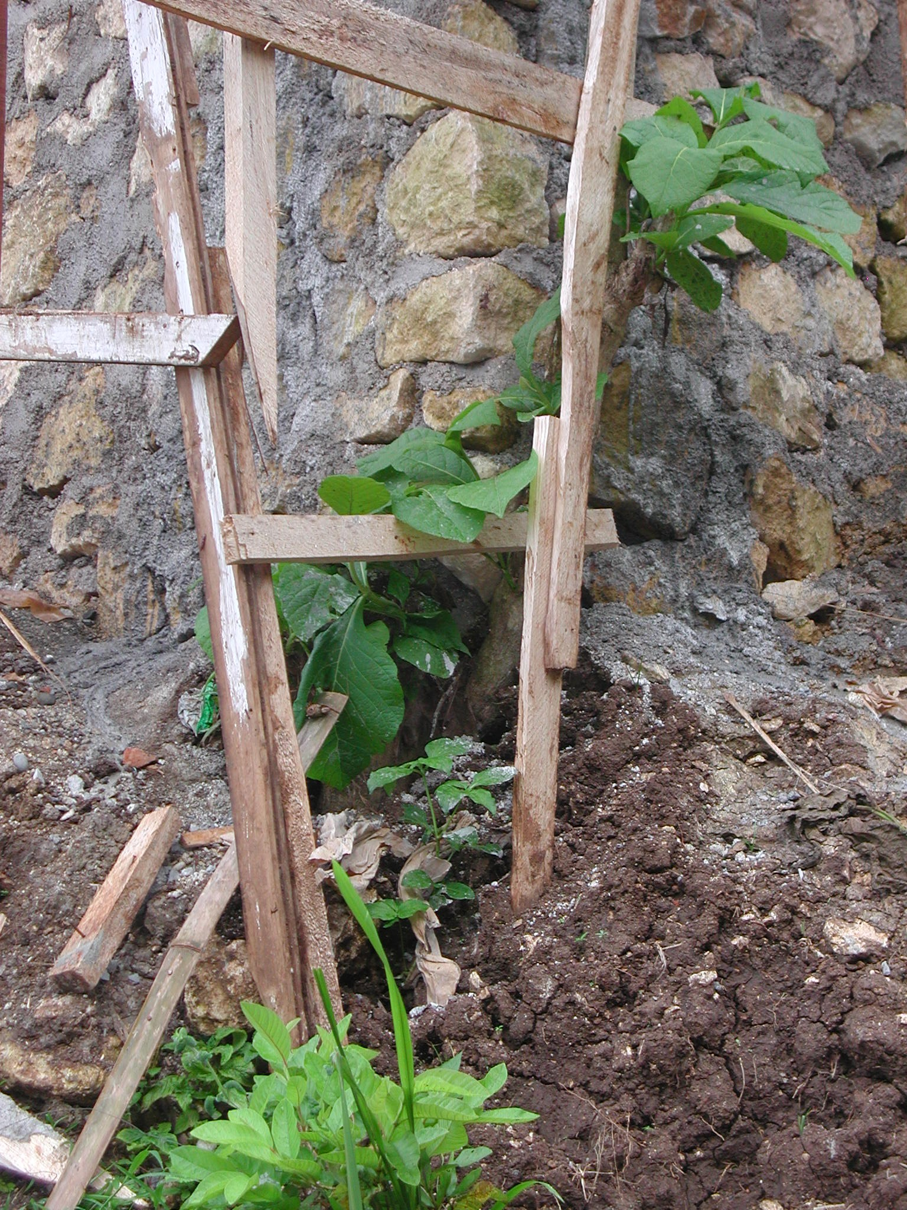

Plate 11: SLTPN4 Pracimantoro showing foundation built on tree.

Extensive site works including retaining walls, storm drains and steps will be required on this site because of the steep slopes. However the consultants have only provided the CM with an outline site plan with no levels indicated for the buildings and no details of the site works. Because of the lack of any site works details it is probable that the consultants have under-estimated the cost of these works and there is a serious danger that the project could run out of funds before the works are complete.

The consultants were therefore asked to stop work on site apart from on the most advanced 3-classroom building and on the administration building, until they had prepared detailed site works drawings and checked their estimate to see if it is sufficient to cover the cost of the work including the site works. The entrance roof to the administration building also requires simplification to reduce the height of the front columns and this building requires an additional retaining wall along the front and side adjacent to the stream.

Work started on January 28th and should be completed by July 14th 2003. At the time of the visit overall progress was 13.74% and the planned progress was 11.043% so work was approximately three days ahead. The administration building had brickwork to cill level and some door and window frames fixed. The site for one 3-classroom building had been cleared but was very close to the stream and the CM was asked to move it at least 2 metres away from the stream. It was also suggested that a protective wall should be built along the stream on the school side. The other 3-classroom building had brickwork complete to ring beam level and the veranda columns had been cast. The stone foundations and the ring beam to the musholla building were complete and the reinforcement for the columns was in place. The library foundations and ring beam were complete and brickwork had been started. The penjaga’s house/canteen and the head teacher’s house had been set out. The foundations for the multipurpose building were being excavated.

The consultants have again not prepared schedules of materials for use by the school committee in ordering the materials and neither have they prepared projections for when the materials will be required, for what labour will be required nor any cash flow projections. There are again problems with the accounts and record keeping which does not seem to be very organised. There have been several very large withdrawals and suppliers are being paid in cash rather than by cheque or transfer. The nearest bank is 50 kilometres away in Wonogiri but the committee is buying materials from three big suppliers there and there does not seem to be any reason why they should not pay by cheque or transfer and the committee was asked to switch over to these methods. Because of the problems on site and the problems with financial record keeping, it was recommended that the CM is changed as soon as possible.

ANNEX 2: REPORT ON VISIT TO LAMPUNG PROVINCE, SUMATRA

1. General

  - Lampung Province was visited between March 17th and March 19th 2003.

  - Meetings were held with the Project Manager and the Procurement Consultant in the PPIU, the two firms of civil works consultants and their site staff and members of school committees and their technical teams on new school sites.

  - New schools were visited in three districts of the Province where construction is taking place. There are two firms of civil works consultants managing the school construction and advising the school committees.

  - A standard design for a junior secondary school has been agreed in the province and this is being used by both firms of consultants. Both firms seem however to have produced their own standard drawings for the school buildings to be used on their own sites. The new schools will consist of six classrooms in two 3-classroom buildings; a multi-purpose building (for life skills teaching); a traditional laboratory; a library; an administration building; a musholla; a canteen/penjaga’s house; a head teacher’s house, a bicycle shed and school toilets. The total area of the buildings is 1,035m².

  - Construction is similar at all schools: foundations are of stone set in mortar; walls are of rendered brickwork with RC columns, ground beams, ring beams and veranda beams; roofs are of clay tiles on battens on rafters on purlins on timber trusses, ceilings are of plywood; windows and doors are of timber with panel doors and timber glazed windows; floors and verandas are of ceramic tiles on screed.

  - Both firms of consultants in this province have prepared good documentation for use on the sites by the construction managers and the school committees. The consultants have prepared comprehensive schedules of materials for use by the school committees in ordering materials, they have prepared projections for when the materials will be required on a weekly basis as well as what labour will be required and when and cash flow projections. Their cost estimates are based on prices from local suppliers.

  - All schools have land certificates, agreements with the Bupatis to providing funding, etc and all have lists of proposed teachers. All schools have school committees and technical teams.

  - Access to all schools was not a problem even though many of them are very remote. Most schools seemed to have sufficient Class 6 pupils in primary schools within their catchment area to provide two streams of Class 1 at the new junior secondary schools.

2. Issues

2.1 Civil Works Consultants: Many of the problems noted at the school sites were the result of poor management and supervision by the civil works consultants, particularly the construction managers (CMs) on site.
    - Approach: Again the civil works consultants need to change the way that they approach these projects. They must realise that community-based projects require a different approach and different documentation to projects that use contractors. CMs based on sites in particular need to realise that they are there to advise the school committees on managing the physical work, on procuring materials to the correct specifications and on keeping financial records as well as in supervising the construction work. They also have an important role to play in improving the skills of workers on the site and ensuring that the quality of the completed work is as specified.

    - Site Works Drawings: At all of the sites visited, there were inadequate site works drawings. All consultants should prepare surveys of the sites and detailed site drawings showing the levels of all buildings and giving details of links between buildings, any retaining walls, steps, etc that are required and site drainage, etc. Without these details it is difficult to see how the consultants can have prepared accurate estimates for the work at the schools and there is a danger on some sites of the funds running out before the construction is completed. The lack of detailed drawings also means that the CMs are having to prepare the site works details and might not have the experience or expertise to do this properly. They also have a lot of other duties to carry out on site and should not have to do this extra work.

    - Site Layouts: At one site, the site layout that the consultants had prepared did not take into account the fact that the site was on top of a small hill and the layout had to be changed on site. In phase 2, consultants must carry out proper site surveys and ensure that they achieve an efficient and economic site layout particularly on sites with large differences in levels.

    - Budgets: At all sites, the consultants were asked to complete the site drawings and check their estimates in order to ensure that there were sufficient funds to complete the site works.

    - Documentation: The consultants in this province have prepared detailed schedules of materials for all buildings, estimates of labour requirements, cost estimates based on surveys of local material prices and wage rates, projections for when the materials and labour will be required and cash flow projections. These must however be updated regularly especially on the site where the start of the work was delayed.

    - Project Guidelines: One of the consultants’ duties is to ensure that the school committees are following the project guidelines with regard to finances, in particular with regard to cash withdrawals, payments to suppliers, financial records, etc. At most sites this is not happening and school committees are not following the guidelines.

2.2 Construction: A number of construction issues were noted during the visits and most of them occurred on more than one site. They included:

2.2.1 Concrete: There are problems with the mixing of concrete on many sites. The problems include: inaccurate measurement of the materials, insufficient mixing of the materials when dry, using too much water in the mix and only mixing part of the materials measured out. On several sites the sand being used for concrete was poor quality. All of these will result in poor quality and weak concrete.

    - Reinforcement: The reinforcement specified on all sites for the main columns and beams is 12mmØ but on many sites 10mmØ or even 8mmØ reinforcement is being used. While 10mmØ may be acceptable (the consultants should check this), 8mmØ is not and should not be used. On many sites the links to the reinforcement were spaced at greater intervals (up to 40cms) than those designed (15cms).

    - RC Columns: On all sites columns in walls are being cast between panels of brickwork rather than being cast in proper formwork before the brickwork is built. This usually results in poor quality concrete because the cover to the reinforcement cannot be controlled; the formwork is not straight, etc. In all cases, columns should be cast in formwork before the brickwork is started and ties for the brickwork should be cast into the columns. At one site the reinforcement for the columns had been turned 90º (SLTPN 02 Sekincau) and must be turned in the correct direction before the columns are cast.

    - Foundations: On most sites, the stone foundations below columns had not been increased in size as shown on the layout drawings. The consultants should prepare a detail of the column foundation for the use of the CMs.

    - Lintels: It was noted that in the design for some schools, there were no lintels over window and door openings and the brickwork was being built off the frames. This is very bad practice and will lead to cracks in the brickwork over the frames and difficulties in future in changing frames.

    - Top-soil: On many sites top soil, roots and vegetable matter had not been stripped off the area of the buildings and was even being used for back-filling. All top soil and vegetable matter should be stripped off the area of the buildings before excavation is started and proper materials should be used for back-filling.

    - Wells and Septic Tanks: On some sites, wells are being excavated in positions very close to septic tanks and soakaways and there are serious dangers of contamination of the wells. Septic tanks should be located at least 15 metres and preferably 30 metres (especially on wet sites) away from wells.

    - Site organisation: On many sites, door and window frames and roof trusses are being made and/or left out in the open, exposed to sun and rain. All materials, particularly finished ones, should be properly protected.

2.3 Other Problems: Several other problems were noted:

2.3.1 Training: More training of the civil works consultants and of school committees in the objectives of the project and in following the project guidelines is required.
2.3.2 Supervision: The CMs should take more care in supervising the work and working with the technical teams. They have to ensure that the work is carried out according to the drawings and specifications and they should be providing quality control and training if necessary to ensure that this is the case. The team leaders should be supervising their field staff to ensure that they are carrying out their duties properly and in accordance with the guidelines. If CMs are found to be incapable of carrying out their duties then they should be replaced and this is the case with the CM at SLTPN 04 Banjit who should be replaced as soon as possible.

The PPIU procurement consultant should also supervise the work of the civil works consultants to ensure that they are carrying out their duties properly and diligently.

2.3.3 Transparency: It was noted that on some sites there were no notice boards. All sites should have notice boards displayed in a prominent position giving full details of the total cost, the expenditure so far, labour employed, etc to ensure transparency.

3. Site Visits

3.1 Kabupaten Lampung Timur: The following school sites were visited:

SLTPN 01 Bumi Agung, Desa Donomulyo, Kecamaten Bumi Agung: The school is being constructed on a large, very wet site surrounded by paddy fields on the edge of a fairly remote, rural village accessed by very muddy, unpaved roads. The site used to be a football pitch and has an area of 7,000m² and there is room for some expansion of the school but not for a sports field. The school was originally supposed to be built on a much wetter site but was later moved to this one. The nearest existing SLTP is 7 kilometres away (outside the Kecamatan) and there are 20 primary schools in the new school’s catchment area with a total of 500 children in the present Class 6. The site is adjacent to the village road and access is not a problem. The school water supply will be from a well that has already been excavated. The water table on the site is very high. There is an electricity supply along the village road.

The consultants have a construction manager (civil engineer S1) on site to manage the work and the head of the technical team is a civil engineer (S1). There are 80 workers, all local, organised into six teams each with a supervisor.

The workmanship is quite good; the concrete work is good (though it is suspected that too much water is being used) and so is the brickwork. The concrete columns are however being cast between brickwork panels with all the problems this entails. The joinery, which is being made in the village, is good as are the trusses which are being made on site; the quality of the timber is also good. The sand and ‘split’ being used is also good quality. There is a problem with the design of the buildings in that there is no RC lintel over the window and door openings but one metre of brickwork sits directly on top of the frames. There will eventually be cracking of this brickwork because of differential movement between the frames and the brickwork. Other problems are that the stone foundations have not been increased in size under the columns; top-soil has not been stripped off the area of the buildings and is also being used for back-fill; and it was planned to construct the toilets and the penjaga’s house right next to the well. The CM was asked to ensure that all top-soil was stripped off and not used for back-fill and to move the toilets and penjaga’s house away from the well and next to the head teacher’s house.

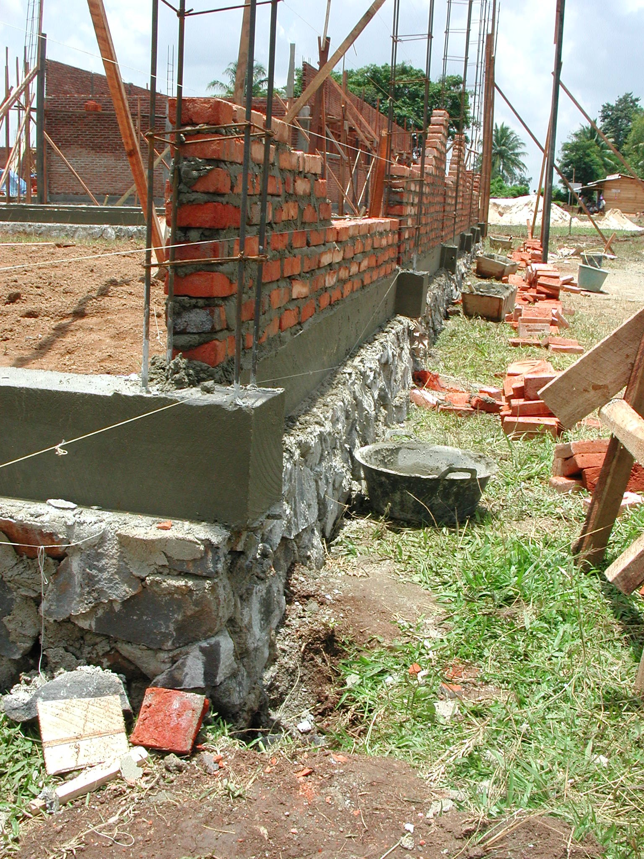

Plate 1: SLTPN 01 Bumi Agung showing lack of foundations under columns.

The budget for the work is Rp1,003,213,000 giving a square metre cost of Rp969,288m² and the consultants stated that they had taken the site conditions into account in preparing the budget. However, there are no site works details and there will now have to be a new bridge over a large drainage ditch to give access to the site

Work started on February 19th and should be completed by July 19th 2003. At the time of the visit the progress as planned should have been 12.50% but was actually 15.9%, approximately 2 days ahead of schedule. The two 3-classroom buildings had brickwork up top ring beam level. The library had brickwork to cill level. The administration building had 70% of brickwork to the top of window frame level. The laboratory had foundations complete and formwork in progress for the ground beam. The multipurpose building had foundations and ground beam complete.

The site is well organised with an office and a store for cement and other materials.
The technical team are purchasing materials and they get quotations from 3 suppliers.
The financial records are not being well kept (receipts are loose for instance and not
in a file) nor are they in accordance with the project guidelines. Large withdrawals
are being made in cash (four separate withdrawals of Rp10million in one day for
instance) because the committee says that the nearest bank is 30 kilometres away and
suppliers will not accept cheques or transfers. There is also no signboard; the site
should have a notice board displayed in a prominent position giving full details of the
total cost, the expenditure so far, labour employed, etc.

SLTPN 02 Jabing, Desa Bungkulu, Kecamatan Jabing: The school is being constructed on a large flat site in the middle of a rural village. The area of the site is 2 hectares and there is plenty of room for expansion of the school and for a sports field. The proposals did not have details of local schools but the committee stated that there were two private SLTPs 5/6 kilometres away and 15 primary schools in three surrounding villages. The primary schools each have about 200 pupils but there were no details of Class 6 sizes. The site is adjacent to the village road which is surfaced and access is not a problem. The school water supply will be from a well and there is an electricity supply along the road.

The consultants have a construction manager (civil engineer S1 with 5 years experience) and the leader of the technical team (SMK) has 10 years construction experience. There are 95 workers on site all from surrounding villages and teams of about 25 are working on each building. Skilled workers are being paid Rp22,500 a day and unskilled workers Rp15,000 a day.

The concrete work is not very good. Concrete was being mixed on site and much too much water was being used. The concrete columns are again being cast between brickwork panels. The quality of the sand and aggregate was however good. The brickwork was not very good and the local bricks being used were not very strong. There is the same problem with the design of the buildings in that there is no RC lintel over the window and door openings. The foundations had again not been increased in size under the columns and top-soil had not been stripped off the building sites and was also being used for back-fill. It was also planned to construct the well right next to the main septic tank and soakaway. The CM was asked to ensure that all top-soil was stripped off and not used for back-fill and to move the well at least 15 metres away from the septic tank and soakaway.

The budget for the work is Rp1,018,046,000 giving a square metre cost of Rp983,619m². The consultants stated that they had taken the site conditions into account in preparing the budget. However there were no site works drawings or details or levels shown on the site plan.

Work started on February 19th and should be completed by July 19th 2003. At the time of the visit the progress was actually 13%. The two 3-classroom buildings had brickwork up to ring beam level, window and door frames fixed and columns being finished. The administration building had foundations and ground beam complete, reinforcement for columns in place and brickwork in progress. The multipurpose building had foundations being excavated. The laboratory and toilets had foundations completed. The library had foundations in progress.

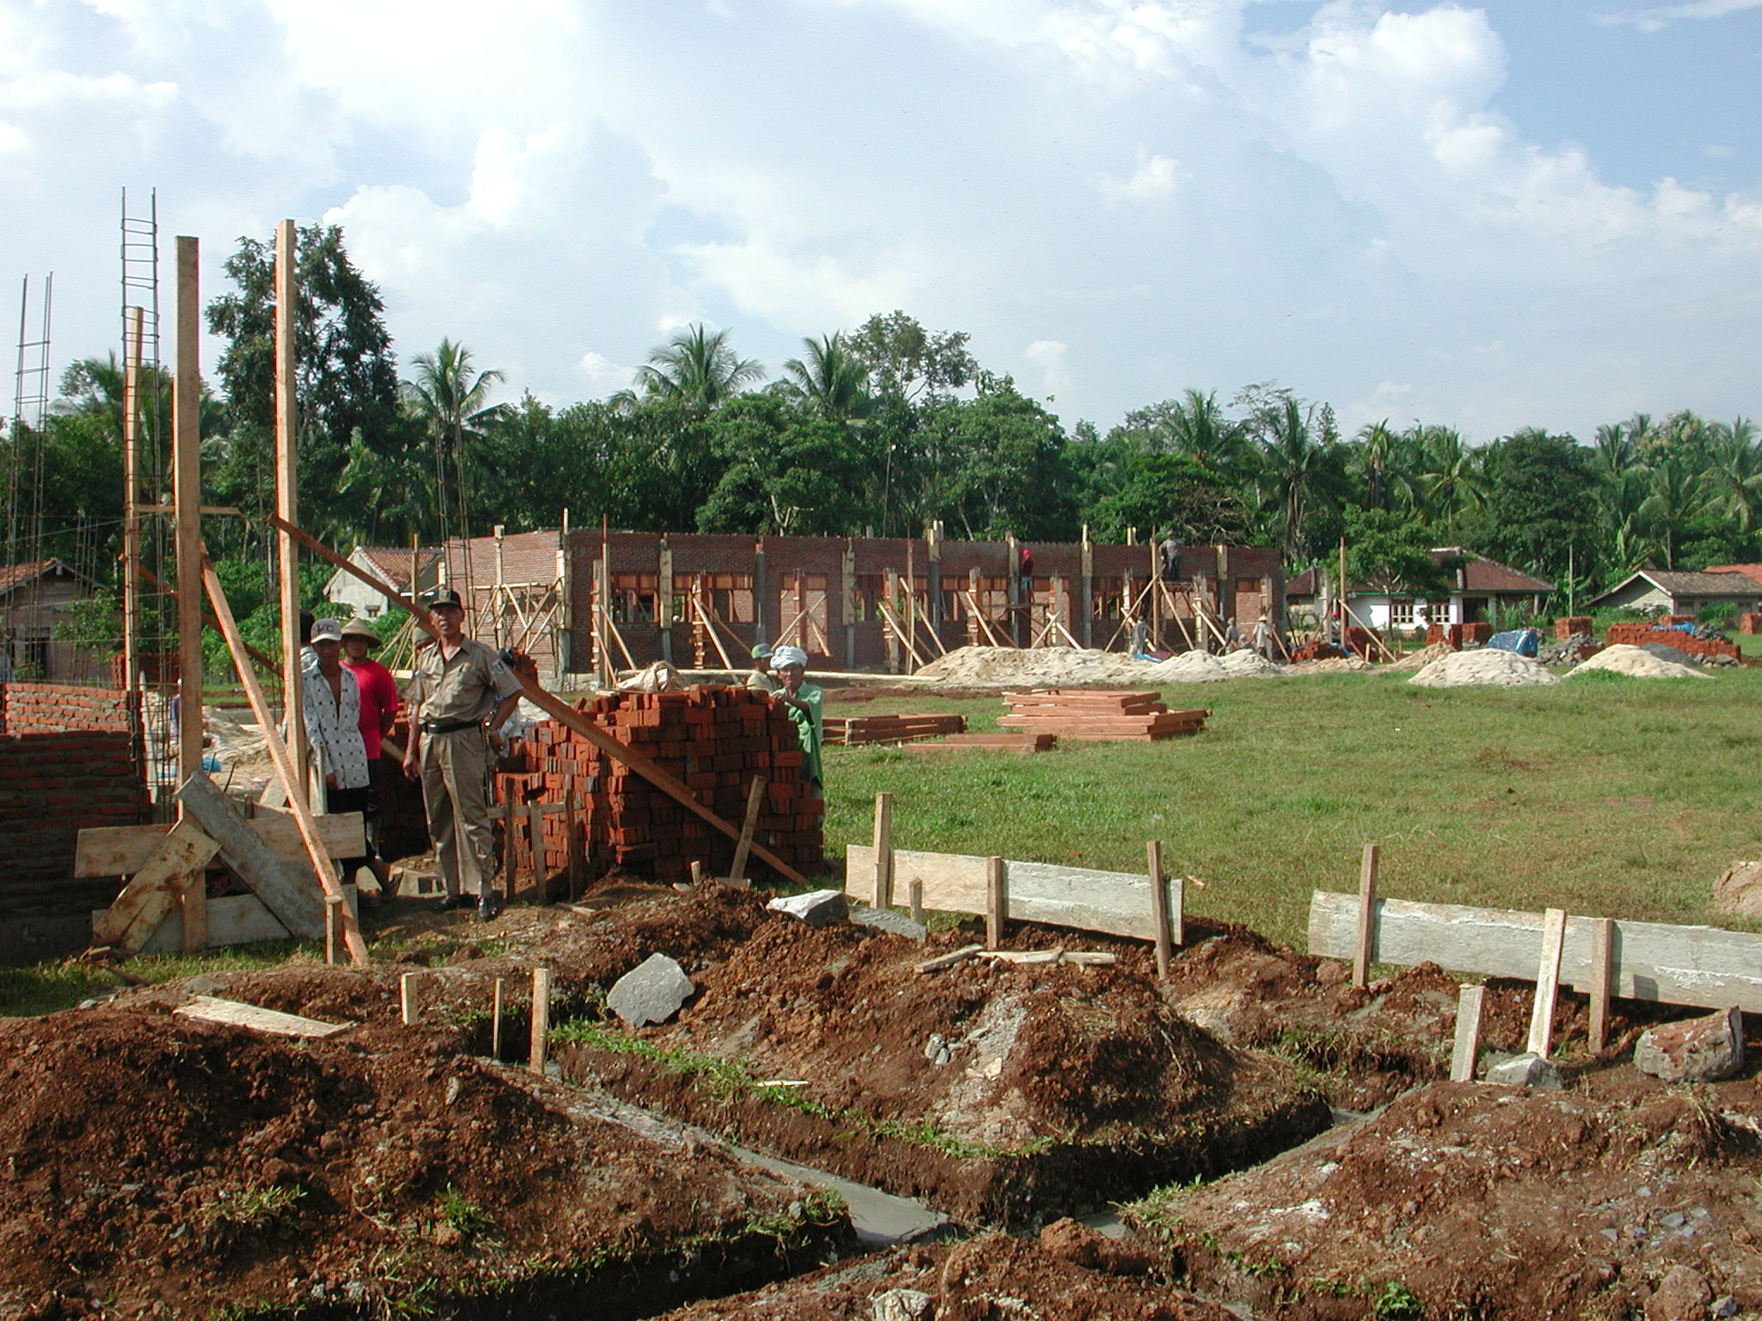

Plate 2: SLTPN 02 Jabing showing top-soil that has not been stripped off within the buildings.

An existing house is being used as the office and store. The timber being used for
joinery and trusses is reasonably good quality and the joinery is quite well made but
could be better finished. The technical team are purchasing materials and they get
quotations from 3 suppliers. The financial records are not being well kept nor are they in accordance with the project guidelines. There were no bank statements and there is confusion between amounts in the books, numbers of receipts, etc. Large withdrawals are being made in cash because the committee says that the nearest bank is 80 kilometres away and local suppliers will not accept cheques or transfers. There is also no signboard.

SLTPN 01 Gunung Pelinding, Desa Penpen, Kecamatan Pelinding: The school is being constructed on a large, flat and rather wet site in a fairly remote, rural village. The site is adjacent to the village road and access is not a problem. The area of the site is 9,000m² and there is room for expansion of the school and for a sports field. There are two private and two government junior secondary schools in the area and 447 pupils in Class 6 in 16 primary schools within a radius of 5 kilometres. There is a village water supply and an electricity supply along the road.

The consultants have a construction manager (civil engineer S1) on site to manage the work and the head of the technical team is also a civil engineer (S1). There are approximately 65 workers all from the village on the site and skilled workers are being paid Rp22,500 a day and unskilled workers Rp15,000.

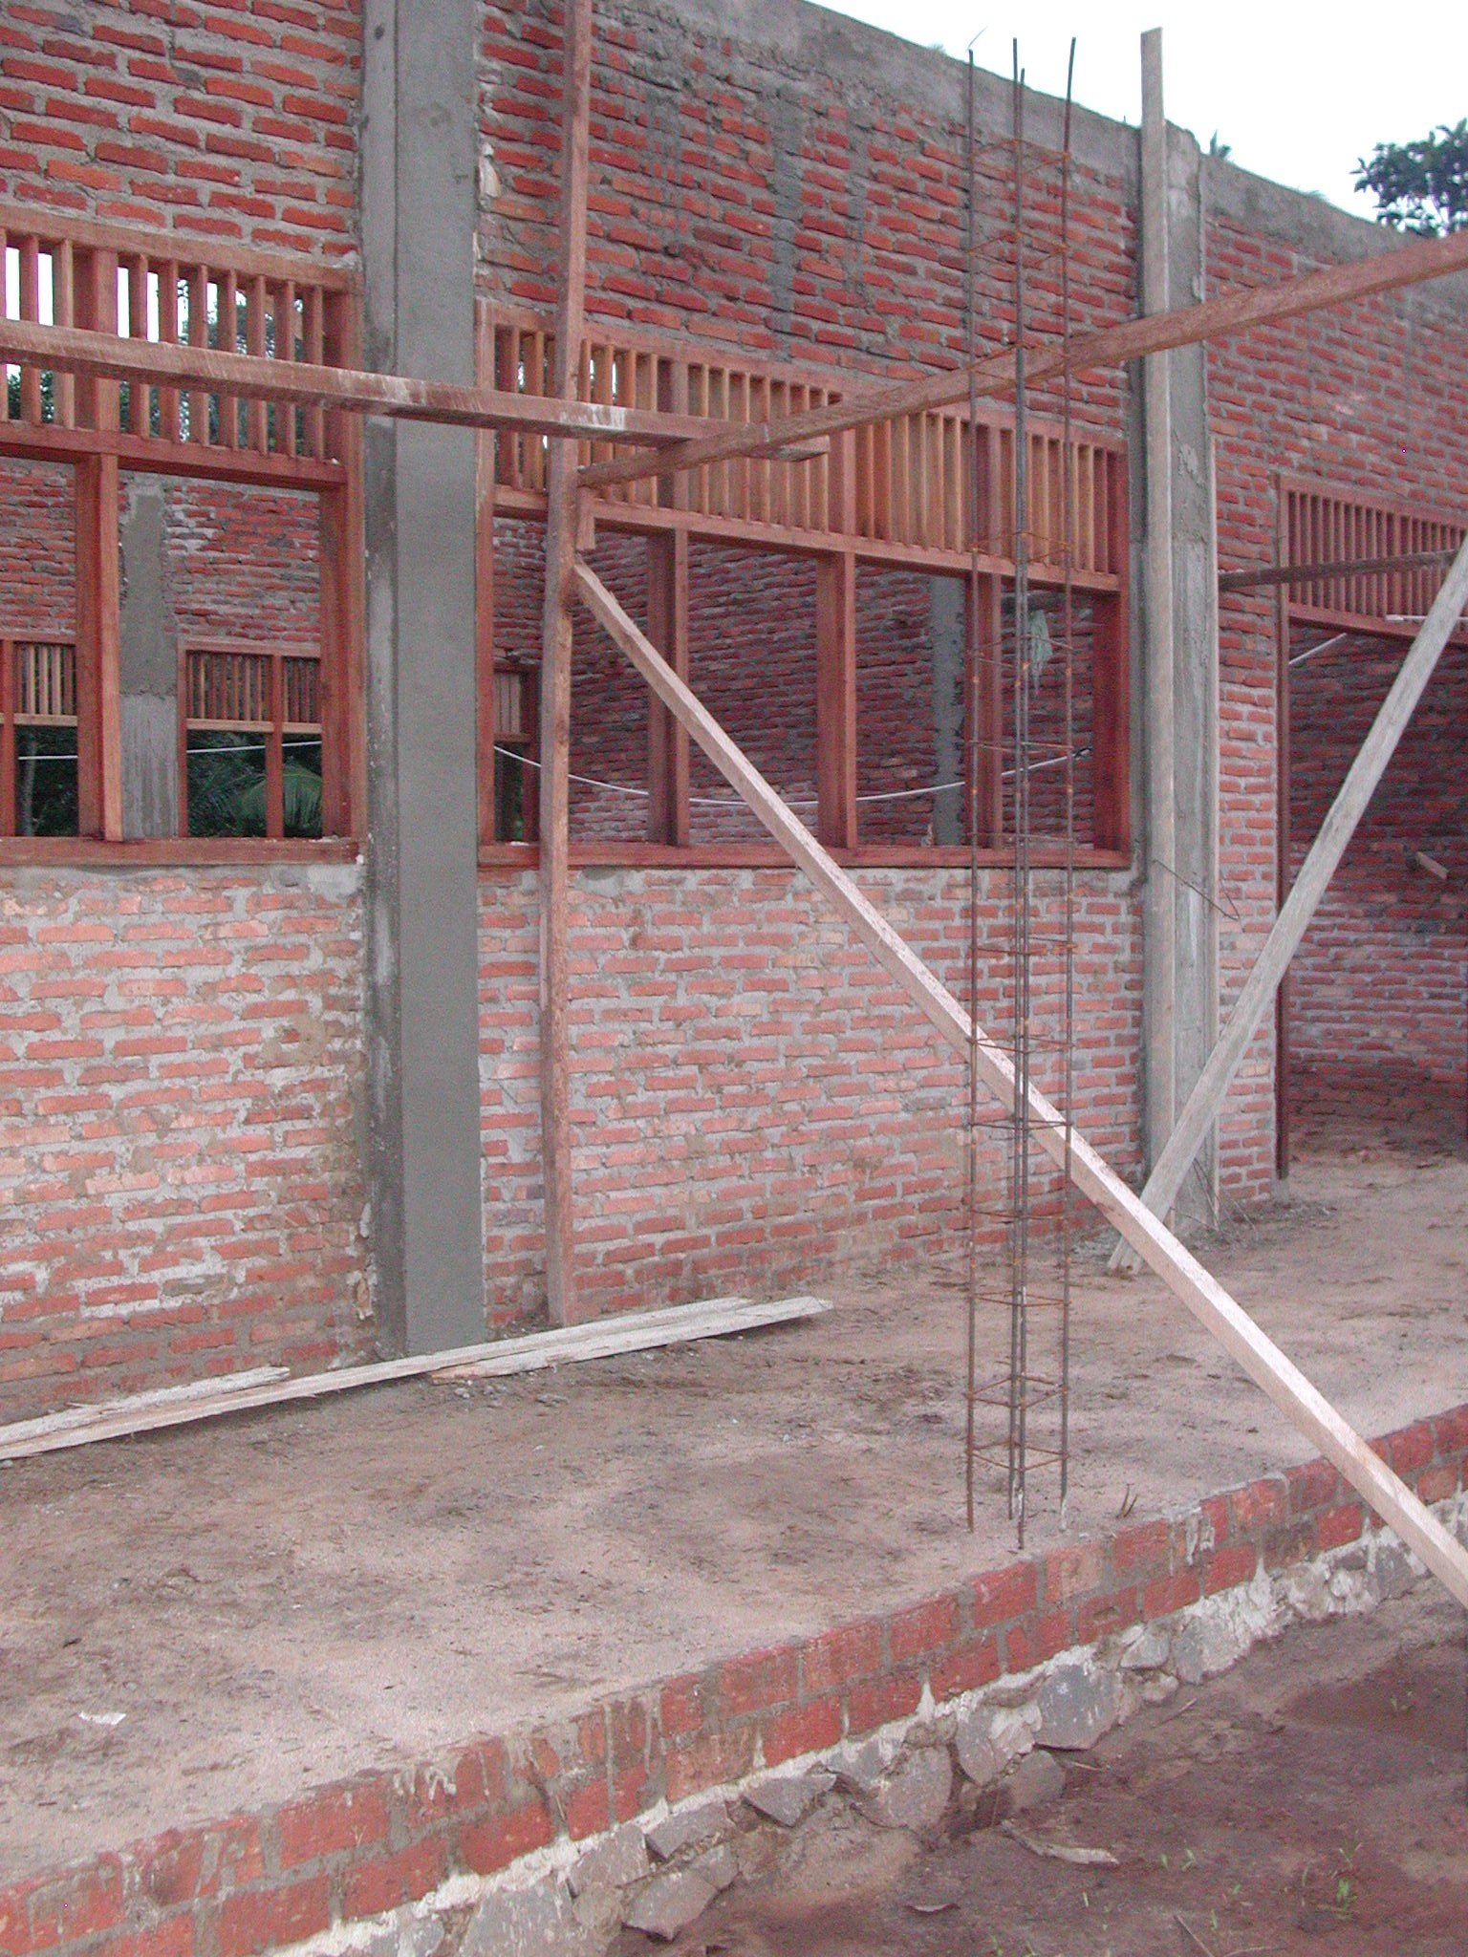

Plate 3: SLTPN 01 Gunung Pelinding showing lack of lintels or beams over window and door openings.

The concrete work is better here than at the last site even though the concrete columns are again being cast between brickwork panels. The reinforcement should be 12mmØ but the only size available was 10mmØ; the consultants should check that this is adequate. The sand and stone being used is good quality. The brick work is good and the joinery and trusses which are being made on site are good; the quality of the timber is quite good. There are again no RC lintels over the window and door openings here but the stone foundations under the columns have been increased in size. Bricks are being used as permanent shuttering instead of timber. The site has an office and store and is well organised.

The budget for the work is Rp1,014,098,000 giving a square metre cost of Rp979,805m². There were again no site works details.

Work started on February 19th and should be completed by July 19th 2003. At the time of the visit the progress as planned should have been 12.42% but was actually 15.54%, approximately 4 days ahead of schedule and about 16% of the budget has been spent. Both of 3-classroom buildings had ring beams complete and roof trusses in progress. The administration building had the ring beam complete. The laboratory foundations were excavated. The multipurpose building and library foundations were being excavated. The remaining buildings had not been started.

The technical team are purchasing materials and they get quotations from 3 suppliers. The financial records being generally well kept but there is some confusion in the book-keeping and they are not in accordance with the project guidelines. Large withdrawals are again being made in cash because the committee says that the
nearest bank is 115 kilometres away and some suppliers will not accept cheques or
transfers. There is also no signboard. The committee stated that teachers will be appointed at the end of April and that they have a budget for furniture.

3.2 Kabupaten Lampung Barat: The following school sites were visited:

SLTPN 04 Banjit, Desa Sumber Baru, Kecamatan Banjit: The school is being constructed on a large site that has been farmland and that slopes in two directions on the edge of a remote, rural village. The site is adjacent to the un-paved village road and access is not a problem. The area of the site is 12,500m² and there is room for expansion of the school and for a sports field. There are 8 primary schools in the Kecamatan with a total of 141 pupils in Class 6 this year. There school water supply will be from two wells and there is no electricity supply.

The consultants have a construction manager (civil engineer S1) on site to manage the work and the leader of the technical team is also a civil engineer (S1). There are approximately 87 workers on the site all from three surrounding villages; the unskilled workers are all from the nearest village. The heads of the teams of workers are being paid Rp18,500 a day; skilled workers Rp16,000 a day; unskilled workers Rp12,500 and the foreman Rp13,500.

The site was not very well organised and the workmanship was generally not very good. The CM stated that it was difficult to find skilled labour at this location but it was pointed out that it was part of his job to upgrade local skills. The setting out of the buildings is not very accurate and the concrete that was being mixed was very wet, the mix did not seem to be very accurate and it was being mixed in un-lined holes in the ground. The reinforcement for columns and beams was all supposed to be 12mmØ but some was 10mmØ and some was even 8mmØ (the consultants should check the reinforcement to ensure that it is adequate). The concrete columns were again being cast between brickwork panels and the foundations had not been increased in size below the columns. The brick work was not very good. The joinery, which is being made in a village a few kilometres away was quite good though not very well finished. The timber being used was however quite good. The two wells on site were both positioned close to toilets and the CM was asked to ensure that the septic tanks and soakaways are constructed at least 15 metres away from the wells. No top-soil or vegetation had been removed from the site before the foundations were excavated and at the time of the visit, top-soil was also being used for back-filling on top of the existing top-soil. As the site had been farmland there is a lot of vegetation all over the site and the CM was asked to ensure that all top-soil, roots and vegetable matter was removed before back-filling took place.

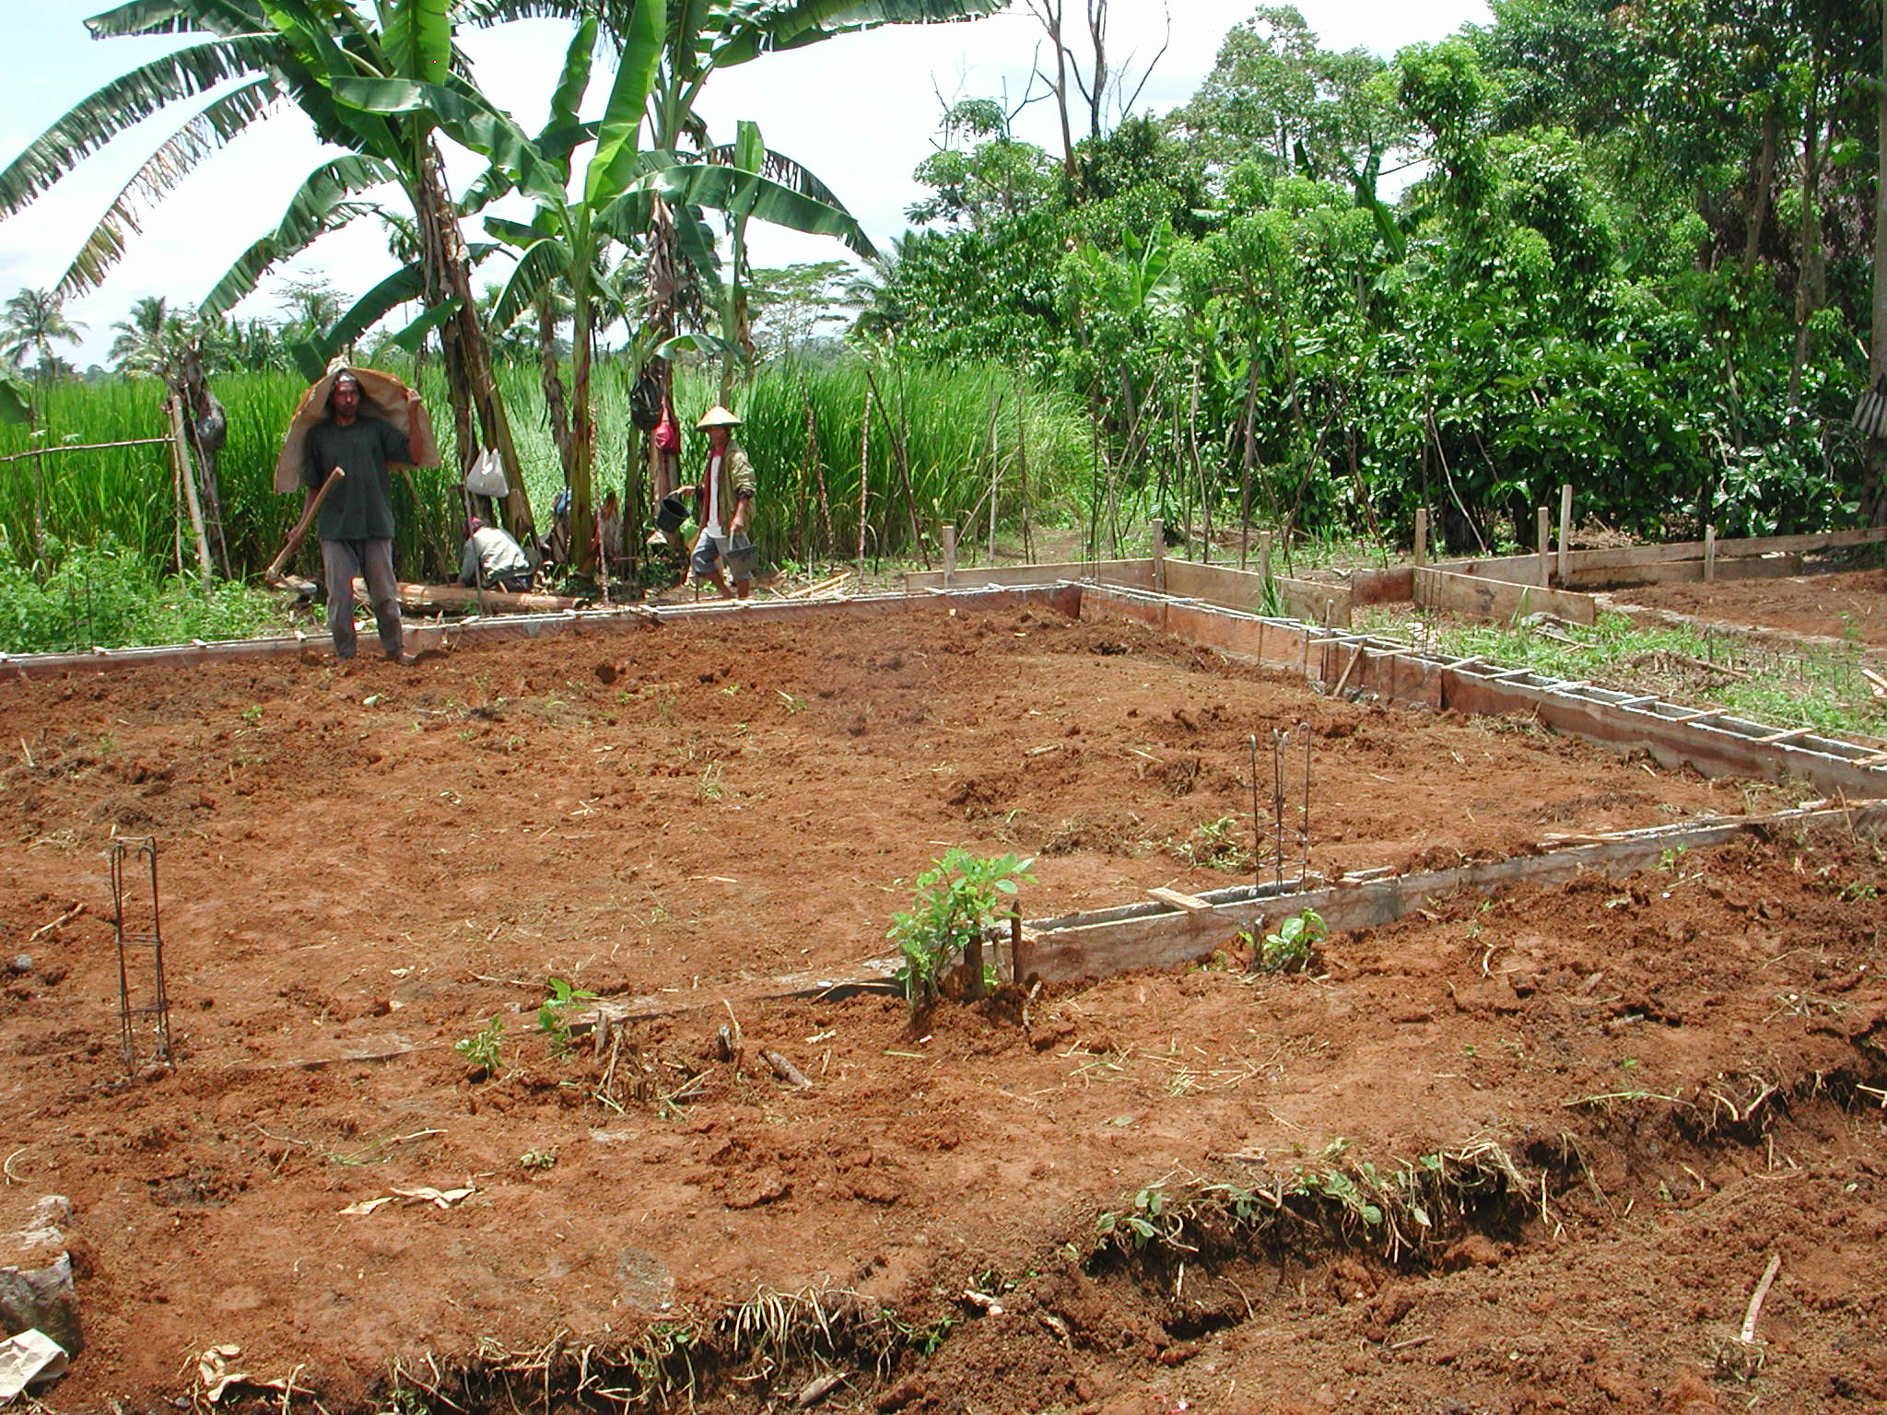

Plate 4: SLTPN 04 Banjit showing top-soil and vegetation within buildings.

The budget for the work is Rp1,021,000,000 giving a square metre cost of Rp986,473m² which seems quite low given the location of the site. The site will require quite a lot of site works but there are no levels shown on the site plan and no site works details at all and it looked as though there might be problems with the links between buildings because of the way the levels had been set. There were also large numbers of workers on the site and the consultants should check the budget in detail to ensure that all site works can be built.

Work started on February 24th and should be completed by June 30th 2003. At the time of the visit the progress should have been 5.69% but was actually 7.92%, two or three days ahead of schedule. One 3-classroom buildings had the foundations and ground beam complete and brickwork in progress. The other 3-classroom building had the foundations and ground beam complete. The administration building had foundations complete and ground beam in progress. The laboratory, multipurpose building, library and head teacher’s house all had foundations and ground beam complete. The toilets and penjaga’s house had foundations complete. The musholla had foundations in progress.

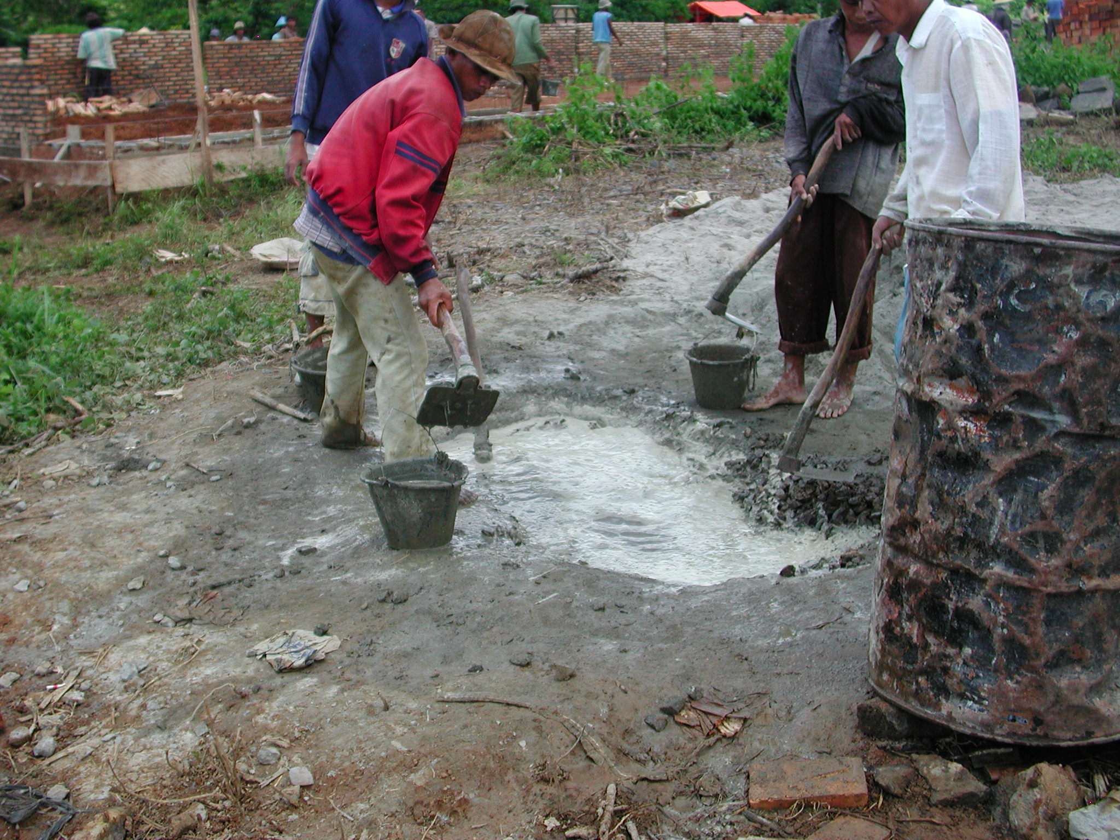

Plate 5: SLTPN 04 Banjit showing concrete being mixed directly on the ground using too much water.

The technical team are purchasing the materials and they get quotations from 3 suppliers. The financial records seem to be well kept and suppliers are being paid by cheque. There is no notice board.

SLTPN 02 Sekincau, Desa Pekan Waspada, Kecamatan Sekincau: The school is being constructed on a large site on top of a small hill on the edge of a remote rural ‘transmigrasi’village. The site is adjacent to the village road and access is not a problem. The area of the site is 10,040m² and there is room for some expansion of the school but not for a sports field because of the slope of the site. There are 6 primary schools within a 5 kilometre radius and the nearest junior secondary school is 7 kilometres away. There are 209 pupils in Class 6 this year. There is a village water supply and an electricity supply along the road.

The consultants have a construction manager (S1 civil engineer) on site to manage the work and the head of the technical team is also a civil engineer (D3).

The workmanship so far is quite good but there are a number of problems. The main columns have been turned round 90º for some reason and must be turned back so that the longest dimension is at right-angles to the walls. The quality of the sand and the bricks being used was good and the quality of the brickwork was good. However, the quality of the timber was variable and only the good timber should be used. Although the sub-soil on the site is clay and the site has been stripped of top-soil, top-soil was being used for back-filling and the CM was asked to stop this practice. The foundations as constructed were much wider than shown on the drawings and were wide enough for the columns unlike at other sites. This area is prone to earthquakes and the consultants had put in extra beams above and below windows. The size of the reinforcement being used should however be checked; there was some doubt as to whether it was actually 12mmØ.

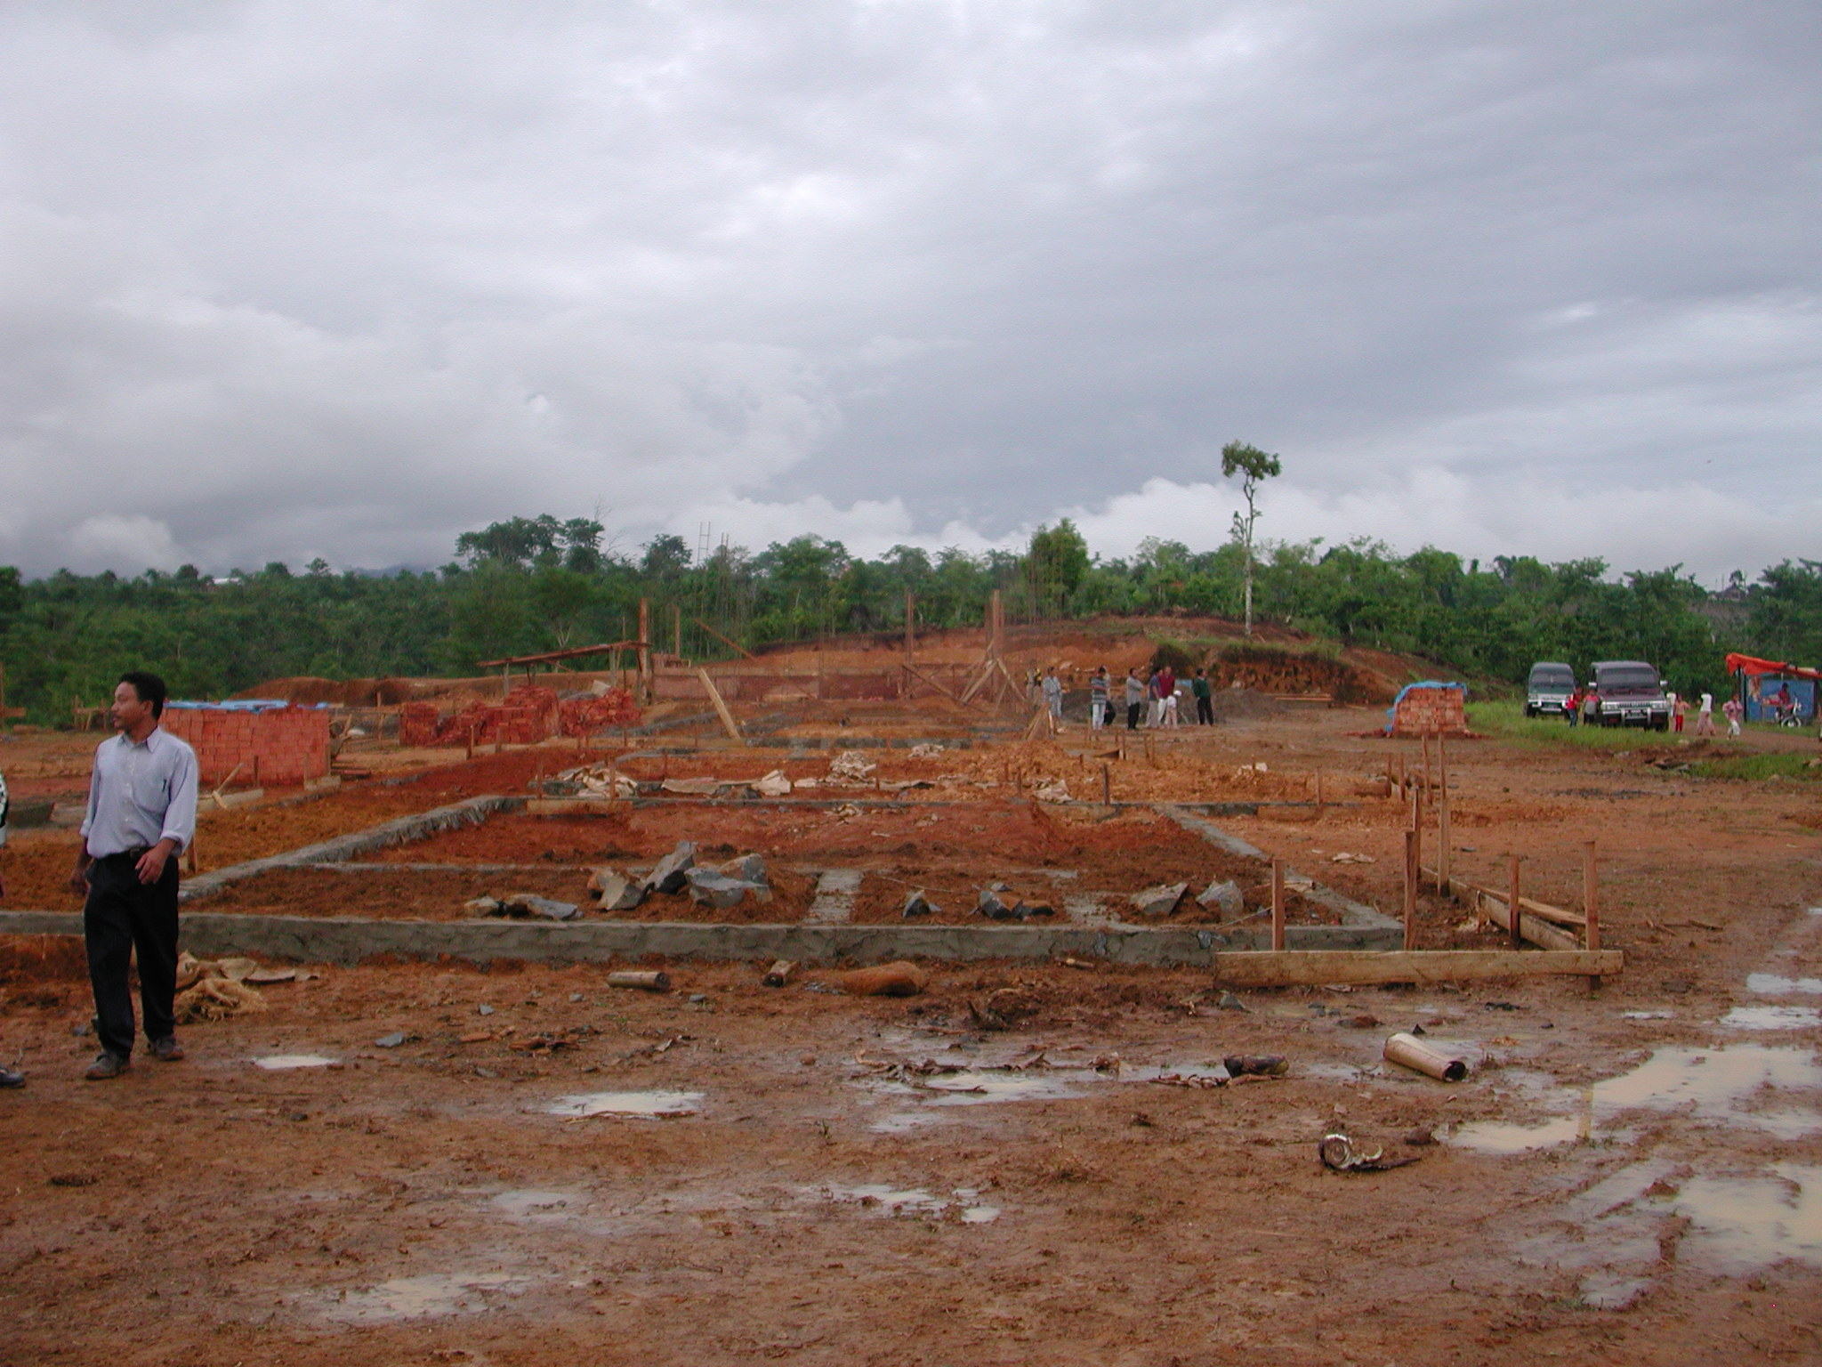

Plate 6: SLTPN 02 Sekincau showing site levelling in back ground.

The budget for the work is Rp1,027,000,000 giving a square metre cost of Rp992,270m². The site will require a lot of site works including reduction of levels, cut and fill, retaining walls, steps, drainage, etc. No detailed site layout or site works details had been prepared and the consultants should check the budget in detail to ensure that all site works can be built. The CM said that the site layout had to be changed before work started to take into account the actual levels on the site.

The work was supposed to start on February 26 but was delayed until March 5th because the funds were not released by the district finance office. The work was supposed to be finished in June but will now probably be completed in July 2003. The CM should prepare a new programme, schedules, etc to reflect the actual starting date. It was not possible during the visit to check whether the work was on schedule or not. A large area of the site has been reduced in level by hand and levelling needs to be completed. One 3-classroom building had foundations complete and reinforcement for the ground beam and columns were in place. The other 3-classroom building had been set out. The musholla foundations had been excavated. The administration and multipurpose buildings foundations were complete. The library foundations and ground beam were complete and brickwork was to cill height.

The site office is in an existing building in the village and the head of the technical team has lent the project his computer and printer. The technical team are purchasing the materials and they get quotations from 3 suppliers. The consultants have prepared comprehensive schedules of materials, etc but they now need to update these schedules and projections to take into account the actual starting date. The financial records are being quite well kept here with details of all transactions, receipts, etc but there was some confusion in the book-keeping and they are not in accordance with the project guidelines. The school committee has also not been following the guidelines in terms of cash withdrawals but has been paying suppliers large sums of money in cash. The committee said that their suppliers were now prepared to take cheques.

3.3 Kabupaten Lampung Selatan: the following school site was visited:

SLTPN 02 Sidomulyo, Desa Suka Banjar, Kecamatan Sidomulyo: The school is being constructed on a large site in a rural village 40 kilometres from Bandar Lampung and just off the main road to the ferry to Java. The short access road from the village road is very soft and muddy and slopes down to the site. The site falls away from the access road to farmland below and is very wet. The site is close to the village road and access is not a problem. The area of the site is 1.2 hectares and there is room for expansion of the school and a sports field. There are seven primary schools in the catchment area of the new SLTP and approximately 205 pupils in the present Class 6. The nearest SLTP is 5 kilometres away. The school water supply will be from a well; the well is over 30 metres away from the proposed septic tanks. There is an electricity supply along the road.

The consultants have a construction manager (S1 civil engineer with 8 years experience) on site to manage the work. The head of the technical team is also a civil engineer with 15 years experience and the two are working well together. There are 100 workers registered and 80 are working on the site. The heads of teams are being paid Rp25,000 a day; skilled workers Rp22,500 a day; unskilled workers Rp15,000.

The site is well organised and the workmanship is generally good. The sand, brick work and concrete work is good. The concrete columns are again however being cast between brickwork panels and the foundations under the columns have not been widened. The joinery is being made to a very good standard using good quality timber.

The budget for the work is Rp986,579,000 giving a square metre cost of Rp953,216m². The site will require a lot of site works including cut and fill, retaining walls, steps, drainage, etc. The site drawings do not have levels and there are no site works details. The access road will have to be re-built with a drainage gulley at the bottom to stop storm water flooding the site and it was not clear whether this was included in the estimate. The consultants said that the site works were included in the budget but they should check the budget in detail to ensure that all site works can be built.

Work started on February 18th and should be completed by July 18th 2003. At the time of the visit progress was 19.6% and the planned progress was 18.16% and the work was two or three days ahead of schedule. The two 3-classroom buildings had door frames fixed and brickwork to cill level. The laboratory foundations were complete and the ground beam was in progress. The administration building foundations and ground beam were complete, the reinforcement for columns was in place and brickwork was in progress. The brickwork to the head master’s house and toilets were in progress and the septic tank and soakaway were in progress. Foundations to the penjaga’s house and multipurpose building were complete. The foundations to the library and musholla were complete and the ground beams were in progress.

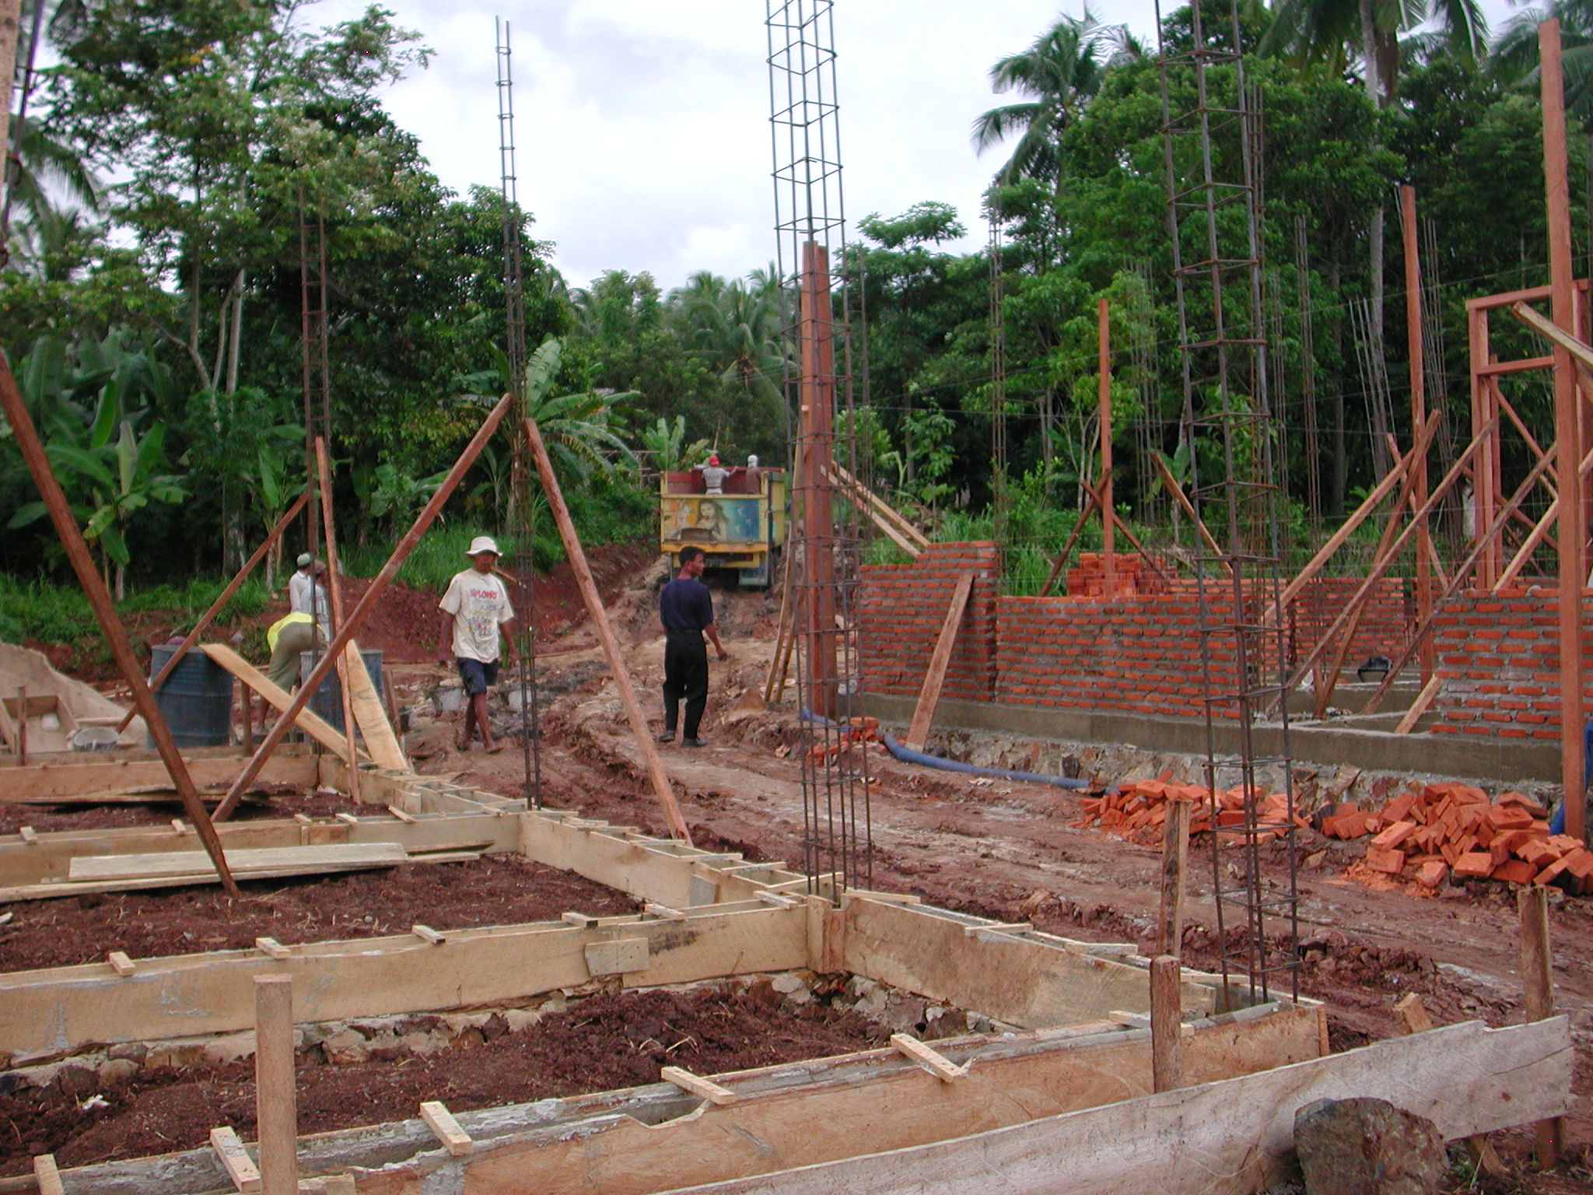

Plate 7: SLTPN 02 Sidomulyo showing access road in back ground.

The technical team are purchasing the materials and they get quotations from 3 suppliers. Good records are being kept of all payments that are made and the receipts are well organised. Large withdrawals have however been made to pay for materials because the suppliers will not accept cheques or transfers.

ANNEX 3: REPORT ON VISIT TO JAMBI PROVINCE, SUMATRA

1. General

  - Jambi Province was visited between March 20th and March 22nd 2003.

  - Meetings were held with the Project Manager and the Procurement Consultant in the PPIU, the civil works consultants and their site staff and members of school committees and their technical teams on new school sites.

  - Two new schools were visited in two districts of the Province where construction is taking place. One firm of civil works consultants is managing the school construction and advising the school committees. An existing school in Jambi City was also visited that is receiving a matching grant to fund renovations to the school facilities.

  - A standard design for a junior secondary school has been agreed in the Province and the consultants have produced standard drawings for the school buildings to be used on the sites. The new schools will consist of six classrooms in two 3-classroom buildings; a multi-purpose building, a library; an administration building; a musholla; a canteen/penjaga’s house; a head teacher’s house, a bicycle shed and school toilets. The total area of the buildings is 925m².

  - Construction is similar at all schools: foundations are of stone set in mortar; walls are of rendered brickwork with RC columns, ground beams, ring beams and veranda beams; roofs are of corrugated steel sheets on purlins on timber trusses, ceilings are of plywood; windows and doors are of timber with panel doors and timber glazed windows; floors and verandas are of ceramic tiles on screed.

  - At both schools visited, the land certificates were still being processed by BPN and there were agreements with the Bupatis to providing funding, etc. Both schools had school committees and technical teams.

  - Access to the schools was not a problem even though they were both very remote. Both schools seemed to have sufficient Class 6 pupils in primary schools within their catchment area to provide two streams of Class 1 next year.

2. Issues

2.1 Civil Works Consultants: Many of the problems noted at the school sites were the result of poor management and supervision by the civil works consultants, particularly the construction managers (CMs) on site.

2.1.1 Approach: As in the other Provinces, the civil works consultants need to change the way that they approach these projects. They must realise that community-based projects require a different approach and different documentation to projects that use contractors. CMs based on sites in particular need to realise that they are there to advise the school committees on managing the physical work, on procuring materials to the correct specifications and on keeping financial records as well as in supervising the construction work. They also have an important role to play in improving the skills of workers on the site and ensuring that the quality of the completed work is as specified. This is true at schools receiving matching grants as well as at those receiving block grants.

    - Site Works Drawings: At both of the sites visited, there were inadequate site works drawings. The consultants should prepare surveys of the sites and detailed site drawings showing the levels of all buildings and giving details of links between buildings, any retaining walls, steps, etc that are required and site drainage, etc. Without these details it is difficult to see how the consultants can have prepared accurate estimates for the work at the schools. The lack of detailed drawings also means that the CMs are having to prepare the site works details and might not have the experience or expertise to do this properly. They also have a lot of other duties to carry out on site and should not have to do this extra work.

    - Budgets: The consultants were asked to complete the site drawings for all sites and check their estimates in order to ensure that there were sufficient funds to complete the site works. They should also make sure that the CMs on all sites balance spending on materials with progress on the site; at one school there was a danger of the funding running out before enough work had been completed to justify the school committee applying for the second tranche of funding.

    - Documentation: At both of the sites visited, the other documentation that the consultants should have prepared according to the project guidelines was missing. The consultants should have prepared detailed schedules of materials for all buildings, estimates of labour requirements, cost estimates based on surveys of local material prices and wage rates, projections for when the materials and labour will be required and cash flow projections. All of these were missing and the CMs were having to prepare some or all of this material on site.

    - Project Guidelines: One of the consultants’ duties is to ensure that the school committees are following the project guidelines with regard to finances, particularly with regard to cash withdrawals, payments to suppliers, financial records, etc. At neither site was this happening nor are the school committees following the guidelines.

2.2 Construction: A number of construction issues were noted during the visits and most of them occurred on both sites. They included:

2.2.1 Concrete: There were problems with the mixing of concrete on both sites. The problems include: inaccurate measurement of the materials, insufficient mixing of the materials when dry, using too much water in the mix and only mixing part of the materials measured out. All of these will result in poor quality and weak concrete.

    - Reinforcement: The reinforcement specified for the main columns and beams is 12mmØ but on one site 10mmØ and 8mmØ reinforcement was being used. While 10mmØ may be acceptable (the consultants should check this), 8mmØ is not and should not be used. On many sites the links to the reinforcement were spaced at greater intervals (up to 40cms) than those designed (15cms).
    - RC Columns: On both sites columns in walls were being cast between panels of brickwork rather than being cast in proper formwork before the brick work is built. This usually results in poor quality concrete because the cover to the reinforcement cannot be controlled; the formwork is not straight, etc. In all cases, columns should be cast in formwork before the brick work is started and ties for the brickwork should be cast into the columns.

    - Lintels: It was noted that in the design for the schools, there were no lintels over window and door openings and the brickwork was being built off the frames. This is very bad practice and will lead to cracks in the brickwork over the frames and difficulties in future in changing frames.

    - Roof Trusses: At the second site visited, the timber being used for the roof trusses was very poor quality and in one building trusses had been nailed not bolted. The CMs must ensure that good quality timber is used and all joints bolted with adequate laps as shown on the drawings.

    - Roof sheets: It was also noted that the roof sheets being used on both sites is only 0.2mm thick. These sheets are very poor quality and will not last very long and the consultants should ensure that the school committees use the materials that are specified.

    - Top-soil: At one site top soil, roots and vegetable matter had not been stripped off the area of the buildings. All top soil and vegetable matter should be stripped off the area of the buildings before excavation is started and proper materials should be used for back-filling.

    - Wells and Septic Tanks: On one site, a septic tank and soakaway was being located very close to a well and there were serious dangers of contamination of the well. Septic tanks should be located at least 15 metres and preferably 30 metres (especially on wet sites) away from wells.

    - Site organisation: On both sites, door and window frames and roof trusses are being made and/or left out in the open, exposed to sun and rain. All materials, particularly finished ones, should be properly protected.

2.3 Other Problems: Several other problems were noted:

2.3.1 Training: More training of the civil works consultants and of school committees in the objectives of the project and in following the project guidelines is required.

2.3.2 Supervision: The CMs should take more care in supervising the work and working with the technical teams. They have to ensure that the work is carried out according to the drawings and specifications and they should be providing quality control and training if necessary to ensure that this is the case. The team leaders should be supervising their field staff to ensure that they are carrying out their duties properly and in accordance with the guidelines (this is the case with matching grant schools as well as those receiving block grants). If CMs are found to be incapable of carrying out their duties then they should be replaced and this is the case with the CM at SLTPN 07 Tungkal Ulu who should be replaced as soon as possible.

The PPIU procurement consultant should also supervise the work of the civil works consultants to ensure that they are carrying out their duties properly and diligently.

2.3.3 Transparency: It was noted that on both sites there were no notice boards or the notice boards did not show the information that they should. All sites should have notice boards displayed in a prominent position giving full details of the total cost, the expenditure so far, labour employed, etc.

2.3.4 Matching grants: At the one matching grant school visited, there was a serious drainage problem. Under the guidelines as they exist however, funding should not be spent on improving site drainage. It would seem sensible to amend the guidelines so that drainage problems can be resolved. Drainage in this case is a lot more important than the site walls that were being constructed using the matching grant funds.

3. Site Visits

3.1 Kabupaten Tanjung Jabung Barat: The following school site was visited:

SLTPN 07 Tungkal Ulu, Desa Tebing Tinggi, Kecamaten Tungkal Ulu Tanjab Barat: The school is being constructed on a very remote, large, gently sloping site on the edge of oil palm plantations. The site used to be covered with bush and has been stripped using a bulldozer. There is a lot of surface water running across the site. The area is 1.76 hectares and there is room for expansion of the school and for a sports field. There was no certificate of land ownership (it is still being processed by BPN). There are 9 primary schools within 5 kilometres of the new school and there are 222 pupils in Class 6. The area has a lot of plantation and forestry workers and most of the students will probably be their children. The site is adjacent to a main road and access is not a problem. The school water supply will be from a well that has already been excavated. There is no electricity supply.

The consultants have a construction manager (civil engineer S1) on site to manage the work and the head of the technical team used to be a builder/foreman. The head of the school committee is a teacher at a school 30 kilometres away and he therefore has a 60 kilometre round trip to visit the site. He does not therefore visit the site very often. There are only 49 workers on the site, mainly local. The CM stated that it was very difficult to find workers at this location as there was a lot of work available in the plantations and this has also meant that wages are higher here. The heads of work teams receive Rp50,000 a day; skilled workers Rp35/40,000 a day and unskilled workers Rp20,000 a day.

The site was very badly organised with timber, window and door frames left out in the open and sand and aggregate scattered around the site, etc. The workmanship in general was also not very good. The trusses that had been erected had not been bolted and the timber that had been used was very poor quality. The timber in general was not good quality and the joinery was also not very good. The concrete work varied in quality and some of it was very bad. The concrete columns are being cast between brickwork panels with all the problems this entails. The reinforcement to the main columns seemed to be 10mmØ and not 12mmØ as designed and the internal columns seemed to be 8mmØ both with links at 40cm centres not 15cm centres as designed. The consultants should check the sizes of the reinforcement and ensure that it is adequate and ensure in future that the steelwork is as designed. The columns have reinforced concrete foundations with brickwork foundations between columns. The brickwork was reasonable quality but the rendering was not very good. The concrete sand was not very good quality. There is a problem with the design of the buildings in that there is no RC lintel over the window and door openings but one metre of brickwork sits directly on top of the frames. There will eventually be cracking of this brickwork because of differential movement between the frames and the brickwork. The well has been excavated and it was planned to construct the septic tank near to the well. The soil is very loose and sandy and the CM was asked to ensure that the septic tank and soakaway was moved at least 30 metres away from the well. The consultants were asked later to replace the CM on this site.

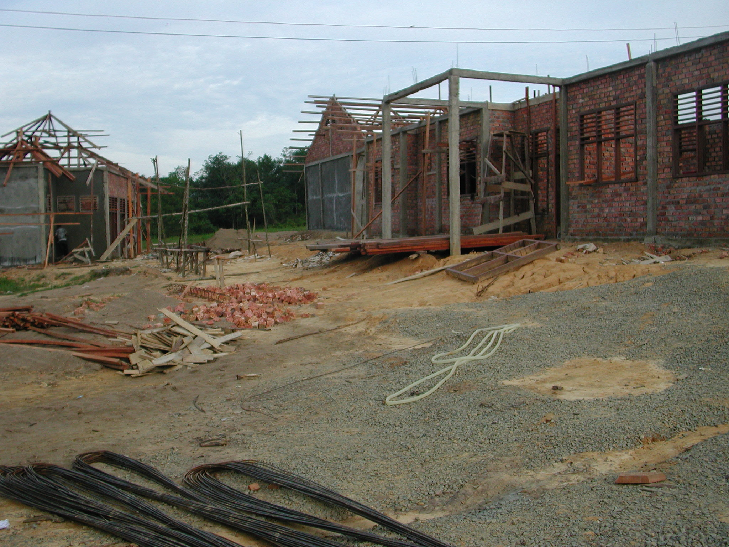

Plate 1: SLTPN 07 Tungkal Ulu showing disorganised site and inadequate concrete beams and columns to administration

The budget for the work is Rp928,184,000 giving a square metre cost of Rp1,003,442m². The site plan (scale 1:500) prepared by the consultants had no levels and there were no site works details and it is difficult to see how the consultants had estimated the cost of the site works. The consultants should prepare site works drawings, including retaining walls, drainage runs, etc as soon as possible and check their estimates to ensure that it will be possible to complete all the site works. They should also prepare a consolidated progress chart so that the progress of the job can be easily checked. At present there are separate charts for each building.

Work started on January 16th and should be completed by June 25th 2003. At the time of the visit the progress as planned should have been 33.85% but was actually 26.24%, approximately 2 weeks behind schedule. The musholla had brickwork and concrete work complete, roof trusses fixed and rendering in progress. The multipurpose building and the head teacher’s house were as the musholla but the rendering was complete. The toilets had brickwork to ring beam level. The administration building had brickwork and ring beam complete. One 3-classroom building had brickwork and ring beam complete and roof trusses in progress. The other 3-classroom building was similar but rendering was in progress. The library had brickwork complete and ring beam ready for casting.

The financial records were being well kept but they were not very clear and should be
checked to see if they are in accordance with the project guidelines. Very large
withdrawals are being made in cash (there have been withdrawals of Rp40, 50, 75 and
80million in one day and the nearest bank is in Jambi, 134 kilometres away) but the
committee is not spending large amounts and it was not clear why the money was
being withdrawn or where it was being kept. The committee was asked to stop
this very dangerous practice.

3.2 Kabupaten Bungo: the following school site was visited:

SLTPN08 Muara Bungo, Desa Pasir Putih, Kecamatan Muara Bungo: The school is being constructed on a small sloping rural site 8 kilometres from Bongo town. The area of the site is 6,000m² (the land certificate is being processed by BPN) and there is room for some expansion of the school but not for a sports field. The proposals did not have details of local schools but the committee stated that there were 3 primary schools in the catchment area of the new school and there are 89 pupils in Class 6. The site is adjacent to a surfaced road and access is not a problem. The water supply is at present from a well but there is a piped supply nearby but no electricity supply.

The consultants have a construction manager (civil engineer S1 with 8 years experience). There are 52 workers on site and the head of work teams are being paid Rp45,000 a day, skilled workers are being paid Rp35,000 a day and unskilled workers Rp20,000 a day. The CM said that there are problems with recruiting workers here; there had only been 14 workers on the site for the first two weeks of construction.

The concrete work was quite good. The reinforcement was the correct size and this was the only site where the columns were being cast using proper formwork before the brickwork was built. The brickwork was however not very good and there were no lintels over the window and door openings. The concrete and rendering sand was good but the timber on site was not very good quality especially for joinery work. Even some of the timber used for the roof trusses should be changed. The roof trusses in one of the 3-classroom buildings had been nailed not bolted. The site had been cleared using a machine but a lot of top-soil and vegetable matter had been left. The CM was asked to make sure that this was stripped off over the area of the buildings and all vegetable matter got rid of; he should also ensure that good material is imported for back-filling.

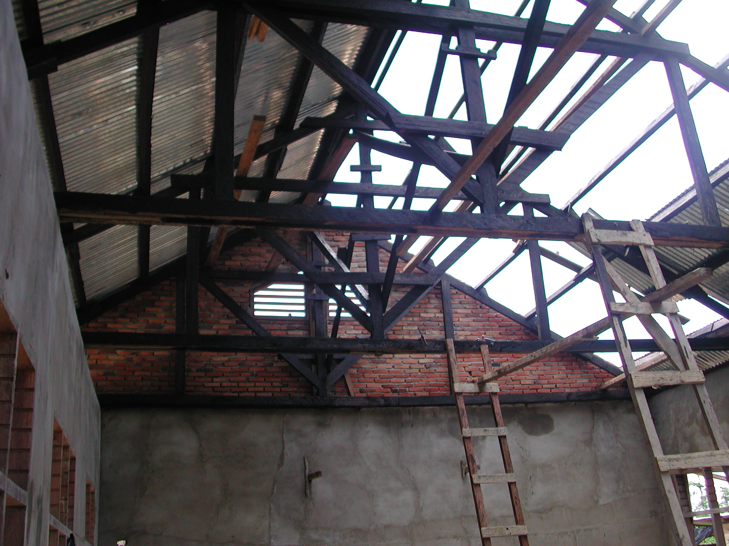

Plate 2: SLTPN08 Muara Bungo showing poor quality timber and nailed joints to trusses.

The budget for the work is Rp896,126,000 giving a square metre cost of Rp968,785m². The consultants stated that they had taken the site conditions into account in preparing the budget. There were however no site works drawings or details or levels shown on the site plan. The site slopes and has a lot of surface water running on to it from the road. It will require a lot of site works including retaining walls and site drainage and the consultants were asked to complete the drawings and details as soon as possible and check their estimates to ensure that there were sufficient funds to pay for all the site works.

Work started on January 8th and should be completed by the end of May 2003. At the time of the visit the progress as planned should have been 41.08% but was actually 30.40% and was about 2 weeks behind schedule. The CM stated that heavy rain had delayed the work. One of the 3-classroom buildings had brickwork, ring beams and rendering complete and roof trusses in progress. The other 3-classroom building had RC columns complete to ring beam, brickwork in progress and shuttering to veranda columns in progress. The musholla brickwork was complete and rendered, roof timbers were complete and roofing was in progress (roof sheets only 0.2mm thick). The administration and library buildings had brickwork and ring beams complete and rendering in progress. The multipurpose building had brickwork, ring beams and rendering complete, roof trusses being bolted and roof sheets in progress. The toilets and head teacher’s house had brickwork and ring beams complete and rendering in progress.

An office and store have been built on the site and the site was quite well organised although window frames had been left lying around the site. The CM on this site has prepared materials schedules for each building with a breakdown of the money required to purchase them for the first three months. The technical team are purchasing materials and they get quotations from 3 suppliers. The financial records and accounts seemed to be well kept. There was a problem in that the school committee are not paying the suppliers direct but a third party though the reason for this was not clear. The committee also stated that their bank would not allow them to issue cheques; they were advised to change banks! They were not following the guidelines in that the cash withdrawals were much greater than Rp10million. They were also not following the procurement guidelines; they had quotations from suppliers but had not issued purchase orders. They also need to balance their spending on materials with the progress of the work; there was a danger that they would run out of money before they had completed 36% of the work and could get the next tranche of finance. The CM and the head of the school committee both seemed competent and there also seemed to be a very good team spirit with the CM and the school committee working well together.

3.3 Kota Jambi: the following school site was visited:

SLTPN 18 Jambi: This existing school is situated on a large urban site in the suburbs of Jambi City and has received a matching grant. The total budget is Rp157,328,000 of which the community has donated 2½%. The site slopes quite steeply down from the access road to a new drainage channel at the bottom of the site (probably 3 metres fall). Part of the school, the library and a classroom building is on the other side of the channel. The bottom part of the site is very wet and is usually flooded in the rainy season (there is a flood mark 70cm up the end wall of a classroom building) and the drainage channel is an attempt to stop flooding from an adjacent swamp. The school has 471 pupils. The school water supply is from a well that dries up in the dry season. The well cannot be excavated any lower because of the presence of oil at lower levels (there is an oil well just across the road) and the school buys water in the dry season. There is a signboard at the front of the site giving details of the work and the cost.

Matching grants can only fund a limited number of activities including: books, equipment, teacher training and recruitment, water supplies, renovation or construction of classrooms, toilets, libraries, multipurpose rooms and administration and renovation of school fields, retaining walls and fences.

61 schools are receiving matching grants in the Province and the work is being supervised by 8 civil engineers. This school is the only one in Jambi City receiving a grant and is being supervised by the deputy team leader of the consultants.

The funds here are being spent on new ceilings, painting, security mesh to windows and furniture for the library (complete); new floors and painting to the laboratory (in progress); repairs to roofs, floors and ceilings and replacement of doors and painting to two classroom buildings (not yet started); repairs to paving around buildings (not yet started); construction of three new pupils toilets (not yet started); paving the school playground (in progress); renovating part of the existing site wall and building a new section of site wall (in progress) and the un-lined storm drain (complete). The cost of the new drain has been taken out of the cost of the new wall.

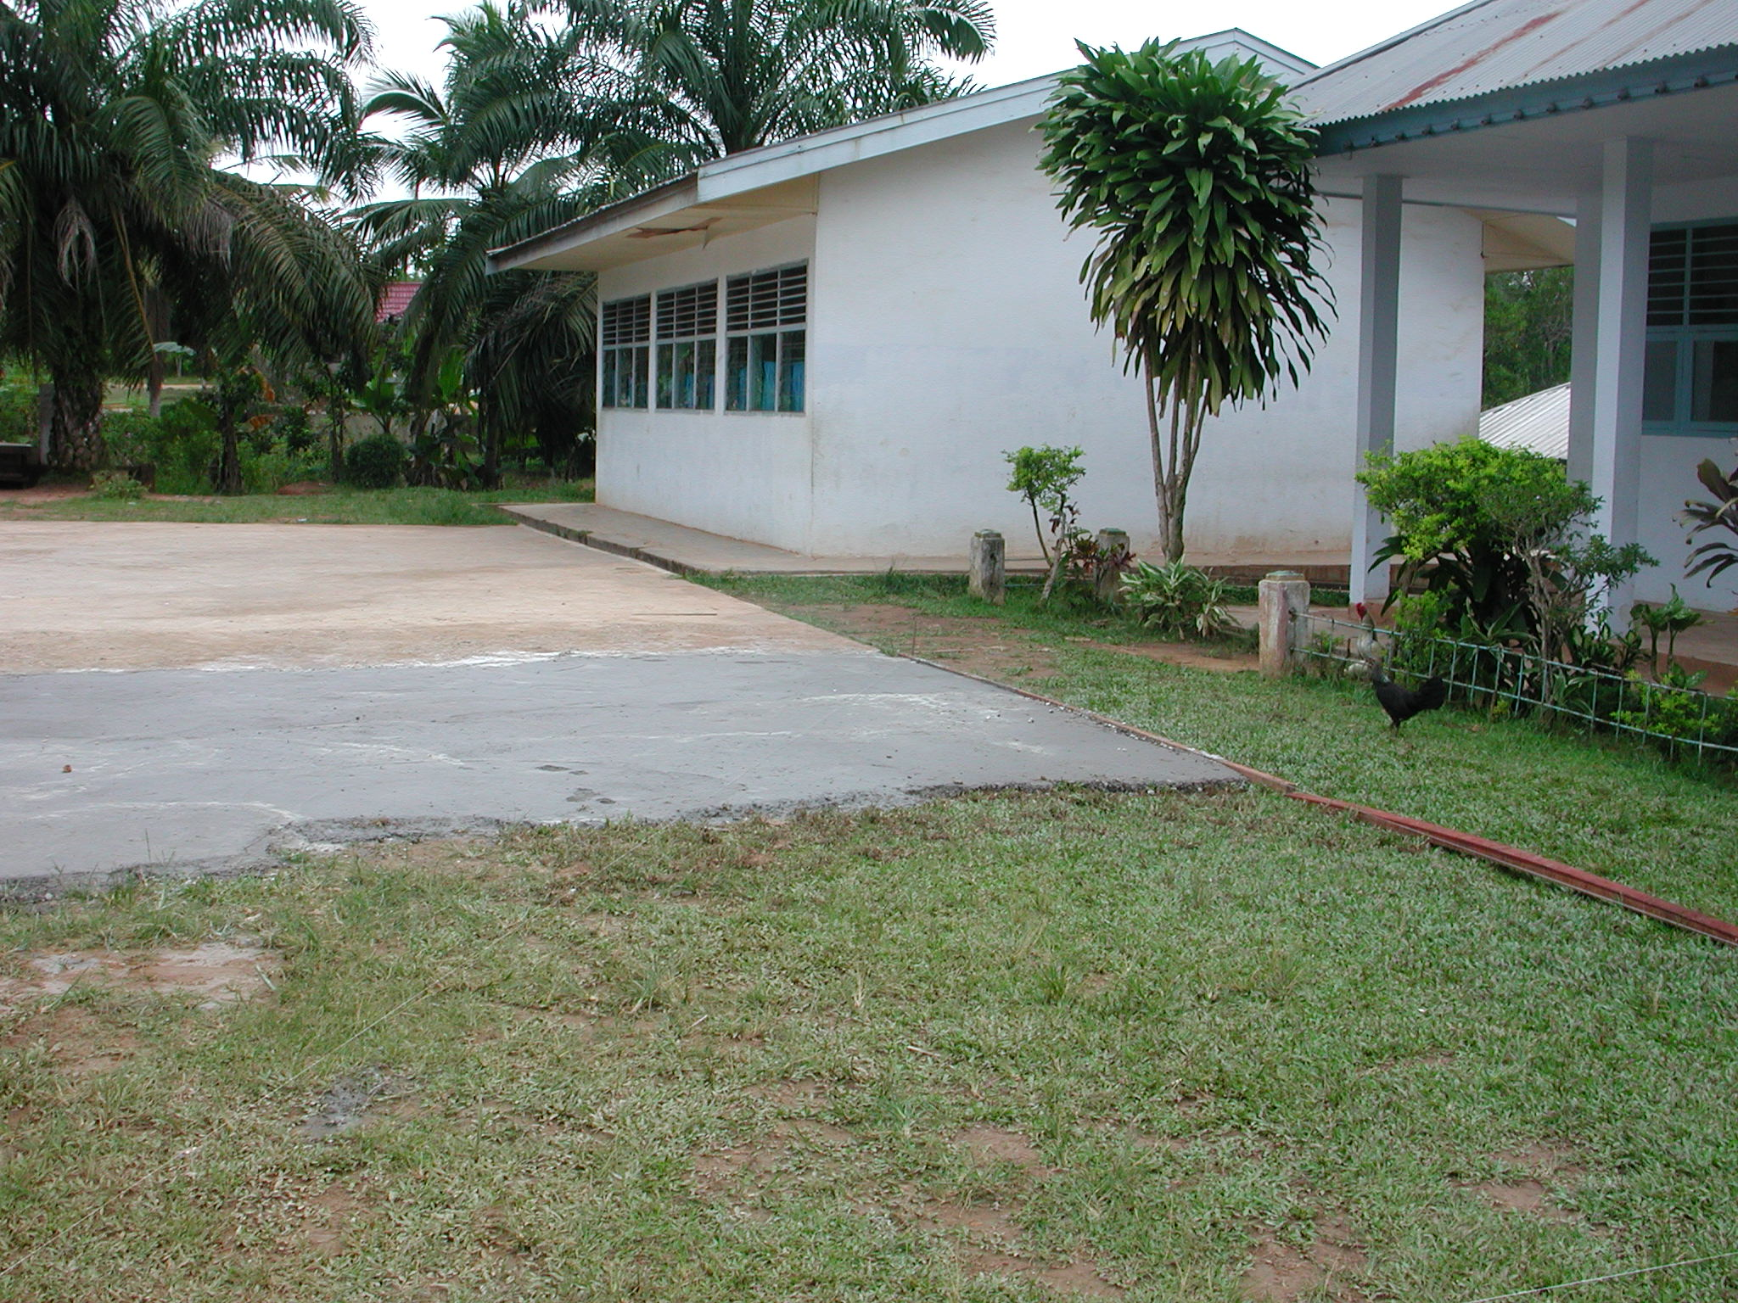

Plate 3: SLTPN 18 Jambi showing very thin screed to playground being laid on top-soil and vegetation.

The standard of the work so far is not very good. The new ceilings in the library are not very level and the standard of painting is not very good. The school playground has not been stripped of vegetation and top-soil and the paving is a very thin screed which is being laid directly on the top-soil. The screed is not being divided into panels and will undoubtedly crack. The paving should have been thicker and of proper concrete divided into panels. Because of the drainage problems on the site it would have been more sensible to spend money on dealing with this problem rather than on a wall to the site which does not seem to be a high priority.

The consultants here seem to have seen their role as a supervisory one rather than as working with the school committee in establishing priorities and then managing the work and ensuring that it is carried out to a good standard. Much more money should have been spent on resolving the site drainage problem and in lining the storm drain that has been built.

ANNEX 4: REPORT ON VISIT TO WEST SUMATRA PROVINCE

1. General

  - West Sumatra Province was visited between March 26th and March 28th 2003.

  - Meetings were held with the Project Manager and the Procurement Consultant in the PPIU, the civil works consultants and their site staff and members of school committees and their technical teams on new school sites.

  - Two new schools were visited in two districts of the Province where construction is taking place. One firm of civil works consultants is managing the school construction and advising the school committees. An existing school being renovated under the matching grant scheme was also visited.

  - A standard design for a junior secondary school has been agreed in the Province and the consultants have produced standard drawings for the school buildings to be used on the sites. The new schools will consist of six classrooms in two 3-classroom buildings; a multi-purpose building, a library; an administration building; a musholla; a canteen/penjaga’s house; a head teacher’s house, a bicycle shed and school toilets. The total area of the buildings is 986m².

  - Construction is similar at all schools: foundations are of stone set in mortar; walls are of rendered brickwork with RC columns, ground beams, ring beams and veranda beams; roofs are of corrugated steel sheets on purlins on timber trusses, ceilings are of plywood; windows and doors are of timber with panel doors and timber glazed windows; floors and verandas are of ceramic tiles on screed.

  - At both schools visited, land certificates were still being processed by BPN but agreements had been signed by the Bupatis to providing funding, etc. Both schools had school committees and technical teams.

  - Access to both schools was not a problem even though they were quite remote. Both schools seemed to have sufficient Class 6 pupils in primary schools within their catchment area to provide two streams of Class 1 next year.

2. Issues

2.1 Civil Works Consultants: Many of the problems noted at the school sites were the result of poor management and supervision by the civil works consultants, particularly the construction managers (CMs) on site.

2.1.1 Approach: As in other Provinces, the civil works consultants need to change the way that they approach these projects. They must realise that community-based projects require a different approach and different documentation to projects that use contractors. CMs based on sites in particular need to realise that they are there to advise the school committees on managing the physical work, on procuring materials to the correct specifications and on keeping financial records as well as in supervising the construction work. They also have an important role to play in improving the skills of workers on the site and ensuring that the quality of the completed work is as specified.

    - Site Works Drawings: At both of the sites visited, there were inadequate site works drawings. The site drawings were to a very small scale and had very few setting out dimensions and site works details. The consultants should prepare surveys of the sites and detailed site drawings showing the levels of all buildings and giving details of links between buildings, any retaining walls, steps, etc that are required and site drainage, etc. Without these details it is difficult to see how the consultants can have prepared accurate estimates for the work at the schools. The lack of detailed drawings also means that the CMs are having to prepare the site works details and might not have the experience or expertise to do this properly. They also have a lot of other duties to carry out on site and should not have to do this extra work.

    - Budgets: At both sites, the consultants were asked to complete the site drawings and check their estimates in order to ensure that there were sufficient funds to complete the site works. They were also asked to reduce the numbers of workers at the second school in order to reduce the wage bill. There is a danger at this school of the funds being insufficient to complete the construction work unless the wage bill is reduced.

    - Documentation: At both of the sites visited, the other documentation that the consultants should have prepared according to the project guidelines was missing. The consultants should have prepared detailed schedules of materials for all buildings, estimates of labour requirements, cost estimates based on surveys of local material prices and wage rates, projections for when the materials and labour will be required and cash flow projections. All of these were missing and the CMs were having to prepare some or all of this material. Some staff did not have the experience or expertise to carry out this work. It was also noted that the working drawings for the buildings were very sketchy with not many details, few dimensions, etc.

    - Project Guidelines: One of the consultants’ duties is to ensure that the school committees are following the project guidelines with regard to finances, in particular with regard to cash withdrawals, payments to suppliers, financial records, etc. At most sites this is not happening and school committees are not following the guidelines.

2.2 Construction: A number of construction issues were noted during the visits and most of them occurred on more than one site. They included:

2.2.1 Concrete: There are problems with the mixing of concrete on both sites. The problems include: inaccurate measurement of the materials, insufficient mixing of the materials when dry, using too much water in the mix and only mixing part of the materials measured out. On one site the aggregate had much too much sand in it and additional sand was being added. All of these will result in poor quality and weak concrete.

    - Reinforcement: The reinforcement specified for the main columns and beams is 12mmØ but on one site 10mmØ was being used. The consultants should check that this is acceptable. On many sites the links to the reinforcement were spaced at greater intervals (up to 40cms) than those designed (15cms).

    - RC Columns: On both sites columns in walls are being cast between panels of brickwork rather than being cast in proper formwork before the brick work is built. This usually results in poor quality concrete because the cover to the reinforcement cannot be controlled; the formwork is not straight, etc. In all cases, columns should be cast in formwork before the brick work is started and ties for the brickwork should be cast into the columns.

    - Foundations: On both sites, the stone foundations below columns had not been increased in size as shown on the layout drawings. The consultants should prepare a detail of the column foundation for the use of the CMs.

    - Lintels: It was noted that in the design for the schools, there were no lintels over window and door openings and the brickwork was being built off the frames. This is very bad practice and will lead to cracks in the brickwork over the frames and difficulties in future in changing frames.

    - Joinery: The quality of the finished joinery and the timber being used for the joinery was not very good at one site.

    - Top-soil: On one site top soil, roots and vegetable matter had not been stripped off the area of the buildings. All top soil and vegetable matter should be stripped off the area of the buildings before excavation is started and proper materials should be used for back-filling.

    - Wells and Septic Tanks: On one site, a septic tank and soakaway was located very close to a well and there were serious dangers of contamination of the well. Septic tanks should be located at least 15 metres and preferably 30 metres (especially on wet sites) away from wells.

    - Site organisation: On both sites, door and window frames and roof trusses were being either made and/or left out in the open, exposed to sun and rain. All materials, particularly finished ones, should be properly protected.

2.3 Other Problems: Several other problems were noted:

2.3.1 Training: More training of the civil works consultants and of school committees in the objectives of the project and in following the project guidelines is required.

    - Supervision: The CMs should take more care in supervising the work and working with the technical teams. They have to ensure that the work is carried out according to the drawings and specifications and they should be providing quality control and training if necessary to ensure that this is the case. The team leaders should be supervising their field staff to ensure that they are carrying out their duties properly and in accordance with the guidelines. If CMs are found to be incapable of carrying out their duties then they should be replaced. The CM at SLTPN 03 Kinali should be closely supervised and if he cannot perform properly then he should be replaced.

The PPIU procurement consultant should also supervise the work of the civil works consultants to ensure that they are carrying out their duties properly and diligently.

2.3.3 Transparency: It was noted that on both sites there were no notice boards or the relevant information was not displayed. All sites should have notice boards displayed in a prominent position giving full details of the total cost, the expenditure so far, labour employed, etc to ensure transparency.

3. Site Visits

3.1 Kabupaten Solok: The following school site was visited:

SLTPN03 Pantai Cermin, Kecamatan Pantai Cermin: The school is being constructed on a small sloping site on the outskirts of a village not far from the kabupaten centre. The area of the site is 6,069m² (the land certificate is being processed by BPN) and there is room for some expansion of the school but not for a sports field. The site used to be a rice paddy and has paddy fields on three sides. There are 8 primary schools in the catchment area of the new school and there are 163 pupils in Class 6. The site is adjacent to a surfaced road and access is not a problem. There is a piped water supply in the road and an electricity supply.

The consultants have a construction manager (civil engineer D3) on site to manage the work and the leader of the technical team is a builder. There is also a local civil engineer in the technical team. There are 64 workers on site and skilled workers are being paid Rp27,500 a day and unskilled workers Rp20,000 a day. The school committee selected the skilled workers. The chairman of the school committee is a teacher in a school 6 kilometres away where he is teaching 6 hours a week; the rest of the time he spends on the site.

The quality of the work was generally good. The reinforcement was the correct size (12mm) and the CM stated that they were going to construct the columns using formwork before constructing the brickwork walls. The top-soil has been stripped off the sites for the buildings, foundations are being excavated down to firm soil and back-filling is being done using clay sub-soil being excavated on site. There was however no widening of the stone foundations under the columns. The concrete sand and aggregate was good and the sample of timber to be used for joinery work was very good.

The budget for the work is Rp994,000,000 giving a square metre cost of Rp1,008,114m². The drawings as a whole were very basic. The site plan had contours but no levels and there were no site works drawings or details. There were very few setting out dimensions on the site plan. There were also very few dimensions on the building layouts. The site slopes and is very wet and will require a lot of drainage and site works probably including retaining walls. The consultants should complete the site drawings and details as soon as possible and check their estimates to ensure that there were sufficient funds to pay for all the site works. The consultants have not prepared schedules of materials for the buildings but stated that they used local material prices and labour rates in conjunction with their analysis of the building elements to calculate the budget.

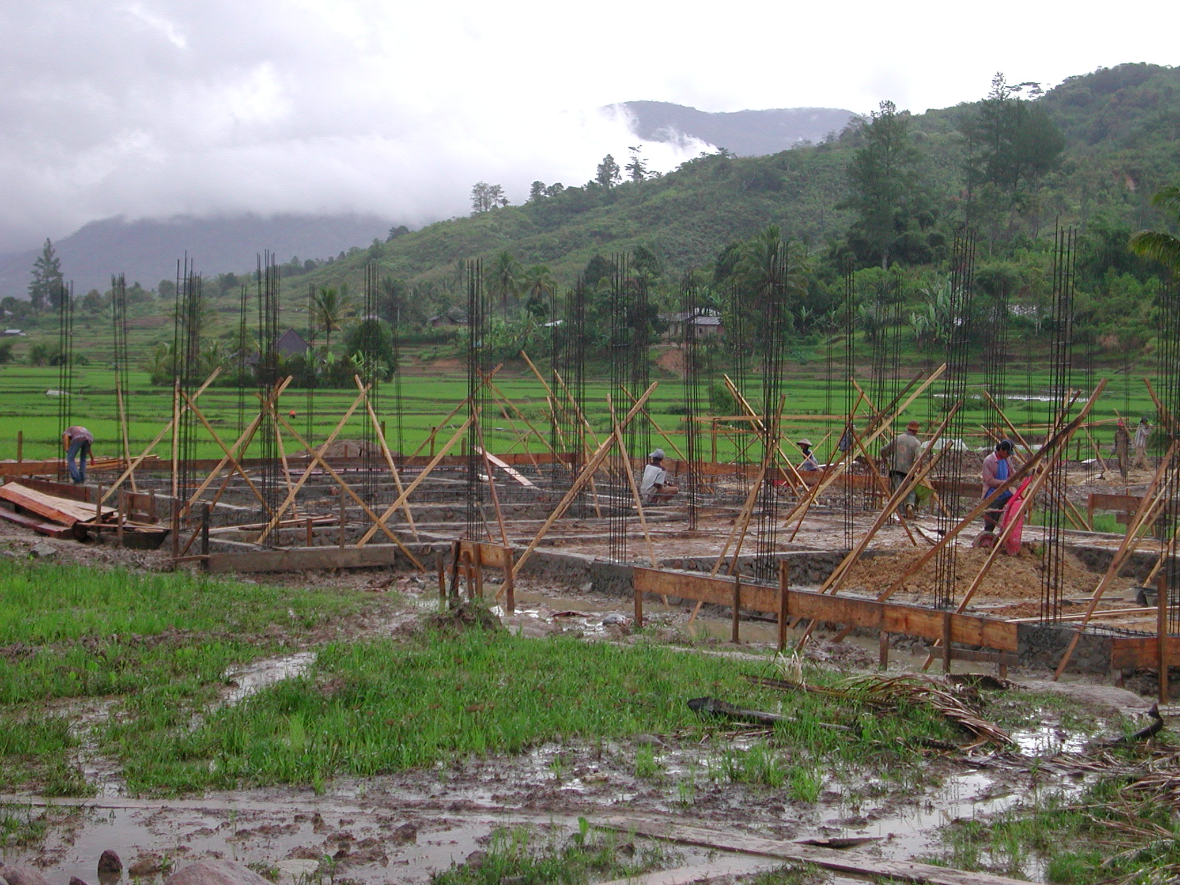

Plate 1: SLTPN 03 Pantai Cermin showing rice paddies adjoining site and clay being used for back-fill.

Work started on March 13th and should be completed by July 23rd 2003. At the time of the visit the progress as planned should have been 7.5% but was actually 4.7%. The CM stated that heavy rain had delayed the work. One of the 3-classroom buildings had foundations complete, ground beams in progress and reinforcement for columns in place. The other 3-classroom building had foundations in progress. The library and multipurpose buildings foundations were being excavated. The head teacher’s house foundations were complete. The administration building had foundations complete, ground beams in progress and reinforcement for columns in place. The musholla and toilets had not been started.

An office and store have been built on the site and the site was well organised. The technical team are purchasing materials and they get quotations from 3 suppliers. The financial records and accounts seemed to be well kept. They have a file for bank statements and withdrawals have been kept to Rp10million although on two occasions two withdrawals were made on the same day. Receipts are neatly kept in a file and there is a book recording expenditure in detail and another one summarising expenditure. The CM and the head of the school committee were both obviously very competent and there seemed to be a very good team spirit with the CM and the school committee working well together. The Bupati has promised to supply teachers and 17 have been selected. The head of the school committee will be the head of the school. Enrolment of pupils will start in June. The project will give the school Rp100million for operations for the first 6 months and the district will take over funding the school after that. There was a notice board outside the site office giving a breakdown of the budget, amounts spent, etc.

3.2 Kabupaten Pasaman: the following school site was visited:

SLTPN 03 Kinali, Kecamaten Kinali: The school is being constructed on a flat, rather wet site in a rural village. The site will need a new access road into the site. The site used to be a coconut plantation covered with bush and has been stripped using a bulldozer. The area is 2.0 hectares and there is room for expansion of the school. There is a large depression at the far end of the site which has been levelled and will be used as volley ball court. There was no certificate of land ownership (it is still being processed by BPN). There are 8 primary schools within 5 kilometres of the new school and there are 174 pupils in Class 6. The nearest junior secondary school is 8 kilometres away. The site is just off the main road north and access is not a problem. The school water supply will be from the village supply and there is also an electricity supply.

The consultants have a construction manager (civil engineer D3) on site to manage the work and the head of the technical team used to be a builder. There are approximately 100 workers on the site, mainly local. The heads of work teams receive Rp35,000 a day; skilled workers Rp30,000 a day and unskilled workers Rp20,000 a day. The wage bill is approximately Rp15million a week.

The site is well organised with a site office and store and the buildings are neatly set out using timber profiles. There are a number of problems however with the
construction: 1) The river aggregate being used for the concrete has very little stone in it and too much sand and additional sand is being added to it; 2) the reinforcement is 10mmØand not 12mmØ as specified; 3) the columns are being cast between brickwork panels and not in formwork before the brickwork is built; 4) The lap to the steel in columns and beams is generally too small; 5) The stone foundations have not been increased below the columns; 5) the concrete is being mixed very badly; it is not being measured very accurately; it is not being thoroughly mixed when dry; too much water is being used in the mix and not all of the materials in a batch are being mixed at one time; 6) the window frames that have been made are not very good and the timber that is being used is not very good quality. The brickwork is however quite neat. A demonstration was given as to how to mix concrete by hand and the CM and staff were asked to take much more care in measuring the materials and mixing the concrete. The consultants were asked to check that sufficient reinforcement is being used especially in the columns. The team leader should supervise this site more carefully to ensure that the CM is carrying out his duties properly and that the work is being carried out as specified. If the CM cannot perform then he should be replaced.

The budget for the work is Rp994,024,000 giving a square metre cost of Rp1,008,138m². The site drawings were again very limited in scope. The site plan (1:500) had contours but no levels and there were no site works drawings or details. There were very few setting out dimensions on the site plan. There were also very few dimensions on the building layouts. The site is flat but has the large depression at the end which will require protection to the sloping sides if they are not to be washed away. The consultants should complete the site drawings and details as soon as possible and check their estimates to ensure that there were sufficient funds to pay for all the site works. The consultants again have not prepared schedules of materials for the buildings but stated that they used local material prices and labour rates in conjunction with their analysis of the building elements to calculate the budget.

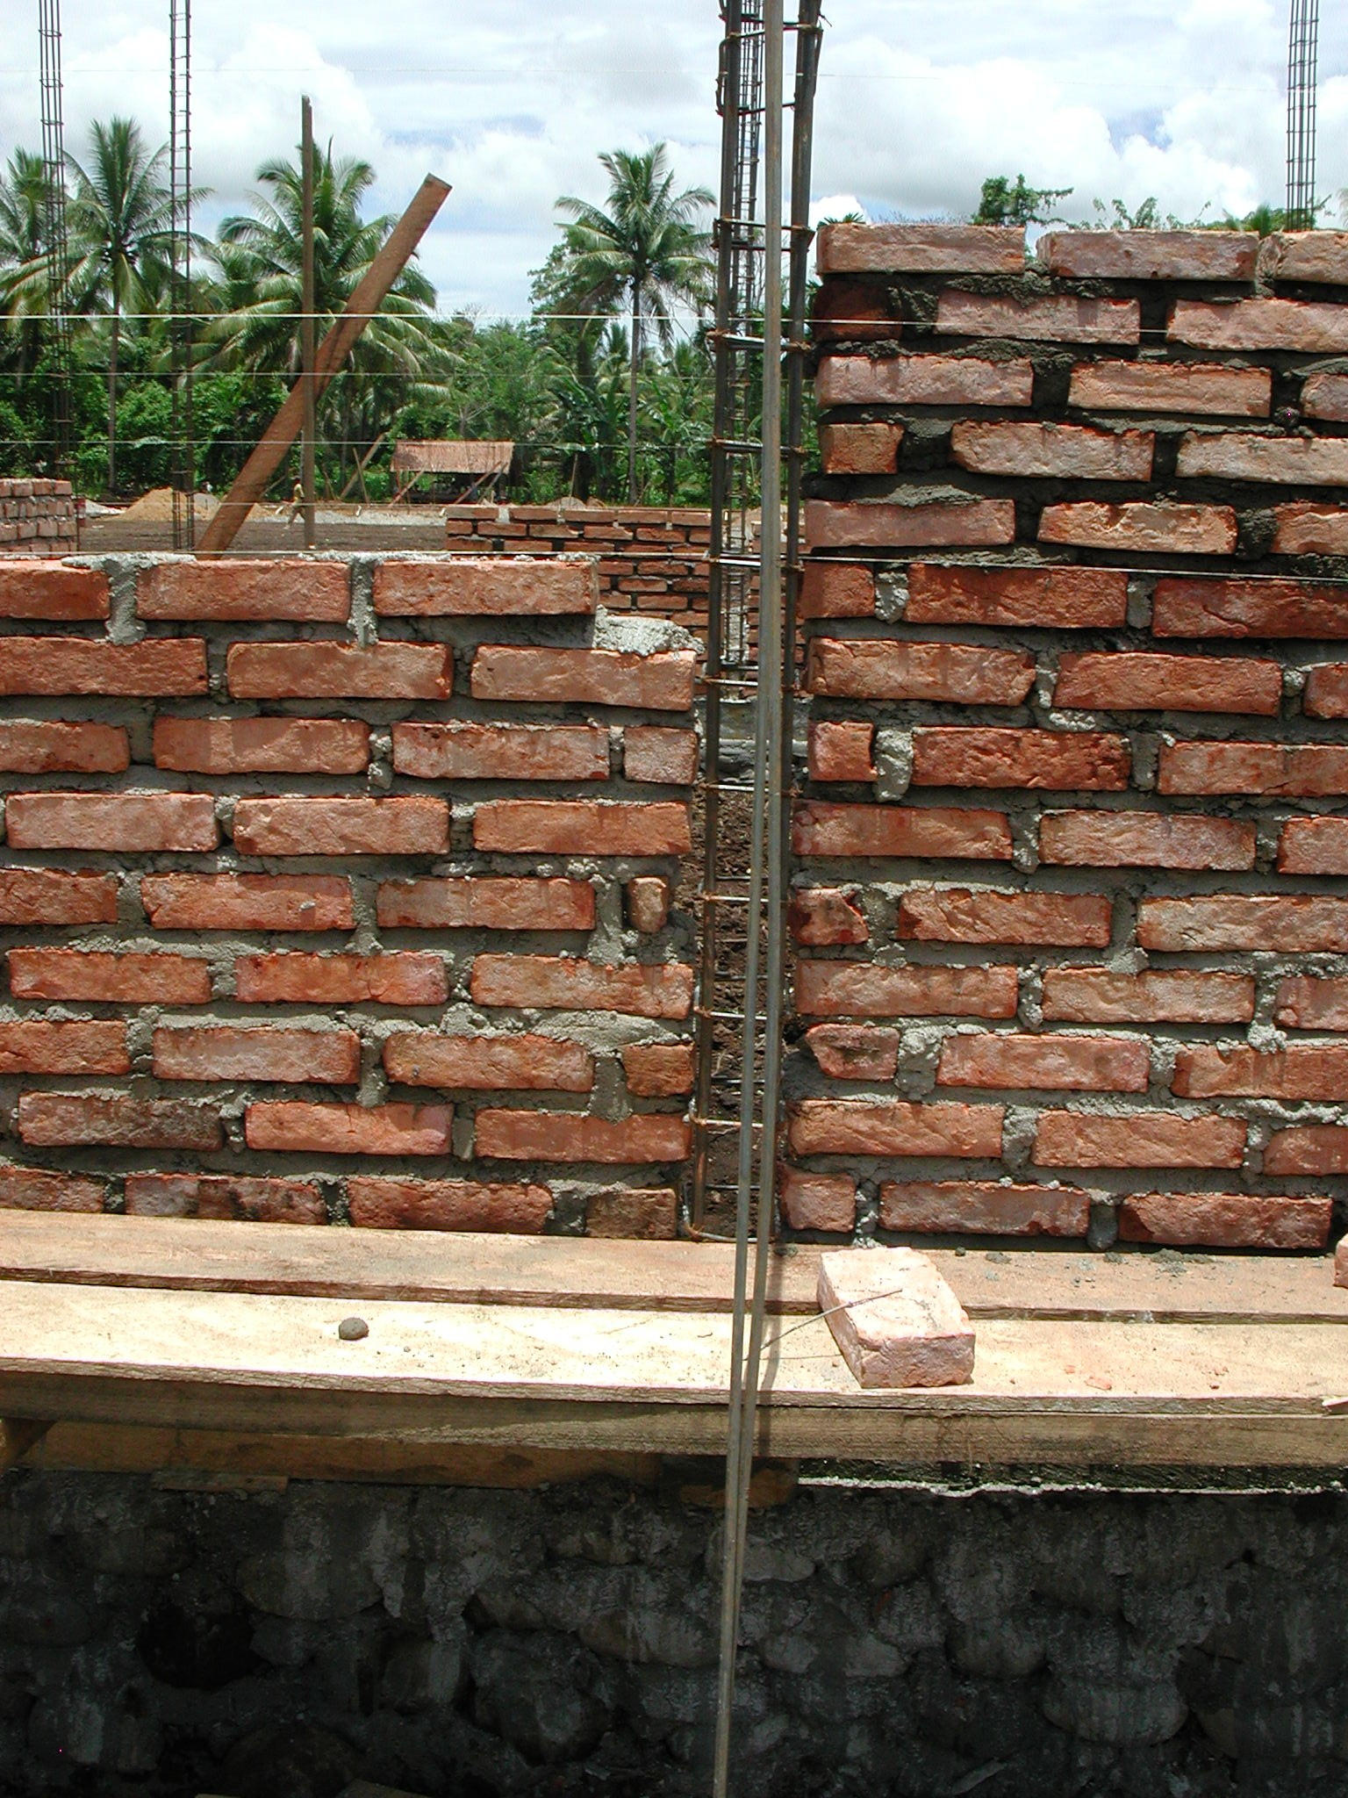

Plate 2: SLTPN 03 Kinali showing columns being cast between brick panels.

Work started on March 6th and should be completed by July 23rd but it was hoped to finish the work by the end of June 2003. At the time of the visit the progress as planned should have been 0.88% but was actually 9%, approximately 2 weeks ahead of schedule. The musholla had foundations and ground beam complete and brickwork to cill height. The multipurpose building had foundations complete and formwork for the ground beam in progress. The toilets had foundations complete and ground beam in progress. The administration building had foundations complete and reinforcement for the ground beam in progress. One 3-classroom building had foundations complete and ground beam in progress. The other 3-classroom building had foundations and ground beam complete and brickwork to cill height. The library had foundations complete and ground beam being cast. The head teacher’s house had foundations and ground beam complete and brickwork in progress.

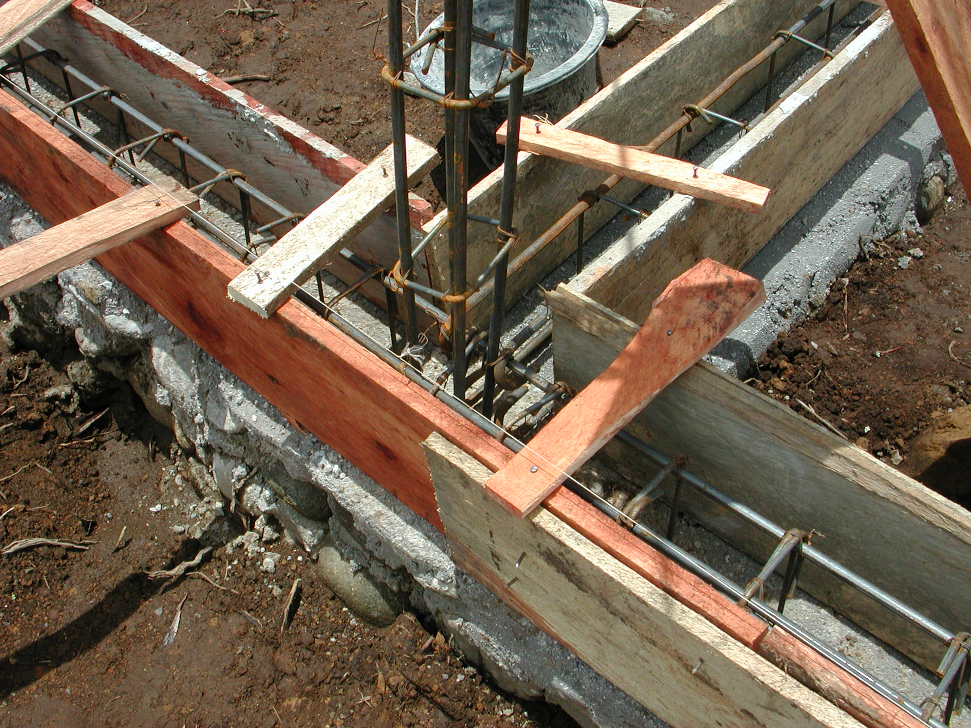

Plate 3: SLTPN 03 Kinali showing inadequate laps between reinforcement.

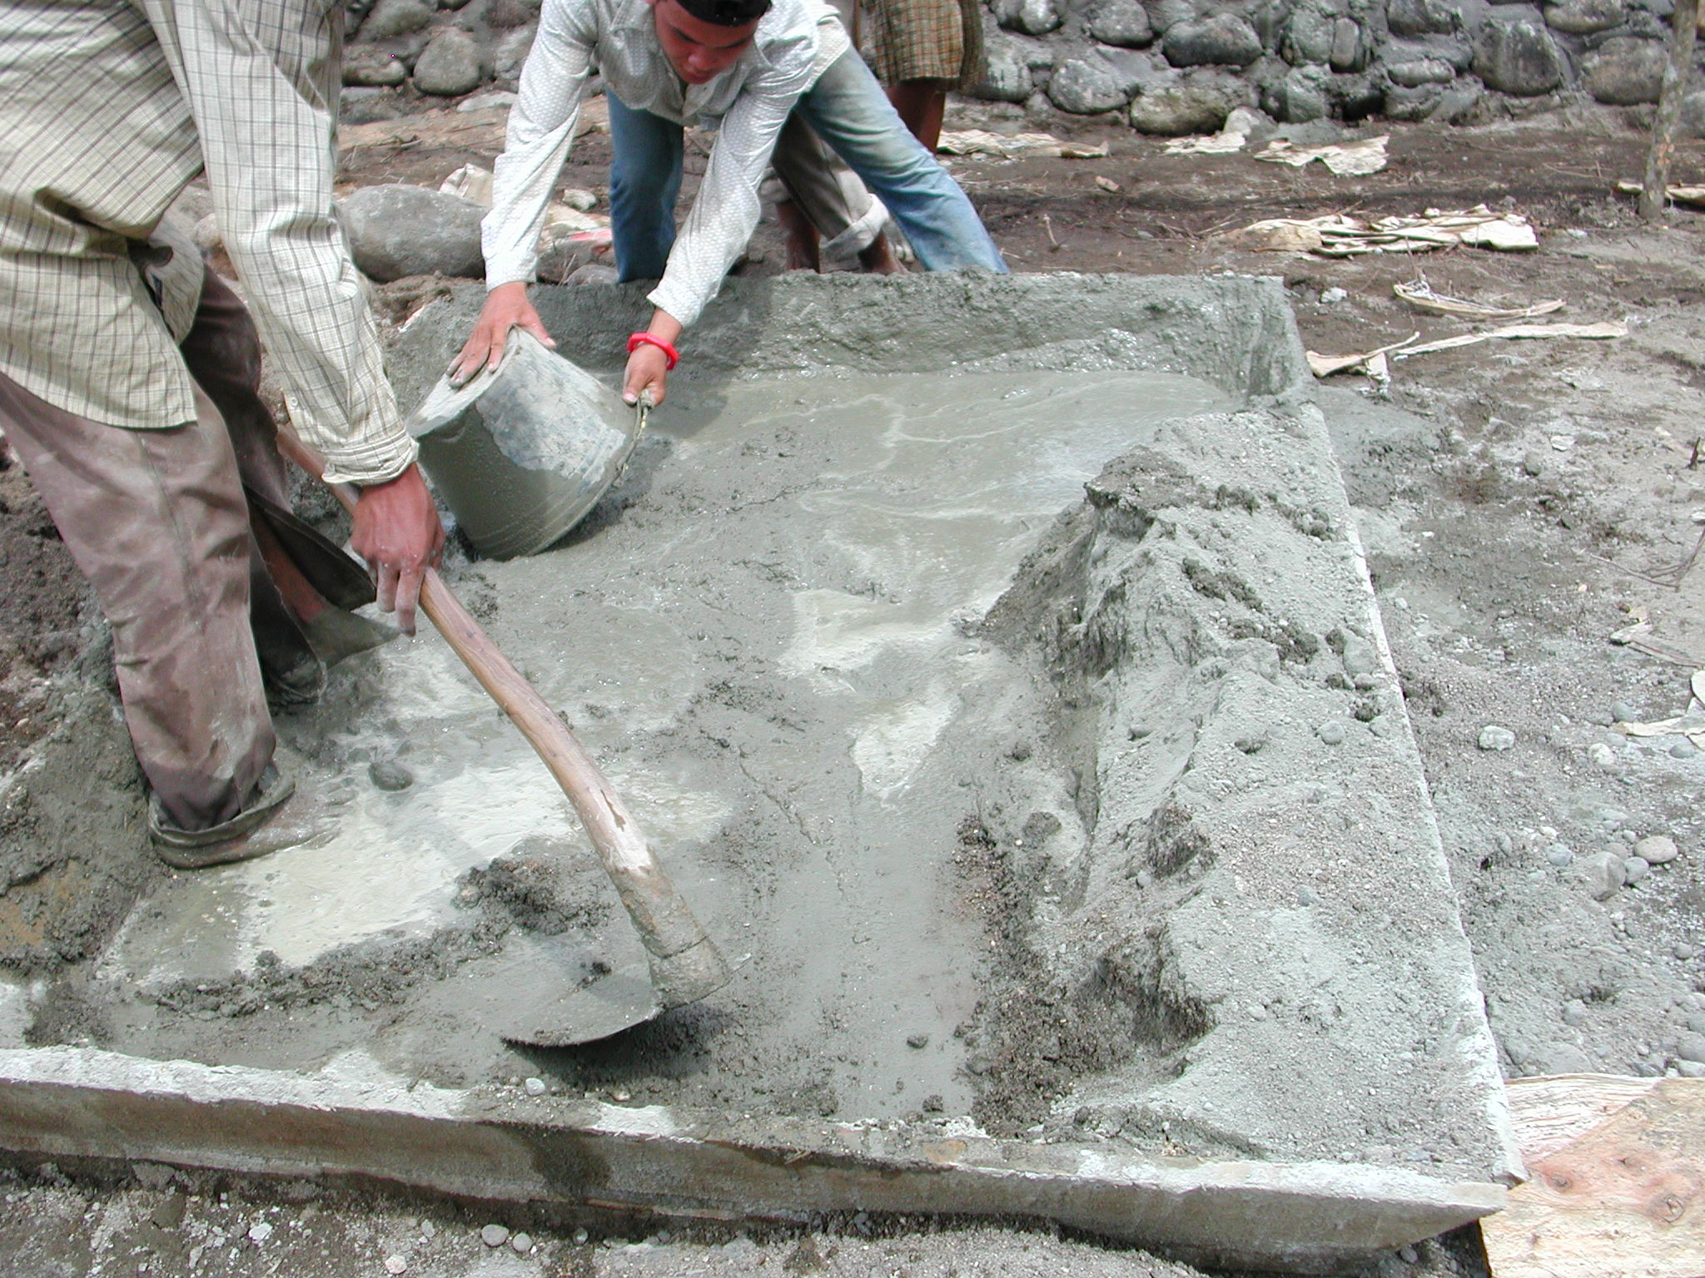

Plate 4: SLTPN 03 Kinali showing inadequate mixing of concrete using too much water.
The school committee has an office in a house in the village. The financial records were not being well kept. Payments and withdrawals were listed in one book and the receipts were very confused; there seemed to be two sets of receipts for the same materials. Large withdrawals were also being made in cash to pay suppliers for materials (there had been withdrawals of Rp20 and Rp30million). The CM had not done any schedules of materials, cash flow projections, etc and it was not clear how they were ordering materials, etc. Because of the large numbers of workers being employed and the high labour bill, there was a possibility that the budget would not be sufficient to pay for the work. The team leader should make a detailed check on the budget and the number of workers should be reduced and the consultants and the PPIU should ensure that the project guidelines were being followed. There was no notice-board at either the site office or the committee’s office and no details of expenditure were displayed. It was thought that the head of the school committee would become the head teacher but there had been no proposals so far for the teachers and no enrolment of pupils. The committee had a letter from the district confirming that funds would be available for running the school next year.

3.3 Kabupaten Padang Pariaman: the following school site was visited:

SLTPN 03 Batang Anai, Kecamatan Batang Anai: This existing school is situated on a flat, rather wet site in an urban area and has received a matching grant of Rp180million. The grant has been used to construct a new 2-classroom building and a library and a school playground. An administration room will also be constructed and furniture, books and equipment have been purchased.

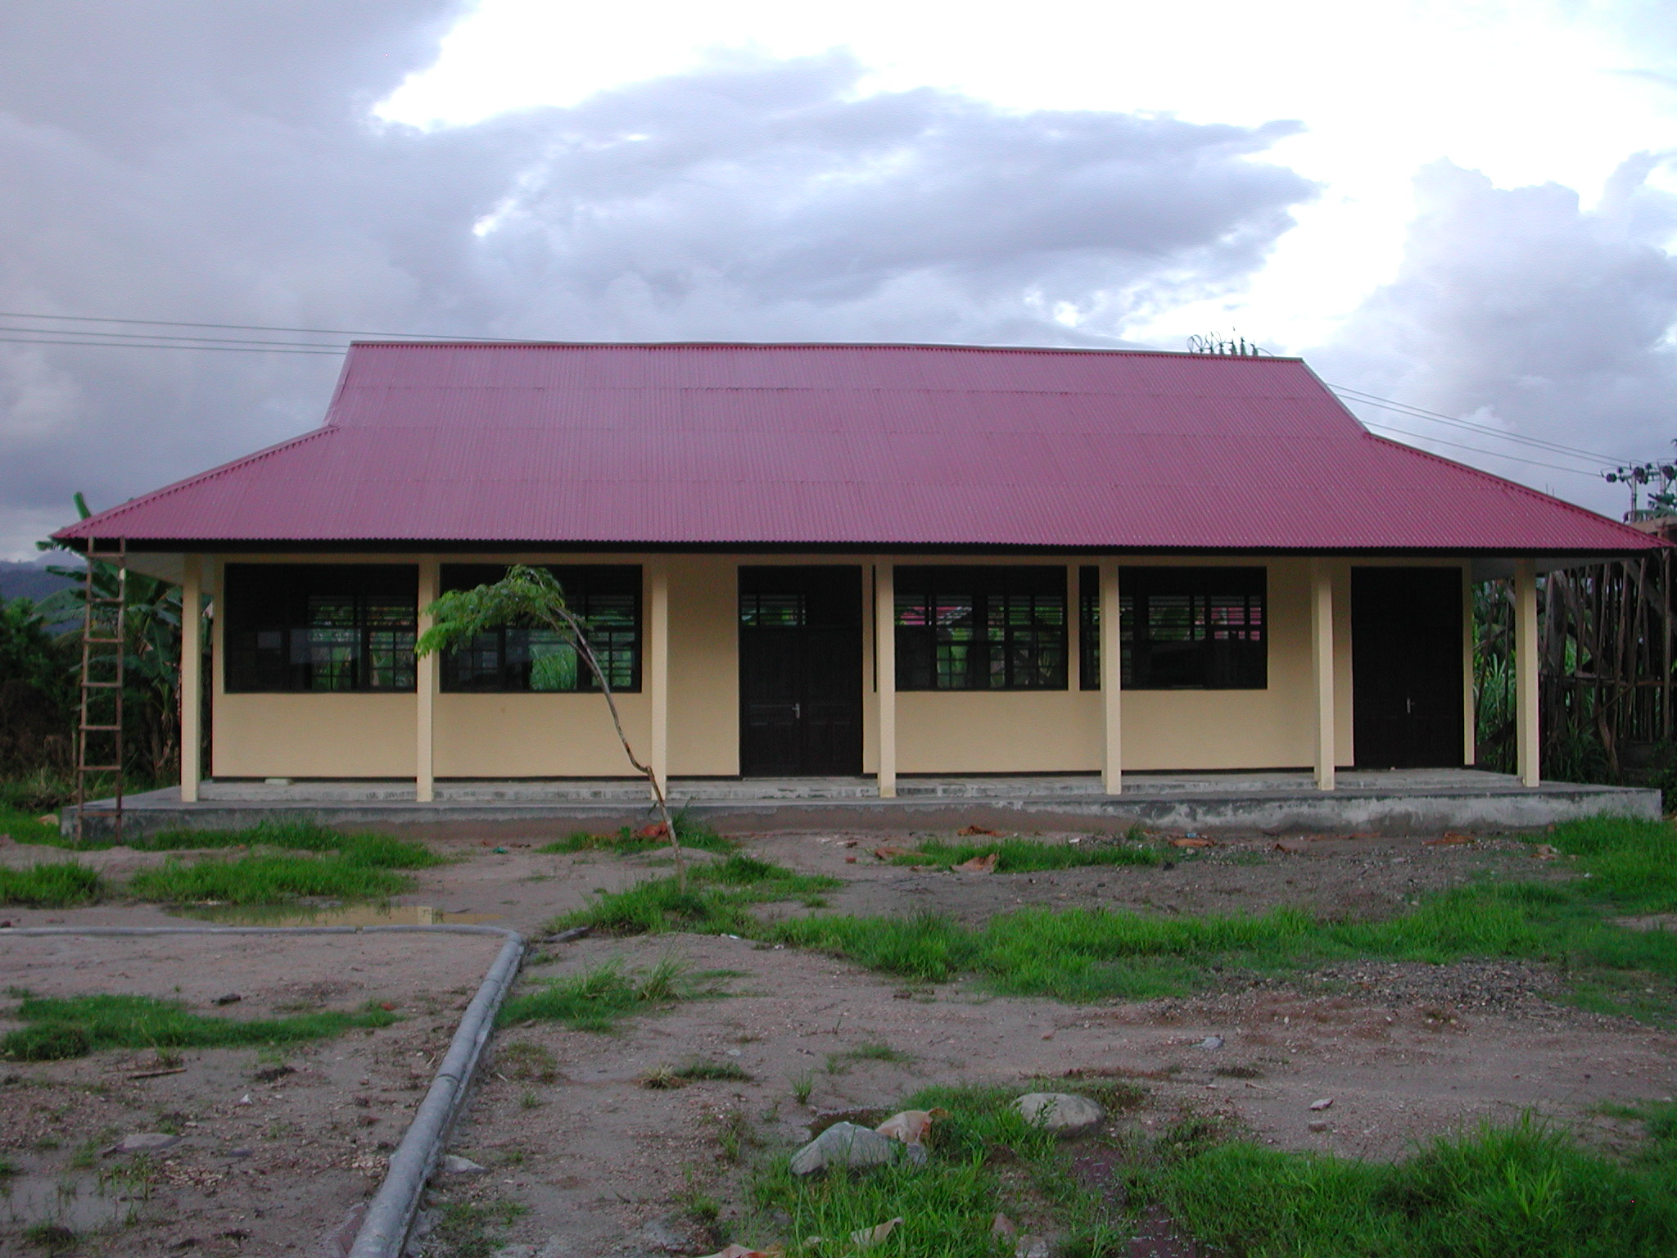

Plate 5: SLTPN 03 Batang Anai showing new 2-classroom building.
The buildings seem to be quite well constructed with corrugated steel roof sheets, plywood ceilings, rendered brick walls, RC columns and cement floor tiles to rooms and verandas. The joinery work is not very well finished however.

BP3 are also renovating and extending an existing building to provide 4 classrooms and 2 offices.

ANNEX 5: REPORT ON VISITS TO SCHOOLS RECEIVING MATCHING GRANTS IN WEST KALIMANTAN AND JAMBI PROVINCES BY ENGINEER HERNAWAN MAHFUDZ

1. Abbreviations :
- MCs = Management Consultants
- BG = Block Grant [USB]
- MG = Matching Grant
- PPIU = Provincial Project Implementation Unit
- FCs = Field Consultants

2. Schools Visited

West Kalimantan Province :
- SLTPN 6 Teluk Keramat (Type–D) : Rp. 946.274.000
- SLTPN 3 Jawai (Type-D) : Rp. 942.314.000

Jambi Province :
- SLTPN 4 Mendahara (Type–D) : Rp. 928.293.000
- SLTPN 6 Muara Sabak (Type-D) : Rp. 928.293.000

3. Summary of Report

A. Block Grants
- Site preparation: At all schools visited by the Consultant, the sites were relatively flat. In West Kalimantan, the sites had already been cleared by the communities and were ready for construction to start.

- Land certification: All sites were categorised as SHM (sertifikat hak milik). At some schools the certificate was already available but at other schools the certificate was still being processed by BPN.

- Documentation: The documents available at the sites were cost estimates and working drawings including site plans and detailed drawings for all buildings.

- Construction committees (KP-USBs): The KP-USBs were established through community meetings. The minutes of the meetings and the lists of people present were all available. The members of the KP-USBs come from the communities and they do not seem to have conflicts of interest with their other positions in the community. In all cases the process of establishing the KP-USB seems to have been both transparent and democratic.

- Readiness of the PPIU, KP-USB and MCs: [only in West Kalimantan] The PPIU has already followed up the letter from the head of the program by conducting orientation programmes for the MCs and KP-USBs in implementing the program while ensuring compliance with the BG Manual. The readiness of KP-USBs was indicated by the availability of a secretariat, a list of available labour, agreed salary levels, surveys of material prices, book-keeping and reporting. The readiness of the MCs was indicated by the preparation of drawings, RAPP documents, time schedules and technical specifications. The MCs still have to complete the documentation with the breakdown of RAPP in the form of schedules of materials required on a monthly and weekly basis and cost control documents.

- Site works drawings: At all schools, comprehensive site works drawings had not been prepared. The MCs should prepare detailed site works drawings showing storm drain systems (including direction of flow and levels), access roads, details of cut and fill and any retaining structures.

- Field Consultants’ performance: The civil works consultants and particularly the Team Leaders, need to ensure that the FCs more fully understand their role in the construction process; they should be acting as counterparts to the school committees and not just supervising the construction. They have to be able to interpret the technical aspects of the construction process to the school committees and communities in as simple and easy to understand way as possible.

- Financial documentation: The documents for reporting and monitoring financial expenditure were available at most sites but not in an organised form. The forms were generally in compliance with the BG Manual.

4. Conclusions

  - The MCs, particularly the FCs are not performing to their maximum potential in the process with regard to the MG teams or the KP-USBs. They are still acting as supervisors not as counterparts.
  - The implementation documents were available at the schools but were not well organised.
  - The site works documentation prepared by the MCs at all schools were not comprehensive.
  - Preparation of the KP-USBs in West Kalimantan was on the right track and they were ready to implement the programme.
  - The implementation of both the MG and the BG were generally in compliance with transparency, effectiveness, efficiency and accountability.

5. Recommendations

- It is recommended that the Team Leaders of MCs for both MG and BG conduct re-orientation of the FCs to ensure that they act as counterparts not only supervisors in the construction process.
- It is recommended that the MCs put together in one document the school proposals.
- It is recommended that the MCs prepare comprehensive site works drawings for all USBs.
- It is recommended that the MCs prepare simple and easily understood documentation for both the school committees and communities for both the technical and financial aspects of the programme.
- The Consultant recommends that the programme should continue as long as points ‘a’ to ‘d’ are complied with.

