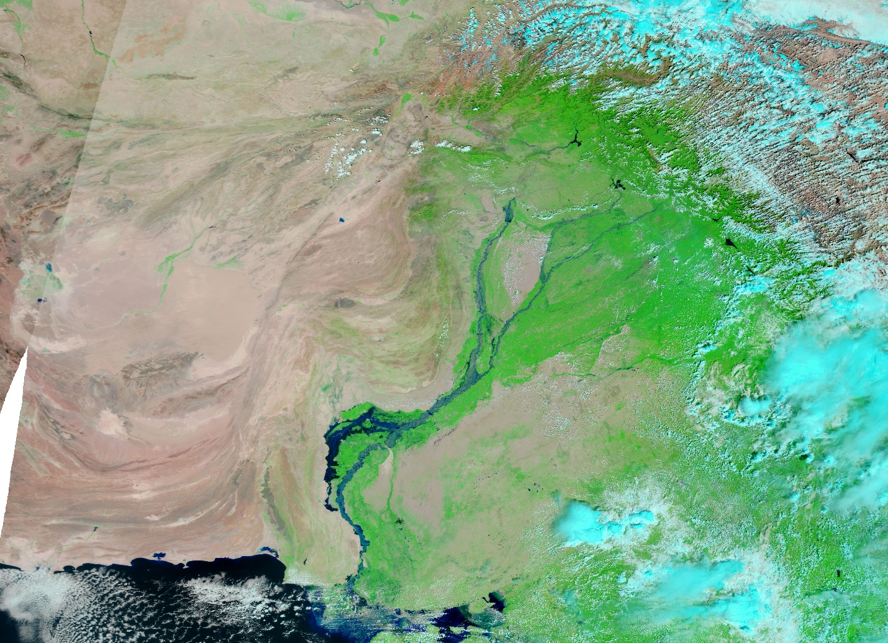

Climate and Health:
Guidelines for the Design of Climate-Resilient Health Facilities in Pakistan
(final draft)

The World Bank
April 2024

Frontispiece: 2022 floods in Pakistan. Source: NASA Earth Observatory images by Joshua Stevens, using Landsat data from the US Geological Survey and VIIRS data from NASA EOSDIS LANCE, GIBS/Worldview, and the Joint Polar Satellite System
Table of Contents
Acknowledgments 5
Acronyms/Abbreviations 6
Foreword 7
Section 1: Introduction & Objectives 8
1.1 Introduction 8
1.2 Objectives 9
Section 2: Context 10
2.1 Health and Climate Change 10
2.1.1 Health System Policies and Strategies Related to Climate Change 10
2.1.2 Climate Change and Health Risks 10
2.1.3 Climate Change Impact on Health in Pakistan 11
2.1.4 Climate Change Resilience and Preparedness 11
2.1.5 Recommendations for Strengthening Climate-Resilience of the Pakistan Health System 13
2.1.6 Examples of Interventions from Pakistan and Other Countries 14
2.1.7 Monitoring and Evaluation of Health and Climate Resilience 15
Section 3: General Design Guidelines 16
3.1. Reduction of Carbon Emissions 16
3.1.1 New Construction 16
3.1.2 Renovation 17
3.2. Seismic Risk 17
3.2.1 New Construction 17
3.2.2 Renovation 18
3.3. Flood Events 18
3.3.1 New Construction 18
3.3.2 Renovation 19
3.4. Infection, Prevention, and Control 19
3.4.1 New Construction 19
3.4.2 Renovations………………………………………………………………………………………………………………………..20
3.5. Climate and Comfort 20
3.5.1 New Construction 20
3.5.2 Renovation 20
3.6. Maintenance of Health Facilities 21
Section 4: Design Guidelines for Specific Climatic Zones 22
4.1. Design for Cooler Uplands and Mountainous Areas 22
4.1.1 Climatic Conditions 22
4.1.2 Design Considerations 23
4.1.3 Summary of Measures 23
4.2. Design for Hot, Dry and Arid Areas 24
4.2.1 Climatic Conditions 24
4.2.2 Design Considerations 25
4.2.3 Summary of Measures 27
4.3. Design for Maritime Desert Areas 28
4.3.1 Climatic Conditions 28
4.3.2 Design Considerations 29
4.3.3 Summary of Measures 29
4.4. Design for Composite Climates 30
4.4.1 Climatic Conditions 30
4.4.2 Design Considerations 30
4.4.3 Summary of Measures 30
Section 5: Design Guidelines for Renovation 31
5.1. Cooler Upland and Mountainous Areas 31
5.1.1 Design Considerations 31
5.1.2. Summary of Measures: 31
5.2. Hot, Dry and Arid Areas 32
5.2.1 Design Considerations 32
5.2.2 Summary of Measures: 32
5.3. Maritime Desert Areas 33
5.3.1 Design Considerations 33
5.3.2 Summary of Measures: 33
5.4. Composite Climate Areas 33
5.4.1 Design Considerations 33
5.4.2 Summary of Measures: 33
References 35
Annex 1: Wind Towers or Wind Catchers 37
Annex 2: Guidelines for Managing the Maintenance of Health Facilities 38
Annex 3: Illustrations 41

Table of Figures
Figure 1: Pakistan’s Topography 111
Figure 2: Pakistan’s Resilient Recovery: Vision, Strategic Recovery Objectives, and Foundation 122
Figure 3: WHO’s Operational Framework for Building Climate-Resilient Healthcare Systems - comprising ten components and their connections to the building blocks of health systems. 122
Figure 4: Aga Khan University Hospital showing courtyard, planting and water feature 144
Figure 5: Aga Khan Maternal and Childcare Centre showing wind towers 144
Figure 6: Floods in 2022 in Sindh Province 199
Figure 7: Colonial era government offices in Banjul, the Gambia showing external wall of perforated blockwork that allows light and ventilation internally but keeps direct sunlight off the main walls of building……………………………………………………………………………………………………………………………………………21
Figure 8: Mountainous area of Khyber Pakhtunkhwa Province…………………………………………………….. 222
Figure 9: Section through a single-storey building 244
Figure 10: Section through a two-storey building 244
Figure 11: Single-storey courtyard building: daytime 255
Figure 12: Single-storey courtyard building: night-time 255
Figure 13: Two-storey courtyard building: daytime 266
Figure 14: Two-storey courtyard building: night-time 266
Figure 15:Section through a two-storey building with double roofs 288
Figure 16: Section through a single-storey building with a vaulted brick roof and ventilated ceiling 288
Figure 17: Section through a two-storey building 299
Figure 18: Section through a two-storey building 31
Figure 19: Wind towers in Lower Sindh 377
Figure 20: Aga Khan University Hospital showing deep-set windows and colonnaded, shaded walkways 41
Figure 21: Aga Khan University Hospital showing courtyards, water features, jaalis and shaded walkways 41
Figure 22: Aga Khan University Hospital showing courtyards, water features, jaalis and shaded walkways 42
Figure 23: Street scene in Sana’a, Yemen, showing shade provided by constructing buildings close together 422
Figure 24: Friendship Hospital in Bangladesh from above showing courtyards 433
Figure 25: Friendship Hospital in Bangladesh showing wide covered walkways keeping the sun off the main walls 433
Figure 26: Courtyard in General Hospital of Niger 444
Figure 27: Maternity Clinic in Senegal showing courtyard and clostra blocks 444
Figure 28: Maternity Clinic in Senegal showing corridor protected from the sun by clostra blocks 444
Figure 29: Elevation of Food and Drug Laboratory in the Gambia showing the external clostra block walls protecting the main walls from the sun. 455
Figure 30: Ougadougou Health Centre showing double roofs 455
Figure 31: Section through single-storey health facility in the Gambia showing double roofs 455
Figure 32: Section through single-storey and two-storey health facilities in the Gambia showing double roofs 466
Figure 33: Part section through Food and Drug Laboratory in the Gambia showing double roofs 466
Figure 34: Oecusse Hospital, Timor Leste; lightweight construction for mountainous regions 477
Figure 35: Oecusse Hospital, Timor Leste showing the high, steeply pitched roofs 477

Acknowledgments
These guidelines were prepared by Kanako Yamashita-Allen, Senior Health Specialist, World Bank; Mazvita Zanamwe, World Bank; and Nigel Wakeham AA Dipl., Consultant Architect.
The Authors would like to acknowledge the assistance of the following in the development of these Guidelines: Director and staff of the Project Management Unit – Health Component of the Khyber Pakhtunkhwa Human Capital Investment Project; Department of Health, Khyber Pakhtunkhwa Province; Director Technical of the Department of Communications and Works, Khyber Pakhtunkhwa Province; Murtaza Noonari, World Bank Consultant; and Shiraz Shahid, Consultant Engineer.
All views expressed in this report are those of the Authors and do not represent policy or commitment to action by either the World Bank or the Government of the Republic of Pakistan.
The Guideline was generously funded by the Government of Japan through the Japan PHRD Fund and administered by the World Bank.
April 2024

Acronyms/Abbreviations

CCAP | Climate Change Action Plan
CDRS | Climate and Disaster Risk Screening Tool
GHG | Greenhouse Gas
EDGE | Excellence in Design for Greater Efficiencies
ESMAP | Energy Sector Management Programme
GRID | Green Resilient and Inclusive Development
IPCC | Intergovernmental Panel on Climate Change
KPP | Khyber Pakhtunkhwa Province
NAPs | National Adaptation Plans
NCCP | National Climate Change Policy
NDCs | Nationally Determined Contributions
NDMP | National Disaster Management Plan
OECS | Organisation of Eastern Caribbean States
PAHO | Pan American Health Organisation
PDNA | Post Disaster Needs Assessment
PHC | Primary Health Care
SDGs | Sustainable Development Goals
UHC | Universal Health Coverage
UN | United Nations
UNFCCC | United Nations Framework Convention on Climate Change
WB | World Bank
WBG | World Bank Group
WHO | World Health Organisation

Foreword

To be prepared by KP Health Department and/or KP Communication & Works Department

Section 1: Introduction & Objectives

1.1 Introduction
Climate change is having a significant impact on the health of the population in Pakistan, the broader South Asia Region, and globally. In 2022, Pakistan endured devastating droughts and floods that destroyed critical infrastructure and livelihoods with concomitant loss of lives. Furthermore, climate change threatens to reverse decades of development achievements in the health sector. Existing health-related challenges are increasingly compounded by the effects of climate change including heat stress, water scarcity and dehydration, malnutrition, an increase in waterborne and infectious diseases due to floods and torrential rains, which also impact on vulnerable populations, including women and children. (1)
The recently published Pakistan Post-Disaster Needs Assessment (PDNA) of the 2022 floods estimate the total cost of reconstruction to be least US$16.3 billion. Support is also required for Pakistan's adaptation to climate change and strengthening its resilience to future climate shocks. (15) This support should include strategies for strengthening resilience in the healthcare system through mitigation and adaptation activities including reducing carbon emissions, using solar energy, investing in early warning systems, and investing in infrastructure.
Globally, health systems have been severely affected by the COVID-19 pandemic, compounded by the increasing effects of climate change-related extreme weather events. Health systems are vulnerable to climate change-related hazards and adaptation and mitigation measures have the potential to improve the capacity of health systems to manage future extreme weather events and infectious disease outbreaks. All components of the healthcare system including governance/leadership, the workforce, information systems, essential medical products and technologies, service delivery, and financing can contribute to strengthening the system’s climate resilience and assist in the achievement of Universal Health Coverage (UHC) with Primary Health Care (PHC) as the cornerstone. (10)
Healthcare facilities are impacted by climate change and their surrounding environments and through their operations, also produce greenhouse gases, carbon emissions, air pollution, and healthcare waste, all of which contribute to climate change. Currently the health sector produces up to 4.4 percent of the global GHG emissions. (17) Climate change will also result in economic inequalities that will not be uniformly distributed and will affect vulnerable populations disproportionately. (1,8) Climate-resilient and sustainable healthcare facilities will be better able to cope with risks produced by climate change and should contribute to higher quality of care and access to services and will be an important factor in achieving UHC. (5)
These guidelines are aligned with the UN Framework Convention on Climate Change (UNFCCC); the Paris Agreement of UNFCCC; the World Health Organization (WHO) Operational Framework for Building Climate-Resilient Health Systems; WHO’s Safe Hospital Initiative guidance which aims to ensure the safety of health infrastructure from threats from a range of hazards, including extreme weather events; the International Health Regulations (IHR, 2005); Sustainable Development Goals (SDGs), and the Sendai Framework for Disaster Risk Reduction; the National Adaptation Plans (NAPs) which aim to develop a comprehensive response to the risks presented by climate change;(10) and the Energy Efficient Cities initiative in the Energy Sector Management Program (ESMAP) which includes health facilities.(18)
The World Bank is committed to lending operations being aligned with the ‘Paris Agreement’ and consistent with a country’s pathway towards low greenhouse gas emissions and climate-resilient development. (5, 7) The World Bank provides evidence-based policy advice and contributes to climate-related finance while enhancing the overall resilience of client countries through climate change adaptation and mitigation interventions in health systems that are aligned with the goals of the Green, Resilient, and Inclusive Development (GRID) framework (6), and the WBG Climate Change Action Plan (CCAP) 2025 climate change targets. (17)

1.2 Objectives
In Pakistan, minimum standards for climate-resilient healthcare infrastructure have not yet been developed. The existing infrastructure needs to be assessed to determine its climate-resilience and whether improvements are possible, while new infrastructure must be designed to reduce its contribution to climate change and improve its resilience to the impact of climate-related hazards/events. (2)
The objectives of these guidelines are to provide advice on adaptation and mitigation activities that will produce a climate-resilient healthcare system; on improving basic health services and physical infrastructure in a climate-resilient and sustainable manner; on providing comfortable health facilities for staff and patients; and on managing the extremes of weather experienced in the country as well as other factors such as frequent earthquakes and floods and, given the recent outbreak of COVID-19, the increased need for infection prevention and control in health facilities.
While these guidelines offer advice on these objectives, the design and construction of any new health facilities in Pakistan must also adhere to relevant Government of Pakistan policies and legislation on design, construction, and seismic control together with the standards for healthcare facilities set out in the Essential Package of Health Services and the Minimum Service Delivery Standards for each Province.
The primary target audience for these guidelines are policymakers including the Federal Ministries and Provincial Departments for Health, Planning and Development, Civil Works and Infrastructure, Disaster Relief and Management, and Communications; architects, engineers and healthcare professionals working on health sector projects involving infrastructure; and the broader public and private health sector stakeholders.
These guidelines provide advice on developing climate-resilient healthcare infrastructure and propose climate change adaptation and mitigation measures. Designs for healthcare infrastructure and facilities are proposed that embrace energy efficiency, ‘green’ building, resilience and environmental sustainability.
The guidelines are not prescriptive but make proposals for the management of climate change risks; the reduction of carbon emissions; the comfort of users; climate control; resilience to extreme climate-related events, and other factors.

Section 2: Context

2.1 Health and Climate Change

2.1.1 Health System Policies and Strategies Related to Climate Change
Global and regional policies relevant to climate change and the promotion of resilient and environmentally sustainable healthcare systems and healthcare infrastructure include the WHO Global Strategy on Health, Environment, and Climate Change; the Paris Agreement of the UNFCCC; WHO Climate Change and Health Vulnerability and Adaptation Assessment Guidance (2021); the Sendai Framework for Disaster Risk Reduction, and the 2030 Agenda for Sustainable Development. (9)
The Paris Agreement of the UNFCCC includes measures to assist countries in developing their Nationally Determined Contributions (NDCs), including health-related climate targets and policies. The Sendai Framework for Disaster Risk Reduction 2015–2030 aims to make communities safer and more resilient to disasters. Furthermore, the health component of the National Adaptation Plans (NAPs), established under the UNFCCC agenda, aim to support countries in identifying medium and long-term adaptation and mitigation measures against climate change and highlights and addresses the health-related risks of climate change. (8,9)
Pakistan has shown commitment to combating climate challenges through several policies, strategies, and agreements relevant to health, including adaptation and mitigation measures, with implementation led by the Pakistan Ministry of Climate Change. A National Climate Change Policy (NCCP), a National Disaster Management Plan (NDMP) with multi-hazard early warning systems, a National Monsoon Contingency Plan, a Framework for Implementation of Climate Change Policy (2014-2030), a National Disaster Risk Reduction Policy (2013), and Nationally Determined Contributions (NDCs) have all been developed.
Although the Pakistan National Health Vision (2016-2025) has no specific strategies/actions to address climate change, some activities could be tailored to support health-related climate change adaptation and mitigation. Similarly, while the Climate Change Act (2017) does not include health-related components, the Nationally Determined Contributions (2nd edition) contains a comprehensive set of health-sector-specific adaptation and mitigation measures, including research, monitoring, and forecasting systems for pandemic and disease outbreaks, geospatial analysis, and standardized emergency procedures; all measures for improving climate-resilience in the healthcare system. (11) Although the Karachi Heatwave Management Plan includes measures to reform existing building and land use regulations in the city, the implementation of the plan has been limited.

2.1.2 Climate Change and Health Risks
Climate change has resulted in many countries experiencing changing weather patterns, including variations in rainfall and temperatures, increased frequency and severity of tropical storms and coastal rains, glacial melts, flooding, loss of biodiversity, desertification, and droughts. (15) Climate change has also led to an increase in the incidence of water and vector-borne diseases and heat-related deaths and WHO estimates that 250,000 deaths annually are attributable to climate change, and this number is expected to increase as climate change accelerates. (5)
These climate change-related hazards challenge the infrastructure, support systems, and supply chains that healthcare facilities and their populations depend upon and impact healthcare facilities directly during extreme weather events (e.g. through storm damage or healthcare waste contamination), and result in increased demand for their services. Adverse environmental impacts such as air pollution and GHG emissions produced by healthcare facilities through their construction, energy consumption, waste disposal, pharmaceuticals, and medical equipment and supplies must therefore be reduced as far as possible. (9)

2.1.3 Climate Change Impact on Health in Pakistan
According to the Pakistan National Disaster Management Authority, approximately 33 million people were affected by the 2022 floods, including nearly 8 million people who were displaced. The majority affected were in the provinces of Balochistan, Sindh, and Khyber Pakhtunkhwa. The floods took the lives of more than 1,700 people, one-third of whom were children. Critical infrastructure including roads, schools, and health facilities was damaged and forced to close, and there were secondary impacts from disease and the lack of food and clean water. It is estimated that Pakistan is the fifth most vulnerable country in the world to climate change. (2)
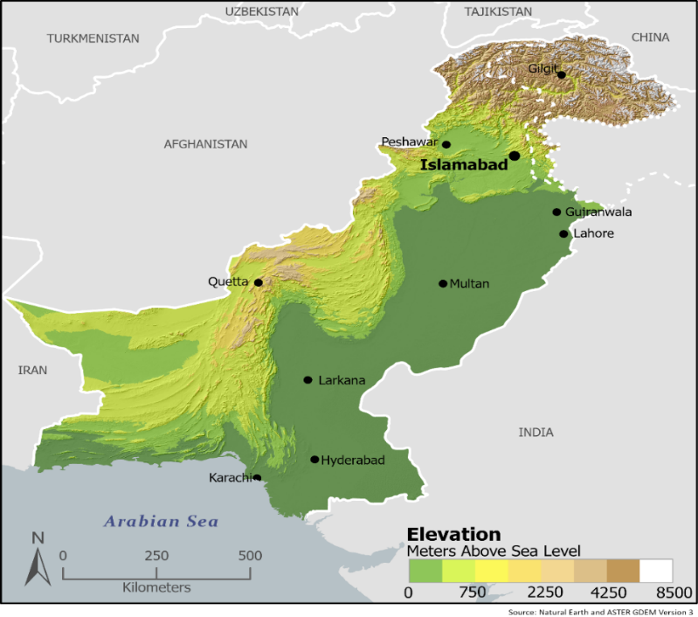
Figure 1: Pakistan’s Topography
The diversity of Pakistan’s topography, (see Figure 1) characterized by high-altitude mountain ranges, significant arid and desert areas as well as major river basins results in substantial climatic differences across the country, and this affects the adaptive and mitigation measures that can be taken to reduce the country’s vulnerability to climate change.
According to the recently completed Pakistan Climate Change and Health Vulnerability and Adaptation Assessment, (2) temperature increases in Pakistan are accelerating, mostly affecting Sindh, Punjab, and Balochistan Provinces; and temperatures are expected to increase through 2030 to the 2050s. Furthermore, there is already a high vulnerability to drought, and this is expected to increase particularly in Balochistan and the Federally Administered Tribal Areas. (2)
As a direct consequence of the 2022 floods, the national poverty rate is projected to increase to 4 percent, showing Pakistan’s high vulnerability to climate change and its adverse impacts on human capital with the reversal of development gains. Over 13 percent of health facilities have been shown to be vulnerable to floods. (2,11)

2.1.4 Climate Change Resilience and Preparedness
A paradigm shift is required to strengthen resilience to climate change in the health sector. This requires a multisectoral approach, from the government, the private sector and development partners, that builds on evidence-based good practice that is inclusive, gender-sensitive and supports vulnerable populations.
Pakistan’s Resilient Recovery, Rehabilitation, and Reconstruction Framework (19) highlights a foundation of three principles approaches - (i) building back better; (ii) people-centred socio-economic recovery; and (iii) building systematic resilience against natural hazards and climate change impacts. Built on this foundation are four strategic recovery objectives including - (i) enhancing governance and capacities of the state to restore lives and livelihoods of the affected people, especially the most vulnerable; (ii) restoring livelihoods and economic opportunities; (iii) ensuring social inclusion and participation in all aspects of recovery and related development; and (iv) restoring and improve basic services and physical infrastructure. (see Figure 2). (19)
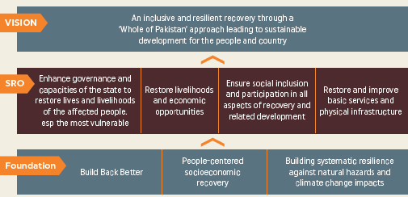
Figure 2: Pakistan’s Resilient Recovery: Vision, Strategic Recovery Objectives, and Foundation
The World Bank Climate and Disaster Risk Screening (CDRS) tool can be utilized to assess climate change risks and vulnerabilities and potential adaptation and mitigation measures, while the adaptive capacity for managing climate change health risks can be assessed utilizing the WHO Operational Framework for Building Climate Resilient Health Systems, based on the building blocks of the health system. (see Figure 3). (4, 10)
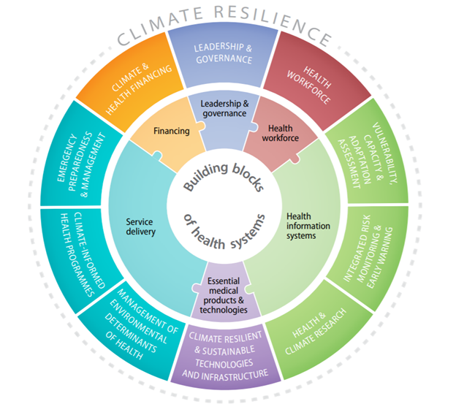

Figure 3: WHO’s Operational Framework for Building Climate-Resilient Healthcare Systems - comprising ten components and their connections to the building blocks of health systems.
It is recommended that the following approach should be adopted to provide a climate-resilient healthcare system:
- Conduct assessments to establish baseline information on climate resilience in health facilities and make recommendations for addressing gaps.
- Build health system capacity using climate-change resilient and environmentally sustainable measures.
- Review regulations, policies, and institutional arrangements for healthcare and climate change in relation to adaptation (e.g. climate-change resilient water safety plans) and mitigation measures (e.g. co-benefits in transport and energy efficiency policies), with an emphasis on multisectoral collaboration.
- Develop plans for interventions in the immediate and short term (up to 12 months), medium and long-term, rooted in a detailed analysis, including multi-hazard risk assessments.
- Adapt current healthcare infrastructure (see section 4), technologies, and processes with specifications for construction and retrofitting of healthcare facilities to ensure climate resilience and environmental sustainability.
- Undertake capacity building of health professionals and other personnel on climate change resilience, working in collaboration with relevant climate-sensitive health programmes (e.g., vector-borne diseases, nutrition, infectious diseases, disaster risk reduction) to build the resilience of programmes.
- Monitor and evaluate indicators of climate change impacts (utilizing baseline estimates), for response capacity and emergency preparedness, and climate resilience and environmental sustainability, and establish a comprehensive surveillance system using new technologies such as satellite imagery. (7,12)

2.1.5 Recommendations for Strengthening Climate-Resilience of the Pakistan Health System
Pakistan’s Resilient Recovery, Rehabilitation, and Reconstruction Framework utilizing the approach of “Building Back Better” recommends the following measures to reduce the impact of future climate change-related extreme events (19):
- Conduct a comprehensive review of current healthcare infrastructure to identify climate change-related vulnerabilities and adaptive capacity. Baseline information will also be required on environmental determinants of health, including water, sanitation, and hygiene coverage in healthcare facilities. (1)
- Conduct climate change and health system Vulnerability and Adaptation Assessments; with the development and implementation of the health component of National Adaptation Plans.
- Develop minimum standards for climate-resilient healthcare infrastructure, in order to reduce the vulnerability of existing and new facilities.
- Assess existing building codes and recommend changes, as necessary.
- Improve service delivery through the construction of new healthcare facilities or the renovation of existing ones focusing on climate-specific adaptive measures in the design of facilities, and water and sanitation systems in both rural and urban areas (see section 4). Incorporating sustainability principles in the rehabilitation plans for health care facilities affected by flooding or other climate change impacts.
- Promote energy efficiency through the use of energy efficient systems; green building designs; and the use of renewable energy technologies such as solar panels, air and ground-source heat pumps, windmills, and small hydroelectric power units. This should also include the use of electric/hybrid vehicles and energy efficient lights, fans, central air conditioners, vaccine refrigerators, sterilization equipment, cold rooms and other equipment.
- Establish integrated risk monitoring and early warning systems for health facilities including monitoring of carbon emissions from health systems. (2,7)

2.1.6 Examples of Interventions from Pakistan and Other Countries
Pakistan - Aga Khan Development Network (20)
The Aga Khan Development Network supported the construction of the Aga Khan University Hospital, Karachi (Figure 4) and the Aga Khan Maternal and Childcare Centre, Hyderabad (Figure 5) both of which have design features aimed at reducing the impact of climate change and high temperatures using passive measures. It has been reported that the cumulative effect of these measures in the Aga Khan University Hospital has been a reduction of 5°C internally compared to similar buildings (for further details see Section 4.3 below).
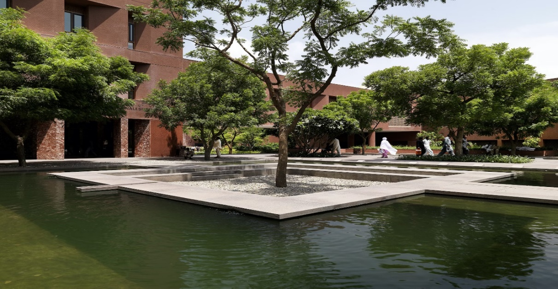
Figure 4: Aga Khan University Hospital showing courtyard, planting and water feature (Khadem Studio/Payette Associates)
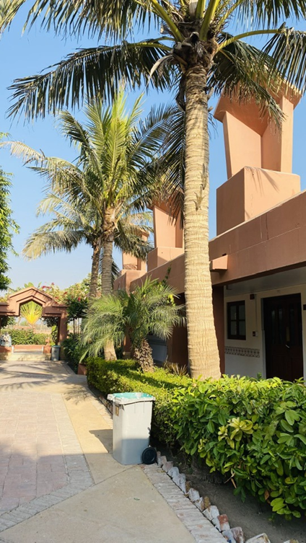
Figure 5: Aga Khan Maternal and Childcare Centre showing wind towers (designer not known)
Pan American Health Organization (PAHO)
Jamaica’s Ministry of Health and Wellness, with the support of PAHO is increasing the resilience of health centers across the country to withstand increased climate-related hazards. Following the guiding principle ‘Safe + Green = Smart’, at least twelve health centres have been identified to receive retrofitting of infrastructure. (14)
The World Bank Group
- The Organization of Eastern Caribbean States (OECS) Regional Health Project for the Caribbean includes the refurbishment of healthcare facilities incorporating climate-resilient designs, energy-efficient lighting, appliances, and equipment, and improved health care waste management. Civil works follow a Green Checklist, utilized under the Smart Health Facilities Initiative, which incorporates climate-smart actions for healthcare infrastructure. Building Codes focus on climate-resilient infrastructure standards. (7)
- South Sudan: Investments in solar direct drive refrigerators, portable climate-friendly cold chain equipment, and solar electrification of health facilities are strengthening healthcare system resilience while mitigating impacts of climate change in South Sudan’s heavily flood-impacted, low-infrastructure context. (6)
- The World Bank funded Gambia Essential Health Services Strengthening Project aims to increase the climate resilience of healthcare facilities through improved design to cope with the hot and humid climate. Renovated and newly constructed facilities will have improved energy efficiency and will adopt measures to minimize resource consumption and reduce CO2 emissions. Training will also be given to healthcare professionals and the public on measures to take in the event of extreme heat or drought. (7)

2.1.7 Monitoring and Evaluation of Health and Climate Resilience
The implementation of these guidelines should strengthen the overall climate-resilience of healthcare facilities and the health system. This will however have to be monitored and evaluated and the indicators to be used will depend on the vulnerability context and the intended beneficiaries but some health-related examples of adaptation/mitigation indicators used by the World Bank Climate Indicators Team include:
- Number of health facilities rehabilitated/constructed in line with climate-resilient building standards.
- Number of health facilities constructed utilising long life/loose fit principles.
- Number of healthcare facilities equipped with energy-efficient storage facilities for storing specimens and temperature-sensitive medical supplies.
- Increased length of roads for transporting medical supplies made resilient to flood damage and storm vulnerabilities.
- Number of healthcare facilities constructed with flood protection integrated into the design.
- Reduction in susceptibility of water and sanitation infrastructure to river and sea level rise/flooding.
- Surveillance and spatial mapping tools developed to map infrastructure and areas most likely to be affected by climate-induced water-borne diseases.
- Number of healthcare professionals trained in climate-resilience principles for healthcare facilities. (7)

Section 3: General Design Guidelines
These guidelines are intended for use in the design and construction of new health facilities and renovation of existing health facilities.
- Section 3 (this section) covers general design guidelines.
- Section 4 covers specific design guidelines for the four climatic zones in Pakistan.
- Section 5 covers the renovation/retrofitting of existing buildings in the four climatic zones.
While the design of health facilities should take account of all technical considerations set out below, planning and design should also respect local knowledge and cultural traditions, policies and regulations and efforts should be made to engage with local communities over the design of new facilities.

3.1. Reduction of Carbon Emissions

3.1.1 New Construction
Given the global climate emergency, it is essential to minimise the carbon footprint of buildings on a life-cycle basis, through:
- the initial design of health facilities,
- the specification of building materials,
- the construction process,
- the useful life of buildings, including their re-use or demolition.
A range of building materials are in common use in the country, including locally produced cement, steel in various forms, aluminium, burnt bricks, and stone. The manufacture and use of these materials produce differing rates of carbon emissions. In order to reduce the total of embedded carbon, locally available materials that produce the lowest carbon emissions during manufacture and have the lowest embedded carbon should be used.
Cement is one of the worst offenders due to the large amount of GHGs emitted during manufacture and transport to site. This is closely followed by aluminium and steel in all their forms. The use of these materials should therefore be kept to a minimum.
Some companies are however now producing low-carbon cement (Holcim²² is producing Eco Planet cement for instance) and the availability of these in Pakistan should be investigated by designers²³. There have also been experiments with the use of carbon fibre for reinforcing concrete which reduces the amounts of materials used, results in longer service life and allows for complete recycling and this should also be investigated as a way of reducing carbon emissions²⁴.
Bricks are widely produced throughout the country. Although GHGs are produced during manufacture, bricks made close to building sites are preferable to concrete blocks.
For simple, single-storey buildings, preferred materials for constructing walls are local stone, unfired bricks or stabilised-soil blocks (stabilised with small quantities of cement, lime or other pozzolanas), rammed earth or adobe, all reinforced where necessary to afford stability and to resist earthquakes, flooding, etc. Stabilised soil can also be used for floors instead of heavy concrete slabs if they are finished with a hard-wearing, low maintenance finish. Unfired bricks or stabilised-soil blocks (reinforced, if necessary, with concrete frames) would appear to be a very good option for the walls of single-storey or two-storey buildings as they are heavy and most of the materials can be obtained locally.
In hot, dry areas of the country, the amount of concrete can be reduced by replacing reinforced concrete roofs with brick vaults and replacing concrete lintels over openings with brick arches. (see Figure 15).
In areas with high seismic activity, lightweight steel roofs are safer than heavy roofs. Reducing the amount of steel to be used can be achieved by, for example, using lightweight, long-span steel purlins rather than steel trusses, etc. (see Figure 14).
The use of timber in buildings is banned at present; but this ban should be reviewed in areas where local timber is available (in higher, wetter regions). Timber is very effective for use in lightweight roofs; it can also be a sustainable material source, and it sequesters carbon.
Other ways to reduce GHG emissions and reduce the carbon footprint of facilities are the use of:
- solar water heaters,
- photovoltaic panels,
- windmills or small hydroelectric units,
- low-emission light bulbs,
- ground- or air-source heat pumps for heating (in upland areas),
- rainwater harvesting and storage especially in the dryer areas of the country.
The use of natural light and ventilation should be maximized, and the provision of air-conditioning minimized or avoided entirely (although this will be difficult in the hot and dry regions of the country).
Reuse/renovation of existing buildings produces fewer carbon emissions and greenhouse gases than construction of new buildings. Where possible, renovation and/or extension will be preferable to the demolition of existing buildings and the construction of new buildings. If it is essential to demolish a building, the materials produced by demolition should be re-used e.g., concrete floors and roof slabs can be broken down and used as fill or aggregate.
In the context of design of buildings for climate-resilience, the ‘loose fit, long life’ approach is very important as it can reduce the environmental impact of construction and promote the efficient use of resources over time. It emphasises the creation of buildings that are durable, flexible and adaptable to changing needs. The ‘long life’ aspect means designing buildings with durability in mind and using materials that might be more expensive initially but that can withstand wear and tear over many years. The ‘loose fit’ aspect means designing buildings that can be easily adapted and reconfigured to meet changing needs over time. It will be less expensive to incorporate additional space to accommodate future changes during the initial design, rather than by extending the buildings later. The initial building design should therefore consider the possibility of future changes and provide space for internal replanning as well as for future extension.
Where applicable, the EDGE system developed by the International Finance Corporation should be adopted. EDGE (Excellence in Design for Greater Efficiencies) is a green building certification system, focused on making new buildings more resource-efficient, and consists of a web-based software application, a universal standard and a certification system. (21)

3.1.2 Renovation
As with new construction, the planning and design of renovation should minimise the carbon emitted from buildings on a life-cycle basis, taking into account:
- the specification of building materials,
- the construction process,
- the useful lifespan of the building, including possible re-use or demolition.

3.2. Seismic Risk

3.2.1 New Construction
It is important to consider seismic risk to protect buildings against earthquake damage, especially in earthquake-prone mountainous areas of the country.
Seismic risk will not be increased by climate change, but some design/construction principles to mitigate seismic risk may conflict with those for climate change. Decisions will therefore have to be made as to which criteria are the most important.
General design and construction principles to mitigate seismic risk are:
- Square or rectangular buildings are recommended as they have equal rigidity in all directions; ‘T’ or ‘L’ shaped buildings should be avoided.
- Wall openings should be as few and as small as possible.
- Buildings should be symmetrical about centre lines to reduce rotation.
- Lightweight roof construction should be used wherever possible.
- Buildings should be reinforced over the tops of walls (with ring beams); over door and window openings (with lintels); vertically at the side of openings; horizontally in walls and vertically at corners and junctions of walls.
- Foundations should be adequately reinforced and taken down to solid ground.
Professional supervision is essential to ensure that buildings are properly constructed. Designs for buildings in active seismic zones must also meet local regulations for earthquake resistance and comply with the requirements of the Building Code of Pakistan, 2007.

3.2.2 Renovation
It is very difficult to retrofit buildings in active seismic zones to make them earthquake resistant. Any buildings within these zones that do not comply with present-day regulations for earthquake resistance will have to be demolished and re-built.
In some cases, it will be possible to reinforce foundations and walls to resist seismic events- advice from a structural engineer should be sought before attempting this.

3.3. Flood Events

3.3.1 New Construction
The high risk of flooding especially along rivers in the mountainous areas of the country and in the plains of the South will affect the design of healthcare facilities. With the increase in global warming and climate change, there is a likelihood of more frequent and more severe flood events in Pakistan - devasting floods were recorded in 2010 and 2022. It is noted that 2022 flooding was caused as much by excessive rainfall and subsequent run-off as by flooding from over-flowing rivers. There are also the dangers posed by the melting of glaciers and the flooding of glacial lakes in the mountainous areas of the country.
In flood-prone areas, relocate healthcare facilities to higher sites if possible – local knowledge and the participation of local communities will be very important in these areas. If relocation is not possible, the following measures should be considered:
- Construct barriers to prevent flood water from entering sites and buildings.
- Raise the site level above the estimated flood level, using retaining walls and consolidated fill.
- Construct buildings on plinths so that the ground floor is above the estimated flood level.
- Construct buildings on columns above the flood level.
- Use ground floor areas for non-medical functions (e.g. reception/waiting spaces, parking for ambulances) and locate all medical functions on the first floor.

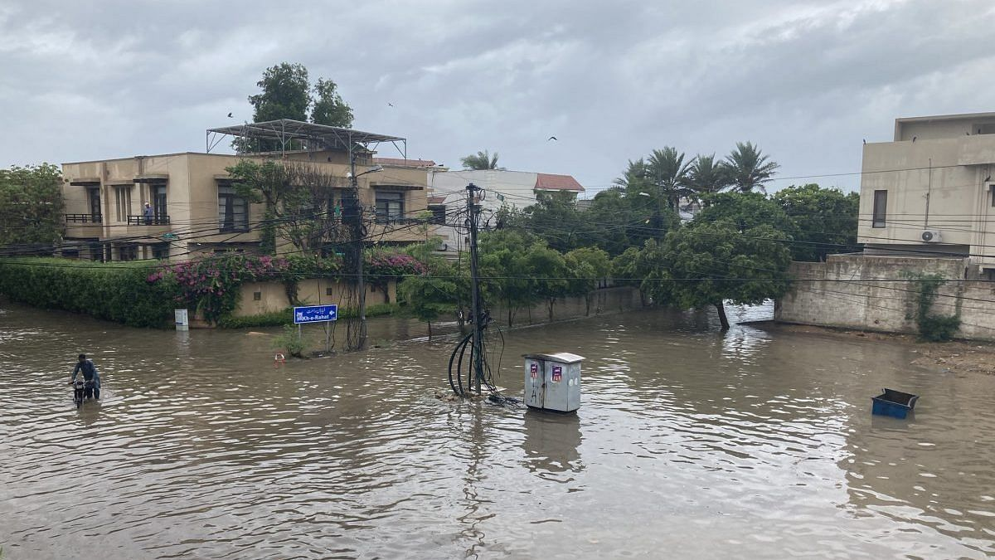
Figure 6: Floods in 2022 in Sindh Province
If none of the above measures are appropriate or affordable then the following measures should be considered:
- Use waterproof and water-resistant materials internally and externally.
- Use easily cleaned materials for floors and walls.
- Raise all electrical and medical gas fittings above the estimated flood level.
The recommendations of the Post Disaster Needs Assessment produced after the 2022 floods should be adopted for the design of new facilities in flood-prone areas.

3.3.2 Renovation
As stated above, in flood-prone areas the relocation of existing facilities to higher sites above flooding levels should be considered. If not possible then the following measures should be considered when renovating facilities:
- Construct barriers to prevent flood water from entering sites and buildings.
- If buildings are single-storey, and if structurally possible, construct additional facilities on the first floor, and move highly serviced and vulnerable facilities to the first floor.
- Apply waterproofing and water-resistant materials internally and externally to ground floor accommodation.
- Replace ground floor finishes with water-resistant and easily cleaned materials such as tiled floors and walls.
- Raise all electrical and medical gas fittings on the ground floor to above the estimated flood level.
The recommendations of the Post Disaster Needs Assessment produced after the 2022 floods should be adopted for the renovation of facilities in flood-prone areas.

3.4. Infection, Prevention, and Control

3.4.1 New Construction
The level of infection, prevention and control in healthcare facilities had to be drastically improved in order to cope with COVID-19, and to prepare for outbreaks of similar respiratory diseases in the future. While the outbreak of COVID-19 was not directly caused by climate change, its effect must be considered when designing healthcare facilities.
This will not be straightforward, especially for facilities in hot dry areas, where it is necessary to keep buildings compact and restrict ventilation during the heat of the day. COVID-19 is mainly spread by droplets in the air produced by coughing, sneezing or even by talking and shouting; and these droplets can travel quite long distances.
The principal measures to be used to counteract this are:
- Ventilation:
- External covered waiting areas should have open sides for maximum ventilation.
- Internal rooms and wards should be provided with cross-ventilation.
- In hot, dry and arid areas the use of exhaust fans may be considered.
- Air cleansing: this can be achieved through the use of germicidal, ultraviolet, air-disinfection units or air filters.
- Social distancing: communal areas such as entrances, waiting and triage areas are the areas where infectious and healthy people are most likely to mix, therefore:
- Entrances and exits should be separated.
- Waiting areas should be external, and generously sized to allow for social distancing; also shaded to provide comfort for waiting patients.
- The flow of movement around the facility should separate patients and staff and reduce unnecessary overlaps between infectious and non-infectious patients.
3.4.2 Renovation
It is difficult to make substantive changes to existing buildings and facilities to control infections such as COVID-19. Changes may be considered relating to ventilation, air cleansing and social distancing, similar to those measures listed in Section 3.4.1 above.

3.5. Climate and Comfort

3.5.1 New Construction
Geography and climate are the most important design parameters to ensure resilience and comfort. Pakistan has a wide range of climatic zones and extremely diverse landscapes - from plains to deserts, forests, hills, plateaus, and mountains.
The country is divided into three major geographical areas: the northern highlands, the Indus River plain, and the Balochistan Plateau. The climate varies from sub-tropical, through temperate to continental steppe, with more arid conditions in the south. The monsoon season brings heavy rainfall resulting in frequent flooding. Rainfall varies greatly from year to year, and patterns of alternate flooding and drought are common. The varied conditions found within these climatic zones are the most important factors affecting the design of health facilities.
The varied geography and climate present problems for designing facilities that provide suitable comfort for staff and patients. Different design solutions are required for the four different climatic zones: the highlands and mountains in the north and west which experience warm summers and very cold winters; the composite climates that are not consistently hot and dry or hot and humid; the hot, arid region of the Indus plain in the Punjab and Sindh; and the hot and humid coastal area.
The climatic constraints and design strategies to be used in designing healthcare facilities in these zones are described in Section 4 following.
The use of wind towers or wind catchers, particularly in the hot, dry and arid zone and the hot, humid coastal area where they have been used for hundreds of years for increasing ventilation and comfort in buildings, should still be considered. The design and use of wind towers is described in Annex 1.

3.5.2 Renovation
As with the design of new facilities, the most important design parameters to be considered in the renovation of health facilities are the geography and climate as described above.
When considering the renovation of existing health facilities, emphasis must be given to passive measures to improve the comfort of users such as providing adequate natural ventilation, improving the insulation of roofs and walls, providing double roofs, painting roofs with reflective paint, planting trees and other vegetation around buildings, providing shading to windows, etc. Air-conditioning should only be provided where necessary.

3.6. Maintenance of Health Facilities
Regardless of how well-designed health facilities are in terms of climate resilience, appropriateness, the comfort of users, etc, this will count for little if the facilities are not well maintained. A maintenance system must be put in place, together with funding, for the long-term maintenance of buildings, services and equipment. Guidelines for the maintenance of health facilities are given in Annex 2.
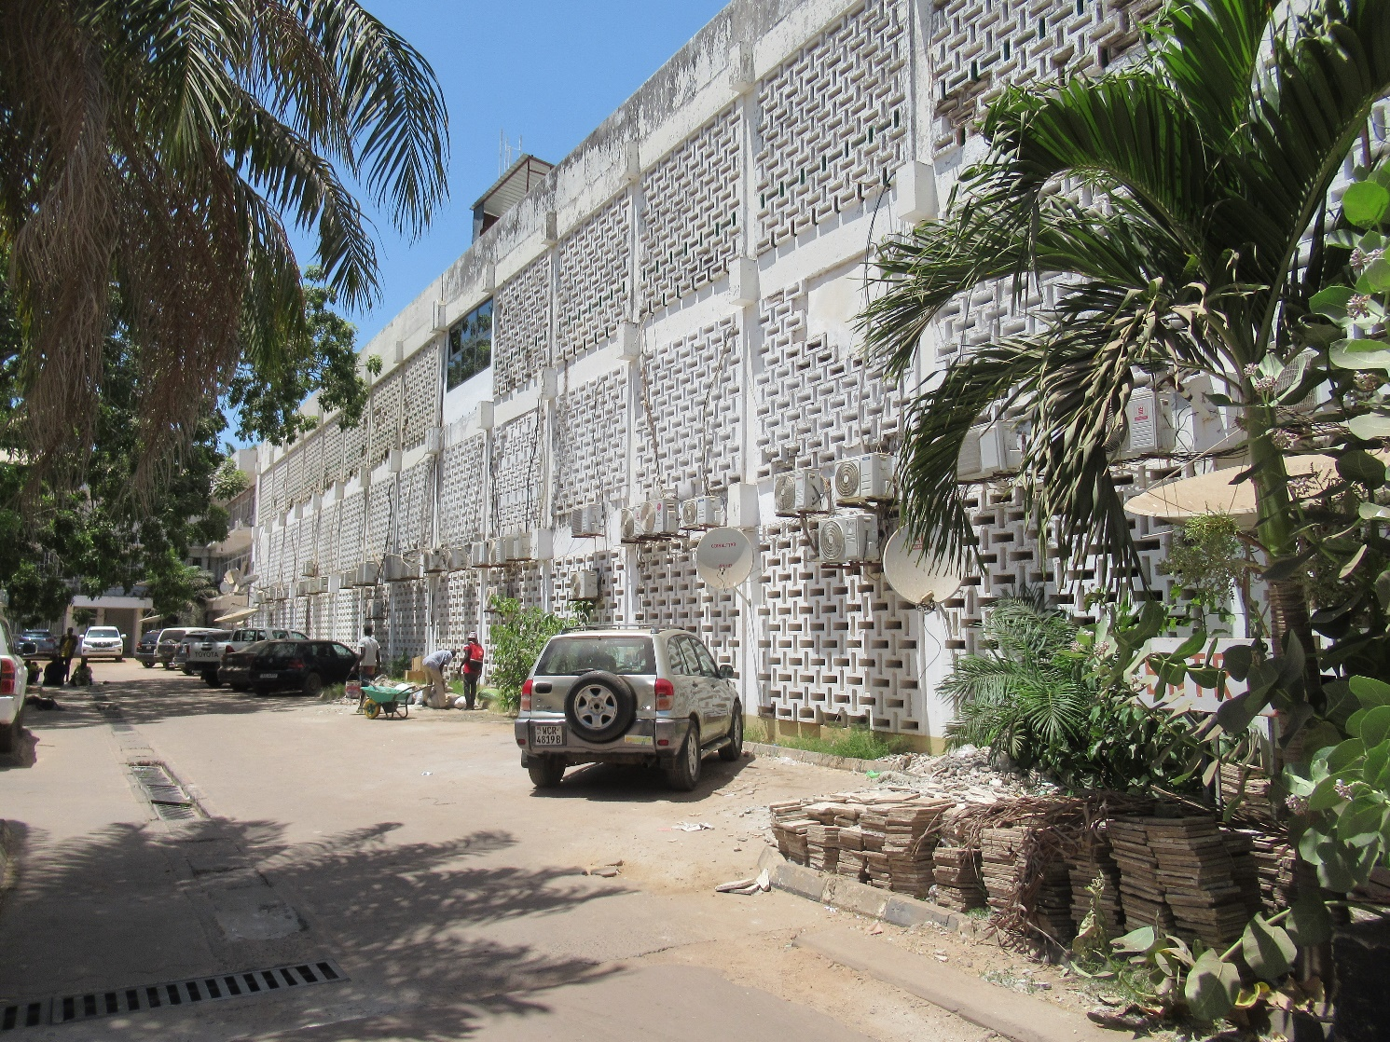
Figure 7: Colonial era government offices in Banjul, the Gambia showing external wall of perforated blockwork that allows light and ventilation internally but keeps direct sunlight off the main walls of the building.

Section 4: Design Guidelines for Specific Climatic Zones

The guidelines below set out the design parameters that will affect the design of health facilities in the four climatic zones of Pakistan.

Note: the drawings assume that the buildings are orientated with the main elevations facing north–south, which means they will require protection from the sun only on the southern side (this also assumes that there are no windows facing east-west). If buildings are orientated with the main elevations facing east–west, they will require protection from the sun on both sides of the building. Any orientation between these two will require varying amounts of protection on all four sides of the building.

4.1. Design for Cooler Uplands and Mountainous Areas

4.1.1 Climatic Conditions
Cooler uplands and mountainous areas are found in Khyber Pakhtunkhwa Province (KPP) as well as in other parts of the country. The north of KPP has a typically continental steppe climate, with average annual precipitation ranging from 100mm per year in the far north to 575mm in the south. Most of this precipitation occurs during the winter, with heavy thunderstorms in the spring. At high elevations in the Hindukush there can be heavy snowfall - Chitral town is cut off from the outside world for most of the year by snowfall. Temperatures in the valleys vary from 30°C (86°F) in July to below 0°C (32°F) in January.
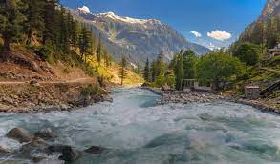
Figure 8: Mountainous area of Khyber Pakhtunkhwa Province
In Dir, Swat and Hazara Division districts, most of the annual precipitation comes during the winter months; but there is also a short powerful summer monsoon. Dir and Hazara districts are some of the wettest places in Pakistan. In Dir, annual rainfall averages 1,450mm, of which 400 mm falls during the summer monsoon from July to September and the rest during the winter rainy season from December to April. In Swat, annual rainfall averages around 825mm, with about 425mm falling between June and September. October and November are the driest months in all areas, with rainfall under 30 mm per month except in the most exposed areas.
Temperatures in this region are warmer than in Chitral, and at 1,200 metres in Abbottabad the heat and humidity can be oppressive during the monsoon season. In winter, most of Swat receives significant snowfall; but in Hazara temperatures are usually around 5°C. Similar climatic conditions to these can also be found in the north and west of the country.

4.1.2 Design Considerations
Designers of health facilities in these areas are presented with a number of significant challenges.
For the comfort of users, buildings have to cope with the climatic extremes: very cold in winter, and hot and humid during the monsoon season. Level sites need to be found to accommodate the facilities, yet secure from flooding and the risk of earthquakes and avalanches.
The buildings should have lightweight and steeply sloping roofs to cope with heavy rain and in places, heavy snow. Roofs and walls should be well insulated from heat during summer, and from cold during winter. Roofs should also be well braced and tied down to the main structure to withstand heavy winds.
Windows require protection from the sun in summer months, usually by the use of projecting roofs and verandas that can be used for waiting and circulation. The roof projections should allow for low angle sun to enter rooms during the winter months. Projecting roofs will protect the walls from sun and rain and reduce the need for maintenance.
Windows should be large and positioned on both sides of rooms to allow cross ventilation during the summer months. The windows should be closable during the winter months.
Foundations could be built of local stone reinforced against earthquakes and walls could also be built of stone or unfired bricks, again suitably reinforced, to reduce the need for cement.
The site will require protection from the rain and stormwater, with storm drains connecting to site drains taking surface water away from the buildings.
In areas that experience water shortages but where there is consistent rainfall, water can be stored for later use in ground level or underground tanks.

4.1.3 Summary of Measures (see also Figures 9 & 10):
- Locate buildings on flat and stable sites away from flood-prone river valleys.
- Design buildings to withstand earthquakes.
- Orientate buildings so that the main elevations face north or south.
- Provide well insulated and lightweight roofs, with large overhangs to protect walls and windows from sun and rain.
- Tie down roofs to the main structure and brace them to provide protection from storm damage.
- Provide verandas to the south sides of buildings for access and protection from the summer sun.
- Roof overhangs should allow solar penetration into rooms in the winter.
- Rooms should not be deep, with windows on both sides to provide good levels of lighting and cross-ventilation in the summer months.
- Provide solar water heaters and photovoltaic panels for hot water and generating electricity.
- Consider the use of small windmills or mini-hydroelectric units to generate electricity.
- Provide light emitting diode (LED) lights to reduce electricity consumption.
- Use air or ground-source heat pumps for heating during the winter.
- Provide double glazed windows for insulation in the winter.
- Provide storm drains around buildings and around the site.
- Plant trees and other vegetation around buildings to protect them from the sun and wind.

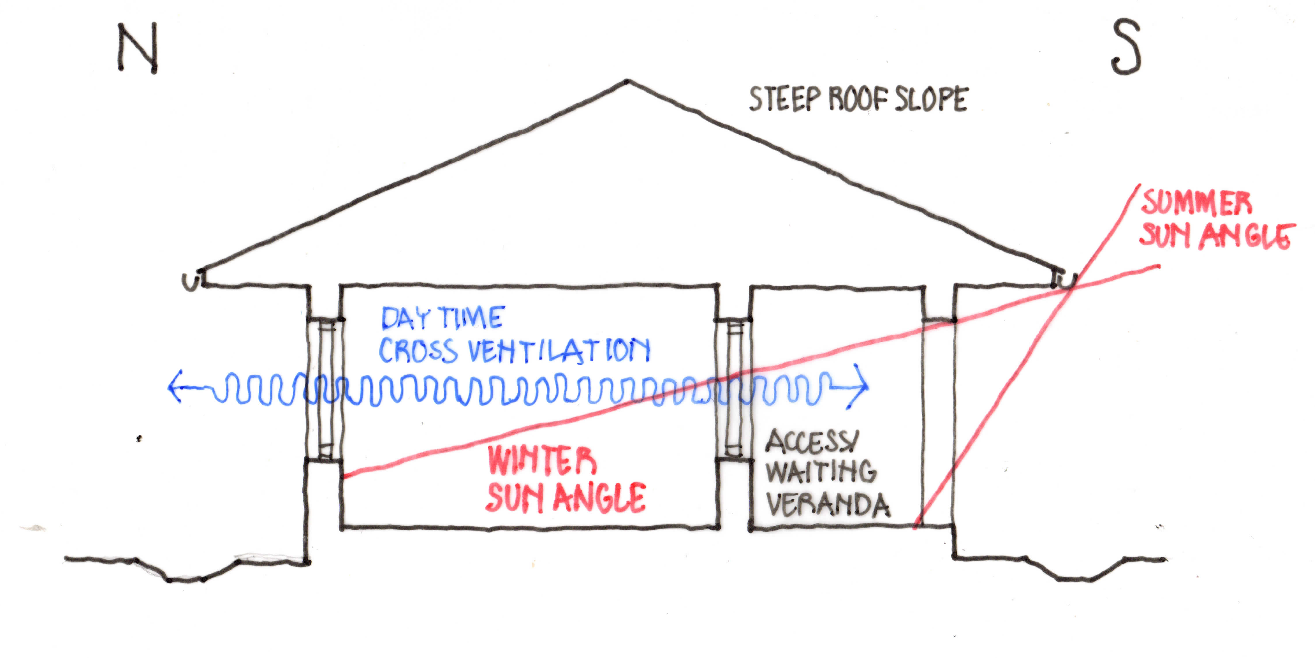
Figure 9: Section through a single-storey building

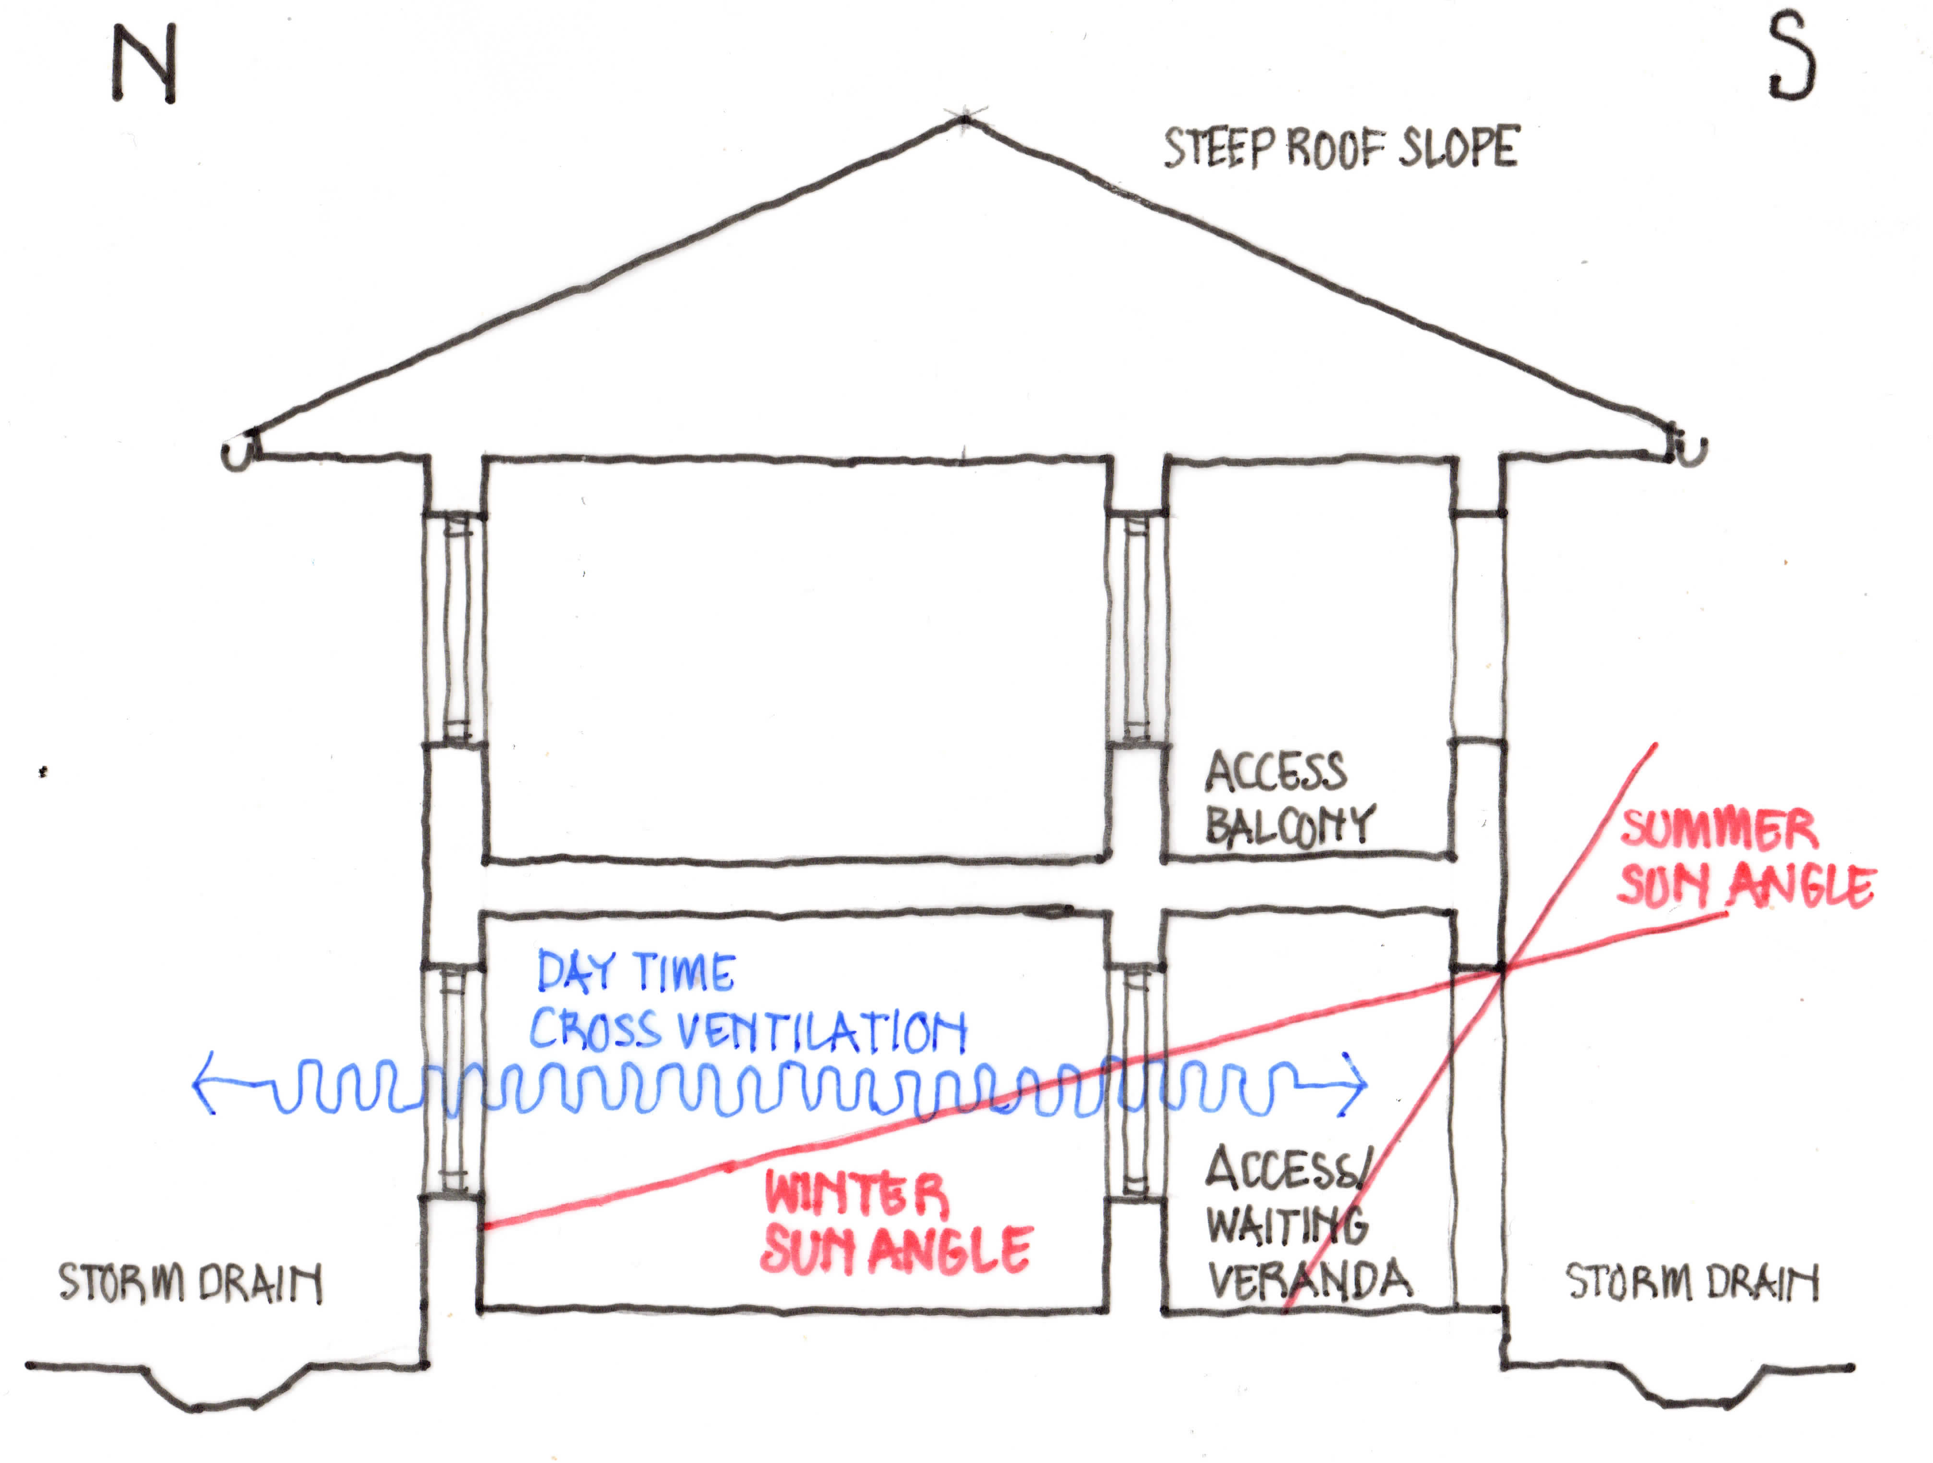
Figure 10: Section through a two-storey building

4.2. Design for Hot, Dry and Arid Areas

4.2.1 Climatic Conditions
The majority of Sindh Province consists of hot, dry and arid areas, and these also extend into parts of Khyber Pakhtunkhwa Province and other parts of the country. These areas are characterised by very hot, dry air, and dry, dusty ground surfaces. Day-time air temperature ranges between 27 and 49°C but at night falls by as much as 22°C.
Humidity is moderate to low, and there is little or no cloud cover to reduce the high intensity of the direct solar radiation. The clear skies permit a considerable amount of heat to be reradiated to the sky at night. The dry air, low humidity and minimal rainfall discourage plant life and the dry, dusty ground reflects the sunlight, producing ground glare. Local thermal winds often carry dust and sand.

4.2.2 Design Considerations
In these conditions, physical comfort during the day depends on a reduction of the intense radiation from the sun, ground and surrounding buildings. The construction of walls and roofs should ensure that, during the day, the inner surface temperatures are less than skin temperature – this allows the body to dissipate some of its surplus heat to the surrounding surfaces by radiation, as well as cool the indoor air by convection.
At night the air temperature is frequently low enough to allow an increase in effective temperature through surface temperatures being higher than the air temperature - such an increase may even be beneficial particularly in a healthcare facility by providing a measure of warmth during the cold nights.
Evaporation is greater than in any other climate zone, and measures to induce evaporation are unnecessary. Natural ventilation cannot be used to advantage unless the air is first cooled and the dust filtered out, processes which are difficult and costly.
Conditions are so hostile in this climate, that buildings and external spaces need to be protected from the intense solar radiation and the hot, dusty winds. Enclosed, compact and inward-looking buildings are the most suitable. By placing as much accommodation as possible under one roof, thermal loading from the sun and hot air will be reduced.
Surfaces exposed to the sun should be reduced as much as possible. Long elevations should face north–south, as these receive the lowest heat loads from solar radiation. Solar radiation is similar on the east and west elevations, but peak intensity in the west coincides with the highest air temperatures in the afternoon. Non-habitable rooms such as toilets and stores should be placed at the western end of buildings to act as thermal barriers.
Figures 11, 12, 13 and 14 illustrate the climatic effect on single and two-storey buildings during the day and at night.
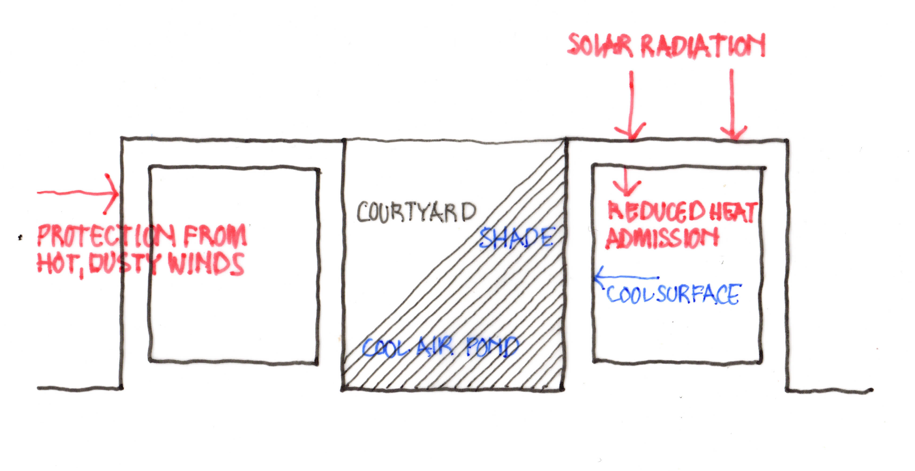
Figure11: Single-storey courtyard building: daytime

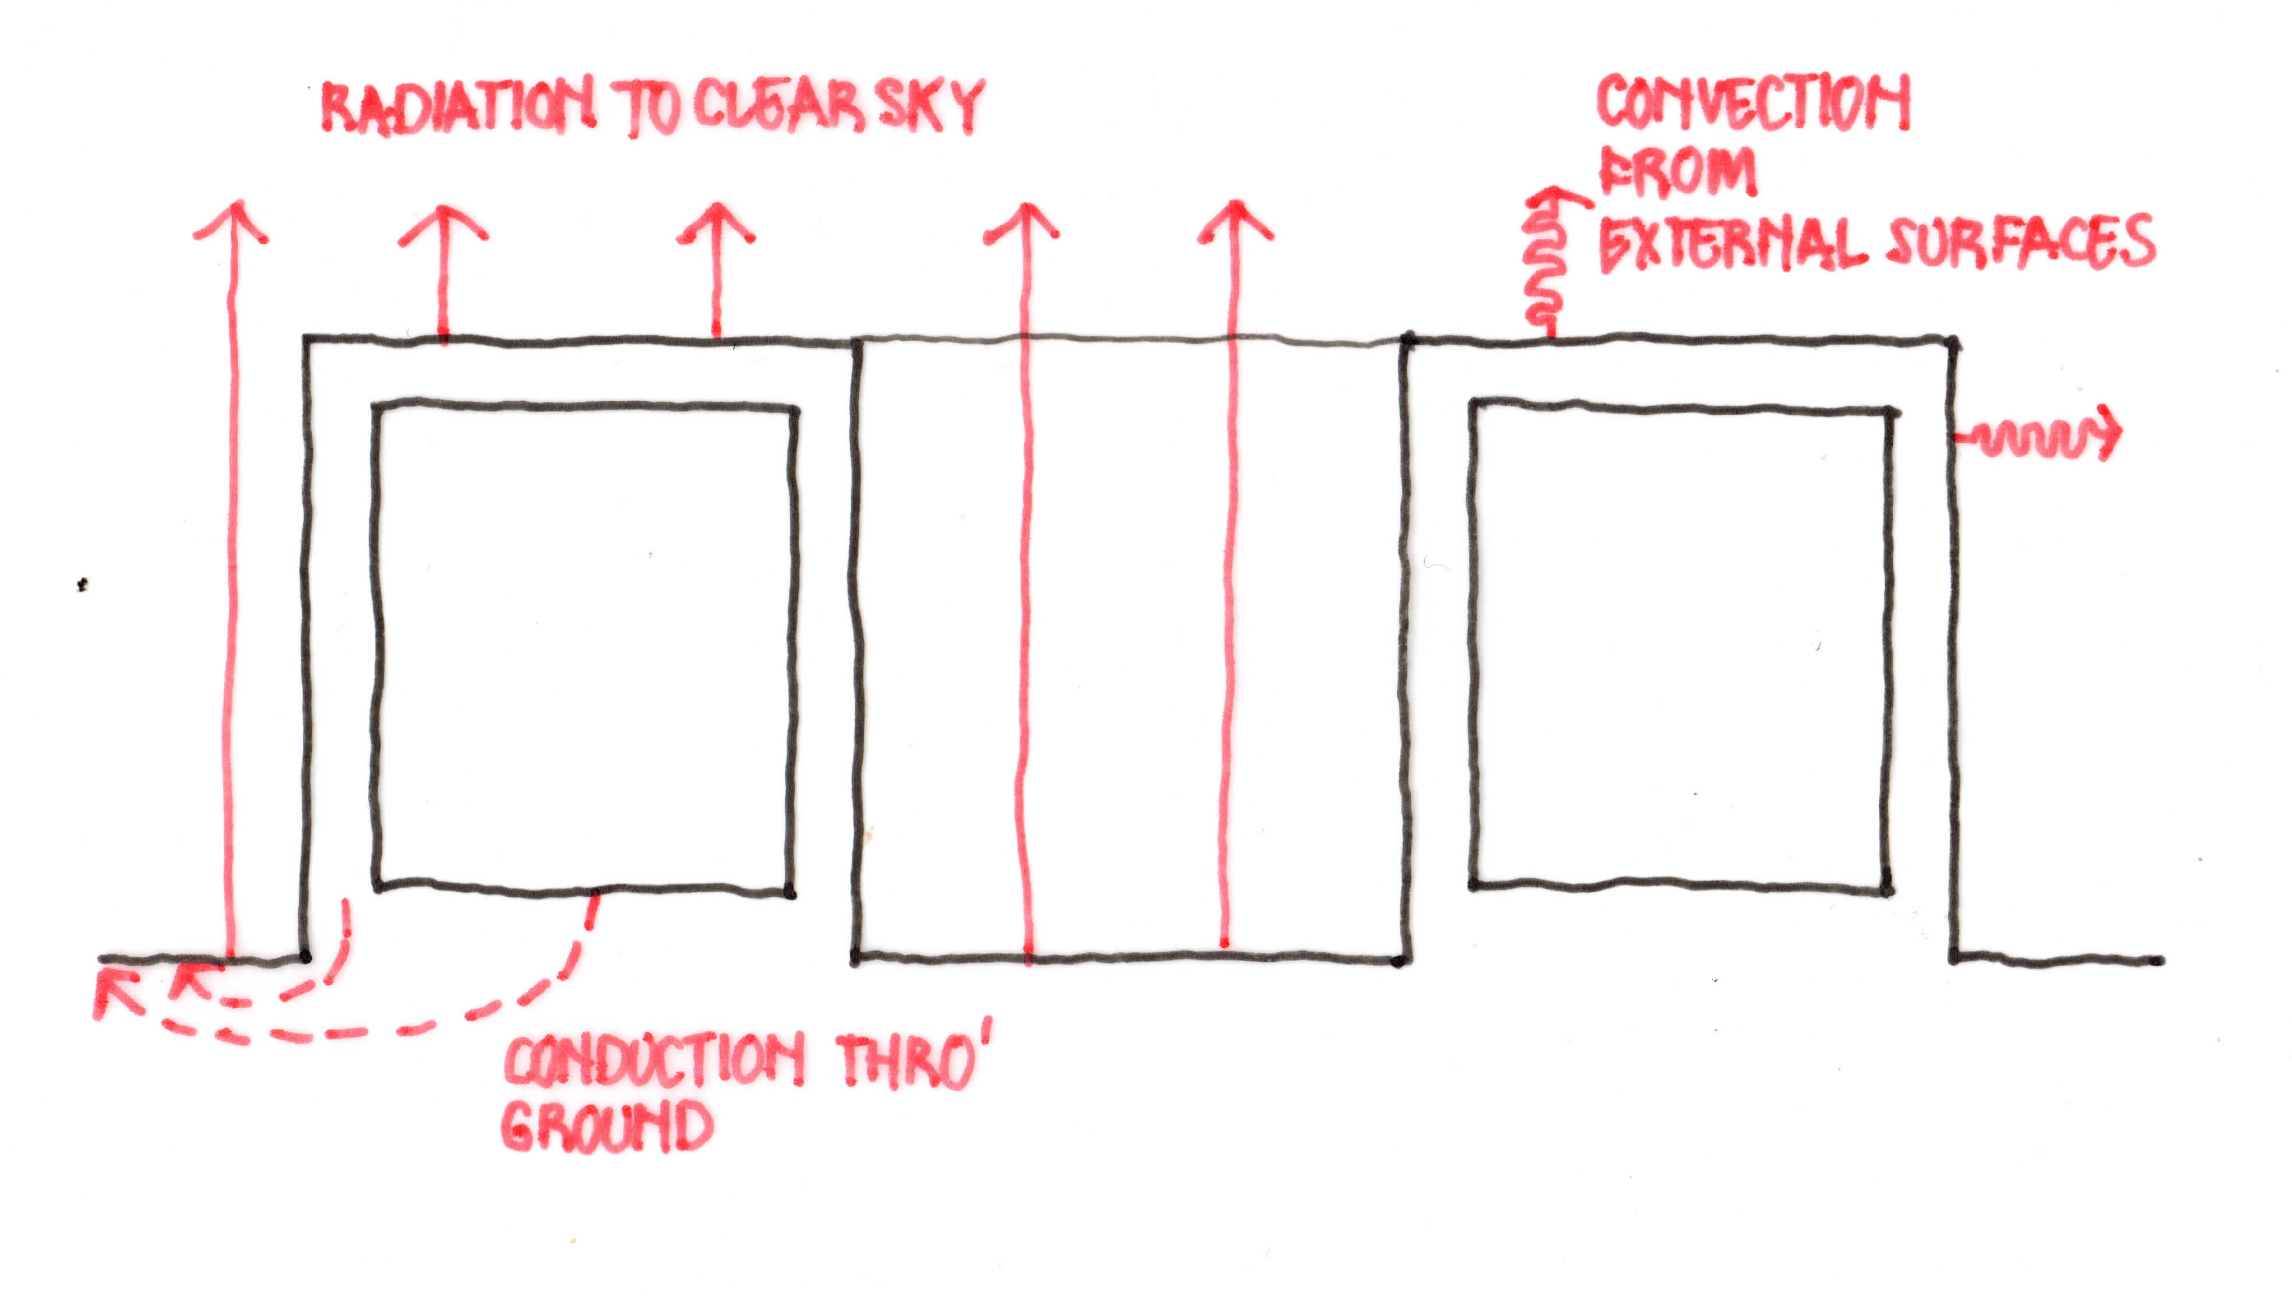
Figure 72: Single-storey courtyard building: night-time
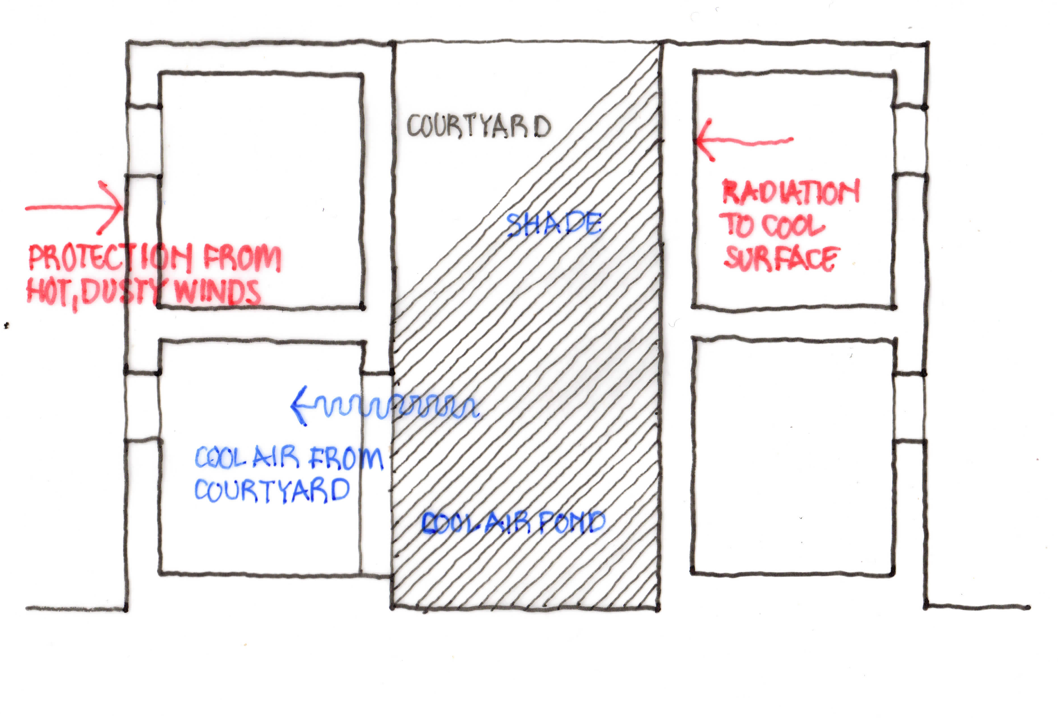
Figure 83: Two-storey courtyard building: daytime

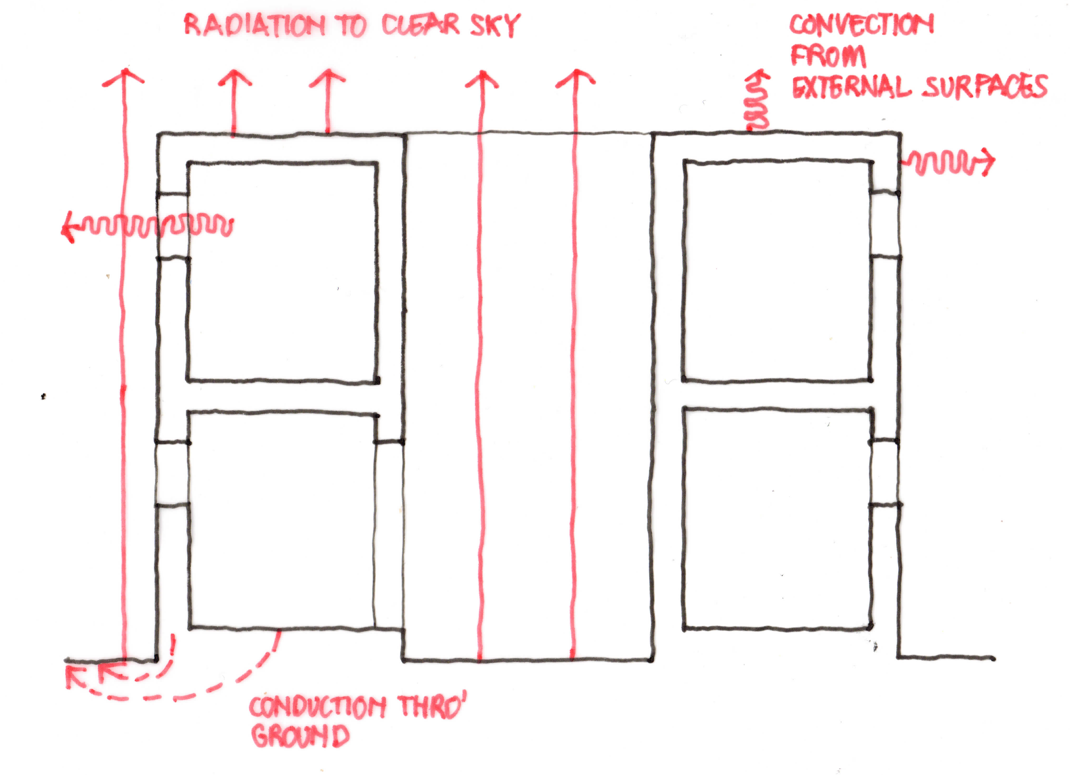
Figure 94: Two-storey courtyard building: night-time
Shading of walls and outdoor spaces can be created with projecting roofs, verandas, external brise-soleil walls, etc. Care must be taken to use low thermal capacity materials for shading devices that are close to openings to ensure their quick cooling after sunset. If the climate allows and water is available, the planting of trees and other vegetation around buildings will create shade and reduce dust.
Shading of roofs is difficult: a most effective method is to construct a second roof over the main roof, with a ventilated space between them. Since the upper roof will reach a very high temperature, it is essential that it is well separated from the main roof. The top surfaces of both roofs should be reflective. If a second roof is not affordable, another option is to have a well-ventilated deep ceiling space with an insulated ceiling.
Walls and roofs should be thick and constructed of heavy materials with a large thermal capacity so as to absorb much of the heat entering through external surfaces during the day. However, this will only be effective if the roofs and walls are as cool as possible in the morning, and the heat stored during the day is dissipated during the night. Cooling through the outer surfaces of the walls and roofs will not be sufficient, and heat dissipation should be assisted during the night by adequate ventilation.
One solution is to have heavy shutters or similar to protect windows and stop heat passing into the building during the day (this will have implications for lighting during the day). These shutters and windows can be opened at night, to allow the cool, night air in. Another solution is to set the windows in deep reveals (assuming that walls are thick) so that they are shaded throughout the day and can be kept closed, with no solar penetration into the rooms.
Shading of walls and reduction of heat gains can also be achieved by keeping buildings close together, especially the east and west walls (see Annex 3). The provision of covered verandas and colonnades for circulation or waiting spaces, and small, enclosed courtyards can help provide shade and coolness. Covered verandas and colonnades can be protected by external screen walls of clostra blocks or brise-soleil that will provide shade and ventilation and keep the sun off the walls of the buildings.
Reduction of heat gains can also be achieved through the provision of courtyards where a pool of cool air is retained during the day. If the courtyard is small (width no greater than height) or if the surrounding buildings are two-storeys high, such pools of cool air will be undisturbed. High walls to the courtyard cut off the sun, and large areas of the inner walls and the courtyard floor will be shaded during the day. The earth beneath the courtyard will draw heat from the surrounding surfaces and re-emit it to the open sky during the night. If a water pool can be constructed within the courtyard this will help reduce the temperature.

4.2.3 Summary of Measures (see also Figures 15 & 16):
- Construct compact buildings with small, shaded courtyards with, if possible, water pools (see Annex 3).
- Provide thick, heavy materials for walls and roofs (consider unfired bricks, stabilised soil blocks or blocks of other materials in order to reduce GHGs and cement content).
- Provide double roofs (with reflective upper surfaces) with a ventilated space between roofs (see Annex 3).
- Provide a deep, well-ventilated ceiling space and an insulated ceiling.
- Use vaulted brick roofs (to reduce the amount of concrete) with an insulated, ventilated ceiling space.
- Provide small windows either set well back in a thick wall or protected by heavy shutters.
- Shade verandas used for waiting and circulation areas.
- Provide external screen walls of clostra blocks or ‘brise-soleil’ to allow light through but prevent solar radiation striking the external walls (see Annex 3).
- Use solar water heaters and photovoltaic panels for generating electricity and LED lights to reduce electricity consumption.
- Provide wind towers to individual rooms or areas of the buildings (see Annex 1).
- If water is available, provide planting to shade buildings and reduce dust.
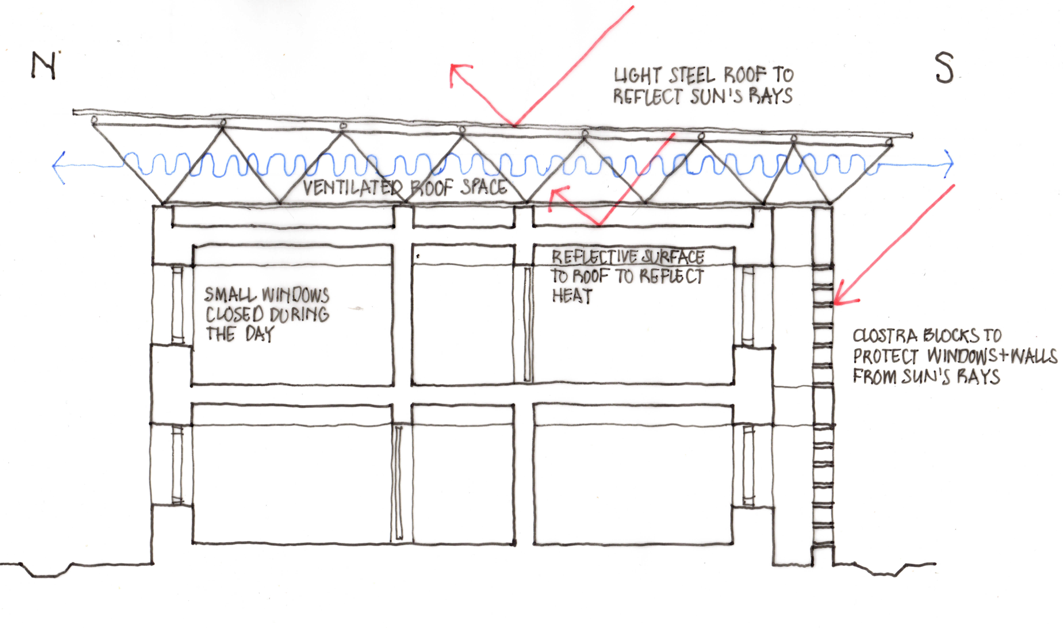
Figure 15: Section through a two-storey building with double roofs.
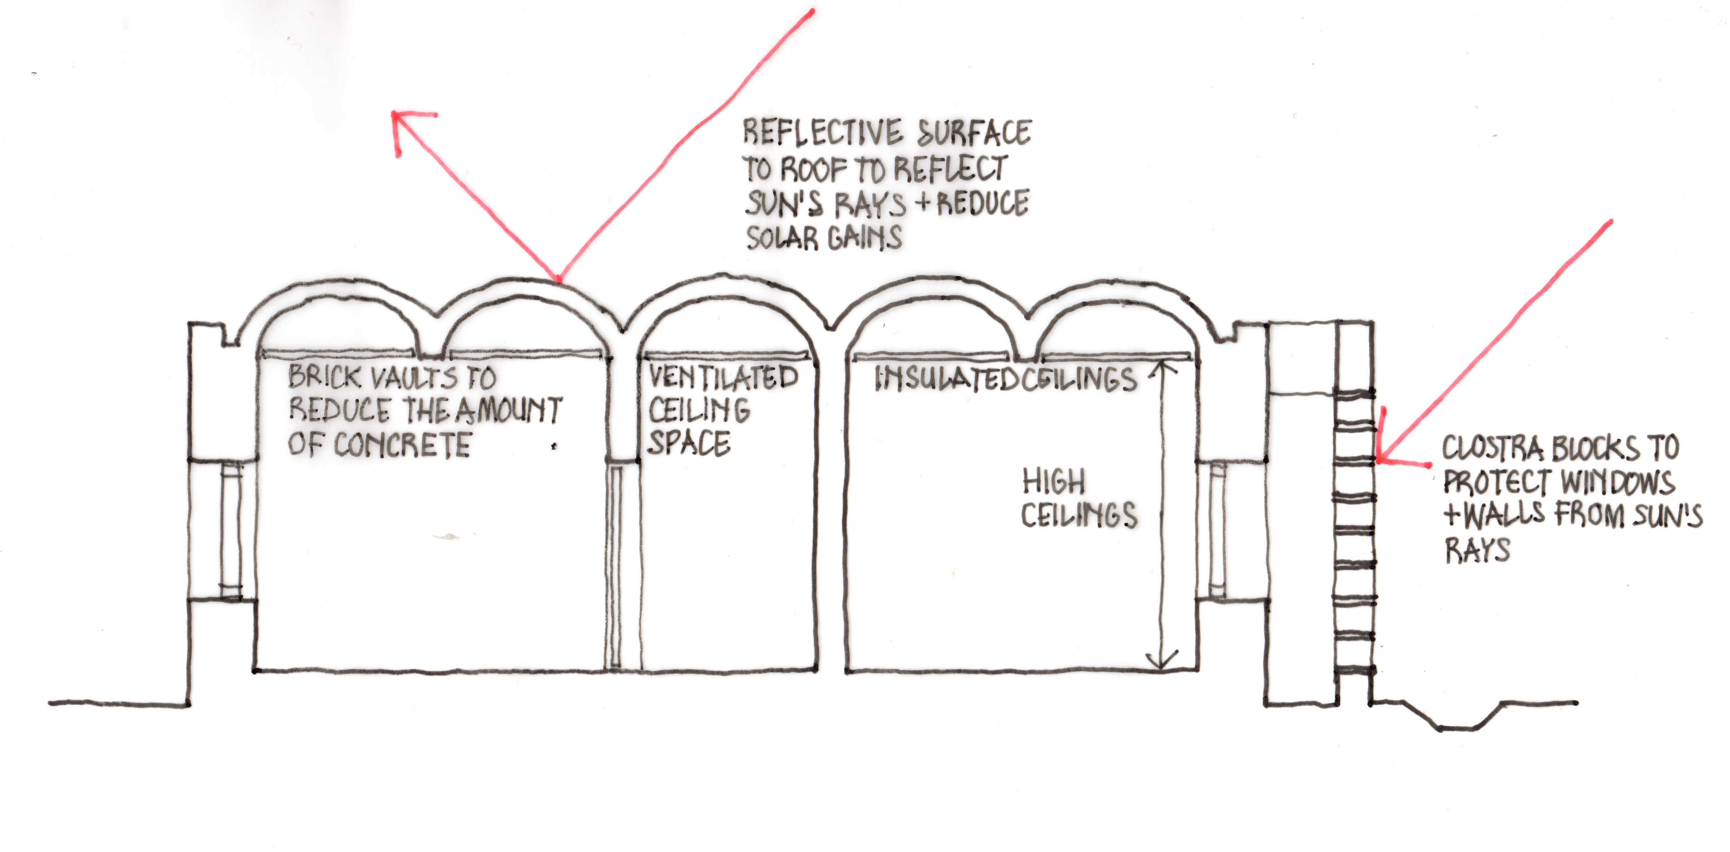
Figure 106: Section through a single storey building with a vaulted brick roof and ventilated ceiling.

4.3. Design for Maritime Desert Areas

4.3.1 Climatic Conditions
The coastal areas of Sindh, including Karachi, have a type of climate which differs only slightly from the hot, dry desert climate - the main difference is the high humidity. The diurnal temperature variations and the maximum temperatures are also lower.
There are two seasons: a hot one and a somewhat cooler one. Mean air temperature in the hot season is around 38°C, and 21°- 26°C during the cool season. The night-time mean temperature ranges from 24°- 30°C in the hot season, and from 10°- 18°C in the cool season.
Relative humidity throughout the year is high at 50% - 90%. Moisture is not precipitated as rain creating very uncomfortable conditions. Precipitation is very low and solar radiation is very strong, even given the thin clouds and suspended moisture. Given the low precipitation, lack of vegetation and dusty conditions, glare is a problem. Winds are mainly local coastal winds caused by the unequal heating and cooling of the land and sea surfaces, blowing off the sea during the day and off the land during the night. Dust and sandstorms may occur and the salt laden atmosphere accelerates corrosion.
This is one of the most unfavourable climates on earth.

4.3.2 Design Considerations
This climate presents the greatest challenge for building design. The use of high thermal capacity structures as in hot, dry and arid areas can be useful; but they will not be as effective as in hot-dry regions. The use of wind towers can be particularly effective in this climate (see Annex 1).
The coastal wind blowing off the sea during the day may be harnessed to ease the heat but the night-time wind blowing towards the sea brings hot inland desert air and dust, which can be decidedly unpleasant and protection from this must be provided.
A possible solution is to provide different spaces for use during the day and during the night. One of lightweight construction for use during the day, especially during the hottest part of the year and one of heavy construction for use at night during the cooler part of the year.
This could take the form of a two-storey building with heavy, high thermal capacity construction on the ground floor, and lightweight construction on the first floor. There should be no openings on either floor on the inland side of the building. The ground floor accommodation would be best used for day-time activities such as consultation rooms, etc and the first-floor accommodation for in-patient wards which will be used 24 hours a day.

4.3.3 Summary of Measures (see also Figure 17):
- Construct buildings with high thermal capacity walls (and roof if single storey) for use at night especially during the cooler part of the year (with no openings facing inland).
- Construct buildings of lightweight materials, the roof providing shade and the side facing the sea having large openings (with no openings facing inland), for use during the day, especially during the hottest part of the year.

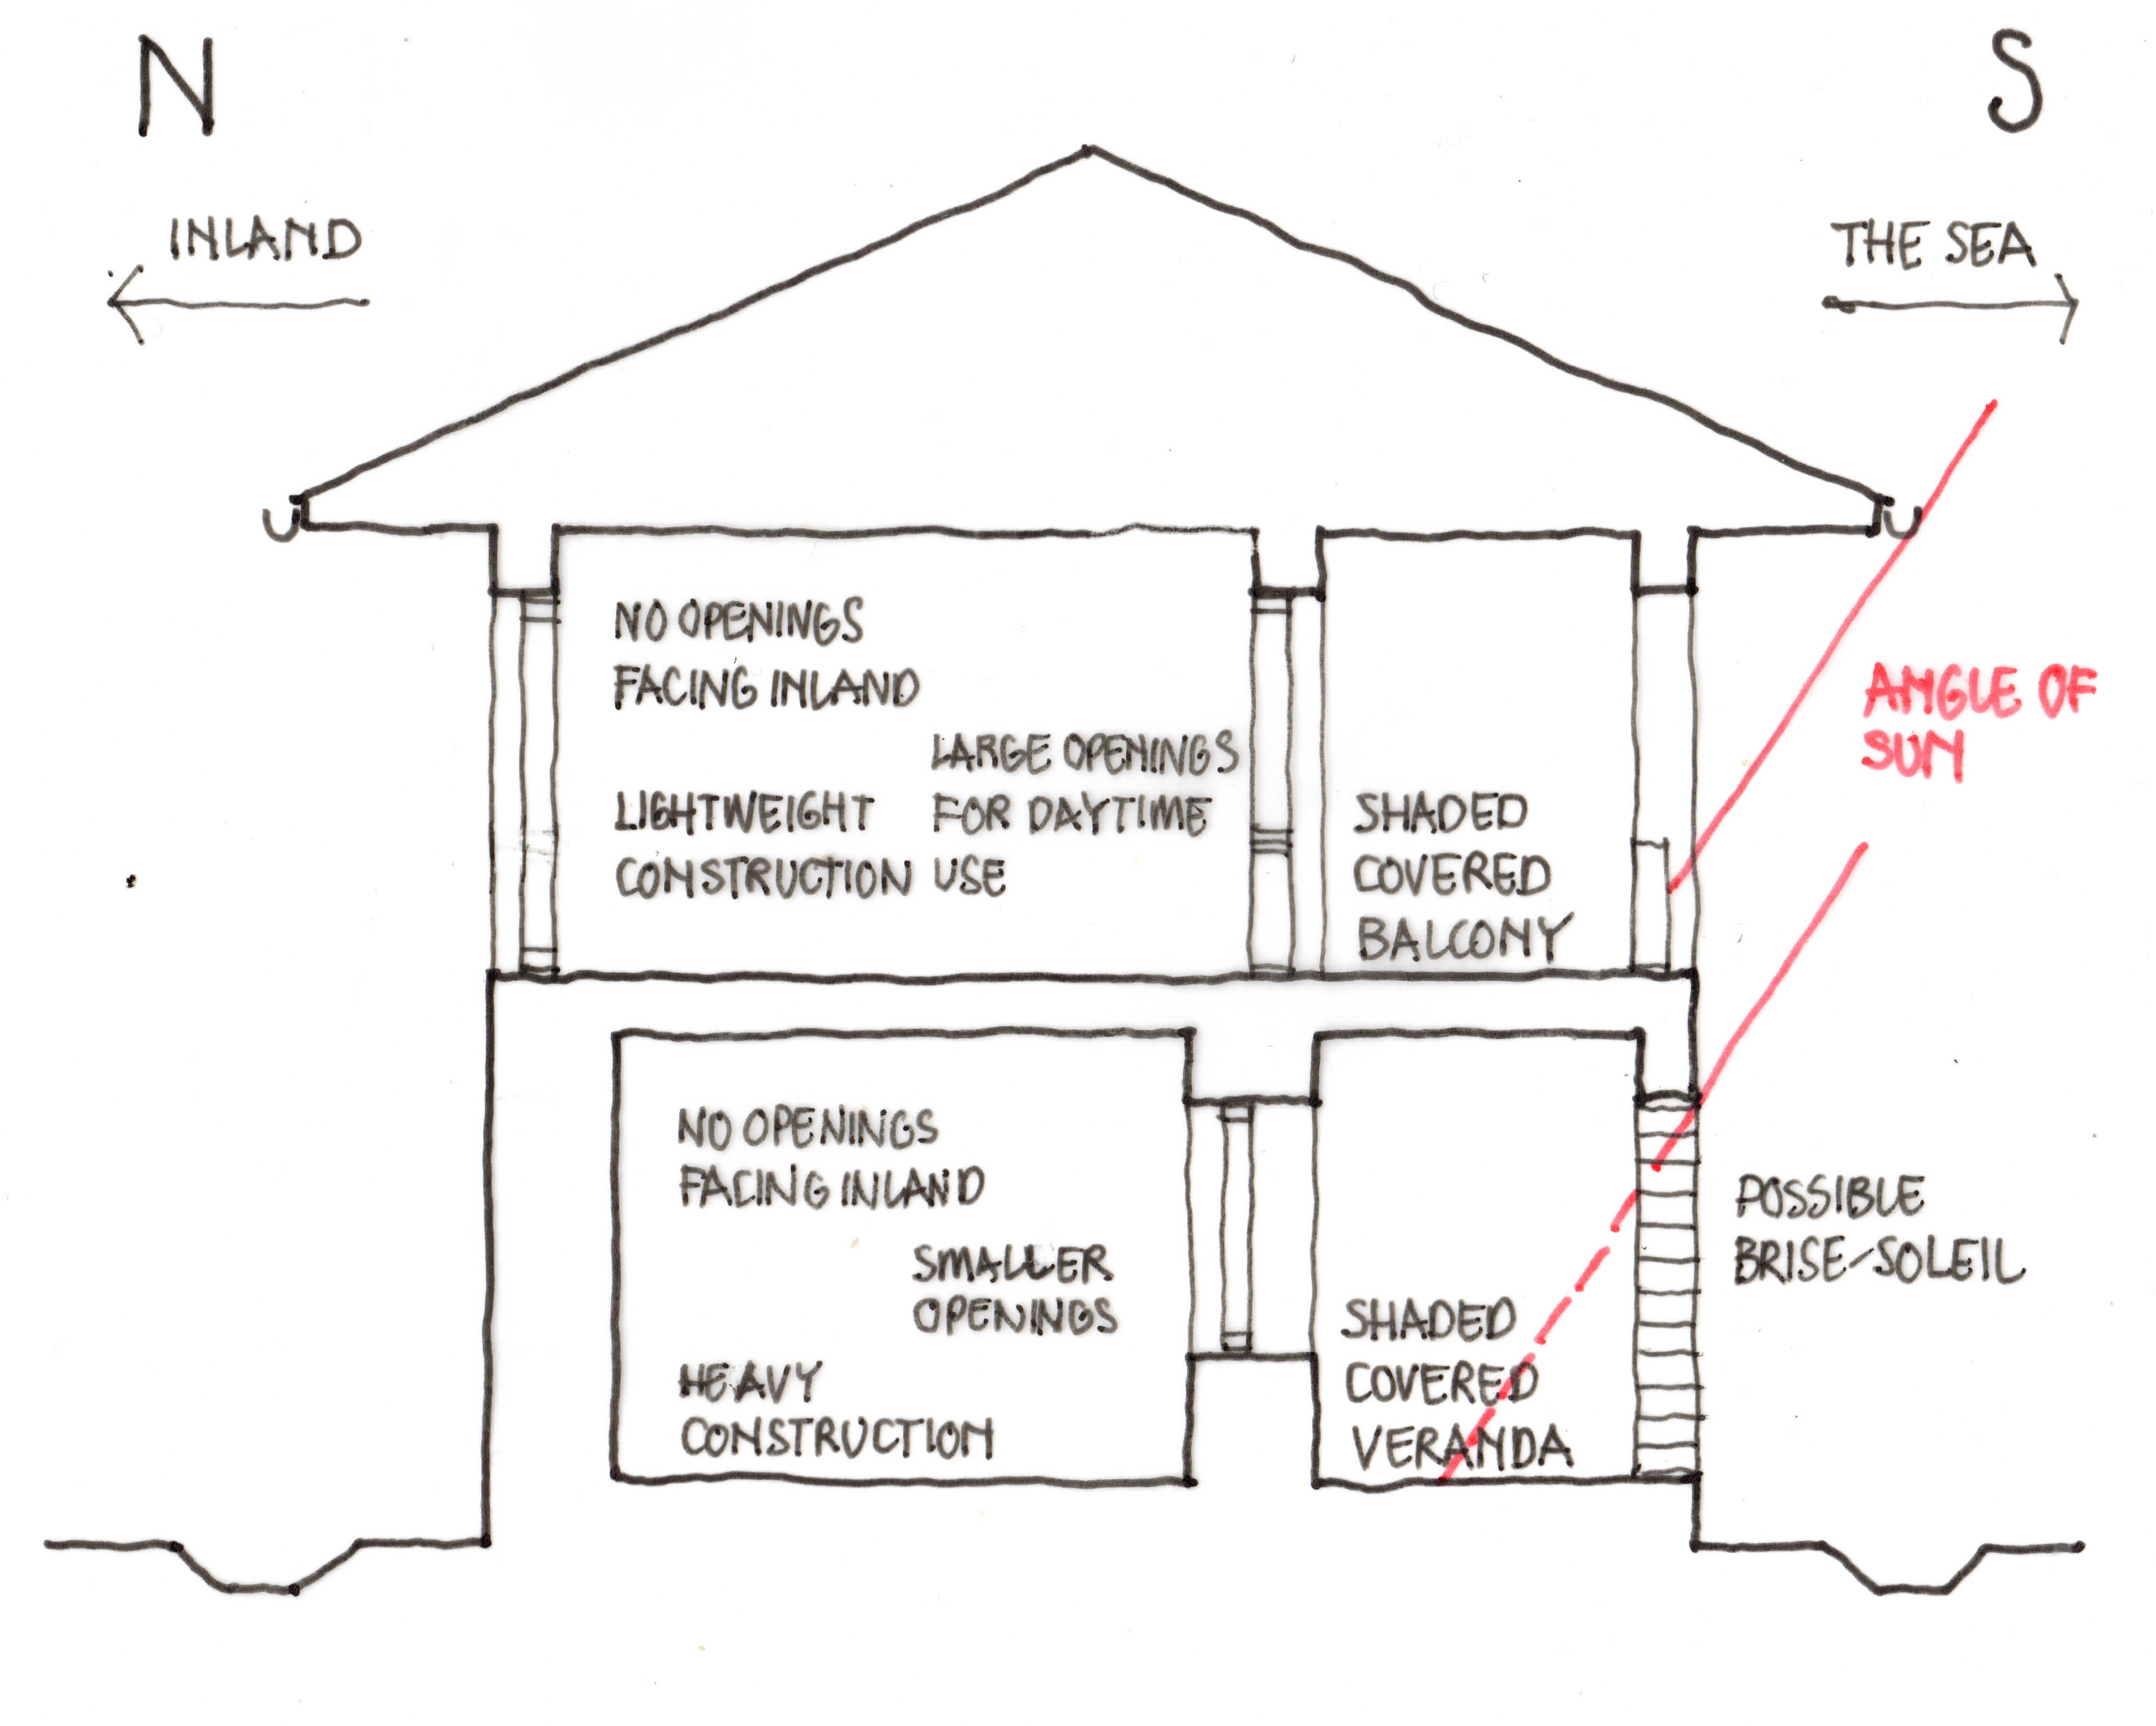
Figure 17: Section through a two-storey building
Two examples of health facilities constructed in this climatic zone are the Aga Khan University Hospital in Karachi and the Aga Khan Maternal and Childcare Centre in Hyderabad. These incorporate features designed to ameliorate the climate and provide more comfortable conditions within and around the buildings including courtyards with planting and water features; high thermal capacity walls; windows deep-set in the walls and shaded from the sun; deep, shaded walkways; ‘jaalis’ or punctured screens providing shade to corridors, etc.; ventilated ceiling spaces and wind towers. Photographs are included in Annex 3.

4.4. Design for Composite Climates

4.4.1 Climatic Conditions
There are climates found in KPP and other parts of the country which are called ‘composite climates’ as they are neither consistently hot and dry, nor warm and humid. Their characteristics change from season to season, alternating between long, hot dry periods to shorter periods of concentrated rainfall and high humidity. In many areas there is also a third season, with dry sunny days and uncomfortable cold nights, which is commonly referred to as ‘winter’. These composite climates pose difficulties for designers as solutions suitable for one season will be unsatisfactory for others.

4.4.2 Design Considerations
A moderately compact building layout with courtyards will be suitable for most of the year. Buildings should be orientated and grouped so as to take advantage of prevailing breezes during the short period when air movement is beneficial.
Two-storey buildings, placed fairly close together, will ensure protection of out-door spaces, provide mutual shading of external walls, shelter from the wind and dust, and reduce surfaces exposed to solar radiation.
Large projecting eaves and wide verandas will be beneficial during the warm-humid season to reduce sky glare, keep out the rain and provide shade for waiting areas and external routes. They can also be an asset during the dry periods. Brise-soleils, louvres, etc used to protect openings during the hot-dry period, also provide protection against rain in the rainy season. Any shading devices should be of low thermal capacity so that they do not store the heat.
Low wall temperatures at night are desirable in the hot-dry season; but walls that retain the heat of the day are useful for cold season nights. External walls and roofs (of single-storey buildings) should therefore be constructed of thick, solid materials.
The orientation of openings will be determined by two factors:
- the direction of the prevailing breeze during the warm-humid season, to harness its cooling effect.
- facing towards the sun during the cold season to harness solar radiation.
But these factors can be contradictory. Window openings should be large and on opposite walls to allow cross-ventilation in the warm-humid and hot-dry seasons; and they should be fitted with heavy shutters to keep out the cold.
A possible solution to address these conditions is a two-storey building with a ground floor with heavy walls and large shuttered openings; and a first-floor structure of lightweight materials with window openings on both sides.

4.4.3 Summary of Measures (see also Figure 18):
- Provide compact two-storey buildings with courtyards.
- Orientate buildings to face the prevailing breeze.
- Use projecting eaves and wide verandas to provide shade.
- Use low thermal capacity shading devices to window openings.
- Use thick, heavy materials for walls on ground floor.
- Use lightweight materials for walls and roof on first floor.
- Provide window openings (protected with heavy shutters) on opposite sides of rooms.
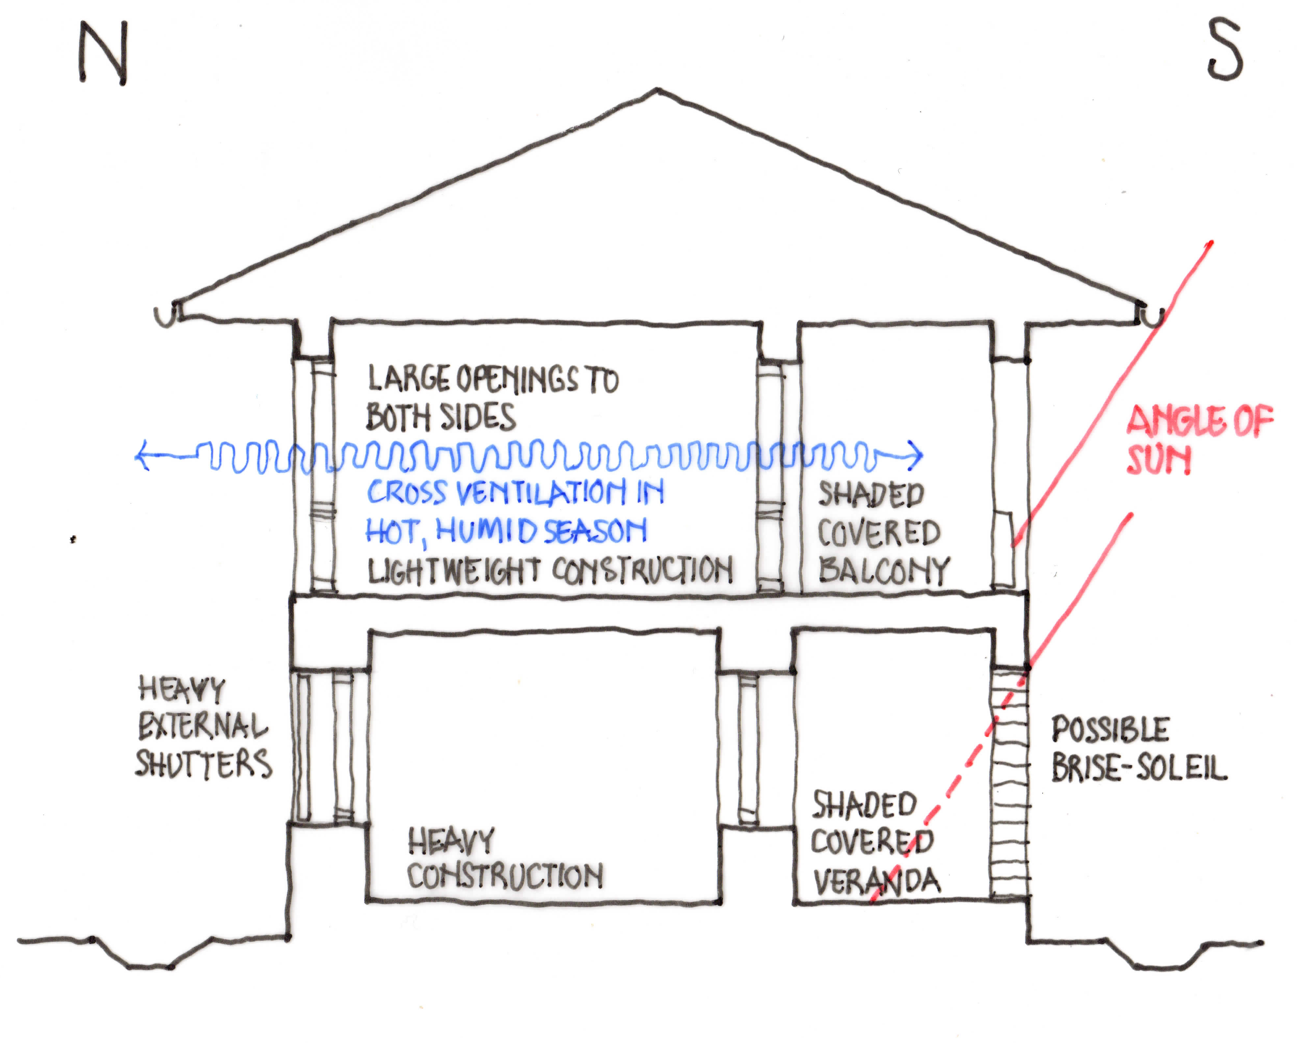
Figure 118: Section through a two-storey building

Section 5: Design Guidelines for Renovation
The reuse and renovation of existing buildings will always produce less GHGs than the construction of new buildings and if it is possible to renovate and if necessary, extend existing buildings this will always be preferable to demolition and construction of new ones. This section therefore provides advice on ways to renovate existing health facilities while reducing the carbon footprint of the facilities.

5.1. Cooler Upland and Mountainous Areas

5.1.1 Design Considerations
As stated in Section 4.1, designers of health facilities in upland and mountainous areas are presented with a number of significant challenges. For the comfort of users, buildings have to cope with the climatic extremes: very cold in winter, and hot and humid during the monsoon season. Measures also have to be taken to protect the buildings against possible flooding and earthquakes.

5.1.2. Summary of Measures:
- Replace low-pitch roofs with lightweight, steep roofs to deal with the frequent rain and in places, heavy snow fall.
- Provide large roof overhangs to protect windows and walls against the sun and the rain.
- Tie down and brace roofs in order to withstand heavy winds.
- Insulate roofs to protect them against the heat during the summer and the cold during the winter.
- Provide ceilings where these are missing.
- Insulate external walls to protect them against the heat during the summer and the cold during the winter.
- Provide covered verandas for access and for waiting areas.
- Provide additional windows as necessary to both sides of rooms to provide cross-ventilation in the hot, summer months.
- Provide solar water heaters and photovoltaic panels for generating electricity.
- Replace existing lights with LED lights.
- Use air or ground source heat pumps for heating during the winter.
- Provide double-glazed windows for insulation in the winter.
- Reinforce foundations and walls to withstand earthquakes.
Sites will require protection from the rain, with storm drains connecting to site drains taking surface water away from the buildings.
In areas that experience water shortages but where there is consistent rainfall, water should be stored for later use in ground level or underground tanks.
Trees and other vegetation planted around the buildings will help protect them from the sun and wind.

5.2. Hot, Dry and Arid Areas

5.2.1 Design Considerations
In hot, dry and arid areas, physical comfort during the day depends mainly on a reduction of the intense radiation from the sun, ground and surrounding buildings. At night the air temperature is frequently low enough to permit an increase in effective temperature through surface temperatures being higher than the air temperature and such an increase may be beneficial in a health facility by providing a measure of warmth during the cold nights.
Buildings and external spaces need to be protected from the intense solar radiation and the hot, dusty winds. Enclosed, compactly planned, inward-looking buildings are the most suitable. Shading of roofs, walls and outdoor spaces is critical through the use of projecting roofs, double roofs, verandas, external brise-soleil walls, etc. Care must be taken to use low thermal capacity materials for any shading devices that are close to openings to ensure their quick cooling after sunset.
Walls and roofs should be thick and constructed of heavy materials with a large thermal capacity in order to absorb much of the heat entering through external surfaces during the day. Windows should be set in deep reveals or protected by heavy shutters that are closed during the day.
Covered verandas and colonnades can be used for circulation or waiting spaces; and small, enclosed courtyards, with pools of water, if possible, can also help provide the shade and coolness. See 4.2 for further details.

5.2.2 Summary of Measures:
- If additional buildings are required, use these to form small courtyards.
- Provide water pools within courtyards.
- If existing walls are not of heavy construction, an extra skin of bricks can be added externally to increase the wall thickness and reduce daytime internal temperatures.
- If existing roofs are not of heavy construction, a lightweight roof above the existing roof with a ventilated space between can reduce the solar load on the existing roof.
- Provide a reflective surface to the existing roof to help reduce the solar load.
- If floor to roof height is sufficient, the provision of deep, well-ventilated ceiling space and an insulated ceiling will help reduce daytime temperatures.
- If walls are thick, or it is possible to increase their thickness, setting windows well back in the wall protected from the sun will reduce daytime temperatures.
- If the walls are not thick and it is not possible to increase their thickness, the provision of shading devices and heavy shutters (closed during the day) will protect windows and help to reduce daytime temperatures.
- Provide external, shaded verandas for waiting and circulation areas.
- Provide external screen walls of ‘brise-soleil’ that allow the light through but prevent solar radiation striking the external walls.
- Provide solar water heaters and photovoltaic panels for generating electricity.
- Replace existing lights with light-emitting diode lights.
- Construct wind towers to individual rooms or areas of the buildings.
- Where water is available, use planting to shade buildings and reduce dust.

5.3. Maritime Desert Areas

5.3.1 Design Considerations
This climate presents the greatest challenge for building design. The use of high thermal capacity structures as in hot, dry and arid areas can be useful but they will not be as effective as in hot-dry and arid regions. The use of wind towers is particularly effective (see Annex 1).
The coastal wind blowing off the sea during the day may be utilised to mitigate the heat. The night-time wind blowing towards the sea brings the hot inland desert air and dust and it can be decidedly unpleasant and protection from this should be provided.

5.3.2 Summary of Measures:
- For existing, structurally sound, single-storey buildings of heavy construction - additional facilities of lightweight construction can be added on the first floor.
- If this is not structurally possible and there is sufficient space on the site, additional buildings of lightweight construction can be constructed for use during the day, while improving existing buildings following the guidelines in 4.3 above and adding wind towers if possible.

5.4. Composite Climate Areas

5.4.1 Design Considerations
A moderately compact building layout with courtyards will be suitable for most of the year. Buildings should be orientated and grouped so as to take advantage of prevailing breezes during the short period when air movement is beneficial.
Two-storey buildings, placed fairly close together, will ensure protection of out-door spaces, provide mutual shading of external walls, shelter from the wind and dust, and reduce surfaces exposed to solar radiation.
Large projecting eaves and wide verandas will be beneficial during the warm-humid season to reduce sky glare, keep out the rain and provide shade for waiting areas and external routes. They can also be an asset during the dry seasons.
Brise-soleils, louvres, etc used to protect openings during the hot-dry period, also provide protection against rain in the rainy season. Any shading devices should be of low thermal capacity so that they do not store the heat.
Low wall temperatures at night are desirable in the hot-dry season; but walls that retain the heat of the day are useful for cold season nights. External walls and roofs (of single-storey buildings) should therefore be constructed of thick, solid materials.
Window openings should be large and on opposite walls to allow for cross-ventilation in the warm-humid and hot-dry seasons, and fitted with heavy shutters that can be closed in the cold season.

5.4.2 Summary of Measures:
- If the existing buildings are single-storey, structurally sound and capable of supporting additional facilities then these should be constructed of lightweight construction on the first floor.
- If this is not structurally possible then existing single-storey buildings should be improved following the guidelines in 4.4.
- If the existing buildings are two-storey and additional facilities are required, these should be provided in additional two-storey buildings, following the guidelines in 4.4, constructed close to the existing buildings to provide shade, courtyards and sheltered spaces.
- Replace existing roofs with roofs with large overhangs to protect walls and windows from the sun and rain. The roofs should be adequately insulated and insulated ceilings should be provided.
- Construct covered verandas to provide external waiting and circulation spaces.
- If existing ground floor windows are small, enlarge them to improve ventilation during the warm and hot seasons and fit them with heavy shutters that can be closed to retain heat during the cold season.
- Protect windows from solar radiation by sun breakers, louvres or brise-soleil.

References
1. World Bank. 2022. Climate and Health Vulnerability Assessment (CHVA) https://worldbankgroup.sharepoint.com.mcas.ms/:w:/s/wbg
2. Pakistan Climate and Health Vulnerability Assessment (CHVA) 2022
3.World Bank. 2017. Climate-Smart Healthcare: Low-Carbon and Resilience Strategies for the Health Sector. World Bank, Washington, DC. https://documents1.worldbank.org/curated/en/322251495434571418/pdf/113572-WP-PUBLIC-FINAL-WBG-Climate-smart-Healthcare-002.pdf
4. World Bank. Country Climate and Development Report (CCDR) HD Guidance Note (2022) https://www.worldbank.org/en/publication/country-climate-development-reports
5. World Bank. 2023. Applying Paris Alignment to all HD projects
6. World Bank. 2022. COP27 Climate and Health https://worldbankgroup.sharepoint.com.mcas.ms/:w:/s/wbggh/EYP94yAMD9dNiFkaPRvb7aIBS42qFCxQj_9l7-fELkS10w?e=067VtO
7. World Bank. 2022. Integrating climate change into HD operations Meeting Corporate Commitments and Enhancing Quality - Guidance Note for Staff
8. WHO health and climate change global survey report. Geneva: World Health Organization; 2021. Licence: CC BY-NC-SA 3.0 IGO.
9. WHO. 2020. WHO guidance for climate-resilient and environmentally sustainable health care facilities. Geneva: World Health Organization; 2020. https://www.who.int/publications-detail-redirect/9789240012226
10. WHO. 2015. Operational framework for building climate resilient health systems. (2015) ISBN: 978 92 4 156507 https://www.who.int/publications/i/item/9789241565073
11. World Bank Group. 2022. Pakistan Country Climate and Development Report. CCDR Series; World Bank, Washington, DC. © World Bank Group. https://openknowledge.worldbank.org/handle/10986/38277 License: CC BY-NC-ND. http://hdl.handle.net/10986/38277
12. WHO. 2021. Health in national adaptation plans: review. Geneva: World Health Organization; 2021. Licence: CC BY-NC-SA 3.0 IGO.
13. World Health Organization & United Nations Framework Convention on Climate Change. ‎2021‎. Health and climate change: country profile 2021: Dominican Republic. World Health Organization. https://apps.who.int/iris/handle/10665/339961. License: CC BY-NC-SA 3.0 IGO
14. PAHO. 2020. Building Resilient Health Centres to Withstand Climate Change. https://www.paho.org/en/stories/building-resilient-health-centres-withstand-climate-change
15. Pakistan Floods 2022: Post-Disaster Needs Assessment (PDNA) https://www.undp.org/ Pakistan/publications/ akistan-floods-2022-post-disaster-needs-assessment-pdna
16.Climate descriptions and diagrams from ‘Manual of Tropical Housing and Building: Part 1 Climatic Design’ by Koenigsberger, Ingersoll, Mayhew, Szokolay, published by Longman, UK.
17. World Bank. 2019. The World Bank Group Action Plan on Climate Change Adaptation and Resilience, Washington, DC: World Bank. © World Bank.
18. World Bank Group. 2017. World Bank Group Approach and Action Plan for Climate Change and Health. © World Bank, Washington, DC. http://hdl.handle.net/10986/27808 License: CC BY 3.0 IGO.”
19. Pakistan Floods 2022: Resilient Recovery, Rehabilitation, and Reconstruction Framework (4RF) https://www.undp.org/pakistan/publications/pakistan-floods-2022-resilient-recovery-rehabilitation-and-reconstruction-framework-4rf
20. The Aga Khan Development Network (AKDN). 2022. Amir Jivraj: Civil engineering behind AKDN’s climate-friendly buildings https://the.akdn/en/resources-media/whats-new/our-stories/amir-jivraj-civil-engineering-behind-akdns-climate-friendly-buildings
21. International Finance Corporation. 2023. EDGE – Excellence in Design for Greater Efficiencies (EN) https://edgebuildings.com/edge-excellence-in-design-for-greater-efficiencies/
22. Holcim is a Swiss multinational company that manufactures building materials and is a global leader in the development of innovative and sustainable building solutions.
23. Portland cement production is responsible for over 8% of global carbon emissions yet its production is set to increase by 25% by 2050 - a period in which rapid global decarbonisation is urgently required. Current methods of reducing the amount of embodied carbon in concrete – replacing cement with supplementary cementitious materials (SCMs) such as slag and fly ash – are inadequate due to their small and declining supply, but there are promising alternatives that can be developed and used to meet these challenges. One plentiful and readily available SCM material is clay. Clays with a high kaolinite content, rich in silica and alumina, have been shown to be highly pozzolanic if calcined at 700-850°C and they exist worldwide in massive quantities. Another abundant SCM is limestone, which can be ground for use at modest ratios in cement in its uncalcined state. Reducing construction industry emissions by the extent necessary to limit warming to 1.5°C will require a huge increase in the use of alternative cements and a shift away from Portland clinker, GGBS and fly ash, in addition to lowering the overall demand for cement where possible.
24. Fibre-reinforced concrete generally has more tensile strength than normal concrete, and it can be used in tough situations where a lot of support is needed. It displays a very high ductility strength and can prevent cracks from appearing. Carbon fibre will add strength, durability, and resistance to tension and is more advantageous than steel because it is almost 80% lighter than steel; it is durable and will not corrode easily; its tensile strength is multiplied by 5; its stiffness is multiplied by two and it can tolerate high temperatures. The use of fibre-reinforced concrete can therefore greatly reduce the amount of concrete that is required in any given situation.

Annex 1: Wind Towers or Wind Catchers
Wind towers, wind catchers or wind scoops have been widely used in North Africa, the Middle East and West Asia for many centuries to provide ventilation and passive cooling within buildings but the use of them in modern times has declined with the increased use of air-conditioning.
Wind towers can function in two ways: by directing airflow using the pressure of wind blowing into it or by increasing airflow using buoyancy forces from temperature gradients (stack effect). The importance of wind pressure increases with increasing wind speed and this is generally more important than stack effect.
The design of a wind tower will depend largely on the prevailing wind direction: if the wind tends to blow from only one direction, it may have only one opening, and no internal partitions. In areas with variable wind directions, there may be internal walls, dividing it into vertical sections with openings facing in multiple directions.
Taller wind towers catch higher winds and these are usually stronger and cooler and the air at high levels is usually less dusty. Taller wind towers also have a stronger stack effect. Wind towers can assist with night-flushing which cools buildings at night by increasing ventilation when the outdoor air is cooler.
Wind towers can also cool air by drawing it over cool objects and they can also cool by drawing air over water and if the air is dry, they will also cool the air through evaporative cooling.
To sum up, the use of wind towers together with other traditional methods of climate control such as heavy wall and roof construction and courtyards (see sections above), could provide very effective and in the long term, economic and energy free, passive cooling in health facilities particularly in hot, dry and arid and maritime desert areas and local consultants are encouraged to explore more fully the use of these techniques.
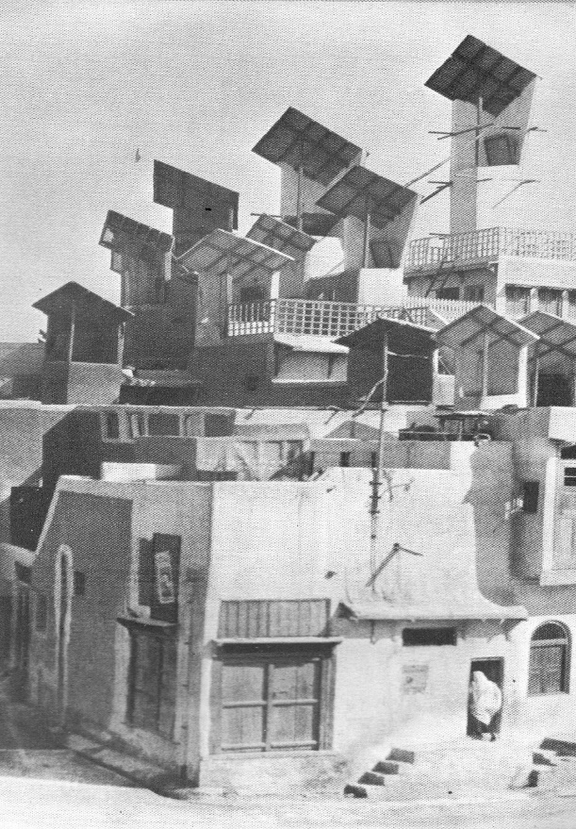
Figure 19: Wind towers in Lower Sindh. Photo from ‘Architecture without Architects’ by Bernard Rudofsky, published by Academy Editions, London

Annex 2: Guidelines for Managing the Maintenance of Health Facilities

1. Introduction
Regardless of how well-designed health facilities are in terms of climate resilience, appropriateness, the comfort of users, etc, this will count for little if the facilities are not well maintained and do not have long, useful lives.
In many less-developed countries, important capital assets including health facilities are run down beyond the point of economic repair. There are many reasons for this but it is mainly due to inadequate management of the maintenance of the facilities and inadequate finance for maintenance.

2. What is Maintenance?
Building maintenance has been defined as ‘work undertaken in order to keep every part of a building, its services and surroundings to an acceptable standard and to sustain the utility and value of the facility’. Its functional role is therefore to retain the usefulness of the facilities to the users on a long-term basis.
Maintenance should be differentiated from renovation or rehabilitation works which are usually one-off projects, large in scale, and expensive. Renovation work also usually means that the building being renovated will be out of use for the length of the renovation programme which will disrupt the services of the facility. Continuous small-scale maintenance of a building should help avoid the need for costly and disruptive renovations.

3. Why Maintain Buildings?
Any building such as a health centre should be seen as an asset for the whole community and will only be able to serve the community appropriately if it is kept in good condition. Nurses will find it difficult to treat patients if the roof leaks or windows are broken, whereas buildings that are regularly maintained and kept in good repair will provide safe, pleasant, and healthy environments for staff and patients. Regular maintenance will also protect the original investment in the facilities.
In areas prone to earthquakes, floods, or other natural disasters, regular maintenance will help to minimize damage to the buildings and contents and ensure that the buildings provide safe places of refuge for the local community.

4. Types of Maintenance
Maintenance can be divided into three basic types:
- Day-to-day, preventative maintenance work directed at the prevention of failure of a building or building component.
- Regular corrective or remedial maintenance such as decorating, re-roofing or rewiring a building or replacing doors or windows in order that the facility can continue to operate.
- Unplanned remedial maintenance or repairs such as repairs.
Wherever possible maintenance should be carried out on a preventative basis with specific time cycles allocated for each particular task such as a four-year cycle for re-painting. Unfortunately, there is always a temptation to extend maintenance cycles when funds are in short supply although this will lead to an ever-increasing backlog of work and increasing difficulty in returning the facilities to an acceptable standard.
An expenditure budget should therefore be established which takes into account regular, planned preventative, and corrective maintenance items but also allows for a variety of unplanned, occasional items such as broken windows, etc.

5. Maintenance Policy
It is important that there is a national policy on maintenance and that the government recognizes the need for regular maintenance and most importantly, the need for finance for maintenance. The ownership of, and the responsibility for maintaining facilities should also be clear.

6. Management of Maintenance
A management system for maintenance should be put in place which should clearly set out the responsibilities for the maintenance of health facilities by all those involved at the provincial, district, and facility levels.
Realistic budgets should also be put in place for planned preventative and corrective maintenance and unplanned emergency repairs at the provincial, district, and facility levels.
The maintenance budget should include funding for all the preventative maintenance cycles together with the planned remedial maintenance items. Some allowance should also be built into the budget for those remedial items or repairs that cannot be foreseen.
The manager in charge of maintenance will be in a stronger position to secure sufficient funds if a fully costed programme is prepared for all the maintenance cycles from which an accurate budget for the whole maintenance programme can be prepared.
While much of the day-to-day maintenance and repairs should be the responsibility of health facility staff, there should also be an effective reporting system for items of repair that are beyond the remit of the facility staff and that will have to be undertaken by district or provincial authorities.

7. Maintenance Manuals
The simple day-to-day maintenance of a facility will be the responsibility of the facility staff (one member of staff should be made responsible for maintenance) and simple maintenance manuals should be prepared to be used by health facility staff. The maintenance manuals should include the following information:
- Date of construction, name of builder and architect, location and means of access.
- As-built-drawings of the facilities showing the buildings, construction details and all electrical, water, telephone and drainage services including those that are concealed. These drawings should be updated to show any later additions and alterations.
- Specifications of all materials and finishes including paint types and colours, etc.
- Details of any special maintenance requirements.
- An indicative maintenance plan showing what items will require maintenance or replacement and when.
- An indicative maintenance budget showing what expenditure is likely and when and what should be budgeted for.
The manuals should also give guidance on maintaining the buildings and on rectifying common faults. Inspections should be carried out regularly and the manual should contain checklists for inspections and preventative maintenance actions that should take place at weekly, monthly, and yearly intervals by facility staff and district and provincial staff.
Records should be kept of maintenance inspections, actions taken to rectify any faults found and the cost of putting them right, and a system should be put in place for reporting more serious problems that cannot be dealt with by the facility staff to the district or other authorities.

8. Maintenance Guidelines
A maintenance plan should be developed for each facility. This plan should cover regular inspections, preventative and remedial maintenance and repairs. Inspections should take weekly, monthly, and annually and preventative maintenance should take place on a 4/5-year cycle.
The daily/weekly action list should mainly cover preventative maintenance actions such as general cleaning in and around the health facility while keeping an eye open for any obvious problems such as the appearance of termite trails, roof leaks, etc. Floors should be swept regularly; furniture should be moved and the floor cleaned underneath and behind and toilets should be kept clean and functioning.
The monthly inspection list should contain items such as inspecting and trimming trees or bushes close to the building; checking roofs and gutters for damage, loose nails or screws and leaves; checking for termites or nesting insects; checking that doors, windows, locks, etc are in working order; checking that toilets, wash-basins, taps, wastes, etc are in working order; checking that storm-drains are not blocked; checking that light fittings are working; checking that furniture is in good order; etc.
The annual inspection list should contain items such as checking the roof for leaks, damage, rust, etc; checking gutters and down-pipes for damage, blockages, etc; checking all exposed roof timbers and fascias for paint finish, rot, etc; checking ceilings for water damage, sagging, etc; checking floors for cracks or damage; checking walls for cracks or damage; checking windows, doors, frames, and hardware for faults and damage; checking the electrical system for faults; checking water supplies for leaks and other damage; checking the whole sanitary installation, septic tanks and soakaways for faults, blockages or damage; checking storm-drains for blockages or damage.
An action list should be pinned up within the facility to remind staff of the weekly maintenance and cleaning actions required of them. Inspection checklists should be devised for the monthly and annual inspections to be used by facility, district, and provincial staff. It must be emphasized that action must be taken as soon as possible if a problem is discovered. Small problems that can be easily dealt with will become much larger problems that will be difficult and expensive to deal with if they are not resolved as soon as they are discovered.
It would also be a good idea to devise a set of rules for staff and patients using the facilities and display these prominently.

Annex 3: Illustrations

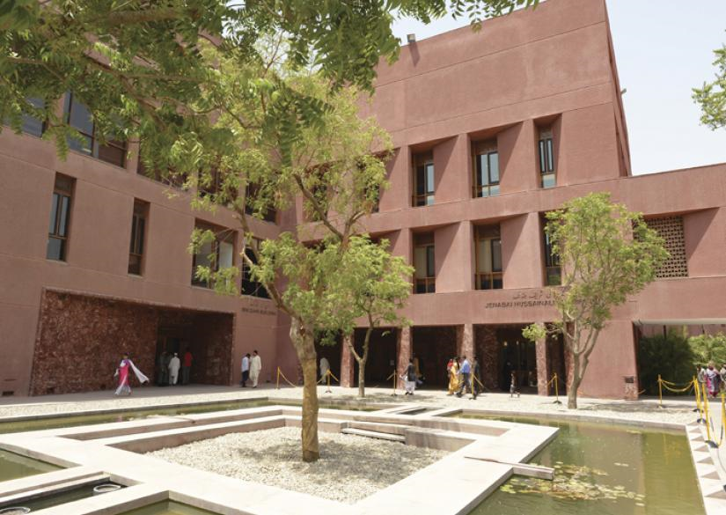
Figure 12: Aga Khan University Hospital: deep-set windows and colonnaded, shaded walkways (Khadem Studio/Payette Associates)
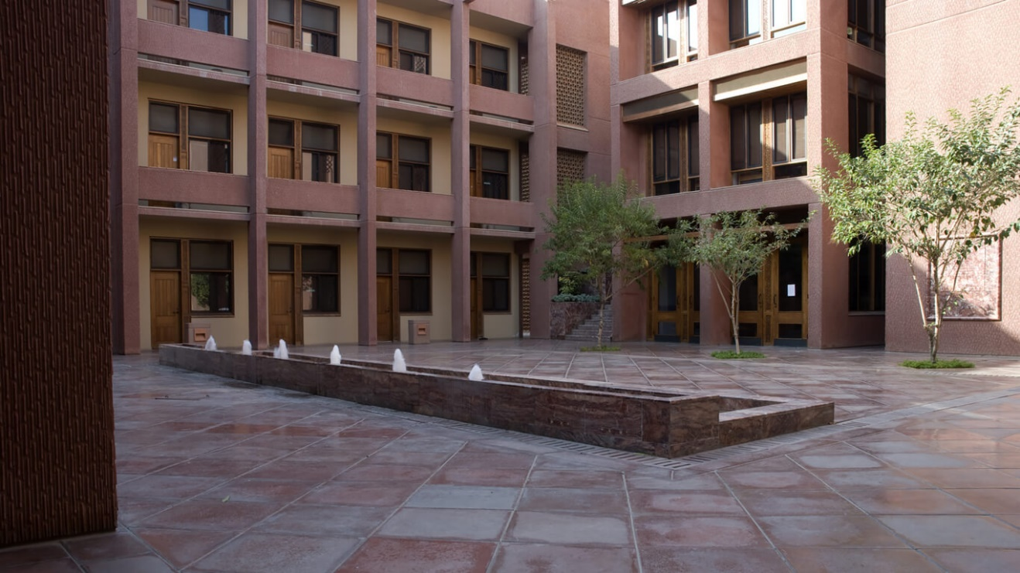
Figure 21: Aga Khan University Hospital: courtyards, water features, jaalis and shaded walkways (Khadem Studio/Payette Associates)
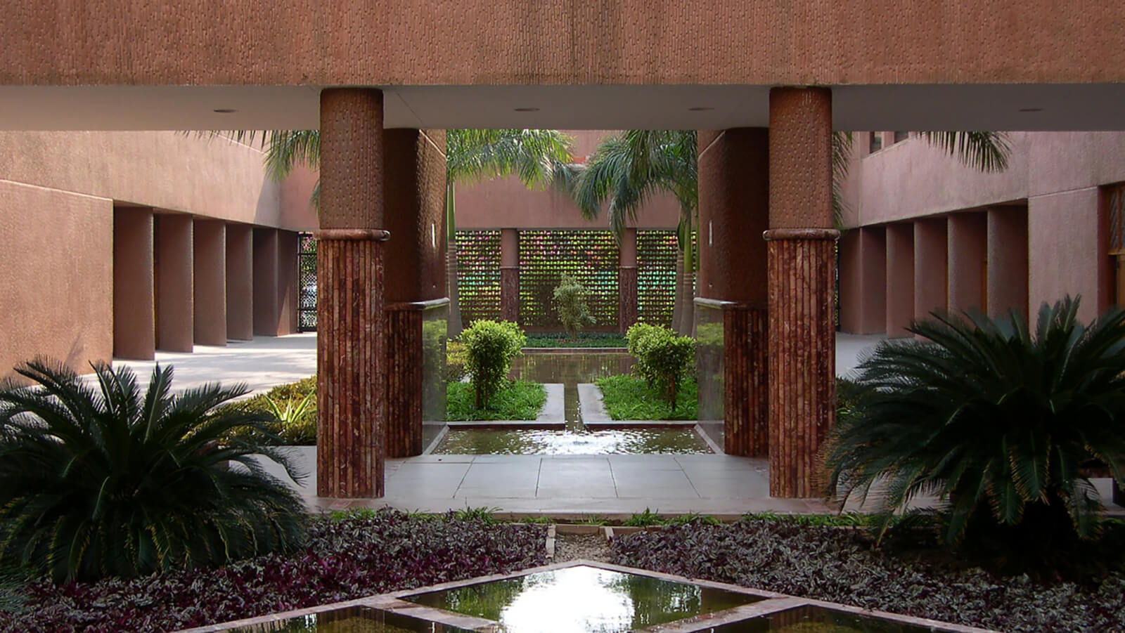
Figure 132: Aga Khan University Hospital: courtyards, water features, jaalis and shaded walkways (Khadem Studio/Payette Associates)
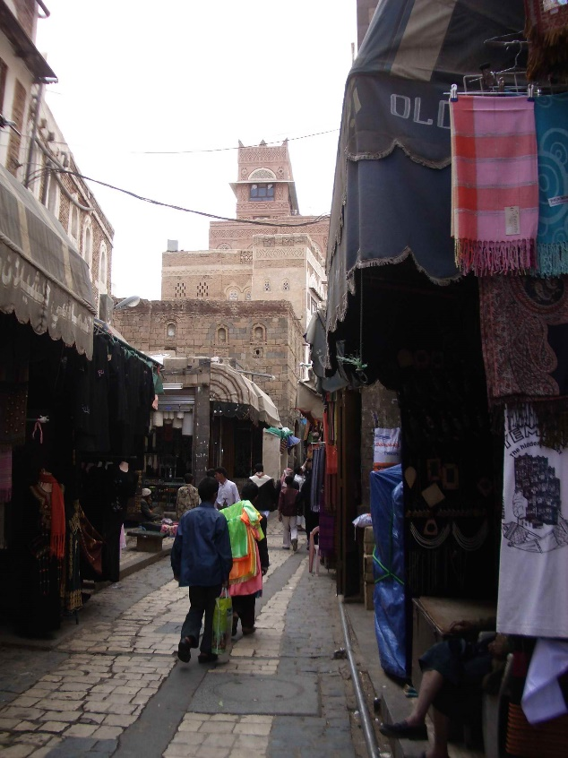
Figure 143: Street scene in Sana’a, Yemen: shade provided by constructing buildings close together (photo: Nigel Wakeham)
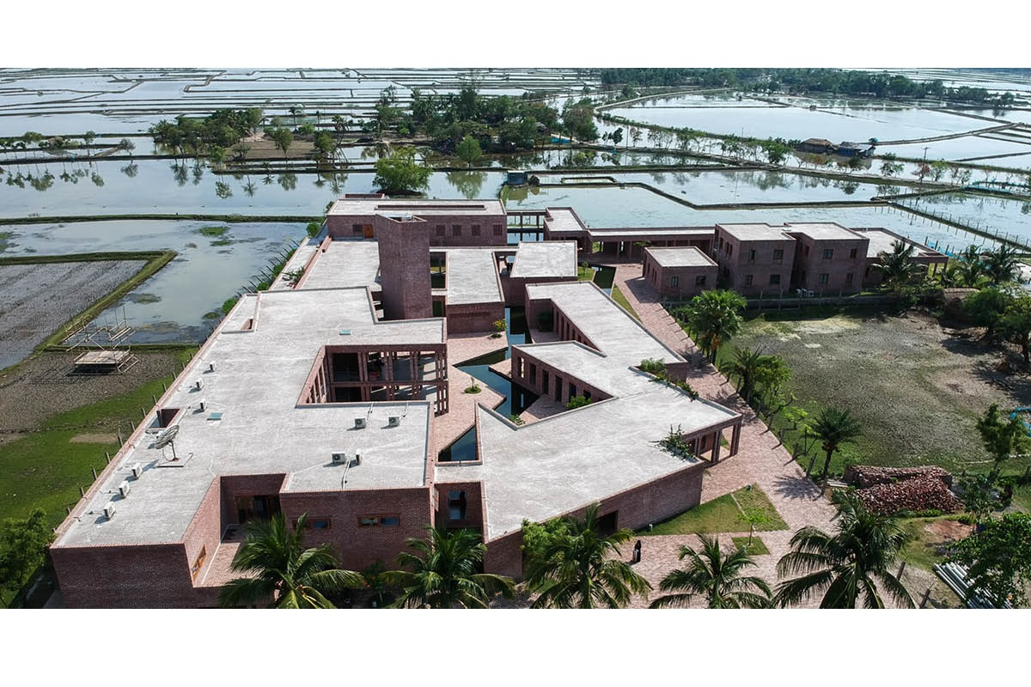
Figure 154: Friendship Hospital in Bangladesh: courtyards (Kashef Chowdhury/URBANA Architects @Asif Salman)

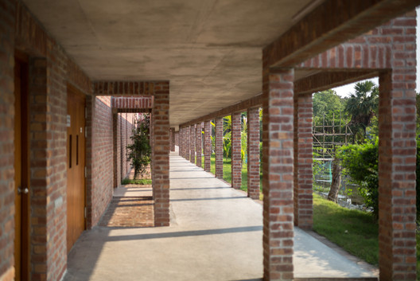
Figure 165: Friendship Hospital in Bangladesh: wide covered walkways keeping the sun off the main walls (Kashef Chowdhury/URBANA Architects @Asif Salman)
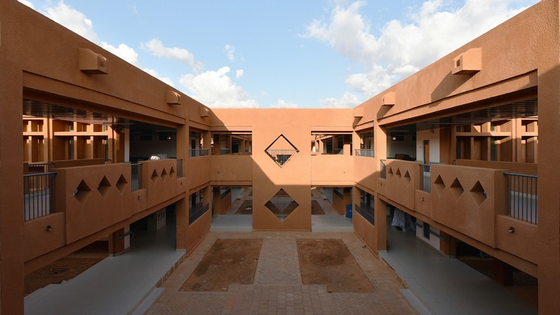
Figure 176: Courtyard in General Hospital of Niger (CADI Architects)
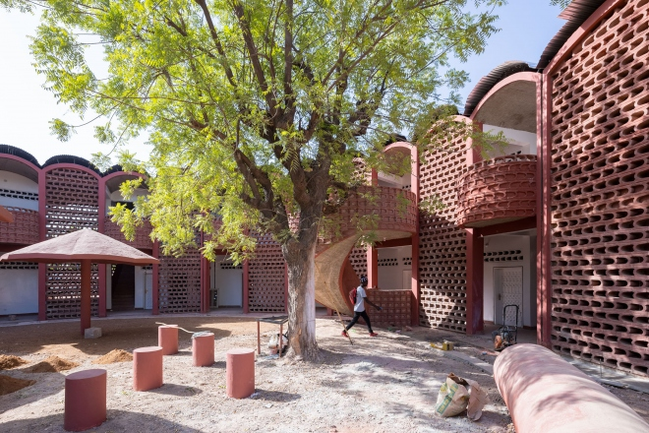
Figure 187: Maternity Clinic in Senegal: courtyard and clostra blocks (Manual Herz Architects)
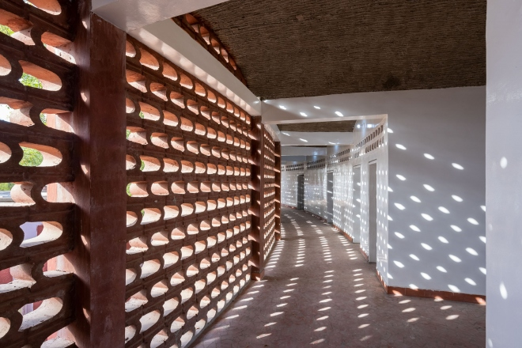
Figure 198: Maternity Clinic in Senegal: corridor protected from the sun by clostra blocks (Manual Herz Architects)
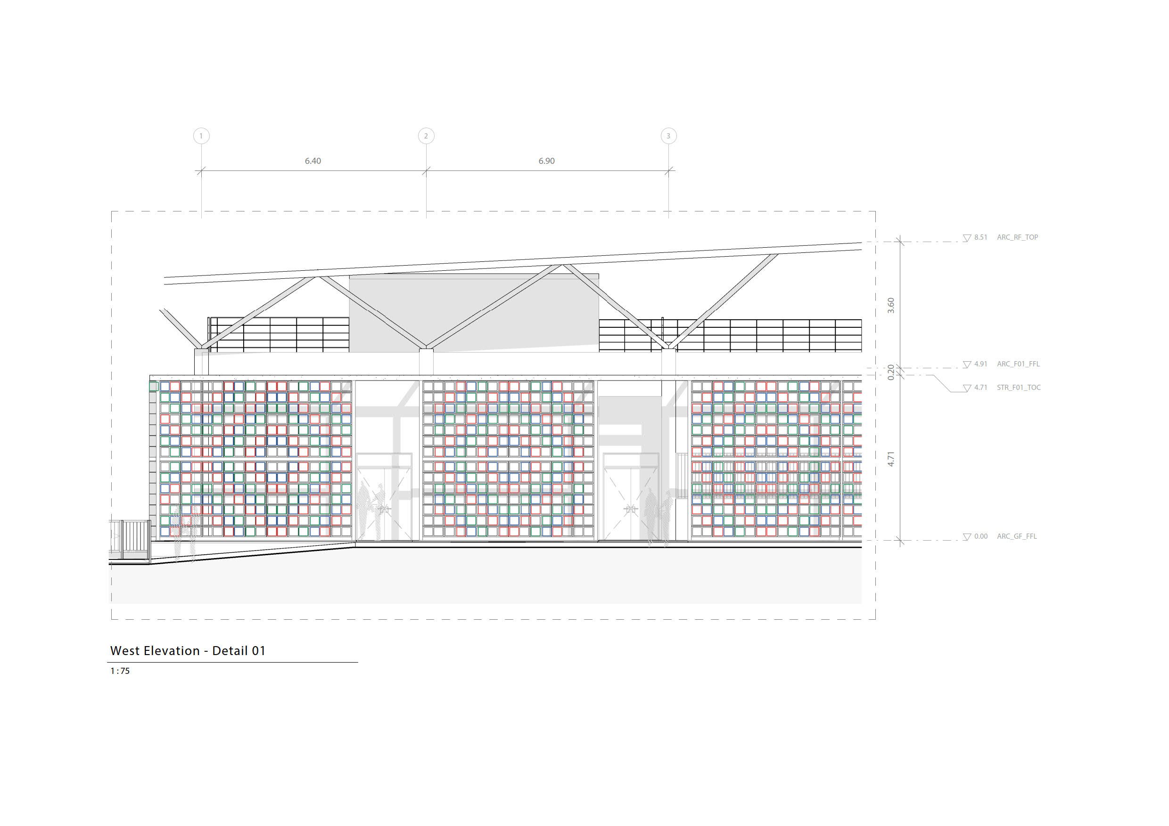
Figure 209: Elevation of Food and Drug Laboratory, the Gambia: external clostra block walls protecting main walls from the sun (IDOM Architects).
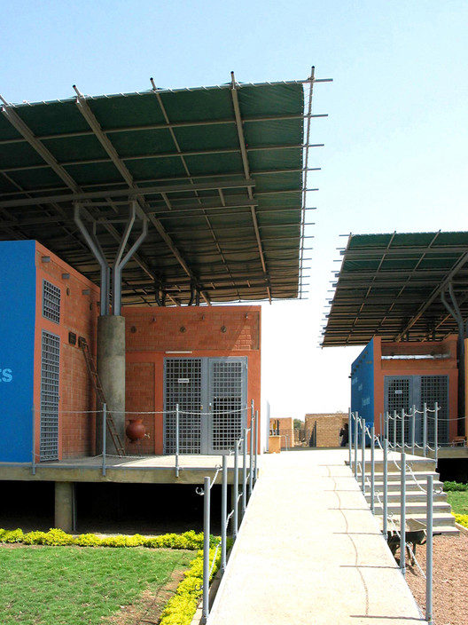
Figure 30: Ougadougou Health Centre: double roofs (FARE studio Architects)

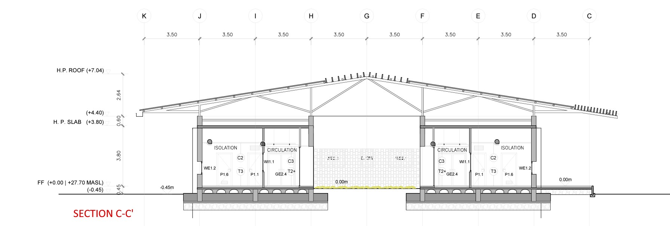
Figure 211: Single storey health facility, the Gambia: double roofs (IDOM Architects)
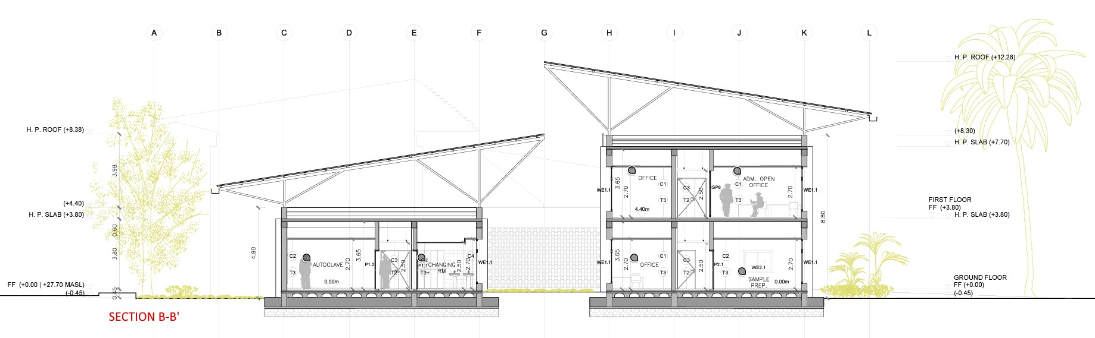
Figure 222: Single-storey and two-storey health facility, the Gambia: double roofs (IDOM Architects)
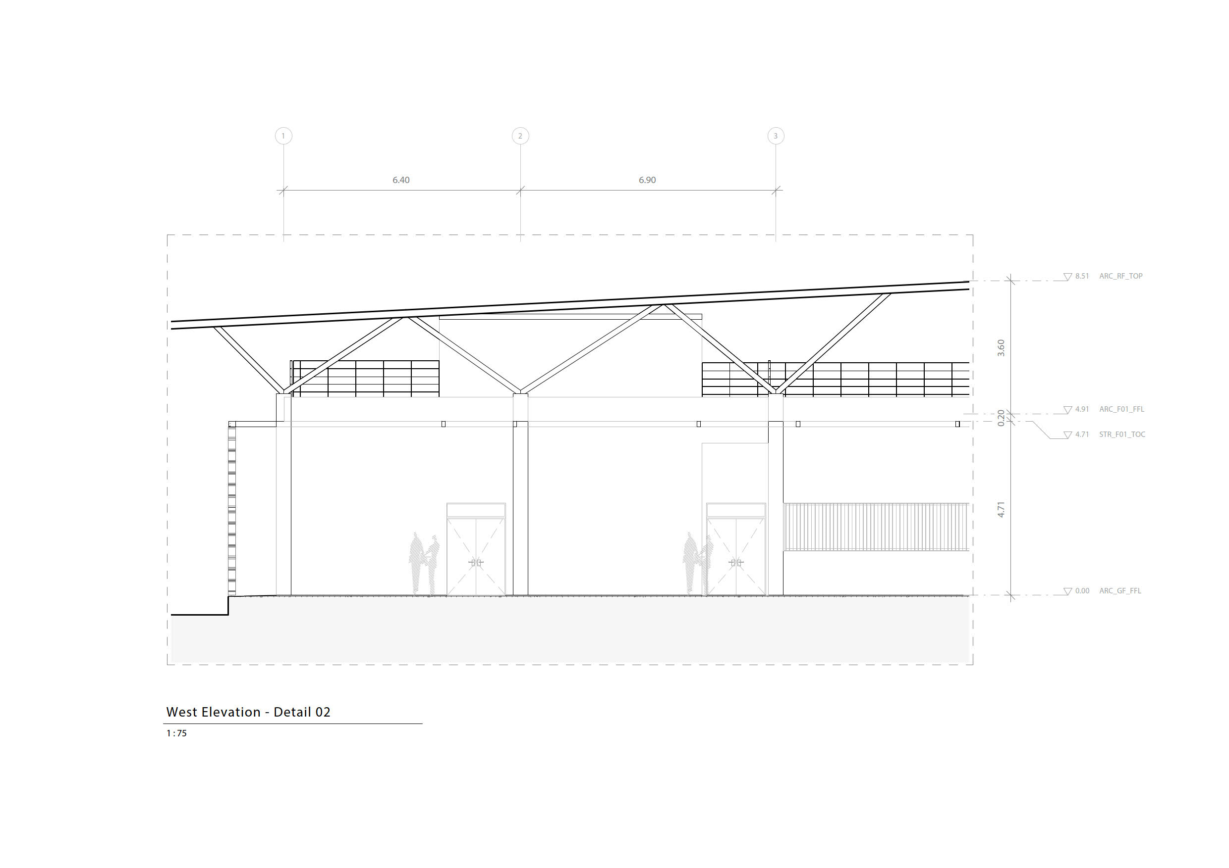
Figure 233: Part section through Food and Drug Laboratory, the Gambia: double roofs (IDOM Architects)
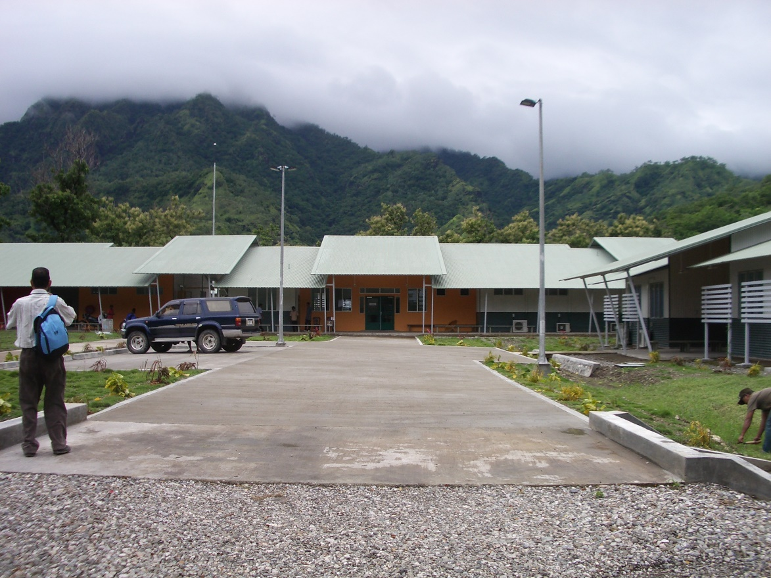
Figure 244: Oecusse Hospital, Timor Leste: lightweight construction suitable for mountainous regions (James Cubitt Australia, Architects. Photo: Nigel Wakeham)
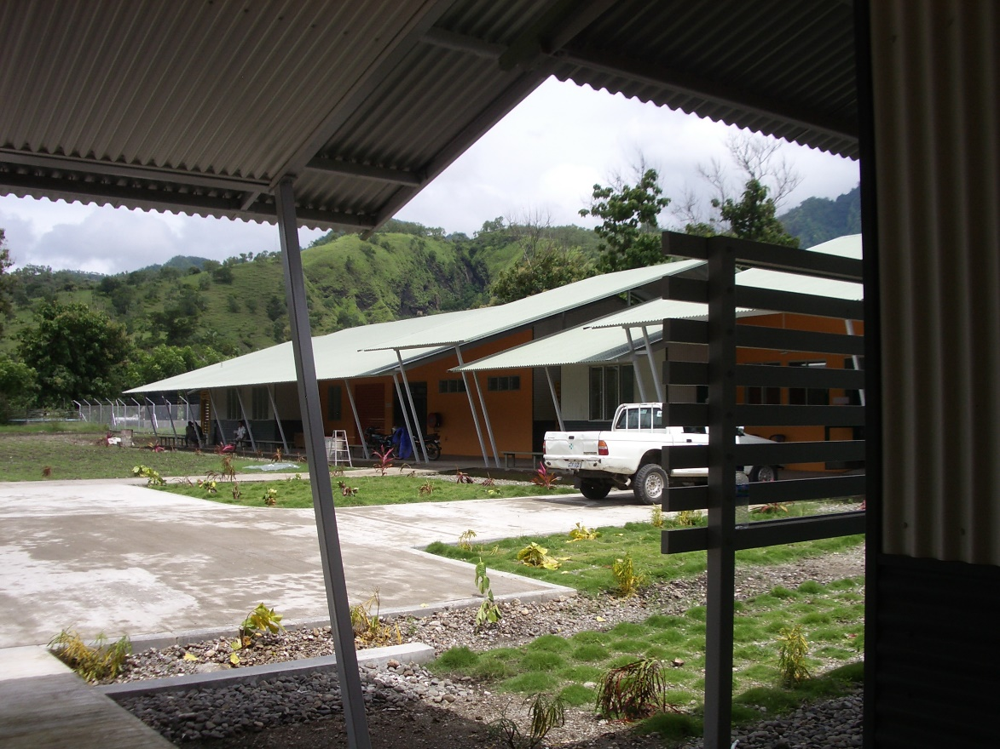
Figure 255: Oecusse Hospital, Timor Leste: high, steeply pitched roofs (James Cubitt Australia, Architects. Photo: Nigel Wakeham)

