Chapter 1: Introduction

1.1. Background
The Government of Indonesia received assistance from JBIC (Japan Bank for International Cooperation) to support Junior Secondary Education (JSE) projects in 12 provinces (now 14 provinces - Banten and Bangka Belitung Povinces have been split off from West Java and South Sumatera Provinces respectively). The fund was used to construct 584 new schools building (USB) between 1996 and 1999. The project was implemented in 3 phases as shown in Table 1 below.
Table 1. Number of constructed Schools

No | Provinces | FY  96/97 | FY  97/98 | FY  98/99 | Total  Schools
1 | West Java (incl.Banten) | 38 | 52 | 55 | 145
2 | Central Java | 38 | 39 | 37 | 114
3 | East Java | 38 | 39 | 36 | 113
4 | Riau | 6 | 6 | 6 | 18
5 | South Sumatra (Incl.Babel) | 11 | 12 | 10 | 33
6 | Lampung | 11 | 12 | 12 | 35
7 | West Kalimantan | 8 | 8 | 3 | 19
8 | South Kalimantan | 4 | 4 | 4 | 12
9 | Central Sulawesi | 4 | 4 | 4 | 12
10 | South Sulawesi | 13 | 14 | 14 | 41
11 | West Nusa Tenggara | 8 | 8 | 8 | 24
12 | East Nusa Tenggara | 6 | 6 | 6 | 18
 | Total | 185 | 204 | 195 | 584
An assessment of the schools constructed in the first and second phases has already been conducted by MONE in 1999/2000. The aim of the study was therefore to assist MONE to carry out an assessment of the schools constructed in the third phase and for this purpose, 195 schools in 12 (now 14) provinces constructed during fiscal year 1998/1999 were visited. The location of schools is shown in the maps in Appendix A.
1.2. Objectives
The objectives of the study were to (1) assess the quality of the construction works at the 195 schools; (2) assess the current conditions of schools; (3) make proposals for any necessary remedial works at the school and (4) assess the sustainability of the schools based on the collected data.
1.3. Methodology
The consultant was to provide a team of civil engineers and architects to carry out site inspections of each of the 195 junior secondary schools. The consultant and his team were to visit the schools and assess the condition of the buildings and collect other data (including the quality of the original construction, remedial work required and the cost of the remedial work) through the use of standard survey instruments. The team was divided into 10 groups, each group consisting of 1 engineer or architect and 1 assistant engineer (D-3 or STM level). Each group was responsible for site surveys, data collecting and analysis and reporting.
To assist the teams in acquisition of data they were provided with standard reporting forms and questionnaires and guidelines to assist in completing the forms. During the site survey, the engineers took photographs of the schools using digital cameras. Each team recorded the data collected at each school on standard forms. Details of the condition of the buildings at all 195 schools can be found in the Inspection Report - Volume 2.
1.4. Number of Schools – Stage III
Initially, a list of 214 junior secondary schools constructed under Stage 3 of the JBIC IP-457 project was given to the Consultant but during the preparation to carry out the schools surveys, a revised list of 199 schools was provided by a construction consultant (Ir.Soekirno) who worked on the project. It transpired however that 4 schools included in this second list were either not constructed or were not funded by the project. These were:
- SLTPN 4 Jatiluhur Kab. Purwakarta – West Java. The accessibility of school site was very difficult.
- SLTPN 4 Klari Kab. Karawang - in West Java.
- SLTPN 2 Hulugurung Kab. Kapuas Hulu - West Kalimantan
- SLTPN 3 Sungai Raya Kab. Pontianak - West Kalimantan (Not funded by JBIC)
A total of 195 schools were therefore surveyed by the team. One of these schools, SLTPN 6 Poso in Central Sulawesi Province is not in operation temporarily because of the security situation there (a riot was in progress when the team visited).
1.5. Arrangement of Report
For convenience, the report will be divided into 7 volumes:
- Volume 1 : Executive Summary /Main Report
- Volume 2.1 : Inspection Report - West Java
Volume 2.2 : Inspection Report - Central Java
Volume 2.3 : Inspection Report - East Java
Volume 2.4 : Inspection Report - Sumatera and Kalimantan
Volume 2.5 : Inspection Report - Sulawesi and Nusa Tenggara
- Volume 3 : Photographs

Chapter 2: School Conditions (Site, Buildings, Students, Teachers, and Maintenance Budget)

2.1. Assessment Criteria
The quality of sites, buildings, furniture and the utilization of school were assessed during the survey by using standard criteria, which were as follows:
a. Site Condition
Grade A: There is no possibility of flooding, landslides or other natural threats that could endanger the building or users.
Grade B: There is possibility of flooding, landslides or other natural threats that could endanger the building or users.
Grade C: There is at least one existing natural threat (flooding, landslide, etc) that could endanger the building or students and required remedial action.
Grade E: There are two or more existing natural threats (flooding, landslide, etc) that could endanger the buildings or students and required remedial action.
b. Site Location
Grade A: The location is close to settlements and is easily accessible by students.
Grade B: The location is close to the settlements but is difficult to access by students.
Grade C: The location is far from settlements and access is difficult.
c. Structural Elements
Grade A: All structural elements are in very good condition and above the specification.
Grade B: All structural elements are in good condition and satisfying the specification.
Grade C: The quality of structural elements is below the specification but they are structurally safe.
Grade D: One or more of the structural elements is (are) weak and is (are) jeopardizing the users. The building needs structural repair.
Grade E: The structural elements are weak and dangerous, and need to be demolished and rebuilt.
d. Roof and Ceiling
Grade A: All roof finishes and ceilings are in excellent condition and there are no leaks.
Grade B: All roof finishes and ceilings are in good condition and there are no (or very few) leaks.
Grade C: All roof finishes and ceilings are in fair condition and there are few leaks.
Grade D: Part of roof finish is damaged or badly laid and requires repair, there are roof leaks and the ceilings requires repairs.
Grade E: Part of the roof finish is badly damaged or laid and requires major repairs or replacement, the roof structure is damaged or deformed and requires major repair or replacement, there are many roof leaks and the ceilings requires major repairs or replacement. The roof or ceiling represents a danger to the occupants of the building.
d. Finishing Works (Paint, floors, doors, windows)
Grade A: All finishing works are in very good conditions.
Grade B: All finishing works are in good condition.
Grade C: One item of finishing work is damaged and requires minor repairs.
Grade D: Two or more items of finishing works are damaged and requires major repairs.
Grade E: All finishing works are damaged and require major repairs or replacement.
e. Utilities (Electrical work, water supply and distribution, sanitation)
Grade A: All utilities are in very good condition.
Grade B: All utilities are in good condition.
Grade C: One utility is damaged and requires minor repairs
Grade D: Two or more utilities are damaged and require major repairs
Grade E: All utilities are damaged and require major repairs or replacement.
f. Furniture
Grade A: All Furniture is in very good conditions
Grade B: All Furniture is in good condition
Grade C: Some (less than 10 %) furniture is damaged and requires minor repair
Grade D: Some (10 - 50 %) furniture is damaged and requires repair or replacement.
Grade E: More than 50 % furnitures are damaged and requires repairs or replacement
g. Student Population
Grade A: The number of students is equal to the school’s capacity
Grade B: The number of students is larger than the school’s capacity or requires 2 shifts
Grade C: The number of students is more than 50 % of its capacity
Grade D: The number of student is less than 50 % of its capacity
Grade E: There are no students or school is not in operation
h. Teacher Population
Grade A: The number of teachers is as the government standard number
Grade B: The number of teachers is more than the government standard number
Grade C: The number of teachers is 10-40 % less than standard number
Grade D: The number of teachers is less than 50 % of the standard number
Grade E: There are no teachers.
- Maintenance Budget (the estimated annual budget required for maintenance is Rp 25 millions per schools. The annual maintenance budget for a building is usually estimated at between 2 and 4 % of initial cost per year depending on the type of building)
Grade A: The budget available to the school is Rp 25 millions/year or more
Grade B: The budget available is Rp 18 - 25 millions/year
Grade C: The budget available is Rp 11 - 18 millions/year
Grade D: The budget available is Rp 5- 11 millions/year
Grade E: The budget available is less than Rp 5 millions/year
2.2. Statistics of School Conditions (see Appendix B for details)
a. Site Condition
113 sites (58%) have been assessed as grade A, 30 (15%) sites are grade B, 12 (6%) sites are grade C, and 39 (20%) are grade D. The majority of sites selected therefore were suitable for construction. It should be noted however that a significant minority of sites (39 equal to 20 %) were assessed as unsuitable for construction.
b. Site Location
Some of the site locations are badly situated
c. Structural Elements
Structural elements have been assessed at an average of grade C and in general are acceptable. However, both SLTPN 2 Pucanglaban and SLTPN 2 Tanggunggunung in East Java requires immediate repairs to structural elements because of problems caused by unstable soil condition and low bearing capacity of foundations.
c. Roof and Ceiling
Leaking roof tiles or roof sheets, and damaged ceiling are the most common problems encountered in school buildings. The main reasons for these problems are as follows:
- Roof tiles or sheets are not fixed properly
- There is insufficient over-lap between roof tiles or roof sheets
- Deformed roof structure caused either by poor quality of timbers or poor quality construction.
- Poor quality timber ceiling framing and nailing too close to edges of ceiling panels.
- Inadequate thickness of ceiling panels.
e. Finishing Works (Paint, floor, doors, windows)
The average grade of finishing works is C and the main problems are as follows:
- Poor quality of paint and insufficient number of coats
- Floor settlement because of poor compaction and loose and broken floor tiles.
- Poor quality and broken door hinges and locks, and window fittings
- Poor quality doors.
f. Utilities (Electrical work, water supply and distribution, sanitation)
The average grade for utilities is C-. Nearly all pupils’ toilets are not functioning and many schools do not have a clean water supply. Shallow wells are the sources of water for most schools. Most schools are not maintaining the electrical installations. It should be noted however that the lack of functioning toilets and of a clean water supply are serious problems that pose health risks to the students and they should be rectified as soon as possible.
f. Furniture
Much of the furniture is poor quality and at least some of furniture in many schools is damaged and unusable. Many of the laboratories are also not furnished. A further problem is that school principals are not allowed to dispose of broken furniture and this in some cases is taking up valuable space in schools.
g. Student Population
All of the schools visited were in operation except SLTPN 6 Poso which was temporarily closed because of the security situation. 52 schools have more students than they were built to accommodate, 27 schools have the correct number of students, and 115 schools have fewer students than they were built to accommodate. The implications of these figures are that some schools should have been larger in order to serve the student population in their catchment area and some schools are badly situated and do not have sufficient students within their catchment area and should have been smaller.
h. Teacher Population
Of the 194 schools, 155 schools have the standard government number of teachers. Some schools, however especially in the urban areas, have more than the standard number of teachers and 39 schools require additional teachers to bring up to the government standard. Most of these schools are located in remote rural area, such as Kalimantan, Nusa Tenggara, etc.
i. Maintenance Budget
It is estimated that the budget required to maintain a school properly is between Rp 18-25 Millions a year. Based on this figure, only 4 schools have an adequate annual budget (more than Rp 18 millions /year), namely SLTPN 2 Momunu (Central Sulawesi), SLTPN 3 Majuleng (South Sulawesi), SLTPN 12 Pare-pare (South Sulawesi), and SLTPN 4 Campalagian (South Sulawesi). Ten schools have an annual budget of between Rp 11 and 18 Millions, and the remaining schools have a budget of less than Rp 11 millions.
All schools receive a government grant for operation and maintenance of between Rp 25 to 30 Million per year but only a small part of this budget (Rp 3-5 millions) is used for maintenance. Some schools raise additional finance themselves or through BP3 (The parents organization). All schools however seem to be equally badly maintained and it is not clear that at any schools, even at those that state that they raise additional funds, the funds are actually spent on maintenance.
Chapter 3: Immediate Action Required at Specific Schools

Immediate action is required at a number of schools because of particularly serious problems. The schools and the action required are as follows:
3.1. West Java
SLTPN 3 Cikande – Serang (School code –001)
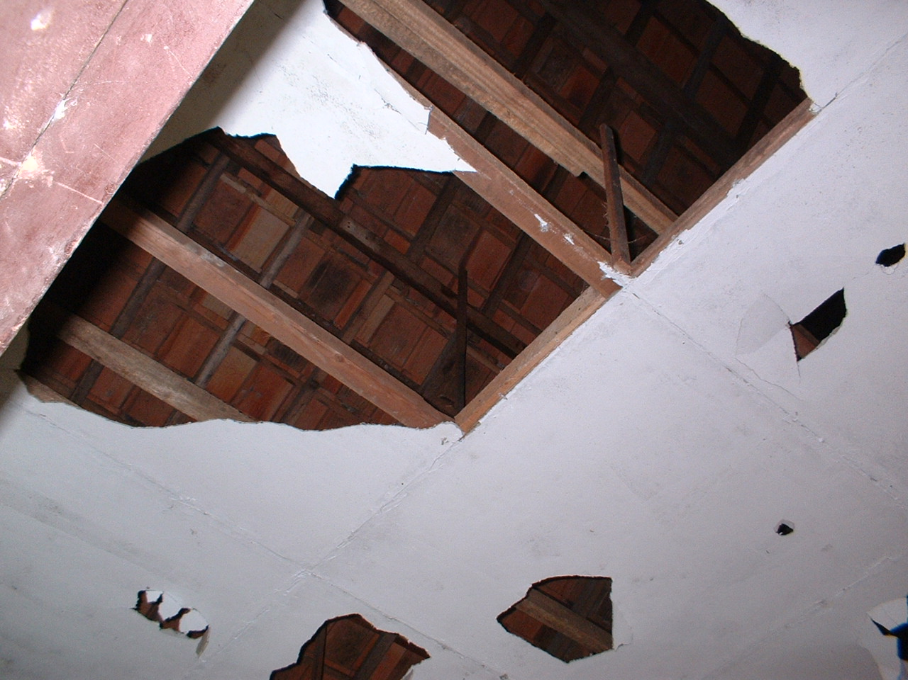
All ceilings are damaged and the ceiling panels and some ceiling framing require replacement as soon as possible. All doors are damaged and require replacement. Wall tiles in laboratory also require replacement

SLTPN 2 Pontang – Serang (chool code-002)
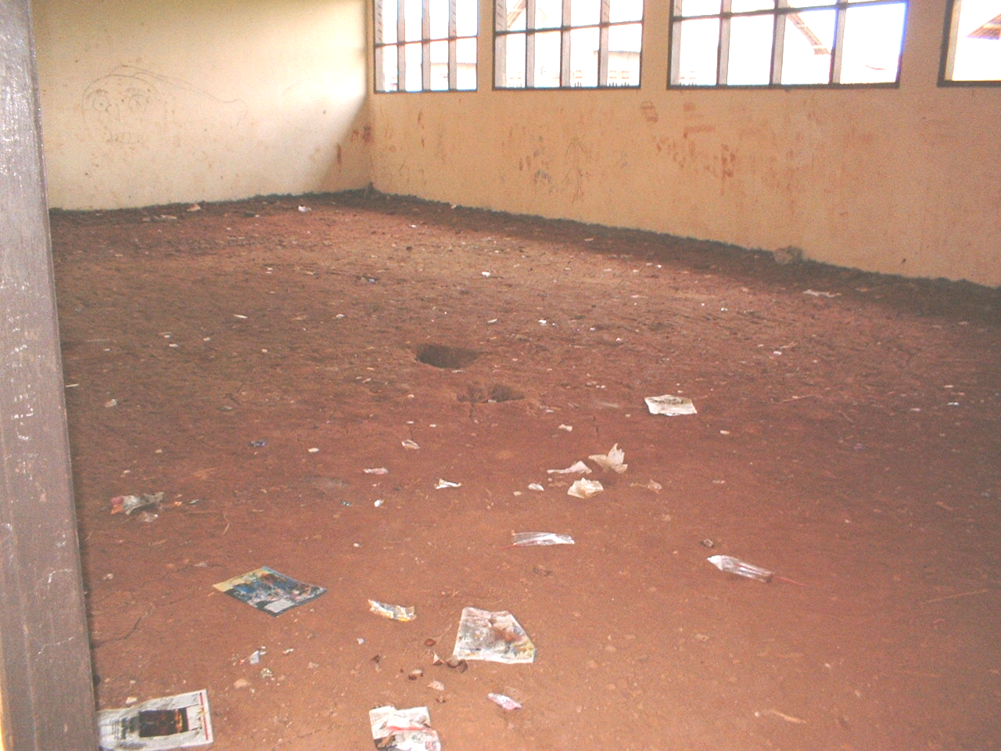
The buildings have not been completed. None of the buildings are painted and floor tiles to some buildings have not been laid. The school is operating therefore in very limited number of rooms. There is also very little furniture. All works should be completed as soon as possible and the remaining furniture supplied.

SLTPN 9 Rangkasbitung – Lebak (School code – 008)

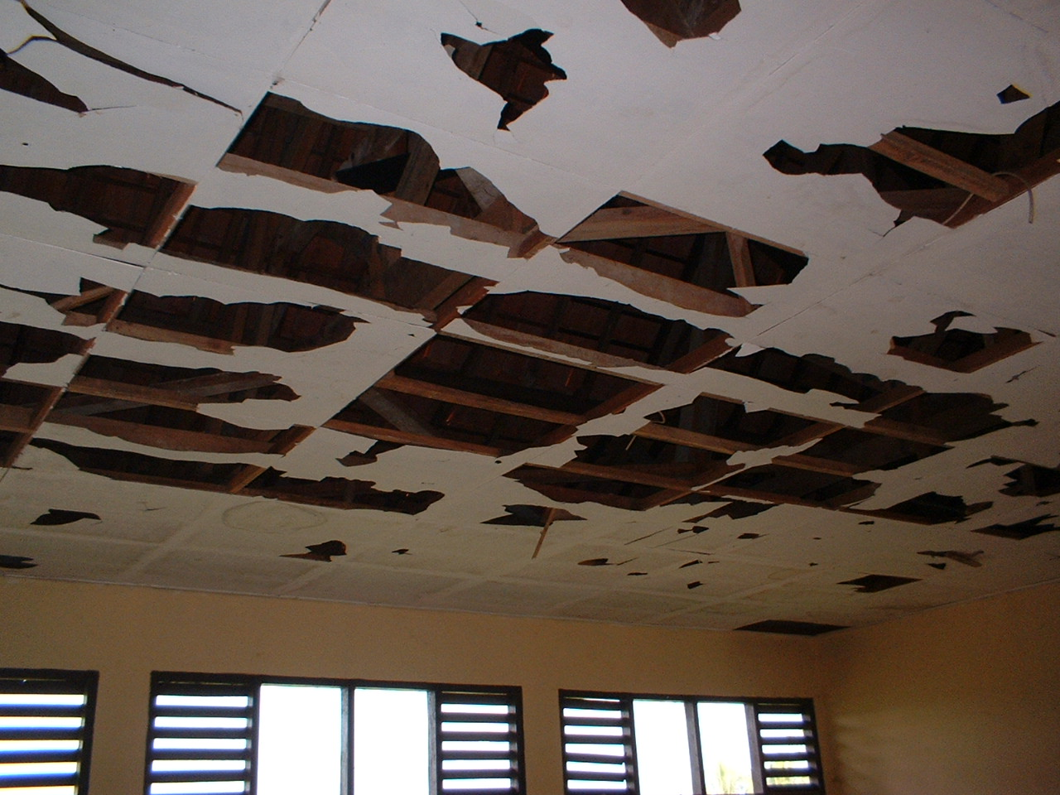
Almost all ceiling are damaged and all ceiling panels and some ceiling frames require replacement as soon as possible

SLTPN 3 Cimarga – Lebak (School code – 010)
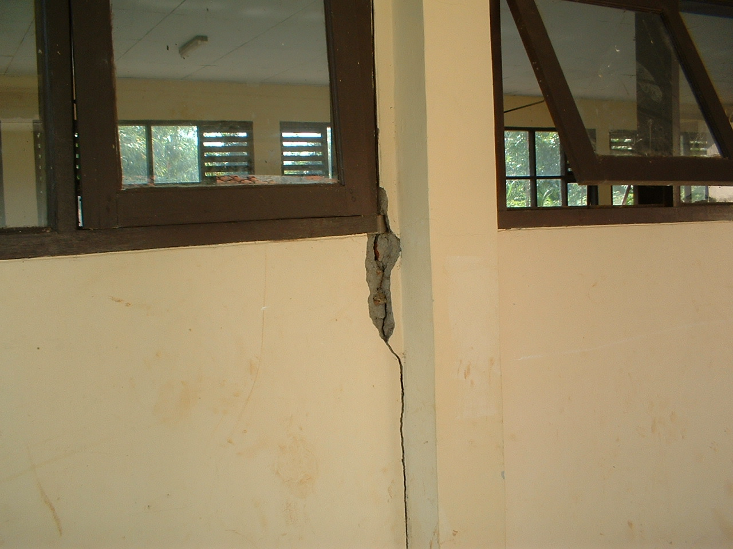
Walls in the handicraft building are seriously cracked and the foundation of the building and the tie beam must be strengthened as soon as possible.

SLTPN 3 Cigudeg – Bogor (School code – 013)

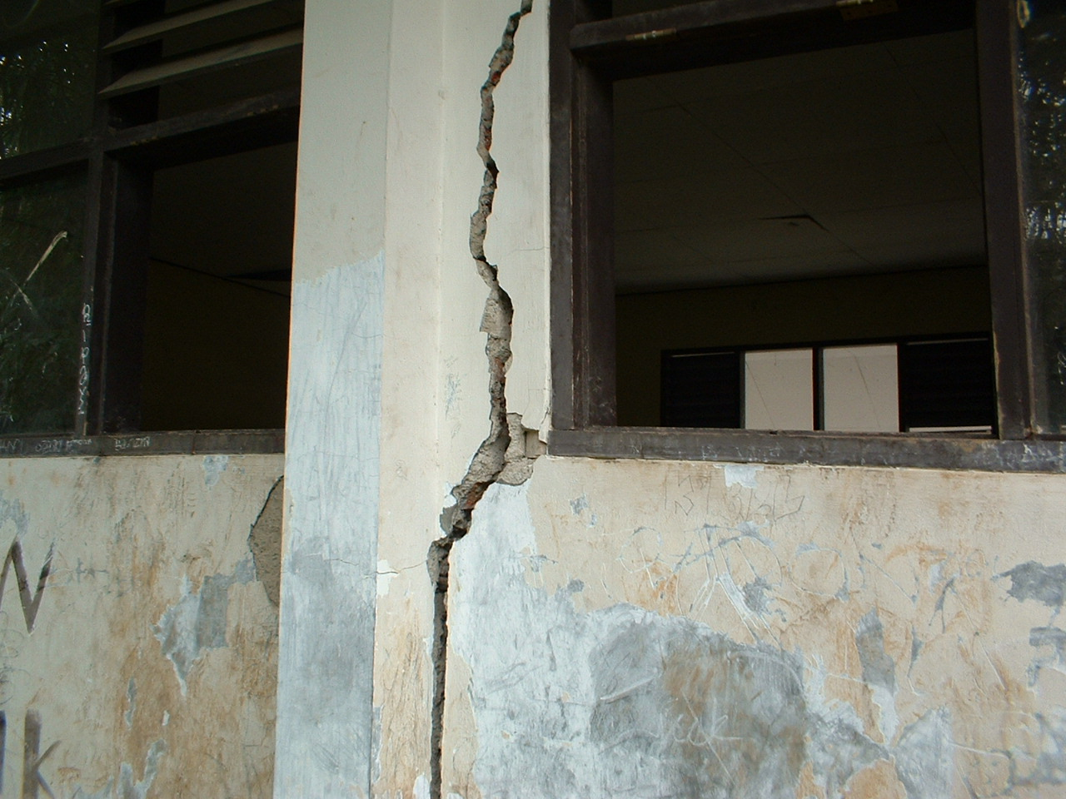
The walls to three classrooms are badly cracked and strengthening of the structure including the foundation is required immediately.
SLTPN 3 Leuwiliang – Bogor (School code – 01)

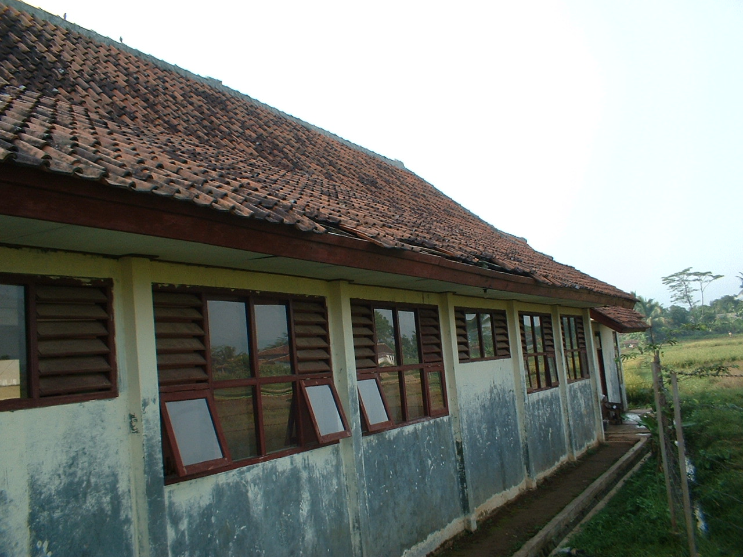

The roof frame to one building is deformed and replacement of the roof frame, ceiling and painting is required.

SLTPN 2 Nyalindung – Sukabumi (School code – 016)
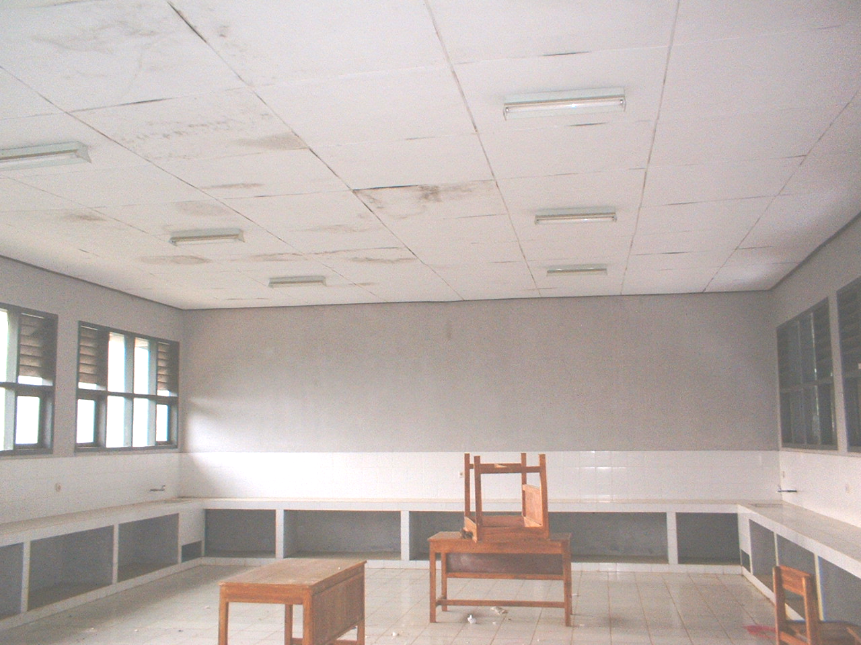
The roof is leaking and the ceiling has been badly damaged. Replacement of part of roof frame and ceiling framing and ceiling panels is required.

SLTPN 2 Kalijati - Subang (School code –036)
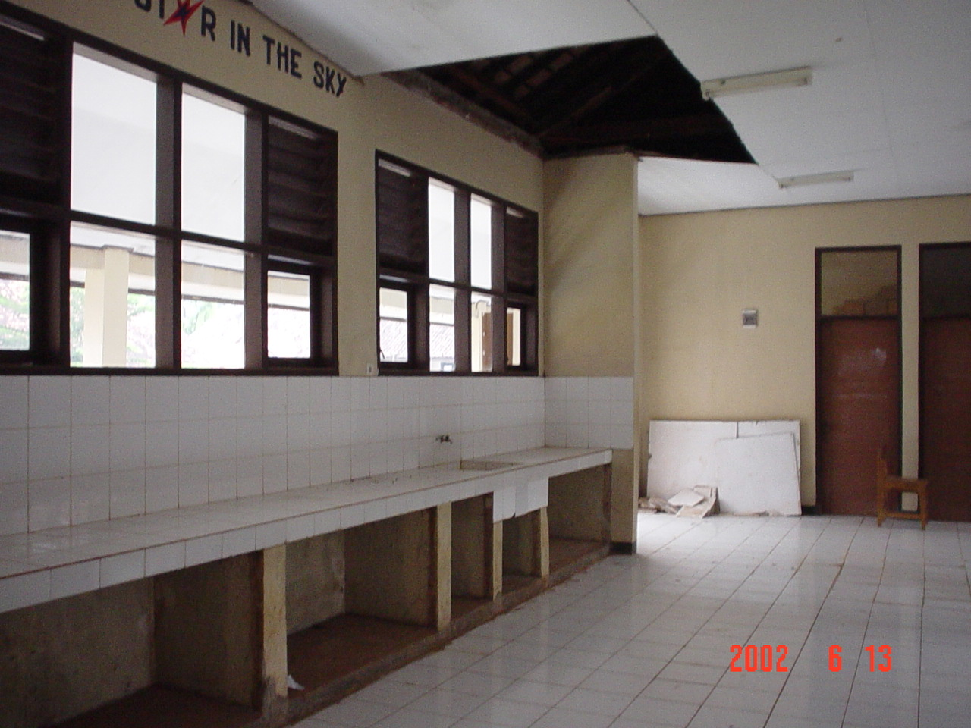
The ceilings of this school are badly damaged and parts have collapsed and other parts are in a dangerous condition.
Remedial works to the ceiling are required immediately.

SLTPN 4 Cilamaya – Karawang (school code – 042)

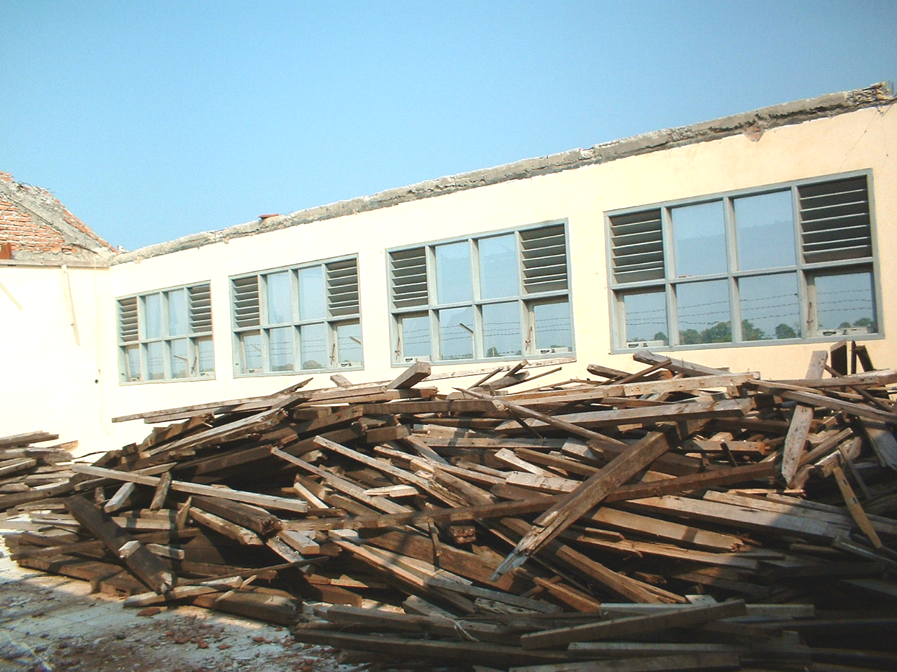
The roof structure of Laboratory and Handicraft building has collapsed and the building is unusable. The building requires complete renovation immediately.

SLTPN 2 Cibarusah – Bekasi (School code – 044)
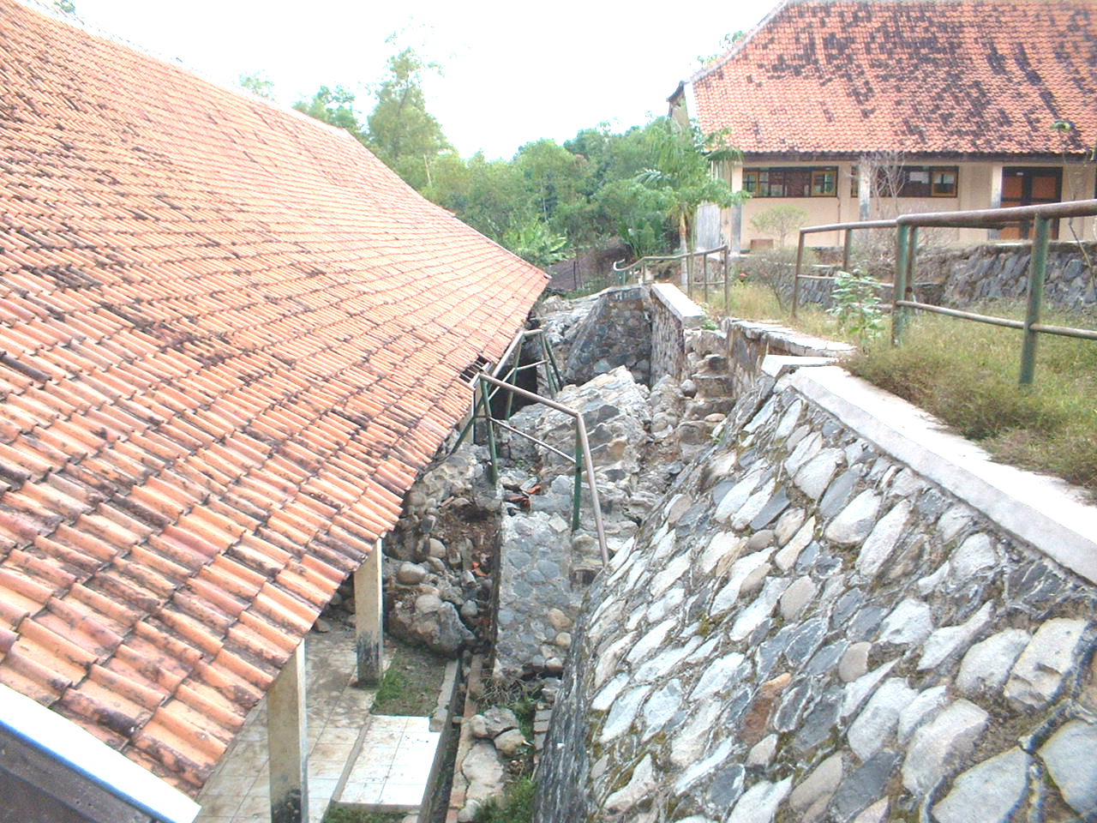
Four classrooms are not being used because the retaining wall in front of classroom has collapsed. A new retaining wall and repairs to the building are urgently required.

3.2. Central Java

SLTPN 2 Jiken – Blora (school code – 077)
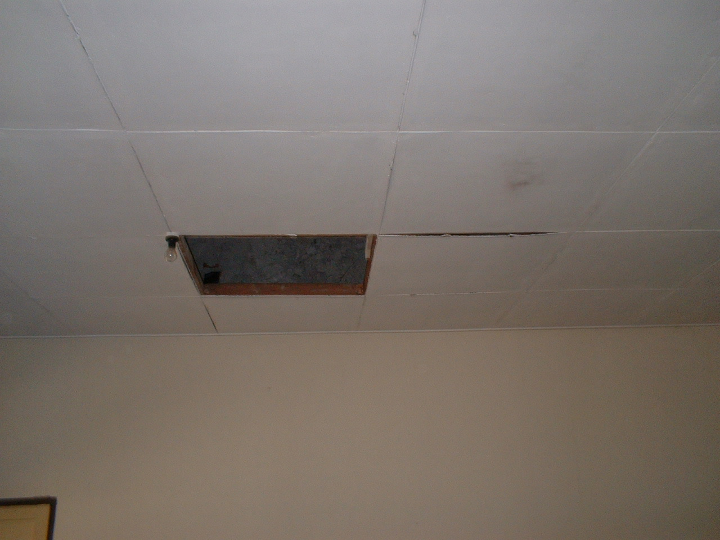
The ceilings to this school are extensively damaged and parts have collapsed posing a danger to students and teachers. Remedial works are required immediately.

SLTPN 3 Wirosari – Grobogan (School code – 081)
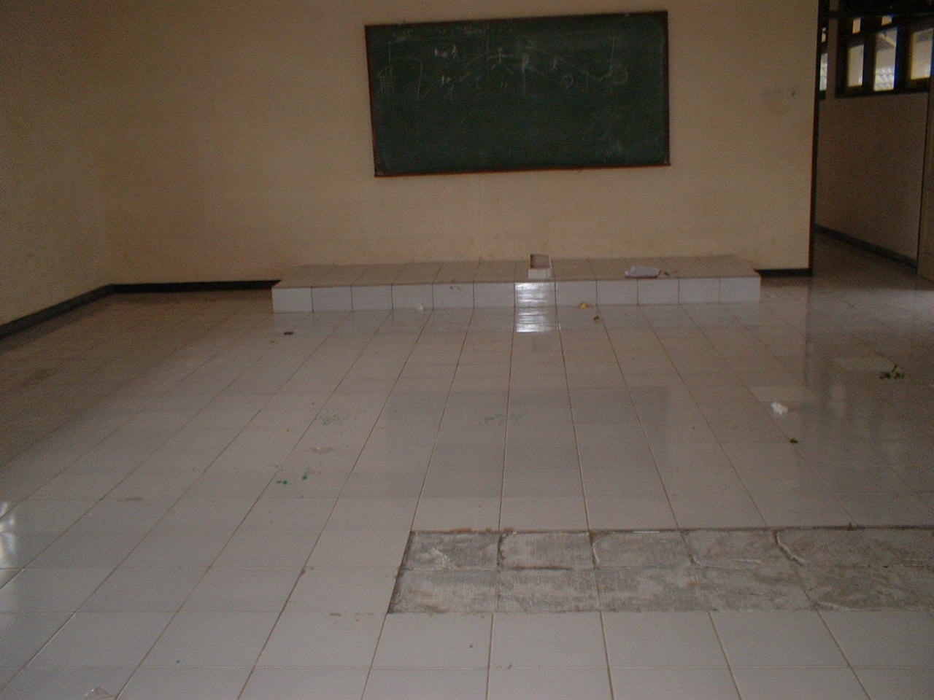
There has been significant settlement (10 cm) to the floor of one building due to insufficient compaction of the sub-soil. Most of the ceramics floor tiles are broken and the floor should be re-built as soon as possible.

3.3. East Java

SLTPN 2 Pucanglaban – Tulungagung (School code- 096)
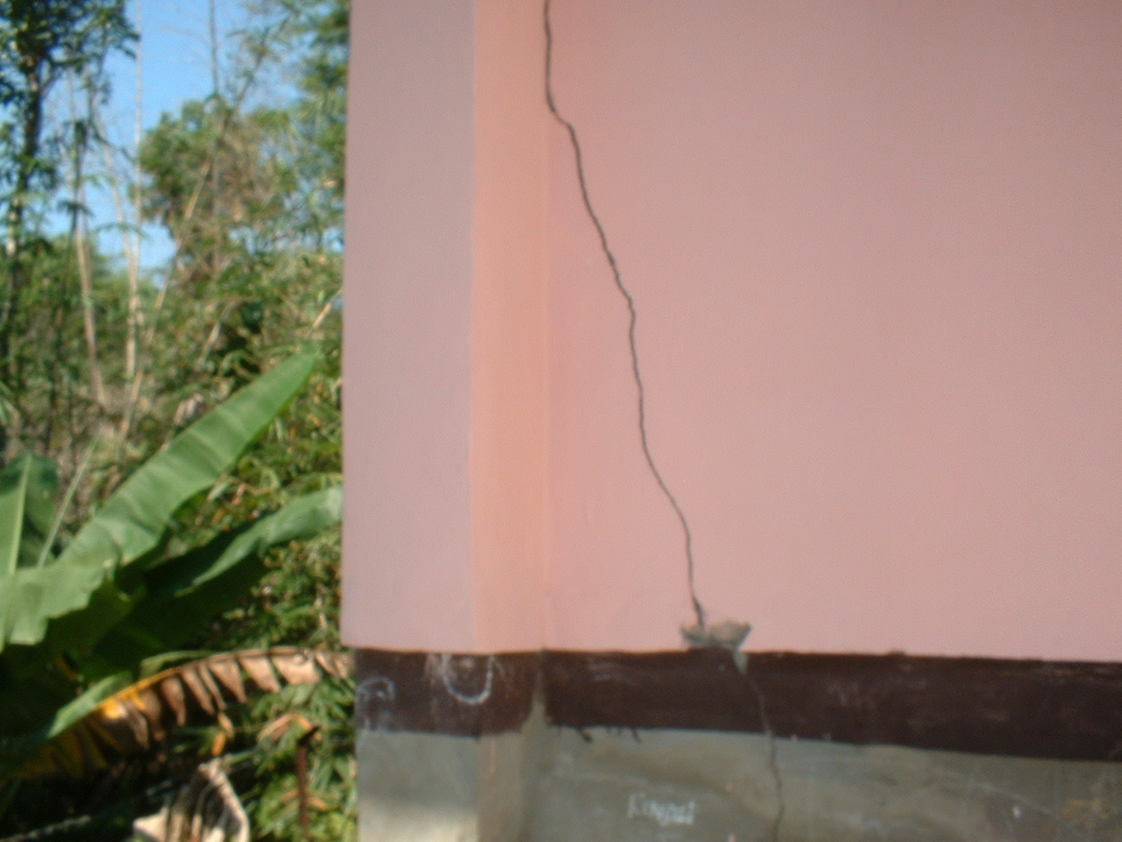

Serious cracking has occurred in the walls of a classrooms building, due to foundation settlement.

Strengthening of the foundation, tie beam and other structural elements are required as soon as possible.

SLTPN 2 Tanggunggunung – Tulungagung (School code- 097)
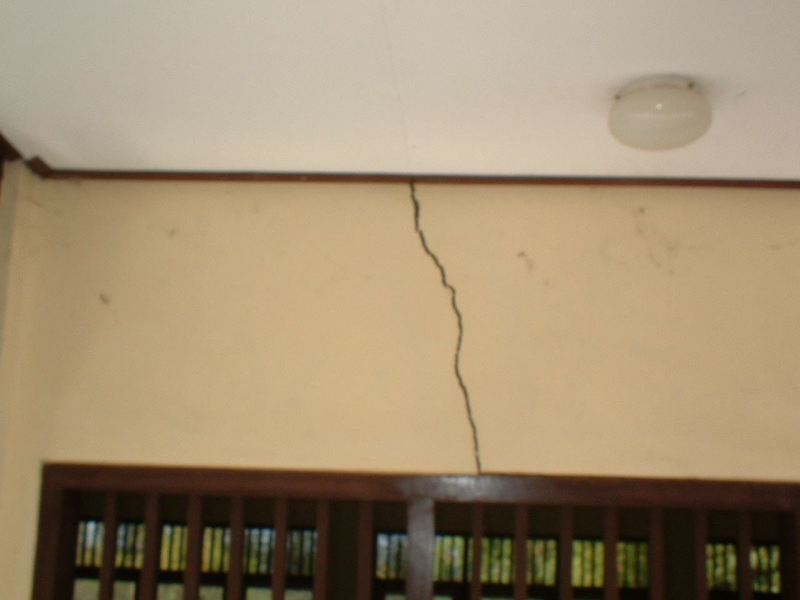
Serious cracking has occurred due to foundation instability.
Part of the ceiling of this school is damaged and remedial works to the structural elements and ceiling are required immediately.

SLTPN 2 Sukapura – Probolinggo (School code- 112)

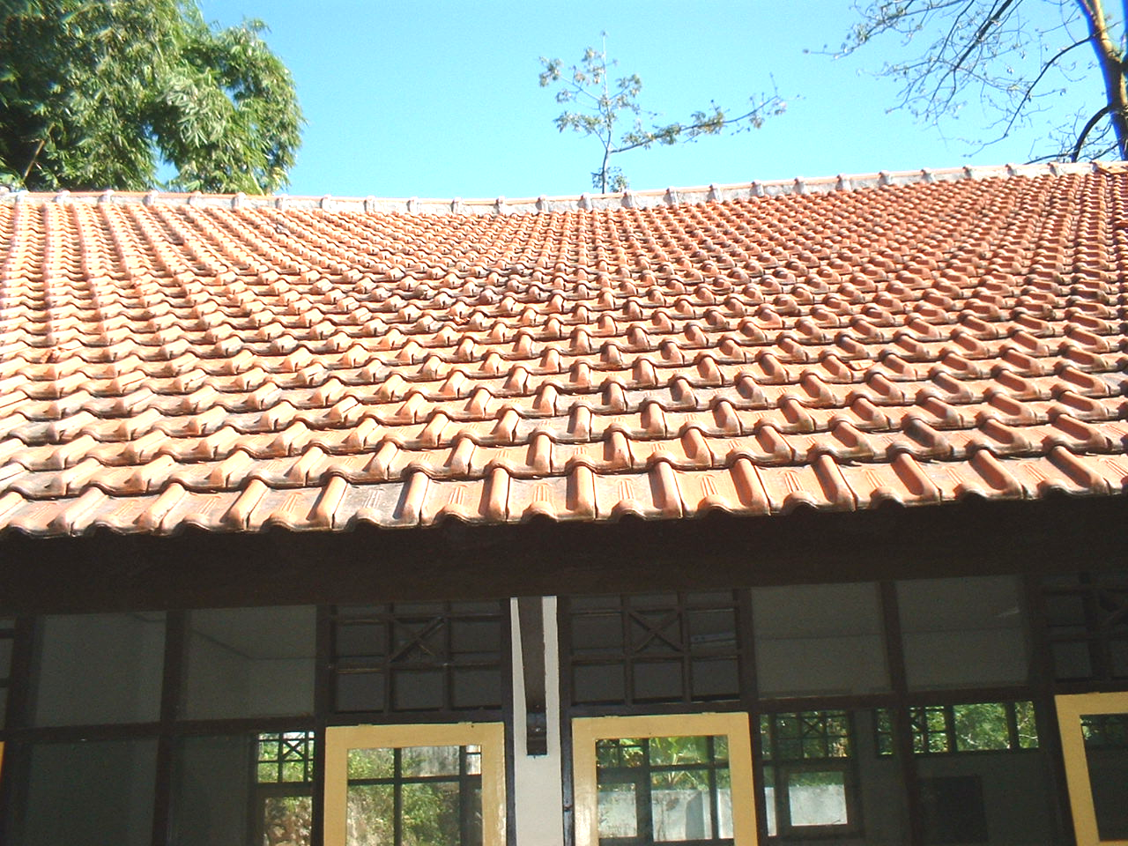
The roof framing has deformed some ceilings are damaged. Remedial works to the roof frame and ceiling are required immediately.

SLTPN 3 Bagor – Nganjuk (School code- 122)

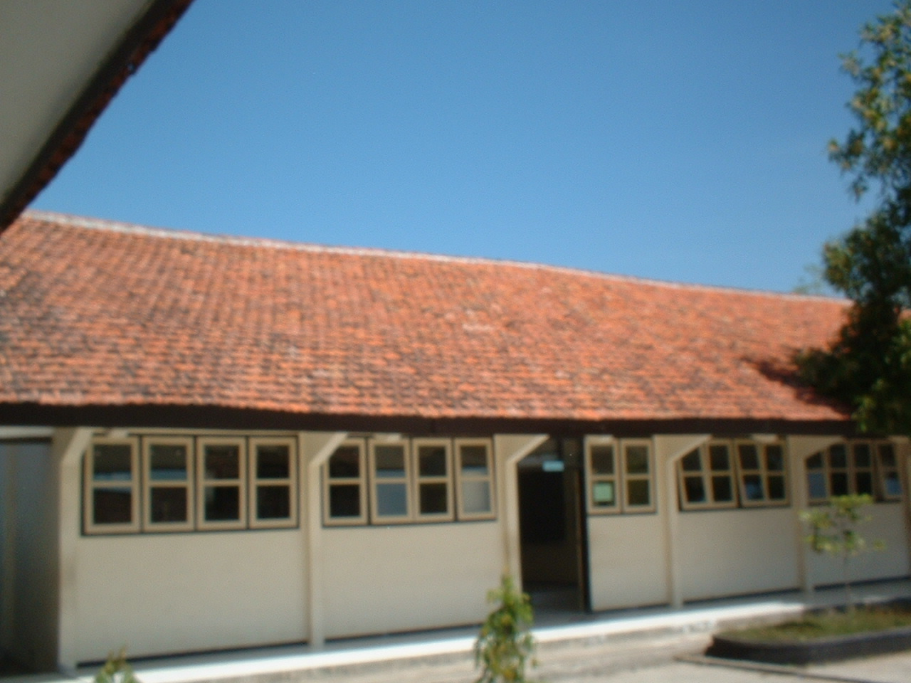
Roof framing has deformed and remedial work is required.

3.4. Riau

SLTPN 5 Keritang (School code- 133)

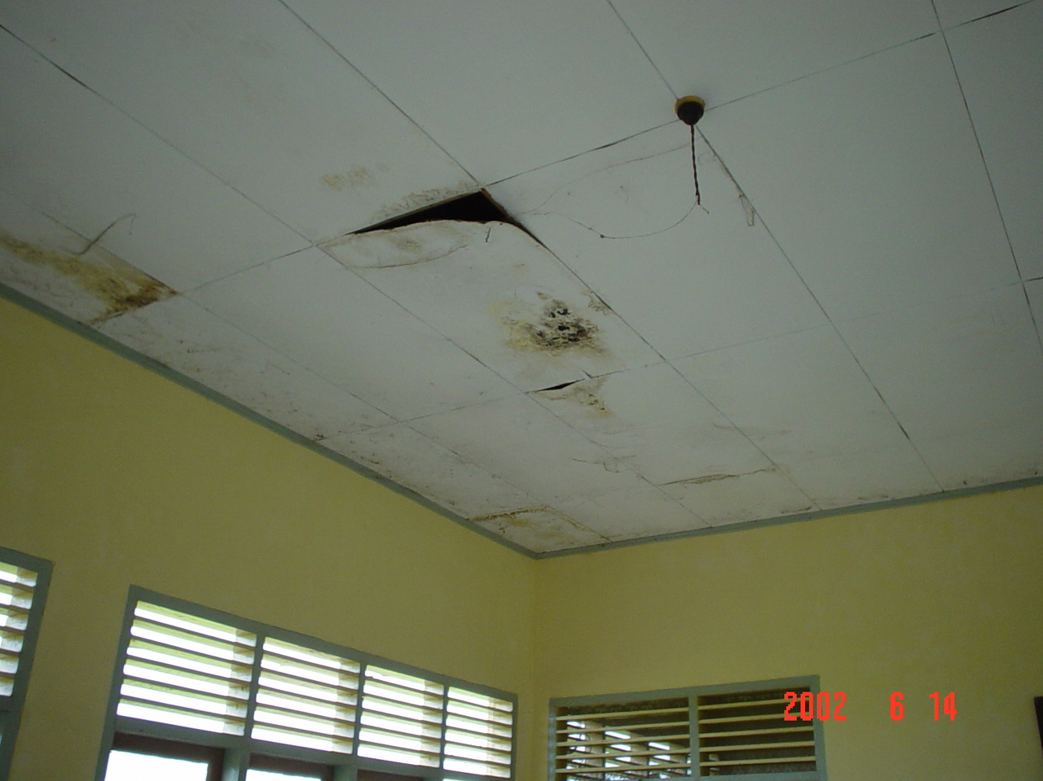
The roof is leaking and the ceiling is damaged. Remedial works to the roof and ceiling are required.

SLTPN 2 Minas (School code- 134)

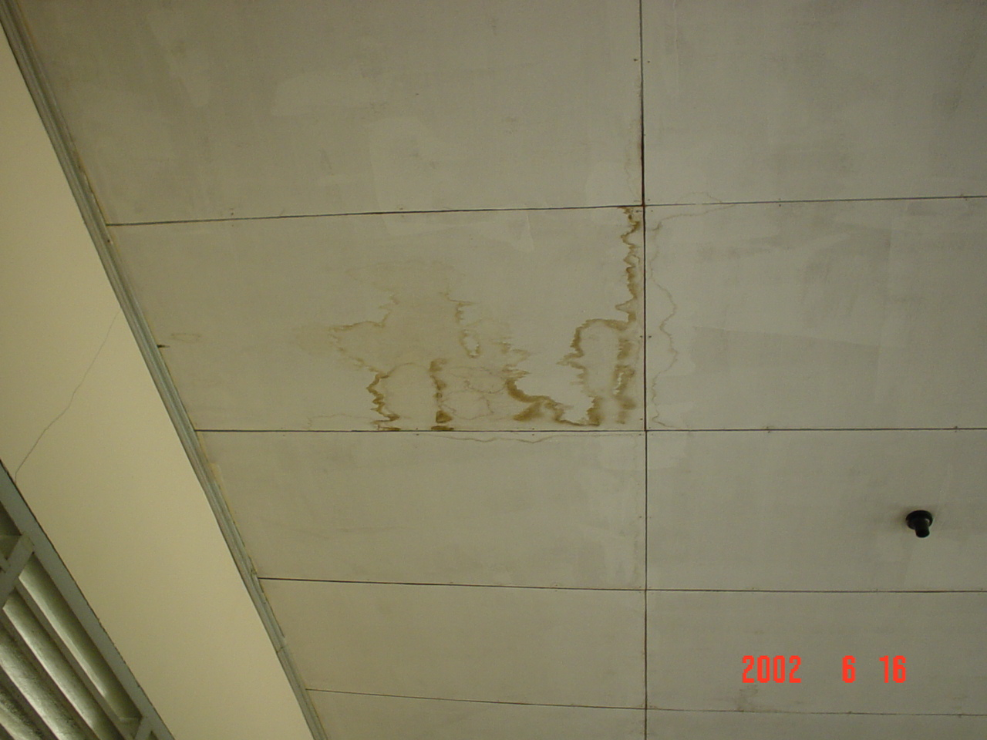
The roof cover is leaking and the ceiling is damaged. Remedial works to the roof and ceiling are required.

Chapter 4. Remedial Works and Development

Details of the repair and development works required at each schools, is given in Appendix C of this Report.
Most of the repair works are to roofs, ceilings, ceramic floor tiles, and painting but some structural repairs to structural frames and foundation are also required.
SLTPN 2 Pontang, West Java in particular requires Rp 628 millions for completing the construction of the school buildings and for some additional works.
Generally, the additional development works required are walls or fence around sites, sport facilities, paving of courtyards. A summary of cost of remedial works and additional development works are given below.

No | Province | Number of School | Repair  Rp | Development  Rp | Total  Rp
1 | West Java | 55 | 5.774.988.846,50 | 10.925.354.300,00 | 16.700.343.146,50
2 | Central Java | 37 | 2.877.444.902,00 | 12.692.443.575,00 | 15.569.888.477,00
3 | East Java | 36 | 3.704.113.299,00 | 4.910.564.500,00 | 8.614.677.799,00
4 | Riau | 6 | 404.484.755,57 | 1.565.352.600,00 | 1.969.837.355,57
5 | South Sumatera | 10 | 241.435.100,00 | 2.545.589.500,00 | 2.787.024.600,00
6 | Lampung | 12 | 522.125.850,00 | 3.284.727.000,00 | 3.806.852.850,00
7 | West Kalimantan | 3 | 359.492.876,00 | 550.698.000,00 | 910.190.876,00
8 | South Kalimantan | 4 | 749.171.900,00 | 605.534.000,00 | 1.354.705.900,00
9 | Central Sulawesi | 4 (-1) | 378.332.060,00 | 1.276.250.700,00 | 1.654.582.760,00
10 | South Sulawesi | 14 | 2.111.506.120,00 | 4.691.949.300,00 | 6.803.455.420,00
11 | West Nusa Tenggara | 8 | 710.417.365,00 | 1.524.411.900,00 | 2.234.829.265,00
12 | East Nusa Tenggara | 6 | 448.564.300,00 | 987.581.900,00 | 1.436.146.200,00
 | Total | 195 (-1) | 18.282.077.374,07 | 45.560.457.275,00 | 63.842.534.649,07

Chapter 5. Recommendation

Lessons can be learned from this survey that should be useful in the design and planning of new junior secondary schools in the future. Five major recommendations are made based on the problems encountered at most of the schools surveyed. These are:
- School Design
Design of new school buildings should be simple and economic and should take into account the climate and likely site condition. It should be possible to arrange and connect the building in different ways on different sites. The roof design in particular should be simple and straightforward and the roof should be simple to build.
- Site Suitability
Many of the schools surveyed were built on unsuitable sites with for instance slopes of more than 10 %. This makes site works expensive, sometimes more expensive than the school buildings. Some sites are also very wet.
Site must be selected carefully and investigated thoroughly using the criteria establishes by the Departemen Pendidikan Nasional (MONE). Engineering advice should be taken before sites are finally selected to avoid the possible problems. The selection of suitable sites will reduce both the cost of the site works and also the possibility of the problems in the future. Adequate funding must also be provided for all the site works required and the budget should be based on the actual requirements at each site and not be a standard amount
- Site Location
Care must also be taken in selecting sites that are easily accessible by the students and teachers and that have sufficient students within their catchment area to make full use of the facilities available. The size of school should be determined by the actual number of students within the school’s catchment area and standard size schools should not be built.
- Construction and Supervision
Almost all school buildings surveyed had problems of one kind or another and these had a number of causes including:
- Bad design
- Poor quality materials
- Poor quality construction
- Poor quality of supervision by both contractors and consultants
All of the schools were constructed by contractors and the construction costs were adequate if not relatively high
As stated above, it is important that schools building are simple and economic to build. However, it is also important that good quality materials are specified and used in the construction as this will reduce maintenance costs in the long run. At nearly all school visited, the quality of doors and hardware (locks, handles, windows fitting, etc) were very poor and many required replacement. Many other problems have been caused by inadequate supervision. Contractors, if used, should provide competent, full-time site supervisors and consultants must ensure that the materials specified are used and that the quality of works is as specified. Many of the problems seen would not have occurred if both the contractors and the consultants had carried out their responsibilities properly.
It should be noted that some World Bank and GoI funded projects now in progress are not using contractors for school construction and renovation but are instead using school committees to implement them. The committees receive funding direct, ue local labor and receive technical assistance from civil works consultants and, when well managed, these projects are producing results in terms of school buildings that are as good as and no more expensive than, those using contractors. This method of implementation should also give more local ownership of, and responsibility for the completed buildings.
It is recommended therefore that this method of school construction and renovation is considered for the future school building projects.
- Water and Sanitation
There are problems with water supplies and sanitation at almost all of the schools surveyed. The problems are with the actual supply, or with the supply system within the site and/or with the quality of the sanitary fittings. Again most of the problem could have been avoided if both consultants and contractors had carried out their duties properly.
The consultants should have ensured that an adequate and reliable drinking water supply was available throughout the year, that the water supply system was properly designed and that the materials used were properly specified. The consultants and the contractors should have ensured that the works were properly executed.
In the future projects more emphasis should be given to ensuring that all schools have an adequate and reliable fresh water supply and functioning toilets.
- Operation and Maintenance
The budget required for building maintenance is estimated at Rp 25 millions per year (between 2% and 4 % per year of the cost of construction At present, the government should provide all schools with Rp 20-25 millions for all operation costs including office supplies, electrical consumption, water, maintenance, etc. but schools generally only allocate Rp 2-6 millions of this for building maintenance. Another source of funding for maintenance comes from tuition fee from parents (BP3). The amount of the fee varies from school to school depending on the school and local economy. Some schools charge Rp 5000, and other schools charge Rp 3000 per month. In general, 10-30 % of this money is spent on maintenance of buildings, or Rp 3 - 5 millions per year.

Obviously additional funding must be found for maintenance if schools are to be properly maintained and renovation costs reduced. It can be said that this funding should come from either local or central government but maintenance of buildings is usually the first budget item to be cut when funds are limited. The only way to provide more funding for school maintenance would seem to be to give more responsibility to the school and community for both the construction and maintenance of school buildings.

